This is the Title PhL 1.11.15

do not edit, has been installed on 12/18/15

H.5 Limits of toroidal functions (and combinations) as n→∞ 1
H.6 Limits of toroidal functions (and combinations) as z→∞ 3
H.7 Limits of toroidal functions as z→1 5
H.8 Alternate series for T(z) near z = 1 7

H.5 Limits of toroidal functions (and combinations) as n→∞

Results below assume ξ ≥ 0 and ξ0 ≥ 0.

From AS2010 p 366 and p 354 we find that, for large ν,

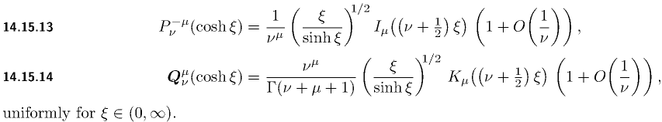

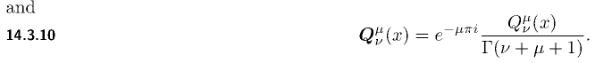 (H.5.1)

Our Q function of interest is the unbolded one. Therefore,

Pν(chξ) → $\frac{ξ}{shξ}$ I0[(ν+1/2)ξ]
Qν(chξ) → $\frac{ξ}{shξ}$ K0[(ν+1/2)ξ] ν→∞ (H.5.2)

so for our toroidal functions.

Pn-1/2(chξ) → $\frac{ξ}{shξ}$ I0(nξ)
Qn-1/2(chξ) → $\frac{ξ}{shξ}$ K0(nξ) . n→∞ (H.5.3)

Here I0 and K0 are modified Bessel functions. From the same source the large z behaviors of I0 and Ko are given by,

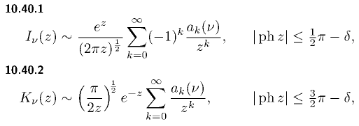
with
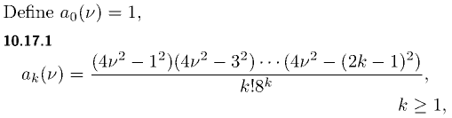 . (H.5.4)
Therefore,

I0(z) → $\frac{1}{2πz}$ ez
K0(z) → $\frac{π}{2z}$e-z z→∞ (H.5.5)
so
I0(nξ) → $\frac{1}{2πnξ}$ enξ
K0(nξ) → $\frac{π}{2nξ}$e-nξ . n→∞ (H.5.6)

Putting the pieces together, we find that

Pn-1/2(chξ0) → $\frac{ξ0}{shξ0}$$\frac{1}{2πnξ0}$enξ$_{0}$ = $\frac{1}{shξ0}$$\frac{1}{2πn}$ enξ$_{0}$
Qn-1/2(chξ0) → $\frac{ξ0}{shξ0}$$\frac{π}{2nξ0}$ e-nξ$_{0}$ = $\frac{1}{shξ0}$$\frac{π}{2n}$ e-nξ$_{0}$ . n→∞ (H.5.7)

so Pn-1/2(chξ0) diverges exponentially as n→ ∞, whereas Qn-1/2(chξ0) converges exponentially. We are interested several special combinations of functions. First,

Pn-1/2(chξ0)Qn-1/2(chξ0) → $\frac{1}{shξ0}$ $\frac{1}{2n}$ n→∞ (H.5.8)

which is only mildly convergent as n→ ∞. Next,

$\frac{Qn-1/2(chξ0)}{Pn-1/2(chξ0)}$ → π e-2nξ$_{0}$ n→∞ (H.5.9)

which is exponentially convergent. Finally,

Pn-1/2(chξ) $\frac{Qn-1/2(chξ0)}{Pn-1/2(chξ0)}$ → $\frac{1}{shξ}$$\frac{π}{2n}$ e-n(2ξ$_{0}$-ξ) n→∞ (H.5.10)

which is exponentially convergent for ξ < 2ξ0.

H.6 Limits of toroidal functions (and combinations) as z→∞

(a) The cases n = 1,2,3....

We start with this x→ ∞ form from AS2010,

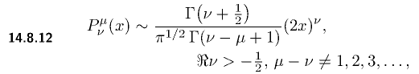 (H.6.1)
Setting μ = 0 we find that

Pν(x) → (1/$\sqrt{π}$)[Γ(ν+1/2)/Γ(ν+1)] (2x)ν ν > -1/2 x → ∞ (H.6.2)

Setting ν = n-1/2 for n = 0,1,2... one finds,

Pn-1/2(x) → (1/$\sqrt{π}$)[Γ(n)/Γ(n+1/2)] (2x)n-1/2 n > 0 x → ∞ . (H.6.3)

For the Q functions one has instead,

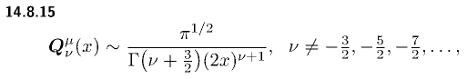
(H.6.4)
Then

Qν(x) → $\sqrt{π}$ [Γ(ν+1)/Γ(ν+3/2)] (2x)-ν-1 . (H.6.5)

Setting ν = n-1/2 for n = 0,1,2...

Qn-1/2(x) → $\sqrt{π}$ [Γ(n+1/2)/Γ(n+1)] (2x)-n-1/2 n = 0,1,2... x→∞ . (H.6.6)

A ratio of interest is this,

$\frac{Qn-1/2(x)}{Pn-1/2(x)}$ → $\sqrt{π}$$\sqrt{π}$

= π $\frac{Γ(n+1/2)/Γ(n+1)}{Γ(n)/Γ(n+1/2)}$(2x)-2n n = 1,2.... x→∞ (H.6.7)

(b) The case n = 0

For Q-1/2(x) we use (H.6.6) with n = 0 above to get

Q-1/2(x) → $\sqrt{π}$ [Γ(1/2)/Γ(1)] (2x)-1/2 = (π/$\sqrt{2}$) x-1/2 . (H.6.8)

The P-1/2(x) function requires much more work, it is a special case. We start with AS2010 ,

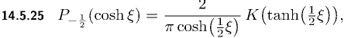 (H.6.9)

which relates P-1/2(x) to the complete elliptical integral K(z). As ξ→∞, tanh(ξ/2) → 1 so we need the behavior of K(z) for z near 1. GR7 8.113.3 gives this expansion of K(k) near k = 1 (small k'),

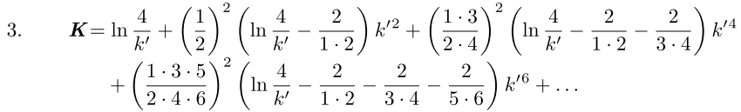

where (H.6.10)
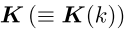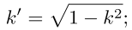

Keeping only the leading term,

K(k) ≈ ln(4/k') = ln(4/$\sqrt{1-k2}$) . (H.6.11)

Now if k = th(ξ/2), then k' = $\sqrt{1-k2}$ = sech(ξ/2) so,

K( th(ξ/2) ) ≈ ln(4 ch(ξ/2)) = (1/2) ln(16 ch2(ξ/2)] = (1/2)ln[ 8 (chξ +1)] . (H.6.12)

Therefore

P-1/2(chξ) = $\frac{2}{π}$ $\frac{1}{ch(ξ/2)}$ K(th(ξ/2)) ≈ $\frac{2}{π}$ $\sqrt{2}$$\sqrt{chξ+1}$ (1/2) ln[ 8 (1+chξ)]

≈ $\sqrt{2}$$\sqrt{chξ}$ ln(8chξ) large ξ (H.6.13)

which is more simply stated as

P-1/2(x) ≈ $\sqrt{2}$x-1/2 ln(8x) . large x (H.6.14)

Notice from (H.6.3) that the other Pn-1/2(x) have fast power decay (2x)n-1/2, but P-1/2(x) has a very slow

We then compute our special n = 0 case Q/P ratio from (H.6.8) and (H.6.14) to be

$\frac{Q-1/2(x)}{P-1/2(x)}$ → $\sqrt{2}$$\sqrt{2}$ = (π2/2) 1/ln(8x) x→∞ (H.6.15)

One could argue that ln(8x) = ln(8) + ln(x) ≈ ln(x) for large x, but that would require very large x indeed. For example, if ln(x) > 20 ln(8), then x > 820 ~ 1017. So we keep the 8.

H.7 Limits of toroidal functions as z→1

From AS2010 as x → 0 from above we have

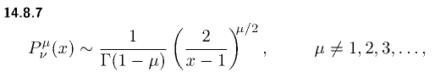 (H.7.1)

Thus we conclude that

Pν(x) → 1 x → 1 (H.7.2)

which is a well known result. The Q function is more complicated :

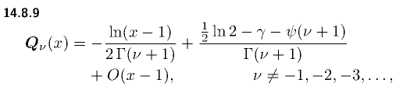 (H.7.3)

The first term shows logarithmic divergence as x→ 1. The second term is a constant where γ is "Euler's constant" (0.557) and ψ(x) is the psi function (the digamma function),

ψ(x) = ∂xlnΓ(x) = $\frac{∂xΓ(x)}{Γ(x)}$ . (H.7.4)

Setting ν = n-1/2 we find that

Pn-1/2(x) → 1 x → 1
Qn-1/2(x) → - $\frac{1}{2Γ(n+1/2)}$ ln(x-1) + $\frac{ln4 - γ - ψ(n+1/2)}{Γ(n+1/2)}$ x → 1 (H.7.5)

To obtain the behavior of Pn-1/2(x) near x = 1, we use (7.4.1)

P(ν,ξ) ≡ Pν(chξ) = (chξ)ν F(-ν/2, 1/2-ν/2; 1; th2ξ) (7.4.1)

where x = chξ. For small ξ we find, using F(a,b;c;z) ≈ 1 + (ab/c) z + O(z2) and thξ ≈ ξ,

P(ν,ξ) ≈ (1 + ξ2/2)ν [ 1 + (-ν/2)(1/2-ν/2) ξ2 ]

= (1 + νξ2/2)( 1 + (ν/2)(ν/2-1/2) ξ2

= 1 + [(1/2)ν + (1/4)ν(ν-1)]ξ2 = 1 + (1/4)[2ν +ν(ν-1) ]ξ2 = 1 + (1/4)[ν2+ν]ξ2

= 1 + (1/4)ν(ν+1)ξ2 . (H.7.6)
Then

Pn-1/2(chξ) ≈ 1 + (1/4)(n-1/2)(n+1/2)ξ2

≈ 1 + (1/4) [n2 - 1/4]ξ2 ξ→0 (H.7.7)

Setting z = chξ ≈ 1+ξ2/2 we have ξ2 ≈ 2(z-1) so then

Pn-1/2(z) ≈ 1 + (1/2) [n2 - 1/4](z-1) (H.7.8)

Except for n = 0 the correction term is positive, therefore

Pn-1/2(z) ≥ 1 as z → 1+ for n = 1,2...∞ (H.7.9)

Application: Consider

T(z) ≡ $\sqrt{z2 - 1}$ Σn=0∞ εn [Qn-1/2(z) / Pn-1/2(z)]

= $\sqrt{z2 - 1}$* 2 * [Q-1/2(z) / P-1/2(z)] + $\sqrt{z2 - 1}$ Σn=1∞ εn [Qn-1/2(z) / Pn-1/2(z)] .

For z very close to 1 we install P-1/2(z) = 1 to get

T(z) ≈ $\sqrt{z2 - 1}$* 2 * Q-1/2(z) + $\sqrt{z2 - 1}$ Σn=1∞ εn [Qn-1/2(z) / Pn-1/2(z)] .

But for n > 0 we know from (H.7.9) that Pn-1/2(z) ≥ 1, so [1/ Pn-1/2(z)] ≤ 1. Therefore,

T(z) ≤ $\sqrt{z2 - 1}$* 2 * Q-1/2(z) + $\sqrt{z2 - 1}$ Σn=1∞ εn [Qn-1/2(z) ]
or
T(1) ≤ limz→1+ ( $\sqrt{z2 - 1}$ Σn=0∞ εn [Qn-1/2(z)] )
or
T(1) ≤ $\sqrt{2}$ limz→1+ ( $\sqrt{z-1}$ Σn=0∞ εn [Qn-1/2(z)] . (H.7.10)
In (B.2.17) it is shown that

Σn=0∞ εn $\sqrt{z -1}$Qn-1/2(z) = (π/$\sqrt{2}$) (B.2.17)

and therefore we may conclude that

T(1) ≤ π (H.7.11)

H.8 Alternate series for T(z) near z = 1

From AS2010 the Wronskian of the P and Q solutions of the Legendre equation is given by.

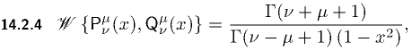 (H.8.1)
so that

W{Pν(z),Qν(z)} = 1/(1-z2) = Pν(z) Qν'(z) - Pν'(z) Qν(z) . (H.8.2)

Now consider the series

T(z) ≡ $\sqrt{z2 - 1}$ Σn=0∞ εn [Qn-1/2(z) / Pn-1/2(z)]

= $\sqrt{z2 - 1}$f(z) f(z) ≡ Σn=0∞ εn [Qn-1/2(z) / Pn-1/2(z)] . (H.8.3)

Then

f '(z) = Σn=0∞ εn [Pn-1/2(z) Q'n-1/2(z) - Qn-1/2(z) P'n-1/2(z)] / [ Pn-1/2(z)]2

= Σn=0∞ εn [ 1/(1-z2) ] / [ Pn-1/2(z)]2 // (H.8.2)

= - (z2-1)-1 Σn=0∞ εn 1/ [ Pn-1/2(z)]2 . (H.8.4)

Then

T'(z) = ($\sqrt{z2 - 1}$)' f(z) + $\sqrt{z2 - 1}$ f '(z)

= (z /$\sqrt{z2 - 1}$) f(z) + $\sqrt{z2 - 1}$ ( - (z2-1)-1 Σn=0∞ εn 1/ [ Pn-1/2(z)]2 )

= (1/$\sqrt{z2 - 1}$) [ z f(z) - Σn=0∞ εn 1/ [ Pn-1/2(z)]2 ] (H.8.5)

so that

$\sqrt{z2 - 1}$T'(z) = z f(z) - Σn=0∞ εn 1/ [ Pn-1/2(z)]2 . (H.8.6)

In the limit z→1, assuming T'(z) is not infinite, this says

0 = f(z) - Σn=0∞ εn 1/ [ Pn-1/2(z)]2
or
f(z) = Σn=0∞ εn 1/ [ Pn-1/2(z)]2 . // for z very close to 1 (H.8.7)

Then from (H.8.3),

T(z) = $\sqrt{z2 - 1}$f(z) = $\sqrt{z2 - 1}$ Σn=0∞ εn $\frac{1}{[Pn-1/2(z)]2}$ for z very close to 1 . (H.8.8)

