On 12/21/5 I removed this for archiving from bowl doc.
It just was not relevant to the current way I do things in Chapter 8.
Just saving it intact here for a rainy day.
This is also stored as Appendix Q, not sure which is more current.

One can write $\sqrt{2}$cos(x) = $\sqrt{1+cosx}$ in the two numerators above, but we prefer the form shown since it resolves sign ambiguity as described in Appendix I.

An analytic explanation of the sign changing of the function $\sqrt{1+cosb}$ at odd multiples of π is provided in Appendix I. [ this was above start of section 7.2 ]

__________________________________________________________________________

Appendix I: The behavior of f(z) = $\sqrt{a+cos(z)}$as an analytic function

The purpose of this rather elaborate appendix is to show why the proper Maple implementation of the function f(x) = $\sqrt{1+cos(x)}$ appearing in our bowl electrostatic potential is the following :

f(x) = (-1)η | $\sqrt{1 + cos(x)}$| where η = floor[(x+π)/2π] . (I.1)

As shown below, this expression results in f(x) being a smooth sinusoid having both positive and negative values,

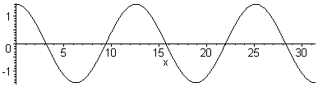 (I.2)

Some analytic mappings

Consider the following drawing :
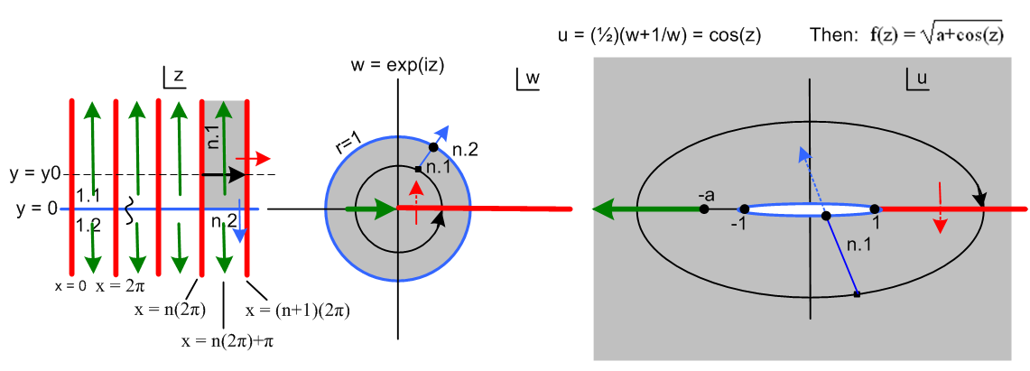
(I.3)

We are considering a three-step mapping of analytic functions:

w = eiz z-plane to w-plane

u = (1/2)(w+1/w) // = cos(z) w-plane to u-plane

f = $\sqrt{a+u}$ // = $\sqrt{a + cos(z)}$ u-plane to f-plane (I.4)

The drawing shows the z-plane, the w-plane, and the u-plane.

In the z-plane, where z = x + iy, the red vertical lines show x = multiples of 2π. All the vertical red lines in the z-plane map into the single red half line in the w-plane and then in the u-plane. The red path in the u-plane folds back on itself since w=0 and w = ∞ both map to u = ∞, while w=1 maps to u = 1.

We select a particular region of the z-plane and mark it gray (region is a half-infinite vertical strip). This region maps to the gray disk in the w-plane (radius 1), and that disk in turn maps into all of the u-plane.

Following the Black Ant

We set up a "tracking ant" in the z-plane which wanders along a path indicated by the black arrow. This path is not along the real z axis, but is elevated above it at y = y0 as shown. The ant moves from n(2π) to (n+1)(2π) in x, while holding y = y0.

As this ant moves in the z-plane along its path, another ant makes a corresponding (mapped) movement in the w- plane, and yet another ant makes a corresponding movement in the u-plane.

In the w-plane the ant's path maps into the black circle shown, a simple phasor path.

In the u-plane, the ant's path is an ellipse, and the traversal direction is now clockwise instead of counterclockwise. The reason for the ellipse is this:

eiz = eix e-y

u = (1/2)(w+1/w) = (1/2)(eix e-y + e-ix ey ) = (1/2)([cosx + isinx] e-y +[cosx-isinx] ey )

= cosx chy - i sinx shy = u1+ iu2 u1 = cosx chy u2 = - sinx shy (I.5)

Then setting y = y0 for the ant path,

$\frac{u12}{ch2y0}$ + $\frac{u22}{sh2y0}$ = cos2x + sin2x = 1 u = (u1,u2) (I.6)

This is an ellipse with semi-major axis chy0, semi-minor axis shy0, and focal points at u = (±1,0).

As x moves along the black arrow starting at x = n(2π), sinx > 0 so u gets a negative imaginary part and the ant moves south in the u-plane. That is why the u-plane ant moves clockwise.

The Green Cut

We are interested in the function

f(u) = $\sqrt{a+u}$ (I.7)

which has a branch point at u = -a. We draw the attached green cut off to the left as shown in the u-plane above.

This function f(u) has two Riemann sheets which we can regard as

f(u) = f1(u) ≡ + $\sqrt{a+u}$ Sheet 1

f(u) = f2(u) ≡ – $\sqrt{a+u}$ Sheet 2 (I.8)

just as $\sqrt{4}$ = ± 2. Imagine that Sheet 1 is the one displayed in the u-plane above. Then Sheet 2 lies underneath Sheet 1. An ant moving on Sheet 1 passes through the cut onto Sheet 2. Since the ant is constrained to the surface, it cannot jump across the cut, but has to descent onto Sheet 2. The connection between the sheets is bidirectional which makes it impossible to model physically. Here is the cut seen edge on
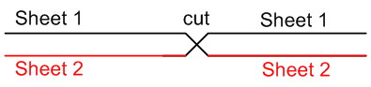 (I.9)

Thus for the particular path shown above in the z-plane, the function f(u) = $\sqrt{a+u}$ changes sign each time that z-plane path passes through an odd multiple of π .

The real-axis path as a limit

The ant path shown in the z-plane is elevated at some y0 > 0. We now lower this path to the real axis (shown in blue). As this happens, the black circle in the w-plane moves toward the blue circle perimeter of the gray disk, and the black elliptical path in the u-plane shrinks to the thin blue path shown there. If
a > 1, this new elliptical path completely avoids the cut, and one finds that f(u) = $\sqrt{a + cos(z)}$ does not change sign, because we just stay on Sheet 1 for the entire path, so our effect of switching sheets does not occur. Notice that the blue thin ellipse in its limiting sense passes to the left of the focal point u = -1.

Now what happens if a = 1 and we have the function f(u) = $\sqrt{1 + u}$? Go back to the ant path up at y = y0, and draw the green cut starting at u = -1 in the u-plane. We then have the sign-switching action as the ant passes odd multiples of π. As we take this ant path down to the blue x axis in the z-plane, the elliptical path in the u-plane always catches on the cut, and we then still have the sign swapping effect. The ant path, no matter how thin its ellipse might be in the u-plane, always passes to the left of the point a = - 1 and this ant is forced to take the dive.

Our conclusions so far are:

1. The function f(x) = $\sqrt{a + cos(x)}$ for a > 1 does not change sign as x passes through odd multiples of π.
2. The function f(x) = $\sqrt{1 + cos(x)}$ does change sign as x passes through odd multiples of π. (I.10)

At x = 0 we assume that f(0) = $\sqrt{2}$ > 0. Then:

Theorem: Given the analytic function f(z) = $\sqrt{1 + cos(z)}$, if we run z along a real path on the x-axis, taking that path to be the limiting path of a complex path above the real axis, then

f(x) = (-1)η | $\sqrt{1 + cos(x)}$| where η = floor[(x+π)/2π]. (I.11)

Here the factor (-1)η implements the sign changes discussed above. Each time x passes through an odd multiple of π, η increases by 1, causing the desired sign change.

Here is some Maple code to illustrate the function f(x). First, consider

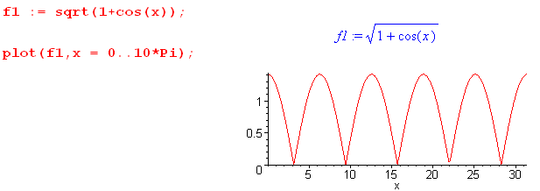 (I.12)

Thus, Maple thinks of $\sqrt{1 + cos(x)}$as being | $\sqrt{1 + cos(x)}$| . This is not the smooth "analytic" result we want. In other words. f1(x) = $\sqrt{1 + cos(x)}$from a Maple viewpoint is a rectified sinusoid with sharp non-analytic discontinuities in slope.

On the other hand, now consider f(x) = (-1)η | $\sqrt{1 + cos(x)}$| which in Maple is f(x) = (-1)η $\sqrt{1 + cos(x)}$:

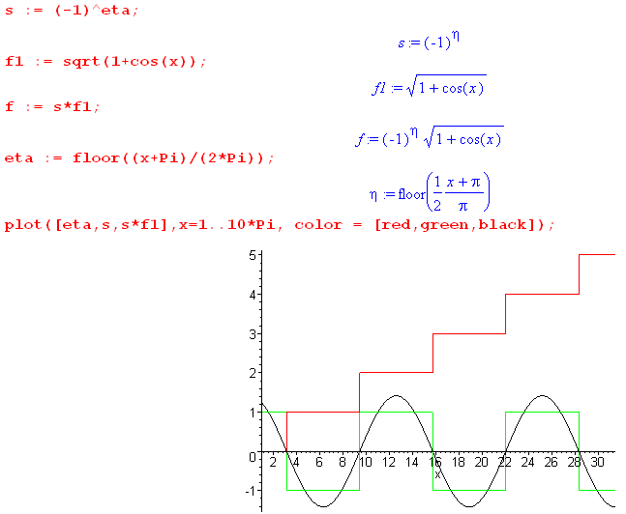 (I.13)

The smooth black sinusoid is the "analytic meaning" of the function f(x) = $\sqrt{1 + cos(x)}$taken as the limit of an analytic function.

