The Charged Bowl in Toroidal Coordinates
Phil Lucht
Rimrock Digital Technology, Salt Lake City, Utah 84102
February 19, 2011
Contents:
1. Introduction. 2
2. Solution of the Charged Bowl Problem in Toroidal Coordinates. 3
(a) Level curves, the charged ellipsoid problem and a dashed hope 3
(b) Cartesian, spherical, toroidal and ellipsoidal atomic forms 3
(c) Smythian forms and one for the bowl 5
(d) Solution to the charged bowl potential problem: the Mehler-Foch Transform 5
(e) Derivation of an integral 8
3. Solution of the Charged Double-Bowl Problem in Toroidal Coordinates. 9
(a) The general double bowl solution 9
(b) the special case of the a bowl with a flat lid. 10
(c) The sessile drop ( lens shaped double-bowl) 11
4. The Single Bowl Surface Charge Densities and Capacitance 11
(a) Charge Densities. 11
(b) Capacitance 13
5. Toroidal coordinates 14
(a) Verbal description 14
(b) Equations 15
(c) More pictures 15
(d) plot of the bowl coordinate u versus coordinates ρ and z 16
(e) plot of u versus coordinates ρ and z after Lebedev's adjustment 17
(f) plot of the toroid coordinate ξ versus coordinates ρ and z 18
6. A selection of charged bowl potential plots 19
7. Doing Mehler integrals. 21
(a) List of useful Mehler integrals 21
(b) The integral X appearing in the charge density calculation above 22
(c) Where to find Mehler integrals (and some errata noted) 23
8. Evaluating the toroidal bowl potential integral into elementary functions 23
9. Using Maple to plot the bowl potential 25
10. Potential and capacitance of a charged toroid. 28
(a) The potential of a charged toroid 28
(b) Capacitance of a toroid 30
(b) Charge density on a toroid 32
Appendix A. Maple code text for plotting the Bowl Potential 33
Appendix B: Comments on computing the capacitance of a toroid and its degenerate limit. 34
Appendix C: Kelvin's approach to the Charged Bowl Problem. 38
Appendix D: Smythe's approach to the Charged Bowl Problem. 41
References. 44

1. Introduction.

This document was motivated by a "stub" section appearing in an informal 2002 paper by Kirk McDonald which reviews various solutions of the charged bowl problem. Here is that section in its entirety:

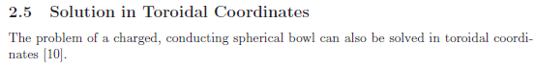

where [10] is our Lebedev reference. The present document is meant to fill in this stub section.

The phrase "charged bowl" refers to an isolated conducting spherical bowl, sometimes called a spherical cap, shell or segment. An arbitrary plane slicing through a full spherical shell divides that shell into two spherical bowls, each with a circular lip. The "charged bowl problem" is this: put some charge on an isolated conducting bowl and determine the resulting electrostatic potential V everywhere as well as the charge densities σ on the inner and outer bowl surfaces. The reader versed in related problems (e.g., the charged disk) would not be surprised to find the charge densities to be divergent (but integrable) at the bowl edge and non-zero everywhere on the bowl.
In 1869 Kelvin used the now-famous method of inversion (last seen lurking in green Jackson) to solve the charged bowl problem for the inner and outer charge densities. Kelvin's "bowl paper" requires great patience to read, and is outlined in McDonald's paper. Modern readers might have "forgotten" things like "the chord theorem" and other geometric properties of circles. We comment more on Kelvin's bowl paper in Appendix C where we explain the well-known fact that the inner and outer charge densities differ by a constant, and in Appendix D we mention a fascinating variation of the Kelvin approach indicated by Smythe.
Various other methods exist to obtain an exact solution of this problem. Perhaps the most well-known is the use of "dual" Legendre series equations in friendly spherical coordinates as outlined by Sneddon and others. One series (Dirichlet) sets the potential to a constant on the bowl, while a radial derivative of that series (Neumann) sets the charge density to zero on the cap. The problem is then to find coefficients which satisfy both equations, neither of which is invertible since it only covers a partial range of polar angle. In matrix language, these two equations are S1Ψ = f and S2Ψ = g where neither Si is invertible, and Ψ is an infinite vector of unknown coefficients. The solution is obtained by finding triangular matrices I and K such that IS1 = KS2 = S where S is invertible. Then one can invert for example the equation SΨ = I f to obtain the solution Ψ = S-1 I f. The devil is in details not obvious from this crude summary.
In the present document we shall obtain an exact solution for both the potential and charge densities using the much less friendly toroidal coordinates. Surely this has been done many hundred times since the mid 19th century, but the author has not found much on the web, certainly not much that is freely downloadable. After doing this we turn our attention briefly to the problem of the charged toroid.
In all that follows, we shall refer to the spherical conducting bowl as the bowl, and shall refer to the unoccupied remainder of the bowl's sphere as the cap.

2. Solution of the Charged Bowl Problem in Toroidal Coordinates.

(a) Level curves, the charged ellipsoid problem and a dashed hope

As one sees scanning through the beautiful pictures in Moon & Spencer's strangely but correctly named Field Theory Handbook, each orthogonal coordinate system has its characteristic level surfaces. In spherical coordinates these are spheres, polar cones and azimuthal planes, whereas in toroidal coordinates they are "bowls and toroids" and azimuthal planes. In spherical coordinates a bowl has a hole in it since the polar angle runs only part of its range, but in toroidal coordinates there is no such "hole". That is to say, a bowl has a label (a value of one of the toroidal coordinates) and as the other two coordinates sweep their full ranges, a bowl is swept out. The fact that the bowl is a level surface in toroidals makes one at least interested in solving the charged bowl problem in this system.
In ellipsoidal coordinates the level surfaces are ellipsoids and asymmetric hyperboloids of one and two sheets, which certainly sounds foreboding. One can solve the "charged ellipsoid problem" and the result is shockingly simple (as Kelvin also showed) and σ on the ellipsoid is simple even in Cartesian coordinates (more magic geometry). A family of confocal ellipsoids can be described by the equation x2/(ξ12- a2) + y2/(ξ12- b2) + z2/(ξ12) = 1 where ξ1 in (0,∞) is the "label" of an ellipsoid. It happens then that the label ξ1 is also the largest semi-major axis of the ellipsoid, while a > b are focal distances associated with the other two axes. Ellipsoidal coordinates are fully separable, and a Laplace-satisfying potential function which is constant on each of these ellipsoids and which vanishes at infinity is given by

V(ξ1)/const = F00(ξ1) E00(ξ2) E00(ξ3) = [(1/a) sn-1(a/ξ1,b/a)] * 1 * 1 = (1/a) sn-1(a/ξ1,b/a)
= (1/a) F[sin-1(a/ξ1),b/a]

Here (ξ1,ξ2,ξ3) are the three ellipsoidal coordinates in Morse & Feshbach notation, E and F are first and second kind Lamé functions, and a different F is the first kind elliptic integral. By setting V = V0 on a particular ellipsoid ξ1 = c, one then obtains the potential anywhere outside this charged ellipsoid,

V(ξ1) = V0 F[sin-1(a/ξ1),k=b/a] / F[sin-1(a/c),k=b/a] (2.1)

Although not immediately obvious, this expression is exactly the same if one swaps a↔b and such a swap is necessary to show that the above form agrees with that of Kelvin.
One might hope that the bowl potential in toroidals could be as simply stated as the ellipsoid potential in ellipsoidals, but alas it is not so, but only in the following sense. In toroidals a certain weight factor cross-links the bowl and toroid coordinates (labels), which makes the Laplace equation separable only in the form of three separated functions times the weight factor $\sqrt{chξ-cosu}$, where ξ is a toroid label and u a bowl label. This weaker kind of separability is called R-separability by Moon and Spencer. A solution $\sqrt{chξ-cosu}$[A(ξ)=1]B(u)[C(φ)=1] evaluated on the surface of bowl u0 gives V = $\sqrt{chξ-cosu0}$ B(u0) which varies with ξ, not allowing V = V0 on the bowl. Nevertheless, it will turn out that the charged bowl potential can be expressed in simple inverse trig functions, and is thus even simpler that the charged ellipsoid potential.

(b) Cartesian, spherical, toroidal and ellipsoidal atomic forms

"Atomic forms" or just "atoms" are the author's private phrases for "harmonics", which word means simple solutions of the Laplace equation which can be superposed to construct non-simple solutions. The Cartesian atoms illustrate the idea that if you curve toward axis in 2 dimensions, you must curve away from axis in the 3rd:

osc osc expo
(1) [sin(kxx), cos(kxx)], [sin(kyy), cos(kyy)], [exp(κzz), exp(-κzz) ] kz = imaginary = iκz
toward toward away κz = $\sqrt{kx2 + ky2}$

For solving practical problems, 2 of the 3 coordinates have to be oscillatory to allow for functional completeness, here on a surface of x and y, so that expansions can be inverted and problems solved. For spherical atoms, two interesting atomic forms can be written in which azimuthal φ is oscillatory:

r in (0,∞) z in (-1,1) φ in (0,2π)

expo osc osc
(1) [ rn, r-n-1] [ Pnm(z), Qnm(z)] [ sin(mφ),cos(mφ)] z = cosθ

osc expo osc
(2) (1/$\sqrt{r}$)[ riτ, r-iτ] [ Piτ-1/2m(z), Qiτ-1/2m(z)] [ sin(mφ),cos(mφ)] n = iτ-1/2
osc expo osc
~ (1/$\sqrt{r}$)[sin(τ lnr), cos(τ lnr)] [ Piτ-1/2m(z), Qiτ-1/2m(z)] [ sin(mφ),cos(mφ)]

The first is doubtless more familiar to the reader, but the second is appropriate for, say, a Dirichlet problem involving a cone, since the atomic form is oscillatory both ways across the surface of a cone, allowing a prescribed potential there to be inverted. The underlying fact is that each oscillatory coordinate becomes a 1D Sturm-Liouville problem with a complete set of eigenfunctions, and then these two sets provide a complete set of eigenfunctions for a 2D surface spanned by those coordinates. In passing, we note that the Legendre functions in form (2) above are called "conical functions" and have |z|<1.

Without further ado, we can write two similar atomic forms for toroidal coordinates,

ξ in (0,∞) u in (0,2π) φ in (0,2π)

expo osc osc
(1) $\sqrt{chξ - cosu}$ [Pn-1/2m(chξ), Qn-1/2m(chξ) ] [ sin(nu),cos(nu)] [ sin(mφ),cos(mφ)]

osc expo osc
(2) $\sqrt{chξ - cosu}$ [Piτ-1/2m(chξ), Qiτ-1/2m(chξ) ] [exp(τu), exp(-τu) ] [ sin(mφ),cos(mφ)]

To solve bowl problems, we need the two coordinates other than the bowl label u to be oscillatory, and that means we must use form (2). In the first form, if a problem has a full azimuth, the parameter m gets quantized to integers, and this indirectly causes parameter n on P to be quantized to integers, so the spectra of both Sturm-Liouville problems are discrete. In form (2) even if m is quantized, parameter τ remains unquantized and, since Pν= P-ν-1, the τ spectrum is restricted to the positive real axis.
Again in passing, the Legendre functions in system (1) are sometimes called toroidal functions or ring functions, argument > 1, whereas those appearing in (2) are called Mehler functions, again with argument > 1. At least that is the author's terminology.

In reference to our earlier charged ellipsoid comments, we just mention the atomic form for ellipsoidal coordinates,

[Emp(ξ1), Fmp(ξ1)] [Emp(ξ2), Fmp(ξ2)] [Emp(ξ3),Fmp(ξ3)]

where 0 < ξ3< b < ξ2< a < ξ1 with a>b the confocal ellipsoid focal distances. As noted earlier, E and F are the first and second kind Lamé functions. The ξi are the three roots of the cubic equation which is the equation of the ellipsoid given above. In this system there is no azimuthal coordinate, and the separated solutions are triply cross-linked in that all three functions bear the same quantum numbers m and p (separation constants arising when the Laplace equation is separated). This system, though quite complicated, is well explained in full detail in the last chapter of Hobson's book.

(c) Smythian forms and one for the bowl

Please forgive the author's predilection for strange phrases. A Smythian form refers to a linear combination (sum or/or integral) of atomic forms which provides a candidate solution to some problem, having some to-be-determined "coefficients". Such a form usually "builds in" certain boundary conditions, such as a continuity between two regions of space on which a Green's point charge lies in a Green's Function problem. Smythe's book makes excellent use of such forms, and one might even refer to "the method of Smythian forms" in a list of effective methods of solving boundary value problems.

So, we propose the following Smythian form for the potential of our charged bowl (since things are azimuthally symmetric, we have only m = 0 atoms)

V(ξ,u) = $\sqrt{chξ - cosu}$$^{\int_{0}^{∞}{}}$dτ Piτ-1/2(chξ)[ A(τ)ch(uτ) + B(τ)sh(uτ) ] (2.2)

where A and B are to-be-determined coefficient functions. Although it is not immediately obvious, this form builds in the boundary condition that the potential vanish at infinity, and for that reason the Q function has been rejected. Since the Mehler P functions form a complete orthogonal set, it is possible to set in some prescribed potential V = f(ξ,u) on the surface of a bowl, and invert to find the coefficient functions. At first it seems odd that there are two functions A and B to be found, and only one boundary condition, but the dilemma is quickly resolved by realizing that we apply the boundary condition separately on each surface of the bowl, so really there are two boundary conditions and two unknown coefficient functions. For our charged bowl problem, the prescribed Dirichlet potential is f(ξ,u) = V0.

(d) Solution to the charged bowl potential problem: the Mehler-Foch Transform

For azimuthally symmetric bowl problems, the appropriate transform generated by the Sturm Liouville problem in the ξ coordinate is called the (non-generalized) Mehler-Foch transform (sometimes Fok):

g(ξ) = $^{\int_{0}^{∞}{}}$dτ P-1/2+iτ(chξ) f(τ) dτ // expansion
f(τ) = τ tanh(πτ) $^{\int_{1}^{∞}{}}$dξ P-1/2+iτ(chξ) g(ξ) // projection (2.3)

Every reasonable Sturm-Liouville problem defines a complete set of functions and therefore defines a transform (there are thousands of them), and this is the transform for our oscillatory ξ coordinate. Admittedly, this transform is more sparsely found in the literature that, say, the Fourier Integral Cosine Transform.
Before we can use this transform to invert our two boundary conditions, we have to first know a little more about the range of our bowl label coordinate u. To that end, here is a picture:

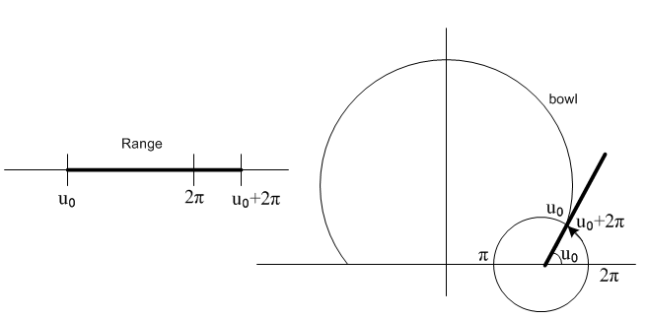
This shows in cross section one up-side-down bowl having label u0. Following Lebedev et. al.'s excellent suggestion, instead of running the bowl label in the usual (0,2π) range, we shall have it lie in (u0, u0+2π) so it can be continuous away from the two sides of the bowl. As we start off with u0 as the angle shown, we can imagine a set of mathematical bowl surfaces attached to the two "focal points" on the x axis, whose labels run from u0 up to u0 + 2π. We will explain all this below, but it is perhaps useful to solve the problem first, then see the details later. The inside surface of the bowl lies at u = u0 while the outside surface is at u = u0+2π, so here then are our two boundary conditions:

V0 = $\sqrt{chξ - cosu0}$ $^{\int_{0}^{∞}{}}$ dτ Piτ-1/2(chξ)[ A(τ)ch(u0τ ) + B(τ)sh(u0τ) ]
V0 = $\sqrt{chξ - cos(2π-u0)}$$^{\int_{0}^{∞}{}}$ dτ Piτ-1/2(chξ)[ A(τ)ch([2π-u0]τ) + B(τ)sh([2π-u0]τ) (2.4)

We use the Mehler-Foch transform to invert these and find,

[ A(τ)ch(u0τ) + B(τ)sh(u0τ) ] = V0 τ th(πτ) $^{\int_{0}^{∞}{}}$dξ sh(ξ) Piτ-1/2(chξ)/ $\sqrt{chξ - cosu0}$ (2.5)
[ A(τ)ch[(u0+2π)τ] + B(τ)sh[(u0+2π)τ] ] = V0 τ th(πτ) $^{\int_{0}^{∞}{}}$dξ sh(ξ) Piτ-1/2(chξ)/ $\sqrt{chξ - cos[u0+2π]}$

Then using this integral (derived in section (e) below)

$^{\int_{1}^{∞}{}}$dx Piτ-1/2(x) / $\sqrt{x - cosu0}$ = $\sqrt{2}$ch[τ(u0-π)]/ (τ sh(πτ)) (2.6)

we can do a simple Cramer's Rule solution to find our coefficient functions

A(τ) = V0 $\sqrt{2}$ch[(π–u0)τ] ch[(π+u0)τ] / ch2(πτ)
B(τ) = – V0 $\sqrt{2}$ch[(π–u0)τ] sh[(π+u0)τ] / ch2(πτ) (2.7)

Inserting these into our Smythian form then gives the potential of the charged bowl of label u0

V(ξ,u) = V0 $\sqrt{2}$ $\sqrt{chξ - cosu}$$^{\int_{0}^{∞}{}}$dτ Piτ-1/2(chξ) ch[(π–u0)τ] ch[(π+u0-u)τ]/ch2(πτ) (2.8)

We are all done! We shall show below that this integral can in fact be evaluated into the following set of elementary functions

V(ξ,u)= (V0/π ) $\sqrt{chξ - cosu}$ *
{ (1/$\sqrt{chξ -cosu}$) cot-1[(-1)η1| $\sqrt{1+cosu}$| / $\sqrt{chξ -cosu}$]
+ (1/$\sqrt{chξ-cos(2u0-u)}$) cot-1[(-1)η2| $\sqrt{1+cos(2u0-u)}$|/ $\sqrt{chξ -cos(2u0-u)}$] } (2.9)

where η1 = floor[(3π-u)/2π] u0 in (0,π)
η2 = floor[(2u0-u+π)/2π] u in (u0, u0+2π)

where the strange η exponents are related to analytic continuation as described later. We can throw this equation into Maple and obtain very nice plots of the charged bowl potential across a symmetric slice of the bowl. Here is the plot for a bowl with u0 = π/4. Along the bowl edge the potential is constant at the value V0= 1, and outside the region shown it drops off to 0 at infinity. Kelvin would have liked Maple.

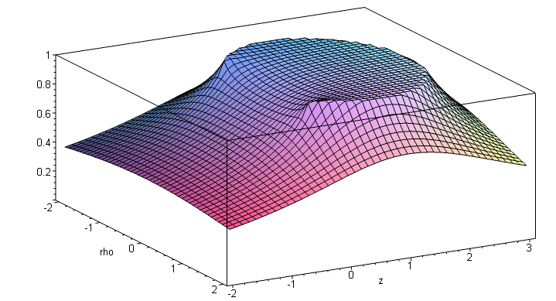

(e) Derivation of an integral

We wish to verify the following key integral (which does not appear as such in the usual sources)

$^{\int_{1}^{∞}{}}$dx Piτ-1/2(x) / $\sqrt{x - cosu0}$ = $\sqrt{2}$ ch[τ(π-u0)]/ [τ sh(τπ)] // LHS = RHS

Expand part of the integrand using (10.3a) below

1/$\sqrt{x - cosu0}$ = (1/π) $\sqrt{2}$ Σn=0∞ εn Qn-1/2(x) cos(nu0)

so that

LHS = ($\sqrt{2}$/π) Σn=0∞ εn cos(nu0) $^{\int_{1}^{∞}{}}$dx Piτ-1/2(x) Qn-1/2(x)

But according to GR7 page 770 7.114.1 the PQ integral above is just 1/(n2+τ2) so that

LHS = ($\sqrt{2}$/π) Σn=0∞ εn cos(nu0) /(n2+τ2)

Then use GR7 page 47 1.445.2, which can be written as

Σn=0∞ εn cos(nx)/(n2+τ2) = (π/τ) cosh[τ(π- u0)]/sinh(τπ) ,

to conclude that LHS = $\sqrt{2}$ cosh[τ(π- u0)]/ [ τ sinh(τπ)].

3. Solution of the Charged Double-Bowl Problem in Toroidal Coordinates.

(a) The general double bowl solution

This seems a good place to address this related problem. Sneddon deals with the problem of two separated bowls having a common symmetry axis. That problem seems to have no closed form solution and Sneddon reduces its solution to solving one or more second-kind Fredholm integral equations. Our double-bowl problem is much simpler in that both bowls have a common lip and the same potential V0. The 3D shapes formed in this way can vary from a sort of 3D lune, to a bowl with a flat lid on it, to a "lens" composed of two spherical surfaces (two facing attached bowls). If the two bowls of the lens have the same size, the solution to this problem describes the evaporation from the surface of a liquid drop sitting on a flat surface, which drop then is half the lens shape. See Hu and Larson regarding such "sessile droplets". Quantity π-u is the "contact angle" of such a drop. It is nice to see that solutions to 19th century electrostatic and heat flow potential theory problems have 21st century applications.
The solution to the double bowl problem follows exactly that of the single-bowl problem. For obscure reasons, we defined the two bowl labels to be u0 and u2 rather than the more reasonable u0 and u1, forgiveness is requested. Here is the picture showing a lune shaped cross section

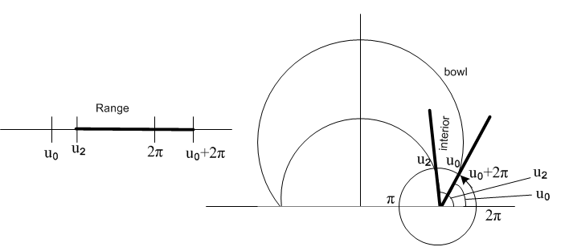
We use the exact same Smythian form as for the single bowl,

V(ξ,u) = $\sqrt{chξ - cosu}$$^{\int_{0}^{∞}{}}$dτ Piτ-1/2(chξ)[ A(τ)ch(uτ) + B(τ)sh(uτ) ] (3.1)

and here then are the boundary conditions:

V0 = $\sqrt{chξ - cosu2}$ $^{\int_{0}^{∞}{}}$ dτ Piτ-1/2(chξ)[ A(τ)ch(u2τ ) + B(τ)sh(u2τ) ]
V0 = $\sqrt{chξ - cos(2π-u0)}$$^{\int_{0}^{∞}{}}$ dτ Piτ-1/2(chξ)[ A(τ)ch([2π-u0]τ) + B(τ)sh([2π-u0]τ) (3.2)

These conditions are for the "exterior problem", we want the potential outside the lune. The second condition is exactly as we had for the single bowl; the first is the same with u0→ u2. The coefficients this time are a little more complicated:

ch(πτ) A(τ) = V0 $\sqrt{2}$Qch[τ(π-u0)] / [C ch(u0τ) + D sh(u0τ) ]
ch(πτ) B(τ) = V0 $\sqrt{2}$Pch[τ(π-u0)] / [C ch(u0τ) + D sh(u0τ) ]
where (3.3)
D = { V2 ch(u0τ) ch[τ(π-u2)] – V0ch(u2τ) ch[τ(π-u0)] }
C = { V0sh(u2τ) ch[τ(π-u0)] – V2sh(u0τ) ch[τ(π-u2)] }

When A(τ) and B(τ) are inserted into the Smythian form, we find after some algebra this relatively simple result for the potential of the charged double-bowl :

V(ξ,u) = V0 $\sqrt{2}$$\sqrt{chξ - cosu}$$^{\int_{0}^{∞}{}}$ dτ Piτ-1/2(chξ) * (3.4)
{ ch[(π-u0)τ]sh[(u-u2)τ] + ch[(π-u2)τ] sh[(2π+u0-u)τ] } / {ch(πτ) sh[(2π+u0-u2)τ] }

This result appears in the Hu paper mentioned above in this form, where β,β1,β2 = u,u0,u2 and α = ξ.

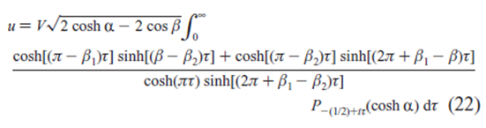
If one takes the limit u2→u0, the solution to the single-bowl problem is recovered. We have not made any attempt to evaluate this integral but it may yield an expression involving elementary functions.

(b) the special case of the a bowl with a flat lid.

Here we take u2 = π to get the flat lid, and our solution reduces to the following, where we use ξ = α , β = u, and u0 = β1,

V(α, β) = V0 $\sqrt{2}$$\sqrt{chα - cosβ}$$^{\int_{0}^{∞}{}}$ dτ Piτ-1/2(chξ) *
{ sh[(2π+β1-β)τ] – ch[(π-β1)τ] sh[(π- β)τ] } / { sh[(π+β1)τ] ch(πτ) } (3.5)

and we may compare this with the result quoted in Lebedev et. al. Problem 503 (page 241) with β0= β1

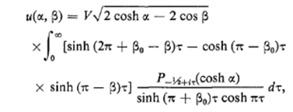

(c) The sessile drop ( lens shaped double-bowl)

This time we take

u0 = β1 = [π-θ]
u2 = β2 = [π+θ]

where θ is the small "contact angle" for the drop. Our potential result is

V(α,β) = V0$\sqrt{2}$$\sqrt{chα - cosβ}$$^{\int_{0}^{∞}{}}$ dτ Piτ-1/2(chξ) ch(θτ) ch[(2π-β)τ] /{ch(πτ) ch[(π-θ])τ]} (3.6)

which appears in the Hu paper as

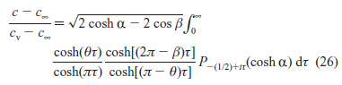

4. The Single Bowl Surface Charge Densities and Capacitance

(a) Charge Densities.

We start with the potential as stated above in (2.8) and set up to compute the charge densities,

V(ξ,u) = V0 $\sqrt{2}$ $\sqrt{chξ - cosu}$$^{\int_{0}^{∞}{}}$dτ Piτ-1/2(chξ) ch[(π–u0)τ] ch[(π+u0-u)τ]/ ch2(πτ) (2.8)

σ+ = – (1/4π) (1/hu) ∂uV(ξ,u)|u=u0 1/hu = (chξ - cosu)/a
σ– = +(1/4π) (1/hu) ∂uV(ξ,u)|u=u0+2π (4.1)

where the sign difference arises from the direction of approach to the surface relative to increasing coordinate u. Quantity hu is the curvilinear scale factor $\sqrt{guu}$in the u direction, and a is the radius of the circular lip of the bowl. Defining the above integral to be f(u), we find that ∂uf|u = ∓ X at the surfaces, where

X = $^{\int_{0}^{∞}{}}$dτ Piτ-1/2(chξ) ch[(π–u0)τ] τ sh(πτ) / ch2(πτ) (4.2)

and this time the two signs arise from evaluating sh[(π+u0-u)τ] = ± sh(πτ) on the two surfaces. Evaluation of this integral (see section 7 (b) below) gives

X = (1/π) [sin(u0/2)/B2] [1 + (A/B) tan-1 (A/B) ] (4.3)
where A = $\sqrt{2}$cos(u0/2) and B = $\sqrt{chξ-cosu0}$

Meanwhile, from above we have

∂uV = V0 $\sqrt{2}$ B (∓ X) + (1/2) sinu { V0$\sqrt{2}$ (1/ B) f(u)} (4.4)

and we finally end up with

σ+ = σin = ( V0/4π2R) [ (B/A) – tan-1(B/A)]
σ– = σout = ( V0/4π2R) [ π + (B/A) – tan-1(B/A)] (4.5)

Therefore

σout - σin = ( V0/4π2R) [ π ] = (V0/4πR) // the famous fact, see Appendix C (4.6)

σin = ( V0/4π2R) { $\sqrt{chξ-cosu0}$/ ($\sqrt{2}$cos(u0/2)) – tan-1[ $\sqrt{chξ-cosu0}$/ ($\sqrt{2}$cos(u0/2))] } (4.7)

which we can compare with Lebedev's Problem 501 claim ( a = R and α = ξ and u0 = β0)

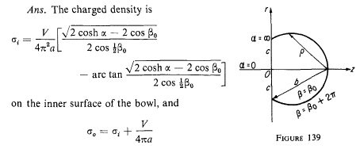

Finally we compare our "inner" σ result above with that of Kelvin, where now we write u0=α (which is different from α=ξ in the screen clip above)

σL =( V0/4π2R) { $\sqrt{chξ-cosα}$/ ($\sqrt{2}$cos(α/2)) – tan-1[ $\sqrt{chξ-cosα}$/ ($\sqrt{2}$cos(α/2))] } // Lebedev (4.8)
σK = (V0/4π2R) { $\sqrt{1-cosα}$/ $\sqrt{cosα - cosθ}$ – tan-1 [$\sqrt{1-cosα}$/$\sqrt{cosα - cosθ}$] } // Kelvin (4.9)

where angles α = u0 and θ are explained by this picture
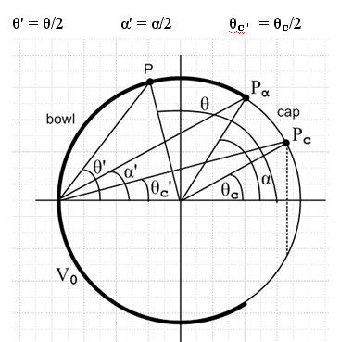

One can show from the toroidal coordinate equations that

$\sqrt{cosα - cosθ}$ = sinα / $\sqrt{chξ-cosα}$ (4.10)

and this makes the Lebedev and Kelvin results agree. In the Lebedev form, the bowl edge lies at ξ = ∞, while in the Kelvin form it lies at θ=α, and in either case σ diverges at the edge, as noted in the Introduction.
Here is Kelvin's actual statement of his result

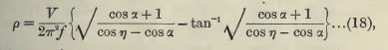 (4.11)

where f = 2R, α(Kelvin) = π-α, and η = π-θ, causing all cosines to negate.

(b) Capacitance

We start again with our toroidal charged bowl potential

V(ξ,u)= V0 $\sqrt{2}$ $\sqrt{chξ - cosu}$$^{\int_{0}^{∞}{}}$dτ Piτ-1/2(chξ) ch[(π–u0)τ] ch[(π+u0-u)τ] / ch2(πτ) (2.8)

The large-r limit is given in our toroidal coordinates by ξ→0 and u→2π, so we set Piτ-1/2(chξ) = 1. Also, we can show from our equations below that, in this limit,

$\sqrt{chξ - cosu}$ ≈ $\sqrt{2}$a / r (4.12)

The residual integral is then (after some work)

I ≡ $^{\int_{0}^{∞}{}}$dτ ch[(π–u0)τ] ch[(u0-π)τ] / ch2(πτ) = (1/2π)[ πb/sin(πb) + 1 ] b = 1-u0/π (4.13)
So
V(ξ,u) ≈ V0 $\sqrt{2}$ $\sqrt{chξ - cosu}$(1/2π)[ πb/sin(πb) + 1 ] ≈ ( aV0 /r) [ b + sinπb/π ]/sin(πb) (4.14)

If we think of this as V = Q/r and using Q = CV0 we find

Q = ( aV0 ) [ b/sin(πb) + 1/π ]

C = ( a ) { b/sin(πb) + 1/π } b = 1-u0/π

= Rsin(u0) { (1-u0/π) /[sin(u0)] + 1/π } a = Rsin(u0)

= (R/π) { π - u0 + sin(u0) } (4.15)

which is indeed the known capacitance of a spherical bowl. In the limit u0 → 0 the formula gives C = R which is the capacitance of a sphere of radius R, while the limit u0→ π (b→0) gives C = 2a/π which is the capacitance of a disk of radius a, a nice spinoff result.

5. Toroidal coordinates

(a) Verbal description

Here is the basic toroidal picture as a slice in any azimuthal plane, where ρ and z are the usual cylindrical coordinates,

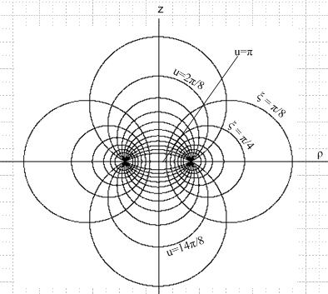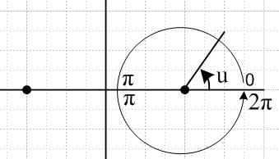

In this picture, the level surfaces of u appear to be vertical set of circles, but each circle is really truncated at the plane z=0 [ since sign(z) = sign(sinu) according to 5.1 below] so we have a set of upper bowls and a set of lower bowls. In this traditional picture, a huge upper bowl has as its limit an iris just above the z=0 plane which is labeled u=0. As these bowls shrink, we pass through the u = 2π/8 bowl shown, and eventually reach very shallow bowls with the limit of a disk of radius a at u = π. Continuing u we cover all the lower bowls and end up with an iris just below the z=0 plane at u = 2π. There is then a discontinuity in u at this iris value, as shown on the right. All these u bowls have a common circular lip in the z=0 plane of radius a, so the distance between the two focal points in the picture above is 2a. One can interpret u as the external bowl lip angle relative to the z=0 plane, but that fact is not very obvious from the above pictures.
Meanwhile the horizontal circles show slices of the toroids labeled by ξ . In the limit ξ →0 one gets an exceedingly fat toroid with no hole whose inner surface sweeps up against the z axis. Conversely, as ξ→∞, the toroids shrink to a thin circular wire matching the bowl lips. It might be noted that these horizontal circles are the famous ones of Apollonius where |r - a|/|r + a| = constant, and in this case that constant is e-ξ.
Toroidal coordinates start life as 2D bipolar coordinates with the same picture as above, but the left side circles have ξ < 0. For 3D toroidal coordinates, one takes just the right side of the above picture with ξ > 0 and rotates this around the z axis to get the 3D bowls and toroids.
Lest it be overlooked, the two sets of circles are orthogonal at all intersections, and are both orthogonal to the azimuthal unit vector at any point. The toroidal system is an orthogonal one with a diagonal metric tensor.

(b) Equations

The defining equations are these for toroidal coordinates (toroid,bowl,plane) = (ξ,u,φ) :

x = a cosφ shξ/(chξ - cosu) ρ = a shξ/(chξ - cosu) ρ2 = x2+ y2
y = a sinφ shξ/(chξ - cosu)
z = a sinu/(chξ - cosu) (5.1)

Here then is a summary of all the basic facts of interest

ρ = ashξ/(chξ–cosu) ρ>0 hξ = hu = a/(chξ–cosu) hφ = shξ hξ
z = asinu/( chξ–cosu) ρ2 = x2+ y2 z/ρ = sinu/shξ (5.2)

ξ = tanh-1[2aρ/(a2+ ρ2+ z2)] metric tensor = diag(hξ2, hu2, hφ2)
tanu = [ -2az/(a2-ρ2-z2)] // use algorithm to find u (see later) (5.3)

r2 = a2 (sh2ξ + sin2u) / (chξ-cosu)2 = ρ2+z2 tanφ ≡ z/ρ = sinu/shξ (5.4)

ρ2 + (z- acotu)2 = a2/sin2u zc = a cot(u) radius = a/|sinu| // vertical circles
(ρ - acothξ)2 + z2 = a2/sh2ξ ρc = acothξ radius = a/|shξ| // horizontal circles (5.5)

ranges: ξ in (0, ∞) u in (0,2π) φ in (0,2π)

Notice that the radius of the sphere on which a bowl u0 lies is R = a/|sinu0|.

(c) More pictures

The following detailed Maple plots of u contours have proved helpful to the author:

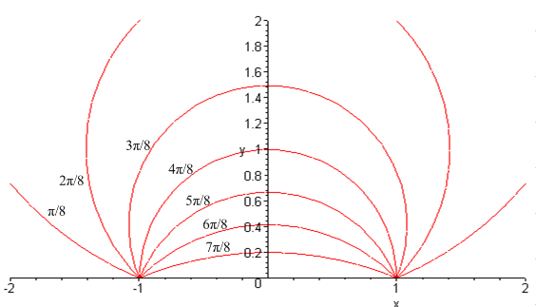
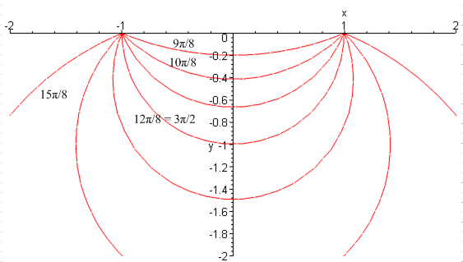

(d) plot of the bowl coordinate u versus coordinates ρ and z

Here is a plot of u oriented roughly to match the pictures in Section (a) above,

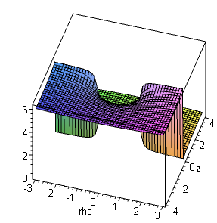
At the upper right (yellow, near "4") we start on the lower plane at u = 0. As we rotate CCW about the right focal point we go up the hill and arrive at the top right on the u = 2π upper plane. Unfortunately this orientation does not show the hill very well, so we rotate things to get a better view

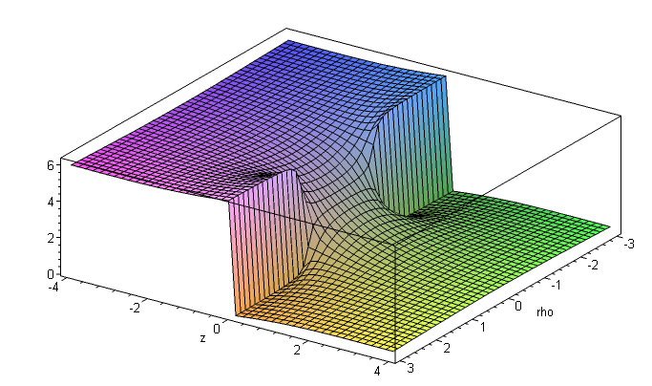
Here the vertical headwall is the discontinuity noted above.

(e) plot of u versus coordinates ρ and z after Lebedev's adjustment

If we adjust things so the u coordinate ranges from u0 to u0 + 2π, the above plot changes. Here is the plot for u0 = π/4 = .78 :

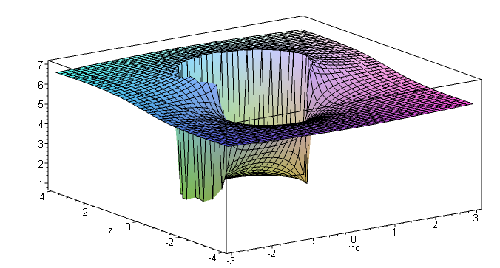

Now the spiral voyage begins inside the bowl at the foot of a vertical curved Niagara Falls which marks the inner boundary of our bowl. We climb up the hill and arrive at the upper plane and walk over to the falls and gaze down from the outer surface of the bowl. Here again is our bowl picture from above

We show all these pictures to make the point that toroidal coordinates are a bit "unfriendly" compared to say spherical coordinates. They have to do violent things to be able to have bowls as level surfaces.

(f) plot of the toroid coordinate ξ versus coordinates ρ and z

This coordinate is much better behaved, though still a bit unusual. The two mountain peaks go up to infinity at the focal points for ξ = ∞, and there is a grounded crease along the ρ axis where ξ = 0. The contour plot on the right is perhaps better -- a top view of it would show our horizontal circle set.

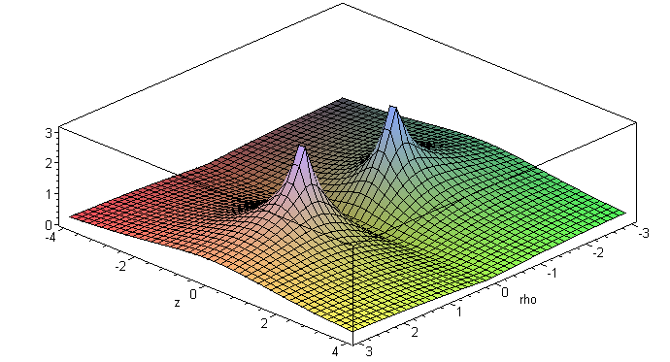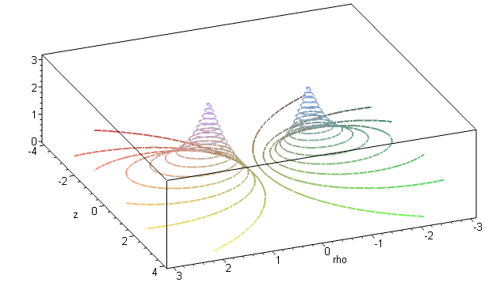

6. A selection of charged bowl potential plots

____________________________________________________________________________
u0 = .01π/8: (basically, u0 = 0)

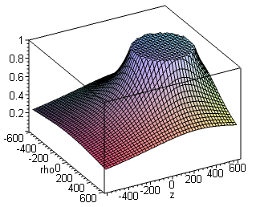

____________________________________________________________________________
u0 = π/8: a bowl that is almost a complete sphere u0 = 2π/8:
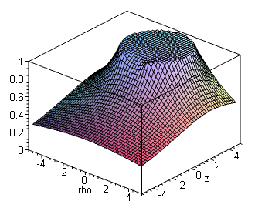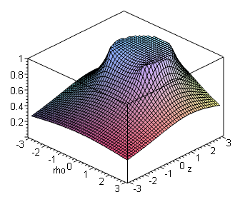

____________________________________________________________________________
u0 = 3π/8: u0 = 4π/8, the hemispherical bowl
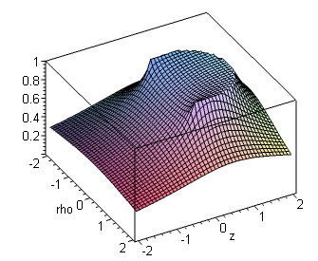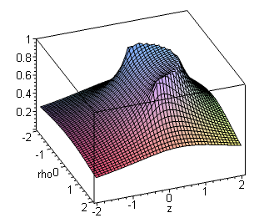
____________________________________________________________________________
u0= 5π/8 u0= 6π/8
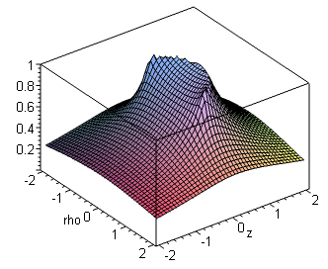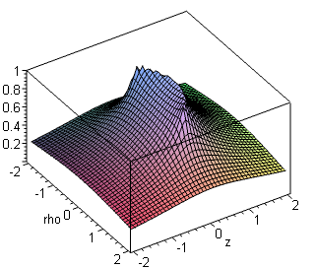
____________________________________________________________________________
u0 = 7π/8 u0 = π, potential of a disk
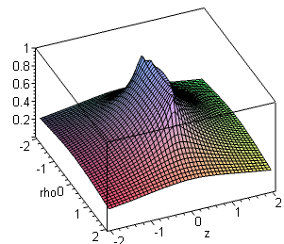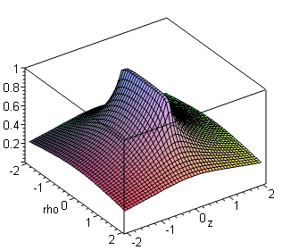
____________________________________________________________________________

When u0 = π, the bowl slice becomes the line between the two foci, and the bowl becomes a perfect disk of radius a. So built into this problem solution is an exact plot of the disk potential. You can see, for example, that if you move 1" off the edge of the disk, V drops faster than if you move 1" out from the disk center.

7. Doing Mehler integrals.

(a) List of useful Mehler integrals

Mehler integration is the seamy underside of using toroidal coordinates in the Mehler function atomic form stated earlier, and is worth some comment. The general form of a "Mehler integral" is this:

G(y) = $^{\int_{0}^{∞}{}}$dτ Piτ-1/2(y) f(τ) normally with y≥1

About the best we can do for P is a form like

P-1/2+iτ (chα) = e-(1/2)αeiατ F(1/2-iτ, 1/2; 1; 1 - e-2α)

which at least isolates the variable τ into just one of the hypergeometric function's parameter arguments. But even so, there is very little literature available on such integrals, so changing from P to F really buys little. There are some integrals of Piτ-1/2(y) f(τ) appearing in the literature, see below. One often has to actually "do" one's own integrals, especially if tables have typos as noted below.

The starting point for doing a Mehler integral is to elevate P into one of these integral representations
( see p 962 GR7 8.715.1 and p 961 8.713.3 setting μ=0 )

P-1/2+iτ(y) = ($\sqrt{2}$/π) $^{\int_{0}^{α}{}}$dx cos(τx) / $\sqrt{y - chx}$ y=chα (7.1)
P-1/2+iτ(y) == ($\sqrt{2}$/π ) ch(πτ) $^{\int_{0}^{∞}{}}$dx cos(τx) /$\sqrt{y+chx}$ (7.2)

which exposes a simple τ dependence. The τ integration can then usually be done, and one is faced with the final x integration which can hopefully be looked up somewhere. Here are some integrals the author has calculated in this manner:

$^{\int_{0}^{∞}{}}$dτ Piτ-1/2(y) = (1/$\sqrt{2}$) (1/$\sqrt{y - 1}$) (7.3)

$^{\int_{0}^{∞}{}}$dτ Piτ-1/2(y) cos(aτ) = (1/$\sqrt{2}$) (1/ $\sqrt{y - cha}$ ) Heaviside(y-cha) (7.4)

$^{\int_{0}^{∞}{}}$dτ Piτ-1/2(y) cos(aτ) sech(πτ) = (1/$\sqrt{2}$) 1/ $\sqrt{y + cha}$ (7.5)

$^{\int_{0}^{∞}{}}$dτ Piτ-1/2(y) cos(aτ) sech2(πτ) = ($\sqrt{2}$/π ) (1/$\sqrt{y-cha}$) tan-1[ $\sqrt{y-cha}$/$\sqrt{1+cha}$] (7.6)

$^{\int_{0}^{∞}{}}$dτ Piτ-1/2(y) ch(bτ) sech2(πτ) = ($\sqrt{2}$/π ) (1/$\sqrt{y-cosb}$) cot-1[$\sqrt{1+cosb}$/$\sqrt{y-cosb}$] (7.7)

$^{\int_{0}^{∞}{}}$dτ Piτ-1/2(y) sh(bτ) th(πτ) sech(πτ) = ($\sqrt{2}$/π ) (1/$\sqrt{y+cosb}$) tan-1[$\sqrt{1-cosb}$/$\sqrt{y+cosb}$] (7.8)

and this set includes all those needed to obtain results given earlier in this paper. Along the way, the following facts are useful

$^{\int_{u}^{∞}{}}$dx x-λ (x+β)ν (x-u)μ-1 = u-λ (β+u)μ+ν B(λ-μ-ν,μ) F(λ,μ; λ-ν; -β/u) //corrected GR7 3.197.2

F(1,1/2; 3/2; z) = [ tanh-1$\sqrt{z}$] /$\sqrt{z}$ and similar special cases of F

(b) The integral X appearing in Section 4(a)

As a Mehler integral example, the integral called X in Section 4 above has this form,

X = $^{\int_{0}^{∞}{}}$dτ Piτ-1/2(y) ch(bτ) τ th(πτ) sech(πτ) // y = chξ and b = π-u0

which has an unpleasant τ factor in the integrand. This integral can be done as X = ∂bY where

Y = $^{\int_{0}^{∞}{}}$dτ Piτ-1/2(y) sh(bτ) th(πτ) sech(πτ)

X = ∂bY = ∂b { ($\sqrt{2}$/π ) (1/$\sqrt{y+cosb}$) tan-1[$\sqrt{1-cosb}$/$\sqrt{y+cosb}$] } // from (7.8) above

Setting y = chξ and b = π-u0 we then find (after doing the above ∂b and some algebra) that

X ≡ $^{\int_{0}^{∞}{}}$dτ Piτ-1/2(chξ) ch([π-u0]τ) τ th(πτ) sech(πτ)

= (2/π) [sin(u0/2) / (2chξ-2cosu0) ]
x [1 + ($\sqrt{2}$cos(u0/2)/ $\sqrt{chξ-cosu0}$) tan-1 ($\sqrt{2}$cos(u0/2) / $\sqrt{chξ-cosu0}$) ]

and we can compare this to the mysterious integral Lebedev et. al. give in Problem 501 (page 239) where they use α = ξ and β0= u0 :

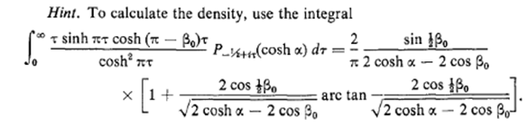

(c) Where to find Mehler integrals (some errata noted)

The largest source of such integrals known to the author is an extremely obscure 1961 Boeing Report #246 written by no less than Professor Fritz Oberhettinger and coworker Higgins. Integral (7.8) appears for example as page 20 #3. Integral (7.6) above as page 20 #5 for y > cha, and the corresponding log form for y<cha has a typo in that the leading factor should be 1/2 instead of 1/$\sqrt{2}$. Similarly, result (7.7) appears as page 20 #6 expressed as tan-1 and in this form a certain exponent has a wrong sign. That erroneous exponent also appears in PBM mentioned next

// wrong

Using cot-1 = π/2 - tan-1 for the principle branch of the arc trig functions, (7.7) above becomes

$^{\int_{0}^{∞}{}}$dτ Piτ-1/2(y) ch(bτ) sech2(πτ)

= (1/$\sqrt{2}$) (1/$\sqrt{y-cosb}$) – ($\sqrt{2}$/π ) (1/$\sqrt{y-cosb}$) tan-1[$\sqrt{1+cosb}$/$\sqrt{y-cosb}$] (7.7A)

which shows the correct placement of the radicals. It can be shown that 7.7A is only valid for |b| < π, whereas 7.7 is valid for |b| < 2π.

The second largest source is volume 3 of the special functions series of PBM which has about 20 integrals of Piτ-1/2(y) against elementary functions and many more against special functions.

Bateman ET 2 has a grand total of 6 Mehler integrals, and GR7 has somewhat more. Perhaps there is some recent collection of Mehler integrals unknown to the author.

8. Evaluating the toroidal bowl potential integral into elementary functions

Start with the form derived above

V(ξ,u)= V0 $\sqrt{2}$ $\sqrt{chξ - cosu}$$^{\int_{0}^{∞}{}}$dτ Piτ-1/2(chξ) ch[(π–u0)τ] ch[(π+u0-u)τ] / ch2(πτ) (2.8)

Expand the ch ch product to get

V(ξ,u)= (V0 /$\sqrt{2}$)$\sqrt{chξ - cosu}$$^{\int_{0}^{∞}{}}$dτ Piτ-1/2(chξ){cosh[(2π-u)τ] + cosh[(2u0-u)τ]} / ch2(πτ) (8.1)

Use integral (7.7) above to find

V(ξ,u)= (V0 /$\sqrt{2}$) ($\sqrt{2}$/π ) $\sqrt{chξ - cosu}$ *
{ (1/$\sqrt{chξ -cos(2π-u)}$) cot-1[$\sqrt{1+cos(2π-u)}$/ $\sqrt{chξ -cos(2π-u)}$ ]
+ (1/$\sqrt{chξ-cos(2u0-u)}$)cot-1[$\sqrt{1+cos(2u0-u)}$/ $\sqrt{chξ -cos(2u0-u)}$] } (8.2)

u0 in (0,π)
u in (u0, 2π+u0) chξ in (1,∞)

and we can if we like replace cos(2π-u) by cosu in three places.
Before one can do any Maple plots, one needs to understand the meaning of the numerator radicals appearing in the above formula. Consider again the underlying integral (7.7)

$^{\int_{0}^{∞}{}}$dτ Piτ-1/2(y) ch(bτ) sech2(πτ) = ($\sqrt{2}$/π ) (1/$\sqrt{y-cosb}$) cot-1[$\sqrt{1+cosb}$/$\sqrt{y-cosb}$] (7.7)

Written in this form, the LHS converges for |b| < 2π and so does the RHS and we can regard the equation as matching two functions analytic in parameter b near b = 0. If the RHS is written in tan-1 form, the RHS is only analytic for |b| < π, which is why we use the cot-1 form. As parameter b makes its excursion from b = 0 to b = 2π, it has to pass by the value b = π, a place where $\sqrt{1+cosb}$ = 0. The correct analytic continuation is to swap branches of $\sqrt{1+cosb}$ when passing through an odd multiple of π, but this fact is not very obvious when one simply writes "$\sqrt{1+cosb}$". Maple, for example, always assumes the positive branch. This continuation issue arises in both cot-1 numerators $\sqrt{1+cosu}$ and $\sqrt{1+cos(2u0-u)}$ appearing above. To clarify the meaning of our integral evaluation, we formalize this sign change as it occurs in both cot-1 numerators, by writing

V(ξ,u)= (V0/π ) $\sqrt{chξ - cosu}$ *
{ (1/$\sqrt{chξ -cosu}$) cot-1[(-1)η1| $\sqrt{1+cosu}$| / $\sqrt{chξ -cosu}$]
+ (1/$\sqrt{chξ-cos(2u0-u)}$) cot-1[(-1)η2| $\sqrt{1+cos(2u0-u)}$|/ $\sqrt{chξ -cos(2u0-u)}$] } (8.3)

where η1 = floor[(3π-u)/2π] u0 in (0,π)
η2 = floor[(2u0-u+π)/2π] u in (u0, u0+2π)

This form provides the correct analytic continuation of our RHS to any real value of u, even beyond the point where the LHS integral actually converges, though we only use it in the convergent region.
In order to rigorously verify this analytic continuation, one has to study the Riemann sheet structure of the function f(z) = $\sqrt{1 + cos(z)}$. One first looks at u(z) = cos(z) which is plenty complicated by itself, and then one has to add a square root branch cut to get to f(z). Here is the kind of picture one ends up having to ponder

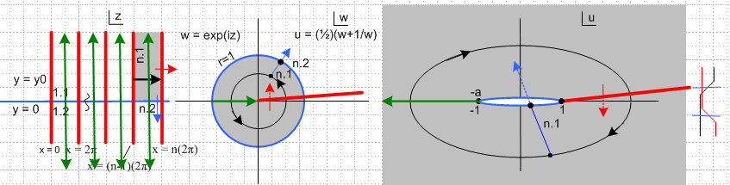

The black arrow in the z plane crosses Re(z) = an odd multiple of π, and we can trace this in black to an elliptical "ant trail" in the u-plane. But the green cut is that from the radical in $\sqrt{1 + cos(z)}$and to analytically continue one must dive through the green cut to arrive at a "the other sheet" of this function, where it has the opposite sign. See Ahlfors's Chapter 3 on analytic mapping.

9. Using Maple to plot the bowl potential

We use Maple because we have it, any computer algebra system will do, though the syntax changes slightly. The code text is given in an Appendix below, here we use screen clips. The first order of business is just to enter the evaluated bowl potential and set a few parameter values,

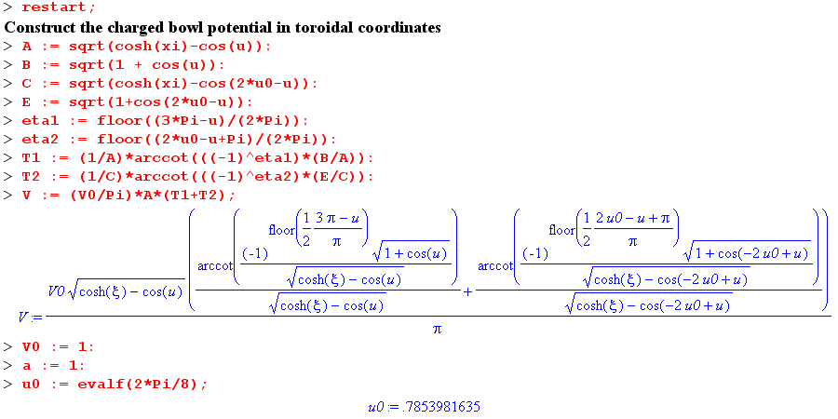
Next, we need a special routine which takes a point (x,y) on a circle and returns a tan-1 angle which lies in the range (0,2π), where the angle is measured CCW away from the x axis. Maple has an internal function that does something like this, but we want to see what is happening, thus

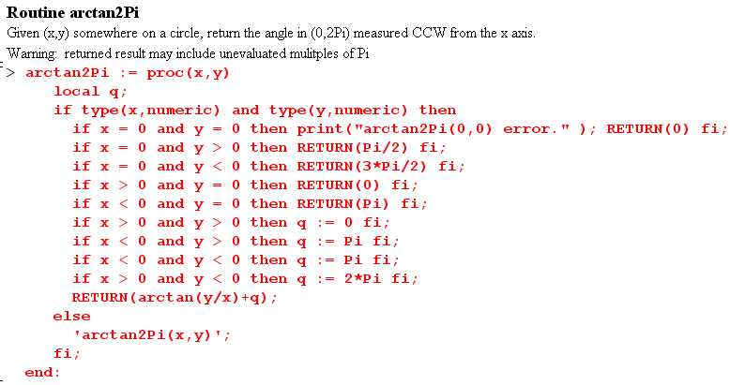

Lastly, but very importantly, we have to figure out how to compute toroidal parameter u from Cartesian coordinates ρ and z ( really cylindrical coordinates, but just think ρ = x). In the toroidal equations section above we wrote in (5.3)

tanu = [ -2az/(a2-ρ2-z2)] => u = tan-1[ -2az/(a2-ρ2-z2)]]

but the letters "tan-1" do not indicate which branch of tan-1() we need to be on for a given value of ρ and z. This information is not present in the equation above. For that reason, we compute cosu and sinu separately from these equations

ξ = tanh-1[2aρ/(a2+ ρ2+ z2)] (5.3)
ρ = ashξ/(chξ–cosu)
z = asinu/( chξ–cosu) (5.2)

and then use the (0,2π) arctan2Pi routine shown above to get the proper u. Finally, we have to adjust this value of u so it fits into the Lebedev-adjusted range (u0, u0+2π). And we have to worry about all the special cases that tend to blow things up when ignored. So here then is a routine to compute u:

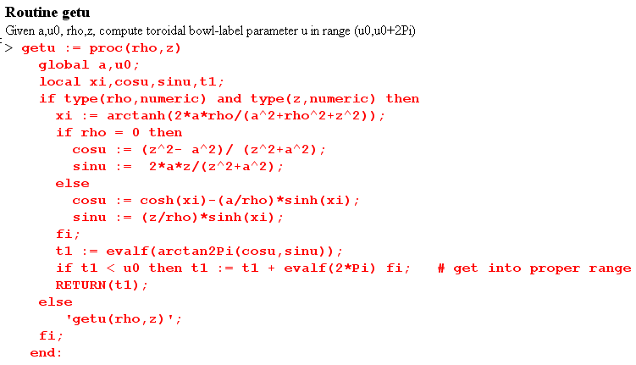

where the type functions relate to an obscure evaluation quirk of Maple and should be ignored. We used this getu function to plot the surfaces of u shown earlier: (you may have to stare at this picture for awhile, it is a camera shot from below the plane)

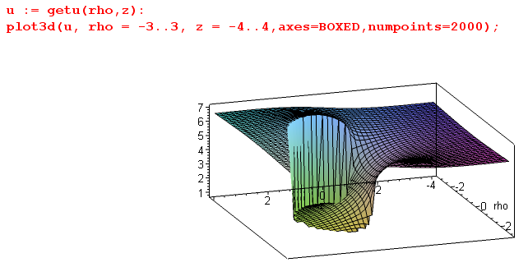

Finally, here is the code to plot the potential surface:

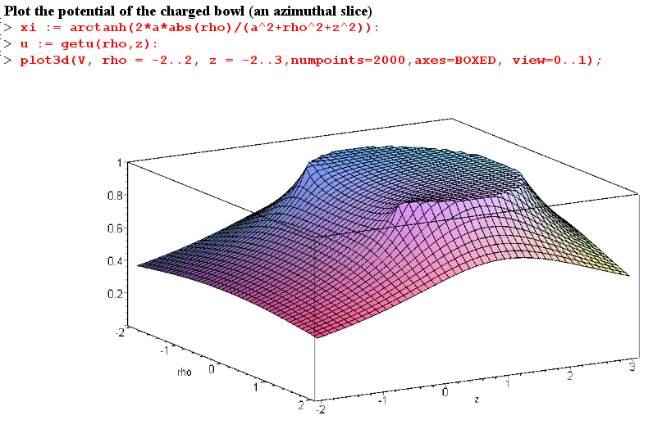

10. Potential and capacitance of a charged toroid.

The solution to the charged toroid problem provides an interesting comparison to the bowl problem.

(a) The potential of a charged toroid

Looking back at the two toroidal atomic forms, we can see that for problems involving a toroid as boundary (ξ = ξ0) we must be oscillatory in the other two coordinates u and φ. Thus we select

expo osc osc
(1) $\sqrt{chξ - cosu}$ [Pn-1/2m(chξ), Qn-1/2m(chξ) ] [ sin(nu),cos(nu)] [ sin(mφ),cos(mφ)]

It is convenient for this problem to put bowl label u in the range (-π,π) as suggested by this picture

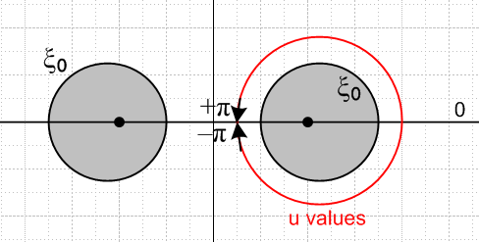

Unlike the situation with the bowl problem, the red path of u values around the grey toroid core is unobstructed so the potential must be periodic in u with period 2π, and this fact causes quantization to integers of the parameter n appearing in the atomic form. Furthermore, we can see that with this range of u, the potential must be symmetric V(ξ,u) = V(ξ,-u), so only the cos(nu) term survives. Thus we quickly arrive at the following Smythian form for the potential of a charged toroid,

V(ξ,u) = $\sqrt{chξ - cosu}$ Σn=0∞ Pn-1/2(chξ) Ancos(nu) (10.1)

where An are coefficients to be determined. As in the bowl case, the Q function is ruled out since it diverges at ξ = 0, whereas ξ → 0 is part of the condition for being "far away" where the potential must vanish. The other part of that condition is u → 0.
The boundary condition of constant potential on the toroid is this

V0/$\sqrt{chξ0 - cosu}$ = Σn=0∞ Pn-1/2(chξ0) An cos(nu) (10.2)

Armed with knowledge of the Fourier expansion and projection of 1/$\sqrt{a - b cos(x)}$

1/$\sqrt{a - b cos(x)}$ = (1/π) $\sqrt{2/b}$ Σn=0∞ εn Qn-1/2(a/b) cos(nx) // expansion
$^{\int_{0}^{π}{}}$dx cos(nx)/ $\sqrt{a - b cos(x)}$ = $\sqrt{2/b}$ Qn-1/2(a/b) // projection (10.3)

and using

$^{\int_{0}^{π}{}}$du cos(nu)cos(n'u) = (π/εn) δnn' where εn = 2-δn,0 = "Neumann's Factor" (Watson)

we can easily invert to find coefficient An

An = V0 ($\sqrt{2}$εn/π) [ Qn-1/2(chξ0)/ Pn-1/2(chξ0)] (10.4)

and we thus arrive at the potential for a conducting charged toroid,

V(ξ,u) = V0 ($\sqrt{2}$/π)$\sqrt{chξ - cosu}$ Σn=0∞ εn Pn-1/2(chξ) [Qn-1/2(chξ0)/ Pn-1/2(chξ0)]cos(nu) (10.5)

which can be compared with Morse and Feshbach 1953 p 1304 ( ξ = μ and u = η )

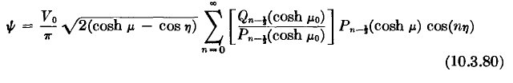 // wrong

where the εn factor has been erroneously omitted. I asked Mark Feshbach if he knew of an errata collection for the massive 2000 page masterwork coauthored by his father, but he did not.

(b) Capacitance of a toroid

Since large r means ξ→0 and u→0, we can set Pn-1/2(chξ) = 1 and cos(nu) = 1 in our potential to get

V(ξ,u) ≈ V0 ($\sqrt{2}$/π)$\sqrt{chξ - cosu}$ Σn=0∞ εn [Qn-1/2(chξ0)/ Pn-1/2(chξ0)] (10.6)

As in the bowl problem, we know from (4.11) that $\sqrt{chξ - cosu}$ ≈ $\sqrt{2}$a / r in the "far limit" so we get

V(ξ,u) ≈ V0 ($\sqrt{2}$/π) $\sqrt{2}$a / r * Σn=0∞ εn [Qn-1/2(chξ0)/ Pn-1/2(chξ0)] (10.7)

If we think of this as V = Q/r and using Q = CV0 we find

Q = ( 2V0a/π ) Σn=0∞ εn [Qn-1/2(chξ0)/ Pn-1/2(chξ0)]

C = ( 2a/π ) Σn=0∞ εn [Qn-1/2(chξ0)/ Pn-1/2(chξ0)] (10.8)

Sometimes this result is expressed in terms of R and ρc shown here (R is the tube radius, ρc is the toroid radius to the center line of the tube)

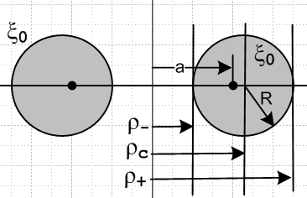

Our toroidal equations (5.5) show that

ρc = a cothξ0 R = a /shξ0 => $\sqrt{ρc2 - R2}$ = a , ρc/R = chξ0 (10.9)

so that the C formula can be written

C = ( 2/π) $\sqrt{ρc2 - R2}$ Σn=0∞ εn [Qn-1/2(ρc/R)/ Pn-1/2(ρc/R)] (10.10)

Setting ρc = 1, we can have Maple plot C as a function of R:

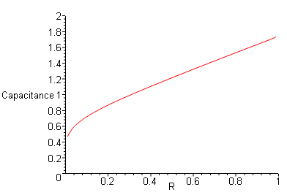

R/ρc = 1 describes a degenerate toroid where the hole just disappears (upper right of plot), and R→0 gives a limiting thin wire ring (lower left of plot). Both these limits are quite fascinating as discussed in some detail in Appendix B below.
The degenerate toroid limit R=1 gives the mysterious value C = 1.7413. The author would love to know if this number is a simple function of π, small integers and simple roots (see Appendix B).
A comparison of this degenerate toroid to a sphere which just encloses it (r=2R)

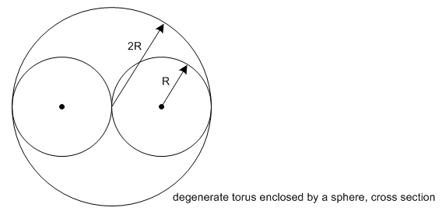
reveals these facts

Ctoroid = 1.7413 // mystery number
Csphere = 2.0000 ratio sphere/toroid = 2.0000/1.741 = 1.149 // C = (2R)

AREAtoroid = 4π2R2 // area = 4π2Rρc
AREAsphere = 16πR2 ratio sphere/toroid = 4/π = 1.273 // area = 4π(2R)2

So the sphere has 27% more area and 15% more capacitance than the enclosed degenerate toroid. We expect the sphere to have more capacitance since it is the optimal shape for keeping the charges apart.

As for the thin-wire-ring limit (left edge of the above plot), here is more detail (notice that the axes are now switched, because Maple V only does semilog plots this way)

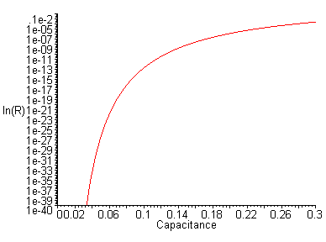
If we go from R/ρc = 10-3 to R/ρc = 10-40, capacitance drops only by a factor 101, so one might say that a wire ring "holds its capacitance quite well" as the wire gets thinner and thinner. Ultimately the capacitance goes to 0 as the wire vanishes out of existence. This can be compared to the capacitance of a metal sphere which is shrunk to a point, in which case C = R → 0 in a more reasonable fashion.
If a metal sphere carrying fixed charge Q is gradually shrunk to a point, work must be done to get the charges closer together which raises the sphere's potential V relative to infinity ( E = CV2/2 = QV/2). The charges are all piled on top of each other in the limit, so C= Q/V goes to 0 quickly. In the toroid case, the charges can stay away from each other to some extend by being spread out around the wire ring, so V rises more slowly as the ring is made thinner.
[ The slowness of the thin ring limit approach is due to the fact that the first term in the series for C dominates, and Q-1/2(z)/ P-1/2(z) → (π2/2) (1/ ln[8z] ) as z→∞, so C(R; ρc=1) ≈ π / ln(8/R). Inverting one gets R = 8 e-π/C so that lnR = ln8 - π/C which is the plot shown above. ]

(b) Charge density on a toroid

Using this formula ( plus sign because ξ decreases moving away from the toroid surface )

σ = + (1/4π) (1/hξ) ∂ξV(ξ,u)|ξ=ξ0 1/hξ = (chξ - cosu)/a (10.11)

and the potential stated above

V(ξ,u) = V0 ($\sqrt{2}$/π)$\sqrt{chξ - cosu}$ Σn=0∞ εn Pn-1/2(chξ) [Qn-1/2(chξ0)/ Pn-1/2(chξ0)]cos(nu)

we get the following expression for the charge density σ on a charged toroid with label ξ0, (R = a/shξ0)

σ(u) = (V0 /4π R) * (10.12)
{ ($\sqrt{2}$/π)($\sqrt{chξ0 - cosu}$)3 Σn=0∞ εn Pn-1/2'(chξ0) [Qn-1/2(chξ0)/ Pn-1/2(chξ0)]cos(nu) + (1/2) }

where Pn-1/2'(z) means ∂zPn-1/2(z) = (z2-1)-1(n+1/2)[ Pn+1/2(z) - z Pn-1/2(z) ]. In the large z limit, it can be shown that σ = (V0/4π R)z0 / ln(8z0), so for a thin wire the linear charge density is λ = 2πRσ and then the total charge is Q = 2πρc λ = π V0 / R ln(8/R), consistent with the capacitance limit found above when ρc=1. Here is a plot of σ(u) for ξ0 = π/4, a toroid marked in our bipolar coordinates picture above, where the horizontal axis shows u in units of π/8 and the height is relative units (left picture)

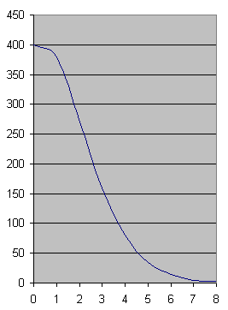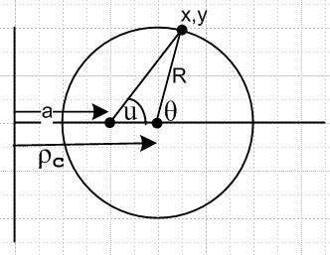

One can convert from angle u to angle θ as shown using the following geometry facts

sinθ = shξ0sinu/(chξ0-cosu) cosθ = (chξ0cosu-1) /(chξ0-cosu) (10.13)

The main idea in the σ(u) sum is that near u = 0 the terms are additive since cos(nu) ~ 1, whereas in the "backward direction" especially near u = π there is term interference from cos(nu) ~ (-1)n, causing the charge to concentrate on the outer toroidal surface just as one would expect. This situation is akin to the forward peak in a scattering amplitude in partial wave analysis. The plot was made from data computed in Maple using 20 terms and confirming term stability as discussed in Appendix B.

Appendix A. Maple code text for plotting the Bowl Potential

My ancient version of Maple is not very friendly when it comes to cutting and pasting text, but the following might be useful to some reader wanting to get this potential plotter up and running.

> restart;
Construct the charged bowl potential in toroidal coordinates
A := sqrt(cosh(xi)-cos(u)):
B := sqrt(1 + cos(u)):
C := sqrt(cosh(xi)-cos(2*u0-u)):
E := sqrt(1+cos(2*u0-u)):
eta1 := floor((3*Pi-u)/(2*Pi)):
eta2 := floor((2*u0-u+Pi)/(2*Pi)):
T1 := (1/A)*arccot(((-1)^eta1)*(B/A)):
T2 := (1/C)*arccot(((-1)^eta2)*(E/C)):
V := (V0/Pi)*A*(T1+T2);
V0 := 1:
a := 1:
u0 := evalf(2*Pi/8);

Routine arctan2Pi
Given (x,y) somewhere on a circle, return the angle in (0,2Pi) measured CCW from the axis.
Warning: returned result may include unevaluated multiples of Pi
> arctan2Pi := proc(x,y)
local q;
if type(x,numeric) and type(y,numeric) then
if x = 0 and y = 0 then print("arctan2Pi(0,0) error." ); RETURN(0) fi;
if x = 0 and y > 0 then RETURN(Pi/2) fi;
if x = 0 and y < 0 then RETURN(3*Pi/2) fi;
if x > 0 and y = 0 then RETURN(0) fi;
if x < 0 and y = 0 then RETURN(Pi) fi;
if x > 0 and y > 0 then q := 0 fi;
if x < 0 and y > 0 then q := Pi fi;
if x < 0 and y < 0 then q := Pi fi;
if x > 0 and y < 0 then q := 2*Pi fi;
RETURN(arctan(y/x)+q);
else
'arctan2Pi(x,y)';
fi;
end:

Routine getu
Given a,u0, rho,z, compute toroidal bowl-label parameter u in range (u0,u0+2Pi)
> getu := proc(rho,z)
global a,u0;
local xi,cosu,sinu,t1;
if type(rho,numeric) and type(z,numeric) then
xi := arctanh(2*a*rho/(a^2+rho^2+z^2));
if rho = 0 then
cosu := (z^2- a^2)/ (z^2+a^2);
sinu := 2*a*z/(z^2+a^2);
else
cosu := cosh(xi)-(a/rho)*sinh(xi);
sinu := (z/rho)*sinh(xi);
fi;
t1 := evalf(arctan2Pi(cosu,sinu));
if t1 < u0 then t1 := t1 + evalf(2*Pi) fi; # get into proper range
RETURN(t1);
else
'getu(rho,z)';
fi;
end:

Plot the potential of the charged bowl (an azimuthal slice)
> xi := arctanh(2*a*abs(rho)/(a^2+rho^2+z^2)):
> u := getu(rho,z):
> plot3d(V, rho = -2..2, z = -2..3,numpoints=2000,axes=BOXED, view=0..1);

> u := getu(rho,z):
> plot3d(u, rho = -3..3, z = -4..4,axes=BOXED,numpoints=2000);

Appendix B: Comments on computing the capacitance of a toroid and its degenerate limit.

The capacitance formula (10.10) given above is this,

C = (2R/π) $\sqrt{z2 - 1}$ Σn=0∞ εn [Qn-1/2(z)/ Pn-1/2(z)] z = chξ = ρc/R (B.1)

It is convenient to remove the leading factor and talk about this function

T(z) ≡ $\sqrt{z2 - 1}$ Σn=0∞ εn [Qn-1/2(z) / Pn-1/2(z)] (B.2)

Basically this is a "special function" that has no name. We can call it the "toroidal capacitance function". It is defined for our purposes on the range z in (1,∞). One can see from this fact

Qν(z)/ Pν(z) ≈ π { Γ(1+ν)2/ [Γ(ν+3/2) Γ(ν+1/2)] } (2z)-2ν-1 (B.3)

that the series converges for z > 1. It is a simple matter to have Maple compute T(z) for a variable number of terms to make sure enough terms are included to give a stabilized result. As z→1, the number of required terms increases. The magic question is to find the limit T(z=1), it if exists. This is the limit which determines the capacitance of a toroid for which the hole has just gone out of existence.
We use appropriate definitions of the P and Q functions as follows, and do some cursory checks:

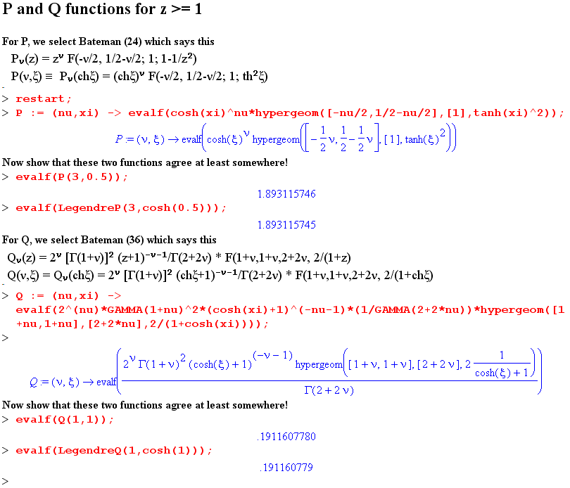

In order to study the behavior of sums involving P and Q functions, we first considered this "sum rule" (which is the 10.3 expansion above with x = 0, b = 1 and a = z)

R(z) ≡ $\sqrt{z-1}$ Σn=0 εn Qn-1/2(z) = (π/$\sqrt{2}$) = 2.221441469 (B.4)

Our Maple program was able to obtain the correct sum to three decimal places down to z = 1.00001 where it had to add 2000 terms. Because this series is in a sense only half as convergent as our intended Q/P series, the partial sums (left) and terms (right) exhibited characteristics of an asymptotic series, for example [ the horizontal axis shows the number of terms added ]

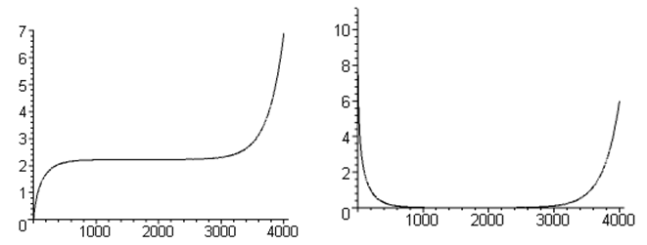

The series R(z)/$\sqrt{z-1}$really is truly convergent, and this Maple behavior arises (we think) from the way Maple computes the hypergeometric function for very large parameters and z near 1, an area known to be problematic. The Q/P series partial sums did not exhibit this asymptotic series behavior.

After this warmup exercise, we turned to the T(z) series (B.2) and computed it the same way, always with a stable number of terms. Our results were as follows: ( the 1.00001 case had too few terms)

z T(z) terms used -log10(z-1)
1.1 2.8465 15 1
1.01 2.7987 140 2
1.001 2.7414 300 3
1.0001 2.7359 600 4
1.00001 2.7353 1200 5
1.000001 2.7353 4000 6 (B.5)

suggesting that we are approaching a limit close to 2.7353 for the value of T(1). We can plot the above points as follows:

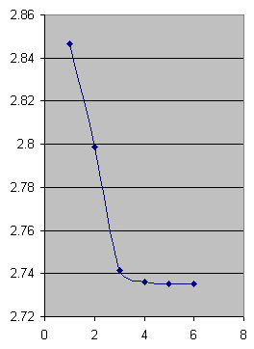

where the x axis is -log10(z-1). The point is that we are coming into the limit T(1) with zero slope.
Using the Wronskian of P and Q, one can show that this slope is given by

T'(z) = { T(z) – $\sqrt{z2 - 1}$ Σn=0∞ εn /[Pn-1/2(z)]2 } / (z2-1) (B.6)

If we conjecture that T'(1) is not infinite, which the picture certainly suggests, we conclude that

T(1) = limz→1{ $\sqrt{z2 - 1}$ Σn=0∞ εn /[Pn-1/2(z)]2 } (B.7)

and we have then a second way to compute T(1). This series is more stable because it avoids the ln(z-1) singularity of the Q functions. Using this series Maple yielded the following results

z = 1.1 above = 2.898517346
z = 1.01 above = 2.751570937
z = 1.001 above = 2.736973437
z = 1.0001 above = 2.735058209
z = 1.00001 above = 2.735362078
z = 1.000001 above = 2.735354499 10,000 terms
z = 1.0000001 above = 2.735353885 40,000 terms (B.8)

We verified most of these results by jamming strings like the following into the Wolfram Alpha website computation window ( the argument 3 indicates off the cut Legendre functions in Mathematica)

sqrt(1.0000001^2-1)*(2*sum(1/LegendreP(n-1/2,0,3,1.0000001)^2,n=1 to 39999) + 1/LegendreP(-1/2,0,3,1.0000001) ^2)

Though it timed out on this case, it did all the other cases listed, confirming Maple's results.
Our conclusion is the following strange fact

T(1) = 2.735353 (B.9)

and therefore we find that the capacitance of a degenerate toroid is given by

C(ρc= R = 1) = (2/π)T(1) = 1.741380 (B.10)

It is interesting that T(1) is slightly larger than e ≈ 2.718282, but for sure T(1) ≠ e. We do not know how to obtain this limit in any other way. We know of no integral representations of inverse Legendre functions, nor of any published series involving them, though PBM has very many series involving Legendre functions and products of same combined with other functions. Perhaps a variation for z ≥1 of Bateman HT I p 149 (11) could be used.

We sometimes read about the interchange of limits giving different results in situations where uniform convergence is lacking in both limits, or where one of the limits does not exist. We have here exactly a case of this second situation:

limz→1 limN→∞ { $\sqrt{z2 - 1}$ Σn=0N εn /[Pn-1/2(z)]2 } = T(1) = 2.735353

whereas

limN→∞ limz→1 { $\sqrt{z2 - 1}$ Σn=0N εn /[Pn-1/2(z)]2 }

= Σn=0∞ εn limz→1 { $\sqrt{z2 - 1}$ } since limz→1Pν(z) = 1

= ∞ * 0

The situation is even worse with the P/Q series since limz→1Qν(z)/Pν(z) = ∞/1 = ∞.

Appendix C: Kelvin's approach to the Charged Bowl Problem.

Lord Kelvin (William Thomson) published his own Collected Works in 1872 and again in 1884 and the latter is the form available on the web as a Microsoft digitized document. The Contents gives section numbers, not page numbers. There are 673 sections filling some 600 pages, and the section numbers just increment through all the many Collected papers.
In the first collected paper (page 1, the ellipsoid paper, "On the Uniform Motion of Heat...", 14p, 1842) Kelvin derives the potential of and charge distribution on a charged conducting ellipsoid and gets the correct result (2.1) above. He bases things on a certain geometric distance p which turns out to be proportional to σ on the ellipsoid: p = 1/$\sqrt{x2/a4 + y2/b4+ z2/c4}$and σ = Qp/(4πabc) where a,b,c are the semimajor axes and Q is the total charge on the ellipsoid (see McDonald's paper). His method is very unusual, there is no formal ellipsoidal coordinate system here, but at age 18 he did the whole thing by brute force. He wanders around between the heat, gravitational and electrostatic manifestations of potential theory, but is mostly concerned with heat.
This brings us then to his bowl paper (paper XV, page 178, sections 231-248, "Determination of the distribution...", 14p, 1869). He opens by quoting the above σ formula (he refers to σ by the symbol ρ) and then specializes it first to an elliptical plate then to a circular disk, noting the disk capacitance C = 2a/π. He finds that σdisk(ρ) = [Q/(4πa)] (1/$\sqrt{a2-ρ2}$) on each side, where ρ is our modern-day cylindrical coordinate and a the disk radius. This is the key result upon which his bowl theory is built. Kelvin notes retrospectively that George Green obtained this result in 1832.
Deviating somewhat from Kelvin's order of presentation, we tack sideways and ponder the inversion of his charged disk into a grounded spherical bowl with a point charge located on the bowl's cap. The point charge appears at the inversion origin in the bowl space when one adds a constant potential in the disk space to bring the disk potential down to 0 so it will map into a grounded bowl in the bowl space. By shifting the charged disk off the symmetry axis, the point charge can be made to appear at any desired point on the bowl's cap:
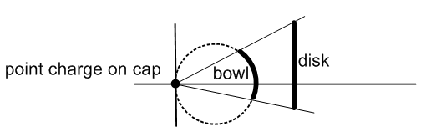

Since Kelvin knows the disk's charge density σdisk(ρ) just stated above, he knows by inversion σ on the bowl. He does not mention the disk's potential, but that maps into the bowl potential by inversion as well. So in the bowl space, we have the grounded bowl with a point charge on the cap, and we know σ on the bowl. Since σdisk is the same on both sides of the disk, σ is the same on both sides of the bowl. Basically, the bowl potential is the Green's Function for the bowl with a restricted placement of the Green's point charge.
Kelvin then does two superpositions.
He first superposes an infinite number these Green's Function situations to obtain a target uniform charge density -σ0 on the bowl's cap. In doing this the point charge has to be properly scaled for each point in the integration as it is made to wander over the cap region. The corresponding bowl σ's are also being superposed in this process. One then ends up with the final σ on the bowl (let's call it σ2,same on both surfaces) as a superposition integral which can be evaluated into trig and inverse trig functions. One can interpret this σ2 as the charge induced on each surface of a grounded bowl due to the presence of uniform -σ0 on the cap. This induced charge on the bowl is brought in from infinity on the traditional "infinitesimally thin wire" grounding the bowl to The Great Metal Sphere at Infinity.
This cap of charge density -σ0 is what we call "sticky charge". It is an infinitely thin layer of charge that is magically glued in place so it cannot move, just as the point charge in a Green's function problem is glued to its location and cannot move.
In a second superposition, Kelvin superposes Problem A and Problem B to get Problem C:

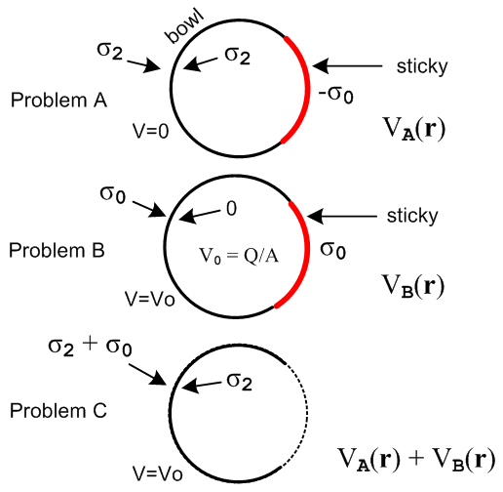

Problem A is the grounded conducting bowl of radius R in the presence of a cap of uniform sticky charge -σ0 as just described above. The bowl is at V=0 and has σ2 on both surfaces.
Problem B is the same conducting bowl carefully prepared to have a uniform free charge density +σ0 on its outer surface along with a cap of sticky charge also of +σ0. Since we have then a full sphere of uniform σ0, the potential on and inside the entire bowl sphere is V0 = Q/R = (σ04πR2)/R = 4πRσ0 = constant. By the same argument used for a full conducting sphere, this bowl must have σ = 0 on its inner surface. One might prepare this Problem B by first shrink-wrapping a neutral conducting bowl's sphere with a full sphere of sticky σ0. One then unglues the sticky charge covering just the bowl part of the sphere. The released charges won't move because there is no tangential E field to make them move.
Each of these two problems represents a valid solution to the Laplace equation in the presence of the same conductor. Kelvin forms a third solution by superposing these two problems as Problem C. In this superposed Problem C one has: (1) V = 0 + V0 = 4πRσ0 on the bowl ; (2) σin ≡ σ2 + 0 = σ2 on the bowl's inner surface; (3) σout ≡ σ2 + σ0 on the bowl's outer surface; (4) exact cancellation of the sticky charge on the cap. Notice that σout – σin = σ0 = V0/(4πR) = a constant.
But Problem 3 is recognized as exactly our "charged bowl problem" for a bowl with potential V0, and we have just shown that σout – σin = σ0 = V/(4πR) = constant, which is the famous result. And of course we know σin = σ2 which came with Problem A. The underlying fact is that a Laplace solution is unique, so if your find something that works, that is the answer. Kelvin's result for σin = σ2 is stated in (4.9) or (4.11) above.

Kelvin uses his hard-won formulas to compute σin and σout at several locations on spherical bowls of various shapes. He does this to 5 decimal places and shows the results in a full page graphic. Had he stopped here, he would have had a great paper, but he had more to say.

Kelvin now knows all about "the charged bowl" problem. Just as he started with a "charged disk" and obtained by inversion the Green's function for a bowl, he now starts with the "charged bowl" and inverts it into either another bowl or a disk, and this time the "inversion-generated point charge" can be made to appear anywhere relative to that bowl or disk. Here are his drawings for these two cases

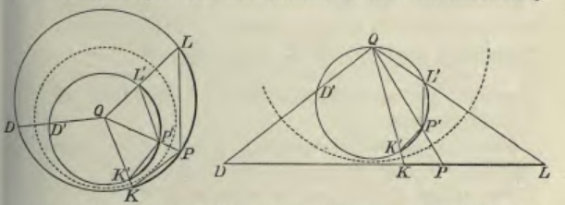

The inversion sphere is shown dashed, and the point charge is at the inversion origin Q. Thus Kelvin has obtained (in theory) the fully general Green's Function for a bowl or a disk. His paper only discusses the charge densities, but the method applies as well to the potential. One can start with the known disk potential (green Jackson p 92 (3.178) with typo corrected)

Vdisk(ρ,z) = (q/a) sin-1 [ 2a/ [ $\sqrt{(ρ-a)2+z2}$ + $\sqrt{(ρ+a)2+z2}$ ] (C.1)

and process it through all of Kelvin's steps above.

Appendix D: Smythe's approach to the Charged Bowl Problem.

In the Kelvin discussion above we saw an inversion of the on-cap bowl Green's Function problem to an off-axis charged disk problem. If the bowl and its on-cap point charge are rotated together so the bowl surface touches the inversion origin, the same bowl Green's Function problem (with the same inversion origin and inversion sphere) can be inverted into an iris Green's Function problem with the point charge in the hole of the iris. ("iris" being an infinite grounded conducting plane containing a circular hole). With the bowl in this position, the bowl's cap maps into the hole in the iris and a point charge on the cap maps into a point charge in the hole of the iris:
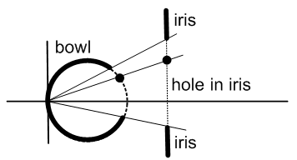

If one could somehow solve this iris Green's Function problem, one could thereby gain full knowledge of the on-cap bowl Green's Function problem, and one could then carry out Kelvin's two superpositions described in the previous Appendix and thereby obtain the potential and charge densities for the charged bowl problem.
This is the approach taken by Smythe in an intriguing set of Problems (38 through 42 starting on page 203 of his 2nd Edition book). The starting point is to figure out the Green's Function for the iris with point charge in the hole, and that can be done by inverting the charged disk using the following planar inversion arrangement (the point charge appears in the iris space at the inversion origin = red crosshair, a distance S from the center of the iris hole)

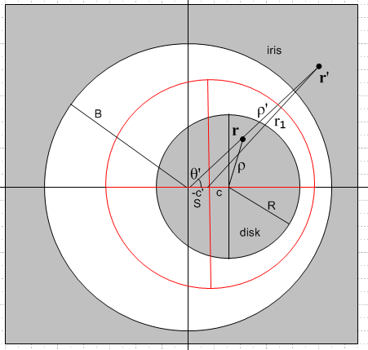

If the iris space has primed coordinates, the solution to this inversion problem, starting with the Jackson charged-disk potential quoted above, is as follows:

V'(r') = 2q1/(πr1) cos-1 [ $\sqrt{2}$B r1 / { $\sqrt{[ (ρ'-B)2+z'2] [ (ρ'+B)2+z'2]}$} ] (D.1)
where
m = (ρ'2+z'2)(S2-B2) + B2(B2- S2 + 2r12)
r12 = ρ'2 + S2 - 2Sρ'cosθ' + z'2 θ' = 0 in direction of the point charge

σ'(r') = - [ q1 / (2π2r12) ] $\sqrt{B2-S2}$ / $\sqrt{ρ'2-B2}$ // either side of the iris, z'=0 in r1 (D.2)

where q1 is the size of the point charge in the hole and B is the radius of the hole. The expression for σ' here is remarkably simple and only appears after considerable brute-force Maple algebra which secretly implements all those Kelvin geometry theorems.
In Problem 38 Smythe asks his reader to come up with σ' as shown above.
In Problem 39 he asks the reader to integrate the point charge problem around a circle, to obtain the charge density on the iris for a centered circular ring of charge in the hole. That result is still amazingly simple:

σ2(ρ) = - (q/2π2) ($\sqrt{B2-S2}$/ $\sqrt{ρ2 - B2}$) / (ρ2-S2) // either side (D.3)

where now we remove the primes, and q is the total charge on the ring in the hole.
In Problem 40 we are instructed to invert this grounded iris + ring charge in hole into a grounded bowl + ring charge on the cap (see first picture above).
Then in Problem 42 we do a weighted integral of this bowl-cum-ring situation to obtain a uniform charge density on the cap set to the target amount -σ0. This corresponds to Kelvin's first superposition described above. We then do Kelvin's second superposition and out pop all the charged bowl results.

Going back now, in Problem 40 Smythe tells his reader to use "Green's Reciprocation Theorem" to find the potential anywhere on the cap of a charged bowl of potential V0. This theorem concerns the charges and potentials on a set of conductors in two "situations", one primed and one unprimed, Σi Vi Qi' = Σi Vi' Qi. In our application here there are only two metal objects, one is the bowl, the other is an imagined fine wire in the location of the ring of charge on the bowl's cap. One situation is a charged bowl, the other is the bowl + ring-on-cap Green's function. One quickly finds that

V(θ) = V0(2/π)sin-1[cos(α/2)/cos(θ/2)], (D.4)

where θ and α are shown in our drawing above equation (4.10).
This result has great significance which is brought out in Problem 41. One now knows that V = V0 on the bowl, and V = V(θ) on the cap, so we have a fully prescribed Dirichlet problem and we can then obtain the potential everywhere by assuming an appropriate Smythian form and inverting to find the coefficients. For the exterior problem that atomic superposition is V(r,θ) = Σn=0∞ An r-n-1Pn(cosθ) and the usual Legendre inversion gives

An = Rn+1 (2n+1)(1/2) $^{\int_{0}^{π}{}}$Pn(cosθ) sinθ V(R,θ,φ) dθ = V0 Rn+1 (2n+1)(1/2)
{(2/π) $^{\int_{0}^{α}{}}$dθ sinθ Pn(cosθ) sin-1 [ cos(α/2) /cos(θ/2) ]) + $^{\int_{α}^{π}{}}$dθ sinθ Pn(cosθ) } (D.5)

where R is the radius of the bowl's sphere. We find that A0 = V0 (R/π) {π - α + sinα }. For large r, we have V → A0/r so A0 is in fact the total charge on the bowl as seen from far away, and we find that capacitance is C = R (1/π) {π - α + sinα }, a result quoted earlier in this document.

We close this appendix with a remark on a related problem which is the Green's Function problem for a disk with the point charge in the plane of (and outside) the disk. One can solve this disk Green's function problem using an inversion picture like this

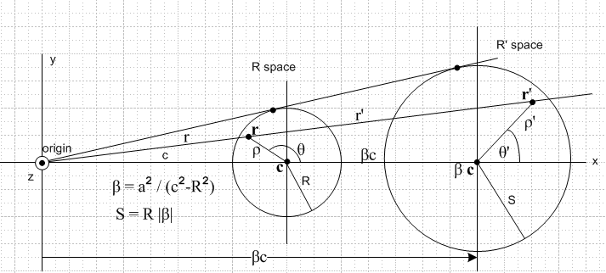

where R' space contains a charged disk, and R space holds our desired Green's function problem for the disk with point charge at the marked origin. Note that the point charge is distance c from the center of the grounded disk. When this problem is solved, one finds a striking resemblance between its solution and that of the grounded iris with point charge in the hole. We now compare these two problem solutions

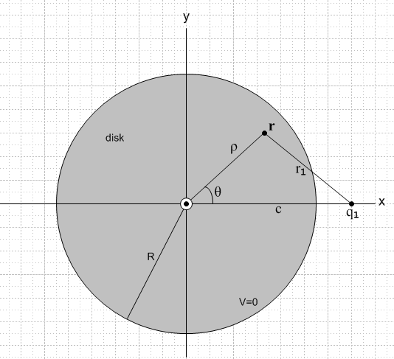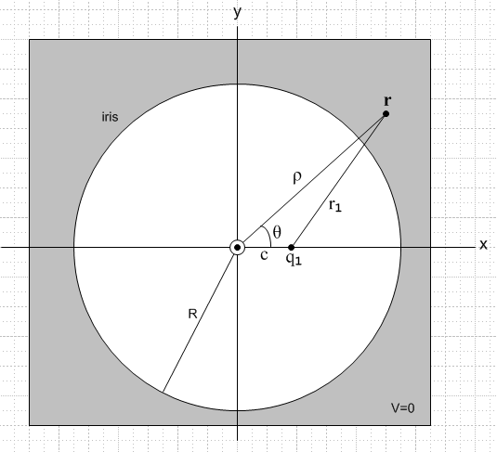
the disk problem the iris problem

Vdisk(ρ,θ,z) = q1 (2/πr1) cos-1 { $\sqrt{2}$R r1 / $\sqrt{[ (R-ρ)2 + z2] [ (R+ρ)2 + z2]}$ }
m = (ρ2+z2)(c2-R2) + R2(R2- c2 + 2r12)
r12 = ( ρ2 + c2 + z2 - 2cρ cosθ ) (D.6)

σdisk(r) = - q1(1/(2π2r12) $\sqrt{c2-R2}$/$\sqrt{R2-ρ2}$ // each side
r12 = ( ρ2 + c2 - 2cρ cosθ ) (D.7)

total charge induced on the disk = - q1 (2/π) tan-1(R/$\sqrt{c2-R2}$)

Viris(ρ,θ,z) = q1(2/πr1) cos-1 [ ($\sqrt{2}$Rr1 / $\sqrt{[ (ρ-R)2+z2] [ (ρ+R)2+z2]}$ ]
m = (ρ2+z2)(c2-R2) + R2(R2- c2 + 2r12)
r12 = ( ρ2 + c2 + z2 - 2cρ cosθ ) (D.8)

σiris(ρ,θ) = -q1[ 1/(2π2r12)] $\sqrt{R2-c2}$/ $\sqrt{ρ2 - R2}$ // each side
r12 = ( ρ2 + c2 - 2cρ cosθ ) (D.9)

total charge induced on the iris = -q1

It turns out that the two problems are related by analytic continuation of the variable ρ from ρ < R for the disk problem to ρ > R for the iris problem. The path going directly through ρ = R is blocked by a branch cut of f(ρ) = $\sqrt{(ρ-R)2 + z2}$ = $\sqrt{(ρ - a+)(ρ - a-)}$ = $\sqrt{ρ - a+}$$\sqrt{ρ - a–}$ joining the points a± = R ± iz, so one must continue around either of the branch points with the result that $\sqrt{(ρ-R)2 + z2}$ → – $\sqrt{(R-ρ)2 + z2}$, and this is the only difference in the disk and iris solution sets shown above.

References.

L. A. Ahlfors, Complex Analysis, 2nd Ed., ( McGraw-Hill, New York, 1966)

A. Erdelyi et. al, Higher Transcendental Functions, Volume I, (McGraw-Hill, New York, 1953). This is the 5-volume Bateman Manuscript project: Higher Transcendental Functions EH 1,2,3 and Tables of Integral Transforms ET 1,2.

I.S. Gradshteyn and I.M. Ryzhik, Table of Integrals, Series, and Products, 7th Ed ( Academic Press, New York, 2007). Editor Dan Zwillinger is collecting errata. (GR7)

H. Hu and R. G. Larson, " Evaporation of a Sessile Droplet on a Substrate", J. Phys. Chem. B 2002, 106, 1334-1344. Points out that 19th century toroidal potential theory has a role in DNA processing.

J.D. Jackson, Classical Electrodynamics, (Wiley, New York, 1962). This is the first edition with a green cover. Later editions (red 1975 and blue 1998 ) omit discussion of the inversion method to make room for more modern subjects.

E. W. Hobson, The Theory of Spherical and Ellipsoidal Harmonics, (Cambridge University Press, Cambridge, 1931). Chapter XI concerns ellipsoidal harmonics, about 50 pages. This approach seemed more readable than Chapter 23 of Whittaker and Watson's A Course of Modern Analysis, 4th Ed., (Cambridge University Press, Cambridge, 1927).

N. N. Lebedev, I. P. Skalskaya and Y. S. Uflyand, Worked Problems in Applied Mathematics, (Dover, New York, 1965). There are not many books like this one. In the first half of the book, 566 problems requiring various mathematical techniques from various fields of physics and engineering are presented with hints as to their solution, and in the second half a subset of these problems is solved (but not those discussed in the present paper).

Maple (Maplesoft), a computer algebra system, today officially Maple 14. See wiki for comments about Maple's history versus Mathematica and other systems.

K. T. McDonald, "Conducting Spherical Shell with a Circular Orifice", PDF file downloadable from his Princeton website. This paper discusses the bowl problem in several ways, and reviews some of Kelvin's papers noted above. The current paper tries to fill in Section 2.5 of this document.

P. Moon and D. E. Spencer, Field Theory Handbook, Including Coordinate Systems, Differential Equations and their Solutions (Springer-Verlag, Berlin, 1961). This book is not about quantum field theory or anything like that, it is about curvilinear coordinate systems, how the Laplace and Helmholtz equations appear in each system, and what the solutions of these equations look like. This husband and wife team wrote several excellent books. They were strangely involved in an accident involving a test of general relativity.

P. M. Morse and H. Feshbach, Methods of Theoretical Physics, ( McGraw-Hill, New York, 1953). This 2000 page behemoth is simply amazing.

F. Oberhettinger and T. P. Higgins, Tables of Lebedev, Mehler and Generalized Mehler Transforms, (Boeing Scientific Research Laboratories, Mathematical No. 246, 1961). This 48 page monograph has about 16 transforms per page. The first author is a member of Erdelyi et. al.

A. P. Prudnikov, Y. A. Brychkov and O. I. Marichev, Integrals and Series: More Special Functions, Vol 3 (Gordon and Breach, New York, 1996). A huge 5 volume set similar to the Bateman / Erdelyi set, but much larger in scope. The Russian editions are perhaps more available and can easily be used by non-Russian readers. (PBM)

W. R. Smythe, Static and Dynamic Electricity, 2nd Ed. ( McGraw-Hill, New York, 1950).

I. Sneddon, Mixed Boundary Value Problems in Potential Theory, (Wiley, New York, 1966). This book treats dual and triple integral and series equations with examples from electrostatics. A lot of output is obtained from basic Abel and Hankel type transforms and infinite triangular matrices.

W. Thomson (aka Lord Kelvin), Reprint of Papers on Electrostatics and Magnetism, 2nd. Ed., (Macmillan, London, 1884). As are several other items in this Reference list, this out-of-print book is available on the web (this one "Digitized by Microsoft"). Converting PDF to DJVU makes things smaller and faster and maintains searchability. The first paper "On the uniform motion of heat..." (1842) treats the potential theory of ellipsoids and includes an interesting opening footnote regarding George Green. Paper XV "Determination of the distribution..." (1869) concerns spherical bowls. This is his famous application of the method of inversion. Another paper is entitled "On some remarkable effects of lightning observed in a farmhouse near Monimail".

