Potential of Half Spherical Shell (v1) PhL started 10.15.09

(9.28.10) This is a failed attempt to solve the charged half-sphere bowl problem using the Stakgold integral equation method ∫σ E(s|ξ)I(ξ)dSξ=1. I tried to imitate the way this method is applied to solve the full sphere problem, but I took a bad turn along the way which led to my Legendre My Problem doc sequence. I then found the problem solved in the Canonical pdf.

These notes relate to Stakgold Volume II Chapter on potential theory, specifically I wrote these notes after studying the following Stakgold book section (before doing the examples)

A. Charged Conductor and Electrostatic Capacity (171)

I think the solid metal sphere is done OK here, but when I casually tried to apply the same method to the half shell of a sphere, something went wrong. Since I try to mimic the full sphere method, I have included those notes here first, to set an example.

Overview ( 9.25.10, 6 pages) 1
A. Review of the Full Charged Spherical Shell Problem 6
B. Attempt of the Half Charged Spherical Shell Problem ("bowl") 8
C. Let's now do cases A and B "side by side" 10
1-7. Derive Σ_{n} P_{n}(z_{s}) I_{n} = 2 for sphere and half sphere, verify full sphere. 10
7a. Make the (incorrect) assumption that $^{\int_{0}^{1}{}}$ dx P_{n}(x) I(x) = δ_{n0} for the half sphere. 12
This is Legendre My Problem. 12
8. Apply $^{\int_{0}^{1}{}}$dz_{s} P_{m}(z_{s}) to get a Matrix Equation R I = R₁ for I_{n.} 13
9. Try expanding P_{n}(z) and I(z) on complete φ_{n} defined on (0,1) 15
10. Try some simple delta-function forms for I(z) 18
11. Search on line for solution to the half sphere problem. 20
12. Discovery of the Canonical PDF (10.31.09) 20
13. Test this Canonical solution. 23
Obsolete old notes 29

__________________________________________________________________________________

Overview ( 9.25.10, 6 pages)

In Part A I treat the full metal shell using the Stak's "integral equation method": ∫σ E(s|ξ)I(ξ)dSξ=1 for s on the spherical shell, an integral equation to solve for charge density here called I, V = 1 on the shell. Here are the steps:

∫σ E(s|ξ)I(ξ)dSξ=1 // starting position
E(s|ξ) = 1/4πR = (1/4π) Σn' Pn'(cosγ) // expand 1/R on Legendres
(1/4π) Σn'∫dΩξ Pn'(cosγ) I(Ωξ) = 1 // insert into the above, I dep on Ωξ
(1/4π) ∫dΩξ { Σn" N0n" Σm" (1/Nm"n") Yn"m"(Ωξ) Y*n"m"(Ωs)} I(Ωξ) = 1 // expand Pn'
(1/4π) ∫dΩξ Σn" N0n" Σm" (1/Nm"n") [δnn"δmm" Nnm] Yn"m"(Ωξ) I(Ωs) = 4π δn0δm0 (*)
// apply ∫dΩs Ynm(Ωs) to both sides, use orthog on each side
∫dΩξ Ynm(Ωξ) I(Ωξ) ≡ Nmn Imn // define projections Imn of I(Ω)
2π ∫dzξ Yn0(zξ) I(zξ) ≡ N0n I0n // only non-zero Imn values
I(Ω) = Σmn ImnYnm(Ω) // corresponding expansion

(2n+1)-1 [Nmn Imn] = 4π δn0δm0 // just rewrite (*) in terms of Imn
Imn = 4π δn0δm0 (2n+1)/Nmn = δn0δm0 4π/N00 = δn0δm0 // solve for Imn
I(Ω) = Σmn ImnYnm(Ω) = Y00 = 1 // do inverse transform to get I

Basically, we do the full Y-Y expansion of 1/R in sphericals (using Stak's Y), we expand I(Ω) on the Y's, we use orthogonality of the Y's, and we end up with Imn = δn0δm0 and then I(Ω) = 1. Not rocket science really. This is really just an SO(3) diagonalization, because we had a full dΩ SO(3) integration.

In Part B I naively try to use this same method for a bowl that is a half-spherical shell. I mimic the above sequence of steps, but I get to this point,

(1/4π) ∫σ dΩξ { Σn" N0n" Σm" (1/Nm"n") Yn"m"(Ωξ) Y*n"m"(Ωs) } I(Ωξ) = 1 = f(s)

I note correctly that (1) the integral dΩξ is only over the upper half shell, but since you know I(Ω)=0 on the lower half shell, you could regard dΩξ as a full sphere integral; (2) the equation is only valid when Ωs is on the upper half shell. Due to (2), you cannot apply full ∫dΩs Ynm(Ωs) to both sides of this equation!!! If you apply ∫upper half dΩs Ynm(Ωs) to both sides, then you cannot use orthogonality. You can define ∫upper half dΩ' Ynm(Ω') I(Ω') ≡ Nmn I'mn for this problem. Since you know I(Ω) = 0 (no charge density in open space) on the lower half, you could conclude that I'mn = Imn of Part A. At this point I have nowhere to go and I am confused. I make a few claims which I shall ignore for now because I am going to start over in the next Part!

In Part C I start over again doing Parts A and B "side by side", and I try to do this carefully in a numbered set of steps:

1-7. Derive Σn Pn(zs) In = 2 for sphere and half sphere, verify full sphere.

1. Write the Stak integral equation for both cases.
2. Install our 1/R expansion for 1/|ξ-s| .
3. In the resulting Stak equation, interchange order Σnm with ∫σ dΩξ .
4. Use result that I = I(Ω) so we end up only with Yn0(Ωξ) in our integrands.
5. At this point, write results in terms of the P functions and we have then:

(1/2) Σn Pn(zs) $^{\int_{-1}^{1}{}}$ dzξ Pn(zξ) I(zξ) = 1 whole sphere valid (-1,1) for zs
(1/2) Σn Pn(zs) $^{\int_{0}^{1}{}}$ dzξ Pn(zξ) I'(zξ) = 1 half sphere valid (0,1) for zs

Since we know the solutions of these two problems will have different I(Ω), I distinguish them now by putting a prime on I for the second problem. Assuming I' = 0 on the lower half in the second case, as discussed at the end of Part B, we can rewrite the above equations so they are exactly the same, though validity ranges are not the same:

(1/2) Σn Pn(zs) $^{\int_{-1}^{1}{}}$ dzξ Pn(zξ) I(zξ) = 1 whole sphere valid (-1,1) for zs
(1/2) Σn Pn(zs) $^{\int_{-1}^{1}{}}$ dzξ Pn(zξ) I'(zξ) = 1 half sphere valid (0,1) for zs

6. We can regard the z integrals shown as the In projections in each case, so we then have

Σn Pn(zs) In = 2 whole sphere valid (-1,1) for zs
Σn Pn(zs) I'n = 2 half sphere valid (0,1) for zs

I observe that In = 2 δn,0 is in fact a solution of either equation. For the full sphere case, I show using the usual P transform that if In = 2 δn,0, you end up with I(θ) = 1 for all θ, which is correct. But we can apply the same argument to the second problem and we find I'(θ) = 1 for all θ which we know is wrong, because we just assumed I'(θ) = 0 on the lower half a few lines above. I conclude that the second problem must have some other solution I'n which differs from In' = 2 δn, and which yields I'(θ) = 0 on the lower half. But I have no idea at this point how to find this solution. [ You can think of Σn Pn(zs) I'n = P • I' and knowledge of this dot product and P does not determine a unique I' ]

Comment added: The half shell problem has some definite V on the lower half sphere, but we don't know what it is. Imagine this "correct V on lower half" is one entry in a list of a million candidate prescribed potentials for the lower half that we add to our V = 1 prescription on the upper half. We then have a million valid Dirichlet problems [ a million interior ones, and a million exterior ones] . As we vary this unknown lower potential through this list, the condition above that Σn Pn(zs) In' = 2 for zs in (0,1) will always remain true! For each list candidate, there will be some solution In' which makes this true, and also gives the candidate prescribed potential on the lower half. The particular solution In' = 2 δn,0 is only the correct solution where the candidate potential on the lower half is the same constant as on the top half! Our equation Σn Pn(zs) In' = 2 for zs in (0,1) must therefore have some other solution [ ie, other than 2 δn,0 ] for our half shell problem! The solution to Σn Pn(zs) In' = 2 is not unique, but is different for each of our million Dirichlet problems. Of course only 1 of these million solutions In' causes I'(θ) = 0 on the lower half sphere, and this is then the solution to our problem. [ That is to say, when you use the "correct" lower sphere prescribed potential and solve the interior and exterior Dirichlet problems, you will find that the radial derivative of the potential has no jump across the lower sphere surface. ] This just says that if you solve only one of a pair of dual integral (or dual series) equations, the solution is not unique and you have not solved the problem!

Another commented added: Now Σn Pn(zs) In' = 2 can be regarded symbolically as ∫dn Pn(zs) I'(n) = 2 which we would call an "integral equation" for function I'(n). Write as ∫dn k(n',zs) I'(n) = f(zs) = 2 which we rewrite as K I' = f = 2. This is a first kind Fred. I conjecture that the boundary conditions on the function I'(n) are not fully determined, and that is why this Fred 1 equation does not have a unique solution. We shall return to this subject below, but in θ space rather than n space. [ I like my dot product argument given above better. ]

7. Here I make use of that fact that (5a) above is valid for the full range of zs so I can use orthogonality to find that In = 2 δn,0 and then I(θ) = 1. Ie, this for the full sphere.

7A. Make the (incorrect) assumption that $^{\int_{0}^{1}{}}$ dx Pn(x) I(x) = δn0 for the half sphere. Let's look again at our two projection definitions for our two problems:

In = $^{\int_{-1}^{1}{}}$ dzξ Pn(zξ) I(zξ)
In' = $^{\int_{0}^{1}{}}$ dzξ Pn(zξ) I'(zξ)

If we assume (wrongly) that 2 δn,0 is the correct solution for both problems, we then have

$^{\int_{-1}^{1}{}}$ dzξ Pn(zξ) I(zξ) = 2 δn,0 full sphere problem
$^{\int_{0}^{1}{}}$ dzξ Pn(zξ) I'(zξ) = 2 δn,0 half sphere problem

We can see at once that I(zξ) = 1 on full range of zξ solves the first equation set, since we can just use the orthogonality of the Pn functions. But we are forced to wonder: is there some function I'(zξ) defined on the upper half sphere that satisfies the second equation set? We write this equation as two equations, dropping the prime for now, and changing to generic variable x:

$^{\int_{0}^{1}{}}$ dx I(x) = 2
$^{\int_{0}^{1}{}}$ dx Pn(x) I(x) = 0 n = 1,2,3.... // ie $^{\int_{0}^{1}{}}$ dx Pn(x) I(x) = δn0

If we could find a solution I(x) defined on x in (0,1) that works in the above equation set, then that I(x) = I'(zξ) would be the solution to our problem, and it would have projections In' = 2 δn,0. So at this point, I sort of reformulated the half-sphere problem as a "search" for a function I(x) solving the above equations. It is clear that I(x) = 2 solves the first equation, but not the others, since the half range integrals of Pn are not all 0 certainly. So any solution I(x) must not be a constant. In addition to work below, I carried out this search in some docs entitled "Legendre my problem XXX .doc" stored in the Stakgold folder. My conclusion reached there after many attempted solutions is that no such function I(x) exists which solves the above equations! [ See the last META doc in this series for a good summary of things. ]

8. Apply $^{\int_{0}^{1}{}}$dzs Pm(zs) to get a Matrix Equation for In . Here (just as I do later in Legendre My Problem vol 2 Section 6) I validly apply $^{\int_{0}^{1}{}}$dzs Pm(zs) to both sides of my equation Σn Pn(zs) $^{\int_{0}^{1}{}}$ dx Pn(x) I(x) = Σn Pn(zs) In = 2, and this leads to a matrix equation which one might solve for the "vector" In. In a note I added today 9.25.10, I observe that this matrix equation is R I = R1 where Rnm ≡ $^{\int_{β}^{1}{}}$dzs Pm(zs)Pn(zs), and that, when β ≠ -1, I conjecture that detR = 0 and that this equation can have solutions for In other than the known solution In = δn0.
But then I continue on assuming that the solution has to be In = δn0 (ignoring factor 2), and I then take a stab at solving the equation $^{\int_{0}^{1}{}}$dx Pn(x)I(θ) = 2 δn,0.
I use φn(x) = (2n+1)1/2 Pn(-1+2x) as a bona fide complete set on (0,1). I then (strangely) expand φn(x) = Σm=0∞ knm Pm(x). [ In light of what I learned very much later in Leg My Prob vol 2 part II Theorem 1A, this is an "existent" series since the Pm form a complete set an in interval that encloses (0,1).] I turn the crank some more and I find this series as my "solution": I(θ) =2 Σn=0∞ kn0 φn(cosθ) . But I find that the coefficients kn0 (known and calculable) seem to diverge as n increases, suggesting that this method is not generating a solution and maybe there is no solution ! I defer further study of this method.

9. Try expanding Pn(z) and I(z) on complete φn defined on (0,1). Here I repeat the above work but in a perhaps more logical manner, using Pn(x) = Σm=0∞ cnm φm(x) in the range (0,1). [I return later to this exact same approach in Legendre My Problem vol 1 Section 6 which is called "Plan C". ] I then find the solution series to be I(x) = Σn=0N Jn φn(x) and I do a few Maple plots and I think maybe this is some kind of unpleasant "distribution", I(x) does not seem like a normal function.

10. Try some simple delta-function forms for I(z). Here I try a few delta-function distribution combinations, blindly searching for a simple solution to $^{\int_{0}^{1}{}}$ dx Pn(x) I(x) = δn0 (later to get the name Legendre My Problem). I even try some differential operators L0 applied to distributions as possible solutions. I get nowhere doing this. My reason for trying deltas is that in the previous section, it seemed that I(x) was some kind of distribution.

11. Search on line for solution to the half sphere problem. I throw up my hands, I cannot solve
∫σ E(s|ξ)I(ξ)dSξ = 1, I decide the time has come to look up the solution of the half sphere "in the literature". Up to this point, I was trying to do it all on my own!

12. Discovery of the Canonical PDF. At this point I discover and download the Russian "Canonical" pdf which contains this problem. I am pretty excited to find the solution somewhere! I do not at this point fully trace the solution, but I am able to derive the "dual series equations" from a general Smythian form for V in terms of some an coefficients. I then quote the result for the an and for σ = I = g for the general bowl. Note that the an are for the potential, they are not the σn I have been messing with above. I set θ0 = π/2 for the half sphere and simplify the results. I seem to find in this case that σ(z) = (2/π)1/$\sqrt{z}$ but I have never studied this result.

13. Test this Canonical solution. Given this expression for I = σ, and still assuming $^{\int_{0}^{1}{}}$ dx Pn(x) I(x) = δn0, it is pretty clear that we are not going to get $^{\int_{0}^{1}{}}$dx Pn(x)/$\sqrt{x}$ = 0 for n = 1,2,3... . This increased my doubts about this δn0 result even more. I formally conclude (bold letters) that the δn0 result must in fact be wrong.
I then again consider Σn Pn(zs) In = 2 where In = $^{\int_{0}^{1}{}}$ dzξ Pn(zξ) I(zξ). Since I(z) = (2/π)/$\sqrt{z}$ according to Canonical, I should be able to compute the In and add up the series and it should sum to 2 for any value of zs in the range (0,1). I have Maple do this for the first 50 terms. The sum is reasonably constant, varying from 2.2 to 2.5 for 10 equally spaced values of zs , but the number seems to be the wrong number. For the time being, I decided to let that discrepancy ride.
Next, I rederive Σn Pn(zs) [$^{\int_{0}^{1}{}}$dx Pn(x) I(x) ] = 2 for the umpteenth time, and I write it in the alternate obvious form which is $^{\int_{0}^{1}{}}$dx [(1/2)Σn Pn(zs)Pn(x)] I(x) = 1 and I am happy to see that this also appears in the Canonical doc, where the bracket thing is called k(zs,x). Remember that I am still uncertain about the δn0 equation. I wondered perhaps for the first time if my stuff=2 equation was wrong due to an illegal order interchange of sum and integral.
I next insert their I(z) = (2/π)1/$\sqrt{z}$and tell Maple to try to verify $^{\int_{0}^{1}{}}$ dx (1/$\sqrt{x}$) Σn Pn(z) Pn(x) = π. With 20 terms in the Σn the LHS is very non constant, but with 50 terms it is fairly constant again with my value of about 2.5, not π. Even today 9.25.10 I don't know what is going on here.
I then ponder the nature of the kernel Σn=0∞ Pn(z) Pn(x). I try to plot it, and I conclude without proof that " the sum Σn=0∞ Pn(z) Pn(x) is in fact a distribution, similar to Σn=0∞ (n+1/2) Pn(z) Pn(x)." At this point, I finally give up and cease and desist. But of course this just means I went to the v2 document.
[in v2, I show that Σn=0∞ Pn(z) Pn(x) may be a perfectly reasonable non-distributional type function! ]

Notes in blue at the end: First 6" is nothing. In fact the whole blue section looks pretty trashy, so I will just ignore it. It does things I have already done, probably these were obs notes before I rewrote certain sections.
_________________________________________________________________________________

A. Review of the Full Charged Spherical Shell Problem

This is a closed surface and we are interested in the exterior problem. The integral equation is this, where we are simply computing the potential by superposition and setting it arbitrarily to u = 1 on the surface:

∫σ E(s|ξ)I(ξ)dSξ = 1 s and ξ are points on the spherical shell of radius 1

E(s|ξ) = 1/4πR = (1/4π) Σn' Pn'(cosγ) γ is the angle between our two rays (r = 1)

Put point ξ at Ω' and put point s at Ω. Then we have

(1/4π) Σn'∫dΩ' Pn'(cosγ) I(Ω') = 1

Install the full Y expansion to get this saying

(1/4π) ∫dΩ' { Σn" N0n" Σm" (1/Nm"n") Yn"m"(Ω') Y*n"m"(Ω)} I(Ω') = 1 // see p 126

Now apply ∫dΩ Ynm(Ω) to both sides. The RHS is then ∫dΩ Ynm(Ω) Y*00(Ω) since in Stak norm we have Y00= 1. On page 395 this integral is δn0δm0 N00 = 4π δn0δm0.

The LHS has ∫dΩ Ynm(Ω) Y*n"m"(Ω) = δnn"δmm" Nnm so we get

(1/4π) ∫dΩ' Σn" N0n" Σm" (1/Nm"n") [δnn"δmm" Nnm] Yn"m"(Ω') I(Ω') = 4π δn0δm0.

(1/4π) ∫dΩ' N0n (1/Nmn) [Nnm] Ynm(Ω') I(Ω') = 4π δn0δm0.

(1/4π) ∫dΩ' (4π/(2n+1)) Ynm(Ω') I(Ω') = 4π δn0δm0.

(2n+1)-1 ∫dΩ' Ynm(Ω') I(Ω') = 4π δn0δm0.

(2n+1)-1 [Nmn Imn] = 4π δn0δm0. // using p 396 A.6 projection

From this we conclude that

Imn = 4π δn0δm0 (2n+1)/Nmn = δn0δm0 4π/N00 = δn0δm0

Then we have found that

I(Ω) = Σmn ImnYnm(Ω) = Y00 = 1.

So we have now "solved our integral equation" and we find that I(Ω) = 1. We can then normalize this so that the total charge on the sphere is Q'. Just going through the steps here.

B. Attempt of the Half Charged Spherical Shell Problem ("bowl")

By wandering off trying to do something "on my own", I got in big trouble here. I wandered in the wilderness and not only could not solve this problem, but opened more cans of worms. See conclusions at the end of this little section. But I can't always just stay on the beaten path. I did learn more about Maple and got to review some earlier Stakgold ODE facts for Legendre.

So here is how I thought I was solving this half-shell problem. Let's just try to mimic the steps above as used for the full sphere.

Part 1: Set things up.

The thin half-shell is treated as an "open surface".

∫σ E(s|ξ)I(ξ)dSξ = 1 s and ξ are points on the spherical half shell of radius 1

where now I(ξ) is the sum of the charge densities on the two sides of our thin half-shell.

E(s|ξ) = 1/4πR = (1/4π) Σn' Pn'(cosγ) γ is the angle between our two rays

Put point ξ at Ω' and put point s at Ω. Then we have

(1/4π) Σn'∫σ dΩ' Pn'(cosγ) I(Ω') = 1 where now ∫σ dΩ' is not a full 4π integral!

Install the full Y expansion to get

(1/4π) ∫σ dΩ' { Σn" N0n" Σm" (1/Nm"n") Yn"m"(Ω') Y*n"m"(Ω) } I(Ω') = 1 // p 126 (*)

Now apply full ∫dΩ Ynm(Ω) to both sides.

STOP!! Let's rewrite (*) this way

(1/4π) ∫σ dΩξ { Σn" N0n" Σm" (1/Nm"n") Yn"m"(Ωξ) Y*n"m"(Ωs) } I(Ωξ) = 1 = f(s)

where integral ∫σ dΩξ is only over the upper half sphere and
where the equation is valid ONLY when s ~ Ω lie on the upper half sphere.

This equation is only valid for point s on the upper half sphere, because that is the surface on which our integral equation is forcing self-consistency. So it is only valid for Ωs on the upper half sphere. It is NOT valid for s on the lower half sphere. Therefore, you cannot apply full ∫dΩ Ynm(Ω) to both sides of this equation!!! If you assume the equation is true on the lower half sphere as well, then you are doing the problem of the full sphere, which we have already done and found I = constant.
The most you can do, if you want, is apply ∫upper half dΩs Ynm(Ωs) to both sides, but then of course you cannot use full Y orthogonality.
Before realizing this STOP!! fact, I ended up getting the I = constant contradiction for the half sphere, so I am now going to delete notes on that subject below since they are resolved.

Here then is what we have so far: [ σ refers to the surface of the half-sphere ]

(1/4π) ∫σ=uhs dΩξ { Σn" N0n" Σm" (1/Nm"n") Yn"m"(Ωξ) Y*n"m"(Ωs) } I(Ωξ) = 1

(1/4π) Σn" N0n" Σm" (1/Nm"n") Y*n"m"(Ωs) { ∫σ=uhs dΩξ Yn"m"(Ωξ) I(Ωξ) } = 1

I will define the projection of I in the standard way as in A.6.

In"m" Nn"m" = ∫σ dΩξ Yn"m"(Ωξ) I(Ωξ) = ∫σ=uhs dΩξ Yn"m"(Ωξ) I(Ωξ)

WARNING: This is a "standard projection" (left =) only if we assume I(Ωξ) = 0 on the bottom half of the sphere. I think this is a reasonable thing to assume since I is the discontinuity of ∂nu. However, to avoid a possible error, let's agree here to just DEFINE Inm by the right =. Let's not assume it is a "standard" projection. We shall then make no assumptions whatsoever about I(Ωξ) at locations other than on σ.

Defining Inm in this way, we get

(1/4π) Σn" N0n" Σm" (1/Nm"n") Y*n"m"(Ωs) In"m" Nn"m" = 1

(1/4π) Σn" N0n" Σm" Y*n"m"(Ωs) In"m" = 1

But let's go ahead now and assume I(Ωξ) has no azimuth dependence. Then we know

Inm Nnm = ∫σ=uhs dΩξ Ynm(Ωξ) I(Ωξ) = δm,0 In0Nn0 = 2π δm,0 $^{\int_{0}^{1}{}}$dz Pn(z) I(θ)

In0 = (2π/ Nn0) $^{\int_{0}^{1}{}}$dz Pn(z) I(θ)

Our integral equation, which started as ∫σ E(s|ξ)I(ξ)dSξ = 1, is now

(1/4π) Σn N0n Pn(cosθs) In0 = 1 // valid only for s on the half sphere ???

Σn=0 In Pn(z)/ (2n+1) = 1 In = In0 valid only for 0 ≤ z ≤ 1

COMMENT: Right at this point we are dead meat! The solution is I0 = 1 and In = 0, and Maple of course confirms that below. So something is WRONG with this equation, no need to go below the line below .

This solution of course makes the equation also be true for θs on the lower sphere half, and then we might as well have started with the full sphere integral equation.

C. Let's now do cases A and B "side by side"

Do it all again, comparing whole sphere to half sphere, maybe that will bring out my error.

1-7. Derive Σn Pn(zs) In = 2 for sphere and half sphere, verify full sphere.

1. We start with the integral equation:

∫σ E(s|ξ)I(ξ)dSξ = 1 σ = whole sphere
∫σ E(s|ξ)I(ξ)dSξ = 1 σ = half sphere

2. We install the YY expansion for 1/R which I believe is true for two points ξ and s on the sphere:

1/|ξ-s| = Σn N0n Σm (1/Nmn) Ynm(Ωξ) Y*nm(Ωs) p 126 A

This is the same for either problem. It's just that in the half sphere problem, we will only apply it for point pairs on the upper half-sphere. So we now have [ dSξ = r2 dΩξ = dΩξ ]

(1/4π) ∫σ dΩξ { Σn N0n Σm (1/Nmn) Ynm(Ωξ) Y*nm(Ωs) } I(Ωξ) = 1 σ = whole sphere

(1/4π) ∫σ dΩξ { Σn N0n Σm (1/Nmn) Ynm(Ωξ) Y*nm(Ωs) } I(Ωξ) = 1 σ = half sphere

3. Now we change order of integration dΩξ and the summations m and n to get

(1/4π) Σn N0n Σm (1/Nmn) Y*nm(Ωs) ∫σ dΩξ Ynm(Ωξ) I(Ωξ) = 1 σ = whole
(1/4π) Σn N0n Σm (1/Nmn) Y*nm(Ωs) ∫σ dΩξ Ynm(Ωξ) I(Ωξ) = 1 σ = half

4. Now we assume I(Ωξ) = indep of φξ , which is the correct symmetry axis, to get

(1/4π) Σn N0n(1/N0n) Y*n0(Ωs) ∫σ dΩξ Yn0(Ωξ) I(Ωξ) = 1 σ = whole
(1/4π) Σn N0n(1/N0n) Y*n0(Ωs) ∫σ dΩξ Yn0(Ωξ) I(Ωξ) = 1 σ = half

5. We can just write in our P functions at this point: and do ∫σ dΩξ = ∫dzξdφξ = 2π ∫dzξ and cancel the N0n matching factors:

(1/2) Σn Pn(zs) $^{\int_{-1}^{1}{}}$ dzξ Pn(zξ) I(zξ) = 1 whole sphere valid (-1,1) for zs
(1/2) Σn Pn(zs) $^{\int_{0}^{1}{}}$ dzξ Pn(zξ) I(zξ) = 1 half sphere valid (0,1) for zs

These appear to be different equations, which we like to see. Now move factor 1/2 and use zξ = x:

Σn Pn(zs) $^{\int_{-1}^{1}{}}$ dx Pn(x) I(x) = 2 whole sphere valid (-1,1) for zs (5a)
Σn Pn(zs) $^{\int_{0}^{1}{}}$ dx Pn(x) I(x) = 2 half sphere valid (0,1) for zs (5b)

These are two distinct "integral equations" and we expect them to have different solutions I(x).

6. If we DEFINE projections by the integrals shown here, we restate the above as

Σn Pn(zs) In(whole) = 2 whole sphere valid (-1,1) for zs
Σn Pn(zs) In(half) = 2 half sphere valid (0,1) for zs

At this point, our two equations look very close, so you wonder how they could have different solutions. In either equation, the obvious solution is I0 = 2 and In = 0 for n>0.
For the first equation, we can use the theory of the complete Legendre poly set which says:

f(θ) = Σn fn Pn(cosz) fn = (2n+1)/2 $^{\int_{-1}^{1}{}}$ dx Pn(x) f(θ)

f(θ) = Σn (n+1/2) Fn Pn(cosz) Fn = $^{\int_{-1}^{1}{}}$ dx Pn(x) f(θ)

So finding In(whole) = δn,0 2 we conclude that I(whole)(θ) = (1/2)*2 = 1, which agrees with our previous solution of the whole sphere problem above.

But what corresponding thing can we say for the second equation? We have no "expansion theorem" for the half sphere problem, so the above line is NOT true for the half sphere. [ Wrong! The expansion theorem is still valid. The problem is that if we assume In(half) = δn,0 2, this valid expansion theorem tells us that I(half)(θ) = 1 for all θ, and we know this is wrong for the half problem. Thus, In(half) = δn,0 2 must be "the wrong solution" for the half problem, though it is certainly a solution. ]
So let's continue along:

7. For the whole sphere equation, we can apply $^{\int_{-1}^{1}{}}$dzs Pm(zs) to (5a) and use orthog to get

Σn $^{\int_{-1}^{1}{}}$dzs Pm(zs) Pn(zs) $^{\int_{-1}^{1}{}}$ dx Pn(x) I(x) = 2$^{\int_{-1}^{1}{}}$dzs Pm(zs)

Σn δn,m 2/(2n+1) $^{\int_{-1}^{1}{}}$ dx Pn(x) I(x) = 2 δm,0 2

2/(2m+1) $^{\int_{-1}^{1}{}}$ dx Pm(x) I(x) = 2 δm,0 2

$^{\int_{-1}^{1}{}}$ dx Pm(x) I(x) = 2 δm,0

If we try our known solution I(x) = 1, this last equation is true. We just replicated the above.

7a. Make the (incorrect) assumption that $^{\int_{0}^{1}{}}$ dx Pn(x) I(x) = δn0 for the half sphere.

This is Legendre My Problem.

Go back to our half-sphere situation

Σn Pn(zs) In(half) = 2 half sphere valid (0,1) for zs

$^{\int_{0}^{1}{}}$ dx Pn(x) I(x) = In(half) // this is the definition of In(half) shown in (5b)

Now let's "try out" the candidate solution Im(half) = 2δm,0. We then have these equations

$^{\int_{0}^{1}{}}$ dx I(x) = 2
$^{\int_{0}^{1}{}}$ dx Pn(x) I(x) = 0 for n = 1,2,3....

and this does seem to take us back to our original disaster in "Legendre my problem.doc", except I now have a 2 instead of a 1 in the first RHS. This constant is arbitrary anyway since once we solve the problem, we have to scale so that first integral above is Q.

8. Apply $^{\int_{0}^{1}{}}$dzs Pm(zs) to get a Matrix Equation R I = R1 for In.

Now go back to the half-sphere integral equation (5b),

Σn Pn(zs) $^{\int_{0}^{1}{}}$ dx Pn(x) I(x) = 2 half sphere valid (0,1) for zs

We can certainly apply $^{\int_{0}^{1}{}}$dzs Pm(zs) to both sides if we like,

Σn $^{\int_{0}^{1}{}}$dzs Pm(zs)Pn(zs) $^{\int_{0}^{1}{}}$ dx Pn(x) I(x) = 2$^{\int_{0}^{1}{}}$dzs Pm(zs)

If we make some obvious definitions, this says

Σn Rmn { $^{\int_{0}^{1}{}}$ dx Pn(x) I(x) } = 2 Rm1 Rmn ≡ $^{\int_{0}^{1}{}}$dzs Pm(zs)Pn(zs)

We can certainly define the integral {} to be In for this problem, and we then have

Σn=0∞ RmnIn = 2Rm1 R I = 2 C solution I = 2 1 !

where C is the first column of the matrix R. This seems to give a matrix equation one could solve for I.

I = 2 R-1C

But I think this is just going to tell us what we already know, that In = δn,0 2.
_________________________________________________________________________________

Note: I "rediscovered" the above matrix equation in Legendre My Problem, vol 2, Section 6.

Note Added 9.25.10. Rescaling I by a factor of 2, the matrix equation above is R I = R1 = R1. It is true that the equation R I = R1 has a solution I = 1. The real question is: are there perhaps other solutions? If detR ≠ 0, then we have I = R-1R1 = 1 as the only solution. But suppose det R = 0. Then we ask whether the equation R ( I - 1) = 0 has a solution other than ( I - 1) = 0. One way to state the answer is that there can be other solutions ( I - 1) ≠ 0 if the operator (matrix) R has a non-trivial nullspace! Then R J = 0 has solutions J ≠ 0. Matrix R has a nullspace if it is less than full rank. This of course would also mean that detR = 0. My conclusion (no proof) is that the matrix Rnm ≡ $^{\int_{β}^{1}{}}$dzs Pm(zs)Pn(zs) with β ≠ -1 is in fact a matrix of less than full rank, and this means det R = 0, and that means other solutions I are possible. Perhaps the dimension of the nullspace is 1 and there is only one "other solution". In the special case that β = -1, we have Rnm ~ δnm so R ~ 1 and this matrix does have full rank and has det R ≠ 0, so when β = -1, the only solution is I = 1. For β ≠ -1, I don't offhand know how you would prove that det R = 0 or that R has less than full rank. R is a matrix with discrete indices but is of infinite dimension. I am more used to having continuous indices for an infinite dimensional matrix, as with the kernel of an integral equation k(x,y). I have never wondered about det k in this case, since this differs from the usual Fredholm determinant. My proof would have to be indirect, perhaps by finding an explicit solution for In. If you solve the charged bowl problem, you will then have your In , and you will then have shown that det R = 0.
___________________________________________________________________________________

The real problem we have is how to construct I(θ) given that In = δn,0 2 . We need some kind of expansion theorem. Here is a candidate expansion theorem for (0,1) taken from below:

fn = $^{\int_{0}^{1}{}}$dx φn(x)f(x) f(x) = Σn=0∞fnφn(x) x = cosθ

where

φn(x) = (2n+1)1/2 Pn(-1+2x) φ0(x) = P0(-1+2x) = 1

$^{\int_{0}^{1}{}}$dx φn(x)φm(x) = δn,m δ(x-y) = Σn φn(x)φm(y)

But the projection WE are dealing with is this:

In = $^{\int_{0}^{1}{}}$dx Pn(x)I(θ) = 2 δn,0

which is not the right expansion for this proposed expansion theorem which wants to see

Jn = $^{\int_{0}^{1}{}}$dx φn(x)I(θ)

Maybe we can related these two sets of projections. We would need this:

φn(x) = Σm=0∞ knm Pm(x) at least valid on (0,1)

Then

fn = $^{\int_{0}^{1}{}}$dx φn(x)f(x) = $^{\int_{0}^{1}{}}$dx Σm=0∞ knm Pm(x)f(x) = Σm=0∞ knm$^{\int_{0}^{1}{}}$dx Pm(x)f(x)

= Σm=0∞ knm Im = Σm=0∞ knm 2 δm,0 = 2 kn0

If we could find this, then we would have

I(θ) = Σn=0∞fnφn(x) = 2 Σn=0∞ kn0 φn(cosθ)

Now let's try to compute the matrix element knm

φn(x) = Σm=0∞ knm Pm(x)

(2n+1)1/2 Pn(-1+2x) = Σm=0∞ knm Pm(x)

Let's TRY (a bit dubious perhaps) applying the full $^{\int_{-1}^{1}{}}$ dx Pi(x) to both sides

$^{\int_{-1}^{1}{}}$ dx Pi(x) (2n+1)1/2 Pn(-1+2x) = Σm=0∞ knm $^{\int_{-1}^{1}{}}$ dx Pi(x)Pm(x)

= Σm=0∞ knm 2 (2i+1)-1δi,m = kni 2 (2i+1)-1

This suggests that

kni = (1/2) (2i+1) (2n+1)1/2 $^{\int_{-1}^{1}{}}$ dx Pi(x) Pn(-1+2x)

In particular we have

kn0 = (1/2) (2n+1)1/2 $^{\int_{-1}^{1}{}}$ dx Pn(-1+2x)

Maple tells us however that these integrals get huge for larger n, at the Pn(-3) end of the range. So this gives a series

I(θ) = Σn=0∞fnφn(x) = 2 Σn=0∞ kn0 φn(cosθ)

which seems to me to diverge for some constant in-range θ! Our next "little problem" for the day.

9. Try expanding Pn(z) and I(z) on complete φn defined on (0,1)

Suppose we try going the other direction: Not φn(x) = Σm=0∞ knm Pm(x) but instead

Pn(x) = Σm=0∞ cnm φm(x) x in (0,1)

In a sense this is "better" because we are expanding on the complete set of eigenfunctions for our correct interval, and we are nowhere involving x elsewhere. Can we now compute these cnm ?
Apply $^{\int_{0}^{1}{}}$dx φi(x) to both sides to get

$^{\int_{0}^{1}{}}$dx φi(x) Pn(x) = Σm=0∞ cnm $^{\int_{0}^{1}{}}$dx φi(x) φm(x) = cni

That was pretty simple. What do these things look like? Here is some Maple:

> with(orthopoly):
> phi := n -> (2*n+1)^(1/2)* P(n,-1+2*x):
> phi(2):
> cc := (n,i) -> int(phi(i)*P(n,x),x=0..1):
> N := 6:
> c := matrix(N,N,cc);

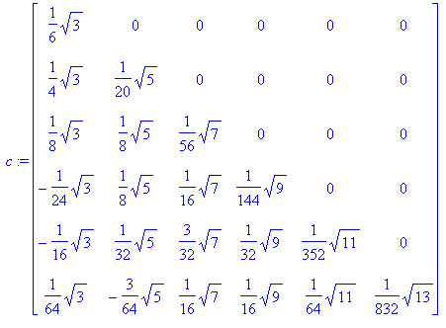

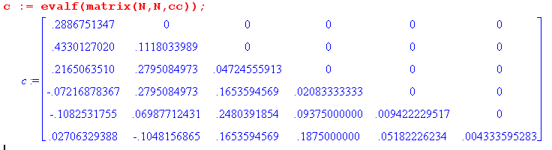

At least these matrix elements seem to be getting smaller as you go down and out.
Now does this help us solve our problem? Here is our valid expansion theorem

Jn = $^{\int_{0}^{1}{}}$dx φn(x)I(x) I(x) = Σn=0∞ Jn φn(x) x = cosθ

and we have

Pn(x) = Σm=0∞ cnm φm(x) (*)

and we have

In = $^{\int_{0}^{1}{}}$dx Pn(x)I(x) = 2 δn,0 Jn = $^{\int_{0}^{1}{}}$dx φn(x)I(x)

So let's apply $^{\int_{0}^{1}{}}$dx I(x) to both sides of (*),

$^{\int_{0}^{1}{}}$dx I(x) Pn(x) = Σm=0∞ cnm $^{\int_{0}^{1}{}}$dx I(x) φm(x)

In = Σm=0∞ cnm Jm I = c J => J = c-1I => Jn = Σm=0∞ c-1nm Im

We know In =2 δn,0 and we need to solve for the Jm so we can put them in our series. But that means we need c-1 . Then we have

Jn = Σm=0∞ c-1nm Im = Σm=0∞ c-1nm ( 2 δm,0) = 2 [c-1]n0 = 2 * first column of c-2

The numbers alternate sign and increase rapidly, just as we saw with the knm approach (which no doubt is exactly the same approach). If you have Maple compute I(x) = Σn=0N Jn φn(x) you get plots like this one, similar to our "Legendre my problem.doc" plots.

> restart: with(orthopoly):with(linalg):
> phi := n -> (2*n+1)^(1/2)* P(n,-1+2*x):
> phi(2):
> cc := (n,i) -> int(phi(i)*P(n,x),x=0..1):
> N := 40:
> c := evalf(matrix(N,N,cc)):
> cinv := evalf(inverse(c)):
> J := col(cinv,1):
> IofX := sum(2*J[n]*phi(n),n=1..N):
> plot(IofX,x=0..1);

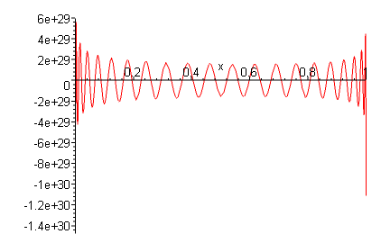

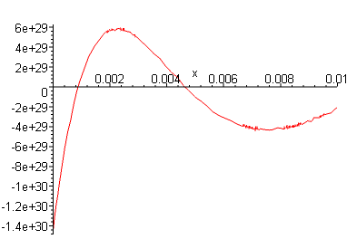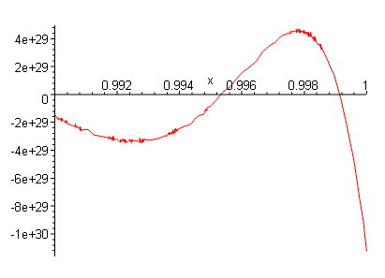

where I show blowups of the left and right ends. Remember that the left end is x = 0 or θ = π/2 which is the edge of our half sphere. and x = 0 is the smooth round top of it. I(θ,φ) is the charge density in this problem. The charge in a piece of area is dΣ = I(x)d(cosθ)dφ = I(x) dx dφ. The charge in a ring around the sphere is then dΣring = 2π I(x) dx . Everything I have done seems to be saying that the charge is peaking up at both the sharp rim and at the smooth center top, which just seems wrong to me. I cannot seem to find the answer on the web.
Physical arguments? The charges are repelled from each other. They want to go to the edge, but maybe the center point would pile up for this reason: charge is repelled equally from all directions toward the center point, so it peaks up there. But in the 2D finite wire we did not see any piling up at the center.

10. Try some simple delta-function forms for I(z)

I think I really believe that this is correct

$^{\int_{0}^{1}{}}$dx Pn(x)I(x) = 2 δn,0

Let's try to go backwards from this to the integral equation we started with. The above solves this:

Σn Pn(zs) $^{\int_{0}^{1}{}}$ dzξ Pn(zξ) I(zξ) = 2 half sphere valid (0,1) for zs

(1/4π) Σn N0n(1/N0n) Y*n0(Ωs) ∫σ dΩξ Yn0(Ωξ) I(Ωξ) = 1 σ = half

(1/4π) Σn N0n Σm (1/Nmn) Y*nm(Ωs) ∫σ dΩξ Ynm(Ωξ) I(Ωξ) = 1 σ = half

(1/4π) ∫σ dΩξ { Σn N0n Σm (1/Nmn) Ynm(Ωξ) Y*nm(Ωs) } I(Ωξ) = 1 σ = half sphere

∫σ E(s|ξ)I(ξ)dSξ = 1 σ = half sphere

So is there some distributional solution so these equations:

$^{\int_{0}^{1}{}}$dx I(x) = 2
$^{\int_{0}^{1}{}}$dx Pn(x)I(x) = 0 n = 1,2,3...

Something like this

I(x) = Aδ(x-0) + Bδ(x-1)

Then our equations above become:

A/2 + B/2 = 2
A/2Pn(0) + B/2Pn(1) = 0

A/2 + B/2 = 2
A/2Pn(0) + B/2 = 0

A/2 [ 1 - Pn(0) ] = 2

But Pn(0) = 0 for odd n, and = f(n) for even n. Then our solution for A would be A(n) for even n and would be ∞ for odd n. Not too good.

How about this

I(x) = a δ(x-1)

Then equations say

a/2 = 2
a/2 = 0

so sorry. You might try something fancier like this:

I(x) = L0δ(x-0) + L1δ(x-1)

where the Li are differential operators. So consider again:

$^{\int_{0}^{1}{}}$dx I(x) = 2
$^{\int_{0}^{1}{}}$dx Pn(x)I(x) = 0 n = 1,2,3...

At the x = 1 end, if we just take L1 = B, then that end generates B/2 for both lines which is not dependent on n. Can we find some L0 that makes the x=1 end independent of n?

$^{\int_{0}^{1}{}}$dx Pn(x) [ L0δ(x-0)] = independent of n.

If L0 is self-adjoint, I think we can write the above as

$^{\int_{0}^{1}{}}$dx [L0Pn(x)] δ(x-0) = (1/2) [L0Pn(x)]|x=0

For example, if L0 = -(1-x2)∂x2 + 2x∂x then [L0Pn(x)]|x=0 = n(n+1)Pn(0) // Schaum p 146.

but this is not independent of n. At the x=1 end we get n(n+1)Pn(1).

11. Search on line for solution to the half sphere problem.

Conclusion: (10.31.09 11:30 AM) There is nothing more I can do with this problem. I have tried solving ∫σ E(s|ξ)I(ξ)dSξ = 1 as best I could. I used Maple, I tried different methods, I keep getting some kind of strange distributional result that does not make any sense. So now is the time when we have to find the answer from someone else.
How would I go about finding the solution to this problem? Let's log some web searches:

search: "hemispherical shell" conductor "charge distribution" 128 hits

12. Discovery of the Canonical PDF (10.31.09)

I found a large PDF and downloaded it from scribd, "canonical structures in potential theory" is part of the title (did this 10.31.09). It has a chapter specifically on spherical shells. This looks very promising. They will do both the spherical cap (more general than my hemispherical shell) and also a spherical barrel. This is the exact right source, I was lucky. Let's follow the notes a bit. Well, maybe this is just Dirichlet for the cap with some prescribed potential on it which he calls U0(θ,φ). I have in mind this is 0 of course. He does the usual Y expansion but calls this a Fourier-Legendre series expansion where αnm are coefficients. The math here is pretty hairy, but he claims to find a general solution. Then he says that if the cap is at a constant potential, things simplify and he did that already in Section 1.4, which I now eagerly look at.
Here is some fascinating opening text:

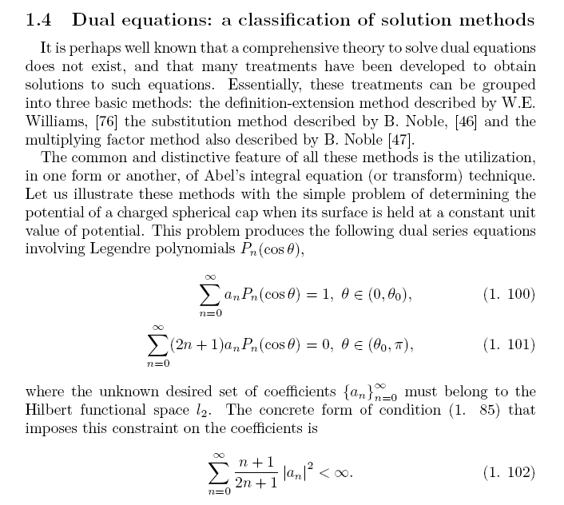

So, where are these two equations coming from? These guys are doing a sort of "form fit" method, so what happens if I try that. Then

u(r,θ) = Σn an rnPn(z) inside r = 1
u(r,θ) = Σn an r-n-1Pn(z) outside r = 1

This form makes u be continuous at r = 1 for all z. This applies to the free space dotted part of the boundary, and also to the spherical cap metal. So setting u(1,θ) = 1 gives 1.100 above, but where is the second equation coming from? On the dotted portion of the sphere, the derivative must be continuous, so
we have

∂ru(r,θ) = Σn an nrn-1Pn(z) inside r = 1
∂ru(r,θ) = Σn an (-n-1)r-n-2Pn(z) outside r = 1

The difference of these is 0 on the dotted boundary so we have

Σn an [ n + n + 1] Pn(z) = 0 on dotted boundary

which is 1.101. These are called "dual series equations".
His next step is to imagine there is some function g(θ) which provides a RHS for 1.101 for the entire range, and happens to be 0 in the high range:

Σn(2n+1) anPn(cosθ) = g(θ) 0 ≤ θ ≤ π g = 0 on high part

I think this g(θ) is the total surface charge density since it is the difference of the gradients, and it is of course 0 on the dotted boundary. So this is I(θ) in my notation!

He then constructs an integral equation for g*(θ) ≡ g(θ)sinθ [ I have seen this idea before]

$^{\int_{0}^{θ0}{}}$dθ' g*(θ') K(θ',θ) = 1 K(θ',θ) = (1/2) Σn Pn(cosθ) Pn(cosθ')

I think this is exactly my integral equation ∫σ E(s|ξ)I(ξ)dSξ = 1 !!! Probably the Pn thing is a way to write 1/R, it certainly looks reasonable to me. He points out: first kind Fred, but no name is assigned to this integral equation. At this point, he uses a method involving "Abel integral equations". Amazingly, he finds the following solution:
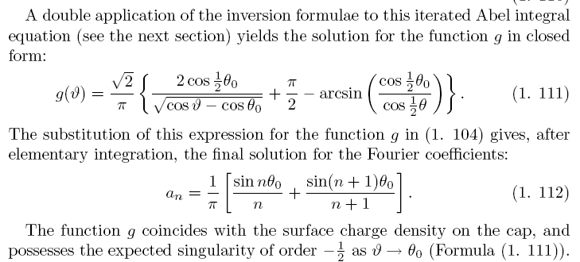

And there is says it, g = Σ and I have found the solution to my problem. Now for the half-sphere, set θ0= π/2. Then

θ0 = π/2
cosθ0 = 0
cos(θ0/2) = cos(π/4) = 1/$\sqrt{2}$

g(θ) = ($\sqrt{2}$/π) { $\sqrt{2}$/$\sqrt{cosθ}$ + π/2 - arcsin(1/[$\sqrt{2}$cos(θ/2)) }

If I draw a standard orientation right triangle with vertical edge 1, diagonal $\sqrt{2}$cos(θ/2), then the angle in the triangle at the lower left is θ. The horizontal edge is then

x2 = 2 cos2(θ/2) - 12 = 1 + cosθ - 1 = cosθ

But this tells us that tanθ = 1/cosθ which seems odd. That seems to say sinθ = 1 and θ = π/2. This must be a strange limit due to doing an exact half sphere. Then the above becomes simply

g(θ) = ($\sqrt{2}$/π) { $\sqrt{2}$/$\sqrt{cosθ}$ + π/2 - π/2 } = (2/π) 1/$\sqrt{cosθ}$

At θ = 0 where cosθ = 1, nothing strange happens (as I expected). It blows up in the usual square root manner at the rim edge. So this seems a pretty reasonable solution, no fancy horrible distributions.

The potential meanwhile has

an = (1/π) [ sin(nπ/2)/n + sin((n+1)π/2)/(n+1) ]

u(r,θ) = Σn an rnPn(z) inside r = 1
u(r,θ) = Σn an r-n-1Pn(z) outside r = 1

and the problem is now completely solved!
So the solution to my problem seems to be this:

I(θ) = (2/π) 1/$\sqrt{cosθ}$

according to the PDF I found (and have carefully saved!!! ).

13. Test this Canonical solution.

The first questions is this:

$^{\int_{0}^{1}{}}$dx Pn(x)I(x) = 0 n = 1,2,3...

[ Since In = δn0, one would expect the above to be true. But by now I know that this is not the right In for this problem, so I am then not surprised to see that the above is not true. ]

I don't think this is going to be true

$^{\int_{0}^{1}{}}$dx Pn(x)/$\sqrt{x}$

This appears p 796 GR with σ = -1/2 which is in the allowed range. Integral is

$\sqrt{π}$ 2-1/2 Γ(1/2) / { Γ(1 - 1/4 - n/2) Γ(-1/4 +n/2 + 3/4) }

= $\sqrt{π}$ 2-1/2 Γ(1/2) / { Γ(3/4 - n/2) Γ(n/2 + 1/2) }

I enter Γ(3/4 - n/2) Γ(n/2 + 1/2) in Maple and try some integer n values, all different. Also can directly evaluate the integral shown, it is different for each n.

Conclusion: My claim that $^{\int_{0}^{1}{}}$dx Pn(x)I(x) = 0 for n = 1,2,3.... must be wrong. [ it is! ] Not too big of a surprise, since it is this equation that leads to the distributional nightmare.

So let's back up a bit. What happens with this expansion:

Σn Pn(zs) $^{\int_{0}^{1}{}}$ dx Pn(x) I(x) = 2 half sphere valid (0,1) for zs

If I insert I(x) = (2/π) 1/$\sqrt{x}$ we get

Σn=0∞ Pn(zs)[ (2/π) $^{\int_{0}^{1}{}}$ dx Pn(x) /$\sqrt{x}$] = 2

Σn=0∞ Pn(zs)[ $^{\int_{0}^{1}{}}$ dx Pn(x) /$\sqrt{x}$] = π

Σn=0∞ Pn(zs) In = π

The RHS is 3.14156. I can make Maple compute the In and do the sums for different zs and with the sum going to some N. If I set N = 50, here is what I get for the LHS setting zs = 0, .1, .2, .... 1.0

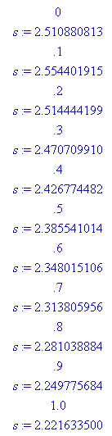

First of all, we don't get π. Second, we don't get a constant result, but it is slowly varying, I will admit that much.

I am thinking now more about 1/$\sqrt{cosθ}$. Can I write this as a Pn double sum? Jackson p 62 reminds us of this fact for two points on a sphere.

1/|ξ-s| = Σn Pn(cosγ) γ is the angle between the two vectors

This then leads to the more general form with the Y's.

Can I show that g(θ) from the paper solves anything at all? The most important would be to show this:

∫σ E(s|ξ)I(ξ)dSξ = 1 // independent of location s on half sphere

All I am doing in the next step is inserting the tried and true expansion for 1/R:

(1/4π) ∫σ dΩξ { Σn N0n Σm (1/Nmn) Ynm(Ωξ) Y*nm(Ωs) } I(Ωξ) = 1 σ = half sphere

then we do the change of order

(1/4π) Σn N0n Σm (1/Nmn) Y*nm(Ωs) ∫σ dΩξ Ynm(Ωξ) I(Ωξ) = 1 σ = half

Next we assume no ξ azimuthal dependence so the last integral is δm,0 ∫σ dΩξ Yn0(Ωξ) I(Ωξ). Hence

(1/4π) Σn Y*n0(Ωs) ∫σ dΩξ Yn0(Ωξ) I(zξ) = 1 σ = half

(2π/4π) Σn Pn(zs)$^{\int_{0}^{1}{}}$dzξ Pn(zξ) I(zξ) = 1 σ = half

Σn Pn(zs) $^{\int_{0}^{1}{}}$dx Pn(x) I(x) = 2 σ = half

$^{\int_{0}^{1}{}}$dx [(1/2)Σn Pn(zs)Pn(x)] I(x) = 1

It seems to me that all these equations MUST be true. If this is the correct solution

I(x) = (2/π) 1/$\sqrt{x}$

then it MUST solve the above equation. Let's look at the PDF version of the integral equation:

$^{\int_{0}^{θ0}{}}$d(cosθ') g(θ') K(θ',θ) = 1 K(θ',θ) = (1/2) Σn Pn(cosθ) Pn(cosθ')

This agrees exactly with my integral equation above! I have θ0 = π/2 as my special case of interest.
So we really do have the same integral equation.
Maybe the order interchange of integration and summation is illegal? To me, it seems such an obvious thing to do, given the PDF line above, to say this:

(1/2) Σn Pn(cosθ) $^{\int_{0}^{θ0}{}}$d(cosθ') Pn(cosθ') g(θ') = 1

Σn Pn(cosθ) gn = 2 gn = $^{\int_{0}^{θ0}{}}$d(cosθ') Pn(cosθ') g(θ')

gn = 2 δn,0

I am doing something wrong right in the above 3 lines!! I have a very fundamental misunderstanding of things I am afraid. [ yup! ] [nope !]
Can I show that their solution solves their integral equation?

$^{\int_{0}^{1}{}}$dx [(2/π) 1/$\sqrt{x}$ ] [(1/2) Σn Pn(z) Pn(x)] = 1

$^{\int_{0}^{1}{}}$ dx (1/$\sqrt{x}$) Σn Pn(z) Pn(x) = π

The PDF processes this with some fancy integral representations. Can I get Maple to help at all ???

> restart: with(orthopoly):
> f := sum(P(n,z)*P(n,x), n = 0..20):
> g := int((x)^(-1/2)*f, x=0..1):
> plot(g, z = 0..1);

This gives a plot which is not very constant,

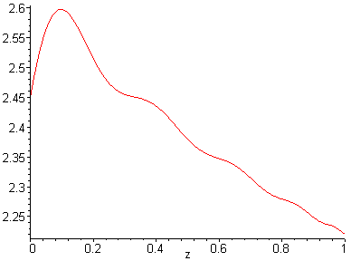

But if I increase the sum to 50 terms, then I get this plot

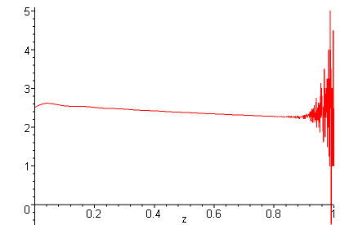

which looks like it is trying to be flat. But why is it flat at 2.3 instead of π ??? I think this is a complete artifact.

What can I say about the convergence of this series:

Σn=0∞ Pn(z) Pn(x)

First of all, I would say it was "not very convergent". There are no 1/n type factors. So we really have to worry about large n behavior of the Pn(x). What does this function even look like if you plot it??? If I do a number of terms like maybe 20, it seems to be a ridge of some sort:
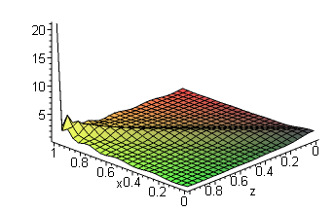

> restart;with(orthopoly):Digits := 20:
> f := sum(P(n,z)*P(n,x), n = 0..20):
> plot3d(f,x=0..1,z=0..1);

I know from Schaum p 147 that
δ(x-z) = Σn=0∞ (n+1/2) Pn(z) Pn(x) web confirm: 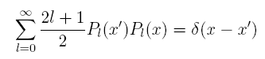

so our sum is not quite a delta function, but you can see it will peak up on the ridge since it is then adding a series of positive terms. Our sum must be ∞ when x = z.

Conclusion: the sum Σn=0∞ Pn(z) Pn(x) is in fact a distribution, similar to Σn=0∞ (n+1/2) Pn(z) Pn(x). Therefore, we are going to have numerical problems with it. Certainly when x = 1 and z = 1 our sum is going to blow up, you see it peaking at the corner of the square above. Consider now:

Σn=0∞ Pn(x) Pn(x) = Σn=0∞ (Pn(cosθ))2

Will this blow up or not? Our PDF paper suggests that this sum would be

(1/2π) $^{\int_{0}^{θ}{}}$dφ / (cosφ - cosθ)

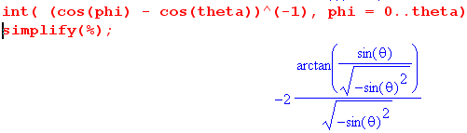
The arctan thing becomes tan-1 (-i) so that tanα = -i and itanα = 1 so tanh(iα) = 1 so α = -i∞ so I would say the numerator was infinite at any θ. We are integrating right into a pole where cosφ = cosθ.

(1/2π) $^{\int_{0}^{θ}{}}$dφ / (cosφ - cosθ)

[ Note: in v2, I show that Σn=0∞ Pn(x) Pn(y) is a multiple of a K function, so it not a distribution. ]

Obsolete old notes
_________________________________________________________________________________

The integral equation failed to diagonalize, and we have merely replaced it with a sum equation which we don't know how to solve. At least we have gotten rid of our inconsistencies!

Now go back to the original integral equation

(1/4π) ∫σ dΩ' { Σn N0n Σm (1/Nmn) Ynm(Ω') Y*nm(Ω) } I(Ω') = 1 // p 126 (*)

and assume as before that I(Ω') = I(θ',φ') = I(θ') only, Then in the above we see

∫σ dΩ' Ynm(Ω') I(θ') = 2πδm,0 $^{\int_{0}^{1}{}}$dz' Pn(z') I(θ') = δm,0 In0Nn0

Therefore, we can slightly simplify (*) in this way

(1/4π) Σn N0n Σm (1/Nmn) Y*nm(Ω) [δm,0 In0Nn0 ] = 1

(1/4π) Σn N0n (1/N0n) Y*n0(Ω) In0Nn0 = 1

(1/4π) Σn N0nPn(cosθ) In0 = 1

and we just arrive at our same result as quoted above.

Part 2: Solve the sum equation.

So now we have to face this thing and solve it!

(1/4π) Σn N0n Pn(cosθ) In0 = 1 valid only for 0 ≤ θ ≤ π/2

Σn=0 In Pn(z)/ (2n+1) = 1 In = In0 valid only for 0 ≤ z ≤ 1

If this were valid on the entire -1,1 range, we would quickly say this: Pn(z) are a complete orthogonal set, so match both sides and conclude that I0 = 1 and In = 0 for n > 0. That is exactly what you would do for the problem of the full sphere, and that would be the correct conclusion.
But here, this thing is NOT valid on (-1,1) so we cannot do that.

Notice, by the way, that this does not align with what a while ago I called my problem Legendre

$^{\int_{0}^{1}{}}$dx I(x) P0(x) = 1
$^{\int_{0}^{1}{}}$dx I(x) Pn(x) = 0 n = 1,2,3,4...∞ My Problem

You could consider a possible solution of the equation Σn=0 (2n+1) In Pn(z) = 1 that had this form, which is to say I0 = 1 and In = 0 for n > 0, but you find that such a solution does not exist. So forget that whole document Legendre my problem.doc.

Now, once again, back to

Σn=0 (2n+1)-1 In Pn(x) = 1 In = In0 valid only for 0 ≤ x ≤ 1

What we really need at this point is a complete set of basis functions on this interval. Consider

[ (2n+1)/2] $^{\int_{-1}^{1}{}}$dx Pn(x) Pm(x) = δn,m

Let x = -1+2x' so that dx = 2dx' so we have

(2n+1)$^{\int_{0}^{1}{}}$dx' Pn(-1+2x') Pm(-1+2x') = δn,m

(2n+1)$^{\int_{0}^{1}{}}$dx Pn(-1+2x) Pm(-1+2x) = δn,m

We then have this set of basis functions

φn(x) = (2n+1)1/2 Pn(-1+2x) φ0(x) = P0(-1+2x) = 1

$^{\int_{0}^{1}{}}$dx φn(x)φm(x) = δn,m

We think that the projection/transform going with this would be

fn = $^{\int_{0}^{1}{}}$dx φn(x)f(x)

f(x) = Σn=0∞fnφn(x)

Go back now to our equation from above

Σn=0 (2n+1)-1 In Pn(x) = 1 In = In0 valid only for 0 ≤ x ≤ 1

Apply $^{\int_{0}^{1}{}}$dx φm(x) to both sides to get

Σn=0 (2n+1)-1 In $^{\int_{0}^{1}{}}$dx φm(x) Pn(x) = $^{\int_{0}^{1}{}}$dx φm(x) 1 = δm,0

Σn=0 (2n+1)-1 In Kmn = δm,0 Kmn ≡ $^{\int_{0}^{1}{}}$dx φm(z) Pn(z)

Define (2n+1)-1 Kmn = Amn then we have

Σn=0 Amn In = δm,0

A I = 1

=> I = A-1 1

So all we have to do is invert an ∞ x ∞ dimensional matrix of known quantities. Probably as you move out into this matrix, quantities get smaller and you hope the solution stabilizes.
Now I ran into exactly this situation in that my problem doc. First, we state our matrix situation using start-with-0 indices:

Σn=0 Amn In = δm,0

Amn = (2n+1)-1 Kmn = (2n+1)-1 $^{\int_{0}^{1}{}}$dx φm(z) Pn(x) =

= (2n+1)-1$^{\int_{0}^{1}{}}$dx { (2m+1)1/2 Pm(-1+2x) } Pn(x)

= (2n+1)-1 (2m+1)1/2 $^{\int_{0}^{1}{}}$dx Pm(-1+2x) Pn(x)

If we want help from Maple matrix machinery, we have to restate this in start-with-1 indices:

Bmn = Am-1,n-1 so B11 = A00

Jn = In-1 so J1 = I0

Then our matrix equation of interest is this:

Σn=1∞ Bmn Jn = δm,1 BJ = 1 J = B-1 1 = first column of B-1

where
Bmn = Am-1,n-1 = (2n-1)-1 (2m-1)1/2 $^{\int_{0}^{1}{}}$dx Pm-1(-1+2x) Pn-1(x) m,n ≥ 1

When I insert this into Maple with a 6x6 matrix, I find that the first column of B-1 is just 1. That seems wrong to me, but if it were correct, it would imply that

J = (1,0,0,0....)

I = (1,0,0,0,0...)

I0 = 1 In = 0 n ≥ 1

But this is exactly the solution I don't want! Something (as usual, it happens daily) is wrong.
Here is the Maple work. First we make sure the first index is row, with this test:

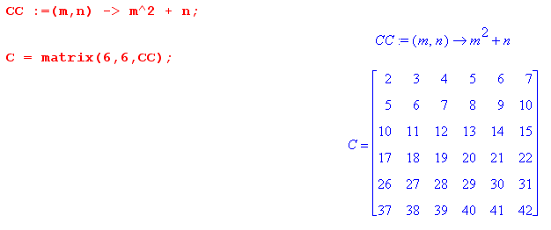

For example, m = 2 would be second row, n = 1 first column, expect 22 + 1 = 5, is correct. Recall from above

Bmn = Am-1,n-1 = (2n-1)-1 (2m-1)1/2 $^{\int_{0}^{1}{}}$dx Pm-1(-1+2x) Pn-1(x) m,n ≥ 1

Now we go ahead and do the real thing:

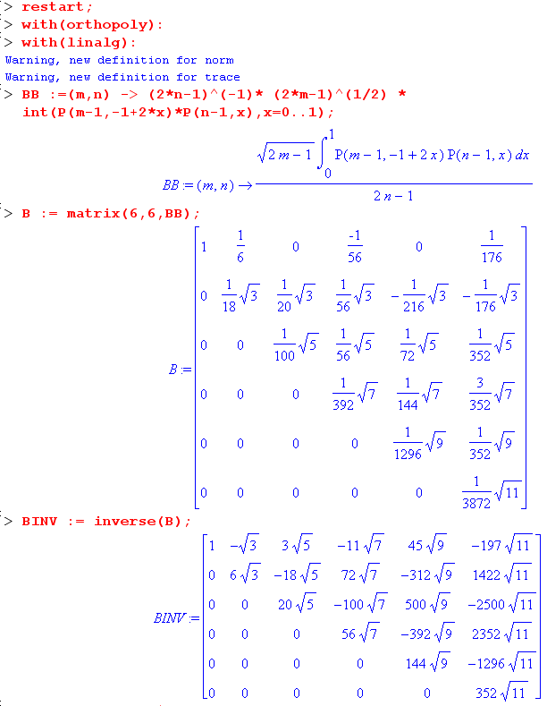

and you see at once the problem that the first column is 1. Here is the Maple code text:

> restart;
> with(orthopoly):
> with(linalg):
> BB :=(m,n) -> (2*n-1)^(-1)* (2*m-1)^(1/2) * int(P(m-1,-1+2*x)*P(n-1,x),x=0..1):
> B := matrix(6,6,BB):
> BINV := inverse(B):
> CC :=(m,n) -> m^2 + n:
> C = matrix(6,6,CC):

So now once again I am stumped. This is the 4th full day I have spent on this half-sphere problem! Today at least I eliminated some of the total conflicts I was having last time I worked on this.

*****************************************************************
I think all this stuff below the above line no longer applies to his half-sphere problem, but
I will leave these notes here for now.

Part 2. Reduce the problem to $^{\int_{0}^{1}{}}$dz I(z) Pn(z) = 0 n = 1,2,3...

So let's go back to

∫σ dΩ' Ynm(Ω') I(Ω') = (2n+1)4π δn0δm0.

which really tells us that

∫σ dΩ' I(Ω') = 4π n = m = 0
∫σ dΩ' Ynm(Ω') I(Ω') = 0 for all n,m ≠ 0,0

The first is sort of a normalization thing. But how do you extract I(Ω') from the second condition set?
OK, let's write this out as (integral only over upper the half shell)

$^{\int_{0}^{2π}{}}$dφ' $^{\int_{0}^{π/2}{}}$sinθ' dθ' Ynm(θ',φ') I(θ',φ') = 0 for all n,m ≠ 0,0

where we have put our z axis as the symmetry axis of our half spherical shell. We certainly expect I to not depend on φ, so we then have

∫σ dΩ' Ynm(Ω') I(Ω') = $^{\int_{0}^{π/2}{}}$sinθ' dθ' I(θ') $^{\int_{0}^{2π}{}}$dφ' Ynm(θ',φ')

= δm,0 2π $^{\int_{0}^{π/2}{}}$sinθ' dθ' I(θ') Yn0(θ',φ')

= δm,0 2π $^{\int_{0}^{π/2}{}}$sinθ' dθ' I(θ') Pn(cosθ') = 0

For m=0 we then get

∫σ dΩ' Yn0(Ω') I(Ω') = 2π $^{\int_{0}^{π/2}{}}$sinθ' dθ' I(θ') Pn(cosθ') = 0
or
$^{\int_{0}^{1}{}}$dz I(z) Pn(z) = 0 n = 1,2,3,4 z = cosθ

Now we have at least simplified our confusion. Note that the Pn are not a complete set on (0,1). We also have that

∫σ dΩ' I(Ω') = 4π = $^{\int_{0}^{π/2}{}}$sinθ' dθ' I(θ') $^{\int_{0}^{2π}{}}$dφ' 1 = 2π $^{\int_{0}^{π/2}{}}$sinθ' dθ' I(θ')

=> $^{\int_{0}^{1}{}}$dz I(z) = 2 = $^{\int_{0}^{1}{}}$dz I(z)P0(z)

But the 1 in our original integral equation ∫σ E(s|ξ)I(ξ)dSξ = 1 was the arbitrary potential on the boundary, we could have set it to 1/2 and then we would get $^{\int_{0}^{1}{}}$dz I(z)P0(z).

Part 3: Attack My Problem

SO, we seem to arrive at My Problem which is to solve these equations for I(z):

$^{\int_{0}^{1}{}}$dz I(z)P0(z) = 1 n=0
$^{\int_{0}^{1}{}}$dz I(z) Pn(z) = 0 n = 1,2,3,4 z = cosθ

When I first arrived at this point in these notes, I thought this would be an easy problem to solve and I would have deduced I(z) for this geometry, I(z) being the sum of the charge on the two surfaces.

Question: given the above condition on I(z), can we deduce what general form I(z) might have?

Comment: it is extremely easy for me to generate questions I cannot answer!

For example, could I(z) be a constant? That would imply that $^{\int_{0}^{1}{}}$dz Pn(z) = 0 for all n > 0. But I know that fact is not true (Maple), so no, I(z) cannot be a constant. We could try to expand I(z) on Pn'(z) in the range (0,1) [ but warning: not a complete set on that interval] and then we get

I(z) = Σn'an'Pn'(z) 0 = $^{\int_{0}^{1}{}}$dz [Σn'an'Pn'(z)] Pn(z)
= Σn'an'$^{\int_{0}^{1}{}}$dz Pn'(z) Pn(z)
= Σn'an' Kn'n

where Kn'n are some known ( symmetric ) constants we can write down. We then have

Σn'=1∞ Knn' an' = 0 for n = 1,2,3...∞

This is an ∞ x ∞ matrix problem Ka = 0. If det(K) = 0, there is a possible non-trivial solution. I have no idea what to do at this point, so I am down a blind alley (what else is new? ). Note: the Pn'(z) do not form a complete set on the interval (0,1) so the expansion I(z) = Σn'an'Pn'(z) is probably invalid.

Conclusion: I do not know how to solve this half-shell problem.

At this point, I spent about 3 DAYS thinking about My Problem as stated above, and I wrote up these ponderings in a document Legendre my problem.doc . I concluded in that document that the solution to My Problem is essentially that f(z) = 0 as some kind of distribution similar in nature to fN(z) = Ncos(Nz) as N→ ∞. So after all this work, I have no idea how charge distributes itself on the half-shell. Perhaps I(z) is a distribution and so maybe some step in my development leading up to My Problem is invalid. I then realized there are a lot simpler problems where I don't know how charge distributes itself, such as the 2D unit disk, and maybe the same disk in 3D. It seems logical to go figure out these seemingly simpler problems and then maybe some day come back to the half sphere problem. Conveniently to this end, Stak is now going to talk about 2D conductors. Another problem would be how charge distributes itself on a finite wire in 1D!
I don't think charge distribution problems are as cookbook as Dirichlet problems. I have no idea on this general how charge distributes itself question, despite doing Jackson. Most of Jackson's three chapters on electrostatics is Green's Function and Dirichlet and support stuff the newbie needs at this point in his/her physics development. But as I peruse Jackson right now, at the very end of Electrostatics II he does an example of this kind of problem: the thin disk in 3D space. He shows in 3.179 that the charge density is finite at the center, and increases as you go to the edge, being infinite at the edge, but in a manner that is still integrable. There is no delta function, but there is an infinity, and somehow that has probably caused problems with my work above. Jackson does see fit to comment in a very long paragraph on page 91 that even this simple geometry was historically a tough problem, involving dual integral equations, and he treats it as a mixed BC problem in cylindrical coords. He mentions no less than five historical methods with people's names. So maybe I should feel better that I could not do it in my 3 day odyssey. I wonder if he has added more in his later edition(s), mine being 1st Ed 1962, 1967 printing.
I suspect that if I were to better catalog all the examples Stakgold has done in this potential theory chapter, I would find one or more examples that apply to this problem, and I would find my mistake made in the half-spherical-shell development above.

