Kelvin's Bowl Paper XV page 178 PhL 2.18.11

I show section numbers.

231. Derives the formula for σ on a charged ellipsoid.

232. Writes an integral for the Capacitance of said b.

233. Takes limits to get the charge density on a flat ellipse and then a round disk. He notes that this disk σ result was first found by Green in 1832.

234. This section is a quote from Green's 1832 paper where Green quotes some work of Biot. Compares the theory to experiment for charge density on a disk and agreement is excellent.

235. Does the capacitance integral in the disk limit and gets C = 2a/π. Note this is less than C of a sphere (globe) and quotes Cavendish data comparing the two.

236. Kelvin rewrites σ on a disk in terms of certain chord distances.

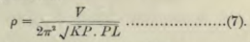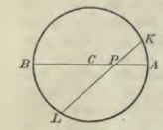

237. Take a charged disk S' at potential V' and set up an inversion into a bowl, which he calls a "spherical segment" S. The inversion sphere has center Q and this is where a point charge will appear. In (8) and (9) Kelvin gives the relation between σ's and V's in his two "spaces". Like me, Kelvin has the disk in R' space, and the bowl in R space, with corresponding primes on the variables.

238. We have here the famous inversion picture and a whole page of geometry. I now see that point N is supposed to be the "pole of the bowl" and M is the center of the disk. Remember that in this inversion you start with a charged disk in R' space, you add there a constant potential to get V'=0, and you thus end up in R space with a grounded bowl plus a point charge, that is, a certain Green's Function problem.

239. The upshot of all this is that he now has an expression for the charge on the bowl in terms of certain distances. He processes this bowl σ through equations 15,16 and arrives at 17:

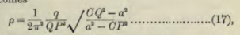

However, he has redefined point C to now mean the pole point of the bowl, what I call rC.

In this formula, CP is the distance shown above in the disk picture. Here is my picture for this disk to bowl inversion:

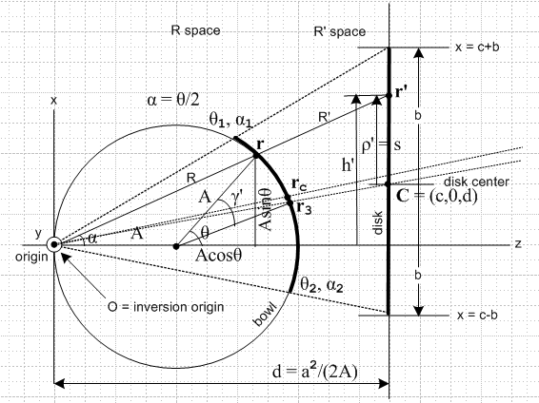

Kelvin me
a b radius of disk
R a radius of inversion sphere
Q origin the inversion origin point
P r point on the bowl
P' r' corresponding point on the disk
M C center of the disk
N=C rC point at center of the bowl
CP |r-rc| a certain distance I recall using once
CQ rc distance from inversion origin to point rc
QP R distance from inversion origin to point r
q ?? size of the Green's point charge at the origin
f/2 A radius of the bowl sphere

So I would rewrite his (17) this way

σ = (1/2π2) (q/R2)$\sqrt{rc2- b2}$ / $\sqrt{b2- |r-rc|2}$

He notes that this result does not depend on my A (sphere radius) but it does depend on the inversion sphere radius. He talks about the A→ limit which I don't understand.

240. We now turn to consideration of a charged bowl. Let Problem 1 be an uncharged grounded bowl. Let Problem 2 be a spherical shell of σ0 just outside this bowl. We superpose to get Problem 3 which is a bowl at potential V0 with σ = σ0 on the outside and σ = 0 on the inside. But we also have an unwanted sticky charge cap of σ0. In order to erase that charge, we have to superpose an infinite number of our Bowl Green's function solutions where we let the point charge wander over the cap, cancelling the cap charge at each point. This superposition erasure process results in the creation of some σi on both sides of the bowl. We thus end up with σi on the inside and σi+ σ0 on the outside.
Smythe pre-works this erasure problem and then just superposes the shell at the end. Smythe used an iris with point charge in the hole to invert to a bowl with point charge on cap, but Kelvin uses the charged disk instead.

241. Here we get details of this erasure process. Page 185 is filled with integrals which must be this process. When the dust settles, we get these famous results,

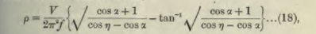

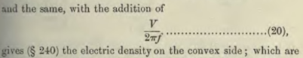

Kelvin has NOT attempted to compute the potential of the charged bowl, just the σ's.

242. Here Kelvin numerically computes σi and σ0 for bowls of different size. He takes half the bowl and takes 5 points equally spaced on the arc so including the pole point he has 6 data points, and he thus stays away from the edge. This data is presented graphically in a famous picture.

243. Now that we have σ's for the charged bowl problem, we can invert the bowl to a shifted disk plus Green's point charge, That is to say, we add a constant potential on bowl space to get V = 0 there on the bowl, then in R' space we get a disk at V = 0 along with a Green's point charge. By positioning the disk in R' space, we can cause the Green's point charge to be at an arbitrary location relative to the disk! So this is then the completely general disk Green's Function problem. (But he is thinking only of σ).
But we could also invert our bowl to another bowl + Green's charge again with arbitrary location. So how we have the arbitrary Green's function for a grounded bowl + Green's charge located anywhere relative to the bowl.
Here are the inversion pictures for these two situations (unprimed is the resulting bowl or disk)
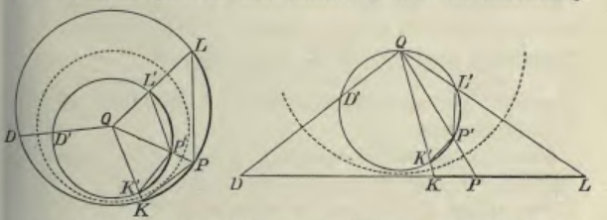
The point D' is the primed bowl's cap pole point, and maps into some point D on the resulting bowl's sphere or the disks plane.

And here is his resulting σ on the new bowl or disk:

so it is in terms of lots of distances and involves tan-1 as shown. This is σfarside . For σnearside he says you have to add a certain other function shown in (26).

244. This section is a geometry construction having to do with point D shown in the pictures above.

245. This construction allows him to simplify his result to be

where C is I think the pole point on the resulting bowl (or disk center)

246. The above formula applies to bowl or disk, so here he takes f→∞ to get the disk limit and he then gives some very slightly simplified results for this case.

247. Now her puts the point charge "on axis" and specializes to this case (for bowl, on axis means two different situations really.) He then gives a numeric table for this situation.

248. He comments on this data, then says that, although he is not going to worry about the potential, someone else might want to do that. How well does a little bowl or disk "screen" reduce potential?

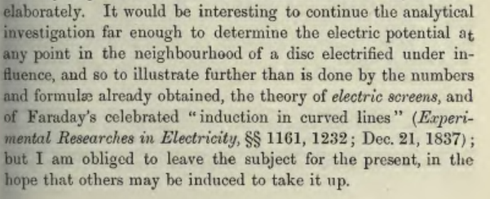

Right now I am going to reread Kirk on Kelvin and see if it makes more sense now. OK, his nice statement is this: in the erasure process what you are doing is computing the charge induced on the bowl by the σ0 cap. If you remove the cap, then you remove that induced charge on the bowl and that is your answer. So you integrate the Green's Function solution over the cap to get the answer. His other comment is that the Jeans book has Kelvin's stuff in it. It is on page 250 of the 5th edition and Jeans calls it a spherical bowl. Jeans just quotes Kelvin's result, there is no derivation at all.

