Review of my Smythe Problem 38 Efforts PhL 6.16.10

These notes relate to the "double inversion" method of doing this problem, which is "the hard way". When reading each section here, put that section's contents in an upper split pane, and read the notes in a lower pane.

CONTENTS:
Attempt #1 1
Attempt #2. 1
Attempt #2A 1
Attempt #3. 3
Attempt #4. 4
Effect of transformations on charges and fields 5
1. Parameter facts for Pic 1 and Pic 2 6
2. How to Actively Rotate the Bowl 6
3. Doing the Second Inversion 8
4. Iris plots 16
Comments: ( written before I computed Φ as reported above in Section 7 of last doc) 16

Attempt #1

In Attempt #1 I state the basic method and draw the first pictures. The method is basically correct, though some details get supplanted later. I give a detailed review of Attempt #1 in the first large section of Attempt #2A (which replaces Attempt #2 completely), so go there if you want more info on Attempt #1.

Attempt #2.

Attempts #2 and #2A are identical through page 8 (except for small edits I later added) where I start doing rotation math. After writing #2, I redid this math in a bad first draft of "how to rotate the bowl" which made that section in #2 be either wrong of just bad notation, so that is why I started #2A and abandoned #2.

Attempt #2A

After the review of Attempt #1, we have a section New Work which I will review here.

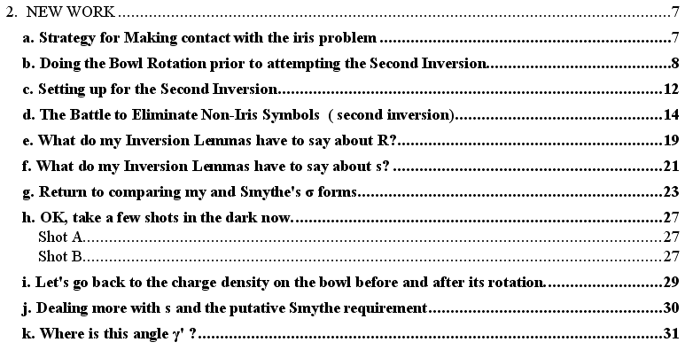

Section (a) lays out the basic inversion - rotation - inversion strategy, all correct.

Section (b) was my first attempt to rotate the bowl, it should be ignored! The result may or may not be right, but it is roughly correct.

In Section (c) I draw the Pic 2 picture for the first time, and write down some of the parameter relations that picture implies.

In Section (d) I have my first systematic battle to write down ALL parameter relations. But much is now confusing due to notation changes I have made regarding the rotated system. In subsection (6) I show the result that R = a2r1/$\sqrt{(d2+S2) (ρ'2+ d2)}$with lots of algebra. In subsection (7) I try to find something nice for s, but it is a mess and a cry "UNCLE" at the end.

In Section (e) I show that the "alternate inversion lemma" gives this same R = a2r1/$\sqrt{(d2+S2) (ρ'2+ d2)}$ with no algebra required, confirming what I found above with algebra.

In Section (f) I am trying to make this same lemma tell me something useful about distance s. The leads to the introduction of new sphere point r3 which is on the ray going to C. I end up with a result that I thought was going to be useful, s = (2AC/R) sin(γ'/2) with cosγ' = (cosθcosθ3 + sinθsinθ3cosφ) = •3. But when I finally solved the problem, this did not play a role.

In Section (g) I do a comparison: I review Smythe's problem which says σSmythe=
-( qhole/2π2r12)$\sqrt{B2-S2}$/ $\sqrt{ρ'2 - B2}$as the incredibly simple answer to this whole problem, in my notation. I then compared this with my result and concluded that the two would agree if
$\sqrt{1-(s/b)2}$ = (1/r1B) $\sqrt{B2-S2}$$\sqrt{ρ'2-B2}$which can be written

(b2-s2) = (1/r12) (b/B)2(B2-S2)(ρ'2-B2)

But b = B (d2+ S2) / (B2- S2) so the above becomes

(b2-s2) = (1/r12) (d2+ S2)2 (ρ'2-B2)/ (B2- S2)

I called this the "putative requirement", something I had to show was true. So this was then the big problem, especially how you get "something for s" to put in the LHS. In the end I did in fact verify exactly this requirement, so my results even at this early point must have been accurate.

In Section (h) I just flailed at bit finding something for s. In Shot A, I fill in cosγ' which is part of the s expression noted above, but I get nowhere. In shot B I write b2 - ρ'2 = (b+ρ')(b-ρ') and then I try to process the two "distances" using the alternate inversion lemma. Led nowhere. [ but did I know about the chord theorem at this time?? I still see no way to use the chord theorem usefully here. ]

In Section (i) I try to make sure that I "fully understand" the expression for σ on the pre-rotated bowl. Don't know what I was confused about.

In Section (j) and (k) I try fiddling with s = (2A/a2)$\sqrt{d2+ c2}$$\sqrt{ρ'2 + d2}$ sin(γ'/2) and that funny angle in an attempt to prove the putative requirement. Ie, this is the only "starting point" for s that I had other than brute force with meaningless messy formulas. Got nowhere.

And so ends Attempt #2A, which I will retain.

Attempt #3.

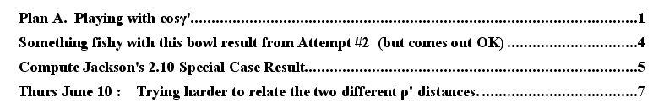

In the opening Plan A section, I try to make my inversion-lemma connection between s and cosγ' work for me. I replaced the four main trig functions of (cosθcosθ3 + cosφsinθsinθ3) with functions of the "parameters", but this is where I wrongly identify the Pic 2 azimuth φ" with the Pic 1 azimuth φ [cos γ' is in Pic 1.] In retrospect, I could have done this

cosγ' = [sinθc sinθ"cosφ" - cosθc cosθ"]cosθ3 + [cosφ" sinθ"] sinθ3

to get proper Pic 2 angles, but then we have a messy triple-trig thing, so forget it. Also, I did not have a catalog of trig functions relating angles to parameters, so kept doing local algebra. Also in retrospect, probably better to let the angle γ' appear in the Pic 2 picture and then connect it there with Pic 2 parameters.
In the next Section (Something Fishy...) I had a small teapot tempest that went away.
In the next Section (Compute Jackson...) I showed that MY result for σiris agreed with Jackson's problem 2.10 special case of charge at iris hole center result exactly. At this time, I was thinking maybe Smythe had a typo in his result.
In the next Section ( Thurs June 10: Trying harder ....) . In (1) I review the s / cosγ' equation. Then in (2) I take the special case of it when φ = 0 (in the plane.) . In (3) I look at Pic 2 stuff in this case. This whole effort goes nowhere! In retrospect, you have to show the "putative requirement" at all angles, not just some special φ=0 case!
In the final scraps section (after bar of ****'s) I seem to have an earlier version of the previous section where I am trying an in-the-plane only analysis, since this simplifies γ'. Maybe I was trying to see if the putative was at least valid when φ = 0.

Overall, Attempt #3 was just a scratch working effort and there is really nothing in this doc that is now of any value, so don't give it another look! I did not have a clean separation between Pic 1 and Pic 2 parameter relations, I did not understand about azimuth angles, I thought in-plane would do it all.

Attempt #4.

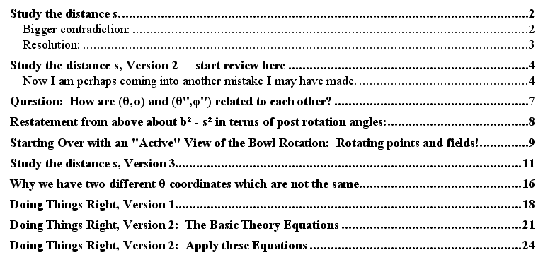

Section "Study the distance s..." : I am getting frustrated now. I know that I only have to show the putative requirement equation, and I have everything I need except for s. And I have that s = C sin(γ'/2)/ cos(θ/2) equation as my only lead (other than brute force). It was at this point that I learned that shrinking concentric circles on the disk map into a set of circles on the disk which have a pole which moves from rc to r3 , an unexpected result ("contradiction and resolution" ).
Section "How are..." : It was at this late-in-the-game point that I realized my confusion of Pic 1 φ and Pic 2 φ. I then for the first time wrote up how (θ,φ) Pic 1 and (θ",φ") Pic 2 are related. This is the only place I did the details of the special case φ = 0 in terms of getting the actual angle θ" within its (0,π) allowed range. I quote here the result:
φ = 0 => θ" =
φ" =

Section "Restatement..." : I then stopped worrying about s = C sin(γ'/2)/ cos(θ/2) and went back to the "brute force" expression for b2- s2 in terms of ρ' and x' now all written in θ" type angles, but I did not go far. This method eventually worked later on!
Section "Starting over with active..." : I then digressed on the notion of "rotating a field" and did an example with a dipole field and some pictures, all good stuff. Trying to understand what you mean by "active rotation of the bowl" and its potential. This is all old hat now, but I was confused then.
Section "Study....Version 3" : Then I am back again with s = C sin(γ'/2)/ cos(θ/2) so I fiddle putting cosγ' into my calculation of b2- s2. But alas, I am still mixing up φ and φ" and get a bogus triangle result. I suspect that in the end, this method could be made to work. [ My Pic 1 and Pic 2 parameter relations were not segregated. ]
Section " Why we have two different θ coordinates which are not the same. " . This was one of the toughest things for me to understand. I had an r in Pic 1 and an r in Pic 2 which had the same θ,φ and thus they "did not correspond". My Pic 2 drawing was such that this was the case. I wanted to use θ,φ in Pic 2 so that second inversion problem could have exactly the same notation as the first, but I later found that it was better to use r" at θ",φ" there to avoid this confusion about lack of correspondence.
Section " Doing things right version 1": In (1) I write the Pic 1 results for Φ and σ. In (2) I rotate the bowl and have things like X" = -cosθcX - sinθcZ, but at this point I did not understand the interpretation of the double-prime symbols, they were just dummy variables. In (3) I wrote Φ and σ in in terms of X" etc. In (4) I just state the fact that (θ,φ) in Pic 1 cannot be "equated" with (θ,φ) in Pic 2. I mean of course that the points do not correspond. If you are trying to get an expression for s, you must use points that correspond! In (5) I write out s in terms of things like X". In (6) I set X" = Asinθcosφ which is of course very confusing. I then say STOP!
Section " Doing things right version 2": This is my "four worlds" approach which I want to come back to later on. Using this method you could go from disk to iris in one step. In the next Section I try to apply this method doing an explicit computation, but it is a big mess, and I give up.

At this point, I realized I really had to understand the geometric meaning of things like θ". I decided also to break down the solution of this problem into a set of several documents, such that a later stage would not corrupt an earlier stage.

Effect of transformations on charges and fields (inversion folder)

I have added on 12.5.10 an Overview inside this doc which has more detail than what appears below.

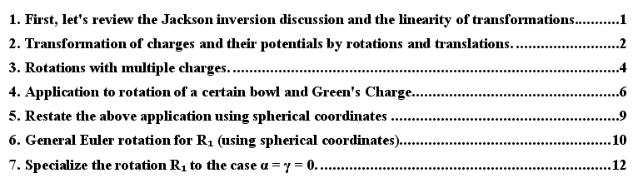

This was a little side document written to clarify some issues. Today I heavily edited it to make it consistent with my later notation, especially relating to double-prime things.

Section (1): I start by comparing inversions, rotations and translations. Only (simple) rotations are linear operations. The Smythe problem of course involves two of these three operations: inversion and rotation, that being my motivation here. I look at (a) rotation, (b) translation, (c) inversion.

Section (2): Now I look at how these various transformations affect a discrete charge position ri and the potential function due to that charge. The ordering is now (a) translation, (b) rotation about vectors' origin ("simple"); (c) rotation about some other origin; (d) combined rotation and translation (thinking Chasle's).

Section (3): I now generalize from one discrete charge "i" to multiple discrete charges so Σi. I then extend this to continuous charges and end up with these results for simple rotations shown on the left:

ρ'(r) = ρ(R-1r) ρ'(r') = ρ(r)
σ'(r) = σ(R-1r) σ'(r') = σ(r)
φ'(r) = φ(R-1 r) φ'(r') = φ(r)

All this seems pretty obvious in retrospect, as shown on the right above, but I actually derived the things on the left from "first principles". [ The right just says these things are scalar fields. ]

Section (4): I now attempt to apply this rotation idea to the Pic 1 picture of the bowl and sphere. I use " in place of ' here since ' is already reserved for my disk R' space. So the rotated space is R" space. I heavily rewrote this section just now to remove old confusions. The upshot is this:

φ"(r"; σ") = φ(r; ξ,σ) = – (2/πR) sin-1 [ 2b / ( $\sqrt{(ρ'-b)2 + (z'-d)2}$ + $\sqrt{(ρ'+b)2 + (z'-d)2}$ ) ] + 1/R
σ"(r") =σ(r) = - (a2/π2R3) / $\sqrt{b2-ρ'2}$ R = | r - ξ |

ρ' = $\sqrt{(x'-c)2 + y'2}$ R = $\sqrt{X2+ Y2+ (Z+A)2}$
x' = (a2/R2)X d = a2/2A
y' = (a2/R2)Y ξ = (0,0,-A) = Green's charge loc
z' = (a2/R2)(Z+A) θc = (θ1 + θ2)/2

Only later in "how to rotate" do I say how to get this in terms of things like X" not X.

Section (5): This was a stupid section, I replaced it with a statement that you can of course take the above and make replacements like X = Asinθcosφ, but it is stupid because that does not get you closer to knowing σ"(r") in r" coordinates.

Section (6): I select a "standard" for parameterizing R1 = a general Euler angle rotation, then make Maple tell me the 3x3 matrix that results. I then apply this to my usual r = (A,θ,φ) vector and see the vector that results, not very useful really.

Section (7): I then look at r" = R1r for R1 = Ry(β) and get the resulting vector. This is the same thing that will appear later in "how to rotate".

The problem with my previous version of these later sections was that I kept writing σ"(r) = σ(R1-1r) and that required me to invent some new notation like r^ = R1-1r in addition to r" = R1 r . I could have continued in this manner, but in the end I found the form σ"(r") =σ(r) to be very much clearer. This was all cleared up in "how to rotate".

1. Parameter facts for Pic 1 and Pic 2

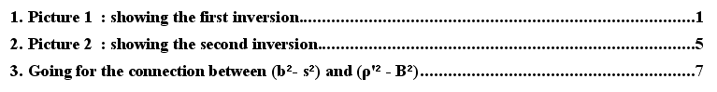

Here I finally made the decision to put the corresponding point as r" in the Pic 2 picture and to draw that picture to better show that this point r" corresponds to the point r in Pic 1. I decided to give up on the idea of using r as the corresponding point in each picture. For a while I did this and then tried to use italic angles θ,φ for the Pic 2 vector, but I got rid of that. There was a small cost for the Pic 2 picture in that we now have R" there and (R")' which is a little ugly, but highly localized unpleasantness. A good trade off for the immense increase in clarity.
I then proceeded to write down the "parameter relations" for Pic 1 and Pic 2 in separate sections with minimal mixing of the two sections. The one mix case was that in the Pic 1 section I wrote b and c in terms of θb and θc and then in the Pic 2 section I had ways to express these two angles in terms of Pic 2 parameters B and S and so I ended up with things like b = B (d2+ S2) / (B2- S2) .
So this doc then became my little "catalog" of useful equations that I could call upon when trying to solve the Smythe problem 38.
In Section 3 I tried to relate (b2- s2) and (ρ'2 - B2) using in-plane points only, but this really was not useful and it can be ignored.

2. How to Actively Rotate the Bowl

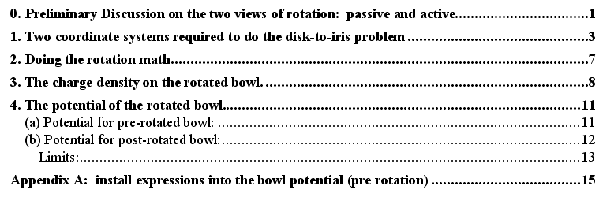

For me this was a breakthrough document, because I finally understood the double-prime coordinates. In retrospect it is all trivial, but I was mightily confused at the time. Various forces were pushing me in different directions, such as strongly wanting to have point r in Pic 2 instead of point r".
In Section (0) I give a simple example of the active vs passive rotation idea. If you need both component sets of a vector (in system S and system S'), one way is to put both r and the actively-rotated r' into the same system S picture. One result is no ' axis needed. I use a single prime in this section hence S' system, but in the application later I use double primes.
In Section (1), I talk about the two coordinate systems which naturally occur in the Smythe problem 38 double-inversion thing. I identify Pic 1 with system S and Pic 2 with S". But then as in the example I put both pictures into the same system S (so no " axis needed), and I show both r and r". I could do this for every point in the S" picture, but I only do it for a few key points, notably r". This was a major clarification for me!
In Section (2) I do the math which relates θ,φ to θ",φ". Concise and to the point, no need for full Euler angles or any of that stuff.
In Section (3) I start by writing down the pre-rotation σ on the bowl, taken from Attempt #2A. I verify that z' = d. I then trivially write σpost(r") = σ(r) and then I replace X stuff with X" stuff, it could not be simpler. I then repeat this before and after using θ,φ coordinates in place of X type coordinates. For example, I get

σpost(r") = σ(r) = – (a2/π2R3) /$\sqrt{b2-s2}$ s = $\sqrt{(x'-c)2 + y'2}$ d = a2/2A
R = 2A[sinθc sinθ"cosφ" - cosθc cosθ" + 1]
x' = (a2A/R2) [-cosθc sinθ"cosφ" - sinθc cosθ"]
y' = (a2A/R2) [sinθ"sinφ"
z' = (a2A/R2) [sinθc sinθ"cosφ" - cosθc cosθ" + 1] // = d

I then understand that all things like x', s and R are just distances in the Pic 1 picture which are here expressed in Pic 2 S" coordinates. Since I don't draw the disk in Pic 2, I cannot point there to distances like s and x', but I could draw them in if I wanted. But I do draw R in both pictures.
In Section (4) I move from σ to consideration of Φ. I copy the pre-rotation Φ from Attempt #2A, and process it just the same way. Nothing is really new except |r| ≠ A in the Φ case. I then start writing blocks of equations showing both σ and Φ at the same time, since the support equations are basically the same for both. Then getting the post-rotation forms is trivial. Just write Φpost(r") = Φ(r) and do the same replacement of θ,φ by θ",φ", but in this case we have scalar r" in place of A in certain places. My final result for both σ and Φ after rotation is this: (bowl after rotation, no second inversion involved)

Φpost(r") = Φ(r) = g(r|ξ) = – (2/πR) sin-1 [ 2b / ( $\sqrt{(s-b)2 + (z'-d)2}$ + $\sqrt{(s+b)2 + (z'-d)2}$ ) ] + 1/R
σpost(r") = σ(r) = – (2Ad/π2R3) /$\sqrt{b2-s2}$ // set r" = A below if doing σ

R = $\sqrt{r"2 + A2 – 2Ar"cosγ"}$ cosγ" = cosθc cosθ" - sinθc sinθ"cosφ"
s = $\sqrt{(x'-c)2 + y'2}$
x' = d(2Ar"/R2)[ -cosθc sinθ"cosφ" - sinθc cosθ"]
y' = d(2Ar"/R2) [sinθ"sinφ"]
z' = d(2Ar"/R2)( sinθc sinθ"cosφ" - cosθc cosθ"+A/r")

R = $\sqrt{X"2+ Y"2+ Z"2 + 2A[sinθcX" - cosθcZ"]}$
s = $\sqrt{(x'-c)2 + y'2}$
x' = (a2/R2)[ -cosθcX" - sinθcZ"]
y' = (a2/R2)Y"
z' = (a2/R2)( sinθcX" - cosθcZ"+A)

where I write the support block two different ways. The other required fact is this

c = d tan(θc/2) (1+ tan2(θb/2))/ (1 - tan2(θc/2) tan2(θb/2))
b = d tan(θb/2) (1+ tan2(θc/2))/ (1 - tan2(θc/2) tan2(θb/2))

Finally, in Appendix (A) I take a shot at finding a "simple form" solution for the iris potential to match the result I got ( = the Smythe Prob 38 result ) for σ (which occurred in the next doc I am about to review). My efforts here however are stymied by the structure of Φ which includes things like (s-b)2 + (z'-d)2 which requires s and not s2. But everything I write for s is then a square root, and I get messy root in a root stuff for Φ which is never going to simplify in Maple. I am sure there is a simple result and I hope to find it soon, or at least comment more on it. [ the final result really does have a root in a root! ]

3. Doing the Second Inversion

This is where I solved Smythe problem 38 and then later found the potential Φ. Here are the top level contents of this doc"

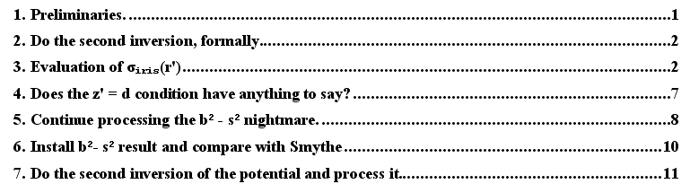

In Section (1) I review the status of things to this point.
In Section (2) I "do the second inversion" formally. There is of course nothing much to do, once you have the post-rotation σ and Φ for the bowl (as found in the last doc above). Here it is:

σiris(r') = (R"/a)3 σpost(r") = (R"/a)3 σ(r)
Φiris(r') = (R"/a) Φpost(r") = (R"/a) Φ(r)

the last items being the pre-rotation bowl quantities.
In Section (3) I attempt the details of evaluating σiris(r'). This involves doing things like replacing sinθ2 with 2dS/(d2+S2), that is, with iris parameters. Looking at the required quantities above, I found these intermediate results:

(cosθc sinθ"cosφ" + sinθc cosθ") = 2d [(d2- S2) ρ' cosφ" + S (d2- ρ'2)] / [(d2+S2) (d2+ ρ'2)]
(sinθ"sinφ) = [2d ρ'/(d2+ ρ'2)] sinφ" = [2d ρ' (d2+S2) sinφ" ] / [(d2+S2) (d2+ ρ'2)]
(1 - cosθc cosθ" + sinθc sinθ"cosφ" ) = 2d2 r12 / [(d2+S2) (d2+ ρ'2)]
R = 2Adr1/ $\sqrt{(d2+S2) (d2+ ρ'2)}$
b = B (d2+ S2) / (B2- S2)
c = S (B2+ d2) / (B2- S2)
x' = – (1/r12) [ρ' (d2- S2) cosφ" + S (d2- ρ'2)]
y' = (1/r12) [ρ' (d2+S2) sinφ" ]
s2 = (x'-c)2 + y'2 r12 = S2 + ρ'2 + 2Sρ' cosφ"

I then resized the iris charge from how it ends up in the inversion process to charge q1. At this point I have
σiris(r') = – (q1/ π2 r13) (d2+S2) / $\sqrt{b2-s2}$

and I have a "big mess" for quantity s. I have again arrived at the putative requirement. I then pause for a moment.
In Section (4) I show that we still have z' = d, even in our fancy double prime coordinates.
In Section (5) I then make my final assault on b2 - s2. I use the items for x' and y' shown above, and I replace cosφ" using the r1 expression. Then I jam it all into Maple and out popped this result:

b2 - s2 = [ (d2 + S2)2/ r12 ] (ρ'2- B2) / (B2-S2)

and amazingly this is exactly the putative thing I needed, and so Smythe 38 was finally solved!
In Section (6) I carefully show that this is really true. Ie, I derive the Smythe 38 solution.
In Section (7), written after some delay, I do the second inversion "formally" for Φ, and then I do lots of processing and checking of things. Since this section is 22 pages long, I will provide more detail here. The various subsections are numbered but are of highly variable length. Here is a dead contents:

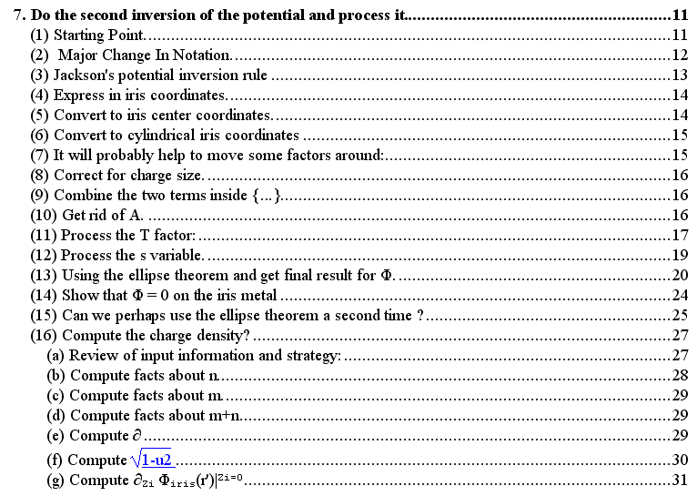

(1) Starting Point. Here we just have our post-bowl-rotation starting point for Φ and a Pic 2 picture.

(2) Major Change In Notation. Since I want to do a new inversion process, I change from r" to r type notation on the sphere. Then I can do a "standard" r to r' inversion procedure. So I restate Φ and draw a new picture, so this is our actual "starting point". We have already rotated the bowl into symmetric Pic 2 position:

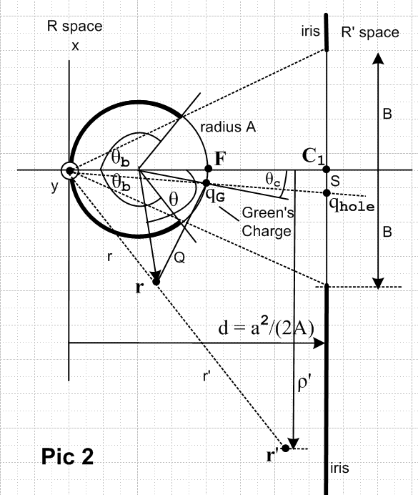

Φpost(r) = – (2/πQ) sin-1 [ 2b / ( $\sqrt{(s-b)2 + (w-d)2}$ + $\sqrt{(s+b)2 + (w-d)2}$ ) ] + 1/Q
σpost(r) = – (a2/π2Q3) /$\sqrt{b2-s2}$
Q = $\sqrt{x2+ y2+ (z-A)2 + 2A[sinθcx - cosθc(z-A)] + A2}$
s = $\sqrt{(u-c)2 + v2}$
u = (a2/Q2)[ -cosθcx - sinθc(z-A)]
v = (a2/Q2)y
w = (a2/Q2)( sinθcx - cosθc(z-A) +A)

Here I have replaced the old charged-disk symbols R,x',y',z' with Q,u,v,w to make sure we don't confuse these variables with any of our Pic 2 coordinates.

(3) Jackson's potential inversion rule. I now apply the simple inversion rule Φiris(r') = (a/r') Φpost(r) so we get the same result as above but with this extra (a/r') factor out front.

(4) Express in iris coordinates. But we want the above in terms of r' = (x',y',z') iris coordinates (not bowl coordinates), so we just use the result r = (a/r')2r' to accomplish this little goal.

(5) Convert to iris center coordinates. But those were inversion-centered coordinates, and we want (Xi,Yi,Zi) Cartesian iris centered coordinates, so that is another small adjustment. As we make these changes, the various expressions above keep getting messier.

(6) Convert to cylindrical iris coordinates . Now I replace Xi,Yi,Zi with cylindrical ρ', φ, Zi since this is certainly the best way to view the final results when we finally get those results!

(7) Now we just shuffle a few factors, and we arrive at this point where now Q = (a/r')2 T :

Φiris(r') = (r'/a) (1/T){ – (2/π) sin-1 [ 2b / ( $\sqrt{(s-b)2 + (w-d)2}$ + $\sqrt{(s+b)2 + (w-d)2}$ ) ] +1 }

T2 = ( ρ'2 + ( Zi+d-A(r'/a)2 )2 + 2A(r'/a)2 { sinθcρ'cosφ - cosθc [ Zi+d -A(r'/a)2] } + (r'/a)4A2 )
u = (r'2/T2) [ -cosθc ρ'cosφ - sinθc{ (Zi+d) - A(r'/a)2}]
v = (r'2/T2) ρ'sinφ Q = (a/r')2 T
w = (r'2/T2))( sinθc ρ'cosφ - cosθc[ (Zi+d) - A(r'/a)2] +A(r'/a)2)

so now the complexity is in factor T, and the leading (a/r') factor gets flipped to be (r'/a).

(8) Correct for charge size. The above Φ assumes that the point charge has the size it had in the first-inversion result. So we want to rescale it to some size q1 which we know how to do. This gets us to

Φiris(r') = q1 (r'/$\sqrt{S2+ d2}$ ) (1/T){ – (2/π) sin-1 [ 2b / ( $\sqrt{(s-b)2 + (w-d)2}$ + $\sqrt{(s+b)2 + (w-d)2}$ ) ]+1 }

(9) Combine the two terms inside {...} We next show how the sin-1 and +1 terms can be combined to get a single cos-1 term:

Φiris(r') = q1 (r'/$\sqrt{S2+ d2}$ ) (1/T)(2/π)cos-1 [ 2b / ( $\sqrt{(s-b)2 + (w-d)2}$ + $\sqrt{(s+b)2 + (w-d)2}$ ) ]

This is done using this little proof:

Proof: let sin-1X = θ, some angle. then

[ π/2 - sin-1X ] = [ π/2 - θ]

cos[ π/2 - θ] = sinθ => [ π/2 - θ] = cos-1 [ sinθ] = cos-1 [ X]

=> [ π/2 - sin-1X ] = cos-1X or cos-1X + sin-1X = π/2

where the last just says the two non-right angles in a right triangle add up to 90 degrees.

(10) Get rid of A. We know that our final result cannot possibly depend on things like A and d and a which relate to the sphere or the technical inversion process, but this fact is not manifest at this intermediate point. I decide to get rid of all A occurrences using A = a2/(2d). We then have various d and θc things still floating around, I just leave them in for awhile.

(11) Process the T factor: We next process the messy T expression shown above in (7). T2 looks like this after step (10),

T2 = ( ρ'2 + ( Zi+d-(r'2/2d) )2 + 2(r'2/2d) { sinθcρ'cosφ - cosθc [ Zi+d -(r'2/2d)] } + (r'2/2d)2 )

I then use

sinθc = 2dS/(d2+S2) cosθc = (d2- S2)/(d2+S2)

and with a Maple assist I find that

(2d)2 (d2+S2) T2 = (2d)2 [ ρ'2 + (Zi+d)2 ] ( ρ'2 + S2 + Zi2 + 2Sρ'cosφ )

I identify the rightmost paren as r12 which is the extension of our Smythe coordinate of this name, but here we have Zi ≠ 0. This is the distance from the Green's charge in the hole to point r'. The middle factor is r'2 where r' is the distance appearing in Pic 2 above. So we now have this very simple result for T:

1/T = $\sqrt{S2+ d2}$/ (r'r1) r12 = ρ'2 + S2 + Zi2 + 2Sρ'cosφ r'2= ρ'2 + (Zi+d)2

At this point, I knew I was on the right track. Installing this gave

Φiris(r') = (2q1/πr1) cos-1 [ 2b / ( $\sqrt{(s-b)2 + (w-d)2}$ + $\sqrt{(s+b)2 + (w-d)2}$ ) ]

and the "leading factor" never changes after this point. This factor no longer depends on d, and shows explicit Zi→ -Zi symmetry.

(12) Process the s variable. Our next task is to deal with the argument of cos-1 which involves the s and w factors. This is by far the most tedious part of the entire calculation. We are faced with

s = $\sqrt{(u-c)2 + v2}$
u = (r'2/T2) [ -cosθc ρ'cosφ - sinθc{ (Zi+d) - (r'2/2d)}]
v = (r'2/T2) ρ'sinφ
w = (r'2/T2){ sinθc ρ'cosφ - cosθc[ (Zi+d) - (r'2/2d)] +(r'2/2d) }

I install the 1/T result shown in (11) above, and install the same θc trig functions to get

(2d) r12u = 2d [ -(d2- S2)ρ'cosφ - S{ 2d(Zi+d) - r'2} ] ≡ u1
(2d) r12v = 2d ρ'sinφ (S2 + d2) ≡ v1
(2d) r12w = { (2d)2 Sρ'cosφ - (d2- S2) [ 2d(Zi+d) - r'2] +(S2 + d2) r'2 } ≡ w1
r12 = ρ'2 + S2 + Zi2 + 2Sρ'cosφ
r'2= ρ'2 + (Zi+d)2

where the three scaled parameters u1, v1, w1 are defined on the right. Then I rewrite

s2 = (u-c)2 + v2
as
[ (B2- S2) (2d) r12 ]2s2 = [ (B2- S2)u1 - [(2d) r12] S (B2+ d2) ]2 + [ (B2- S2) v1 ]2 ≡ s1s

We want to compute the RHS here in terms of the variables B,S,Zi,cosφ, sinφ, r1,d,ρ' . There are a lot of terms! We might have used this fact in both u1 and w1

{2d(Zi+d) - r'2} = (d2 - Zi2 - ρ'2)

Even if we had used this fact, you can see that, were we to manually install u1, v1, w1, the RHS of s1s would have this many terms: [ 2*5 + 2 ]2 + [2*2]2 = 122 + 16 = 160 "terms", where each term is a product of powers of dimension L12 of the list of variables just given. This is why we invoked Maple at this point (Smythe38phiwork.mws). I had Maple replace sin2φ with 1-cos2φ, and then replace

cosφ = (r12-[ ρ'2 + S2 + Zi2])/(2Sρ')

which reduced our variable list to B,S,Zi, r1,d,ρ'. Maple expanded and then factored and found this result for s1s:

s1s ≡ [ (B2- S2) (2d) r12 ]2s2 = (2d)2 (d2 + S2)2 h

where

where newly defined variable h has only 10 terms. So at this point, we had achieved this relatively compact result for our "calculation of s" :

[ (B2- S2) r12 ]2s2 = (d2 + S2)2 h

You might argue that the RHS here is 22*10 = 40 terms, but it factors so we really only have 10 terms to put into the next grinder. Notice, however, that if we were to solve this thing for s, we would get

s = factors * $\sqrt{h}$

Since our potential Φ contains expressions like $\sqrt{(s-b)2+ (w-d)2}$, we would get a very messy result by installing this expression for s! Luckily, I happened to know of a better way from my one-time study of ellipses in ellipses.doc.

(13) Using the ellipse theorem. This theorem applied to the current situation tells us that

( $\sqrt{(s-b)2+ (w-d)2}$+ $\sqrt{(s+b)2+ (w-d)2}$ )2

= 2(s2 + (w-d)2 + b2) + 2 $\sqrt{(s2 - (w-d)2- b2)2 + 4s2(w-d)2}$ ≡ dac2

and the square root of the LHS is what appears in the potential! I had Maple plug into the RHS expressions for s2 and w and b according to these results already obtained above

[ (B2- S2) r12 ]2s2 = (d2 + S2)2 h
b = B (d2+ S2) / (B2- S2)
(2d) r12w = { (2d)2 Sρ'cosφ - (d2- S2) [ 2d(Zi+d) - r'2] +(S2 + d2) r'2 } ≡ w1

After very much fiddling around, Maple and I came up with this relatively simple expression for the RHS of the ellipse theorem (RHS = dac2) shown above,

dac2 = 2 (B2- S2)-2r1-2 (d2+S2)2 (d2+S2)(m+n)

m = (ρ'2+Zi2)(S2-B2) + B2(B2- S2 + 2r12)
n = (B2- S2) $\sqrt{[ (ρ'-B)2+Zi2] [ (ρ'+B)2+Zi2]}$

But since

dac2 = ( $\sqrt{(s-b)2+ (w-d)2}$+ $\sqrt{(s+b)2+ (w-d)2}$ )2

we take the square root to get

dac ≡ $\sqrt{(s-b)2+ (w-d)2}$+ $\sqrt{(s+b)2+ (w-d)2}$ = $\sqrt{2}$(B2- S2)-1r1-1 (d2+S2) $\sqrt{m+n}$

and this is the thing that appears in the denominator of the cos-1 function in our potential Φ. So the complete argument of cos-1 is then 2b/dac and we replace b = B (d2+ S2) / (B2- S2) to get

2b / ( $\sqrt{(s-b)2 + (w-d)2}$ + $\sqrt{(s+b)2 + (w-d)2}$ ) = $\sqrt{2}$ Br1 /$\sqrt{m+n}$

so our result for the potential of the iris is this:

Φiris(r') = (2q1/πr1) cos-1 [ $\sqrt{2}$Br1 /$\sqrt{m+n}$ ]
σiris = -( q1/2π2r12)$\sqrt{B2-S2}$/ $\sqrt{ρ'2 - B2}$
m = (ρ'2+Zi2)(S2-B2) + B2(B2- S2 + 2r12)
n = (B2- S2) $\sqrt{[ (ρ'-B)2+Zi2] [ (ρ'+B)2+Zi2]}$
r12 = ρ'2 + S2 + Zi2 + 2Sρ'cosφ (r1 is the distance from the point charge to r' )
S = distance from hole center to the point charge q1 sitting in the iris hole at φ=π
B = radius of the iris hole
r' = (Zi, ρ', φ) = cylindrical coordinates of point r' relative to hole center.

As expected, the inversion technology parameter d has vanished, and ±Zi symmetry is manifest since only the quantity Zi2 appears. At this point, we might do one rewrite to use a simpler notation for export of this result to other places: ( I throw in the expression for σiris found earlier)

Φiris(r) = (2q1/πr1) cos-1( $\sqrt{2}$Br1 / $\sqrt{m+n}$ ) // export results
σiris = -( q1/2π2r12)$\sqrt{B2-S2}$/ $\sqrt{ρ2 - B2}$

m = (ρ2+z2)(S2-B2) + B2(B2- S2 + 2r12)
n = (B2- S2) $\sqrt{[ (ρ-B)2+z2] [ (ρ+B)2+z2]}$
r12 = ρ2 + S2 + z2 + 2Sρcosφ (r1 is the distance from the point charge to r )
S = distance from hole center to the point charge q1 sitting in the iris hole at φ=π
B = radius of the iris hole
r = (z, ρ, φ) = cylindrical coordinates of point r relative to hole center.

I have never seen this Φ result reported anywhere, but it surely must be out there somewhere. If we set q1 = 1, then Φiris(r) is the Green's Function for an iris for the special case that the point charge lies somewhere in the hole (which we define to be at φ = 0).
The Φiris shown here is the total potential due to the induced charge on the iris and the point charge. If we want the potential just due to the induced charge we would write

Φinduced(r) = Φiris(r) - q1/r1

But this is easy to compute, and we use this result cos-1X + sin-1X = π/2

(2q1/πr1) cos-1x - q1/r1 = (2q1/πr1) [cos-1x - π/2] = - (2q1/πr1) sin-1x
so that
Φinduced(r) = - (2q1/πr1) sin-1( $\sqrt{2}$Br1 / $\sqrt{m+n}$ )

Comment 1: Φ and σ don't simplify much when you set S = 0. Only m becomes simpler.

Comment 2: The only place Φ blows up is at the point charge.

Comment 3: I expect the Ez electric field to blow up at the rim where σ = -∞.

(14) Show that Φ = 0 on the iris metal If we set Zi = 0, then we have

n = (B2- S2) $\sqrt{[ (ρ'-B)2+Zi2] [ (ρ'+B)2+Zi2]}$ = (B2- S2) $\sqrt{[ (ρ'-B)2] [ (ρ'+B)2]}$

= (B2- S2) | ρ' - B | (ρ'+B)

If we are on the iris surface, then | ρ' - B | = (ρ'-B) , whereas in the hole | ρ' - B | = (B-ρ') and this is why the result is different on the iris versus in the hole for Zi= 0. The reason Φ = 0 on the iris is this:

$\sqrt{2}$Br1 / $\sqrt{m+n}$ = 1 so cos-1 [ $\sqrt{2}$Br1 / $\sqrt{m+n}$ ] = 0 => Φ = 0

so all we have to do is show that m+n = 2B2r12. This fact is trivial to show if we just use m and n as discussed above ( Zi = 0 everywhere including inside r1)

m = (ρ2)(S2-B2) + B2(B2- S2 + 2r12) = - (B2- S2)(ρ'2-B2) + 2B2r12
n = (B2- S2) | ρ' - B | (ρ'+B) = (B2- S2) (ρ'-B) (ρ'+B) = (B2- S2)(ρ'2-B2) QED

Inside the hole, however, n has the opposite sign, so we get

m+n = - 2(B2- S2)(ρ'2-B2) + 2B2r12

and then cos-1 [ $\sqrt{2}$Br1 / $\sqrt{m+n}$ ] is some non-constant function of ρ' and φ' .

(15) Can we perhaps use the ellipse theorem a second time ? I thought there might be some other way to write the final result Φ with a sum of two square roots inside the cos-1 denominator. I gave up on this effort and concluded that the form given above is simple as it stands.

(16) Compute the charge density? This of course is "the big test" of the above result. We already know that σ on either side of the metal iris is given by this expression

σ = -( q1/2π2r12)$\sqrt{B2-S2}$/ $\sqrt{ρ'2 - B2}$

so our task is to show that

∂Zi Φiris(r')|Zi=0 = -4πσ = ( 2q1/πr12)$\sqrt{B2-S2}$/ $\sqrt{ρ'2 - B2}$

I was able to verify this fact from the potential given above. To see how this goes, you can look at steps (a) through (g) is the doc we are now reviewing! It took me a while to get it right. This then is pretty solid evidence that the result for Φ is correct. My later plots are not bad either of the field lines.

4. Iris plots

Here I just show some plots of the potential , the induced charge potential, and σ on the iris. [ These are in fact very nice Maple plots! ]

Comments: ( written before I computed Φ as reported above in Section 7 of last doc)

I know of course that there does exist some nice result for Φiris, but I don't know what it is, I have never seen it stated anyway. It will probably have a structure similar to that of the charged disk potential Weber form. It will have that same idea for what happens at the edge but instead of (ρ±a)2 + Zi2 in the square roots we will have something like (B ± ρ')2 + Zi2 . We will then get V = 0 on the iris by the same mechanism. [ this conjecture was correct! ]
Of course this would be a Green's problem for an iris, not a charged iris. I presume that there IS no charged iris problem! There is nothing to stop all the charge from running off to ∞ and then σ = 0 everywhere on our "charged iris". You need the Green's charge in the hole to hold some charge there!
[ BUT, see Smythe hole in plate doc! There is in fact such a charged iris problem! ]
I once conjectured some simple relationship between disk and iris problems, "where you do 1/r somehow and the middle of the disk goes to infinity etc". Well that turns out to be exactly "the inversion method". And the only way to relate disk to iris by that method is by what we have done above: inversion-rotation-inversion. I don't see any inversion method that does not use the bowl as an intermediate object. [ I was blinded! Guilty of 3D thinking when 2D thinking was needed! And there IS in fact a very simple relationship between the iris and disk solutions. ]
Many questions are now left over, I will attempt a partial list:

(1) Now that I know the Smythe σ is correct, I ought to be able to show that it solves the integral equation for the iris that I once wrote somewhere. At that time I was unsure the σ was even right, so I was not too motivated to work hard on this integral equation.

[ Integrals are too hard for me to do! See "Iris Green's Function attempt using the Stak integral equation method.doc" in iris folder. ] [ I may have done this much later after Sneddon reading. ]

(2) I should compute the potential Φ as an integral over the known iris σ and try to get a simple form that is Weber-like.

[ In "attempt to integrate...doc" I try to do this a few ways, but the integrals are too hard for me to do.]

(3) I should try to compare my σ result to the result I got in oblate spheroidals which is some kind of fancy sum of special functions.

[ My messy double sum results are given in E&M\Smythe\Green's for Oblate Hyperboloid doc 5. ]

(4) I should try to learn the more powerful modern methods of solving problems like the integral equation and see why the σ result for the iris is as simple as it is.

(5) I am wondering about the Green's problem of a point charge off the edge of a metal half plane. Maybe can get this as a limit of the iris problem.

[Knowing now (much later) the disk result, you could move the Green's charge very close to the edge of the disk and somehow replace ρ,θ with Cartesian coordinates and probably get a result. ] [ Or work with an extruded half line and use 2D stuff. ]

(6) I should do Smythe's follow-on problems that depend on his Problem 38 result. I think they were good ones giving useful results.

[ I eventually did all these problems. ]

(7) I still want to know more about the spherical bowl. For example, about the charged spherical bowl that Kelvin did, I still have not derived a result for that thing, and there are lots of old mysteries that I left hanging! The barrel can also be considered, as well as the annular ring.

