Parameter facts for Pic 1 and Pic 2 PhL 6.15.10

I am writing this after writing "How to Actively rotate the bowl.doc", where I decided to use θ,φ in Pic 1, but to use θ",φ" in Pic 2. This forces me to think about every angle encountered.

Overview (1/2 page, written 12.5.10) 1
1. Picture 1 : showing the first inversion. 1
2. Picture 2 : showing the second inversion. 5
3. Going for the connection between (b²- s²) and (ρ'² - B²) : in-plane only 8

_________________________________________________________________________________

Overview (1/2 page, written 12.5.10)

In Section 1 I collect and derive a set of "facts" labeled (a) though (g) which relate only to the Pic 1 picture shown blow, which relates to the first inversion problem.

In Section 2 I collect and derive a set of "facts" labeled (a) though (g) which relate only to the Pic 2 picture shown blow, which relates to the second inversion problem.

In Section 3 I try to find the connection between quantity (b2-s2) from the charged-disk space picture and the quantity (ρ'2-B2) from the final iris picture. I try to find this relation using the simple facts collected in this doc, but I am not successful, nor did I try too hard. Later I derive this relationship in "doing the second inversion", and that relation is this:

(b2 - s2) = (ρ'2- B2) (d2 + S2)2 /[ r12(B2-S2)] where r12 = S2 + ρ'2 + 2Sρ' cosφ"

This was so messy to derive that I had to have a Maple assist! There is doubtless some reason it comes out so relatively simple, but I don't know what it is. It is something Kelvin would know. It really involves the 3D geometry of things, and my Pic 1 and Pic 2 pictures are just 2D slices.
_________________________________________________________________________________

1. Picture 1 : showing the first inversion.

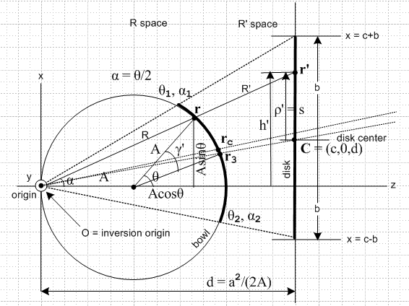

(a) From inversion we know that

r' = (a2/R2) r and thus R' = (a2/R) ( general φ)

(a1) Concerning R we know the following for in plane r :

R2 = (Asinθ)2 + (A+Acosθ)2 = A2 + A2 + 2AA cosθ = 2A2(1+cosθ) = 4A2cos2(θ/2)

=> R = 2A cos(θ/2) // φ = 0 only

(a2) Concerning the Green's Point charge at the origin and Q on the disk. For the disk on the right in Pic 1 we add the following constant potential

-V = -Q/C C = (2/π)b

We then find that by adjusting Q such that

Q = -C/a = -(2/π)(b/a) = - (2b/πa)

we cause the Green's point charge at the inversion in the bowl R space picture to be +1.

(b) staring at the picture we can see right triangles for these three positive polar angles,

tan(θ/2) = (s+c)/d // valid when φ = 0 so r is in the plane of paper
tan(θ1/2) = (b+c)/d
tan(θ2/2) = (b-c)/d

I am willing to restrict my interest (for now) to the situation c > 0 and b > c, as the picture show. Thus, the RHS of the last two expressions are positive, which corresponds to having positive θ1 and θ2. These must be positive if I am calling them polar angles.

We can solve the lower two equations for b and c:

b = (d/2) [tan(θ1/2) + tan(θ2/2) ]
c = (d/2) [tan(θ1/2) – tan(θ2/2) ]

(c) We can define a positive "polar bowl angle" in an obvious manner,

θb = (θ1+θ2)/2 // θb lies in the range (0,π)

(d) Suppose we rotate the circle CW by a small angle ψ. The upper limit moves to θ1 - ψ and the lower moves to θ2 + ψ. We can make these two angles equal by setting θ1 - ψ = θ2 + ψ => 2ψ = (θ1- θ2). We shall give this angle ψ the name θc, so we have

θc = (θ1-θ2)/2

I did things differently in Attempt #1, mainly I now think of θ2 > 0 as well as θ1 > 0. We inverse solve the last two equations to get

θ1 = (θb+ θc)
θ2 = (θb– θc)

In the picture I have drawn rc appearing at angle θc and I make note that the inversion line through r3 does NOT pass through the center of the disk. For this reason, I don't have any simple tan(θc/2) type expression for Pic 1.

(e) Now here is more on b and c. First, I copy from Attempt #1, checking every step,

Lemma: (stated after Therefore about 6" below)

tan(A+B) ± tan(A-B) = (tanA +tanB)/(1-tanA tanB) ± (tanA -tanB)/(1+tanA tanB)

= [ (tanA +tanB) (1+tanA tanB) ± (tanA -tanB) (1-tanA tanB) ] / (1 - tan2A tan2B)

= [ (α +β) (1+α β) ± (α -β) (1- α β) ] / (1 - α2β2)

Let's do the two signs separately. First the + sign

N+ = (α +β) (1+α β) + (α -β) (1- α β)

= α + β + α2β+ αβ2 + α - β - α2β + αβ2

= α + αβ2 + α + αβ2 = 2α + 2αβ2 = 2α(1+β2)

N- = (α +β) (1+α β) - (α -β) (1- α β)

= α + β + α2β+ αβ2 - α + β + α2β - αβ2

= β + α2β + β + α2β = 2β + 2βα2 = 2β(1+α2)

Therefore:

tan(A+B) + tan(A-B) = 2 tanA (1+ tan2B)/ (1 - tan2A tan2B)
tan(A+B) - tan(A-B) = 2 tanB (1+ tan2A)/ (1 - tan2A tan2B)

Now set A = (θc/2) and B = (θb/2) and we then find that

tan((θc/2)+ (θb/2)) + tan((θc/2)- (θb/2)) = 2 tan(θc/2) (1+ tan2(θb/2))/ (1 - tan2(θc/2) tan2(θb/2))
tan((θc/2)+ (θb/2)) - tan((θc/2)- (θb/2)) = 2 tan(θb/2) (1+ tan2(θc/2))/ (1 - tan2(θc/2) tan2(θb/2))

Now replace

(θc/2) + (θb/2) = (θ1/2)
(θc/2) - (θb/2) = - (θ2/2)

And the above then says:

tan(θ1/2) - tan(θ2/2) = 2 tan(θc/2) (1+ tan2(θb/2))/ (1 - tan2(θc/2) tan2(θb/2))
tan((θ1/2)) + tan(θ2/2) = 2 tan(θb/2) (1+ tan2(θc/2))/ (1 - tan2(θc/2) tan2(θb/2))

Then from above we have

b = (d/2) [tan(θ1/2) + tan(θ2/2) ] = d tan(θb/2) (1+ tan2(θc/2))/ (1 - tan2(θc/2) tan2(θb/2))
c = (d/2) [tan(θ1/2) – tan(θ2/2) ] = d tan(θc/2) (1+ tan2(θb/2))/ (1 - tan2(θc/2) tan2(θb/2))

which lets us relate disk parameters b and c to bowl parameters θb and θc. To invert these you would have to do this:

θb = (θ1+θ2)/2 = (1/2) [ 2 tan-1((b+c)/d) + 2 tan-1((b-c)/d)] = tan-1((b+c)/d) + tan-1((b-c)/d)
θb = (θ1–θ2)/2 = (1/2) [ 2 tan-1((b+c)/d) – 2 tan-1((b-c)/d)] = tan-1((b+c)/d) – tan-1((b-c)/d)

(f) For r in the plane (only) we have a similar set of equations involving θ, based on tan(θ/2) = (s+c)/d from above. [ never used these result ]

tan(θ/2) = (s+c)/d cos(θ/2) = d/$\sqrt{(s+c)2 + d2}$ sin(θ/2) = (s+c)/$\sqrt{(s+c)2 + d2}$
sinθ = 2d(s+c)/(d2+(s+c)2)
cosθ = (d2- (s+c)2)/(d2+(s+c)2) // all for r in plane only

(g) Now we want to solve for Smythe's b2 - s2. We know from the in-plane r case that
[ never used results of this section]

tan(θ/2) = (s+c)/d
tan(θ1/2) = (b+c)/d

Rewrite as

s = d tan(θ/2) - c

Then we have this fairly simple result

s2 = (d tan(θ/2) - c)2

b2- s2 = b2 - (d tan(θ/2) - c)2 φ = 0

which gives our Smythian quantity b2- s2entirely in terms of bowl parameters, if we recall that

b = d tan(θb/2) (1+ tan2(θc/2))/ (1 - tan2(θc/2) tan2(θb/2))
c = d tan(θc/2) (1+ tan2(θb/2))/ (1 - tan2(θc/2) tan2(θb/2))

Then we have this

b2 - s2 = F( θ, θc, θb, d)

so we have our result entirely in terms of bowl parameters. As we rotate the bowl to get to Pic 2, we will have to deal with θ, but the other three parameters won't change.

Comment: In order to get our b2- s2 expression here, we had no need to consider r out of the plane.

2. Picture 2 : showing the second inversion.

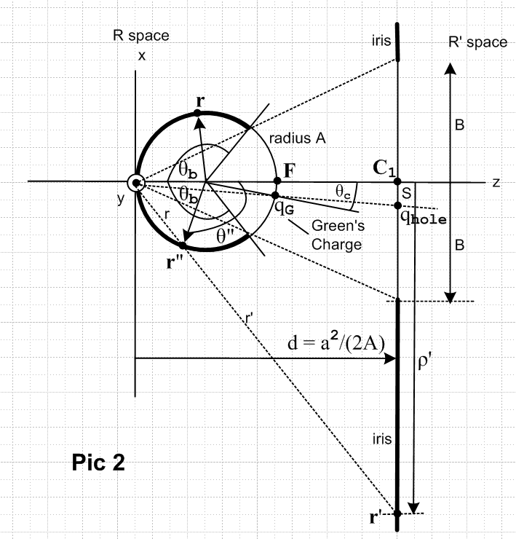

We arbitrarily use the same d as in the previous inversion to reduce symbol clutter. Some of our "facts" will be true for general θ",φ" while others will only be valid for φ" = π (in the plane).

(a) Start with these facts obtained from the picture, where r is in plane

tan[(π-θb)/2] = B/d = cot(θb/2)
tan(θ"/2) = ρ'/d

and this last item I can expand as

tan(θ"/2) = (ρ'/d) cos(θ"/2) = d/$\sqrt{ρ'2 + d2}$ sin(θ"/2) = ρ'/$\sqrt{ρ'2 + d2}$
sinθ" = 2d ρ'/(d2+ ρ'2)
cosθ" = (d2- ρ'2)/(d2+ ρ'2)

Repeating the original two items,

ρ' = d tan(θ"/2)
B = d cot(θb/2)

Then

ρ'2 - B2 = d2 [ cot2(θb/2) - tan2(θ"/2) ]

So right off the bat we have our desired quantity entirely in bowl parameters!

(b) We have some nice θc trig formulas now in Pic 2 (nothing simple in Pic 1)

tan(θc/2) = S/d

which leads to this group of trig formulas:

tan(θc/2) = S/d cos(θc/2) = d/$\sqrt{S2 + d2}$ sin(θc/2) = S/$\sqrt{S2 + d2}$
sinθc = 2dS/(d2+S2)
cosθc = (d2- S2)/(d2+S2)

(c) Other facts:

(R" ') = (a2/R") // since these are inversion points (general φ)

(R" ') 2 = ρ'2+ d2 // right triangle (general φ)

θ"= π - (θ-θc) // (derived in next section) (φ = 0 only)

(d) looking at Pic 1 (a1), the following must also be true for Pic 2

R" = 2A cos(θ"/2)

(e) Concerning the point charges: The point charge on the bowl's sphere is a positive unit charge, since that is how it came to us from the first inversion process where we scaled Q on the disk as discussed above. The bowl's unit point charge is located θ,φ = θc, π as shown in the picture.
The in-iris-hole charge is located a distance S directly below the iris center, as shown above. The size of the hole-in-iris charge can be found from basic inversion theory,

q'i = qi(a/ri) = (ri'/a) ,

and in our case the unprimed charge qi = 1 is located at θc , qi' = qhole, ri' = $\sqrt{S2+ d2}$which is the inversion distance from the inversion origin to the hole charge, as the picture shows. Thus

qhole = ($\sqrt{S2+ d2}$/ a)

(f) If we draw Smythe's r1 vector on the iris, we get this equation

r12 = S2 + ρ'2 + 2Sρ' cosφ"

(g) We can use these facts

tan(θb/2) = (d/B)
tan(θc/2) = (S/d)

to related c and d to iris parameters. From our Pic 1 section above we had

b = d tan(θb/2) (1+ tan2(θc/2))/ (1 - tan2(θc/2) tan2(θb/2))
c = d tan(θc/2) (1+ tan2(θb/2))/ (1 - tan2(θc/2) tan2(θb/2))

so we install to get

b = d (d/B) (1+ (S/d)2)/ (1 - (S/d)2 (d/B)2)
c = d (S/d) (1+ (d/B)2)/ (1 -(S/d)2 (d/B)2 )

b = d2 (1/B) (1+ (S/d)2)/ (1 - (S/B)2 )
c = S (1+ (d/B)2)/ (1 - (S/B)2)

b = d2 B (1+ (S/d)2)/ (B2- S2)
c = S (B2+ d2)/ (B2- S2)

Final results: ( these agree with earlier work in Attempt #2A)

b = B (d2+ S2) / (B2- S2)
c = S (B2+ d2) / (B2- S2)

3. Going for the connection between (b2- s2) and (ρ'2 - B2) : in-plane only

[ results of this section never used, a good section to just ignore! ]

From our document on "How to rotate the bowl", we know that for "corresponding points"

cosθ" = -sinθcsinθcosφ - cosθccosθ

Now in our special case we have φ = 0, and we (luckily) studied this case in detail in section " Question: How are (θ,φ) and (θ",φ") related to each other?" subsection "Special case φ = 0". Our conclusion there was
φ = 0 => θ" =
φ" =

This discussion concerned corresponding points r" = Ry(π-θc)r . In our case, our Pic 1 shows that we have (θ-θc) > 0. Therefore, the point in Pic 2 which corresponds to the point in Pic 1 is this

θ" = π - (θ-θc)
φ" = π

Luckily, only θ" is of concern to us since only it shows up in our Smythian quantity above. So we can compute

tan(θ"/2) = tan[(π - (θ-θc))/2] = cot[(θ-θc)/2]

Therefore we can say

ρ'2 - B2 = d2 [ cot2(θb/2) - tan2(θ"/2) ]

= d2 ( cot2(θb/2) - cot2[(θ-θc)/2] )

where we now have the Pic 1 angle involved. So we can now consider our two expressions:

(b2- s2) = b2 - (d tan(θ/2) - c)2 φ = 0

(ρ'2 - B2) = d2 ( cot2(θb/2) - cot2[(θ-θc)/2] ) φ = π

The point is that both lines have the Pic 1 angle θ now. This is the closest I have ever been to connecting these two quantities! We also know that

b = d tan(θb/2) (1+ tan2(θc/2))/ (1 - tan2(θc/2) tan2(θb/2))
c = d tan(θc/2) (1+ tan2(θb/2))/ (1 - tan2(θc/2) tan2(θb/2))

Now I have both expressions in terms of "bowl parameters" and that was the goal. I regard the amount of bowl rotation π-θc as one of our "bowl parameters".
So let's let this result just sit for a while. One could in theory eliminate θ between the two expressions, but let's not attempt that right now.

