How to Actively Rotate the Bowl PhL 6.15.10

Overview (3.5 pages, written 12.5.10) 1
0. Preliminary Discussion on the two views of rotation: passive and active 4
1. Two coordinate systems required to do the disk-to-iris problem 6
2. Doing the rotation math. 11
3. The charge density on the rotated bowl. 12
4. The potential of the rotated bowl. 14
(a) Potential for pre-rotated bowl: 14
(b) Potential for post-rotated bowl: 15
Limits: 17
Appendix A: install expressions into the bowl potential (pre rotation) 18

_________________________________________________________________________________

Overview (3.5 pages, written 12.5.10)

In Section 0 I give a very excellent description of passive versus active which could be lifted out of this doc and put in some more general place. In the passive view, we look at a vector r in two systems S and S' related by a z rotation, there is no vector r' whatsoever, we have r = (x,y,z) = (x',y',z')' . The axes of system S' are obtained from those of S by a negative z rotation, for example, ' = Rz(-ψ ) . I argue that the active point of view, where a new vector r' = Rz(ψ) r appears in space S, has several important practical advantages. The pictures used to explain how the active view arises are these: [ ψ ~ 10o and z axis toward viewer ]

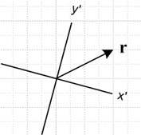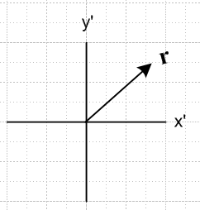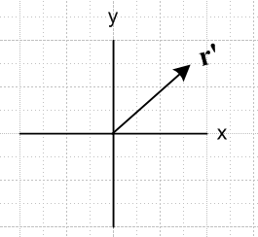

Passive on the left, intermediate in the middle, and active on the right. The advantages are that we don't have to draw tilted axes, and we don't have to put primes on our axes.
This section serves as a template for the notation to be used in rotating the bowl in the next section, except prime becomes double-prime in the next section because primes are already "used up" as coordinates in the charged disk space R'. So we will be thinking below of two systems S and S" (also called R and R").

In Section 1 we think of space S as our Pic1 bowl picture (pre-rotation) and space S" as the frame of reference we could use to project the same unmoved bowl onto an iris. Instead of r' = Rz(ψ) r as in our template, we have here that r" = Ry(π-θc) r which follows from pictures below. The S" stuff is drawn in red, and we draw the pictures corresponding to those above in this way (larger pictures appear below of course). [Here ψ = π-θc ~ 120o and y axis toward viewer.] The red axes lose their tilt in the second picture, and lose their double primes in the third picture, which picture we call Pic 2.

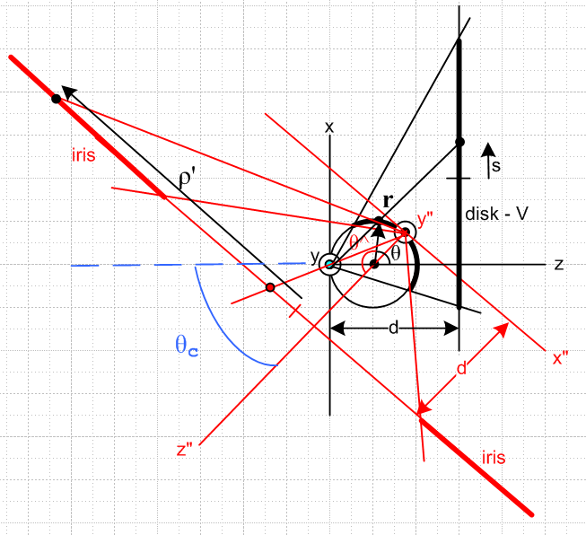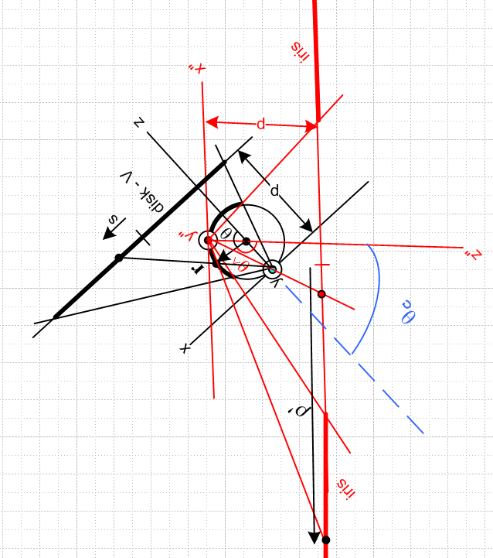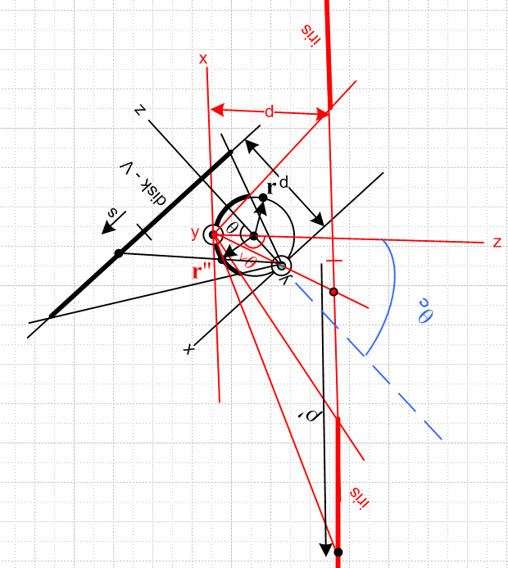

Because I was so crashingly confused at the time I was doing this by my previous (now expunged) bad notation, I carefully defined a phrase "corresponds to". For example, if you start with some point r' in the charged disk space R', it "corresponds to" (maps into by first inversion) a certain point r in space R. When we take our active rotation view, that point r ends up as point r" = Rz(π-θc) r also in R space. The point say is just a point on the bowl which is at r before the active rotation of the bowl, and at r" after same. It is the same point on the bowl, but the bowl has been rotated so the point moves in R space.
We then end up with this method of parameterizing things before and after the bowl rotation:

inversion- sphere-
centered centered
r = (R,α,φ) = (r,θ,φ) spherical // note that α =θ/2 only for r on sphere
r = (x,y,z) = (X,Y,Z) Cartesian // x = X, y=Y, z=Z+A

inversion- sphere-
centered centered
r" = (R",α",φ") = (r",θ",φ") spherical //note that α" =θ"/2 only for r" on sphere
r" = (x",y",z") = (X",Y",Z") Cartesian // x" = X", y"=Y", z"=Z"+A

In each case (pre and post rotation) we have four parameterizations! This is why things were complex. Notice that when we say r" = Rz(π-θc) r, the vectors are sphere-centered.
Lest the point be missed, the notation is confusing because we also have 4 distinct "spaces" to think about in our invert-rotate-invert picture. The first is R' of the charged disk, the second is R of the Pic 1 bowl. The third is R" of the rotated bowl, but we don't use this space at all because we take the active view and draw the post-rotated bowl in R space where points have double-prime coordinates. The final space is a different R' space which is that for the iris with point charge in its hole.

In Section 2 we write out the three equations implied by r" = Rz(π-θc) r . We do this in both Cartesian and spherical coordinates, and in each case we invert the equations. Results are:

X" = -cosθcX + sinθcZ X = -cosθcX" - sinθcZ"
Y" = Y Y = Y"
Z" = - sinθcX - cosθcZ Z = sinθcX" - cosθcZ"

sinθ"cosφ" = -cosθc sinθcosφ + sinθc cosθ sinθcosφ = -cosθc sinθ"cosφ" - sinθc cosθ"
sinθ"sinφ" = sinθsinφ sinθsinφ = sinθ"sinφ"
cosθ" = - sinθc sinθcosφ - cosθc cosθ cosθ = sinθc sinθ"cosφ" - cosθc cosθ"

In Section 3 I carry out the rotation for σ (deferring Φ to Section 4). Basically, all this means is I write σ"(r") = σ(r) and then try to get everything expressed in post-rotation R" coordinates. The σ(r) comes from the first inversion process, where we see some leftover R' charged-disk space coordinates which we can just regard as temporary intermediary variables,

σ(r) = – (a2/π2R3) /$\sqrt{b2-s2}$ s = $\sqrt{(x'-c)2 + y'2}$ d = a2/2A
x' = (a2/R2)X y' = (a2/R2)Y z' = d = (a2/R2)(Z+A) R = $\sqrt{X2+ Y2+ (Z+A)2}$

I use the Section 2 equations shown above to get rid of X,Y,Z in favor of X",Y",Z", and I also express the result in terms of A,θ",φ". Since σ only exists on the bowl, we have this fixed radius A. Here is the latter result:
σpost(r") = σ(r) = – (a2/π2R3) /$\sqrt{b2-s2}$ s = $\sqrt{(x'-c)2 + y'2}$ d = a2/2A
R = 2A[sinθc sinθ"cosφ" - cosθc cosθ" + 1]
x' = (a2A/R2) [-cosθc sinθ"cosφ" - sinθc cosθ"]
y' = (a2A/R2) [sinθ"sinφ"
z' = (a2A/R2) [sinθc sinθ"cosφ" - cosθc cosθ" + 1] // = d

I end the section with a few "interpretive" questions I wonder bother to mention here.

In Section 4 I carry out the rotation for Φ. Again, this just means Φ"(r") = Φ(r) and convert the coordinates to S" space. Since r is now an arbitrary point in space, no longer confined to the bowl, things are a little messier.
In part (a) I quote the potential Φ(r)for the pre-rotated bowl,

Φ(r) = g(r|ξ) = – (2/πR) sin-1 [ 2b / ( $\sqrt{(s-b)2 + (z'-d)2}$ + $\sqrt{(s+b)2 + (z'-d)2}$ ) ] + 1/R
σ(r) = – (a2/π2R3) /$\sqrt{b2-s2}$
R = $\sqrt{X2+ Y2+ (Z+A)2}$
s = $\sqrt{(x'-c)2 + y'2}$
x' = (a2/R2)X
y' = (a2/R2)Y
z' = (a2/R2)(Z+A)

and I show it in both X,Y,Z (above) and r,θ,φ notations.
In Appendix A I asked Maple to insert the above expressions for s,x',y',z' into Φ and all it did was generate a huge mess for the sum of the two radicals, so I did not pursue that further.
In part (b) I used the r,θ,φ of Φ form with the Section 2 angle equations above to get everything into r",θ",φ" coordinates. After pondering a few "limits" on the shape of the bowl, I express Φ in terms of the X",Y",Z" coordinates as well. Then, anticipating the need for a second inversion process, I convert this result to inversion-origin coordinates x",y",z". Here is how we end up:

Φpost(r") = Φ(r) = g(r|ξ) = – (2/πQ) sin-1 [ 2b / ( $\sqrt{(s-b)2 + (w-d)2}$ + $\sqrt{(s+b)2 + (w-d)2}$ ) ] + 1/Q
σpost(r") = σ(r) = – (a2/π2Q3) /$\sqrt{b2-s2}$
Q = $\sqrt{x"2+ y"2+ (z"-A)2 + 2A[sinθcx" - cosθc(z"-A)] + A2}$
s = $\sqrt{(u-c)2 + v2}$
u = (a2/Q2)[ -cosθcx" - sinθc(z"-A)]
v = (a2/Q2)y"
w = (a2/Q2)( sinθcx" - cosθc(z"-A) +A)

Here I replace certain x',y',z' with u,v,w because we are going to soon have a whole new R' world which will be that of the iris! We will be doing the R to R' second inversion. Many of my "forms" of things never got used, I was just trying to be "complete".
__________________________________________________________________________________

0. Preliminary Discussion on the two views of rotation: passive and active

This simple subject is always confusing, even if you have done it 500 times before, so I feel these brief notes are justified, and I will refer back to these notes later on. The problem is mainly with "the words" you use. If you cannot say the words, then you do not really understand what you are doing.

Imagine two coordinate systems S and S'. A unit vector in S would be , one in S' would be '. In the passive view, we can think of a vector r as having components x,y,z in S, and x',y',z' in S'. In order to indicate this unambiguously, we might write

r = (x,y,z) = (x',y',z')'

r = (r•) + (r•) + (r•) = (r•') ' + (r•') ' + (r•') '
= x + y + z = x' ' + y' ' + z' '

where we add the extra prime after the rightmost paren to say these are components in S'. There is only one vector r, and we "measure it" in two different coordinate systems and therefore we get two different triplets of numbers to represent r. Here is the usual picture one draws to illustrate this situation, where S and S' are related by some z rotation, and we only show the x,y plane,

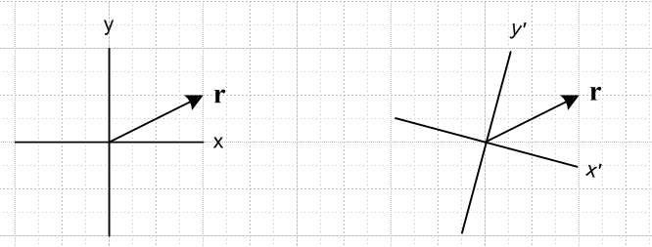

We might say S' = Rz(-ψ )S by which we mean for example ' = Rz(-ψ ) and in our picture perhaps we have ψ = 10 degrees ( points to the viewer + RH rule ). So this is the classic "passive view" where we have "the same vector" in space (it could be any vector, not just a position vector), and we observe it from two coordinate systems, where S' is "back rotated" relative to S by ψ degrees.
Notice that we have no need at this point for the notation r' . There is no vector r'.
Now, a person working in coordinate system S' gets tired of drawing pictures tilted all the time and wants them to be aligned with paper. That person would draw the right side picture this way

In other words, that person takes the right picture above and rotates everything by Rz(ψ) including the axes. For example, (' in new picture) = Rz(ψ) ( ' in old tilted picture). The vector is still just r and is still being drawn in the space S'.
Now our person decides it is painful to constantly put primes on the axis labels, and comes up with a new idea which is the active viewpoint. That person says: " instead of keeping r fixed and back-rotating S to get S', I will instead just always work in coordinate system S and I will forward-rotate vector r and I will call that forward rotated vector r'. " So this person then replaces the above picture with this newer one, where r' = Rz(ψ) r :

[ Note that then ( in newer picture) = Rz(ψ) ( ' in old tilted picture) ] Now that person can write:

r = (x,y,z)
r' = (x',y',z')

and gets the benefits that both triplets are in S space so we don't have to have a notation (-,-,-)' to indicate a triplet in S', our pictures are not tilted, and we have simple axis labels (no primes needed).
Summary: We have a single vector r which we wish to observe from (and "work with" in) two different coordinate systems S and S'. Why we might want to do this is unmentioned. We know that our vector will have different components in S and S': x,y,z and x',y',z' . We might have various algebraic manipulations to do with one or the other of these component sets, for example. Instead of thinking of these two sets of components x,y,z and x',y',z' as the components of the same vector r in two systems S and S', we can instead create a new vector r' in system S such that the components of r' in S are x',y',z' . We can then draw these two vectors r and r' in the same picture with S as coordinates, where r' = Rz(ψ) r,

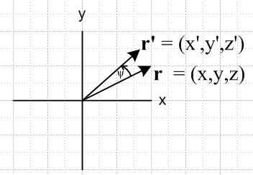

Now in a single picture we have a graphic representation of all six components.

1. Two coordinate systems required to do the disk-to-iris problem

We start with a metal bowl and disk picture (disk is offset vertically) and we call this picture Pic 1, or sometimes "the first inversion picture". Of course this Pic 1 is a slice in the y = 0 plane of the real thing,
and it slices right down through the vertical center axis of the disk which we only see edge-on. The metal bowl is shown by a heavy black curve (it is in fact a spherical metal cap, though it is not immediately obvious that the inversion surface of an offset disk is such a cap).
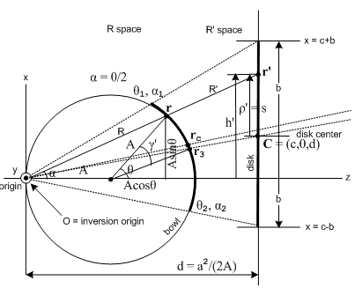Pic 1

We need an unambiguous notation, otherwise we just cycle around the Room of Doom forever, being constantly unsure of what we are talking about. When I drew the above picture, I decided to use the following coordinate notations (which have worked out fine)

inversion- sphere-
centered centered
r = (R,α,φ) = (r,θ,φ) spherical // note that α =θ/2 only for r on sphere
r = (x,y,z) = (X,Y,Z) Cartesian // x = X, y=Y, z=Z+A

So right off the bat we have FOUR different ways to represent a point r in our space. Since we are going to have at least two different spaces to worry about, you see the potential for notational confusion.

We shall call the coordinate system shown in the above picture S, with unit vectors ,, . Now the double-inversion method for solving for the Green's function (point charge in hole) of an iris in terms of the potential of a charged disk requires the use of two coordinate systems, and we shall call the second coordinate system S" (because we like to use the single prime notation in our inversion formalism which always involves R space and R' space). So in terms of our Section 0 discussion above, just replace primes with double primes everywhere. Here is a single drawing showing those two coordinate systems which we want to use to solve our problem: [ We shall draw pictures from our Section 0 analogy on the right. These pictures are only to show the conceptual analogy, nothing more. ]

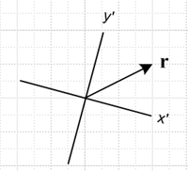

Our original Pic 1 coordinate system S is shown in black, though we show much less detail on the sphere. The red coordinate system is S" with axes ","," . As in Section 0, we are going to want to rotate this red system about sphere center into a more pleasant orientation with " pointing to the right. This then requires that

(" in new picture) = Ry(π-θc) (" in old tilted picture)

Recall in Section 0 the analogous action was

(' in new picture) = Rz(ψ) ( ' in old tilted picture)

so in our conceptual analogy we identify Rz(ψ) with Ry(π-θc). Similarly, in Section 0 we had r' = Rz(ψ) r and here we have r" = Ry(π-θc) r. After doing this on-paper graphical rotation, our picture above becomes the following,

Following the next steps in our Section 0 discussion, we now drop the axis double primes and replace our vector r with a forward-rotated vector r" = Ry(π-θc) r, and we get the next picture in sequence. Notice the red r" in the left picture below, and we have now added the back-rotated vector r to this picture.

The picture on the left with the red axes then becomes what we call Pic 2 (where we now draw these red things all black) ,

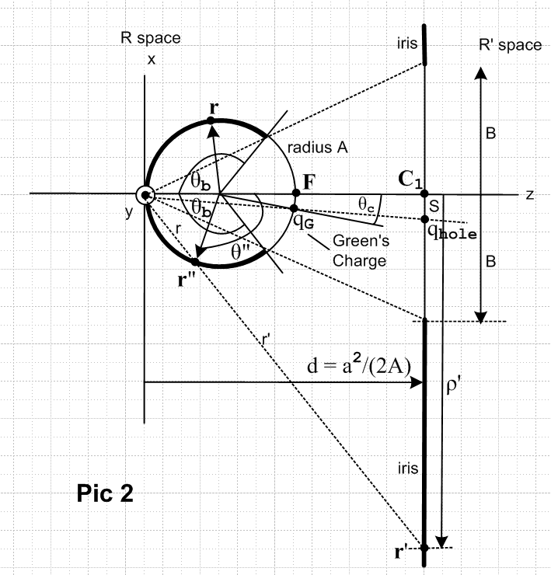

Note: In order to get Pic 2 be useful including the iris on the right, we had to graphically increase the angular size of the metal bowl, so the precise locations of r" and r are a little changed from the previous picture. Conceptually, nothing has changed, we still have r" = Ry(π-θc) r .

Now we want to add a new phrase to the discussion: "corresponds to". In the above picture, the vector r represents a location on the pre-rotated bowl (not drawn, where there was some charge density σ(r) ), and the point r" represents the exact same location on the bowl after the rotation (drawn, where there is some charge density σ"(r") ). We say that the point r" in Pic 2 "corresponds to" the point r in Pic 1. Similarly, in Pic 1, the point r corresponds to a certain point r' on the disk, and in Pic 2 the point r" corresponds to a certain point on the iris. Following through inversion / rotation / inversion, we end up with a point on the disk corresponding to a point on the iris.

When we rotate the bowl as part of our rotation of the entire picture, of course the charge density and potential of the bowl rotate as well. So the reader is not surprised by the claim that σ"(r") = σ(r) which we might write as σPic2(r") = σpic1(r), and similarly for the potential. This says that after we rotate the sphere, the charge density on the post rotated sphere at the point r" will be exactly the same as the charge on the pre-rotated sphere at point r, where r" = Ry(π-θc) r . [ σ is a "scalar field"]

We shall represent the point r" in Pic 2 in this manner (see Pic 1 discussion above)

inversion- sphere-
centered centered
r" = (R",α",φ") = (r",θ",φ") spherical // note that α =θ/2 only for r on sphere
r" = (x",y",z") = (X",Y",Z") Cartesian // x" = X", y"=Y", z"=Z"+A

2. Doing the rotation math.

If r = (r,θ,φ) and r" = (r",θ",φ") and if the two are related by r" = Ry(π-θc) r, we can ask how the sets of angles are related to each other (we know that r" = r, so that part is easy). Consider r" = Ry(π-θc) r where we set r = (X,Y,Z) and r" = (X",Y",Z") now in sphere-centered Cartesian coordinates. We then find that

Ry(β) = $\left(\begin{matrix}cosβ & 0 & sinβ \\ 0 & 1 & 0 \\ -sinβ & 0 & cosβ\end{matrix}\right)$ Ry(π-θc) = $\left(\begin{matrix}-cosθc & 0 & sinθc \\ 0 & 1 & 0 \\ -sinθc & 0 & -cosθc\end{matrix}\right)$

" = $\left(\begin{matrix}X" \\ Y" \\ Z"\end{matrix}\right)$ = $\left(\begin{matrix}-cosθc & 0 & sinθc \\ 0 & 1 & 0 \\ -sinθc & 0 & -cosθc\end{matrix}\right)$$\left(\begin{matrix}X \\ Y \\ Z\end{matrix}\right)$ = $\left(\begin{matrix}-cosθcX + sinθcZ \\ Y \\ - sinθcX - cosθcZ\end{matrix}\right)$
=>
X" = -cosθcX + sinθcZ
Y" = Y
Z" = - sinθcX - cosθcZ

Since Ry-1(π-θc) = Ry(θc-π) = Ry(θc-π +2π) = Ry (π+θc), we can invert the above equations by swapping no-primes with double-primes and negating θc, so we get

X = -cosθcX" - sinθcZ"
Y = Y"
Z = sinθcX" - cosθcZ"

If we now write our vectors in polar angles (recall r" = r)

X = r sinθcosφ X" = r sinθ"cosφ"
Y = r sinθsinφ Y" = r sinθ"sinφ"
Z = r cosθ Z" = r cosθ"

our first set of equations above becomes

sinθ"cosφ" = -cosθc sinθcosφ + sinθc cosθ r" = Ry(π-θc) r
sinθ"sinφ" = sinθsinφ
cosθ" = - sinθc sinθcosφ - cosθc cosθ

so the third equation tells us polar angle θ", and then the first two tell us φ" in (0,2π), all in terms of θ and φ. The inverted equations can be found by the same trivial method used above and we find

sinθcosφ = -cosθc sinθ"cosφ" - sinθc cosθ" r = Ry-1(π-θc) r"
sinθsinφ = sinθ"sinφ"
cosθ = sinθc sinθ"cosφ" - cosθc cosθ"

3. The charge density on the rotated bowl.

From Attempt #2A we quote this result (checked, hence red) for the charge density on our bowl which is the inversion of the disk's surface charge distribution (prior to rotation)

σ(r) = – (a2/π2R3) /$\sqrt{b2-s2}$ s = $\sqrt{(x'-c)2 + y'2}$ d = a2/2A
x' = (a2/R2)X y' = (a2/R2)Y z' = d = (a2/R2)(Z+A) R = $\sqrt{X2+ Y2+ (Z+A)2}$

[ Remark: Notice that we write z' = d = (a2/R2)(Z+A) which implies that z' = d = (a2/R2)z where z is in inversion coordinates. How do we understand this? In our Pic 1 we have r and r' as inversion image points. Therefore we know that r' = (a/R)2r since R is the length of r in inversion coordinates. The z component of this then says z' = (a/R)2z. But z' is on the plane z' = d, so we have z' = d = (a/R)2z . Thus this z' equation tells us nothing exciting and is not really needed for σ, but we keep it along for the ride, and it will be needed for the Φ analysis, in which case we no longer have z' = d. ]

Note that symbols R and s are the actual distances you see appearing in Pic 1.

The charge distribution on the rotated bowl is given by

σpost(r") = σ(r) = – (a2/π2R3) /$\sqrt{b2-s2}$ s = $\sqrt{(x'-c)2 + y'2}$ d = a2/2A
R = $\sqrt{X2+ Y2+ (Z+A)2}$
x' = (a2/R2)X
y' = (a2/R2)Y
z' = d = (a2/R2)(Z+A)

This is fine, but we really want to express things in terms of Pic 2 coordinates (double prime stuff), since we are now going to work in Pic 2 to do our second inversion. No problem, we just use our transformation above

X = -cosθcX" - sinθcZ"
Y = Y"
Z = sinθcX" - cosθcZ"

and insert into the above to get

σpost(r") = σ(r) = – (a2/π2R3) /$\sqrt{b2-s2}$ s = $\sqrt{(x'-c)2 + y'2}$ d = a2/2A
R = $\sqrt{[-cosθcX" - sinθcZ"]2+ Y"2+ (sinθcX" - cosθcZ"+A)2}$
x' = (a2/R2)[ -cosθcX" - sinθcZ"]
y' = (a2/R2)[ Y"]
z' = d = (a2/R2)([ sinθcX" - cosθcZ"] + A)

Later we will worry about the potential, but for the moment we are concerned with the surface charge on the bowl all of which lies at r = A. In this case we set

(X,Y,Z) = A(sinθcosφ, sinθsinφ,cosθ)

and then the above two blocks of expressions starting with σpost can be rewritten. The first becomes

σpost(r") = σ(r) = – (a2/π2R3) /$\sqrt{b2-s2}$ s = $\sqrt{(x'-c)2 + y'2}$ d = a2/2A
R = 2A(cosθ+1)
x' = (a2/R2)Asinθcosφ = (a2A/R2) sinθcosφ
y' = (a2/R2)Asinθsinφ = (a2A/R2) sinθsinφ
z' = d = (a2/R2)(Acosθ+A) = (a2A/R2) (cosθ+1)

The fact that R = 2A(cosθ+1) can be computed from R = $\sqrt{X2+ Y2+ (Z+A)2}$, or can be seen easily from the geometry of Pic 1. Again we want things in Pic 2 coordinates, so we use our rule above

sinθcosφ = -cosθc sinθ"cosφ" - sinθc cosθ" r = Ry-1(π-θc) r"
sinθsinφ = sinθ"sinφ"
cosθ = sinθc sinθ"cosφ" - cosθc cosθ"

to get our new second block of equations,

σpost(r") = σ(r) = – (a2/π2R3) /$\sqrt{b2-s2}$ s = $\sqrt{(x'-c)2 + y'2}$ d = a2/2A
R = 2A[sinθc sinθ"cosφ" - cosθc cosθ" + 1]
x' = (a2A/R2) [-cosθc sinθ"cosφ" - sinθc cosθ"]
y' = (a2A/R2) [sinθ"sinφ"
z' = (a2A/R2) [sinθc sinθ"cosφ" - cosθc cosθ" + 1] // = d

As a reminder, this is the charge density on the metal bowl after the bowl has been rotated and installed into the Pic 2 picture which has a point on the bowl r" = (A,θ",φ"). We can display the parameters on which σpost depends:

σpost(r") = f (b, c; A, d, θc ; θ", φ" )

Since a2 = 2Ad from our inversion theory, we can pick either d or a2 as a parameter, and I picked d.

Interrupt for a Question: How might we interpret things like s, R, x' and so on in the above equations?

Let's look at R. In Pic 1 we have R = | r - Oinv| where Oinv is the inversion origin. We know this distance does not change under a rotation, so we can write this as R = | Ry(π-θc)r - Ry(π-θc)Oinv | . The first vector is just r", while the second vector is the location of the Green's charge in Pic 2 which we might call rg just to make up a name. So R = | r" - 2g | which distance we can easily locate in our Pic 2 picture. That's one answer concerning R. Another answer is that R is just some distance and we can express it in any coordinate system we want, either coordinate system S of Pic 1, or system S" of Pic 2. Similarly, s, x', y', z' are all certain distances one can identify in Pic 1, and the strange expressions in the block above are just these distances being written out in S" coordinates.

Question: Does σpost(r") really depend on d ? If we keep the disk geometry fixed and increase d, moving the disk off to the right. the shape of the bowl (which is the inversion of the disk) changes dramatically. The bowl gets smaller and flatter, so yes, we do expect that σpost(r") varies with d!

It is useful to write θ1 and θ2 and θc in terms of disk parameters.

tan(θ1/2)= (b+c)/d
tan(θ2/2)= (b- c)/d
θc = (θ1 + θ2)/2
θb = (θ1 – θ2)/2
tanθc = tan [(θ1/2)+ (θ2/2)] = d / (d2+b2-c2) // see Attempt #1 p 7

which shows that θc is determined by b,c and d, so we can eliminate θc from our parameter list,

σpost(r") = f (b, c; A, d ; θ", φ" )

Here I am trying to express things as much as possible in "disk parameters". But if I were just describing the Green's function for an arbitrary bowl, I would trade b,c in for θ1,θ2,

c = d tan(θc/2) (1+ tan2(θb/2))/ (1 - tan2(θc/2) tan2(θb/2))
b = d tan(θb/2) (1+ tan2(θc/2))/ (1 - tan2(θc/2) tan2(θb/2))

4. The potential of the rotated bowl.

This works the same way as the charge density. We have

Φpost(r"; σpost) = Φ(r; σ) where σpost(r") = σ(r) r" = Ry(π-θc) r

but we would normally suppress this second argument and just write

Φpost(r") = Φ(r)

Everything "goes through" as above, with these simple changes:

(1) We replace our σ expression with our Φ potential expression
(2) Since r and r" are now arbitrary points in space, we no longer have |r| = |r"| = A.
(3) We will no longer find that z' = d, since this was a Pic 1 condition r being on the disk itself.

(a) Potential for pre-rotated bowl:

We can therefore just crib any block of equations above, install our Φ expression, and change A to the more general number |r| (in the right places). So let's start with our Pic 1 expression for Φ which we obtained by doing an inversion on the known potential of a charged disk. This is of course before doing a rotation of the sphere. ( I keep adding σ just to have it in the same block. )

Φ(r) = g(r|ξ) = – (2/πR) sin-1 [ 2b / ( $\sqrt{(s-b)2 + (z'-d)2}$ + $\sqrt{(s+b)2 + (z'-d)2}$ ) ] + 1/R
σ(r) = – (a2/π2R3) /$\sqrt{b2-s2}$
R = $\sqrt{X2+ Y2+ (Z+A)2}$
s = $\sqrt{(x'-c)2 + y'2}$
x' = (a2/R2)X
y' = (a2/R2)Y
z' = (a2/R2)(Z+A)

If we assume (X,Y,Z) = (r,θ,φ) sphere-centered where now r ≠ A in general, we can look at the R situation

X2+ Y2+ (Z+A)2 = X2+ Y2+Z2 + A2 + 2AZ = r2 + A2 + 2AZ = r2 + A2 + 2Arcosθ

which is law of cosines for the usual R triangle (angle π-θ) but with the r point pulled off the sphere. So rewrite the above in sphere-centered spherical coordinates,

Φ(r) = g(r|ξ) = – (2/πR) sin-1 [ 2b / ( $\sqrt{(s-b)2 + (z'-d)2}$ + $\sqrt{(s+b)2 + (z'-d)2}$ ) ] + 1/R
σ(r) = – (2Ad/π2R3) /$\sqrt{b2-s2}$ // set r = A below if doing σ
R = $\sqrt{r2 + A2 + 2Arcosθ}$
s = $\sqrt{(x'-c)2 + y'2}$
x' = d(2Ar/R2)sinθcosφ
y' = d(2Ar/R2)sinθsinφ
z' = d(2Ar/R2)(cosθ+A/r)
c = d tan(θc/2) (1+ tan2(θb/2))/ (1 - tan2(θc/2) tan2(θb/2))
b = d tan(θb/2) (1+ tan2(θc/2))/ (1 - tan2(θc/2) tan2(θb/2))

This is my final form for the potential in the Green's function problem with the bowl oriented as shown in Pic 1 with the unit Green's charge at the inversion origin. The bowl has polar bowl angle θb and is tipped up by angle θc. The resulting Φ and σ are independent of d so could just set d = 1 everywhere. If we look at the potential on the bowl surface, we set r = A which causes z' = d. This famously causes the sum of the square roots to be 2b when you are on the bowl, so sin-1(1) = π/2 and Φ = -1/R + 1/R = 0. This happens because s < b on the bowl, which we know is true from the disk inversion connection.

One wonders if anything simplifies if we "install" the various expressions? I tried this in Maple with bowl1.mws, see Appendix A below. Nothing good happened.

(b) Potential for post-rotated bowl:

Take the previous result and just install the S" angular coordinates which are

sinθcosφ = -cosθc sinθ"cosφ" - sinθc cosθ" r = Ry-1(π-θc) r"
sinθsinφ = sinθ"sinφ"
cosθ = sinθc sinθ"cosφ" - cosθc cosθ"

so we get [ we are using r" = (r",θ",φ") in Pic 2 , and r = r" ]

Φpost(r") = Φ(r) = g(r|ξ) = – (2/πR) sin-1 [ 2b / ( $\sqrt{(s-b)2 + (z'-d)2}$ + $\sqrt{(s+b)2 + (z'-d)2}$ ) ] + 1/R
σ(r) = – (2Ad/π2R3) /$\sqrt{b2-s2}$ // set r = A below if doing σ
R = $\sqrt{r"2 + A2 + 2Ar"[sinθc sinθ"cosφ" - cosθc cosθ"]}$
s = $\sqrt{(x'-c)2 + y'2}$
x' = d(2Ar"/R2)[ -cosθc sinθ"cosφ" - sinθc cosθ"]
y' = d(2Ar"/R2) [sinθ"sinφ"]
z' = d(2Ar"/R2)( sinθc sinθ"cosφ" - cosθc cosθ"+A/r")
c = d tan(θc/2) (1+ tan2(θb/2))/ (1 - tan2(θc/2) tan2(θb/2))
b = d tan(θb/2) (1+ tan2(θc/2))/ (1 - tan2(θc/2) tan2(θb/2))

In the R expression we recognize an angle γ" (not same angle as in Pic 1 picture) which corresponds to a law of cosines in Pic 2

R2 = r"2 + A2 – 2Ar"cosγ" cosγ" = cosθc cosθ" - sinθc sinθ"cosφ"

So our new block is [ for r" = (r",θ",φ") ]

Φpost(r") = Φ(r) = g(r|ξ) = – (2/πR) sin-1 [ 2b / ( $\sqrt{(s-b)2 + (z'-d)2}$ + $\sqrt{(s+b)2 + (z'-d)2}$ ) ] + 1/R
σpost(r") = σ(r) = – (2Ad/π2R3) /$\sqrt{b2-s2}$ // set r" = A below if doing σ
R = $\sqrt{r"2 + A2 – 2Ar"cosγ"}$ cosγ" = cosθc cosθ" - sinθc sinθ"cosφ"
s = $\sqrt{(x'-c)2 + y'2}$
x' = d(2Ar"/R2)[ -cosθc sinθ"cosφ" - sinθc cosθ"]
y' = d(2Ar"/R2) [sinθ"sinφ"]
z' = d(2Ar"/R2)( sinθc sinθ"cosφ" - cosθc cosθ"+A/r")
c = d tan(θc/2) (1+ tan2(θb/2))/ (1 - tan2(θc/2) tan2(θb/2))
b = d tan(θb/2) (1+ tan2(θc/2))/ (1 - tan2(θc/2) tan2(θb/2))

This is my final result for the potential of the bowl Green's problem in the Pic 2 orientation. In light of all that has gone on, I would call this: "not bad" . We think of θc as defining the polar location of the Green's point charge for this Green's Function problem, as shown in Pic 2. We can see that s will be proportional to d, so is b, thus so is $\sqrt{b2-s2}$, hence σpost(r") is independent of d. Similarly, in the potential the denom with two square roots is ~ d so Φpost(r") is independent of d. We could thus just set d = 0 everywhere and perhaps change the names of things to get a denser answer, but let's just do that in thought only. As things are, we can still picture all variables in terms of Pic 1 distances like s and x'.

Limits:

(1) Staring at Pic 2, we might ask: what happens in the limit that θb→ 0. The bowl seems to approach a point, so maybe this will have some simple limit. Clearly b → 0 so sin-1 → 0 so Φ = 1/R where now R is the distance from our shrunk to a point bowl and the Green's charge. Suppose then you have your Green's unit charge at our Pic 2 location, and you put a microscopic ball of metal at the inversion origin. This is just a probe and does not alter the potential at all, except infinitely close to the probe, so 1/R is the answer we expect to get in this limit!

(2) I don't know how to interpret the limit that θb→ π. You could approach this limit starting with θc= 0. The Pic 1 suggests c = 0 and b → ∞. Then get sin-1(2b/2b) = π/2 and end up with Φ = 0. If you take a metal ball and put a point charge on it but it is grounded, I guess this is the answer you might expect. I might reconsider this limit later.

I don't expect Maple to simplify the above result any better than it did the pre-rotated result.

One last thing: I would like, however, to get the post-rotated bowl position in terms of X",Y",Z" for later reference. To get it, start again from the pre-rotated bowl situation

Φ(r) = g(r|ξ) = – (2/πR) sin-1 [ 2b / ( $\sqrt{(s-b)2 + (z'-d)2}$ + $\sqrt{(s+b)2 + (z'-d)2}$ ) ] + 1/R
σ(r) = – (a2/π2R3) /$\sqrt{b2-s2}$
R = $\sqrt{X2+ Y2+ (Z+A)2}$
s = $\sqrt{(x'-c)2 + y'2}$
x' = (a2/R2)X
y' = (a2/R2)Y
z' = (a2/R2)(Z+A)

and now use

X = -cosθcX" - sinθcZ"
Y = Y"
Z = sinθcX" - cosθcZ"

The R root argument is this

X2+ Y2+ (Z+A)2 = X2+ Y2+ Z2 + 2AZ + A2 = X"2+ Y"2+ Z"2 + 2AZ + A2

so we may write our result this way

Φpost(r") = Φ(r) = g(r|ξ) = – (2/πR) sin-1 [ 2b / ( $\sqrt{(s-b)2 + (z'-d)2}$ + $\sqrt{(s+b)2 + (z'-d)2}$ ) ] + 1/R
σpost(r") = σ(r) = – (a2/π2R3) /$\sqrt{b2-s2}$
R = $\sqrt{X"2+ Y"2+ Z"2 + 2A[sinθcX" - cosθcZ"] + A2}$
s = $\sqrt{(x'-c)2 + y'2}$
x' = (a2/R2)[ -cosθcX" - sinθcZ"]
y' = (a2/R2)Y"
z' = (a2/R2)( sinθcX" - cosθcZ"+A)

And one more little addition: Let's now change to Cartesian coordinates for r" based at the Pic 2 origin point, anticipating that we will be doing some inversion work soon on our post-rotated bowl,

x" = X" r" = (x",y",z") = Cartesian based at inversion origin
y" =Y"
z" = Z"+A

Then the above becomes

Φpost(r") = Φ(r) = g(r|ξ) = – (2/πR) sin-1 [ 2b / ( $\sqrt{(s-b)2 + (z'-d)2}$ + $\sqrt{(s+b)2 + (z'-d)2}$ ) ] + 1/R
σpost(r") = σ(r) = – (a2/π2R3) /$\sqrt{b2-s2}$
R = $\sqrt{x"2+ y"2+ (z"-A)2 + 2A[sinθcx" - cosθc(z"-A)] + A2}$
s = $\sqrt{(x'-c)2 + y'2}$
x' = (a2/R2)[ -cosθcx" - sinθc(z"-A)]
y' = (a2/R2)y"
z' = (a2/R2)( sinθcx" - cosθc(z"-A) +A)

And, again anticipating further inversion work, we might change some names like this:

Φpost(r") = Φ(r) = g(r|ξ) = – (2/πQ) sin-1 [ 2b / ( $\sqrt{(s-b)2 + (w-d)2}$ + $\sqrt{(s+b)2 + (w-d)2}$ ) ] + 1/Q
σpost(r") = σ(r) = – (a2/π2Q3) /$\sqrt{b2-s2}$
Q = $\sqrt{x"2+ y"2+ (z"-A)2 + 2A[sinθcx" - cosθc(z"-A)] + A2}$
s = $\sqrt{(u-c)2 + v2}$
u = (a2/Q2)[ -cosθcx" - sinθc(z"-A)]
v = (a2/Q2)y"
w = (a2/Q2)( sinθcx" - cosθc(z"-A) +A)

Appendix A: install expressions into the bowl potential (pre rotation)

Let's go try it (with d = 1). I did this in a Maple program, but it is of course a big mess because of the denominator function which becomes this
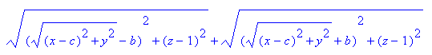

Aside: Maple is not going to know how to do anything with square roots of expressions having square roots. But I do have Ellipse Theorem 3 from ellipses.doc which says this

(1/2) ( $\sqrt{(x-a)2+ y2}$ + $\sqrt{(x+a)2+ y2}$ )2 = (x2 + y2 + a2) + $\sqrt{(x2 - y2- a2)2 + 4x2y2}$

but this does not really help because LHS is squared, so we will still have square roots inside square roots.

OK, so just keep going. If we install s, x', y', z' as per above, (but not R) we get

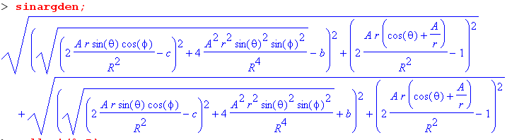

I cannot get Maple to clear the R's out, so need to start over. Define new symbols

C = R2c B = R2b S = R2s Z = R2z' X = R2x' Y = R2y'

( $\sqrt{(s-b)2 + (z'-1)2}$ + $\sqrt{(s+b)2 + (z'-1)2}$ ) = (R2/R2) ( $\sqrt{(s-b)2 + (z'-1)2}$ + $\sqrt{(s+b)2 + (z'-1)2}$ )

= (1/R2) ( $\sqrt{(R2s-R2b)2 + (R2z'-R2)2}$ + $\sqrt{(R2s+ R2b)2 + (R2z'- R2)2}$ )

= (1/R2) ( $\sqrt{(S - B)2 + (Z -R2)2}$ + $\sqrt{(S + B)2 + (Z- R2)2}$ ) = sinargden = sinargdena/R2

s = $\sqrt{(x'-c)2 + y'2}$ = (R2/R2) $\sqrt{(x'-c)2 + y'2}$ = (1/R2) $\sqrt{(X-C)2 +Y2}$

=> S = R2s = $\sqrt{(X-C)2 +Y2}$

We then get this result

and if we insert R = $\sqrt{r2 + A2 + 2Arcosθ}$ at this point we get

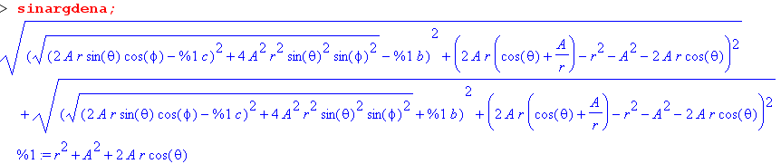

Notice now we have symbols r, c, b, A/r floating around in here. Things don't simplify because A,b,c are random positive real numbers so you have a function of four unrelated arguments A,b,c,r.
If we set r = A to get the potential on the sphere, this becomes

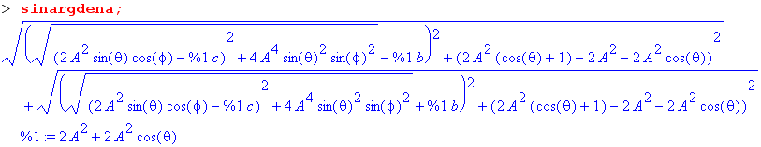

which is still a big mess and a function of those three random numbers A,b,c.

