Plots of Iris Things PhL 6.22.10

1. First, here are the facts from "top level review"

Φiris(r) = (2q1/πr1) cos-1( $\sqrt{2}$Br1 / $\sqrt{m+n}$ ) // export results
σiris = -( q1/2π2r12)$\sqrt{B2-S2}$/ $\sqrt{ρ2 - B2}$

m = (ρ2+z2)(S2-B2) + B2(B2- S2 + 2r12)
n = (B2- S2) $\sqrt{[ (ρ-B)2+z2] [ (ρ+B)2+z2]}$
r12 = ρ2 + S2 + z2 + 2Sρcosφ (r1 is the distance from the point charge to r )
S = distance from hole center to the point charge q1 sitting in the iris hole at φ=0
B = radius of the iris hole
r = (z, ρ, φ) = cylindrical coordinates of point r relative to hole center.

2. Next, we enter the expressions above stuff in Maple ("iris plots.mws"). σ1 means the charge on one side only of the iris (both sides are the same).

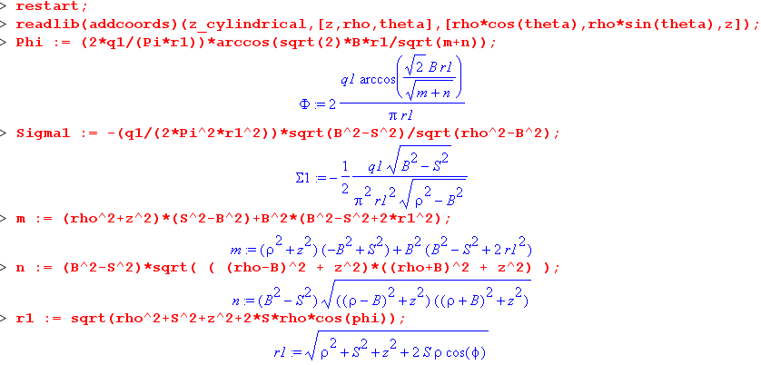

The first line is described in Maple/Plotting Issues/ "plotting in various coordinate systems.doc". It lets you give ranges for cylindrical coordinates, but things are still plotted in Cartesian coordinates. You can give a range of only two of the three variables and this gives a 3D plot.

3. Here are some potential plots:

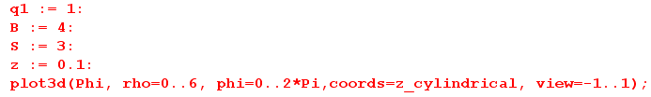

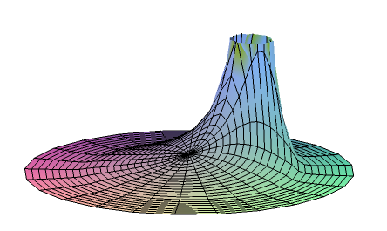
We have a very small value of z so we are just above the iris plane. You see the hole boundary at rho = 4 beyond which the potential is basically glued to 0, but of course not quite. Of course the potential peaks at the location of the point charge at S = 2.
Recall two theorems from Stak Chapter 6 (see meta meta)

Theorem 3: g is positive throughout R.
Theorem 4: For n ≥ 3, g < E throughout R

So we are not surprised to see Phi positive everywhere! Now if we go to a larger value of z, the peak becomes a small bump and Φ = 0 almost everywhere in such a plane as well. Here is z = 2. The potential can be non-zero beyond ρ = B now.

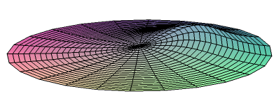
So really this exhausts the nature of this kind of plot.

We can instead plot the potential of the induced charge (see top level review)

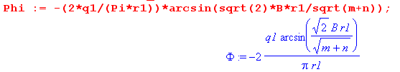

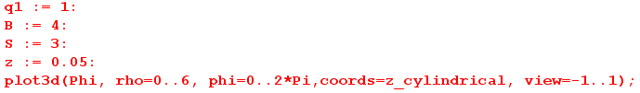

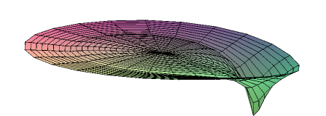

You know that the negative iris surface charge is largest at the ring and this creates the kind of potential you see above. The negative peak is at the point closest to the point charge and is probably peaked right at the iris edge. In fact, σ is infinite all around the exact rim, but this plot does not show that fact because the mesh misses the exact rim. Here is an attempt to show this fact a little better

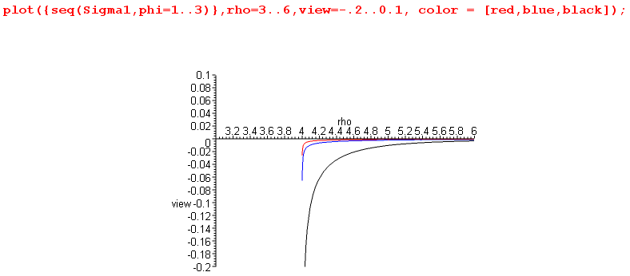

Here you see for various φ values that σ always blows up at the rim.

Next, we plot σ on the iris, with a high magnification (we have z = 0 for σ)

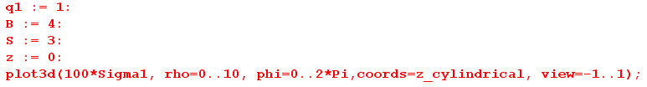
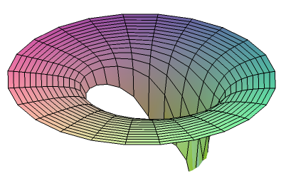
You see σ exists mostly around the rim and a little ways back, with a peak on the rim at the point closest to the point charge which here is at 3/4 of the radial distance.
Here I set φ = π + .1 and look at some potential profiles with ρ at various z values

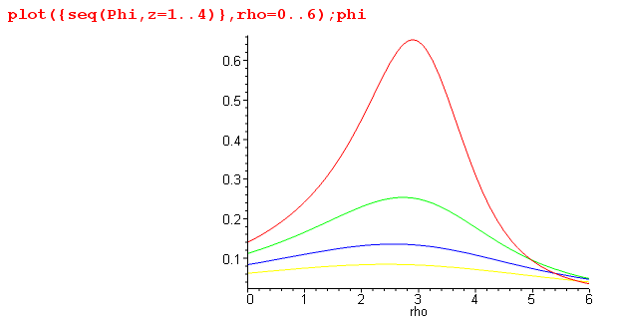

so of course for smaller z, we pass closer to the point charge and have a larger peak. And you see how the potential remains non-zero outside the hole beyond ρ = 4, since we are not at Z = 0.

Electric field.

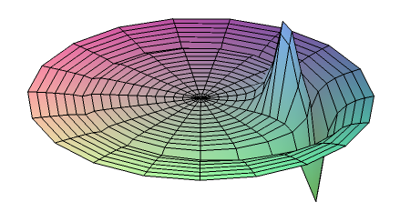

This thing should be -∞ at ρ = B+ε because σ = -∞ on the rim. This plot at least shows a small ring of negative peaking around the hole boundary, but misses the ∞ due to the mesh. At the point charge, we expect Ez pointing up (we are above the iris), but at the large negative charge at the rim nearest the point charge we expect Ez pointing down.

