Attempt to Integrate Smythe problem 38 to get the iris potential. PhL 6.18.10

Statement of The Problem: Smythe Problem 38 gives the σ on an iris with a point charge in the hole. If we integrate σ in the sense Φ = ∫σ/R, we should obtain the potential due to this induced charge σ on the iris. We know the answer, the question is: can we do this 2D integral to get that answer? (no!)

Overview (2.5 pages, written 12.6.10) 1
1. Draw a picture and write down the integral. 3
2. Convert the Angular Integral to a Contour Integral and Shrink the Contour 5
3. Try expanding 1/R in cylindricals 11
4. Comments: 13

___________________________________________________________________________________

Overview (2.5 pages, written 12.6.10)

In an earlier document "iris/ Iris Green's Function attempt using the Stak integral equation method.doc"
(Section C (b) ) I examined this same integral but in the sense of an integral equation setting V = 0 on the iris or disk. I was unable to show that the Problem 38 σ "worked" in this equation, but in the last section of that doc I came pretty close (Section E).

So, in Section 1 below I set things up in cylindrical coordinates, draw a picture, and I install the Problem 38 σ, and the potential is then given by

Φ(ρ,φ,z) = q1/r2 – (q1/π2) $\sqrt{B2-S2}$ $^{\int_{B}^{∞}{}}$ρ' dρ' (1/$\sqrt{ρ'2 - B2}$) $^{\int_{0}^{2π}{}}$dφ' (1/r1')2 (1/R)

where see below for details of the symbols involved. The double integral involved here is this monster:

I == $^{\int_{B}^{∞}{}}$ρ' dρ' (1/$\sqrt{ρ'2 - B2}$)$^{\int_{0}^{2π}{}}$dφ' (1/[ ρ'2 + S2 - 2ρ'Scosφ']) (1/$\sqrt{ρ2 + ρ'2 - 2ρρ'cos(φ-φ') + z2}$)

and I decide to try just the φ integral which I call J

J = $^{\int_{0}^{2π}{}}$dφ' (1/[ a - bcosφ']) (1/$\sqrt{c- dcos(φ-φ')}$)

where see below for a,b,c,d.

In Section 2 I convert this to the following contour integral

J = (1/i)(2R)3/2(1/b)(1/[de-iφ])1/2 dz$\sqrt{z}$ (1/[(z1-z)(z-z2)] (1/)

where see below for the zi . The contour is a circle which I try to shrink around a cut located inside the circle, but I finally give up as the mess gets worse and worse.

In Section 3 I start over with the idea of doing one of my famous candlelight supper 1/R expansions for the 1/R factor appearing in Φ as shown above. I write down three candidate expansions. I go first with the JJ one, which of course introduces Σm and $^{\int_{0}^{∞}{}}$dk which just adds to the mess on the RHS of Φ. After some fiddling I reject that and try again with the "hybrid Q" 1/R expansion which has the benefit of adding only Σm to the soup which already has $^{\int_{B}^{∞}{}}$dρ'$^{\int_{0}^{2π}{}}$dφ'. I am able now to do the dφ' integration using a GR7 result, but then I am left with a horrible $^{\int_{B}^{∞}{}}$dρ' whose integrand is a hopelessly messy function of ρ' and also includes a Q function with a messy argument which is a function of ρ'. So I reject this approach as well.

In Section 4 I just make some Comments. First, I note that maybe doing the integration as dρ dφ adds complexity because it uses the concentric ring as the basic unit, and R has a nasty variation on a ring, so you are slicing the problem into pieces whose shape is "ugly". Perhaps the pieces should be little wedges pointing to the point charge, or some other family of shapes show somehow fits on the iris.
I observe that I saw a similar "bad shape" situation arise in my Cartesian Green's function for a plane calculation. A first integration tangled things up into messy K function stuff, but then the second integration made everything simple again.
My last comment is that the disk-disk inversion method is really impressive for solving this problem compared to trying to do the double integral above.
Just for completeness, here is Φ for the iris problem obtained from inversion

Φiris(ρ,φ,z) = q1(2/πr1) cos-1 [ ($\sqrt{2}$Br1/$\sqrt{[ (ρ-B)2+z2] [ (ρ+B)2+z2]}$ ]
m = (ρ2+z2)(S2-B2) + B2(B2- S2 + 2r12)
r12 = ( ρ2 + S2 + z2 - 2Sρ cosφ )

which compare to the double integral

Φ(ρ,φ,z) = q1/r2 – (q1/π2) $\sqrt{B2-S2}$ $^{\int_{B}^{∞}{}}$ρ' dρ' (1/$\sqrt{ρ'2 - B2}$) $^{\int_{0}^{2π}{}}$dφ' (1/r1')2 (1/R)
r1'2 = | r' - S|2 = ρ'2 + S2 - 2ρ'Scosφ'
r22 = | r - S|2 = ρ2 + S2 - 2ρScosφ + z2
R2 = | r - r'|2 = ρ2 + ρ'2 - 2ρρ'cos(φ-φ') + z2

Perhaps this picture taken from the disk-disk inversion doc is giving us a hint as to the proper "shapes" that we should be adding up to get an iris (or disk) : circles which are not concentric.

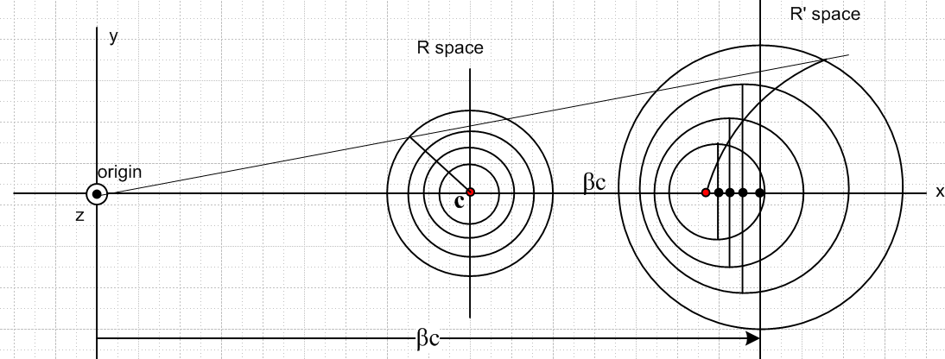
_______________________________________________________________________________

1. Draw a picture and write down the integral.

This was considered somewhat in "Iris Green's Function attempt using the Stak integral equation method.doc" in my iris folder. There I wrote the integral with general unknown σ, set V = 0, and regarded that as an integral equation which one wants to solve for σ. Of course this is part of a dual integral problem, and I did not get far.

But now I know that Smythe's problem 36 solution for σ is correct because I derived it myself (see inversion folder). So I would like to attempt to integrate over this σ to find the potential of the iris in this Green's function situation. I could omit the point charge in the hole to get the potential just of the induced charge on the iris, or I could include the potential of the charge in the hole to get the total potential, which is the actual "Green's Function" for the problem, and which in fact shows V = 0 on the iris.

First of all, the result that Smythe and I agree on for the iris charge density is this: [ this is expressed in my Pic 2 coordinates of my inversion derivation ]

σ(ρ', φ") = – ( q1/π2r12)$\sqrt{B2-S2}$/ $\sqrt{ρ'2 - B2}$ r12 = S2 + ρ'2 + 2Sρ' cosφ"

The metal iris has the same charge density on both sides, and this expression is for the sum of both sides. B is the radius of the hole in the iris. ρ' is the usual radial coordinate. S is the distance of the Green's point charge from the hole center. φ" is the azimuth measured from a line opposite the Green's charge. r1 is the distance from the observation point ρ', φ" to the point charge in the hole.
It seems reasonable to redefine azimuth to be 0 at the point charge, and rewrite the above as

σ(ρ, φ) = – ( q1/π2r12)$\sqrt{B2-S2}$/ $\sqrt{ρ2 - B2}$ r12 = S2 + ρ2 – 2Sρ cosφ

where we are now in simple cylindrical coordinates relative to iris center, iris is at z = 0. All the φ dependence is in this simple 1/r12 factor which has the form 1/(a-bcosφ). But in our integral, we shall obtain a second factor 1/R which is of the form 1/$\sqrt{c-dcos(φ-φ')}$, and this makes a tough integral.
Now let's draw a picture to show the situation,

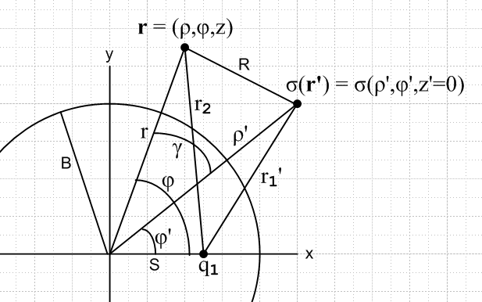

where we have tried to label everything of interest. The potential observation point is the 3D point labeled, and of course σ(ρ', φ') only exists on the z = 0 plane.

Now if ra and rb are two points in cylindrical coordinates (unrelated to points in the picture), we can write things like xa = ρacosφa etc and we quickly conclude that

| ra - rb |2 = ρa2 + ρb2 - 2ρaρbcos(φa-φb) + (za-zb)2

We can apply this several times to the picture:

r2 = ρ2 +z2
r'2 = ρ'2
r1'2 = | r' - S|2 = ρ'2 + S2 - 2ρ'Scosφ'
r22 = | r - S|2 = ρ2 + S2 - 2ρScosφ + z2
R2 = | r - r'|2 = ρ2 + ρ'2 - 2ρρ'cos(φ-φ') + z2

=> r2 - R2 = -ρ'2 + 2ρρ'cos(φ-φ')

If for some reason we wanted to know angle γ, we do law of cosines,

R2 = r2+ ρ'2 - 2rρ' cosγ

=> cosγ = (r2+ ρ'2 - R2)/(2rρ') = (2ρρ'cos(φ-φ'))/(2rρ') = (ρ/r)cos(φ-φ')

= (ρ/$\sqrt{ρ2 +z2}$) cos(φ-φ')

As a check, if z = 0, then r and r' are in the same plane z = 0 and we get γ = φ-φ'.

Here then is the integral for the potential due to this iris's induced charge σ and the point charge:

Φ(ρ,φ,z) = q1/r2 + $^{\int_{B}^{∞}{}}$ρ' dρ' $^{\int_{0}^{2π}{}}$dφ' σ(ρ',φ')/R
or
Φ(ρ,φ,z) = q1/r2 – (q1/π2) $\sqrt{B2-S2}$ $^{\int_{B}^{∞}{}}$ρ' dρ' $^{\int_{0}^{2π}{}}$dφ' (1/r1')2 (1/$\sqrt{ρ'2 - B2}$)(1/R)

where

r1'2 = | r' - S|2 = ρ'2 + S2 - 2ρ'Scosφ'
r22 = | r - S|2 = ρ2 + S2 - 2ρScosφ + z2
R2 = | r - r'|2 = ρ2 + ρ'2 - 2ρρ'cos(φ-φ') + z2

The integral we have to deal with here is this:

I = $^{\int_{B}^{∞}{}}$ρ' dρ' $^{\int_{0}^{2π}{}}$dφ' (1/r1')2 (1/$\sqrt{ρ'2 - B2}$)(1/R)

= $^{\int_{B}^{∞}{}}$ρ' dρ' (1/$\sqrt{ρ'2 - B2}$)$^{\int_{0}^{2π}{}}$dφ' (1/[ ρ'2 + S2 - 2ρ'Scosφ']) (1/$\sqrt{ρ2 + ρ'2 - 2ρρ'cos(φ-φ') + z2}$)

so there is our first look at the monster! So here is the angular integral

J = $^{\int_{0}^{2π}{}}$dφ' (1/[ ρ'2 + S2 - 2ρ'Scosφ']) (1/$\sqrt{ρ2 + ρ'2 - 2ρρ'cos(φ-φ') + z2}$)

= $^{\int_{0}^{2π}{}}$dφ' (1/[c-dcosφ']) (1/$\sqrt{a - bcos(φ-φ')}$)

= $^{\int_{0}^{2π}{}}$dφ' (1/[c-dcos(φ+φ')]) (1/)

Wolfram has nothing to say about this, nor does Maple, definite or indefinite.

2. Convert the Angular Integral to a Contour Integral and Shrink the Contour

Let's define

a = ρ'2 + S2
b = 2ρ'S
c = ρ2 + ρ'2 +z2
d = 2ρρ'

Then we have

J = $^{\int_{0}^{2π}{}}$dφ' (1/[ a - bcosφ']) (1/$\sqrt{c- dcos(φ-φ')}$)

= $^{\int_{0}^{2π}{}}$dθ (1/[ a - bcosθ]) (1/$\sqrt{c- dcos(θ-φ)}$)

It ain't purdy. First reaction is to go look in GR7, but of course nothing like this appears. I suspect this has to be done as a contour integral somehow, with that first factor becoming a pole somewhere, etc etc.

Aside: consider f(x) = (x2+ α2)/(2αx) with α > 0. This is a famous (for me) situation which looks like this for α = 2

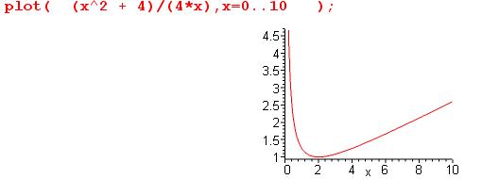

The conclusion is that f(x) ≥ 1 but f(x) = 1 when x = α. [ if x is all reals, then for x < 0 we have f(x) ≤ -1 but f(x) = -1 when x = -α ]

We now consider the first factor possibly being 0. This would happen if

cosθ = a/b = (ρ'2 + S2)/( 2ρ'S) = f(ρ')

We in general do NOT get a pole because in general we have this condition saying |cosθ| > 1. But when ρ' = S which is on the cylinder containing the point charge, we do get a pole, so something interesting happens when we are on this cylinder.
A similar thing happens with cos(φ-θ) inside the radical. We have

cos(φ-θ) = c/d = (ρ2 + ρ'2 + z2)/( 2ρρ')

so in this case we only get a singularity when z = 0 AND when ρ = ρ', which means that the observation point is on the iris itself. Of course this is the situation in which we expect to get Φ = 0.
So if we stay for the moment off the iris, only the first term has a potential singularity.

So let's try to convert this to some kind of contour integral. We define

z = Reiθ // R and z are unrelated to symbols R and z above

dz = izdθ dθ = (1/i) dz/z

cosθ = (z2+ R2)/(2zR)

cos(θ-φ) = (z2e-iφ+ R2eiφ)/(2zR)

where I did these last two (consistent) results on scratch paper. Then look at

J = $^{\int_{0}^{2π}{}}$dθ (1/[ a - bcosθ]) (1/$\sqrt{c- dcos(θ-φ)}$)

= (1/i) dz/z (1/[ a - b(z2+ R2)/(2zR)]) (1/$\sqrt{c- d(z2e-iφ+ R2eiφ)/(2zR)}$)

= (1/i)(2R) dz/z * z (1/[ 2azR - b(z2+ R2)]) (1/$\sqrt{c- d(z2e-iφ+ R2eiφ)/(2zR)}$)

= (1/i)(2R)3/2 dz/z * z3/2 (1/[ 2azR - b(z2+ R2)]) (1/$\sqrt{2czR- d(z2e-iφ+ R2eiφ)}$)

where we have a CCW contour at radius R in the z plane.

Let's now study the second denominator:

f(z) = 2czR - d(z2e-iφ+ R2eiφ) = -de-iφ [ z2 - (2cR/d)eiφ z + R2ei2φ ]

Now define

α = (c/d) = (ρ2 + ρ'2 +z2)/(2ρρ') ≥ 1

β = Reiφ

Then we get

f(z) = 2czR- d(z2e-iφ+ R2eiφ) = -de-iφ(z2 - 2αβz + β2)

Consider

(z2 - 2αβz + β2) = (z-z3)(z-z4)

B2-4AC = 4β2(α2-1)

z3,4 = αβ ± β$\sqrt{α2-1}$ = β [ α ± $\sqrt{α2-1}$] φ

Next, look at the first denominator. We take the above results and replace c,d with a,b and set φ = 0 and define some new symbols"

γ = (a/b) = (ρ'2 + S2)/(2ρ'S) γ ≥ 1

=> g(z) = -b ( z2 - 2γRz + R2)

B2 - 4AC = 4R2(γ2-1)

z1,2 = γR ± R$\sqrt{γ2-1}$ = R [ γ ± $\sqrt{γ2-1}$] g(z) = -b (z-z1)(z-z2) = b(z1-z)(z-z2)

f(z) = -de-iφ(z-z3)(z-z4) = de-iφ (z3-z)(z-z4)
So rewrite our integral as

J = (1/i)(2R)3/2 dz$\sqrt{z}$ (1/[ 2azR - b(z2+ R2)]) (1/$\sqrt{2czR- d(z2e-iφ+ R2eiφ)}$)

= (1/i)(2R)3/2(1/b)(1/[de-iφ])1/2 dz$\sqrt{z}$ (1/[(z1-z)(z-z2)] (1/)

Now examine the contour integral

K = dz$\sqrt{z}$ (1/[(z1-z)(z-z2)] (1/)

z3,4 = β [ α ± $\sqrt{α2-1}$] α ≥1 α = (ρ2 + ρ'2 +z2)/(2ρρ')

z1,2 = R [ γ ± $\sqrt{γ2-1}$] γ ≥1 γ = (ρ'2 + S2)/(2ρ'S)

Note from quick Maple plots that

[ α + $\sqrt{α2-1}$] is ≥ 1 = 1 when α = 1
[ α - $\sqrt{α2-1}$] is ≤ 1 = 1 when α = 1

So, when we encounter our vanishing denominators in the dθ integral where the integrand "blows up", here that happens when α = 1 or γ = 1 and that appears as the pair of x's pinching the contour shown below. So here is the z plane situation.
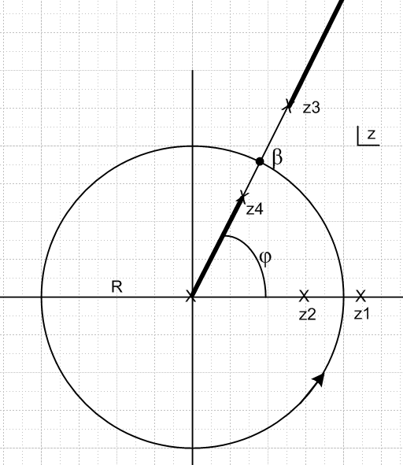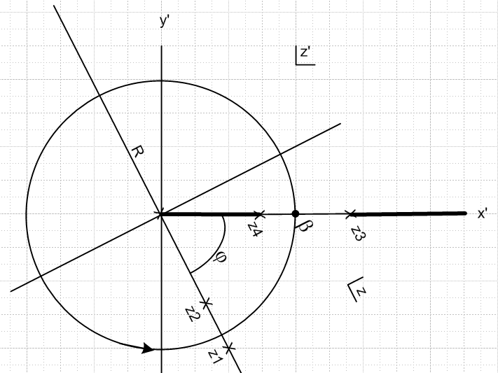

Notice there are three square root type branch cuts, but we can connect two of them together as shown (z4 and origin) so the contour does not cross any cuts and is therefore on a single sheet (as it must be).

At this point we can shrink the contour down around the inside cut shown, perhaps rotate the picture, and obtain an integral that might be doable.

But remember, even if we can do this integral, it is only the first of two integrals! One suspects there is a better way to approach this double integral.

But let's continue anyway, I want to bring the black segment down to the horizontal, so define

z' = z e-iφ z3' = z3e-iφ etc for all points.

Then we have the picture on the right with x', y' axis as shown. We want to integrate the discontinuity across the cut. Only this part of the integrand has a discontinuity:

k(z) = $\sqrt{z/(z-z4)}$ = $\sqrt{z'/(z'-z'4)}$ = k(z')

In the usual manner we set

z' = |z'| = z'

(z'-z'4)± = | z'-z'4|e±iπ = (z4'-z') e±iπ

k+ - k- = $\sqrt{z'/(z4'-z') e+iπ}$ - $\sqrt{z'/(z4'-z') e-iπ}$ = e-iπ/2 $\sqrt{z'/(z4'-z')}$ – e+iπ/2 $\sqrt{z'/(z4'-z')}$

= e-iπ/2 [$\sqrt{z'/(z4'-z')}$ – e+iπ $\sqrt{z'/(z4'-z')}$ ] = -2i$\sqrt{z'/(z4'-z')}$

So we are then left with this as our integral

K = dz$\sqrt{z}$ (1/[(z1-z)(z-z2)] (1/)
= dz'$\sqrt{z'}$ (1/[(z'1-z')(z'-z'2)] (1/)

= (-2i )-1 $^{\int_{0}^{z4}{}}$dz'$\sqrt{z'}$ (1/[(z'1-z')(z'-z'2)] (1/)

where

z'1,2 = e-iφz1,2 = e-iφ R [ γ ± $\sqrt{γ2-1}$]

z'3,4 = e-iφz3,4 = e-iφ β [ α ± $\sqrt{α2-1}$] = e-iφ Reiφ [ α ± $\sqrt{α2-1}$] = R[ α ± $\sqrt{α2-1}$]

If we pull out all the R factors to the front, we can define some new animals

z"1,2 = z'1,2/R = e-iφ [ γ ± $\sqrt{γ2-1}$]
z"3,4 = z'3,4 /R = [ α ± $\sqrt{α2-1}$]
z" = z'/R

Then our integral becomes

(-2i )-1(R)-3/2 $^{\int_{0}^{z4"}{}}$dz"$\sqrt{z"}$ (1/[(z"1-z")(z"-z"2)] (1/)

(-2i )-1(R)-3/2 $^{\int_{0}^{z4"}{}}$dx$\sqrt{x}$ (1/[(z"1-x)(x-z"2)] (1/)

And so we have converted our θ integral first to a contour integral, and then to this integral. We can at this point (we could have earlier as well) deal with the fraction in the middle

1/(z"1-x) + 1/(x-z"2) = (z"1-z"2)/ [(z"1-x)(x-z"2)]

to get our integral broken down into two simpler ones

(-2i )-1(R)-3/2(z"1-z"2)-1 $^{\int_{0}^{z4"}{}}$dx$\sqrt{x}$ { 1/(z"1-x) + 1/(x-z"2) | (1/)

We now send an advance crew off to GR7 so see if we can spot something useful there. The action starts on page 92, but nothing there of this form. But I don't see anything with all three of these factors. But the Wolfram integrator has a result:

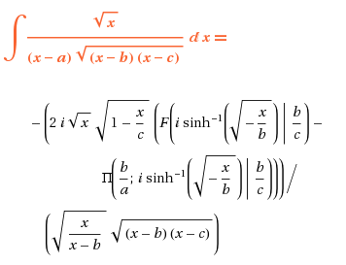

showing elliptic functions as I expected. I don't know why GR doesn't know this one, but OK. You can see I think that our φ' integral, as I called it above, will not be very pleasant. Then we are faced with integrating that result again over ρ'. Surely it all works out right in the end, but I don't think this is a good path for me to follow, I want something simpler.

3. Try expanding 1/R in cylindricals

Here once again is our integral

Φ(ρ,φ,z) = q1/r2 – (q1/π2) $\sqrt{B2-S2}$ $^{\int_{B}^{∞}{}}$ρ' dρ' (1/$\sqrt{ρ'2 - B2}$)$^{\int_{0}^{2π}{}}$dφ' (1/r1')2 (1/R)

R = | r - r'| r1'2 = | r' - S|2 = ρ'2 + S2 - 2ρ'Scosφ'
r22 = | r - S|2 = ρ2 + S2 - 2ρScosφ + z2
R2 = | r - r'|2 = ρ2 + ρ'2 - 2ρρ'cos(φ-φ') + z2

I have three options from my cylindrical 1/R document: [ in can set z' = 0 in all of these for my app ]

1/R = Σm=0∞εm cos[m(φ-φ')] $^{\int_{0}^{∞}{}}$dk exp(-k|z-z'|) Jm(kρ) Jm(kρ')

1/R = (2/π) Σm$^{\int_{0}^{∞}{}}$ dk cos[k(z-z')] Im(kρ<) Km(kρ>) eimφ e–imφ'

1/R = 1/(πρρ') Σm=0∞εm cos[m(φ-φ')] Qm-1/2(β) β = [ ρ2 + ρ'2 + (z-z')2 ]/(2ρρ')

The first form "exposes" the φ and ρ' dependence pretty well, so restate as

1/R = Σm=0∞εm cos[m(φ-φ')] $^{\int_{0}^{∞}{}}$dk exp(-k|z|) Jm(kρ) Jm(kρ')

Then we have for our second term integral

I = $^{\int_{B}^{∞}{}}$ρ' dρ' (1/$\sqrt{ρ'2 - B2}$)$^{\int_{0}^{2π}{}}$dφ' (1/r1')2 (1/R)

= $^{\int_{B}^{∞}{}}$ρ' dρ' (1/$\sqrt{ρ'2 - B2}$)$^{\int_{0}^{2π}{}}$dφ' (1/r1')2 { Σm=0∞εm cos[m(φ-φ')]$^{\int_{0}^{∞}{}}$dk exp(-k|z|) Jm(kρ) Jm(kρ')}

= Σm=0∞εm $^{\int_{0}^{∞}{}}$dk Jm(kρ) exp(-k|z|) $^{\int_{B}^{∞}{}}$ρ' dρ' (Jm(kρ')/$\sqrt{ρ'2 - B2}$)$^{\int_{0}^{2π}{}}$dφ' (1/r1')2cos[m(φ-φ')]

r1'2 = | r' - S|2 = ρ'2 + S2 - 2ρ'Scosφ'

Now the φ' integral is much simpler, though of course we have added another integral over dk, so not clear we have moved forward at all.
So let's instead try our Q form:

I = $^{\int_{B}^{∞}{}}$ρ' dρ' (1/$\sqrt{ρ'2 - B2}$)$^{\int_{0}^{2π}{}}$dφ' (1/r1')2 (1/R) β = [ ρ2 + ρ'2 + z2 ]/(2ρρ')

= $^{\int_{B}^{∞}{}}$ρ' dρ' (1/$\sqrt{ρ'2 - B2}$)$^{\int_{0}^{2π}{}}$dφ' (1/r1')2 { 1/(πρρ') Σm=0∞εm cos[m(φ-φ')] Qm-1/2(β)}

= (πρ)-1 Σm=0∞εm $^{\int_{B}^{∞}{}}$dρ' (Qm-1/2(β) /$\sqrt{ρ'2 - B2}$)$^{\int_{0}^{2π}{}}$dφ' cos[m(φ-φ')] (ρ'2 + S2 - 2ρ'Scosφ')-1

which has the same φ' integral as last time. What does the scouting party to GR7 say now? We shall need integrals of these forms

$^{\int_{0}^{2π}{}}$dx cos(mx) / (a - b cosx) = 2 $^{\int_{0}^{π}{}}$dx cos(mx) / (a - b cosx)

$^{\int_{0}^{2π}{}}$dx sin(mx) / (a - b cosx) = 0

So here is what we are looking for

J = $^{\int_{0}^{2π}{}}$dθ cos(mθ) / (a - b cosθ) = (2/a) $^{\int_{0}^{π}{}}$dθ cos(mθ) / (1 - (b/a)cosθ)

and this integral luckily appears on page 366 of printed GR which I first found it, but p 391 of GR7.

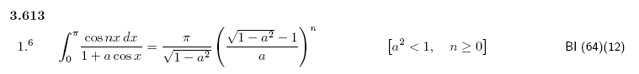

So I replace a here with (-b/a) and I get

$^{\int_{0}^{π}{}}$dθ cos(mθ) / (1 - (b/a)cosθ) = π/$\sqrt{1-(b/a)2}$ ( $\sqrt{1-(b/a)2}$ - 1)m (-b/a)-m

Then

J = (2π/a) (1/$\sqrt{1-(b/a)2}$) ( $\sqrt{1-(b/a)2}$ - 1)m (-b/a)-m

In our case we have

a = ρ'2 + S2
b = 2ρ'S

1 - (b/a)2 = ( a2- b2)/a2 = [(ρ'2 + S2)2 - 4ρ'2S2]/( ρ'2 + S2) = (ρ'- S)2/ (ρ'2 + S2)

$\sqrt{1-(b/a)2}$ = |ρ'-S|/$\sqrt{ρ'2 + S2}$

Then on scratch I show that

J = (2π/ |ρ'-S| ) (ρ'2 + S2)m-1/2 [|ρ'-S|/$\sqrt{ρ'2 + S2}$ - 1]m (-2ρ'S)-m

= (2π/ |ρ'-S| ) (ρ'2 + S2)m/2-1/2 [|ρ'-S| +$\sqrt{ρ'2 + S2}$]m (-2ρ'S)-m

Going backwards then we have

I = (πρ)-1 Σm=0∞εm $^{\int_{B}^{∞}{}}$dρ' (Qm-1/2(β) /$\sqrt{ρ'2 - B2}$) *

$^{\int_{0}^{2π}{}}$dφ' { cos(mφ)cos(mφ') + sin(mφ)sin(mφ') } (ρ'2 + S2 - 2ρ'Scosφ')-1

= (πρ)-1 Σm=0∞εm $^{\int_{B}^{∞}{}}$dρ' (Qm-1/2(β) /$\sqrt{ρ'2 - B2}$) cos(mφ) $^{\int_{0}^{2π}{}}$dφ' cos(mφ') (ρ'2 + S2 - 2ρ'Scosφ')-1

= (πρ)-1 Σm=0∞εm cos(mφ) $^{\int_{B}^{∞}{}}$dρ' (Qm-1/2(β) /$\sqrt{ρ'2 - B2}$) {J}

= (πρ)-1 Σm=0∞εm cos(mφ)$^{\int_{B}^{∞}{}}$dρ' (Qm-1/2{[ ρ2 + ρ'2 + z2 ]/(2ρρ')} /$\sqrt{ρ'2 - B2}$) *

{ (2π/ |ρ'-S| ) (ρ'2 + S2)m/2-1/2 [|ρ'-S| +$\sqrt{ρ'2 + S2}$]m (-2ρ'S)-m }

and then, alas, we are stuck with a hopelessly messy integral with 5 factors AND a special function. I lose.

4. Comments:

I think the double integral is correct

Φ(ρ,φ,z) = q1/r2 – (q1/π2) $\sqrt{B2-S2}$ $^{\int_{B}^{∞}{}}$ρ' dρ' $^{\int_{0}^{2π}{}}$dφ' (1/r1')2 (1/$\sqrt{ρ'2 - B2}$)(1/R)
Φ(ρ,φ,z) = q1/r2 + $^{\int_{B}^{∞}{}}$ρ' dρ' $^{\int_{0}^{2π}{}}$dφ' σ(ρ',φ')/R
where
r1'2 = | r' - S|2 = ρ'2 + S2 - 2ρ'Scosφ'
r22 = | r - S|2 = ρ2 + S2 - 2ρScosφ + z2
R2 = | r - r'|2 = ρ2 + ρ'2 - 2ρρ'cos(φ-φ') + z2

This IS the potential expressed as the double integral. It's just that I can't DO the double integral. Certainly the φ,ρ coordinates are the most direct for writing down the integral. But I think what is happening is this: we take as our basic integration unit a ring's worth of the iris at some ρ' radius. As we go around that ring, R varies in an ugly way, and so does σ through its factor (1/r1')2. So even if the full final answer is something simple, this "slice" of the answer -- contribution of a ring -- is very ugly, although as shown above you can at least write it down!

I saw this kind of thing happen before in the following doc

Stakgold / Finding Green's Functions by the Dirichlet Method.doc

where I was obtaining the Green's function for a point charge next to an infinite plane, doing it "a hard way". I wrote the following Smythian form for the potential of the non-point-charge part of the desired Green's function,

V(x,y,z) = ∫dkx∫dky A(kx, ky) exp(ikxx) exp(ikYy) exp(–$\sqrt{kx2+ky2}$z)

and then tried to compute the coefficients using V(x,y,0) = 1/$\sqrt{x2 + y2 + a2}$ being the known Dirichlet potential on the planar surface due to the point charge,

A(kx, ky) = (-q) (1/2π)2$^{\int_{-∞}^{∞}{}}$dx $^{\int_{-∞}^{∞}{}}$ dy exp(-ikxx) exp(-ikyy)/ $\sqrt{x2 + y2 + a2}$

The final result is a very elementary function

A(kx, ky) = (-q/2π) exp(- aK)/K K ≡$\sqrt{kx2+ ky2}$

but the result after doing just one of the integrations is pretty messy,

A(kx, ky) = 2 (-q) (1/2π)2 $^{\int_{-∞}^{∞}{}}$dx exp(-i kx x) K0($\sqrt{x2 + a2}$ky)

showing a non-elementary function. In this case the special function arises from doing just integrating on a strip on one of the Cartesian directions on the infinite plane.

This gives me more respect now for the Smythe inversion/reflection/inversion method of writing down the potential! That result was ugly, but at least there were no integrals to do. [ and even more respect for the simpler disk-disk inversion method. ]

I imagine my double integral here can be done if you use smart integral representations as a tool to do it. I don't know enough now to do this.

