Effect of transformations on charges and fields PhL 6.11.10

In this doc we discuss the effect of Galilean transformations, and also the inversion transformation, on a set of point charges (including continuous charge) and on the fields created by these charges.

Overview (3 pages, written 12.5.10) 1
1. First, let's review the Jackson inversion discussion and the linearity of transformations. 3
2. Transformation of charges and their potentials by rotations and translations. 4
3. Rotations with multiple charges. 7
4. Application to rotation of a certain bowl and Green's Charge. 10
5. Restate the above application using spherical coordinates 11
6. General Euler rotation for R₁ (using spherical coordinates) 12
7. Specialize the rotation R₁ to the case α = γ = 0. 14

_________________________________________________________________________________

Overview (3 pages, written 12.5.10)

In Section 1 I ponder inversion, rotation and translation as general transformations T acting on points in space r. Here they are so presented:

r' = T(r) r T(r) = (a2/r2) 1 inversion
r' = T(θc) r T(θc) = Rz(θc) rotation
r' = T(rc) r T(rc) r = r + rc translation

The first two have T = matrix, but translation is different. Inversion is different in that the parameter of the transformation T is a function of space, while the other cases have constant parameters.
I then compute the effect of each transformation on ar1+ br2 to see which of these are "linear", which means T(ar1+ br2) = a Tr1 + b Tr2. Only the rotation is linear.

In Section 2 I look at how these transformations affect a discrete charge position ri and the potential function due to that charge. Today I added a note below which summarizes the conclusions of this section, which I now display here. For any kind of rotation or translation, we know that a scalar field will be the same when measured in two frames R and R' related by a Galilean transformation T, but the inversion is not such a transformation,

φ'(r'; ri') = φ(r; ri) // Galilean
φ'(r'; ri') = (a/r') φ(r; ri) // inversion

which can be written this way

φ'(r; r'i) = φ(T-1(α)r; ri) // Galilean, α = parameter like θc or rc or other
φ'(r; ri',qi') = (a/r) φ(T-1(a2/r)r; ri, qi) // inversion

In the inversion case, there is an extra fact to keep track of. A charge qi at location ri in space R, gets scaled to be qi' and location ri' in space R' where qi' = (a/ri)qi. In the Galilean cases there is no change in charge size. I have therefore added charge as an argument in the inversion case above.

In Section 3 we generalize to multiple charges including charge distributions ρ and σ. The equations shown above in Section 2 are initially derived for a single point charge located at ri . If we simply sum (integrate) the two equations over a set of discrete charges qi at ri both equations will still be true, though you have to ponder this just a bit, looking at the form of the equations. We then have

φ'(r; ρ'(r')) = φ(T-1(α)r; ρ(r)) // Galilean, α = parameter like θc of rc or other
φ'(r; ρ'(r')) = (a/r) φ(T-1(a2/r)r; ρ(r)) // inversion : both equations also valid ρ→σ

I then wander off a bit and think of a ρ distribution as a set of delta function point charges which brings me to the conclusion that ρ'(r) = ρ(T-1r) for the Galilean cases. In retrospect, ρ is just another scalar field like φ, so this has to be true. I then give a little graphical interpretation when T = rotation. The same results above obtain for σ which is also a scalar field (which happens to be 0 except on surfaces).
My motivation for this entire doc was to understand what happens in the Problem 38 Hard Way method when we rotate our bowl as the middle step between inversions. The relevant equations are the second of these three equations where think of T as R, the bowl rotation,

ρ'(r) = ρ(T-1r) // T = Galilean, all three lines here (1)
σ'(r) = σ(T-1r) (2)
φ'(r; σ') = φ(T-1 r; σ) // same for ρ in place of σ (3)

The last two equations show how the surface charge AND its potential field change under a rotation. These three equations would be true for any Galilean T. For completeness, here are the corresponding equations for an inversion transformation

ρ'(r) = (a/r)5 ρ(T-1(a2/r)r) // T = Inversion
σ'(r) = (a/r)3 σ(T-1(a2/r)r)
φ'(r; σ'(r')) = (a/r) φ(T-1(a2/r)r; σ(r)) // inversion (same for ρ in place of σ)

The first two lines here arise because charges change size under inversion (as noted above) and the differential volume changes size under inversion. I include these results without derivation in this doc since they are derived elsewhere.
I have emphasized the appearance of T-1 in the above equations and have had r be the variable on the left hand side, just because the LHS is " some new function of r " and you see how it is created from the old function on the right. In practice, one usually uses this alternate and simpler form of all these equations:

ρ'(r') = ρ(r) // T = Galilean, all three lines here (1)
σ'(r') = σ(r) (2)
φ'(r'; σ') = φ(r; σ) // same for ρ in place of σ (3)

ρ'(r') = (a/r)5 ρ(r) // T = Inversion
σ'(r') = (a/r)3 σ(r)
φ'(r'; σ'(r')) = (a/r) φ(r; σ(r)) // inversion (same for ρ in place of σ)

In Section 4 I apply the above equations (2) and (3) specifically to the bowl rotation situation. One must think of transformations as R'(charged disk) → R(bowl) → R"(rotated bowl). The single prime thus already has a meaning, so we replace primes with double primes in (2) and (3) above. The results are:

φ"(r"; σ") = φ(r; ξ,σ) = – (2/πR) sin-1 [ 2b / ( $\sqrt{(ρ'-b)2 + (z'-d)2}$ + $\sqrt{(ρ'+b)2 + (z'-d)2}$ ) ] + 1/R
σ"(r") = σ(r) = - (a2/π2R3) / $\sqrt{b2-ρ'2}$ R = | r - ξ |

ρ' = $\sqrt{(x'-c)2 + y'2}$ R = $\sqrt{X2+ Y2+ (Z+A)2}$
x' = (a2/R2)X d = a2/2A
y' = (a2/R2)Y ξ = (0,0,-A) = Green's charge loc
z' = (a2/R2)(Z+A) θc = (θ1 + θ2)/2

Here, primed quantities refer to a location r' in R' space, while X,Y,Z are a location r in R space (with origin at bowl center). Parameters A,R,a,c,θi,d are explained in the picture shown in the raw doc below. So the above shows the middle step of the invert-rotate-invert step of Problem 38 The Hard Way!

In tiny Section 5 I just comment that you could replace X = Asinθcosφ etc where θ,φ would be polar angles of a point r in R space. In R" space your point r" would have angles θ",φ". I was struggling to find the right way to parameterize points in R and R" space.

In Section 6 I have Maple compute R(α,β,γ) = Rz(α)Ry(β)Rz(γ) as a messy 3x3 matrix. I think the lost point here is this. We could start with (X,Y,Z) = Rz(φ)Ry(θ) to represent a point in R space (before bowl rotation). We could then apply to this point a general bowl rotation α,β,γ and see where the point ends up in R" space. This just makes a big mess like so

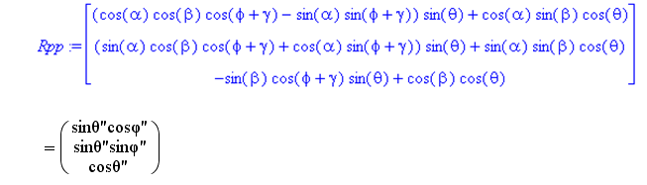
It would take some work to deduce θ"and φ" from this set of 3 equations.

In Section 7 I specialize to the case Rz(α)Ry(β)Rz(γ) = Ry(β), since this is the actual rotation of the bowl which appears in our Hard Way problem. The three equations above are simpler and we find a solution as follows:

cosθ" = cosβ cosθ - sinβ sinθ cosφ
tanφ" = tanφ * (1 / [ cosβ + sinβcotθsecφ ] )

In doc " 2, How to Actively Rotate the Bowl.doc" I give the detailed description of the Bowl Rotation step of the Problem 38 Hard Way method, and I may use the first of the above results with β = θc. Remember that these results show what happens to a point (θ,φ) in R space when the bowl is rotated.

_________________________________________________________________________________

1. First, let's review the Jackson inversion discussion and the linearity of transformations.

In the inversion situation we have two spaces, R space and R' space. The transformation used here is this, where the transformation acts on a point charge and its position,

ri' = (a2/ri2) ri = T(ri) ri => ri' = a2/ri
r' = (a2/r2) r = T(r) r => r' = a2/r

q'i = qi(a/ri)

φ'(r ; q'i, r'i) = (a/r) φ(r' ; qi, ri) = (a/r) φ(T(r) r ; qi, ri)

The last line is my "theorem 1" which relates the potential φ'(r) in space R' to that in space R. If we look at the transformation on charge or observation position, it is this (charge)

ri' = T(ri) ri T(ri) = (a2/ri2) 1 1 = 3x3 unit matrix

(a) Rotation. This is not like the transformations we normally deal with like R = Rz(θc) which have a fixed parameter. For inversion, the transformation is a function of the point you are transforming.
To show that R was a linear transformation, we would show that

Rz(θc) ( ar1+ br2) = a Rz(θc) r1 + b Rz(θc) r2

Since Rz(θc) is a matrix, we know this is true and the transformation is linear.

(b) Translation. In contrast, a translation transformation ri' =T(rc) ri = ri + ra is not linear. We find that

T(rc) ( ar1+ br2) = ( ar1+ br2) + rc ≠ a T(rc) r1 + b T(rc) r2 = a ( r1+ rc) + b ( r2+ rc)

because in one case you have the adder rc and in the other you have the adder (a+b) rc. I suppose this fact is something I was not particularly aware of.

(c) Inversion. If we now look at the inversion transformation we find (here I use A for the inversion sphere radius)

T(|ar1+ br2|) ( ar1+ br2) = (A2/|ar1+ br2|2) ( ar1+ br2) = (aA2/|ar1+ br2|2) r1 + (aA2/|ar1+ br2|2) r2
while
aT(ar1) r1 + bT(br2) r2 = a (A2/[ar1]2) r1 + b (A2/[br1]2) r2 = (A2/ar12) r1 + (A2/ar22) r2

Since the RHS's are obviously not equal, we conclude that the inversion transformation is non-linear, which is exactly what your intuition would tell you. This would be true in general of any matrix transformation where the matrix elements depend on the coordinates of the points being transformed, which I think is the case in general relativity (but no digression on that here).

2. Transformation of charges and their potentials by rotations and translations.

(a) Translation. Suppose we have a point charge ri of size qi and we simply translate it. R space is before translation, and R' space is after translation. ( in this case, qi' = qi so don't use qi')

ri' = T(rc) ri = ri + rc
r' = T(rc) r = r + rc

φ(r; ri) = qi/|r-ri|

φ'(r'; ri') = qi/|r'-r'i| = qi/|r-ri| = φ(r; ri) = φ(r'-rc; ri) = φ(T-1(rc) r'; ri)

=> φ'(r'; ri') = φ(T-1(rc) r'; ri)

where we use the fact that the distance between two points does not change if both points are translated.
The point r' that is the argument of φ' here is arbitrary and can be any point in space. In particular, we can select the point r for this argument. We then get

φ'(r; ri') = φ(T-1(rc) r; ri) = φ(r - rc; ri)

which we can compare to the inversion result

φ'(r ; q'i, r'i) = (a/r) φ(T(r) r ; qi, ri) = (a/r) φ((a2/r2) r ; qi, ri)

We are used to seeing T-1 appearing as in the first translation case, but for inversion we instead get T and we also get an external scaling factor. Very different animals here!

(b) Rotation about vectors' origin. Now let's repeat our work above but this time for a rotation about the origin used for our various vectors like r and ri

ri' = R(θc) ri
r' = R(θc) r

φ(r; ri) = qi/|r-ri|

φ'(r'; ri') = qi/|r'-r'i| = qi/| R(θc)r- R(θc)ri| = φ(r; ri) = φ(R-1(θc) r'; ri)

=> φ'(r'; ri') = φ(R-1(θc) r'; ri)

where we use the fact that the distance between two points does not change if both points are rotated about the origin. As before, we evaluate r' at the point r to get

φ'(r; ri') = φ(R-1(θc) r; ri) = φ(R-1(θc) r; ri) // rotation
φ'(r; ri') = φ(T-1(rc) r; ri) = φ(r - rc ; ri) // translation

We see that the results are very similar, both involving the inverse transformation as shown.

(c) Rotation about some other origin. Now suppose we want to do a rotation about an origin which is NOT the origin we use for the various vectors. We then might have a picture like this, and we define RO'(θc) as a rotation about the origin O' which differs from the origin O used for our unlabelled vectors like r and r'.

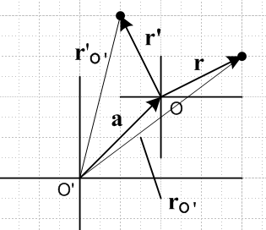

Then it seems pretty clear that (first equation is same rotation we discussed above)

RO'(θc) rO' = r'O' => RO'(θc) ( r + a) = r' + a

=> r' = RO'(θc) ( r + a) - a = RO'(θc) r + RO'(θc) a - a ≡ RO' r

r' = RO'r = RO'(r) r = RO'-1 r' = RO'(θc)-1 r' + RO'(θc) a - a

where we make up a new symbol for this combined transformation. So operation RO' is not linear. (Yes, it can be linearized by going to 4x4 Galilean matrices).

So this is a famous and simple result that you first translate, then rotate, then translate back. I don't intend to do this kind of rotation much, but thought it good to mention it. Here is how our potential would move under such a combined transformation (pretty ugly)

φ'(RO'r; ri') = φ(r; ri) where r' = RO'r
=> φ'(r; ri') = φ(RO'-1 r; ri) = φ(RO'(θc)-1 r + RO'(θc) a - a; ri)

(d) Combined rotation and translation. Now let's attempt a transformation which is a combined rotation and translation. ( the rotation here is about our vectors' origin as in (b) above ) Write

U(rc, θc) = T(rc)R(θc)

where our transformation is called U, and we (arbitrarily) first rotate, then translate. As in the cases of simple rotations and translations, U is not going to change the distance between two points. We get

ri' = U(rc, θc) ri = R(θc) ri + rc
r' = U(rc, θc) r = R(θc) r + rc => r = R-1(θc) (r' - rc) = U-1(rc, θc) r'

φ(r; ri) = qi/|r-ri|

φ'(r'; ri') = qi/|r'-r'i| = qi/| U(rc, θc)r- U(rc, θc)ri| = φ(r; ri) = φ(U-1(rc, θc) r'; ri)

=> φ'(r'; ri') = φ(U-1(rc, θc) r'; ri)

As before, we evaluate r' at the point r to get

φ'(r; ri') = φ(U-1(rc, θc) r; ri) = φ(R-1(θc) (r - rc) ; ri)

Note added 12.5.10. For any kind of rotation or translation, we know that a scalar quantity will be the same when measured in two frames R and R' related by a Galilean transformation T. In what follows, the first argument of φ is the true field argument, while the second specifies the location of a point charge.

φ'(r'; r'i) = φ(r; ri) r' = Tr
φ'(r'; r'i) = φ(T-1r'; ri)
φ'(r; r'i) = φ(T-1r; ri) (*)

A look above confirms that we get form (*) in all three non-inversion cases studied, where T = R(θc) for a rotation, T = T(rc) for a translation and T = RO' for a rotation about some origin O'.
The inversion case is different. We now have "Jackson method of inversion formulas" and I pick the following one and then process it

φ'(r') = (a/r') φ(r) ri' = (a2/ri2) ri = T(ri) ri => ri' = a2/ri
φ'(r'; ri') = (a/r') φ(r; ri)
φ'(r'; ri') = (a/r') f(T-1(r)r'; ri)
φ'(r; ri') = (a/r) φ(T-1(r')r; ri)
φ'(r; ri') = (a/r) φ(T-1(a2/r)r; ri)

So lets put this next to our result for the Galilean cases

φ'(r; r'i) = φ(T-1(α)r; ri) α = parameter like θc of rc or other (Galilean)
φ'(r; ri') = (a/r) φ(T-1(a2/r)r; ri) // inversion

The forms are all similar, but for inversion we have a factor out front, and the transformation is dependent on position in space through a2/r while the Galilean cases have transformations dependent on constant parameters,

3. Rotations with multiple charges.

Above we dealt with a single charge qi located at ri in R space. Here our rotation will be about the origin of the involved vectors so we don't have to do translate/rotate/translate. We can generalize the result of section 2 (b) as follows:

φ'(r'; ri') = Σi qi/|r'-r'i| = Σi qi/| R(θc)r- R(θc)ri| = φ(r; ri) = φ(R-1(θc) r'; ri)

=> φ'(r; ri') = φ(R-1(θc) r; ri) ri' = R(θc) ri for each charge i

where now the parameter ri refers to the list of locations of the charges r1, r2....rN . As we can see, the final result is exactly the same, a result of the linearity of rotations.
The result would also be the same if the charges formed a continuous 2D or 3D distribution. We would in these cases have

φ(r; ρ) = Σi ρ(ri)d3ri/|r-ri| = ∫d3ri ρ(ri) /|r-ri|
φ(r; σ) = Σi σ(ri)d2ri/|r-ri| = ∫d2ri σ(ri) /|r-ri|

and the transformation rule for the potential would be

φ'(r; ρ') = φ(R-1(θc) r; ρ)
φ'(r; σ') = φ(R-1(θc) r; σ)

But now we have some new objects to think about like ρ and ρ' and σ and σ'. These are really mathematical fields and introduce something new to ponder, compared with having discrete charges. Consider

ρ(r) = Σi dqi δ(r-ri) where dqi = ρ(ri)d3ri

Notice that the dimensions are correct in that ρ = Q/L3. If we go from R space to R' space by some transformation U, we will be moving our points like so

ri' = U ri
r' = U r

In R' space we will surely have

ρ'(r') = Σi dq'i δ(r'-ri') where dq'i = ρ(ri')d3r'i

= Σi ρ(ri')d3r'i δ(r'-ri')

= Σi ρ(r')d3r'i δ(r'-ri') // since delta forces ri' = r'

= Σi ρ(r')d3ri δ(r'-ri') // since d3ri' = d3ri for translations / rotations

=>

ρ'(r) = Σi ρ(r)d3ri δ(r-ri')

= Σi ρ(r)d3ri δ(r - U ri)

Now for a transformation U of the kind we consider, the Jacobian of r' = U r will be unity which means in general we have

δ(a-b) = δ(Ua-Ub) => f(a) δ(a-b) = f(Ua) δ(Ua-Ub)

Recall that the Jacobian in any curvilinear transformation is related to the factor by which volume elements change, and when v = 1 we get J = 1, and this is the case for our U. This we can say

ρ'(r) = Σi ρ(U-1r)d3ri δ(U-1r - ri)

= ρ(U-1r) ρ'(r) = ρ(R-1r)

This is a long-winded derivation of something that is completely obvious if you look at a simple example.
Suppose ρ(r) is a charge distribution with a strong density cloud near r = a. Our rotation of the charges in the cloud will cause the new cloud ρ'(r) to have the same large density at the point r = Ra = r'. In fact, we are going to have ρ'(r') = ρ(r) . This says that the rotated density at a rotated point has the same numerical value as the original density at the original point. We can state this fact several ways

ρ'(r') = ρ(r)
ρ'(Rr) = ρ(r)
ρ'(r') = ρ(R-1r') => ρ'(r) = ρ(R-1r)

Here is a picture

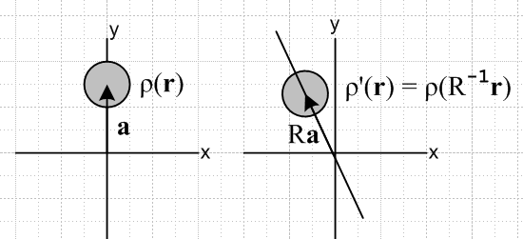

In the left drawing ρ(r) is large when r = a. In the right drawing we can see that ρ'(r) is large when r = Ra. We thus have ρ'(Ra) = ρ(R-1Ra) = ρ(a) = large.
The quantity ρ is a scalar field over R3 and this is how scalar fields transform. The conclusion is the same for a surface charge σ, so we summarize

φ(r; ρ) = Σi ρ(ri)d3ri/|r-ri| = ∫d3ri ρ(ri) /|r-ri|
φ(r; σ) = Σi σ(ri)d2ri/|r-ri| = ∫d2ri σ(ri) /|r-ri|

φ'(r; ρ') = φ(R-1(θc) r; ρ)
φ'(r; σ') = φ(R-1(θc) r; σ)

ρ'(r) = ρ(R-1r)
σ'(r) = σ(R-1r)

In a delta function derivation for σ we would replace dq'i = ρ(ri')d3r'i with dq'i = σ(ri')d2r'i and then the same derivation goes through.

We have now shown what happens to a surface charge distribution and its potential if we do an active rotation of all that point charges that make up the charge distribution:

σ'(r) = σ(R-1r)
φ'(r; σ') = φ(R-1(θc) r; σ)

4. Application to rotation of a certain bowl and Green's Charge.

This section has been rewritten since the original draft, to wit:

Consider our "famous" situation of a tilted spherical bowl with some surface charge on it. Here is the picture

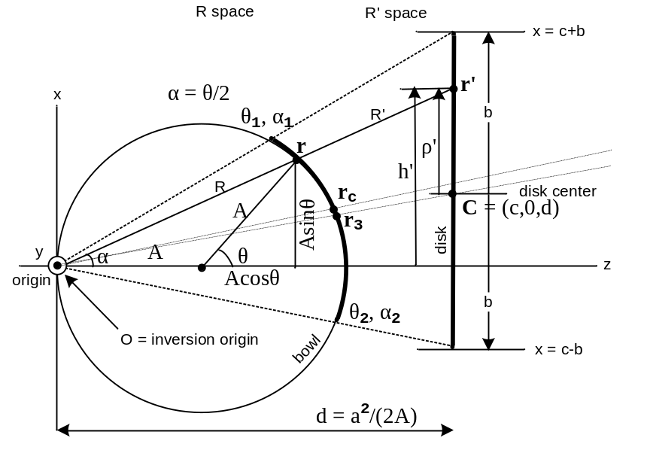

and the charge on the bowl is this, along with the potential due to the bowl and point charge (all this is before rotation)

g(r; ξ,σ) = – (2/πR) sin-1 [ 2b / ( $\sqrt{(ρ'-b)2 + (z'-d)2}$ + $\sqrt{(ρ'+b)2 + (z'-d)2}$ ) ] + 1/R
σ(R) = - (a2/π2R3) / $\sqrt{b2-ρ'2}$ R = | r - ξ |

ρ' = $\sqrt{(x'-c)2 + y'2}$ R = $\sqrt{X2+ Y2+ (Z+A)2}$
x' = (a2/R2)X d = a2/2A
y' = (a2/R2)Y ξ = (0,0,-A) = Green's charge loc
z' = (a2/R2)(Z+A) θc = (θ1 + θ2)/2

We must now take note of certain changes in our notation:

(1) Since here we already use single-prime for the disk stuff, we will use double-primes for things after rotation.

(2) We are using r = (X,Y,Z) so in what is now R"-space we will have r" = R1r , where R1 is the new name we will use for a rotation.

(5) Things are potentially very confusing because we use the symbol R for three things: it appears in our phrase "R space", it is the length of r when measured in inversion-origin coordinates, and it is the symbol used for a rotation matrix. One must be careful!

So, we wish to apply an active rotation R1 to the physical bowl and Green's charge. We expect that in R" space, after doing this active rotation of all the charges on the sphere, we will have, based on our rules just derived above for charges and potentials in transformation,

φ"(r"; σ") = φ(r; ξ,σ) = – (2/πR) sin-1 [ 2b / ( $\sqrt{(ρ'-b)2 + (z'-d)2}$ + $\sqrt{(ρ'+b)2 + (z'-d)2}$ ) ] + 1/R
σ"(r") =σ (r) = - (a2/π2R3) / $\sqrt{b2-ρ'2}$ R = | r - ξ |

ρ' = $\sqrt{(x'-c)2 + y'2}$ R = $\sqrt{X2+ Y2+ (Z+A)2}$
x' = (a2/R2)X d = a2/2A
y' = (a2/R2)Y ξ = (0,0,-A) = Green's charge loc
z' = (a2/R2)(Z+A) θc = (θ1 + θ2)/2

Basically we have just copied down our results from above. The problem that remains is that we would like to get the results in R" space to be in terms of things like X" as opposed to the X we now have.

5. Restate the above application using spherical coordinates

We can take everything in the previous section and make these replacements

X = Asinθcosφ
Y = Asinθsinφ
Z = Acosθ

so that everything is then expressed in terms of R space angles θ and φ. No need here to rewrite all of the above, we can see how to do these simple substitutions. In terms of R" space, we still have the problem that we would like to have things like σ"(r"; σ") expressed in terms of θ",φ" and not θ,φ.

6. General Euler rotation for R1 (using spherical coordinates)

Note added later: I don't know why I wrote out r = A Rz(φ)Ry(θ) here, I could have just written this as its obvious vector form r = A(sinθcosφ, sinθsinφ,cosθ), but no harm done. Except for the general Euler case, I do all this stuff later in "how to rotate..." doc.

The usual way I represent a general rotation is by some Euler angles. Goldstein uses Rz(ψ)Rx(θ)Rz(φ) and does a lot of stuff with them. M&M on page 566 use Rz(γ)Rx(β)Rz(α) . Tinkham on page 102 (5-14) uses Rz(α)Ry(β)Rz(γ) with Ry in the middle. I tend to prefer this y in the middle because if you directly apply Ry(β) to a vector in the z direction, you get a vector with φ = 0. Also, I think I first learned about Euler angles from Tinkham in Spring 1970 at Harvard, though I did Goldstein the same semester. So I will use the Tinkham form

R1 = Rz(α)Ry(β)Rz(γ) = R(α,β,γ) // Tinkham form I will adopt

I looked a bit and I don't see that I have written this stuff out anywhere, maybe I will find it later. I want to do this using my own simple matrices not the equation editor. So I will start quoting from my doc in ang mom about matrices

Rx(θ) = 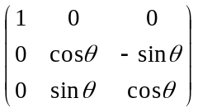 Ry(θ) = 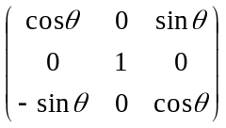 Rz(θ) = 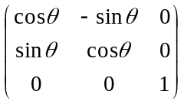

And now let's transcribe

Rx(θ) = $\left(\begin{matrix}1 & 0 & 0 \\ 0 & cosθ & -sinθ \\ 0 & sinθ & cosθ\end{matrix}\right)$ Ry(θ) = $\left(\begin{matrix}cosθ & 0 & sinθ \\ 0 & 1 & 0 \\ -sinθ & 0 & cosθ\end{matrix}\right)$ Rz(θ) = $\left(\begin{matrix}cosθ & -sinθ & 0 \\ sinθ & cosθ & 0 \\ 0 & 0 & 1\end{matrix}\right)$

Now we can construct our full Euler rotation, just for fun,

R(α,β,γ) = Rz(α)Ry(β)Rz(γ) = $\left(\begin{matrix}cosα & -sinα & 0 \\ sinα & cosα & 0 \\ 0 & 0 & 1\end{matrix}\right)$$\left(\begin{matrix}cosβ & 0 & sinβ \\ 0 & 1 & 0 \\ -sinβ & 0 & cosβ\end{matrix}\right)$$\left(\begin{matrix}cosγ & -sinγ & 0 \\ sinγ & cosγ & 0 \\ 0 & 0 & 1\end{matrix}\right)$

and get a little help from Maple:

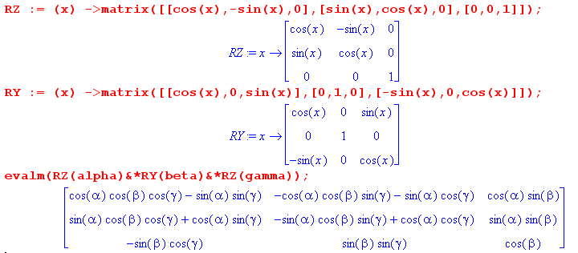

So the above is the fully general Euler rotation matrix, for what it's worth.

Now our interest will be in computing

r" = R1r

and for r = (X,Y,Z) we use

X = Asinθcosφ
Y = Asinθsinφ
Z = Acosθ

which we can represent as

r = A Rz(φ)Ry(θ)

which we have Maple confirm:

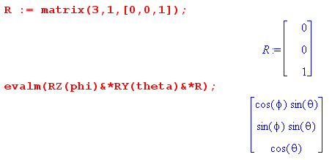

Then we can say

r" = R1R = ARz(α)Ry(β)Rz(γ) Rz(φ)Ry(θ) = ARz(α)Ry(β)Rz(φ+γ)Ry(θ)

and Maple then tells us that R" is this: ( see euler stuff.mws)

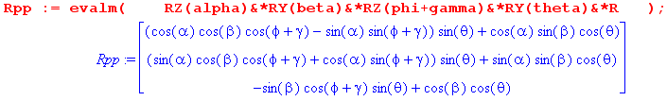

= $\left(\begin{matrix}sinθ"cosφ" \\ sinθ"sinφ" \\ cosθ"\end{matrix}\right)$

Thus we get a simple result for our θ" angle

cosθ" = – sinβ cos(φ+γ)sin(θ) + cos(β)cos(θ)

but finding the azimuth is harder. The ratio second row/ first row = tanφ" so we get

tanφ" =

So φ" = artan { [...]/[...] } which I don't think can be simplified.

7. Specialize the rotation R1 to the case α = γ = 0.

We now have

R1 = Ry(β)

R" = R1R = ARz(α)Ry(β)Rz(γ) Rz(φ)Ry(θ)
= ARy(β)Rz(φ)Ry(θ)

and Maple tells us

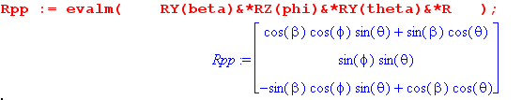

so we get

cosθ" = cosβ cosθ - sinβ sinθ cosφ

and now for φ" we get

tanφ" = sinφ sinθ / [ cosβcosφsinθ + sinβcosθ ]

= sinφ / [ cosβcosφ + sinβcotθ ]

= tanφ * (1 / [ cosβ + sinβcotθsecφ ] )

