A Retrospective Discussion of "Problem 38 the Hard Way" PhL 11.25.10

This is being written well after my work on this problem was completed.

1. History. 1
2. Why did it take so long? 2
(1) Even a single inversion is complicated. 2
(2) Triple Kinematics as a Problem 3
(3) Rotating the bowl as a problem in itself. 6
(4) Mysterious simple algebraic relations 6

1. History.

Smythe Problem 38 wants to know the charge density σ on a grounded metal iris due to a point charge in the hole of the iris. I also wanted to know the potential Φ for this problem, which is known as "the In-plane Green's Function for an Iris". (Notice that since an iris goes out to ∞, it is necessarily "grounded". )

The solution for σ is incredibly simple (symbols are shown in the picture below)

σ(ρ') = – ( q1/π2r12)$\sqrt{B2-S2}$/ $\sqrt{ρ'2 - B2}$ r12 = ρ'2 + S2 - 2S ρ' cosφ

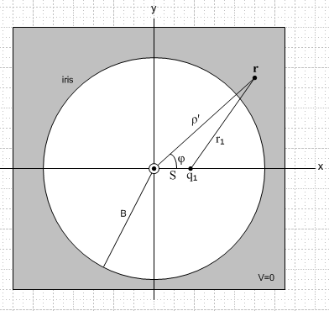

Because of this simple answer, I was intrigued by this problem thinking there must be a very simple way to solve it. I never found a trivial solution method, but the disk-to-disk inversion method provided a moderately simple method of getting both σ and Φ. This solution is carried out in "iris by inversion, Problem 38 the easy way.doc" in the "Problem 38 Easy Way" folder. The iris result and the disk result are both stated in "doing the disk by inversion.doc" in the "ring and disk" folder, and the results are essentially identical, related by a simple analytic continuation.

But I was unaware of this disk-to-disk inversion scheme which directly connects the Charged Disk Problem to the In-plane Green's Function for an Iris by a single inversion process. Why didn't I think of this? I felt that the only simple inversion geometry connected disks or irises to bowls. There, you are always relating, in essence, a part of one sphere's surface in R space to a part of one sphere's surface in R' space. I never thought of using the equatorial plane of a sphere in both spaces as the surface of interest, though in retrospect it is now totally obvious.
So a lesson here is that you sometimes miss a key point of view and, in thus missing out, you end up having to do a much harder problem. I do think, however, that this is the "nature of things". Often people first do something "the hard way", and then they or someone else finds "the easy way".

Needless to say, in the timeframe of my efforts here I was totally unfamiliar with dual-integral equations and Sneddon, so that avenue of solution was not open to me, though I knew it existed. I think it is an avenue. I had tried some Stakgold integral equation methods on the disk and iris problems, but they led me nowhere. For example, in one case I ended up with an infinite set of integral equations. Besides, all the hints from Smythe (and later Jackson) were that this was an inversion-soluble problem.

Early on, I could not even come up with my hard-way dual inversion method. I wandered aimlessly around. For example, I could relate the charged bowl to the on-axis disk Green's function, and I spent time worrying about that Green's function. Really that was a completely separate problem that was also of interest to me, namely, what is the σ and Φ for a charged bowl (and barrel). So I was working on several problems at once, perhaps confusing them together.

One fine day I finally realized that the problem could be solved by a dual-inversion process, and I was quite excited to find that pathway. I realized that the inversion surface of a bowl is a disk for one orientation of the bowl, and an iris for another orientation of the same bowl on the same bowl sphere. So my scheme was to start with a charged disk, compute σ and Φ for the bowl. Then I would rotate the bowl to the other position, rotating the σ and Φ with it. Then I would invert again to the iris. So the idea was invert, rotate, invert. Later these inversions became "the first inversion" and "the second inversion". For each inversion I eventually drew a picture, and these were called Pic1 and Pic2.

In slightly more detail, I would start off with a charged disk vertically offset from the usual symmetric position I was used to. Even this idea of a vertical offset seemed pretty clever to me. The inversion of such a charged disk is the On-cap Green's Function for a tilted bowl. When you rotate that grounded tilted bowl on its sphere to a certain new symmetric position, the Green's charge also rotates and goes to some point on the sphere facing the bowl but off axis. Then in the second inversion, the grounded bowl maps into a grounded iris (no vertical shift), and that Green's charge maps into a charge in the hole of the iris, so THIS inversion relates the On-cap Green's Function for the bowl to the In-hole Green's Function for an iris. I felt that this overall scheme was immensely clever. After all, I could see no other way to solve this problem, it was my only option.

I eventually completed this program and got the right answer for the iris, but it took me a very long time, maybe 15 days as suggested by my work flow doc. Along the way, I wrote at least 10 Word docs, and several Maple ones and made many Visio drawings (all reviewed in " 0. Top level review of Smythe inversion bowl.doc".) My retrospective question is this: why did this take so long; why was it so hard?

2. Why did it take so long?

I submit here four answers to this question.

(1) Even a single inversion is complicated.

Even by itself, a single inversion process is very complicated. The actual inversion relations for σ and Φ are deceptively simple. You say things like

Φ'(r) = (a/r)Φ(r') σ'(r) = (a/r)3σ(r') r' = (a2/r2)r

which are certainly simple looking equations. In practice, you have to have a detailed picture showing all the details of this problem. For example, here is the picture Pic1 for my first inversion relating disk to bowl ( the picture should really be 3D, but just drawing the y=0 plane slice is plenty of work)

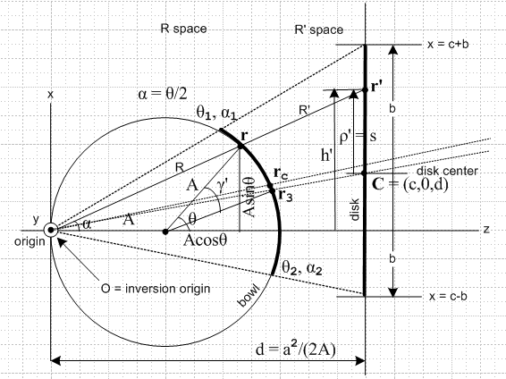

Notice all the distances and angles involved here. There are 7 angles labeled and maybe 10 distances. The vectors r and r' which appear in the simple formulas just quoted are shown, and they are relative to what is called "the inversion origin" shown at the left. Due to the possible confusion with normal polar coordinates for vectors whose origin is circle-center, I use R and R' as the lengths of r and r'. In fact there are 3 different "origins of interest" in the picture: inversion origin, sphere origin, and disk origin! The inversion sphere is not drawn, but it is a sphere of radius a centered on the inversion origin which passes between the bowl and disk. Some of the distances relate to "variables", such as r and r' and ρ' and R and R' and h' and s, while other distances are "parameters" like A (sphere radius) and b(disk radius) and c (vertical offset) and d (distance from disk to inversion origin) and a (inversion sphere radius).
My point is that there is a lot of geometric parameterization going on here. I sometimes call the choice and labeling of variables and parameters "kinematics". Normally this refers to making such choices for a problem describing the mechanical motion (kine) of something like a bicycle. But here we have lots of kinematics for a simple static electrostatics problem!
Moreover, there are many geometric relationships between the different symbols that are required to solve the problem, which relations of course do not appear in "a picture". This is just trigonometry, not rocket science, but still it is messy. You can just page through " 1. Parameter facts for Pic 1 and Pic 2.doc" to see what some of these trigonometric relations look like.
So I hope the reader agrees that even a single inversion problem is technically somewhat complicated, where one has to keep track of all these variables and parameters and their relations.
The practitioner of inversion alleviates the complexity somewhat by constantly thinking of the two systems related by inversion as the R system and the R' system, so variables in the R' system have primes, and those in the R system do not. At least then one knows which system a variable relates to. (This rule is not adhered to for the parameters as the above picture attests).

(2) Triple Kinematics as a Problem

So we have established that a single inversion is itself complicated, requiring significant tracking resources on the part of the practitioner's kinematics radar. We then need to rotate the bowl and its charge, and then plan a second inversion. In laying out our "kinematics" to do this, what is one to do with variable and parameter names? This is perhaps the biggest single issue in this problem, and IT is I think a big reason why it took me 15 days.
One approach would be this: original disk has variables like R', this inverts to a bowl which has variables like R, you then rotate the bowl and then the rotated bowl has variables like R", and you then invert the bowl to an iris and have variables like R'''. A computer could maybe think this way, but a person is unhappy with all these primes running around. It just overloads the tracking radar, there are too many targets to track at once, there are too many "symbols" including all those primes, things are too cluttered. You are trying to think of everything at once, and you end up drawing ridiculous pictures like this one, which tries to show the first inversion problem in black and the second inversion problem in red. The problems are rotated so there are two inversion origins.

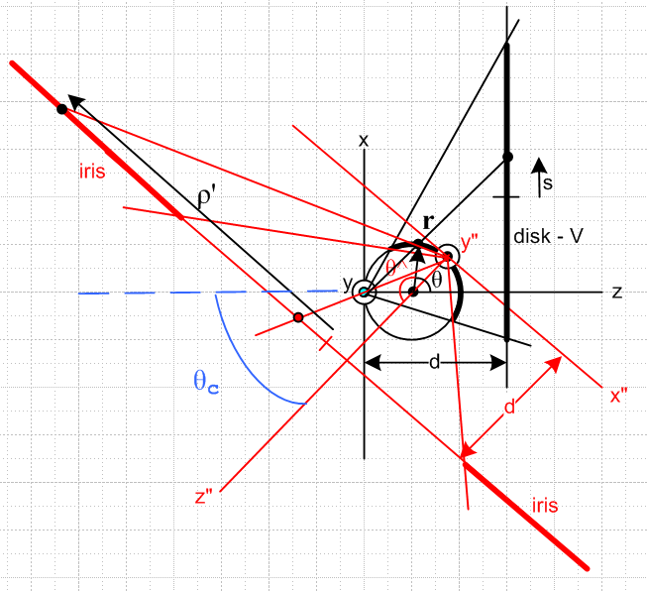

As a simplified conceptual picture, this drawing is perhaps useful since it shows the two inversions in one picture. But the reader can just imagine what this picture would look like if all the variables and parameters were labeled for both inversion problems (and the rotation problem). If this picture were "fully instrumented for engineering use", as they say, it would be a true nightmare. You would have to draw the bowl sphere much larger to show all the angles and distances, but then the iris would be 3 feet away on your paper. This would probably require a whole day with a nice D size piece of paper. I could do it in Visio, but I could not print it on anything I have.
A better approach is a computer subroutine approach where we treat each of the three problems -- invert, rotate, invert -- as a separate modular problem and within each problem we assign "local variables" which are the subroutine input and output call parameters. Using this idea, the second inversion can use the same R space and R' space concept used in the first inversion, which makes the inversion practitioner happy. So here then is the second inversion Pic2 using this approach.

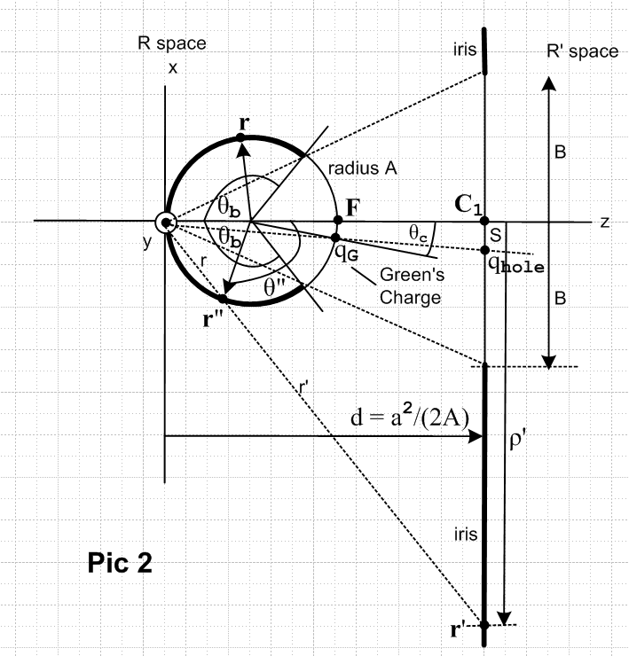

Again, this problem has the same complex kinematics of the first inversion. Before using the above second inversion plan, one has to of course compute σ and Φ from the first inversion, do the rotation of (the bowl and σ and Φ) as a separate modular problem, and then get set up for this second inversion. One has to take the output of the previous module and rename the variables as appropriate for input to the next module; this is a cost of the modular approach.

There were two confusing (to me) issues that arose in doing things this way.
First, I was confusing the r of the original inversion problem with the r of this second inversion problem, so you can see that in the above picture I went so far as to call r by the name r" (but length r). I just had trouble thinking of r as a dummy parameter of a subroutine call. If I called them both r, I was then thinking the two points so labeled were the same point on the sphere, whereas in fact each is just a dummy label and they are not related. The modules are not completely decoupled because you have to relate variables and parameters of the final iris problem to those of the initial disk problem, and if things have the exact same names due to the modular approach, one gets confused, an example is given below.
Second, due to the nature of the geometry, it was impossible for me to draw the two pictures Pic1 and Pic2 using a bowl of the same angle! A small bowl makes Pic1 easy to draw (see above), but such a bowl would make Pic2 require a huge vertical piece of paper since the iris is so large. All I can say is that this drawing problem makes angles look different and adds confusion. In particular, it adds confusion regarding the confusion of the previous paragraph!

So far then, we have argued that it is the "triple kinematics" of the three sequential problems that caused confusion and delay in getting the problem solved. In doc " 1. Parameter facts for Pic 1 and Pic 2.doc" I finally got things reasonably modularized for the two inversion problems. I "nailed things down" here, you might say.

(3) Rotating the bowl as a problem in itself.

I might add that doing the rotation of (the bowl and σ and Φ) was itself confusing to me and required a separate doc to get understood, though it is in the end fairly trivial. How do you "rotate a field Φ" ? Of course it is just a scalar field, so the answer is Φ'(r') = Φ(r) and ρ'(r') = ρ(r), but as with inversion, these equations are deceptively simple. So even the relatively simple middle process of rotation was not trivial.
[ see " Effect of transformations on charges and fields.doc" in the inversion folder. ]

(4) Mysterious simple algebraic relations

There was (and is still) another complexity issue lurking in this approach that is a little hard to put one's finger on. Remember that as you carry out each modular step, the results contain carried-through parameters and variables of the input problem, so these things are then dragged through all three steps. In the end, you have to get rid of the parameters and variables of the disk problem and somehow express them in terms of the parameters and variables of the iris problem. After all, an iris problem knows nothing about some obscure disk problem you might have used as part of your solution pathway. And it knows nothing about parameters like a and d, so those had better not appear anywhere in results.
In this situation, the big residual problem of this nature was that I had to show this fact

(b2 - s2) = [ (d2 + S2)2/ r12 ] (ρ'2- B2) / (B2-S2)

Looking at the pictures above, you see that s and b appear in the disk problem, while S and B and ρ' appear in the iris problem. The quantity r12 = ρ'2 + S2 - 2S ρ' cosφ contains all iris problem objects, where φ is the azimuthal angle of the point r', so this is just a law of cosines thing. ( note again that our pictures should all be 3D but we settle for one planar slice, yet another measure of the kinematic complexity!) The quantity d2+S2 is the distance2 from the inversion origin to the charge-in-hole in Pic 2, which is also an iris problem object. In order to prove the above result, I had to invoke Maple's algebra system, it was just too complicated for me to do in short order.
I think there really is some easier way to show the above critical fact, but I could not find it. Kelvin knew what it was, but it is buried in his paper which is hard to understand. I think it involves an application of the chord theorem for a circle, where you think of b2 - s2 = (b+s)(b-s) and then the last two factors are the two parts of a chord in a picture with two intersecting chords. But I don't know how to make this go. Kelvin was an expert in such matters.
When a relation is "pretty simple" like the one shown above, there is usually a simple way to prove it, but I could find no simple way so I had to resort to brute force Maple algebra. The simplicity of the above equation is a major reason why the end result for σ on the iris is simple.

