Smythe Problems 38-42: a Review PhL 12.3.10

This set of problems basically served as my "final exam" for Stakgold Chapter 6 on potential theory. It took me roughly 9 months to do this final exam, Nov 2009 through July 2010. Of course I learned many things along the way, including details of several curvilinear systems (ellipsoidal, oblate, cylindrical, spherical, toroidal) and the theory of inversion. I computed the on-axis Green's function for an oblate spheroid and then for an oblate hyperboloid, both significant efforts. I learned atoms and tensors and ellipses.doc. I learned Sturm-Liouville theory and practice, and did much reading in Morse & Feshbach and in Smythe. I did the charged disk problem following Jackson cylindrical, also in oblates, and also in ellipsoidals. I did transforms.doc. This could only be called in fact an Advanced Course in Electrostatics, more generally, potential theory. Lots of Maple learning was also done.
These 5 problems are heavy duty exercises in (1) the method of inversion; (2) superposition and related integrations; (3) Reciprocation; (4) Smythian form in sphericals.
________________________________________________________________________________

Overview.

In Problem 38 we do a disk-disk inversion of a charged disk to learn all about a grounded iris with a point charge in its hole. I found both σ and Φ for such an iris. [ inversion]

In Problem 39, we integrate the result of Problem 38 to learn all about an iris with a ring charge in its hole. I could have, but did not, integrate the potential; we just wanted to know the σ on an iris with this ring charge in the hole. [ superposition]

In Problem 40 we do a completely different inversion to relate the grounded iris with ring charge in hole to a grounded bowl with ring charge on the cap. Using the Green's Reciprocation Theorem and our knowledge of our iris, we are able to find the potential anywhere on the cap of a charged bowl!

In Problem 41 we see that we have a fully defined Dirichlet problem for the charged bowl, and we compute the potential both inside and outside in terms of some coefficients En which we leave as integrals. We compute just the E0 integral and find the capacitance of the bowl. I have never tried to do the other integrals, but probably they are doable and this gives the potential everywhere for a charged bowl.

In Problem 42 we look again at the Problem 40 situation of our grounded bowl + ring charge on cap. By two sequential superposition methods, we are able to deduce the charge on both surfaces of a charged bowl, the famous Kelvin result. This method makes it pretty obvious why the inner and outer σ's differ by a constant amount.

________________________________________________________________________________

Problem 38 asks for σ on a grounded iris with a point charge in the hole. I found both the requested answer σ, and also the potential Φ everywhere around the iris, which is of course the Green's Function. I first did this "the hard way" by a fancy double inversion. Then I did it "the easy way" using a single inversion that I learned from Mr. Kirk and Kelvin. Both these methods required a lot of algebra and I did not find a silver bullet method that allows one to bypass this algebra. Here are the results where we keep our iris in R'-space and thus prime the variables ρ',θ',z' :

Φ'(r') = 2q1/(πr1) cos-1 [ $\sqrt{2}$B r1 / { $\sqrt{[ (ρ'-B)2+z'2] [ (ρ'+B)2+z'2]}$} ]
m = (ρ'2+z'2)(S2-B2) + B2(B2- S2 + 2r12)
r12 = ρ'2 + S2 - 2Sρ'cosθ' + z'2 θ = 0 in direction of the point charge

σ'(r') = - q1 / (π2r12) * $\sqrt{B2-S2}$ / $\sqrt{ρ'2-B2}$ // sum over both sides
r12 = ρ'2 + S2 - 2Sρ'cosθ θ = 0 in direction of the point charge

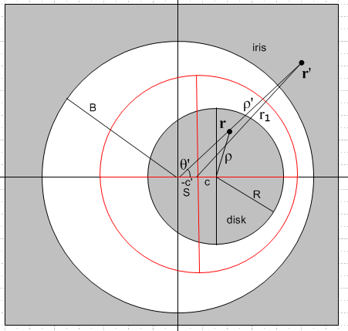

It took me quite a long time to understand how to do this problem.

Problem 39 asks for σ on a grounded iris with ring of charge in the hole. The method is to treat the previous Problem 38 as if the point charge were a piece of the ring, then integrate the result around the ring. The resulting charge density on the iris is found to be

σ1(ρ) = - (q/2π2) ($\sqrt{B2-S2}$/ $\sqrt{ρ2 - B2}$) / (ρ2-S2) // either side

where q is the total charge on the ring. I did not attempt to integrate the potential around the ring at this time.
But I did integrate the Problem 38 σ over the iris and found a total of -q1. Obviously, the Problem 39 integral would then give -q. I also did some Maple plots of the Problem 38 equipotential surface in a certain slice, and then added some electric field lines from a program I developed later on.

Problem 40 asks us to invert the above Problem 39 grounded-iris-cum-ring-charge-in-hole to get a grounded spherical bowl with a ring charge on the cap. Then we are supposed to use that result in combination with something called Green's Reciprocation Theorem to show that, in another problem, that of the charged bowl, the potential on the bowl cap is given by V(θc) = V0 (2/π) sin-1 [ cosα' / cosθ' ].
Here is the picture:

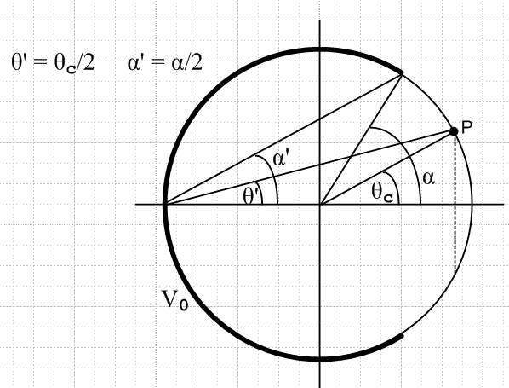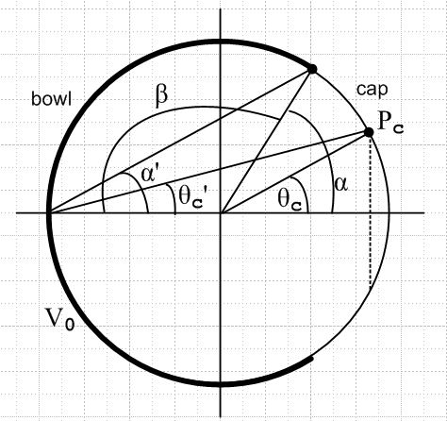

I had to go learn this Green's thing, and I then used it to show that V(θc) = - V0 (q1/Q2) where -q1 is the total charge on the bowl, and Q2 is the total charge of the ring charge on the bowl's cap. I knew from Problem 39 all about the charge density on the iris (both sides the same) and about the ring charge there, total charge q, so it was then a question of inverting these two charges from R' space over to R space where the bowl lives. I did that for σ, and then integrated σ on the bowl to get -q1 and this result was of course proportional to the iris ring charge q. Then I computed the total charge on the R space cap ring, called Q2, and found Q2 = q ($\sqrt{d2+ S2}$/a)-1. From these results I found (q1/Q2) and thus the answer to the problem. For me, this was a very difficult problem and the doc is 33 pages long, which includes a 5 page overview. I spent a lot of time trying to understand the reciprocation theorem. We learn by doing.

Problem 41 considers the charged bowl of Problem 40 and we realize that we have a fully defined Dirichlet problem for the charged bowl! We know Φ=V0 on the bowl and V(θc) on the cap. Using the usual spherical Smythian form we show how one can find either the internal or external potential, and we end up with an integral for the Legendre expansion coefficients which are called En. By evaluating just E0 for the exterior problem we find that Φ drops off as something over r, and in the usual manner this tells us the capacitance of the charged bowl. The answer is C = (A/π)(β + sinβ) where β is the bowl angle shown on the right above.

Problem 42 again considers the situation of Problem 40, grounded bowl + ring of charge on cap. We are asked to use our Problem 40 work to deduce σ on each surface of a charged bowl! This is a famous Kelvin result. The method is a tricky one of superposition. We superpose rings of charge on the cap which are each scaled such that the cap ends up with a constant σ0 on it. At the same time, we superpose the bowl σ's implied by each ring. This σ was an intermediate result obtained in Problem 40. We do the integral and obtain σb(θ) to be this quantity

σb(θ) = V0/(4π2A) { sin(α/2)/ $\sqrt{sin2(θ/2) -sin2(α/2)}$ – sin-1 [sin(α/2)/sin(θ/2) ] }

This is the charge density on either side of the grounded bowl with a uniform cap with σ0 = -V0/(4πA) . We then superpose onto this situation a metal sphere with -σ0 on the outer surface. This cancels out the cap charge and gives us a charged metal bowl in isolation. The inner surface of the bowl has σb(θ), while the outer surface has σb(θ) - σ0 . We thus get the very famous result that the inner and outer σ's differ by a constant amount, which at first blush seems very strange.
So Smythe has taken us on an amazingly circuitous route to get this Kelvin bowl result.

