Smythe Problem 39 PhL 6.22.10

Here I solve Problem 39, but give information about Problem 38 as well that is perhaps out of place. But Problem 38 was such a mess, I don't want to move this information there.

Problem 39: Find the Green's Function for, and find σ on, an iris with ring charge in the hole.

[ Problem 38: Find the Green's Function for, and find σ on, an iris with point charge in the hole. ]

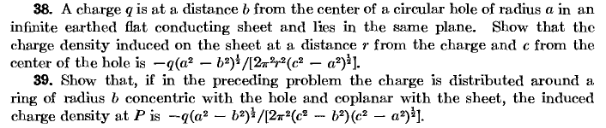

Overview (1 page, written 12.2.10) 1
1. Integrating Problem 38 σ to get the Problem 39 σ₁. 2
2. Problem 38: What is the total induced charge on the iris (with point charge in hole) 4
3. Problem 38: Maple Plotting of the in-hole Green's Function for the iris. 6
4. Problem 39: what is the potential right on the in-hole ring of charge? 7

_________________________________________________________________________________

Overview (1 page, written 12.2.10)

Section 1. In Problem 38, we considered a metal iris of radius B with a point charge q1 in the hole located distance S from hole center. By doing a relatively simple disk-disk inversion analysis, we were able to relate this iris Green's Function problem to the Charged Disk problem, and we found this result for the charge density σ on the iris, where φ is the angle measured away from a point opposite the point charge,

σ(ρ,φ) = -q1( 1/2π2r12)$\sqrt{B2-S2}$/ $\sqrt{ρ2 - B2}$ // either side

r12 = ρ2 + S2 + 2Sρcosφ // r1 is the distance from the point charge to r = (ρ,φ)

If we think of q1= dq = (q/2π)dφ where this point charge dq is a patch on a ring of radius S, we can superpose all the patches on the ring to get a full ring of total charge q, and we can at the same time superpose the induced charge distributions on the iris to get the iris surface charge σ1 in the presence of this full ring in the hole. The resulting iris surface charge is this:

σ1(ρ) = – (q/4π3) ($\sqrt{B2-S2}$/ $\sqrt{ρ2 - B2}$)$^{\int_{-π}^{π}{}}$dφ / (ρ2 + S2 + 2Sρcosφ)

= - (q/2π2) ($\sqrt{B2-S2}$/ $\sqrt{ρ2 - B2}$) / (ρ2-S2) // either side

and this is the result that Smythe gives as the answer, so we are done.
In Section 2 as "extra credit", I ask a second question: going back to the point charge q1 in the hole which induces σ(ρ,φ) on the iris (ie, Problem 38) , what is the total charge on the iris?

Q = $^{\int_{B}^{∞}{}}$ρdρ$^{\int_{-π}^{π}{}}$dφ σ(ρ,φ)

I work out this double integral, and find the result to be Q = -q1. This says that all the flux lines from the point charge land on the iris. No field lines end up at points on the Great Sphere away from the iris plane.
In Section 3 I show some Maple 2D plots of the potential for Problem 38, and I throw in a field line calculation I did much later, just a picture.
In Section 4 I conclude that the potential on the Problem 39 ring of charge is logarithmically divergent.
__________________________________________________________________________________

1. Integrating Problem 38 σ to get the Problem 39 σ1.

Here is our previously derived formula for the charge on the iris due to q1 at S from center, and iris radius B, (this is charge on one of the sides of the iris metal)

σ(ρ,φ) = -q1( 1/2π2r12)$\sqrt{B2-S2}$/ $\sqrt{ρ2 - B2}$

r12 = ρ2 + S2 + 2Sρcosφ (r1 is the distance from the point charge to r )

If we want to have a ring at radius B with total charge q, we have 2πBλ = q, where λ is the linear charge density. A point of charge on this ring is then dq = λds = λBdφ so

dq = λBdφ = (q/2πB)Bdφ = (q/2π)dφ

which is pretty obvious, and then this charge contributes this to the induced charge on the iris

dσ1 = -[ (q/2π)dφ]( 1/2π2r12)$\sqrt{B2-S2}$/ $\sqrt{ρ2 - B2}$

= - (q/4π3) ($\sqrt{B2-S2}$/ $\sqrt{ρ2 - B2}$) dφ/r12

We superpose (integrate) to get

σ1 = - (q/4π3) ($\sqrt{B2-S2}$/ $\sqrt{ρ2 - B2}$)$^{\int_{-π}^{π}{}}$dφ / (ρ2 + S2 + 2Sρcosφ)

= - (q/4π3) ($\sqrt{B2-S2}$/ $\sqrt{ρ2 - B2}$)$^{\int_{-π}^{π}{}}$dφ / (ρ2 + S2 + 2Sρcosφ)

This is a classic indefinite integral, GR 7 page 172 2.553.3

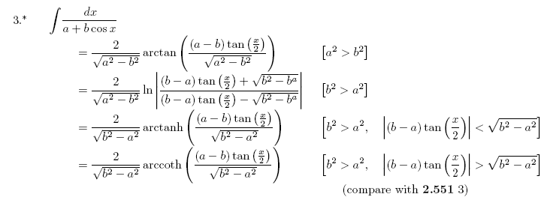
But I usually just find this in the definite integrals section.

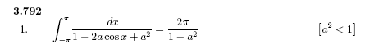

and I did a special little study of this integral in my "integral" binder notes. But taking the above, we know that

$^{\int_{-π}^{π}{}}$dφ / (ρ2 + S2 + 2Sρcosφ) = (1/ρ2) $^{\int_{-π}^{π}{}}$dφ / (α2 +1- 2Sαcosφ) α = - S/ρ

= (1/ρ2) 2π/(1-S2/ρ2) = 2π/ (ρ2-S2) at least for ρ > S (true on iris! )

So we end up with

σ1 = - (q/4π3) ($\sqrt{B2-S2}$/ $\sqrt{ρ2 - B2}$)$^{\int_{-π}^{π}{}}$dφ / (ρ2 + S2 + 2Sρcosφ)

= - (q/4π3) ($\sqrt{B2-S2}$/ $\sqrt{ρ2 - B2}$) 2π/ (ρ2-S2)

= - (q/2π2) ($\sqrt{B2-S2}$/ $\sqrt{ρ2 - B2}$) / (ρ2-S2)

In Smythe problems 38 and 39 we have

B → a
S → b
r1→ r
c → ρ

So we would translate the above to say

σ1= - (q/2π2) ($\sqrt{a2-b2}$/ $\sqrt{c2 - a2}$) / (c2-b2)

= - q ($\sqrt{a2-b2}$/[2π2(c2-b2) $\sqrt{c2 - a2}$)) ]

and this is the correct answer. Here again are the two problems of interest.

2. Problem 38: What is the total induced charge on the iris (with point charge in hole)

The total σ on the iris (both sides) is this, from above

σ(ρ,φ) = -q1( 1/π2r12)$\sqrt{B2-S2}$/ $\sqrt{ρ2 - B2}$

r12 = ρ2 + S2 + 2Sρcosφ (r1 is the distance from the point charge to r )

The total charge on the iris is then this

Q = $^{\int_{B}^{∞}{}}$ρdρ$^{\int_{-π}^{π}{}}$dφ σ(ρ,φ)

= -q1( 1/π2) $\sqrt{B2-S2}$ $^{\int_{B}^{∞}{}}$ρdρ (1/ $\sqrt{ρ2 - B2}$) $^{\int_{-π}^{π}{}}$dφ [ρ2 + S2 + 2Sρcosφ ]-1

We have just done the φ integral above and we got

$^{\int_{-π}^{π}{}}$dφ / (ρ2 + S2 + 2Sρcosφ) = 2π/ (ρ2-S2) ρ > S

so we then have

Q = -q1( 2/π) $\sqrt{B2-S2}$ $^{\int_{B}^{∞}{}}$ρdρ [$\sqrt{ρ2 - B2}$(ρ2-S2) ]-1

First, scale out the B2 factor by defining ρ = Bρ' so

$^{\int_{B}^{∞}{}}$ρdρ [$\sqrt{ρ2 - B2}$(ρ2-S2) ]-1 = $^{\int_{1}^{∞}{}}$(Bρ')(Bdρ') [$\sqrt{ρ'2B2 - B2}$(ρ'2B2-S2) ]-1

= B2(1/B) (1/B2)$^{\int_{1}^{∞}{}}$ρ' dρ'[$\sqrt{ρ'2 - 1}$(ρ'2-S2/B2) ]-1

So define

a = (S/B)2 ρ'2 = x 2ρ'dρ' = dx

so we continue the above

= B2(1/B) (1/B2) (1/2) $^{\int_{1}^{∞}{}}$dx [$\sqrt{x - 1}$(x-a) ]-1

= (1/2B) $^{\int_{1}^{∞}{}}$dx [$\sqrt{x - 1}$(x-a) ]-1 a < 1

Wolfram claims this: (Maple presents it in a complicated manner)

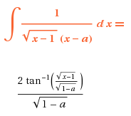

Evaluated at x = ∞ means tan-1(∞) = π/2. Evaluated at x = 1 gives tan-1(0) = 0. So we must have

$^{\int_{1}^{∞}{}}$dx [$\sqrt{x - 1}$(x-a) ]-1 = 2 (π/2)/$\sqrt{1-a}$ = π/$\sqrt{1-a}$ = π/$\sqrt{1-S2/B2}$ = πB/$\sqrt{B2-S2}$

Then we have found that

$^{\int_{B}^{∞}{}}$ρdρ [$\sqrt{ρ2 - B2}$(ρ2-S2) ]-1 = (1/2B) $^{\int_{1}^{∞}{}}$dx [$\sqrt{x - 1}$(x-a) ]-1

= (1/2B) πB/$\sqrt{B2-S2}$ = (π/2) /$\sqrt{B2-S2}$

And then we get our desired result which is

Q = -q1( 2/π) $\sqrt{B2-S2}$ $^{\int_{B}^{∞}{}}$ρdρ [$\sqrt{ρ2 - B2}$(ρ2-S2) ]-1

= -q1( 2/π) $\sqrt{B2-S2}$(π/2) /$\sqrt{B2-S2}$ = -q1

which is the result I expected. The point charge q1 located anywhere in the hole induces total charge -q1 on the iris. Certainly this same result will hold for the iris + ring charge situation, where q1 is then the charge of the entire little ring of charge in the hole.

3. Problem 38: Maple Plotting of the in-hole Green's Function for the iris.

This result says that all the flux lines from the point charge land on the iris. No field lines end up at points on the Great Sphere away from the iris plane. Here are some potential line plots in the plane that contains the point charge, at a few different scales (from " iris plots potential lines.mws"). I use the potential given in the disk-disk iris inversion doc, and these plots do serve to somewhat verify that my potential is reasonable. I don't have verification of my potential result anywhere. These plots have the point charge in the plane of the plot.

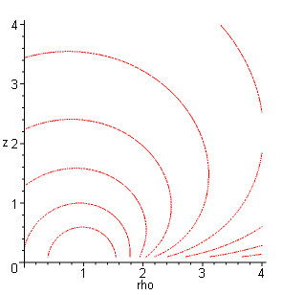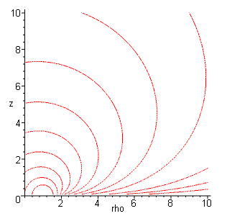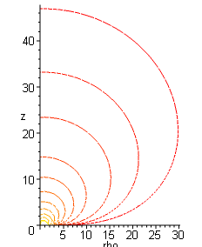

In the left plot, we see the lines becoming just circles around the point charge which is at ρ = 1, and we have the iris edge at ρ = 2. In the middle picture we have moved further away. You see the lines coming in tangent to the iris starting at ρ = 2, which means the field lines are landing at right angles. As we get very far away the distant potential lines seem to be approaching some simple generic shape.

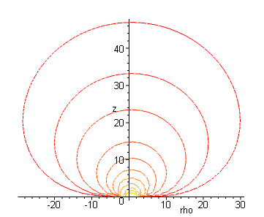

The plot above got me wondering about what the field lines look like. As commented above, they don't go off to the great sphere. I still don't know how you can analytically find the field line equations, but I got Maple to plot some E field lines, here is a typical plot, which confirms the nature of the lines.

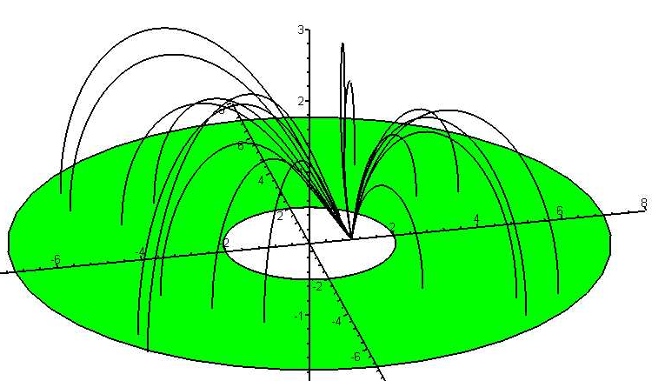

I never plotted the potential surfaces in 3D but they must look like my 2D plots above, but not really symmetrical about the z axis. Small spheres around the point charge, then squashed asymmetrical water balloons as suggested above.

4. Problem 39: what is the potential right on the in-hole ring of charge?

In the case of the ring, what is the potential in the hole? Does the spreading out of the point charge into a ring cause the potential to be finite on the ring?

One way to answer this: do an integration to compute the potential just of the induced charge σ1(ρ) at an arbitrary point Φ(ρ,φ,z) and see what happens at the ring. Well, obviously that is going to give a finite result at the ring.
The more interesting question is computing the potential due to the ring itself. Luckily, Jackson produces this result (green) on page 63. Picture is on page 63 with the ring lifted distance b above the origin of a spherical coordinate system. The potential everywhere is given by 3.48 on page 64. If we set θ = α and r = c, we are evaluating it right on the ring and we get

Φ(on the ring) = (q/c) Σn=0∞ [Pn(cosα)]2

which looks divergent to me. A related situation is the potential of a line charge, known to be V(r) ~ ln(1/r). If you to right onto the line charge, it blows up. If you take a small 2a interval around a point on the line, you have $^{\int_{-a}^{a}{}}$dz λ/|z| = 2λ$^{\int_{ε}^{a}{}}$dz/z and this blows up from the low end ε→0. So this same thing is happening with the ring charge above.
So the point is that spreading the hole in the iris charge onto a circle did not remove the divergence, it just lowered it from 1/r in nature to ln(1/r) in nature. This is good Stakgold stuff!

