Jackson method of inversion META PhL 1.13.10

Nine weeks have passed since my raw notes on this subject.

In the last section below, I stumbled onto my invert-rotate-invert method of doing Smythe Problem 38. This section was added May 26, 2010, so this is when I got that idea, and I then started the big grind and implemented that plan, as shown in the Problem 38 the Hard Way folder, first half of June 2010. Only in July did I discover the Easy Way.

Overview: You might regard "Jackson method of inversion formulas.doc" as an overview of this META doc. This META doc is just as big as the raw doc (!). That means I was still learning new stuff.

Part I: The Theory of Inversion. 1
Theorem 1 (Inversion Theorem): 1
Theorem 2 (Sphere Theorem) 6
Special Plane Case of Theorem 2 6
Maple Program. 7
Theorem 3 (The Inside Outside Theorem) 7
Theorem 4 (Charge Densities) 7
Comparison between 3D inversion transformations and 2D conformal map transformations. 8
Metal Theorems and the Usefulness of the Inversion Transformation 9
Theorem 5 (Constant Potential Theorem) 10
Example 2: Constant potential V = A. 10
Theorem 6 (Superposition Theorem) 11
Corollary to Theorems 5 and 6 11
Part II: Examples with a sphere mapping onto a plane 11
Example 1A: Two unequal point charges. 11
Example 1B: Grounded Full Sphere and point charge. 12
Example 3: Charged Metal Sphere. 13
Example 4: Grounded Metal Sphere. 15
Example 5: Superposition: Recreate Example 3 by adding the situations of Examples 2 and 4. 16
Example 6: Charged Spherical Bowl 16
Example 7: Grounded Spherical Bowl 17
III. Can you learn about the Spherical Bowl using Inversion of Disk? 18
Comments on Bowl By Inversion of Disk using Example 7: 18
What about just dealing with the charge densities σ ? 19
Jackson's Kelvin Comment 19
A look at Kelvin on this subject. 19
New section added 5.26.10. 23
Example 8: (disk to bowl Green's) 23
Example 9: (iris to bowl Green's) 24

Part I: The Theory of Inversion.

Theorem 1 (Inversion Theorem): Consider different "charge distribution situations" called R and R'. In R, we have a point charge qi at ri relative to some origin. In a certain "transformed space" R' we have point charge q'i at r'i relative to the same origin. The values for q'i and r'i in the R' situation are these:

q'i = qi(a/ri) and ri' = (a2/ri2) ri, // note that ri' = a2/ri =>

where a is an arbitrary positive constant. We certainly know these facts to be true

φ(r ; qi, ri) = qi / | r - ri| φ = potential for R situation
φ'(r ; q'i, r'i) = q'i / | r - r'i| φ' = potential for R' situation

Then here is what the Theorem 1 claims:

φ'(r ; q'i, r'i) = (a/r) φ(r' ; qi, ri) // LHS = RHS

where r' = (a2/r2)r (hence r' = a2/r ). Abbreviated, the theorem says φ'(r) = (a/r) φ(r') so that the potential φ'(r) in R' can be obtained from the potential φ in R by: (1) evaluating the potential φ in R at the inversion point r', and then (2) multiplying that by the dimensionless factor (a/r)

So far, a is just a positive constant, but soon we shall think of it as the radius of a circle centered at the origin. In the following drawing, we show this circle, and a possible location of the point charges and the various vectors mentioned above. One should think of this picture as a graphical superposition of situations R and R'. Remember that in situation R, only ri and qi are present, while in situation R' only r'i and q'i are present. In either situation we will have the observation point r and its inverted observation point r' . I will use the picture on the left, but the picture on the right is also correct.

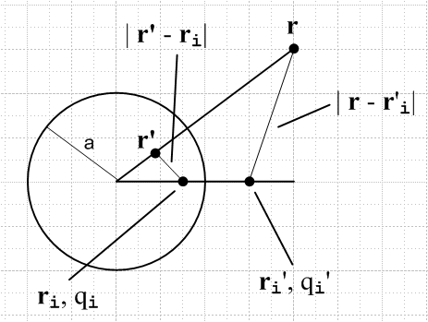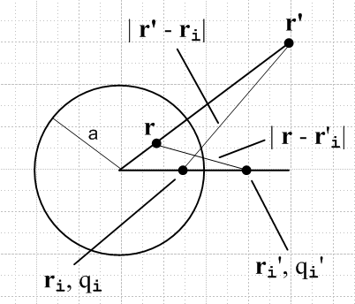

Lemma: | r' - ri| = (ri/r) | r - r'i|

We shall now prove Theorem 1, but first we need a key lemma which relates two distances indicated in the drawing. ( Had we drawn ri outside the circle, ri' would be inside the circle, and our two distance lines would cross each other, but the following Lemma will still be true )

PreLemma Facts: (complete obvious, but let's state them) (each point pair is "symmetric")

ri' = (a2/ri2) ri i = i' ri ri' = a2
r' = (a2/r2) r = ' r r' = a2

Lemma: | r' - ri| = (ri/r) | r - r'i| ri', qi'

Proof of Lemma : We start with this fact, where r' = (a2/r2) r [ and therefore r' = a2/r and ' = ] and the law of cosines for the small triangle in the above left picture (or upper long one in right picture)

| r'- ri|2 = r'2 + ri2 - 2 r' ri (' • i)

= (a2/r)2 + ri2 - 2 (a2/r) ri ( • i)

= (ri/r)2 (a2/ri)2 + (ri/r)2 r2 - 2 (ri/r)2 r (a2/ri) ( • i)

= (ri/r)2 [(a2/ri)2 + r2 - 2 r (a2/ri) ( • i) ]

= (ri/r)2 [ ri'2 + r2 - 2 r ri' ( • i) ]

= (ri/r)2 | r - ri' | 2 QED

Note that each step above is simply a "rewrite", no new information is being added. We don't have to have any pictures to prove this lemma, but they are useful "interpretations".

Although only the above Lemma will be used in the proof of Theorem 1 below, here is a useful "alternate lemma" which is the above lemma with ri↔ ri', and I will also show a more general form of this lemma.

Alternate Lemma: | r' - ri'| = (ri'/r) | r - ri| = (r'/ri) | r - ri| ri', qi'

Proof of Alternate Lemma : We start with this fact, where r' = (a2/r2) r [ and therefore r' = a2/r and ' = ] and the law of cosines for the smaller triangle in the below left picture (or large one in right picture)

| r'- ri'|2 = r'2 + ri'2 - 2 r' ri' ( • i)

= (a2/r)2 + ri'2 - 2 (a2/r) ri' ( • i)

= (ri'/r)2 (a2/ri')2 + (ri'/r)2 r2 - 2 (ri'/r)2 r (a2/ri') ( • i)

= (ri'/r)2 [(a2/ri')2 + r2 - 2 r (a2/ri') ( • i) ]

= (ri'/r)2 [ ri2 + r2 - 2 r ri ( • i) ]

= (ri'/r)2 | r - ri | 2 QED

Basically this Lemma is valid for any two pairs of symmetric points, you just have to get the labels in the right place. Here are the pictures for this Alternate Lemma:

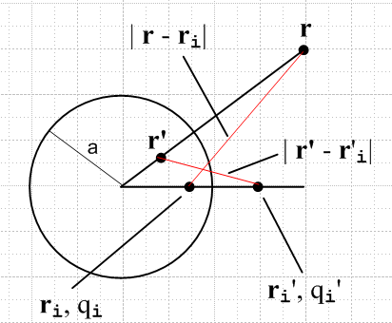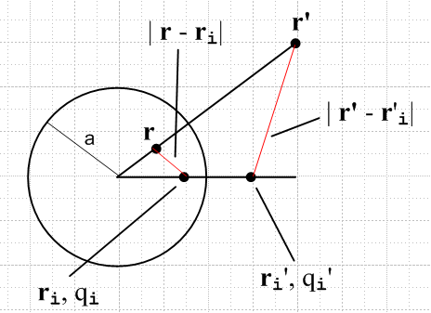

Alternate Lemma: | r' - ri'| = (ri'/r) | r - ri|

More General Statement of Lemma: You have two points in R and two symmetry points in R'. Call these points r1, r2, r1' and r2'. The symmetries are r1↔ r1' and r2↔ r2'. Then:

PreLemma Facts: (complete obvious, but let's state them) (each point pair is "symmetric")

r2' = (a2/r22) r2 2 = 2' r2 r2' = a2
r1' = (a2/r12) r1 1 = 1' r1 r1' = a2

Then the lemma says this:
| r1' - r2| = (r2/r1) | r1 - r'2| or: 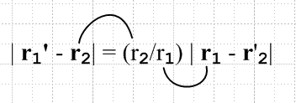

To get the alternate lemma, we simply "swap" one pair of symmetry points, for example r2↔ r2'. If you do this swap, the pair you get are still symmetric and all the algebra goes through unchanged except that we swap the primes on r2 and r2' everywhere they appear. This is just a relabeling issue. Then we get

| r'1 - r'2| = (r2'/r1) | r1 - r2| or : 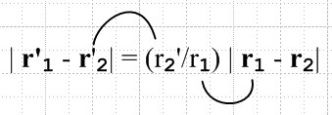

In both cases, the little curves show what variables go where. Here is another way to express this:

| r'1 - r'2| / | r1 - r2| = (r2'/r1) = (r1'/r2)

The rule is that on both sides you have primed over non-primed.

Significance of the Alternate Lemma: I did not realize this until pretty late in the game. Suppose you are doing an inversion problem and you are relating configuration R to configuration R'. You have two points of interest in R, and their two symmetry points in R'. This lemma makes a statement relating distances | r1 - r2| and | r'1 - r'2|. It can take a HUGE amount of algebra to show that such lengths are simply related. That is to say, we are relating a length in the R world to a length in the R' world!

We now resume the main flow:

Proof of Theorem 1: We use q'i = qi(a/ri) and our Lemma on the first line:

RHS = (a/r) φ(r' ; qi, ri) = (a/r) qi/ | r' - ri| = (a/r) [q'i(a/ri)-1 ]/ [ (ri/r) | r - r'i| ]

= (a/r) (ri/a)(r/ri) q'i / | r - r'i| = q'i / | r - r'i| = LHS QED

Comments:
(1) This theorem is one of geometry and algebra. There is no fancy invocation of the Laplace equation or anything like that.
(2) In regard to our space R, we start with a point r and we select an arbitrary a. If we draw a sphere of radius a about the origin, r might be inside or outside that sphere. Whichever is true, then r' is on the other side of the sphere. For this reason, we can think of r and r' as being "inverted" or reflected in some sense by the sphere. Of course the perp distance from r to the sphere is not the same as from r' to the sphere; the fact is that r r' = a2.
(3) the point r' is the same as the point r* (a common notation) which is the "inverse point" used in constructing the Green's Function of a sphere (centered at origin, radius a) using the "method of images". And the charge q' = q(a/r) is the magnitude of the image charge used in that problem, though the image charge is q* = - q' .
(4) In Ahlfors, a complex point z* is called "the symmetry point of z" (relative to a circle of radius a centered at the origin) if the following is true: z* = a2/z, which means |z*| = a2/|z|. This symmetry point is the 2D analog of the 3D inverse point r*.
(5) Since an arbitrary charge distribution can be thought of as a sum of point charges, the theorem applies to a potential generated by an arbitrary charge distribution. Each R-space component point charge is then inverted "through the sphere of radius a" to some R'-space component point charge on the other side of the sphere. It is in this charge distribution sense that Theorem 1 acquires some important horsepower.

Different Forms of the Inversion Theorem.

Above we showed that

φ'(r ; q'i, r'i) = (a/r) φ(r' ; qi, ri)

which we abbreviate as

φ'(r) = (a/r) φ(r') r' = (a2/r2) r rr' = a2

=> φ(r') = (r/a) φ'(r) = (a/r') φ'(r)

We can swap r ↔ r' and write the above as

φ'(r') = (a/r') φ(r) r' = (a2/r2) r rr' = a2

=> φ(r) = (r'/a) φ'(r') = (a/r) φ'(r')

=> φ'(r') = (a/r') φ(r)

So here is a summary of some different ways to present Theorem 1:

φ'(r) = (a/r) φ(r')

φ(r) = (a/r) φ'(r')

φ'(r') = (a/r') φ(r)

φ(r') = (a/r') φ'(r)

Theorem 2 (Sphere Theorem): In the transformation from R to R', part of the story is r' = f(r) , the other is q' = g(q). We see that function f is a mapping f: R3 → R3, specifically, it is r' = (a2/r2) r [ and q' = q(a/r) ] . Theorem 2 states that under this mapping, any sphere in R is mapped into some sphere in R'.

In my raw notes, I prove this theorem. I start in R with sphere | r - c | = ρ centered at c, radius ρ. This maps into a sphere in R' which is | r' - c' | = ρ' where c' = β c and ρ' = |β| ρ with β = a2/(c2-ρ)2. Thus, both the center and radius of the R' sphere are functions of a, c and ρ.

Special Plane Case of Theorem 2. If the sphere in R has c = ρ (which says this sphere touches the origin, and which says β = ∞ so ρ' = ∞), then the corresponding sphere in R' is a plane located d = a2/2ρ from the center of the a-sphere (which is the touch point). The plane's normal vector lies on the line defined by the a-sphere origin and the ρ-sphere origin. Here is an example (spheres shown sliced through center) [ Here ρ shown as R ]

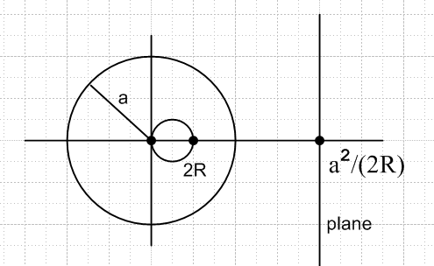

As you slide the small ρ-sphere to the left or right of this position, the ρ'-sphere (shown in the picture as a vertical line on the right) bends to the left or right and becomes a finite sphere. This situation is shown in Jackson page 39.

Note: in my raw notes, I refer to ρ as R, and ρ' as S. Here I use ρ because the symbol R is already used to describe "the situation" (configuration of charges in space) before we do our inversion. Also, I use r* and q* in place of r' and q', but here I want symbols that match R', the "inverted situation".

Maple Program. If you arrange for the a-sphere and ρ-sphere to have their centers on the x-axis, as in the picture above, then in the z=0 plane (plane of paper below) all spheres appear as great circles, which is the meaning of the above plot. I wrote a simple Maple program "method of inversion circles.mws" to draw the z=0 plane projections of the three spheres: the a-sphere, the ρ-sphere, and the ρ'-sphere. Here are some code lines:

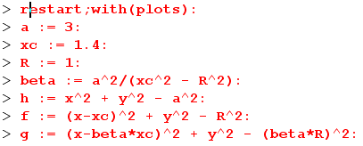

where you set in some values for a, c and ρ. Then we can identify h = 0 as the a-sphere (grey), and f=0 with the ρ-sphere (red), and g=0 with the ρ'-sphere (green). On the right is a plot with the values shown above. The left shows the result when xc = 0.7. Obviously xc = 1 gives the green plane case.

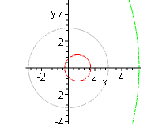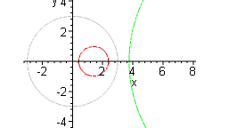

There are just examples of what happens when the ρ-sphere is slid a little to the left or a little to the right of its position where it touches the origin, and the ρ'-sphere in that case is a plane.

Theorem 3 (The Inside Outside Theorem). First, just stare at the above pictures. We know that points on the x axis very close to the a-sphere (shown gray) map into each other. In the left picture, therefore, the outside of the red sphere maps into the inside of the green one. But in the right picture, this same argument shows that the outside of the red sphere maps into the outside of the green one. In either picture,
we can say that the outside of the red sphere maps into the region to the "left" of the green boundary shown. The case we really care about is when the green sphere is a plane. In that case, the outside of the red sphere maps into the left half-space bounded by the green plane, and of course then the inside of the red sphere maps into the right half plane.

Theorem 4 (Charge Densities). Above we saw how a point charge transforms going R to R': q' = (a/r) q. Continuous charge distribution densities transform slightly differently simply because our mapping f: R3 → R3 changes the volume element. For charge densities, the statements analogous to q' = (a/r) q are:

ρ'(r') = (r/a)5 ρ(r) 3D charge density

σ'(r') = (r/a)3 σ(r) 2D surface charge density

Proof: Since r' = (a2/r2) r we find that d3r' = (a/r)6 d3r. Then q' = q(a/r) tells us that

q' = ρ'(r')d3r' = (a/r) ρ(r) d3r = (a/r) q => ρ'(r')d3r' = (a/r) ρ(r) d3r

=> ρ'(r'){ (a/r)6 d3r } = (a/r) ρ(r) d3r => ρ'(r')(a/r)6 = (a/r) ρ(r)

=> ρ'(r') = (r/a)5 ρ(r)

Compared to q' = (a/r) q, you see how the 6 powers of (a/r) due to the volume element change overwhelm the 1 power shown in q' = (a/r) q, so we end up with ρ' =(a/r)-5 ρ.

For the surface charge density, we have d2r' = (a/r)4 d2r which yields the second result.

We will find more useful the equations above expressed in another way. First, swap the roles of the variables r and r' , then replace r' by a2/r . The second line then follows in the same way:

ρ'(r) = (r'/a)5 ρ(r') = (a/r)5 ρ(r')
σ'(r) = (r'/a)3 σ(r') = (a/r)3 σ(r')

We can rewrite these in various ways, as we did for the potential. Swap r ↔ r' to get these forms

ρ'(r') = (r/a)5 ρ(r) = (a/r')5 ρ(r) => ρ(r) = (a/r)5 ρ'(r') = (r'/a)5 ρ'(r')
σ'(r') = (r/a)3 σ(r) = (a/r')3 σ(r) => σ(r) = (a/r)3 σ'(r') = (r'/a)3 σ'(r')

Comparison between 3D inversion transformations and 2D conformal map transformations.

The inversion method involves a mapping f: E3 → E3 [ r' = (a2/r2) r ]. Notice that this is not a broad range of mappings, such as all analytic functions w = f(z) subject to a few minor restrictions, but there is some flexibility in that we can choose an arbitrary positive value of constant a. Also, if we think of the inversion sphere of radius a as being relative to a fixed origin as we have shown above, we can position the pieces of our Poisson problem any way we like relative to our inversion sphere origin. Obviously this is the same as saying we are free to position the origin of our sphere anywhere we like relative to the pieces of our problem. So we have freedom of origin and radius for our a-sphere.
In 2D conformal mapping, we know that linear transformations map circles into circles, and in our 3D inversion mapping we know that spheres map into spheres.
In 2D conformal mapping we know that "angles are preserved", and Jackson claims this is also true for the inversion mapping in 3D, though I have not proved this. It seems reasonable since things are smooth under the mapping.
In 2D mapping "scale is preserved" in all directions, by which I mean that there exists a local scaling factor that is independent of orientation. I suspect this is true also in 3D inversion mapping, though Jackson does not comment on this. This would say that a 3D pixel image would get mapped into another such image such that locally you have only a rotation and scaling factor, no rotational distortion.
Due to the preservation of angles and presumably of scaling, you might think of inversion mapping as some kind of 3D conformal mapping. However, what is missing is the powerful 2D theorem which I quote here from my Ahlfors notes"

"Statement of Theorem 2. Assume we have a mapping f:R→R' where f(z) is 1-to-1, and onto. We know from elsewhere (outlined in section below) that: (1) this means f-1(w) exists; (2) if we further assume that f(z) is analytic, and that f '(z) ≠ 0 in R, then we know that f-1(w) is analytic on R'. Since f-1(w) exists, we know that the functions x and y shown above exist. THEN, suppose φ(x,y) is real and harmonic in R. Then we can write φ(x,y) = φ(x(u,v), y(u,v)) ≡ Φ(u,v). We clearly end up with a real function Φ(u,v) defined on region R'. Theorem 2 claims that this function Φ(u,v) is harmonic on R', something that is not immediately obvious. "

In our inversion scenario, we start with φ(r) and end up with φ'(r) = (a/r) φ(r') for a point charge. It is true that φ(r) is harmonic in R (3D harmonic, meaning satisfies 3D Laplace), and φ'(r') is harmonic in R'. Each situation just describes the potential of a point charge which we know is harmonic. It's just that in 2D this is true for w = f(z) for ANY analytic function f(z), whereas in the 3D case, it is only true for our dinky inversion transformation where all we can set is the origin and radius of the a-sphere. A second big theorem of 2D conformal mapping concerns Green's Functions and depends on the fact that in 2D, a boundary at constant potential maps into a boundary at the same constant potential, a feature completely missing from the 3D inversion situation, which is obvious just staring at the equation φ'(r) = (a/r) φ(r').

Metal Theorems and the Usefulness of the Inversion Transformation

So far we have dealt with some abstract "math properties" of our inversion mapping. Now we want to see how such a mapping might help us solve a hard electrostatics problems by somehow relating it (by inversion) to a simple electrostatics problem.
Electrostatic problems usually involve "surfaces" which hold surface charge and which may or may not be grounded or held at a constant potential. We are familiar now with the Dirichlet and Neumann problems where a potential or a charge distribution is specified on a surface and we are supposed to find the Laplace solution everywhere. And we are familiar with the class of problems where we put some charge on an isolated conductor and ask "what happens". This problem is a little harder because we have to figure out both how the charge distributes itself on the metal, and what the potential is everywhere, and since these two features are each a function of the other, we tend to find integral equations involved in solving this class of problem. A fourth type of problem is the Green's Function problem where we ground some metal conductor configuration, install a point charge somewhere, and ask what the potential is everywhere, and from that we can compute the surface charge distribution on the conductor.
So let's now look at a few "metal theorems"

Grounded Metal Theorem. Suppose Φ(r) is a potential in R with Φ=0 on a piece of metal which is a portion of some sphere in R. Then

Φ'(r) = (a/r) Φ(r')

will be a solution in R' with Φ' = 0 on a "piece of metal" there. This piece of metal will lie on some sphere in R'. Think of this theorem as mapping grounded metal to grounded metal.

Practical Application A. Suppose we have two spheres of interest ahead of time in R and R', and we custom tune our inversion transformation (set origin and a) such that these spheres map into each other. Then if we already have a solution of a Poisson problem in R involving a grounded piece of metal on the sphere of interest there, then we also know the solution of a problem in R' which has a grounded piece of metal which is the mapping of the first piece of metal from R to R'. These two problems can have some random charges floating around, but they must be related to each other as noted above. Suppose, for example, in our known solution of the problem in R, we know the surface charge on the piece of metal there which we find from the solution (normal derivative at surface). Then in the other problem in R', the surface charge there must be given by the transformation rule stated above for surface charges!

Special case of the above application. Usually one of our two "spheres of interest" will be a plane. Presumably problems are easier to solve for a problem with a planar piece of grounded metal than they are for a spherical piece of grounded metal. We solve the problem in the flat world, then we know the solution in the other world using our formula above, and our charge transforming formulas as well.

Theorem 5 (Constant Potential Theorem). The R'-space potential that is the inversion transform of a constant R-space potential φ = A is given by φ'(r) = q'/r where q' = aA. This is of course a point charge at the origin in R' space.

Proof: We know at once from Φ'(r) = (a/r) Φ(r') that if Φ = A, then Φ'(r) = (a/r)A = [aA]/r.

We can think of this situation as the limit of a large metal sphere of charge shown on the left.

Example 2: Constant potential V = A.

R-space problem R' space problem
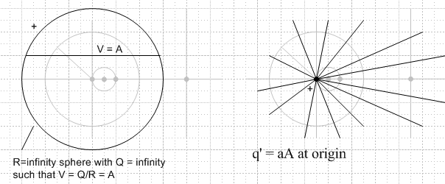

In the limit, both Q and R go to ∞, but their ratio remains V = Q/R = A. These pictures are first of many in which I will show the two "problems" not superposed in the same picture, but in separate pictures.

Theorem 5 reversed. Suppose φ'(r) = A over in R' space. Then in R space we have

Φ(r') = (r/a) Φ'(r) = ([a2/r']/a) Φ'(r) = (a/r') Φ'(r)

where we started from our exact same equation that we started with in Theorem 5 with the constant moved to the other side, and then we replace r in favor of r. Now suppose Φ'(r)= A as stated. Then we have Φ(r') = (a/r')A which we can write as Φ(r) = (Aa)/r. Thus, the potential in R space is that of a point charge of size Aa located at the origin. So this theorem works the same way both directions.

Theorem 5 stated more generally: A constant potential V = A in one space maps in the other space into the potential of a point charge of size aA located at the origin of that other space.

Theorem 6 (Superposition Theorem). Suppose we have an inversion transform pair of potentials φ1 and φ1' which go with each other. And suppose another pair φ2 and φ2' also go with each other. Then any linear combination of these pairs is also a valid transform pair.

Proof: This is obvious since we know our transformation is, for any fixed point r, linear:

φ3 ≡ φ1 + φ2 φ3'(r) ≡ φ'1 + φ'2 = (a/r) φ1(r') + (a/r) φ2(r') = (a/r) [φ1(r') + φ2(r') ]

= (a/r) φ3(r')

This shows that if φ1 and φ2 are transform pairs, so is φ3 .

Application: We might be able to assemble an R space configuration of interest by superposing simpler configurations.

Corollary to Theorems 5 and 6. If you "add" a constant A to the potential in R-space, you have to "add" a point charge at the origin in R' space whose size must be q' = aA.

Part II: Examples with a sphere mapping onto a plane

Example 1A: Two unequal point charges. Suppose in R-space we position two unequal point charges (on the symmetry axis) such that they cause φ = 0 on the sphere on which we are going to materialize a spherical metal cap. [ We know we can do this because we know about the image method for the sphere. ] As we create the cap, what happens?

R-space problem R' space problem
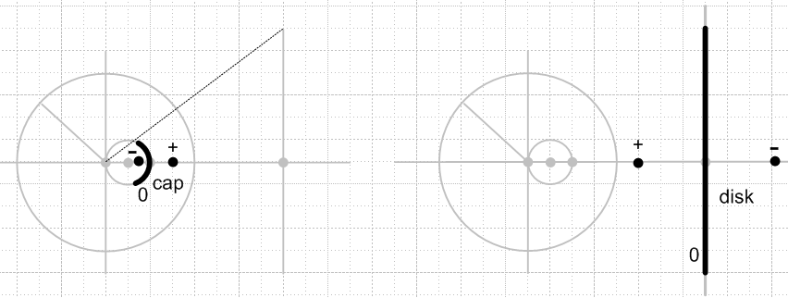

Since φ = 0 everywhere on the cap already, no charges are going to move around on the cap, so it will have no surface charge on either surface, and φ = 0 everywhere on the spherical cap, and also in the no-metal "math surface" that is the rest of the sphere. In R' the metal is a planar disk and the two point charges are now equal and opposite on two sides of the disk. The disk will have φ = 0 and no surface charge (and in fact φ = 0 on this entire plane in R'). There is a solution to Laplace in R and in R' and the two solutions are related by the method of inversion formula. Of course both solutions in this case are trivial -- just the sum of the potential of two point charges. This example is just relating the "image method for the sphere" to the "image method for the plane" by the "method of inversion". The amount of metal on the sphere or plane does not matter since φ = 0 on both surfaces whether or not there is metal there. The picture is shown above.

Comment: The above example links two problems each of which we already know how to solve.

Question added 5.26.10 [ read this only after reading both Examples 1A and 1B ] . In Example 1B we have a closed metal sphere in R. When both point charges are present, the sum of their potentials gives φ = 0 on the metal sphere. But of course inside the sphere we have some non-zero potential which in fact is infinite at the negative point charge. When we first ground the sphere, then delete the inside charge, the potential inside the sphere becomes φ = 0 everywhere, and it is only the potential outside the sphere that is the same in the two situations. The question is: how do we apply this concept to the unclosed sphere of Example 1A?
Well, in 1A above, if we first ground the two piece of metal, nothing happens. Then if we delete the point charges, yes, negative charge flows onto both pieces of metal from infinity. But, in R, the potential, although φ = 0 on the metal, is no longer φ = 0 on the entire math sphere. Similarly, in R' the potential is φ = 0 on the disk, but is no longer φ = 0 on the plane outside the disk. Thus, from a Dirichlet Problem point of view in either space, we no longer have the same boundary conditions. Thus, the solution φ (in either space) after grounding and negative charge deletion will NOT be the same the solution when the two charges were there. In 1B, however, the boundary conditions ARE the same before and after the process of grounding and negative charge deletion, so the solution in R outside the sphere is the same before and after.

Example 1B: Grounded Full Sphere and point charge. Suppose in the above scenario we have a full metal sphere in R (and a full metal plane in R'). We first ground the metal regions, then instantly make the negative charge disappear.

R-space problem R' space problem
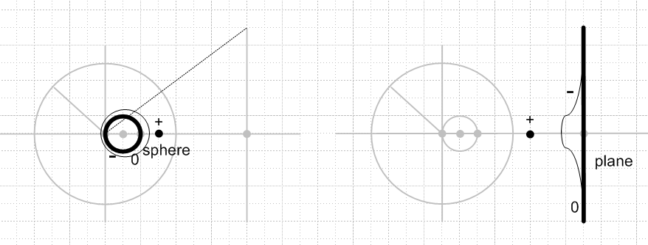

The first step of just grounding the metal pieces does nothing, since both metals are at φ = 0. But then when we instantly delete the negative point charge in each case, negative charge will flow from ∞ onto the metal in both R and R' and will form a charge distribution on the metal surfaces, both of which remain at φ = 0 (since they are grounded). Since outside the sphere in R (and to the left of the plane in R') the boundary conditions are exactly the same before and after the negative charge is removed (namely, φ = 0 on the metal boundary), Dirichlet tells us that the Laplace solutions stay the same in both R and R'. In each space we can apply our "method of images" knowledge to find the potential. We could then use these solutions to compute the surface charge density on the two pieces of metal. Of course the Laplace solution in each case is now just the Green's Function for that case, and we are just showing that the Green's Functions are related by the method of inversion equation. If you knew the one for the plane, you could compute the one for the sphere. Above is the 1B picture, where I have added some very crude representations of the charge distributions on the metal objects.

Comment: This example links "the Green's Function for a Sphere" with "the Green's Function for a Plane". We already know how to solve each of these problems.

Example 3: Charged Metal Sphere. Charged metal sphere in R space, touching the origin. Here it is:

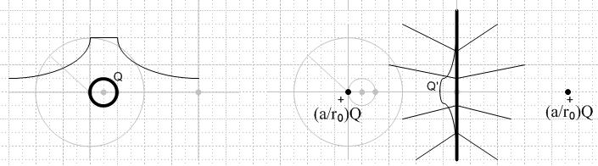

This is quite a complex example although it looks pretty simple. It is an example of what happens when you have a metal object in R-space which has a constant potential φ = A ≠ 0. In the raw notes, I have comments (1) through (11) on this example which consume many pages! [ Remember that, although the potential on the sphere in R is a constant, it is not a constant on the plane in R' so, although the sphere might be metal, the plane cannot also be metal. ]
We are now going to think about the potential in R-space and in R'-space. According to our Inside Outside Theorem, the outside of the sphere maps to the left half plane.
So the potential outside in R-space looks like that of a point charge of Q located at r0, so in R'-space the potential will look like that of a point charge of (a/r0)Q at location a2/r0 which, we see consulting above, is twice the distance from the origin as the wall, where I have drawn the charge on the far right. So in R'-space, on the left side of the plane, the potential is that of this fictitious point charge on the right side of the plane. Remember that there is no actual charge in R' except on the plane, because in R the only actual charge is on the sphere. We only put this fictitious charge on the far right to match the hypothetical point charge at the center of the R space metal sphere.
Similarly, the inside of the R-space sphere maps to the right half plane. On the left V = A = Q/r0 = constant (only on the inside), so (according to Theorem 5) on the right this appears as a charge at the origin of size aV = aQ/r0. This is also a fictitious or image charge. It is not really there, because the potential is not really constant everywhere in R-space.
So here is the R'-space situation: on either side of the plane, the potential appears to be coming from a point image charge of size aQ/r0 sitting on the other side of the plane, distance a2/(2r0) from the plane! [ the picture above shows the charge sizes, not any distances. ] I have drawn some electric field lines in R' space suggesting this fact. I show in the raw notes that, for a coordinate system (x',y',z') centered on the plane, the potential in either half space can be written

potential = (aQ/4πr0) / $\sqrt{(|x'|+x1)2+ y'2 + z'2}$

where x1 = a2/2r0 is the distance from the plane to the charges shown. (Remember, only one of these image charges is there "at a time" depending on which half space you are thinking about.) The potential is clearly symmetric about the plane. Since this potential has a non-vanishing normal gradient at the plane on either side, we could use it to compute the charge distribution that must lie on this (non metal!) plane using a little Gaussian pillbox. But we will compute this below by a different method.
On the plane in R'-space the potential is φ = (a/r)A = (a/r)(Q/r0) where r is distance to the origin on the left from a point on the plane. Clearly this is not a constant, so the plane cannot be metal.
The R-space sphere has surface charge only on its outside. This will map to a surface charge on the left side of the plane (as the figure attempts to show). According to Theorem 4, that surface charge will be

σ'(r) = (r'/a)3 σ(r')

where we know that σ(r) = Q/(4πro2) = constant. Thus.

σ'(r) = (r'/a)3 Q/(4πro2) = (a/r)3 Q/(4πro2)

This surface charge in R'-space all by itself generates the symmetric potential and E field lines I have drawn, and there are in reality no point charges anywhere in R'-space. There is no distinction as to which side of the plane the charge is on ("sticky charge monolayer"), but there is a distinction in R space because there we have a metal object, whereas in R' space we the plane is not metal.
In the raw notes, I show that the integrated charge on the plane is Q' = (a/r0)Q. An easy way to see this is to move far to the right in R'-space and look to the left. You think you see that left image charge which has just this value of Q'. But this potential is really coming from the aggregate surface charge on the plane, which is quite localized and must therefore like a point charge Q', so its integral is Q'.
We are now on page 15 of the raw notes.

Comment: This example links the "charged metal sphere" with "a certain charge distribution on a non-conducting infinite plane". The R'-space problem does not seem to have any physical interest or even realization, unless you were to glue down the resulting charge distribution there.

Example 4: Grounded Metal Sphere. This example is the previous example where we have added a negative constant to the R space potential to make φ = 0 on the sphere. So this example is one of "grounded metal" to "grounded metal". First, here is the picture.

R-space problem R' space problem
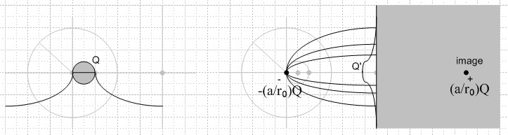

Our R space potential is this:

Φ(r,θ,φ) =(Q/4π) / $\sqrt{(x-r0)2 + y2 + z2}$ - (Q/4πr0) // outside sphere
Φ(r,θ,φ) = 0 // on and inside sphere

R has Φ = - Q/4πro at infinity so is a cause for caution. The surface charge on this sphere is just as in Exercise 3, so it maps to a plane of charge with σ' same as given in Ex 3. We know that the plane in R' will all be at potential Φ' = 0, from our general rule. And now we also know that the entire right side of the plane will be at Φ' = 0 since that is where "inside sphere" maps to -- just as if the sphere were solid metal. The potential on the left side of the plane will have two components: as we learned in Ex 3, the first term above gives rise to a point charge in R' located on the right side of the plane, making a potential of a point charge which is then "seen" from the left side of the plane. The second term (the constant A = - (Q/4πr0)) we know from Ex 2 will create a point charge in R' located at the origin. The size of this point charge will be q' = 4πaA = -4πaQ/(4πr0) = -Q(a/r0). Therefore, the potential on the left side of the plane in our R' problem is that due to two point charges which are equal and opposite in size and are equally spaced on the two sides of the plane, with the right side charge being sign of Q. We well know that this set of point charges causes V = 0 on the center plane, so things are consistent. This is just the method of images for a half space of metal.
Notice that the R' potential to the left of the plane is just that due to the origin charge and the image charge, you don't add all three (two point charges + the σ charge). But Dirichlet tells us that the R' space problem on the left of the plane has the same solution as the two point charge solution, since V = 0 on the boundary, so we know we can delete the image charge and replace it with the σ' surface charge and get the same result on the left. If we did not know the solution to this problem, our method of inversion has sort of derive the image charge method for us.

Comment: This example links "the grounded metal sphere" (infinity is then at some -Vo) to " Green's Function for an infinite plane". We know the solution to both problems already by simple methods.

Example 5: Superposition: Recreate Example 3 by adding the situations of Examples 2 and 4.

Example 2: R-space problem R' space problem

Example 4: R-space problem R' space problem

When we add these situations, the positive Ex 2 point charge cancels out the left negative Ex 4 point charge, so the potential to the left of the plane is just due to the charge on the right of the plane. Meanwhile, on the right side the Ex 4 potential of 0 is now added to that of the Ex 2 positive point charge potential at the origin. Thus, it is a no brainer superposition and we get

Example 3: R-space problem R' space problem
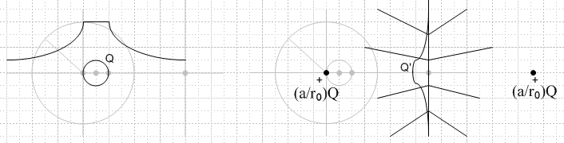

Example 6: Charged Spherical Bowl. This is the Example 3 picture shown directly above, but with the sphere replaced by a spherical cap (bowl). Our picture is then this:

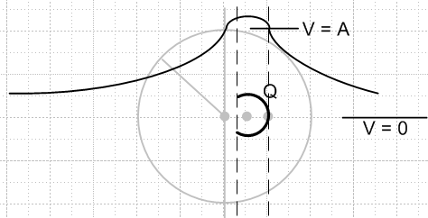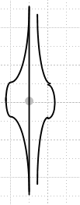

But now we don't know much of anything! The bowl has some inside and outside σ, and these map into right and left σ' on the right, which lie there on a finite non-conducting disk. We know we can just add these two σ's and think of the right as a single σ. We don't know any of these charge distributions in either R-space or R'-space. Similarly, we don't know either space's potential, though on the left we draw some guess as to what it looks like on the center line.
This example then relates something we would like to learn about (left picture) to something we know nothing about (some weird charge distributions on a non-conducting plate).

Example 7: Grounded Spherical Bowl. We don't know the value of A above, but whatever it is, we could add -A to the left potential to bring the bowl surface to V = 0. We know this creates an origin charge on the right, so here is out picture:
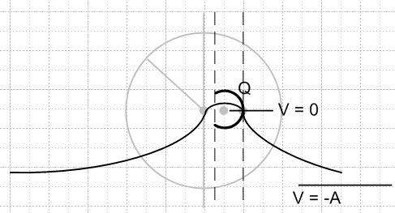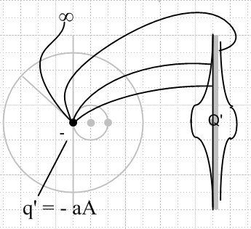

This is grounded metal to grounded metal. But now in R'-space we have a problem we might be able to solve! It is the on-axis Green's function for a circular plate. Suppose we knew what that was, how would we proceed?
Suppose we knew on-axis Green's Function for the disk. Then I would take a charge q' = -aA and put it a distance d = (a2/2r0) from the disk, on axis. I would then know Φ' everywhere, meaning on both sides of the disk. I could compute from that the charge densities on both sides of the disk. I could map back to R-space and I would then know the potential everywhere there, and again compute the charge densities on both sides of the bowl. Everything would, of course, be a function of parameter A. But then I could integrate the charge density on the bowl to get Q, and that would tell me A as a function of Q, and then the problem is completely solved.
The R-space problem with V = 0 and charge Q on the bowl is a capacitor problem against the sphere at r=∞ which is at potential V = -A. The capacitance is determined from Q = CV, so C = Q/V = Q/A and thus when we know A, we know the capacitance of the bowl as well.

III. Can you learn about the Spherical Bowl using Inversion of Disk?

Comments on Bowl By Inversion of Disk using Example 7:

At this point we are at page 19 of the raw notes, and I go on there to "instrument" the bowl for analysis with various angles and so on. When I did that, I thought the R'-space problem was going to have some simple solution, because I thought at that time that the R'-space problem was just finding the charge distribution on a charged disk. THAT is a problem I now know how to do in oblate spheroidal coordinates, and Jackson shows the simple answer on page 93 using another method.
BUT, I now know that the R'-space problem is, in fact, the on-axis Green's function for a finite disk. After a monstrous digression into the subject of oblate spheroidal analysis, I was finally able to write down an expression for this on-axis Green's Function, with Smythe's assistance. That result is this:

Vo(ζ,ξ) = q/[4πjc1ε] Σn,even (2n+1) [(2j/π) Qn(jζ0) – Pn(jζ0)] Qn(jζ) Pn(ξ)
- q/[4πjc1ε] Σn,odd (2n+1) Pn(jζ0) Qn(jζ) Pn(ξ)

Vi(ζ,ξ) = q /[4πjc1ε] Σn,even (2n+1) [(2j/π) Qn(jζ) – Pn(jζ) ] Qn(jζ0) Pn(ξ)
- q/[4πjc1ε] Σn,odd(2n+1)Pn(jζ) Qn(jζ0) Pn(ξ)

where
q = Green's point charge
c1 = radius of the disk
ζ0 = "radial" location of the Green's point charge relative to the center of the disk
ζ = oblate radial coordinate
ξ = oblate angular coordinate

In my "Smythe... cone" doc I show how these oblate coordinates are related to the Cartesian ones in both directions. But here is a better source, my "2 Oblate Spheroidal..." doc ( note that (ξ,η)MF = (ζ,ξ)Smythe )

ζ2 = (1/2) (r2/a2-1) { 1 + sign(r2-a2) $\sqrt{1 + 4a2z2 / (r2-a2)2}$} a = focus = c1
-ξ2 = (1/2) (r2/a2-1) { 1 – sign(r2-a2) $\sqrt{1 + 4a2z2 / (r2-a2)2}$} r2 = x2+ y2 +z2

Recall that in Smythe the x-axis is the symmetry axis for the spheroid or plate, whereas my formulas above assume that z is the symmetry axis.

So the upshot is this: Using our "method of inversion" with Example 7, we could learn about the "spherical bowl" situation by transforming the "on axis Green's function for the disk" problem. But the solution I have come up with for the disk -- which is a Smythian solution -- is a "complete mess" :

• it involves infinite sums of Legendre P and Q functions

• the arguments of these functions are oblate coordinates, and when these are expressed in spherical or Cartesian coordinates, you get very ugly things, as shown above

So this avenue is not "panning out" for me the way I hoped it would. I invested heavily, learned a lot of things, but did not get closer to a solution to the bowl problem!

What about just dealing with the charge densities σ ? I did attempt to compute the charge density on the disk for the on-axis Green's function, and here is what I found:

"In the limit where the spheroid squashes down to a circular metal plate, ζ1= 0 and the above becomes

σplate = – q/[4πc12] [ ξ ]-1 Σn (2n+1) [Qn(jζ0)/Qn(0+) ] Pn(ξ)

Qn(0+) = (-1)(n+1)/2 (n-1)!! / n!! n odd
Qn(0+) = (-1)n/2 (-jπ/2) (n-1)!! / n!! n even

which we can write in Cartesian coordinates as

σplate = – q/[4πa2]( 1/$\sqrt{1 - (ρ/a)2}$) Σn (2n+1) [Qn(jζ0)/Qn(0+) ] Pn(±$\sqrt{1 - (ρ/a)2}$)

where now ± refers to the front or back surface of the plate. Again, the back surface will have less σ due to the interference of terms. "

So this tells us the σ on the two sides of the plate, and from this we could use our inversion to get the σ's on the surfaces of the bowl. Well that is at least a little easier than the huge mess above for the full potential. But still, we have a messy infinite sum on n

Jackson's Kelvin Comment

On page 40 Jackson makes some mysterious comments. He says that in 1847 Kelvin solved the charged conducting bowl problem by inverting the simple charged circular disk. Jackson does not say this disk is a conducting disk, but he then refers to his solution for the charged conducting disk. We are told to see page 186 of Kelvin's collected papers which I have and also Jeans p 250-251.
This comment seems to go against everything I have learned in my inversion studies. If the R'-space disk is non-conducting, then all I know is that there is some unknown charge distribution on it! I am obviously missing some key fact, or I have some key misunderstanding, as so often happens.

A look at Kelvin on this subject.

But first I want to get PDF to DJVU. But that will take 14 hours I now estimate. So let's use the PDF for now. This subject is in a Kelvin paper begun on page 178

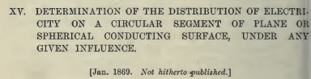

On page 181 we have this interesting text,

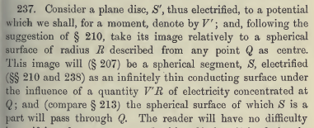

So our disk is S', it is a conducting disk at potential V' unknown. The inversion sphere radius is called R instead of a. The center of the sphere is point Q which is my origin. The bowl is then the "spherical segment" he calls S. The bowl is conducting. He does not say the bowl is grounded. But now he says the bowl is "electrified under the influence of a point charge V'R at the origin. And his surface S "passes through Q". So he must be talking about this picture, as I would draw it:

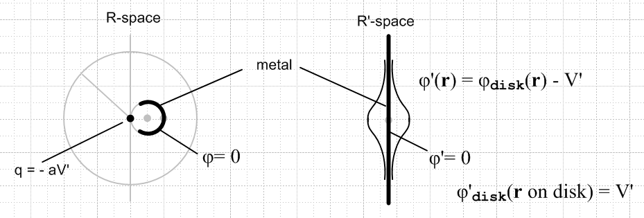

My only disagreement with Kelvin is that I think the point charge in R-space should be -aV', not aV', because I have added -V' to the R'-space potential. I am always wrong about these things, but for now I will stick to my guns.

This is NOT one of my considered examples above! Even Kelvin felt the need to draw a picture, and here is his picture:

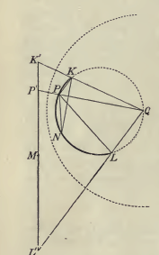

which has the disk on the left. Notice that his bowl and disk are off-center, so a more general case than I was considering. Notice Q at the center of the large dotted circle (the inversion circle).

OK, going back to my picture, take that as a hint and ask: what can I do with such an inversion? The "charged metal object" is on the right now, it is the disk. If it is at a constant potential V', then I know that the bowl cannot be at constant potential, so the bowl is not metal (nor does Kelvin say it is). I know all about the potential and charges in the R'-space picture, so yes, I could compute everything for the picture on the left. But the picture on the left does not seem to have any relevance! It is not a Green's Function for the bowl since the bowl is not even at a constant potential, much less grounded.

So OK, go back to the picture:

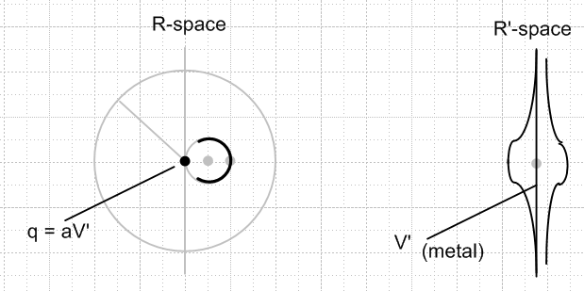

Start with the charged metal disk on the right, which I know all about. In the distance, V → 0 for such a disk. Assume that the disk is at potential V'. Now change the problem by adding a constant -V' to the R' space problem. Then the disk on the right is at V=0, and then so is the one on the left, and yes this added constant on the right creates a point charge on the left at the origin.
So what we now have on the left is "The Green's Function for a Bowl" ( for a very special placement of the Green's point charge). So this problem is relating the "Green's Function of a Bowl" in R-space to "Charged disk + constant potential" on the right. I know the surface charge densities on the right -- it is just the Jackson result and is not affected by the fact that I have added constant -V' to the potential. Therefore, I know the inverted charge densities on the left!

So this is pretty amazing just in itself: Inversion starting with something I know about and which is very simple ( σ on a charged disk) is yielding the Green's Function for a bowl! I would regard the latter as pretty complicated, so finally we have an example in which a simple result can help solve a hard problem.
[ But it is not the general on-axis Green's function for the bowl. It is the Green's function only for the point charge being in a specific on-axis position -- at the pole of the bowl. ]

So, imagine that we do this and we have the on-axis Green's Function on the left. There are charges on the inner and outer surfaces of the bowl which we now know. (they are the same)

Now comes the next Big Step. Suppose we have the Green's point charge q1 and suppose we integrate the sphere charge on both surfaces to get q2 = -f q1 where f is some fraction. [ Remember some of the point charge field lines go to ∞ ].

What happens now on the left if we subtract the potential of the point charge from the Green's problem potential?? We can certainly mathematically do the subtraction. We are left with a metal bowl of charge q2 that is all alone in space. The potential that we get from the subtraction must be the potential of this charged bowl !!! Then of course we could compute the σ on the bowl! [ Wrong. You do get the potential contribution of the bowl this way, but that is not the potential of an isolated charged bowl! In other words, if you remove the point charge, the surface charge will readjust itself on the bowl. ]

I think this is it! I will pursue this in another document.

" Later: Well, I did that pursuit and got nowhere. ("Kelvin bowl attempt"). My paragraph above (which one?) makes no sense now in the light of day. Start with the grounded bowl + charge (Green's situation). There is some charge distribution on the bowl. Now unhook the bowl from ground. Bowl still at V = 0 and still has its charge distribution. Then change it to sticky plastic. Bowl is still at V = 0, holding sticky charge unchanged. Now delete just the point charge. Fine. The potential on the sticky plastic bowl is no longer constant. So this is NOT the situation of an isolated charged metal bowl. There is only one way to make this sticky bowl have constant potential without altering its charges: add back that point charge. The other way is to alter the charge distribution and NOT add back the point charge. But that is the problem I am trying to solve! "

Reviewing this doc on 5.26.10, I am confused by the last paragraph which just how I put in quotes. It says that if you have a grounded spherical cap with the point charge as shown above on the left, then if you unground the bowl then delete the charge, the bowl is no longer at a constant potential and so is not just an isolated "charged bowl". But I know that. My picture above is saying the Green's problem on the left (point charge + grounded metal) is the image of the charged disk problem on the right. I think that is still correct. Since I know all about such a charged disk, I could use inversion to find the Green's function for the left picture. Yes, this is a very limited Green's function since the point charge is exactly at the pole.
So apart from this strange quoted paragraph (which might be left over from earlier doc version), I have now reviewed this entire 10 page doc and I pronounce it good and pretty clear.

New section added 5.26.10.

I am looking now at Jackson's problem 2.10 on page 53. He claims that we can relate the physics of an isolated charged disk (which I know all about), to the Green's problem of a metal iris with a point charge located at an arbitrary point in the hole! I think this is Smythe's problem #38 that I have been battling with for perhaps several months, on and off. Jackson says you can relate these problems "by the method of inversion", something Smythe did not tell us. I think I am onto it now, so let's crank up two more examples:

Example 8: (disk to bowl Green's) This is just an off-center version of what we did above. We start with a simple charged disk in R' space. It happens to be shifted up a little bit as shown. If such an isolated disk has charge Q, we know that it will be at some constant potential V which we can compute. Suppose in R' space we have such a disk, but we add to this disk's potential the constant potential -V. Then in R' space we know everything there is to know: we know the potential everywhere in R' space, and we know the charge distribution on either side of the disk (same on the two sides). We know all this from "other work". Given Q, we know V because we know the capacitance of such a disk. Meanwhile, from theorem 5 above, we know that the added constant potential -V in R' space maps into a point charge appearing in R space of size a(-V) sitting at the origin. So all this is drawn in our picture.

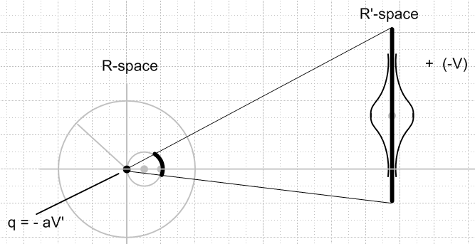

Now because we added (-V) in R' space, we know that the resulting disk there is 0 potential. Therefore, the asymmetric spherical bowl shown as a heavy curve in R space is also at 0 potential. Therefore, because we know "everything" in R' space, we know how to compute the Green's function for a spherical bowl where the Green's charge lies at an arbitrary position on the mathematical complement of the bowl's surface! So this is somewhat better than our earlier example where we had the Green's point charge be only at the exact opposite pole.
So let's imagine we go off and do this problem in great detail, and we find this Green's function and we can write it in some nice notation.
One little detail. The picture I show above is just a slice in the plane of paper. I assume we started with everything symmetrical then I moved the disk straight upwards so the plane of paper still passes through the center of the disk. The detail is this: how do we know that this disk maps into a spherical bowl on the grey sphere in R space? All we really know is that the disk maps onto some portion of the sphere, but when we say "bowl" , we are implying that the boundary of this sphere portion is a circle. This is a little geometry problem that is not obvious.

Geometry Lemma Needed

Let r be an arbitrary point on the spherical bowl-like region, and r' the corresponding disk point. The connection is this:

r' = (a2/r2) r which of course implies r' = a2/r

We have to parameterize r' on the disk, and then see what it maps into on the sphere.
I will assume the conclusion is correct, and I defer this problem for a while.

Example 9: (iris to bowl Green's) In R-space, we have our asymmetric bowl Green's function going on with some point charge q there (not at the origin). Although the bowl is a different size than in Example 8, and is at a different orientation and the point charge is at a different location, since we assume now that we have completely "solved" Exercise 8, we know the Green's function for this bowl on the left. That of course implies that the bowl is grounded, and that in turn implies that the iris into which the bowl maps on the right is also at 0 potential.

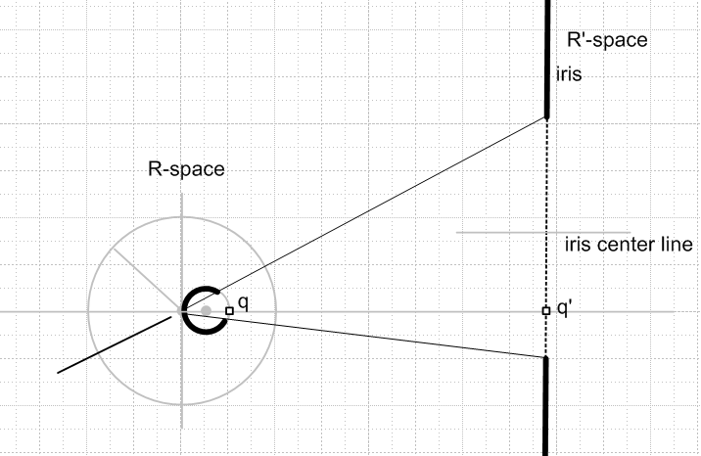

Now imagine the above picture without the two little point charges shown. If we knew one surface was at V = 0, the other would also be at V = 0. This is just the inversion-world statement that metal-at-0 maps into metal-at-0. Any surface charges would also map as outlined in our text earlier. We don't have any "constant potentials" in this picture on either side. Now, we add the square point charge on the left on the axis, and we then add the corresponding "inversion" charge on the right. We note that since q is on the grey small sphere on the left, the image charge q' lies where the disk used to be, that is to say, q' lies somewhere in the hole in the iris! This is what we have long been looking for. Given q we know how to compute q'. Now, once q is installed as shown in R space, we have our Green's problem there, and we know all about its solution from Example 8. Therefore, we can now calculate "everything" on the right, which means we can calculate the Green's function for the iris for the Green's point charge at some arbitrary location in the hole of the iris. And of course we can compute the charge density on the iris as well.

Comment 1. This surely is the method Smythe wanted his problem-solver to use to solve his famous problem 38 on page 201 [ ha! ]

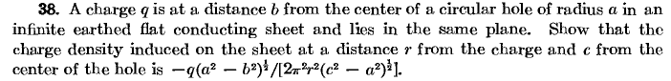

I have been struggling with this problem for a long time. Smythe never says "use the inversion method". Nor is this problem surrounded by other inversion problems, so we really had no hint. The problem is followed by a sequence of 4 other dependent problems (which I will soon do) .
So I was just lucky to notice this same problem (without the answer given) in Jackson as 2.10, and Jackson gave the hint that it was an "inversion" problem, and that allowed me to find the path.

Comment 2. I have in fact solved for the Green's function of the iris with the point charge at an arbitrary location in the hole. I did this in oblate spheroidal coordinates. The potential and the charge densities are all complicated double sums of P and Q functions and I could never see a way to get the simple result Smythe shows above. In fact, I still don't believe Smythe's result until I derive it, but at least I now have a method of attempting that derivation. I think I could solve for this same Green's function in toroidal coordinates, but I think the result is again going to be a messy sum of toroidal Q functions times P functions, and the above formula will not be obvious at all.

