Jackson method of inversion PhL 11.2.09

These notes concern section 2.6 p 35-41 of green Jackson. I see that I have no notes in the book, so maybe we skipped this when I took the course. This is somewhat of a long Jackson section, being 6 full pages. This is more than "the method of images" but is related very much to the image method. I see that in the most recent blue Jackson 1998 that this method of inversion section has been deleted, but he still has the reference to Kelvin doing the spherical cap problem. He uses the term "bowl" which might help in my web searching on this problem.

Comment: You can see why Jackson dropped the inversion discussion from his later editions. It is a lot of work to learn and use, but it is only useful for simple problems involving spheres, bowls, irises and disks and nothing else. A "curiosity". Better to replace these pages with pages showing how to do numeric work to find the potential in practical situations. Kelvin did not have this numerical option.

Overview? There is a META version of this doc, and another doc summarizes all formulas.

Units: In this doc I use units where φ = q/r for a point charge, NOT the units φ = q/[4πεr] .

Theorem: 1
Derivation of 2.20 and 2.21 2
Continue reading p 36. 3
Discussion page 37 C. 3
Page 38. 3
So I need to know why spheres go into spheres. 3
Circle Theorem: 6
Comparison: 2D conformal mapping vs the 3D method of inversion 7
Continue reading top page 39. 9
Examples: 9
Example 1: 9
Example 1A: 9
Example 1B: 10
Example 2. 10
Example 3 : charged metal sphere in R mapping into a plane in R' (many pages!) 11
Example 4: 18
Example 5: 18
Example 6: 19
Connecting the Spherical cap (ie, the bowl) with a disk. 21
1. Geometry. 21
2. Discussion of the two problems related by the above transformation 24
3. Transforming the Charge Density 24
Below this line is all junk, but maintain it for a while. 26

Theorem: You have some qi charges at some positions ri in spherical coordinates where there is some origin O somewhere. Assume the resulting potential is φ1(r) . Call this problem 1. Put an imaginary sphere around this origin of radius a.
Now consider a second problem where all the charges are moved to their image points ri* relative to this imaginary sphere, and are scaled as well to be qi* = qi (a/ri). The claim is that the potential for the second problem is related to that of the first problem like so:

φ2(r) = (a/r) φ1(r*) (2.17)

Proof: To prove this, just consider one charge qi, the potential is as shown p 35 A. Now move and scale the charge according to the rules and you get B. Here is the picture he does not draw:

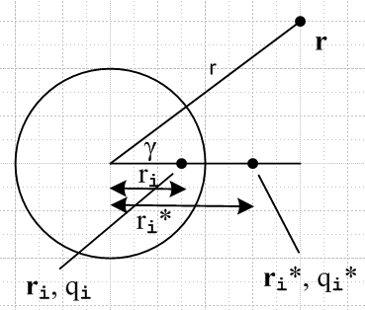

Remember that R is given by the law of cosines which is what you see as the radical in A. Of course it is trivial to see that B is the RHS of 2.17. So he has proven 2.17 for one charge, hence for any distribution of charges (superposition).
So φ2(r) = (a/r) φ1(r*). In his picture 2.7, let P' = r* . So the potential in the left picture at point P' is related to the potential in the right picture at point P = r .

Derivation of 2.20 and 2.21

Let r be a point inside the sphere and r* be outside. Then (a/r) > 1.

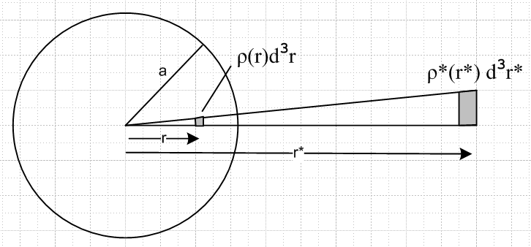

Consider a charge q = ρ(r)d3r inside the sphere. It's inversion world charge is q* = ρ*(r*) d3r*.
We know that dr* = -(a2/r2)dr so in our case |dr*| > |dr|. As someone says, every linear dimension in the inversion world is larger by ratio (a/r)2 than in the original world. So d3r* = (a/r)6 d3r, which you can also show by differentiation. The point that is clear is that, d3r* is LARGER than d3r (in my picture).
So now we require that q* = (a/r) q which just says this:

ρ*(r*) d3r* = (a/r) ρ(r)d3r

But d3r* = (a/r)6 d3r so we have

ρ*(r*) (a/r)6 d3r = (a/r) ρ(r)d3r

ρ*(r*) (a/r)5 = ρ(r) // note that this says ρ*(r*) is SMALLER than ρ(r)

ρ*(a2/r,θ,φ) (a/r)5 = ρ(r,θ,φ)

ρ*(a2/r,θ,φ) = (r/a)5 ρ(r,θ,φ)

Now let R = a2/r to get [ this says r = a2/R so that (r/a) = (a/R) ]

ρ*(R,θ,φ) = (a/R)5 ρ(a2/R,θ,φ)

and this is what 2.20 says. The same argument gives 2.21 for surfaces since dA* = (a/r)4 dA.

Continue reading p 36. The delta function stuff on page 37 is just providing an example of 2.20. If you apply 2.20 to p 36 A you end up with p 37 B which you know is the right answer.

Discussion page 37 C. Look at 2.17. Imagine that Φ = A on some surface in space ( can be far from the charges that make the potential, can be unrelated to these charges). Then in the inverted space, you will have some inverted surface from the mapping r→a2/r. Φ' on this inverted surface will be A(a/r) where you have different r's for different points on the inverted surface, so you won't have Φ = A nor will you even have Φ' = constant. Exception: if A = 0, then the fact that Φ=0 on the surface is preserved.

Page 38. Here Dave does what I do below in Example 2 where we discover that Φ = A (constant) really involves charges at ∞ and when you do the map, you get a point charge at the inversion origin that you have to keep in mind. This is now totally understood, his paragraph A on page 38. On first reading I was confused by this section.

Bottom of page 38 sees a list of "properties" of this 3D conformal mapping. As in 2D conformal, angles are preserved. He does not comment on local scaling, I would have to investigate that. He claims that an area patch transforms as (r/a)4 , something I have already dealt with above when doing σ surface charge. The last two items are basically the same item. So I am now going to make myself happy about the sphere to sphere claim:

So I need to know why spheres go into spheres.

Consider this equation of a sphere in the original space

| r - c | = R

Another way to write this is as follows (law of cosines, or just square the thing above) ( we have selected a coordinate system with origin at the inversion origin! )

r2 + c2 - 2rc • = R2

• = (r2 + c2 - R2)/2rc (*)

Now make the transformation to the inverted world

r → r* = (a2/r) = (a/r)2r

The claim is that we get a sphere in the new world, so we must have this form:

| r* - b | = S

but I go further and conjecture that b = βc so I claim our new sphere looks like this

| r* - β c | = S

so if we can find β and S that makes this equation consistent with the original equation, then we are done.
So this new world locus is this:

| (a/r)2r - β c |2 = S2

(a/r)4r2+ β2c2- 2(a/r)2 β rc • = S2

Now insert (*) above to get

(a/r)4r2+ β2c2- 2(a/r)2 β rc (r2 + c2 - R2)/2rc = S2

a4/r2+ β2c2- 2βa2r-1c(r2 + c2 - R2)/2rc = S2

a4/r2+ β2c2- βa2r-2(r2 + c2 - R2) = S2

a4/r2+ β2c2- βa2 - βa2r-2c2 + βa2r-2 R2 = S2

a4 + (β2c2- βa2)r2 - βa2c2 + βa2 R2 = S2r2

(a4 - βa2c2 + βa2R2) + (β2c2- βa2 - S2)r2 = 0

Can we find β and S that make this last equation be true? Select β such that

(a4 - βa2c2 + βa2R2) = 0

(a2 - βc2 + βR2) = 0

a2 = β(c2-R2) β = a2 / (c2-R2)

Then S2 is determined by

S2 = β2c2- βa2 = β(βc2 - a2) = [a2 / (c2-R2)][ a2 c2 / (c2-R2) - a2]

= a4 [1 / (c2-R2)][ c2 / (c2-R2) - 1] = a4 [1 / (c2-R2)][ c2 - (c2-R2) ]/ (c2-R2)

= a4 [1 / (c2-R2)2][R2 ] = a4R2/ (c2-R2)2 = R2 β2

Conclusion: a sphere of locus | r - c | = R in the original world becomes, in the inverted world, a sphere
of locus | r* - β c | = S. So:

original sphere: radius R center c

new sphere: radius S center βc

where
β = a2 / (c2-R2) S = R |β|

Example: Sphere through the origin would have c = R. This gives β = ∞ and S = ∞, so such a sphere maps into a plane. Here is a picture

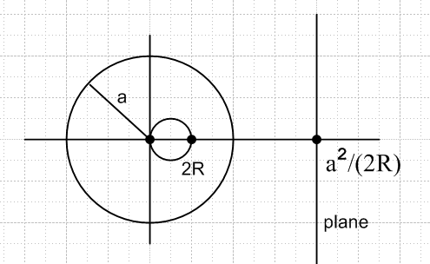

from which I conclude that the distance from inversion center to the plane is D = (1/2) a2/ R where R is the radius of the circle which hits the center.

Note added 6.4.10. Suppose we add another condition in the above analysis that | r - c1| = R1 where the point c1 is in the interior of the R-space sphere and R1 < R. This equation describes a second sphere of radius R1 centered at c1, but our interest is really in the fact that, if we combine this condition with the original condition | r - c | = R, then we are talking about a circular locus on the original sphere. You can think of this circular locus as the intersection of the two spheres if you like. I think we can accept the little theorem that "the intersection of two intersecting spheres is a circle". Here is a picture:
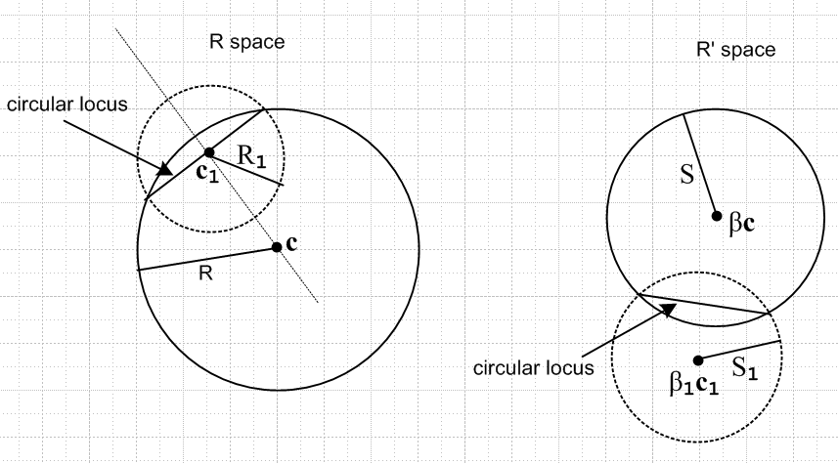

Now if we process our second sphere through the inversion into R' space, it of course becomes a sphere in R' space and we would conclude for this second pair of spheres that

original second sphere: radius R1 center c1
new second sphere: radius S1 center β1c1

where
β1 = a2 / (c12-R12) S1 = R1 |β1|

The point is that, given ANY circular locus on the solid sphere in R space, we can find a dotted sphere in R space such that the intersection of these two spheres is that circular locus. Every point on this circular locus is on both the solid and dotted spheres. Over in R' space, every point on the mapping of that circular locus must lie on both spheres as well. Thus, that mapping must be the intersection of the two spheres in R' space, and such an intersection must be a circular locus in R' space. Therefore, a circular locus must map into a circular locus and we have thus proven the following Circle Theorem.
In our construction, c1 is the center of the circle in R space. This point maps into point β1c1 in R' space, and this is generally NOT the center of the mapped circular locus there!

Circle Theorem: the inversion mapping always takes circles into circles.

Any circle we specify on the original sphere can be defined by the condition | r - c1| = R1 for a second sphere, and such a circle ends up as the circle | r* - β1c1| = S1 on the first R' space sphere.

Application of this theorem: In the mapping from sphere to plane shown above, if we put a disk on the plane, then the perimeter of that disk is a circle, and this must therefore map into a circle on the sphere, and therefore the inverse map of a disk on a plane is in fact a hemispherical bowl, and not some kind of strange spherical patch with an elliptical boundary.

At this point I wrote some notes on conformal mapping, and now I continue here.

Comparison: 2D conformal mapping vs the 3D method of inversion

This method does involve a mapping f:R → R' where both R and R' are in E3. Specifically, the mapping is this

f(r) = r* f(r,θ,φ) = (a2/r,θ,φ) f(r) = (a/r)2r

Notice that this is not a broad range of mappings [ such as all analytic functions w = f(z) subject to a few minor restrictions]. There is some flexibility, however, in that we can choose an arbitrary positive value of constant a. Also, if we think of the inversion sphere of radius a as being relative to a fixed origin as we have shown above, we can position the pieces of our Poisson problem any way we like relative to our inversion sphere origin. Obviously this is the same as saying we are free to position the origin of our sphere anywhere we like relative to the pieces of our problem. So we have freedom of origin and radius.

The claim (proven above) is that if Φ(r,θ,φ) is the solution of Poisson's equation involving some distribution of charge in R, then provided you transform the charges so in R' they look like this

q' = (a/r) q point charges
σ'(r,θ,φ) = (a/r)3 σ(a2/r,θ,φ) surface charges
ρ'(r,θ,φ) = (a/r)5 ρ(a2/r,θ,φ) volume charges

then the function

Φ'(r,θ,φ) = (a/r) Φ(a2/r,θ,φ)

is the solution of Poisson's equation in R' involving these transformed charges. Away from the charges, we of course know that Φ(r,θ,φ) is harmonic in R, and Φ'(r,θ,φ) is harmonic in R'
We can write the above this way

Φ'(a2/r,θ,φ) = (r/a) Φ(r,θ,φ) r*r = a2 r/a = a/r*

Φ'(r*) = (a/r*) Φ(r) r in R, r* in R'

In the 2D world, the equation similar to the last one above would be this (making a small notational change from my conformal notes),

φ'(u,v) = φ(x(u,v), y(u,v))
or
φ'(w) = φ(z) z in R, w in R'

This points out one big difference between the 2D and 3D methods. In 2D, if φ = constant on the boundary σ of R, then φ' = that same constant on the boundary σ' or R'. But in 3D, this is obviously not true, due to the (a/r*) factor in our equation Φ'(r*) = (a/r*) Φ(r) . The one exception is if the constant is 0, then it is preserved. This is a very convenient exception if we want to deal with grounded pieces of metal that are spherical.

Mapping of Shapes

In the 2D conformal world, we know that if we have an analytic mapping w = f(z), some arc in R will map into some arc in R', and if we study a mesh of arcs, we find the "conformal properties" that angles and local scale are preserved. In general, a circle is mapped into some closed shape that is not a circle. However, in the special case that f(z) is a "linear transformation" , meaning the (az+b)/(cz+d) form, then it happens that circles map into circles.

In the 3D method of inversion world, we are dealing only with a one specific transformation class, and it has the property of transforming spheres into spheres, which I have proven in my Jackson notes. We include plane in our word "spheres".

So, in the 3D world, we can relate the solutions of two Poisson problems. Suppose we have a problem in R where we have a piece of grounded metal (φ=0) which can be fitted onto a sphere. Examples would be any piece of a plane, or a spherical cap, or spherical barrel, or any spherical patch, a circle, any 2D curve that can be inscribed in the surface of a sphere or a plane. If we apply our inversion transformation to this piece of metal, the piece of metal will end up lying on some different sphere in R'. In the R' problem we will have φ' = 0 on our new piece of metal. So here is what we know:

3D Inversion Theorem 1. Suppose Φ(r,θ,φ) is the solution in R with Φ=0 on a piece of metal there which fits on a sphere. Then

Φ'(r,θ,φ) = (a/r) Φ(a2/r,θ,φ)

will be a solution in R' with Φ' = 0 on the piece of metal there. This piece of metal will lie on some sphere in R'.

3D Inversion Theorem 2. Suppose we have two spheres of interest ahead of time in R and R', and we custom tune our inversion transformation (set origin and a) such that these spheres map into each other. Then if we already have a solution of a Poisson problem in R involving a grounded piece of metal on the sphere of interest there, then we also know the solution of a problem in R' which has a grounded piece of metal which is the mapping of the first piece of metal from R to R'. These two problems can have some charges floating around, but they must be related to each other as noted above. Suppose, for example, in our known solution of the problem in R, we know the surface charge on the piece of metal there which we find from the solution (normal derivative at surface). Then in the other problem in R', the surface charge there must be given by the rule stated above for surface charges!

3D Inversion Theorem 2A. Usually one of our two "spheres of interest" will be a plane. Presumably problems are easier to solve for a problem with a planar piece of grounded metal than they are for a spherical piece of grounded metal. We solve the problem in the flat world, then we know the solution in the other world using our formula above, and our charge transforming formulas as well.

Continue reading top page 39. First, the three drawings on page 39 show cases where the inversion origin is to the left of, is at, and is to the right of the left end of the R space sphere. The middle case makes the plane. I imagine morphing between the first two figures the sphere S' must open up until it becomes the plane shown, (sliding the source sphere S to the left). Then the plane must start curving to the left again while it moves to the right as we keep going. This would be a good computer graphics assignment. Well let's try it in Maple. Think of things as circles centered on the x axis.

circle S (x - xc)2 + y2 = R2

circle S' (x - βxc)2 + y2 = R2β2 β = a2 / (c2-R2)

OK, I implemented this idea in file "method of inversion circles.mws" which plots the three circles in different colors and you can enter a,R,xc and just see what things look like, pictures similar to Jackson bottom page 39.

He now presents two examples. The first is my Example 4 below for which I drew a picture and this is his Fig 2.10. He then comments that in this example if you slide the R-space sphere to the left so it includes the inversion origin, you end up with a point charge at the origin still and a metal sphere, so the R'-space problem is now one for a Green's function for a point charge near a conducting sphere. If you move the source sphere the other way (Jackson's third picture p 39), then you get the R' problem being the internal Green's function for the sphere, something he asks about in Problem 2.9 (c).

Jackson wraps up his section saying that Lord Kelvin in 1847 used this method to solve the spherical cap problem! And he gives the reference to boot! End of section.

**********************************************************************************

Examples: We are now going to study many pages worth of examples, and then return afterwards and continue reading the Jackson method of inversion section

Example 1: Suppose we have a grounded metal spherical cap and one or more point charges nearby. There is obviously some solution to this problem (it is the external Green's Function if one point charge), and there will be some surface charge distribution on the spherical cap. Let's say this is the problem in space R. We then select an origin and radius a to cause this spherical cap to be mapped into a disk on a plane in R'. The point charges get mapped somewhere in R' by this mapping. So in space R', our problem is to find a solution to Poisson where φ = 0 on the disk, and we have to account for the nearby transformed charges. So in this example, two external Green's functions are related to each other if there is only one point charge involved. In Example 6 below, we shall return to the spherical cap situation without the grounding requirement.

Example 1A: Suppose in R-space we position two unequal point charges (on the symmetry axis) such that they cause φ = 0 on the sphere on which we are going to materialize our spherical cap. [ We know we can do this because we know about the image method for the sphere. ] As we create the cap, what happens? Since φ = 0 everywhere on the cap already, no charges are going to move around on the cap, so it will have no surface charge on either surface, and φ = 0 everywhere on the spherical cap, and also in the no-metal region that is the rest of the sphere. In R' the metal is a planar disk and the two point charges are now equal and opposite on two sides of the disk. The disk will have φ = 0 and no surface charge. There is a solution to Laplace in R and in R' and the two solutions are related by the method of inversion formula. Of course both solutions in this case are trivial -- just the sum of the potential of two point charges. This example is just relating the "image method for the sphere" to the "image method for the plane". The amount of metal on the sphere or plane does not matter since φ = 0 on both surfaces whether or not there is metal there.

Example 1B: Suppose in the above scenario we first ground the metal regions, then instantly make the negative charge disappear. Charge will flow from ∞ onto the metal in both R and R' and will form a charge distribution on the metal surfaces, both of which remain at φ = 0. In each space we can apply our "method of images" knowledge. Since the boundary conditions are the same before and after the negative charge is removed (namely, φ = 0 on the metal boundary), Dirichlet tells us that the Laplace solutions stay the same in both R and R'. We could then use these solutions to compute the surface charge density on the two pieces of metal. Of course the Laplace solution in each case is now just the Green's Function for that case, and we are just showing that the Green's Functions are related by the method of inversion equation. If you knew the one for the plane, you could compute the one for the sphere.

Example 2. Suppose we have φ = A in R with no known charges anywhere and no metal surfaces. Obviously this is a viable Laplace solution for R, although the fact that it does not vanish for large r is a cause for caution. In space R' the potential is Φ'(r,θ,φ) = (a/r) Φ(a2/r,θ,φ) = (a/r)A and is, therefore, not a constant as Jackson points out. In fact, this is the potential of a point charge of size q' = aA located at the origin in R'. The inverted point back in R for this charge in R' is the point at r* = a2/0 = ∞. The size q of the charge back in R is found from q' = (a/ri)q where q' is the size of the charge in R', and where ri is the location of the charge in R. We know that q' = aA so q = (r/a)q' = (r/a) aA = rA = ∞. So somehow, in this example, we really do have some charge in R. Think of this as charge uniformly distributed on a large sphere of radius s. Before we take the limit s→∞, we know that the potential for a finite sphere is φ = Q/s = A inside and at the edge of the sphere, and it falls off outside. So inside this sphere we have φ = constant, which is the A of our R space problem. So we then take both Q and s to infinity together and we maintain φ = A in space R. So this is how we can interpret the solution φ = A in space R: it is coming from a spherical shell of radius s uniformly containing charge 4πAs in the limit that s→ ∞.
The implication here is this: If you add a constant A to a solution of an R-space problem, you will be "creating" a finite point charge at the origin in your R'-space problem, and so you will be adding a point potential to the R'-space problem of charge q' = aA located at the origin in R', so that added potential is given by Φ' = aA/r. [ confirmed Jackson page 38 0

Example 2: R-space problem R' space problem
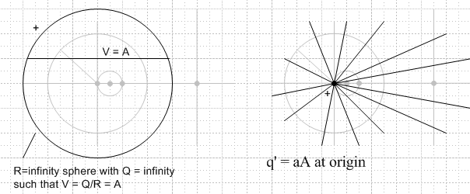

Example 3 : charged metal sphere in R mapping into a plane in R' (many pages!)

I thought this example was going to be simple. It turned out to be very complex and fills several pages below.

(1) Imagine a metal sphere of radius ro in R carrying charge Q in free space. This is the R-space problem. We think we know the full Poisson solution here. Outside the sphere, the sphere looks like a point charge and has potential Φ(r,θ,φ) = Q/4πr. On the sphere, and inside the sphere, the potential is Φ(r,θ,φ) = Q/4πro. So we have an example of Φ = A, a constant ≠ 0, on a piece of metal in R. Warning: these equations are correct when the origin is at the center of the sphere. In what follows, we will have our origin NOT at the center of our metal sphere, so be careful! I blew a lot of time on this account.

(2) We select an inversion mapping which maps our sphere into a plane in R'. The potential on that plane in R' must be Φ'(r,θ,φ) = (a/r) Φ(sphere in R) = (a/r) Q/4πro which varies with r and is therefore not a constant. So we cannot put "metal" on this plane, it is just a plane in R' of interest. r is the distance from our inversion sphere origin to a point on the plane and clearly varies as you move on the plane. We know from above that the plane center is located at x = (1/2)(a2/r0).

(3) Question: The sphere has an inner and an outer surface, and the plane has a left surface and a right surface if we draw things as in Jackson p 39 middle picture. The question is: do we know which surface maps to which, or equivalently, do we know which side of the sphere maps to which side of the plane? If we go with this Jackson picture, our inversion sphere has center at the origin. If we take the point r=∞ in R, this maps into r* = a2/∞ = 0 which is on the left side of the plane, which makes us think the outside of the sphere maps to the left side of the plane. Conversely, the point at r0 (on the sym axis) lies inside the sphere, and this maps to r* = a2/r0. In my Jackson inversion notes, I computed that the distance from inversion center to the plane is D = (1/2) a2/r0. Therefore, we see that our point r* is on the right side of the plane.
Conclusion: outside of sphere maps to left side of plane ( in Jackson's p 39 picture)
inside of sphere maps to right side of plane

(4) Since there are surface charges on the sphere in R, these will be mapped into charges on the plane in R'. If we imagine our sphere and plane has having just a slight thickness Δs, we can say that the surface charge density on the inside of the sphere (which is 0 because E = 0 inside the outer shell) maps to a transformed surface charge on the right side of the plane which will also then be 0. At the same time, the surface charge on the outside of the sphere, which is σ = Q/(4πr02), will be mapped into a transformed surface charge on the left side of the plane, which should be

σ'(r,θ,φ) = (a/r)3 σ(a2/r,θ,φ) = (a/r)3Q/(4πro2)

which is seen to vary as 1/r3 where r is distance from the inversion center to a point on the plane. We can then combine these two surface charges and just think of one surface charge as shown above.

(5) Let's now restate the potential in R due to the metal sphere there, which we know is centered not at the origin, but at the point (x,y,z) = (r0/2, 0, 0) Then

Φ(r,θ,φ) =(Q/4π) 1/ $\sqrt{(x-r0)2 + y2 + z2}$ // same as point charge located at x = r0

Here is a picture where now we overload the symbol R to also mean its usual E = 1/4πR sense. The law of cosines for the thin triangle with lower left corner angle α is this

R2 = r2 + r02 - 2rr0cosα

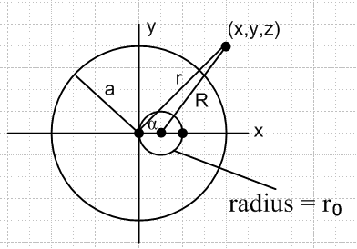

where α (usually called γ) is the angle between the vectors r and . Our picture shows the z=0 plane slice of the R space, but the point r is meant to be arbitrary in 3D. The thin triangle is tilted out of the plane of paper. This thin triangle is coplanar with a larger triangle two of whose edges are r and x and we know from this triangle that cosα = x/r, something we just note in passing. This is just the usual z = rcosθ of polar coordinates, but shifted into our variable names.

Our outer potential in R (point charge Q at x = r0) can now be written

Φ(r,θ,φ) =(Q/4π) 1/ $\sqrt{r2 + r02 - 2rr0cosα}$ // potential in R outside metal sphere

(6) Now we want to look at the mappings of the potential. We shall apply the rule

Φ'(r,θ,φ) = (a/r) Φ(a2/r,θ,φ)

The potential on the inside of the sphere is Φ = Q/4πro which is a constant, so we find that the potential on the right side of the plane is this

Φ'(r,θ,φ) = (a/r) Φ(a2/r,θ,φ) = (a/r) Q/4πro = (a/4πr0)Q/r // right side

This is seen to be the potential of a point charge Q' = Q(a/r0) located at the origin x = 0.

The potential on the outside of the sphere is shown just above, so we find that the potential on the left side of the plane is this

Φ'(r,θ,φ) = (a/r) Φ(a2/r,θ,φ) = (a/r) (Q/4π) (1/$\sqrt{(a2/r)2 + r02 - 2(a2/r)r0cosα}$ )

= (aQ/4π) / $\sqrt{a4 + r2r02 - 2a2rr0cosα}$ // left side

Since this potential in R was the same as a point charge Q located at x = r0, in R' it must be the potential of a point charge Q' = (a/r0)Q located at x = a2/r0, which is the mirror point of the inversion origin on the right side of the plane.
Our conclusion then is this: in R' we have a plane centered at x = x1 = (1/2)(a2/r0). To the right of this plane, the potential is that of a point charge Q' = (a/r0)Q located at the origin. To the left of this plane, the potential is that of an identical point charge located at the mirror point. Thus, we see at once that the potential is symmetrical about the plane. On either side it is that of a single point charge! Very simple. The potential is NOT, by the way, that produced by two point charges so placed. That is a similar but different problem (the Neumann problem with ∂nu=0 on the plane, hence no charge on the plane).

(7) I want to make sure that this potential is continuous at the plane! Here is another picture

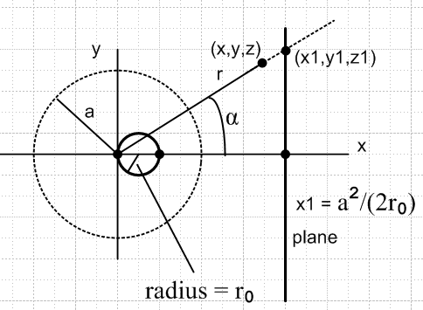

If we go to the plane on both sides, we get: [ where r1 = (x1, y1,z1) ]

Φ'LeftSurface = (a/4π r0)Q/r1
Φ'RightSurface = (aQ/4π) / $\sqrt{a4 + r12r02 - 2a2r1r0cosα}$

These will be the same if the following is true:

(a/4π r0)Q/r1 = (aQ/4π) / $\sqrt{a4 + r12r02 - 2a2r1r0cosα}$

1/(r0r1) = 1 / $\sqrt{a4 + r12r02 - 2a2r1r0cosα}$

(r0r1)2 = a4 + r12r02 - 2a2r1r0cosα

From the picture we know that cosα = x1/r1 ( it is also x/r as above.) We also know that x1 = a2/(2r0) so cosα = a2/(2r0r1). We are then looking to show that

(r0r1)2 = a4 + r12r02 - 2a2r1r0{ a2/(2r0r1)}

(r0r1)2 = a4 + r12r02 - a2{ a2}

(r0r1)2 = r12r02 // yes!

So we have verified that Φ'(r,θ,φ) is in fact continuous at the plane in the R' space. This was something I was having a lot of trouble with when I had the potential wrong for the sphere because I failed to realize that the metal sphere is not centered at the origin.
In retrospect, we showed earlier that the potential in R' is symmetric about the plane and this fact alone implies it is continuous at the plane, being then some f(|x|,y).

(8) Summary of what we have found in this example:
In the R-space, we have the well known potential of a metal spherical shell alone in space carrying a charge Q. The sphere radius is ro so σ = Q/(4πr02) on the outer surface, and σ = 0 on the inner surface. The potential on the surface of the metal sphere is the constant value V = Q/4πro. One purpose of this example is to study a case where we have a metal surface on which the potential is constant but not 0.
In the R' space, things are more complicated. The metal sphere maps into a certain plane, and the potential on that plane is aQ/(4πr0r1) where r1 is the distance from the inversion origin to a point on the plane. Thus, the potential varies with position on the plane, so we cannot have this plane be made of metal! It is just a mathematical plane in R' space. On the right surface of this plane we find a surface charge σ' = 0. On the left surface, we find σ' = (a/r1)3Q/(4πro2) which again varies with r1. We can of course just treat these as a simple plane of charge σ' = (a/r1)3Q/(4πro2) . The potential in R' space is given by (in polar coordinates with origin at inversion sphere center and as polar axis):

Φ'(r,θ,φ) = (a/4πr0)Q/r (as if from point charge at origin) // on the right of the plane

Φ'(r,θ,φ)= (aQ/4π) / $\sqrt{a4 + r2r02 - 2a2rr0cosθ}$ // on the left of the plane

but we have seen that each of these is just the potential of a point charge Q' = (a/r0)Q located on the other side of the plane at distance x1 = (1/2)(a2/r0).

The angle α is the angle θ if we align our spherical coordinate system to the axis (as I would do were I starting over on this whole mess). We know then that cosα = a2/(2r0r1) = (a/r1)(a/2r0) so we can always make this replacement (a/r1) = (2r0/acosα) . For example, we then have

σ'Left Surface = (a/r1)3Q/(4πro2) = ((2r0/acosθ))3Q/(4πro2)

= (1/2π) (Qr0/a3) csc3θ

= a3Q/(4πro2) [r12] -3/2 = a3Q/(4πro2) [x12 + y12 + z12 ] -3/2

So to repeat, in R' we basically get a plane of charge with the above charge density. It seems clear that if we were to express the two potentials above in a coordinate system centered on the center of the plane, we should find that the potential is just mirrored through the plane, "the same on both sides". In the next section I verify that this conjecture is true.

(9) Show that potential is a mirror image. Really we already did this above, but let's do it again. Put a new coordinate system x',y',z' centered at plane center. Then we know these facts:

y' = y z' = z x' = x - x1.

We know that cosθ = x/r as noted way above. And we know r2 = x2+ y2+ z2. So:

r = $\sqrt{(x'+x1)2+ y'2 + z'2}$

Potential on the right of the plane:

Φ'(x',y',z') = (a/4πr0)Q/r = (aQ/4πr0) / $\sqrt{(x'+x1)2+ y'2 + z'2}$

Potential on the left of the plane:

Φ'(r,θ,φ)= (aQ/4π) / $\sqrt{a4 + r2r02 - 2a2rr0cosθ}$

The expression inside the radical is this:

H = a4 + r2r02 - 2a2rr0cosθ

and we now make the replacements

r = $\sqrt{(x'+x1)2+ y'2 + z'2}$ rcosθ = x = x'+x1

So we get

H = a4 + ro2 [(x'+x1)2+ y'2 + z'2] - 2a2r0(x'+x1)

= r02 * { stuff + y'2 + z'2 }

and then we will have to the left of the plane

Φ'(r,θ,φ) = (aQ/4π) / $\sqrt{H}$

= (aQ/4πr0) / $\sqrt{stuff + y'2 + z'2}$

If we can show that stuff = (-x'+x1)2 , then we will have shown that the potential really is a mirror image on the two sides of the plane, as we know it must be. So let's see: [ we get to use x1 = a2/2r0 ]

stuff = a4/r02 + (x'+x1)2 – 2a2(x'+x1)/r0

= a4/r02 + (x'+x1)2 – 2a2(x'+a2/2r0)/r0

= a4/r02 + (x'+x1)2 – 2a2x'/r0 – a4/r02

= (x'+x1)2 – 2a2x'/r0

= (x'+x1)2 – 2(2r0x1)x'/r0

= (x'+x1)2 – 4x1x'

= (–x'+x1)2 QED

(10) Summary of the summary:

R space: metal sphere of radius ro carrying charge Q

inversion: radius a, maps the above sphere into a plane, distance to plane x1 = a2/(2r0)

R' space: non-metal plane of charge density σ = (1/2π) (Qr0/a3) csc3θ

= a3Q/(4πro2) [x12 + y12 + z12 ] -3/2

= a3Q/(4πro2) [x12 + y'2 + z'2 ] -3/2

potential = (aQ/4πr0) / $\sqrt{(|x'|+x1)2+ y'2 + z'2}$

where (x',y',z') is a coordinate system centered at plane center.

So in this example, the R' "problem" is not one you would necessarily have a great interest in solving, it being a plane of glued-down charge having some weird charge density σ. Nevertheless, we obtain a solution to this problem by knowing the solution of the simple problem in R and using the method of inversion. We could no doubt quickly obtain the solution to the R' problem just by integrating σ/4πR over the surface of the plane.
Once we know that the potential in R' is that of a point charge on the other side of the plane, we could use that potential to compute σ = ∂nu (modulo 4π). We would find from this calculation that each side of the plane carries half the σ' total shown above, then we would add these to get the same result.

(11) How to draw the pictures. You are tempted to draw both the R and R' problem in the same picture since that picture shows how the inversion situation works. But I think that is a very confusing thing to do, and you should really draw two separate pictures, perhaps from the same inversion template. I will now do this for Ex 3.

Example 3: R-space problem R' space problem
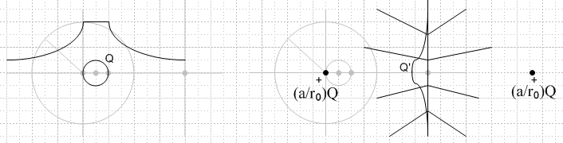

(12) The above picture brings up yet another question: What is the integrated σ' (I call it Q') on the plane in the R' problem? We could of course just do the integral and find out. But I think there is an easier way. The R' space problem is this: some charge is spread σ' is spread out on a plane, there is nothing else around. So the potential created by this charge σ' is the SAME as the potential created by the alternate point charges as shown above. Suppose in R' space we view the situation from a vantage point 100 miles to the right. In one model we see the point charge at the origin. In the other model we see the surface charge. In both cases, we are so far away that both are really point charges, and we conclude that the integrated charge on the plane must be the same as the point charge on the left, which is to say, Q' = (a/r0)Q. Here is another proof of the same thing. Go 100 miles away on the left and you see Q as just a point charge. This point charge maps into a point charge Q' = (a/r0)Q in R'. As we close in, we see that this Q' is really our surface charge distribution. OK, I believe it.

Meta notes OK to here.

Example 4: Same as Ex 3 but sphere has charge Q and is now grounded so Φ = 0 on sphere.

Our R space potential is this:

Φ(r,θ,φ) =(Q/4π) / $\sqrt{(x-r0)2 + y2 + z2}$ - (Q/4πr0) // outside sphere
Φ(r,θ,φ) = 0 // on and inside sphere

R has Φ = - Q/4πro at infinity so is a cause for caution. The surface charge on this sphere is just as in Exercise 3, so it maps to a plane of charge with σ' same as given in Ex 3. We know that the plane in R' will all be at potential Φ' = 0, from our general rule. And now we also know that the entire right side of the plane will be at Φ' = 0 since that is where "inside sphere" maps to -- just as if the sphere were solid metal. The potential on the left side of the plane will have two components: as we learned in Ex 3, the first term above gives rise to a point charge in R' located on the right side of the plane, making a potential of a point charge which is then "seen" from the left side of the plane. The second term (the constant A = - (Q/4πr0)) we know from Ex 2 will create a point charge in R' located at the origin. The size of this point charge will be q' = 4πaA = -4πaQ/(4πr0) = -Q(a/r0). Therefore, the potential on the left side of the plane in our R' problem is that due to two point charges which are equal and opposite in size and are equally spaced on the two sides of the plane, with the right side charge being sign of Q. We well know that this set of point charges causes V = 0 on the center plane, so things are consistent. This is just the method of images for a half space of metal. Picture:

Example 4: R-space problem R' space problem
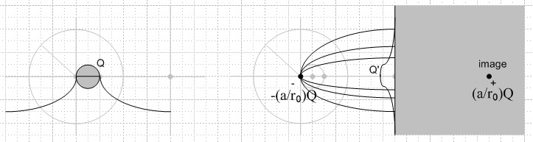

Notice that the R' potential to the left of the plane is just that due to the origin charge and the image charge, you don't add all three (two point charges + the σ charge). But Dirichlet tells us that the R' space problem on the left of the plane has the same solution as the two point charge solution, since V = 0 on the boundary, so we know we can delete the image charge and replace it with the σ' surface charge and get the same result on the left. If we did not know the solution to this problem, our method of inversion has sort of derive the image charge method for us.

Example 5: Let's now superpose the Ex 2 and Ex 4 problem to replicate the Ex 3 problem.

Example 2: R-space problem R' space problem
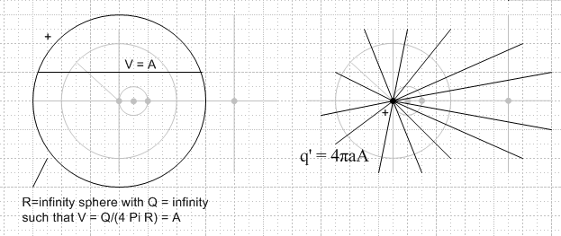

Example 4: R-space problem R' space problem

When we add these situations, the positive Ex 2 point charge cancels out the left negative Ex 4 point charge, so the potential to the left of the plane is just due to the charge on the right of the plane. The potential. Meanwhile, on the right side the potential of 0 is now that of the new positive point charge at the origin. Thus, it is a no brainer superposition and we get

Example 3: R-space problem R' space problem

Example 6: What happens if the hollow metal sphere is replaced with a spherical cap on the right part of the sphere? (Also known as a bowl)

• In this case, the bowl maps onto a finite disk in the plane.

• Consider now the "Example 3" type problem whose picture is shown just above, but for the bowl. Here is what the left picture will look like:

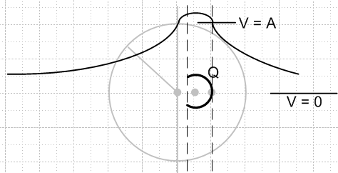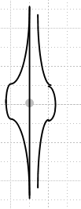

We plot the potential along the center line. It is never constant, but of course where this center line intersects the bowl, V = A, where A is the constant potential on the bowl. I have no idea what this curve really looks like, so just a super crude plot. On the right, we get a finite disk of some surface charge σ' and this disk is NOT an equipotential, we are not talking a "metal disk" on the right, rather a non-conducting finite disk with charge glued on it. So for Example 3', call it, we don't know what is going on in either problem, and the R'-space problem seems pretty useless and uninteresting. q' = - aA ∞

• Consider next the "Example 4" type problem whose picture we now replicate here.
(1) On the left we get the same thing as above but with the potential lowered so it is 0 on the bowl , at V = -A at infinity.
(2) We can treat Example 4 R-space as the Example 3 situation to which we have superposed V = -A. We know that this superposition creates a charge at the origin of size q' = -4πaA in R' space.

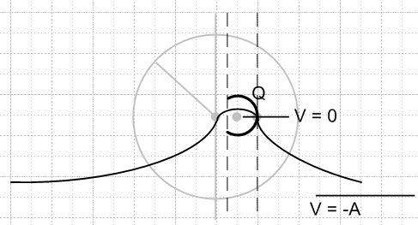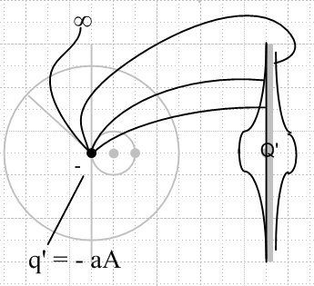

Now in R'-space the bowl maps into a finite disk, and this will be at V = 0, so we can consider this disk to be a piece of metal! That is the big difference from Example 3. The sphere on the left will have some surface charges on the inner and outer surfaces, unequal, and these will map into unequal surface charges on the two sides of the disk in R'-space which I have very crudely tried to draw. The R'-space situation also has the induced point charge shown, and I have drawn a few electric field lines emphasizing that some lines come from the back of the disk and some go to infinity. The situation on the right is in effect the Green's function for a point charge of some size located near a finite metal disk. The situation on the right is NOT just a charged finite metal disk sitting in empty space, make sure that is understood. The total charge on the disk will be - q' = f 4πaA where f is some fraction. [ If the cap gets tiny, so does the disk, and we know then most lines will go off to infinity. ] Of course a is the arbitrary inversion parameter, and A is the unknown potential from the R-space problem.
(3) It is tempting to think that the problem in R'-space can be considered the superposition of two separate situations. One situation is the disk in isolation containing a charge f 4πaA which distributes itself naturally in some manner. The second situation is just the point charge at the inversion origin with charge -4πaA. But this is wrong. The counterexample is provided by the well known point charge near a sphere. There, the resulting field for a V=0 sphere is not the sum of the external point charge plus an opposite signed point charge at the center of the sphere. Rather, you have to use the carefully sized image charge located NOT at the center of the sphere.

Status: Using the method of inversion, I have been able to relate the (R-space problem of the isolated charged metal bowl in space) to the (R'-space problem which is the Green's Function problem for a finite disk. ) . I have made no connection to a third problem which would be an isolated charged disk in space.

So I now need to solve this problem: Green's Function for a finite metal disk for point charge on axis.

Suppose we knew on-axis Green's Function for the disk. Then I would take a charge q' = -aA and put it a distance d = (a2/2r0) from the disk, on axis. I would then know Φ' everywhere, meaning on both sides of the disk. I could compute from that the charge densities on both sides of the disk. I could map back to R-space and I would then know the potential everywhere there, and again compute the charge densities on both sides of the bowl. Everything would, of course, be a function of parameter A. But then I could integrate the charge density on the bowl to get Q, and that would tell me A as a function of Q, and then the problem is completely solved.
The R-space problem with V = 0 and charge Q on the bowl is a capacitor problem against the sphere at r=∞ which is at potential V = -A. The capacitance is determined from Q = CV, so C = Q/V = Q/A and thus when we know A, we know the capacitance of the bowl as well.

Comment: Jackson's Lord Kelvin remark on page 40 is a little misleading if I am right here. The problem Kelvin must have transformed must have been the on-axis Green's Function problem for the disk, not the problem of the isolated charged disk. For example, the charged disk has the same σ' on both sides, but we know the bowl will have different σ on the two sides. [ Well, I think Kelvin really does something similar to Smythe's sequence of problems 38-42. ]

**********************************************************************************

Connecting the Bowl with a disk.

This whole section is now on hold. Part 1 on geometry is fine, but Part 3 is baloney since I had not at the time correctly understood that the R'-space problem is a Green's Function problem, not an isolated charged disk problem. [ This later becomes Pic 1 of my invert-rotate-invert method.]

1. Geometry.

We need a good picture because the geometry is detailed, and then we will have several comments to make about the picture:

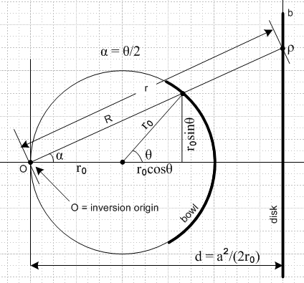

• The inversion circle of radius a centered at O is not drawn. The value of a determines how far away the plane is located from O, as shown in the value of d. That in turn controls the location of the disk edge b. The solution to the problem here will be independent of a.

• The picture shows a general point on the bowl at "polar bowl angle" θ relative to sphere center.

• Our inversion theory uses spherical coordinates relative to the inversion origin O. Our drawing is of course a central slice through things and we shall take the plane of paper to be azimuth φ = 0. Using these coordinates we have [ in what would be normally written (r,θ,φ) notation ]

general bowl point = (R,α,0) ≡ R general disk point = (r,α,0) ≡ r

Warning: we have used θ as the bowl polar angle, while α is the inversion system polar angle. Don't get these two angles confused.

• The bowl has radius r0. Distance R is from O to this general bowl point, while distance r is from O to the corresponding point on the disk. We expect that rR = a2, since points r and R are related by inversion, and we shall verify this fact soon.

• It turns out that α = θ/2 but I cannot see this in an obvious geometrical way. Instead, I have to rely on this derivation of that fact:

tan α = r0sinθ / ( r0 + r0cosθ) = sinθ / ( 1 + cosθ) = tan(θ/2) // p 16 Schaum

• If we move to the extremal upper point of the bowl (not marked in the picture), we will be at angle
α0 = θ0/2 and the line to the wall through this extremal bowl point lands at location "b" on the edge of the disk. At this point we will have

tan α0 = tan(θ0/2) = b/d => b = d tan(θ0/2)

So if we imagine we have selected some inversion radius a, that determines d, and the above shows us then the value for b, namely, b = d tan(θ0/2).

• When doing algebra with this geometry, we tend to "flail" because there are no less than four variables which can be individually used to indicate the general bowl or disk point: R, r, θ, ρ. So it is good to write down how these variables are related to each other. Here I will derive all these relations and then summarize them at the end of this little section. First, an obvious one:

r2 = ρ2 + d2 // relates r and ρ

For the next one we need to do just a little work:

R2 = (r0sinθ)2 + ( r0 + r0cosθ)2 = r02 [sinθ2 + ( 1 + cosθ)2] = r02 [2 + 2cosθ]

= 2 r02(1 + cosθ) = 2 r02 2 cos2(θ/2) = [ 2r0cos(θ/2)]2

R = 2r0cos(θ/2) // relates R and θ

Next, consider

cos(α) =cos(θ/2) =d/r so we have

r = d /cos(θ/2) // relates r and θ

Now let's eliminate θ between last two results to see how r and R are connected:

cos(θ/2) = R/(2r0) = d/r = (a2/2rr0)
so
R = a2/r // relates r and R

and we have now verified the inversion point relation mentioned earlier. Moving right along

tan(α) = tan(θ/2) = ρ/d // relates θ and ρ

So here is our summary of relations among R, r, θ, ρ

d = a2/(2r0) // definition of d
r2 = ρ2 + d2 // relates r and ρ
r = d /cos(θ/2) // relates r and θ
R = a2/r // relates r and R
R = 2r0cos(θ/2) // relates R and θ
tan(α) = tan(θ/2) = ρ/d // relates θ and ρ

It's just nice to have these guys ready to go if needed.

2. Discussion of the two problems related by the above transformation

OUCH! I added this section and then realized that my R'-space problem is NOT the isolated charged metal disk, so this whole approach is going to fail.

3. Transforming the Charge Density

Our R-space problem is the bowl (charge σ), while our R'-space problem is the disk (charge σ'). The transformation rule for surface charge density we just quote from above:

disk charge = σ'(r,α,φ) = (a/r)3 σ(a2/r,α,φ) // r here means distance origin O to point on disk

Both charges are independent of azimuth angle φ, so we can simplify the above as

disk charge = σ'(r,α) = (a/r)3 σ(a2/r,α)

Remembering that rR = a2 we can do some quick scratch algebra to invert the above to get

bowl charge = σ(R,α) = (a/R)3 σ'(a2/R,α)

Now from Jackson's work we know the charge density on the disk (holding Jackson charge q) to be:

σ'(ρ) = (q/2πb) 1/$\sqrt{b2- ρ2}$ where b = d tan(θ0/2) from above

We need to write this as a function of inversion polar coordinates, so consider

tan(α) = ρ/d so use ρ = d tan(α) to get

σ'(r,α) = (q/2πb) 1/$\sqrt{b2- d2tan2(α)}$

Remember that we are thinking of a, hence d, hence b as constants. We see that the disk charge expressed in inversion polar coordinates can be written as above so as only to depend on polar angle α. If course it is true that as we vary α, r will vary, but we prefer to show α dependence since this simplifies the transformation rule, which we now evaluate:

bowl charge = σ(R,α) = (a/R)3 σ'(a2/R,α)

= (a/R)3 (q/2πb) 1/$\sqrt{b2- d2tan2(α)}$

We would like to see this as a function only of bowl polar angle θ, so use R = 2r0cos(θ/2) to get

σ(R,α) = (a/[2r0cos(θ/2)] )3 (q/2πb) 1/$\sqrt{b2- d2tan2(θ/2)}$

= (a/2r0)3 (q/2πb) [ cos3(θ/2) $\sqrt{b2- d2tan2(θ/2)}$] -1

But now use b = d tan(θ0/2) so this becomes

= (a/2r0)3 (q/[2π d tan(θ0/2)]) [ cos3(θ/2) $\sqrt{d2 tan2(θ0/2)- d2tan2(θ/2)}$] -1

= (a/2r0)3 (q/[2π d2 tan(θ0/2)]) [ cos3(θ/2) $\sqrt{tan2(θ0/2)- tan2(θ/2)}$] -1

Finally, replace d = a2/(2r0) to get

= q (r0/a) / ( 4πr02) [ tan(θ0/2) cos3(θ/2) $\sqrt{tan2(θ0/2)- tan2(θ/2)}$] -1

Now recall our discussion from far above that concluded Q' = Q(a/r0) where Q' was the charge in the R' problem, here called q. So we should then have Q = Q' (r0/a) = (r0/a)q. Then our final result is this:

σ = Q / ( 4πr02) [ tan(θ0/2) cos3(θ/2) $\sqrt{tan2(θ0/2)- tan2(θ/2)}$] -1

The dimensions of the result are correct and the result is independent of a, two good things.

An immediate sanity check would be the limit θ0 = π in which case the bowl becomes a closed sphere and we expect to see a constant charge density:

θ0 = π θ0/2 = π/2 tan(π/2) = +∞ σ = 0 !!! expecting σ = Q/(4πr02)

Not good, Kemo Sabe. Well, I reconsidered the R'-space problem and found that it is in fact not the isolated charged disk, so this whole method is wrong. I need to know the on-axis Green's Function for the metal disk.

Below this line is all junk, but maintain it for a while.
*******************************************************************************

This is mostly a geometry problem. Here is a picture

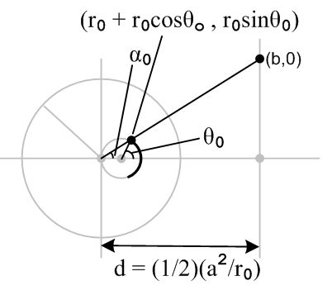

The cap is shown darkened and goes down to angle θ0 which is what my canonical PDF uses I think. Angle α0 is what we need to know. If we make a right triangle dropping a vertical segment from the dot on the circle, we find that

tanα0 = rise/run = r0sinθ0 / ( r0 + r0cosθ0) = sinθ0 / ( 1 + cosθ0).

This is the limiting angle. For any other angle we have

tanα = sinθ / ( 1 + cosθ).

where θ is the cap angle, and α is the inversion angle.

For the half sphere cap, we have θ0 = π/2 so this thing is tanα = 1 and we are at 45 degrees. Meanwhile, we know that

tanα0 = rise/run = b/d d = a2/(2r0)

Therefore we are done, the radius of our disk is this

b = d tanα0 = d sinθ0 / ( 1 + cosθ0)

Now assume there is some charge density σ on the spherical cap, call it σ(r,α,φ) . It is of course unknown. The density on the disk is given by:

σ'(r,α,φ) = (a/r)3 σ(a2/r,α,φ) r here means distance origin to point on disk

where α is our usual polar angle relative to the inversion origin.
Now from Jackson's work we know the charge density on the disk to be:

σ'(ρ) = (q/2πb) 1/$\sqrt{b2- ρ2}$

but we want to express this in the polar coordinates (r,α,φ) relative to the inversion center.

ρ2 + d2 = r2 ρ2 = r2 - d2

σ'(r,α,φ) = (q/2πb) 1/$\sqrt{b2 + d2 - r2}$ = σ'(r) r here means distance origin to point on disk

Now write our equation above the other way around:

σ'(r,α,φ) = (a/r)3 σ(a2/r,α,φ) now set r = a2/ R :

σ'(a2/R,α,φ) = (a/[a2/R])3 σ(R,α,φ)

σ'(a2/R,α,φ) =(R/a)3 σ(R,α,φ)

(R /a)3 σ(R,α,φ) = σ'(a2/ R,α,φ)

σ(R,α,φ) = (a/ R)3σ'(a2/ R,α,φ) R here means distance origin to point on sphere!

so it seems to have the same form "either way". The answer to our problem is then this:

σ(R,α,φ) = (a/R)3 σ'(a2/R) = (a/R)3 (q/2πb) 1/$\sqrt{b2 + d2 - (a2/R)2}$

d = (1/2)(a2/r0) b = d tanα0

What is R?

R2 = (r0sinθ)2 + ( r0 + r0cosθ)2 = r02 { sin2θ + (1+cosθ)2 }

{ sin2θ + (1+cosθ)2 } = 1 + cos2θ + 2cosθ + sin2θ = 2(1+cosθ) = 2(2 cos2(θ/2)) = 4 cos2(θ/2)

R2 = r02 4 cos2(θ/2) R = 2r0 cos(θ/2)

and of course we know that Rr = a2 where r is defined above. So we can write

σ(R,α,φ) = (a/R)3 σ'(a2/R) = (a/R)3 (q/2πb) 1/$\sqrt{b2 + d2 - r2}$

Our result for σ is expressed now in inversion origin coordinates. We want it in terms of angle θ on the spherical cap.

tanα = sinθ / ( 1 + cosθ)

cosα = d/r => r = d secα

It looks messy. The inside of the radical is

b2 + d2 - r2 = b2 + d2 - d2sec2α = d2 tanα02 + d2 - d2sec2α

= d2 [ sec2α0 - sec2α ]

so we now have

σ(R,α,φ) = (a/R)3 σ'(a2/R) = (a/R)3 (q/2πdb) 1/$\sqrt{sec2α0 - sec2α}$

= (a/R)3 (q/2πd2tanα0) 1/$\sqrt{sec2α0 - sec2α}$

= (a3 / d2) R-3 (q/2π) cotα0 / $\sqrt{sec2α0 - sec2α}$

But this is not supposed to depend on "a", but we have d = (1/2)(a2/r0)

(a3 / d2) = a3 / { (1/2) a2/r0}2 = 4 r02/a

so our final answer is this:

σ(R,α,φ) = 4 r02 a-1 R-3 (q/2π) cotα0 / $\sqrt{sec2α0 - sec2α}$

where R = 2r0 cos(θ/2)

so that factor of "a" sitting there should not be there. But dimensions are correct with it. Ah yes, recall from our earlier examples this fact

Q' = (a/r0)Q

So in our problem here, Q' is the charge on the disk, called q, so the charge on the spherical shell is going to be Q = (r0/a) q so we need to make the replacement (q/a) → Q/r0 and we then get

σ(R,α,φ) = 4 r02 (q/a) R-3 (1/2π) cotα0 / $\sqrt{sec2α0 - sec2α}$

= 4 r02 (Q/r0) R-3 (1/2π) cotα0 / $\sqrt{sec2α0 - sec2α}$

= (2/π) Q r0 ( 2r0 cos(θ/2))-3 cotα0 / $\sqrt{sec2α0 - sec2α}$

= (1/4π) (Q/r02) sec3(θ/2) cotα0 / $\sqrt{sec2α0 - sec2α}$

where tanα = sinθ / ( 1 + cosθ).

Draw this triangle and compute s:

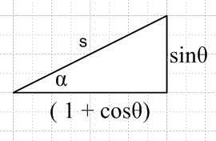

s2= 1 + cos2θ + 2cosθ + sin2θ = 2(1+cosθ) = 2(2 cos2(θ/2)) = 4 cos2(θ/2)

s = 2 cos(θ/2) = diag

1 + cosθ = 2 cos2(θ/2) = run

cosα = run/diag = 2 cos2(θ/2) / 2 cos(θ/2) = cos(θ/2)

α = θ/2

A little late in the game to be "realizing" this fact. If true, then we can rewrite our answer:

σ(R,α,φ) = (1/4π) (Q/r02) sec3(θ/2) cot(θ0/2) / $\sqrt{sec2(θ0/2) - sec2(θ/2)}$

What is my result when we have the half-cap?

θ0 = π/2 sin(θ0/2) = 1/$\sqrt{2}$ = cos(θ0/2) cot(θ0/2) = 1

σ(R,α,φ) = (1/4π) (Q/r02) sec3(θ/2) / $\sqrt{2- sec2(θ/2)}$

= (1/4π) (Q/r02) sec2(θ/2) / $\sqrt{cosθ}$

Here is the answer given in my "canonical" PDF paper for charge density

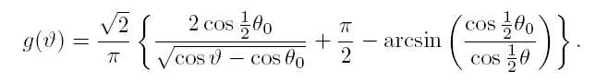

I computed the limit of the above to be

g(θ) = ($\sqrt{2}$/π) { $\sqrt{2}$/$\sqrt{cosθ}$ + π/2 - π/2 } = (2/π) 1/$\sqrt{cosθ}$

So there is a dim semblance.

What is my result when we have a full sphere, θ0 = π ?

σ(R,α,φ) = (1/4π) (Q/r02) sec3(θ/2) cot(θ0/2) / $\sqrt{sec2(θ0/2) - sec2(θ/2)}$

θ0 = π sin(π/2) = 1 cos(θ0/2) = 0

In this case think of sec(θ0/2) as very large so we have

cot(θ0/2) / $\sqrt{sec2(θ0/2) - sec2(θ/2)}$ = cot(θ0/2) cos(θ0/2) = 1

Then my answer is

σ(R,α,φ) = (1/4π) (Q/r02) sec3(θ/2)

but has to be constant, so my sec3(θ/2) factor is not supposed to be there.

α θ ρ

