Early brief comments re the on-axis Green's Function for a disk PhL 11.6.09

Overview ( 1/3 page, written 12.7.10). This is indeed an early (5 page) doc in my disk/iris travails, Nov 2009. Probably due to a Richard Price through Jim suggestion, I got interested in oblates for doing disk problems. And I was just learning inversion at the same time. I saw that the charged bowl is the inversion of the on-axis disk Green's, and I actually did the latter problem in oblates and got some confirmation of my result from Smythe's Problem 85. So if you add factor (a/r) or whatever, this oblate sum does apply to the bowl if you are willing to somehow invert all those coordinates, maybe not so bad. But hard to imagine how the oblate P and Q style sum would give the classic elementary function results for the bowl's σ in and out, for example.
I discovered the Kelvin papers (a Jackson bowl reference) and started parsing them a bit, and in itself that led to many hours of work since I got involved in Kelvin's earlier paper as well. I was still very far from doing the bowl problem. Even today I don't really have a form for the bowl potential because I need to do that Canonical dual equation approach and I keep putting that off. I could alternately know the potential if I wanted it, from the 38-42 sequence.)
Below is a much earlier overview of this doc.

Overview of this Doc. [4.3.10] This is a very early document in my electrostatics "research". My motivation was to somehow "do" the spherical bowl problem as an inversion of the flat disk problem. I thought (and still think) this requires finding the on-axis Green's function for the disk, hence the title above. I stumbled upon the famous Smythe problem 85 (which I later studied elsewhere and did the problem, see 4.17.10 note below) and I make here various wrong comments about the expression shown in problem 85 quoted below, which is an oblate spheroidal coordinates problem. Problem 85 gives the on-axis Green's function for the disk with the point charge subtracted out.
Next, I take note of Jackson's comment that Kelvin did exactly this inversion problem in his collected papers, and I downloaded those papers and started trying to "parse" some of Kelvin's work. Kelvin has a simple expression for the charge density on a charged ellipsoid which I note below, and it is true that the disk is a limit of an ellipsoid and you can then know the charge distribution on a charged disk. Jackson solves this problem a different way.
But the charged disk problem is not the same as the on-axis Green's function problem for the disk, so it is really not relevant to the inversion problem for the spherical bowl. In other docs I later did further parsing of Kelvin's work. [ Well, Kelvin and Smythe in problems 38-42 show that you can in fact start with the charged disk and learn things about the charged bowl, but it is a lot more than a simple inversion.]

Question 1: What is the on-axis Green's Function for a disk ?

• I did a quick scour of Jackson and Griffiths books and found nothing.

• The Smythe book has this:

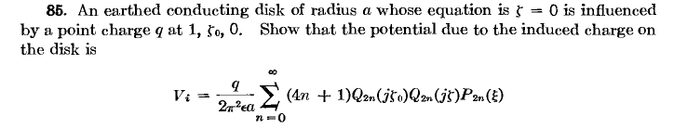
This is only a problem, and it is unclear what the geometric relation is between the disk and the point charge! Otherwise, this is a disk Green's function problem and it does not appear elsewhere in his book. He does do ellipsoids, however, where we can take limits. But I just want the result. I think he is talking about the fancy coordinates ξ, ζ,φ that I have not yet learned about.

Note added 12.3.09. [ this was just an early conjecture that was not correct] I think the above are oblate spheroidal coordinates in Smythe notation [ that is correct] , and I suspect that the solution shown is a Green's Function of this "full eigenfunction" form [ this suspicion is wrong, I am pretty sure ]

g(x|ξ) = Σn φλn(x)λn(ξ) / λn

where the Q functions are the φ functions. Later in Ch 6 meta meta I quote this for the 2D strip

g(x,y |0,y') = Σn=1∞ (1/nπ) e-(nπ/a)|x| sin(nπy/a) sin(nπy'/a) // = 6.127 (5)

which again vaguely resembles the Vi result above of Smythe. Does Q0(z) vanish at z=0 by any chance?
Q0(z) = (1/2) ln[ (z+1)/(z-1)] so the answer is NO. Q0(0) = (1/2) ln(-1) = iπ/2 , it is at least finite. So how does Smyth's formula above cause V = 0 on the disk which is ζ = 0 ? Not term by term I guess. I am missing something here methinks.

Comment #1 added 1.11.10. OK, two months have passed (!) and I have now computed the on-axis Green's Function for a disk, based on the Smythe problem above. The expression he gives is "Green's Function - potential of point charge" [???] and thus does not vanish on the spheroid (or disk). The solution I found and which Smythe's formula relates to is not a "full eigenfunction expansion" of the form Σn φλn(x)λn(ξ) / λn . In fact, I still don't know what the eigenfunctions are for a metal oblate spheroid. I imagine they are functions much worse than Legendre functions, in the complexity ratio of jn(kr) to rr.
[ Very much later from Moon and Spencer: they are Legendre Wave Functions! ]

Note added 4.17.10. In doc "On-axis Green's Function for Oblate Spheroid.doc" (there is a corresponding meta doc) I solve for the on-axis Green's Function for an oblate spheroid. I then take the limit that the spheroid becomes a disk. I then subtract out the contribution to the solution from the point charge, and I am left with an expression for the potential due to the charged induced on the disk. This is the expression which appears in Smythe problem 85 and which is shown above. In another doc " Exterior general Green's Function for an Oblate Spheroid.doc" I solve this problem for an arbitrary location of the point charge. But all this was far in the future when I wrote this little doc your are reading!

• Some web searching on "Green's Function disk|disk" and similar turns up nothing much.

• What about Stakgold's general method for "grounded conductor in external field" p 181.

There we have u0 as the external potential, and us as that caused by the conductor. But the discussion there just leads to an integral equation 6.160. And this one is especially bad for the disk since the cosine is 0 everywhere on the disk!

• Jackson P 40 says that Kelvin did an inversion problem in 1847 relating the disk to the spherical bowl and gives a reference. I found this on the web

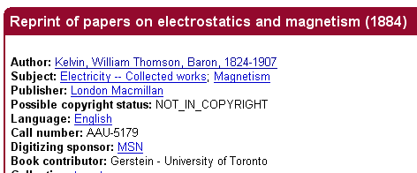

It is a 43 MB download from here

http://www.archive.org/details/reprintofpaperso00kelvuoft

The djVu is 26 MB, but I already am half way done. So maybe I can actually look at how Kelvin did this, Jackson's reference is a Macmillan 2nd Ed London 1884 book called "Reprints of papers on Electrostatics and Magnetism". We shall see if this is what I am downloading. Jackson refers to page 186.

Yup, it is the correction document:

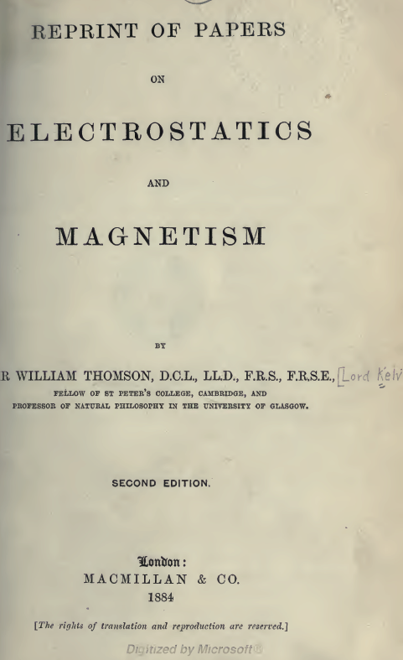

The relevant section starts page 178, and we have this opening claim

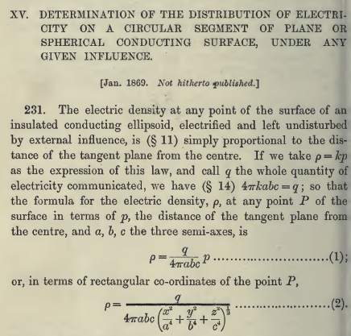

How do we know that? One way would be to know the potential outside a conducting ellipsoid.
I do know that the volume of an ellipsoid is (4/3)π abc, and that the area is some horrible elliptic function.

Parsing the above Kelvin snippet:

what does (§ 11) mean above? And what is this § character, anyway? Web says it is called a section symbol, hex A7.

"In science and mathematics, it has several uses. Many 19th century science and mathematics textbooks use the section symbol to refer a reader to another section. Some examples are the Treatise on Natural Philosophy by Sir William Thompson and Peter Guthrie Tait and College Geometry by Nathan Altshiller-Court. The symbol can also be used to represent an animal type specimen."

So maybe this book of Kelvin papers is done up in sections similar to Schiff where they just run through the whole book increasing in number without regard to chapters or, in this case, papers. Maybe the above is showing section 231. So Section 11 is on page 7, which page number you can just enter into the bottom window in Acrobat.

OK, on page 7 he says this: Take an ellipsoid and make a similar one slightly larger surrounding the original one. This means to increase the three semi-major axes by the same amount so δa/a = δb/b = δc/c. He defines p not as "r", but as the perpendicular distance from ellipse center to the plane which is tangent at point r on the ellipse. He calls this distance p, and the above three are equal to δp/p. He claims that δp is in fact the thickness of the thin shell you have formed at point r, and I agree. He lets ρ = thickness of the shell. So for a given pair of near ellipsoids, I agree that ρ = kp so as you move to different points on the shell, the thickness ρ varies in this manner. I agree. So we have

δa/a = δb/b = δc/c = δp/p = k and δp ≡ ρ so ρ = k p

Now I can do the next item without looking at section 14. We know that

V = (4π/3)abc => dV = (4π/3)[ δa/a abc ... ] = (4π/3)[ k abc ...] = 4πkabc

where dV is the volume of our thin shell.

Kelvin is imagining the charge is spread out in 3D in this thin shell. I think he sees the 3D density of the charge as a constant,
_______________________________________________________________

I am now pushing the stack down one level:

Question 2: What is the surface charge distribution on a metal ellipsoid holding charge Q.

I think the answer is shown above in (2), but I don't know why this is the answer. Go to a new doc.

Comment #2 added 1.11.10. Well, time has passed since 11.6.09 and I have "parsed" Kelvin and I know all about the potential of a conducting ellipsoid and how the charge is distributed on it. I know a little about the Lamé functions which are the ellipsoidal "solution terms", but I have never tried to solve any more significant problem in ellipsoidals, such as the Dirichlet or Neumann or Green's Function problems. Kelvin had his unusual way of doing things. I have learned a lot in the last two months, I would say, since I wrote the words above.

