Superposition in Electrostatics PhL 1.17.09

Overview. We consider here the notion of superposition of "situations". Can we superpose the potential of situations 1 and 2 to get the potential of situation 3? The conclusion is summarized in the following theorem. It is probably easier to ignore this formal theorem and look at the simple examples which follow and which came first. We are used to thinking that "superposition" is a general idea which always "works", but there are cases where it doesn't work, and I mark these with a "red flag".

______________________________________________________________________

The Red Flag Superposition Theorem.

Define the following sets:

S1 = the set of finite, localized pieces of metal in situation 1
S2 = the set of finite, localized pieces of metal in situation 2.

Now it may happen that some or all of the pieces of metal in these two situations are the same pieces of metal in the same locations, so that, in situation 3, each of those pieces of metal appears only once. Define this set of pieces of metal which are the same in 1 and 2 to be Sint, so Sint = S1 ∩ S2 .

Theorem: If Sint = S1 or Sint = S2 , then you CAN add the two potentials 1 and 2 to get the potential for situation 3. Otherwise you cannot do so.

Proof: Suppose Sint = S1, so S2 might have some extra pieces of metal. In situation 1, each of the S1 pieces of metal has some constant potential V1i. In situation 2, these same pieces of metal have some constant potential V2i. Therefore, in situation 3, these same pieces of metal will again each have a constant potential, namely, V3i = V1i + V2i, since we are after all just adding potentials. This means that in situation 3, those "pieces of metal" can really be pieces of metal.
On the other hand, suppose Sint < S1. Then there is a set S1 - Sint which contains pieces of metal which are in S1 but not in S2. These pieces of metal have constant potentials Vi1 in situation 1. But in situation 2, the ghost surfaces where these pieces of metal would be if they were present in S2 have in general non-constant potentials Vi2(r). I sometimes call these "math surfaces". Thus, in the superposition 3, these pieces of metal will have potential Vi3(r) = Vi1 + Vi2(r). Since the potentials Vi3(r) are not constant, these cannot really be pieces of metal in situation 3. They can only be math surfaces holding sticky charge.

Example T1: Let S1 and S2 each contain 1 piece of metal, and suppose Sint = Ø. The theorem says that you cannot superpose. This is the case studied in all of the examples below, for example, superposition of two different metal spheres.

Example T2: Let S1 = Ø and some S2 contains 1 piece of metal. Then you CAN superpose. A case here would be this: situation 1 = point charge + metal disk at V = 0 (which disk will hold some charge Q1, and situation 2 = same charged metal disk but in isolation with charge Q2, which disk will have some potential V2. Then you can superpose and you end up with a disk at potential V2 and charge Q1+Q2.

________________________________________________________________________________

Example 1. Two Conducting Spheres

Attempting Problem 1 + Problem 2 = Problem 3 by superposition. [ Example 2 is a generalization of this example, so we won't draw a picture for Example 1 ]

Let Problem 1 be a charged metal sphere of radius b centered at x = a where a > b. This can be thought of as a Dirichlet problem where V = 1 on the boundary of the sphere. We know the solution will have a uniform charge density on the sphere's surface. Outside the sphere, potential is that of a point charge at sphere center.

Let Problem 2 be a similar metal sphere centered at x = -a, same radius, but V = -1.

Can we superpose these two problems? What does this question mean?

First, what you intuitively mean is this: can you add the potentials of Problem 1 and Problem 2 and obtain the correct potential for Problem 3 which consists of the two metal spheres, one at V = 1 and the other at V = -1 ?

The answer is very clearly no, this does not work. If you could just add the two potentials, then neither sphere would be an equipotential surface: for example, on sphere A the potential contributed by Problem 1 sphere A would of course be constant on sphere A, but the potential contributed by Problem 2 sphere B is not constant on sphere A, so the total potential on sphere A is not constant.

In fact, the Problem 3 potential of two metal spheres has I think no closed form answer, and is usually treated as an iterative series, see Smythe or web.

Why does superposition fail in this example? In problems 1 and 2, each sphere has a uniform charge distribution. When you place the two spheres near each other, if either is charged, it induces a polarization distribution of charge on the other (the integral of which is 0). This new distribution is then added to the original uniform distribution. Since the charge distribution on each sphere is no longer the same as it was, and since potential is generated by charge, each sphere now generates a different potential than it did in its source Problem. So the resulting potential is not just the sum of the source problem potentials.

So when you combine charged metal objects, each affects all the others and you do NOT get simple superposition. It is because the charge is free to move around on conducting surfaces that this happens.

Example 2. One piece of metal in each starting problem.

Let's first identify a set of non-intersecting Dirichlet surfaces (possibly open) in 3D space, For example, here is a case where we have identified two such surfaces: (dotted lines means just a math surface)

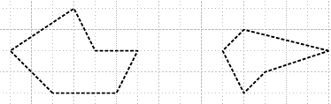

Suppose in Problem 1 only the left surface is metal, and in Problem 2 only the right surface is metal. Then here is what these two problems look like:

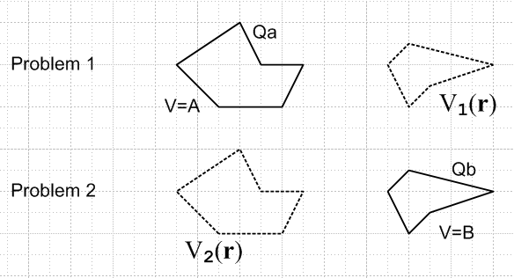

We can superpose these two problems to get a "Problem 3" as follows:

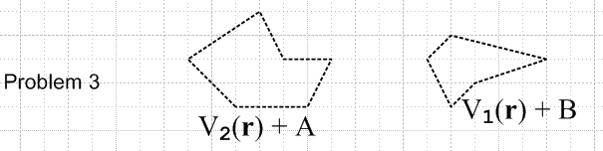

where we show the two Dirichlet functions for Problem 3. Since each varies on its surface, neither surface can be metal in the superposed problem.
So here we show that we can "do superposition" as long as we understand that the Dirichlet functions for the two surfaces are the sums of the Dirichlet functions on these same surfaces in Problems 1 and 2. In this example, the Dirichlet sum is non-constant on both surfaces, so neither can be metal.
If you mean by "superposition" that you want both surfaces metal in Problem 3, then superposition is not valid. In this sense, Example 1 is a special case of Example 2.

Example 3. Here is a slight variation on Example 2:

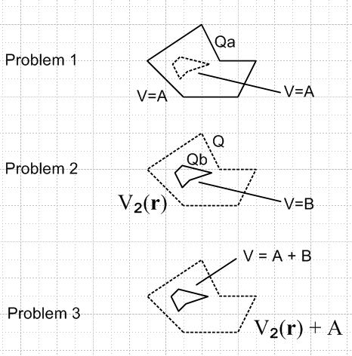

We do our superposition as per Example 2, but we find that in Problem 3, the potential on the inner surface is a constant, so in this case it can be metal. In Example 3 we are implying that that outer surface is a closed surface, which is why V = A on the inner dotted surface.

Example 2A. Let's now reconsider example 2 where the object on the right when dotted is just a math surface, but when lined red, is a surface containing some sticky charge distribution σ. Then we have:

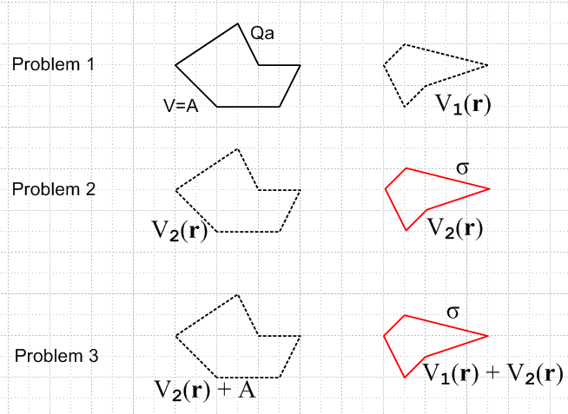

Here, V1(r) is the potential (variable) on the right surface in Problem 1 that is generated by the charges on the left surface. In Problem 2, V2(r) is generated by the sticky charge distribution on the right surface. In the superposition, our sticky charge just sits there and the surface on the left cannot be metal.
This tells us that if we superpose a metal object with a sticky charge distribution, we cannot superpose to have a metal object plus a charge distribution! We can only superpose in the sense above.

Example 3A. Now we vary Example 3 in the obvious way. The difference here is that the inner surface is not a constant potential in the superposition, so cannot be metal.

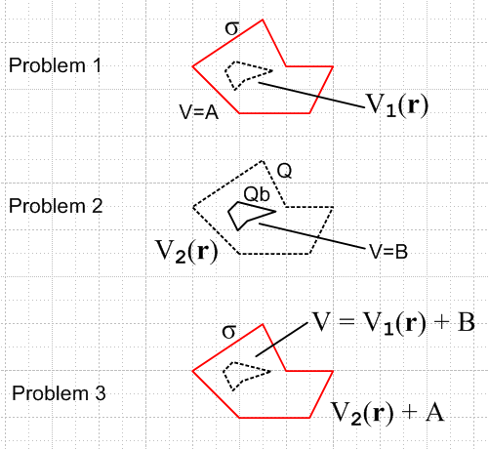

Example 3B. Now we vary Example 3A by installing a very special sticky charge surface -- one that has a uniform surface charge on it:

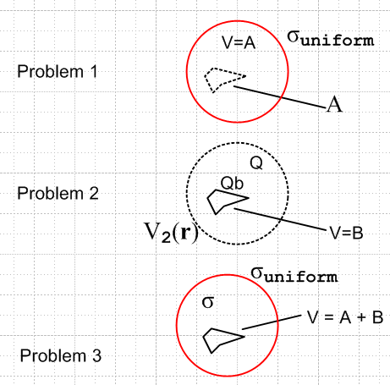

In this case, we know in Problem 1 that the potential is constant (call it A) inside the uniform charge distribution. Therefore, in Problem 3 the potential is constant on the inner surface, and it can therefore stay metal! The only requirement here is that the outer sphere completely enclose the inner one.

Example 1A. Two Stickies. Suppose Problem 1 has one sticky charge surface, and problem 2 has another sticky charge surface. Superposition works fine, and in Problem 3 we have the union of these two sticky charge surfaces and the sum of their potentials. No problem. This is just like superposition of point charges. No need for a picture.

I may come back here and do more examples if the need arises. // The need arose on 7.1.10:

Example 4: Suppose Problem 1 is a grounded metal object plus a sticky charge, and Problem 2 is the same grounded metal object plus some other sticky charge. Can you superpose?

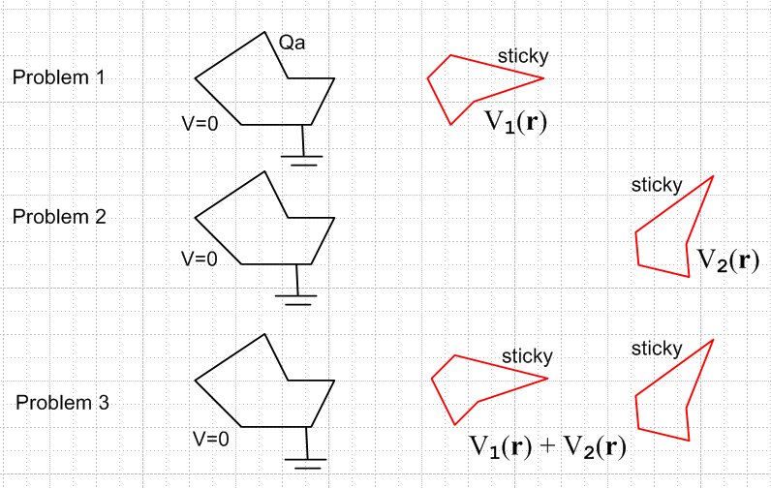

In Problem 1, the sticky charge exists and causes an induced charge σ1(r) on the metal object such that the total potential V1(r) vanishes on the metal surface. In Problem 2, same idea. Now, suppose you try to superpose the two potentials to get Problem 3. Certainly V1(r) + V2(r) will vanish on the metal surface, since each term separately vanishes there. Thus, V1(r) + V2(r) is a solution of Laplace at every point in space outside the metal object, and it satisfies all the boundary conditions (object and ∞), so it must be the unique solution to Problem 3. So yes, in this case you can superpose. Thus, the charge distribution on the metal object in Problem 3 is just the sum of σ1 and σ2. This idea is used in Smythe problem 42.

Example 5A: Which arises in Smythe Problem 42

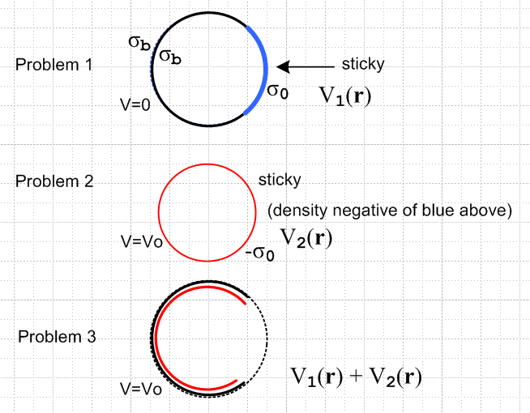

In Problem 1 the black is a metal bowl and the blue is some negative sticky charge on the entire cap. The bowl was grounded, but we have just removed the ground wire, it remains at V = 0. The bowl has some charge density σb which is equal on both surfaces of the bowl, something we know because the inversion is a black iris with blue planar charge in the hole, and in that case both sides of the iris have the same σ. The uniform blue charge density we call σ0 and of course we know that σ0 and σb have opposite sign and we also know that they have different magnitudes.

In Problem 2 we have a sphere of red charge density which is the exact negative of the blue charge density, so it has -σ0. This sphere of sticky charge has potential V = V0 = Q/A near the sphere surface, because it acts as if it were a point charge Q in the center. That is, V2(r) = Q/r outside this sphere, and Q/A inside. The radius of the red sphere is A-ε.

Problem 3 is the superposition. The bowl is still at a constant potential, so it "can be metal", which means our superposition is viable. The red charge density must be -σ0 = Q/4πA2 = V0/4πA. In Problem 5A then we have σb on the outer surface of the bowl, and σb - σ0 on the inner surface of the bowl:

σouter = σb σinner - σouter = V0/4πA
σinner = σouter + V0/4πA

Example 5B: What changes in Example 5A if we make the Problem 2 shell have radius A+ε ? If there is nothing different, then we have a contradiction. In Example 5B we would conclude that

σinner = σb
σouter = σinner + V0/4πA σinner - σouter = -V0/4πA

Smythe's Problem 42 suggests that only Example 5B is correct!
Here is a possible argument in favor of Example 5B. Imagine that we start with Problem 1 and that we slowly materialize the red sphere starting with σr = 0 and ramping it up. In problem 5B (not drawn), the metal bowl lies entirely inside the red shell, so the added potential from the red shell (radius A+ε) is exactly the same at all points on the bowl (remember, V = constant = Q/A everywhere inside the red shell due to its charge). Therefore, there is nothing to alter the σb which lies on each surface of the bowl. The charge cannot move or alter if V = constant at all times during our materialization process.
In contrast, in Example 5A (drawn above), the metal sphere lies just outside the bowl. But here the red sphere potential is Q/(A+ε) and is also constant on the metal sphere, so same argument seems to apply. Hmmm. A nice little paradox.
In either example, the final potential in Problem 3 is V1(r) + V2(r). The only question is how the charge distributes itself on the two surfaces of the bowl.

Idea for Resolution: In Examples 5A and B, I was using "sticky charge", which means the charge is not free to move. If we do Example 5A, it will stay on the inner surface because it is not free charge. So this is not really the example we want! This leads to:

Example 6: Right for Smythe Problem 42:

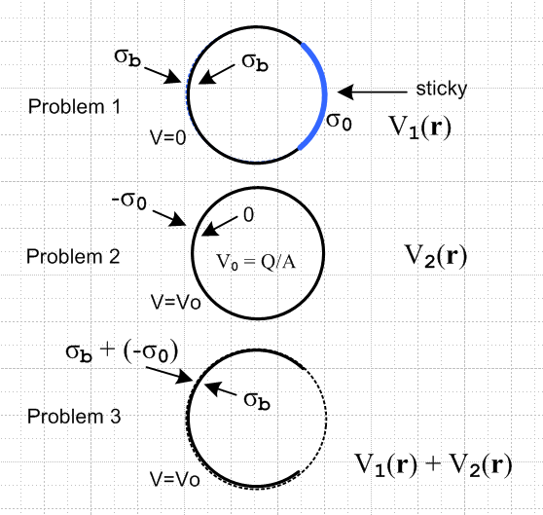

Problem 1 is the same as in both Examples 5A and 5B.

Problem 2 is no longer a sticky charge. It is a real metal sphere with -σ0 on the outer surface. We cannot create a metal sphere with charge in the inner surface (see below). When we superpose the Laplace solution for Problem 3, what happens?
In this example, the metal object in Problem 1 is a bowl, while in Problem 2 it is a full sphere, so these are different metal objects, though they are aligned in space as shown. In both Problems 1 and 2, the potential on the bowl part of the sphere is constant (0 and V0). Therefore, the potential on the bowl in problem 3 is the sum of those which is V0 and is still a constant, so we are "legal". On the cap part of the sphere in Problem 3 we have some unknown complicated potential from problem 1 which is added to V = 0 in problem 2 to make the same complicated result on the cap in Problem 3, not constant of course. So no contradictions. Problem 3 is a solution to the Laplace equation and meets the boundary condition that V = V0 on the bowl. It is the superposition of two Laplace problems which are each valid. That is to say, we know that both V1(r) and V2(r) satisfy Laplace at all points in space away from the metal, so it is only a question of boundary conditions to see whether superposition is legal, and problem 3 has the right boundary conditions.
Problem 2 has V0 = Q/A everywhere inside the sphere, so there can be no gradient of V inside, so there can be no σ inside. That is why it is all on the outside. When we superpose Problems 1 and 2, everything is in equilibrium so no charges move and we end up as shown.

But, something is not quite right (2.19.11). If you superpose a metal bowl with a metal sphere, what is the metals configuration for problem 3? You would still have metal on the sphere cap.

Example 6A: A new attempt at Example 6

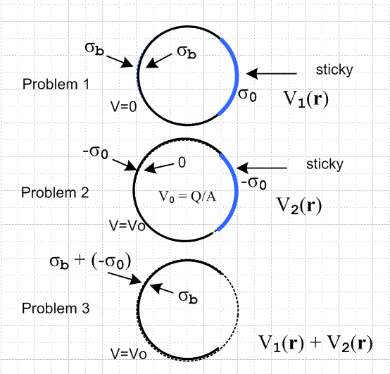

Problem 1 is the same as in both Examples 5A and 5B.

Problem 2 consists of an isolated spherical bowl prepared in the following manner. Initially the bowl has no charge. A full spherical shell of sticky charge density is wrapped around the outer surface of the bowl's sphere. At this point V = V0 on and inside the bowl due to the presence of a uniform shell of -σ0. The glue is then released on the sticky charge just on the bowl portion of the sphere. The charge stays put on the outer surface of the bowl because there is no electric field tangential to the surface to make it move. There is no charge on the inner bowl surface since V = V0 in a region surrounding where such charge would be. So in Problem 2 we have a spherical bowl at potential V0 having a uniform free charge density σ = -σ0 on the outer surface, and σ = 0 on the inner surface, and we also have a cap of sticky charge with σ = -σ0.

Problem 3 is then the obvious superposition that we want.

