The Wilson Toroid Paper PhL 2.11.11

This 2004 paper is by two Alabama guys Scharstein and Wilson from EE and Aerospace.

This paper solves several problems, but the "charged donut" is not among them, so there is no mention of donut capacitance and its interesting special function.

Introduction. They draw a toroid with radii a > b. They give a "toroidal equation set" on page 3, using ξ as the donut label and η as the bowl label, and they have a very nice picture which agrees with my set up for this problem (for me, η = u )

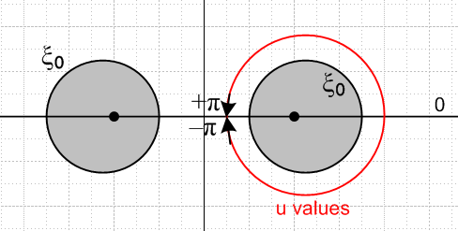

Then quote the 1/R expansion in toroidals in their (7) which agrees with my 1/R toroidal paper result. Then refer to εn as the "Neumann number".

In each section below, authors to a rigorous exact solution, then they take limits as appropriate. They are especially interested in the thin ring limit

Axial Exciting Electric Field (p 5). So we put a donut perp to an E field

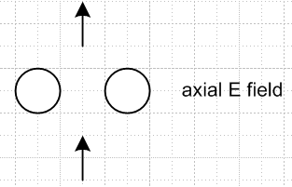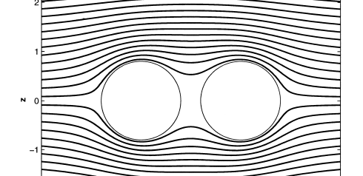

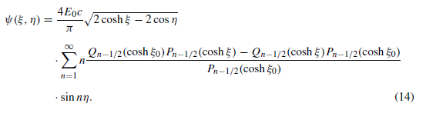

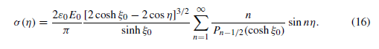

and we expect get + charges on one side of the donut and negative on the other. They write a Smythian form and solve this problem. Only sin(nu) terms appear since, unlike the charged donut, this thing has negative inversion symmetry. They compute the potential and the charge density. Potential is plotted in a 2D plot on page 6 and you see how the parallel E field lines sort of distort around the "interference" of the donut.

Transverse Exciting Electric Field (p 7). This one has cos(nu) only, they do a Smythian form and solve the problem with these results
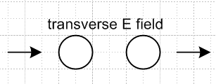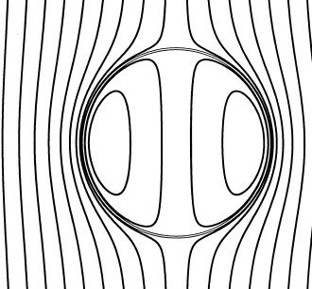
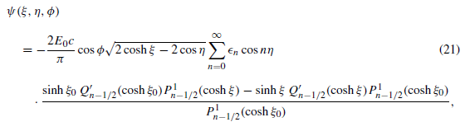
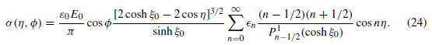

Point Charge Excitation (p 9) . So here they give the Green's Point charge an arbitrary φ=0 position and solve this problem using my "Green's by Dirichlet Method" (see docs of that title).

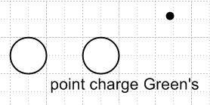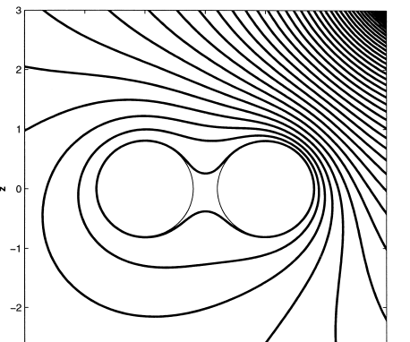

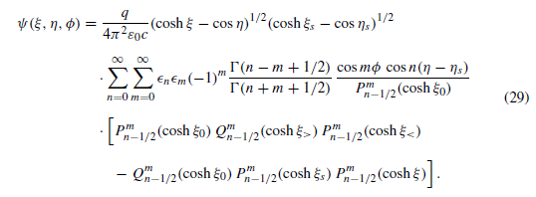

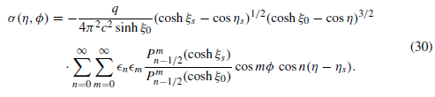
He is able to convert σ to a Q/Q form using Whipple.

Integral Equation for Ring Charge Density.

The authors are now going to re-examine the same 3 problems but now they will use a Stakgold integral equation method approach. In all three problems, they require that the metal donut have V = 0 (something we always assume for the Green's problem). Stak's equation then says

where ψi is the applied excitation (static in these problems). If you put the huge 1/R expansion in there, the integral equation is too hard to solve, but in the thin ring limit, you can use an approximation for the 1/R kernel which is this
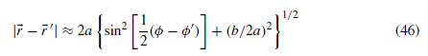

what they call the "thin wire kernel approximation" attributed to Wu 1962 (I think Wu took Kings chair on his retirement) , and they have a picture showing the meaning of things. Then in each of the three cases, they solve the integral equation for σ, and in each case they show how the result matches the general toroidal results found earlier. They encounter here integrals that I have often dealt with, those angular integrals that give Q and K functions.

In the final section they try to apply this electrostatics work to dynamical problems. These guys like me just enjoyed solving these classical electrostatics problems, but to "justify" their 2005 paper they had to say that their work lends justification to the thin ring kernel approximation which people use in antenna theory with time varying EM fields.

References. One of their references is none other than my friend RWP King with whom I did independent study and wrote a little paper on "units". He wrote my 1955 book on transmission line theory, and here the reference is to a 1969 paper her wrote on loop antennas that is included in a collection of papers. He went emeritus in 1972, died in 2005, born 1905. So in 1970 he was already 65 years old, I got him just before he retired. I don't remember his age. He died at age 100, very nice obit here. He was nice to me as well.

http://www.news.harvard.edu/gazette/2006/04.20/13-kingobit.html

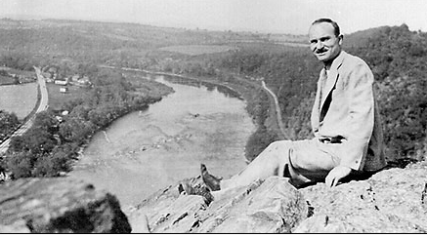

Other references include Jackson, Hobson, Smythe, Moon & Spencer, two Lebedev's, M&F, A&S. I see that Smythe also has a solutions book I did not know about

This is 183 pages, very few hits. Marriott has the main book but not this little adder. Worldcat says

"Wrs-1893-7-5. ...Complete set of solutions to the 679 problems posed in the 3rd ed. (1968), of which 581 also appeared in the 2nd ed. (1950)." WOW! Worldcat says there is a copy in Boulder. Fascinating.

