Find 2D wire equipotential curves in Cartesian coordinates PhL 10.16.09

Comment: I thought this would be trivial, and ended up flailing for 12 hours and could not find the answer. So here I am going to try to be "more careful". I am thus starting over. // I then spent another 10 hours on 10/17 debugging this document and fixing algebra errors, and finally ended up showing that the locus of | z + $\sqrt{z2-1}$| = K really is a specific ellipse. I guess I am not very good at algebra, despite my heavy effort at avoiding errors. When there are 200 steps, you are going to make mistakes, so the trick is to have a traceable record and that is what I have done here, and that is why we have 20 hours going into this trivial problem. Reminds me of debugging a hardware design that does not work. It is obvious to me now that there is some better way to do all this, but that is not for this document. [ See math/ geometry/ ellipses.doc ]

Overview (written 12.9.10, 1 page) 1
1. Background for the Problem 2
2. The problem then is this: 4
False Start. 5
The Plan. 5
Find a and b. 6
Insert a and b into our locus equation. 8
CONCLUSIONS: 11
Old Garbage Notes Retained (IGNORE ALL OF THIS!) 12
The Ellipse Mystery Resolved. 12
Check my a+ib calculation against Maple 15
Try to Resolve the Maple Contradiction 17
Older notes 19
The Factor Question: 23

___________________________________________________________________________________

Overview (written 12.9.10, 1 page)

This doc was written after the v1 and v2 docs, and makes use of the potential of the 2D wire which is obtained in the v2 doc.

In Section 1 I show quickly that the equipotential contours for the 2D wire are given by | z + $\sqrt{z2-a2}$| = K where z = x+iy. I do implicit plots in Maple for a = 1 and these sure look like ellipses.

In Section 2 after a massive amount of algebra I show that the above locus is the same as this locus (see also ellipses.doc in math/geometry ), which is in fact an ellipse with foci at ± a:

x2/A2 + y2/B2 = 1
A = semimajor axis distance = a(K2+ 1)/2K = (a/2) (K + 1/K)
B = semiminor axis distance = a|K2– 1| /2K = (a/2) | K - 1/K |
C2 = A2-B2 = a2
eccentricity = ε = C/A = a/A = 2K/(K2+1) // circle has ε = 0
as K→ 1, ε → 1 and B → 0 so we get the super-thin ellipse surrounding our wire

So that is basically it for this doc! I later wrote more on this subject in ellipses.doc just noted. There, I show two important facts that I will just add right here.
The first is that this same ellipse can be described by this equation, pretty obvious,

|z-a| + |z+a| = 2A = a (K + 1/K)

which is of course "the string theorem". I derive this in ellipses.doc, though it is a familiar result.
The second result is what I call my "ellipse string theorem" , a lot less "familiar" :

(1/2) ( $\sqrt{(x-a)2+ y2}$ + $\sqrt{(x+a)2+ y2}$ )2 = (x2 + y2 + a2) + $\sqrt{(x2 - y2- a2)2 + 4x2y2}$

The inside of the LHS (....) is in fact |z-a| + |z+a| written out in 2D geometry. This "theorem" can be proven in about 60 seconds by just squaring the LHS, and there are various ways to write the inside of the radical on the RHS. This is a useful theorem where you can regard x,y,a as three arbitrary real variables, but you have to pay attention to analytic continuation in this general case. The issue is what you pull out of the RHS radical in the case that x or y is zero : which sign? Since we are presumably on principle branches, the sign is such that you get + | x2 - y2 - a2 | as the second term on the RHS.

___________________________________________________________________________________

1. Background for the Problem

The potential for a 2D wire with a = a

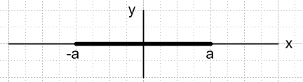

is given by:

u(x,y) = – (1/4π)ln(2/a) -(1/4π) ln( z + $\sqrt{z2-a2}$) + c.c. z = x + iy

The potential contours are therefore given by

ln( z + $\sqrt{z2-a2}$) + cc = C C = real constant

which can be written as

ln{ ( z + $\sqrt{z2-a2}$)( z + $\sqrt{z2-a2}$)*} = C

ln | z + $\sqrt{z2-1}$|2 = C

| z + $\sqrt{z2-a2}$|2 = eC

| z + $\sqrt{z2-a2}$| = eC/2 = K

So our canonical form is going to be this:

| z + $\sqrt{z2-a2}$| = K

Now we know we can always scale things, so just set a = 1. We can use the implicitplot function to make Maple give us a plot of some of the contours. Here are the contours for K = 2,3 and 4:

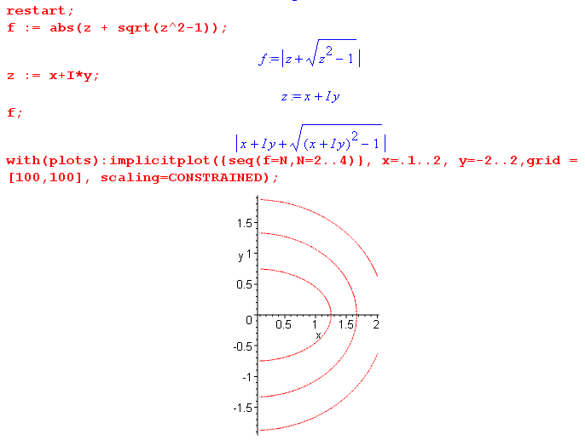

As K → 1, the contour sucks down onto the wire. For example, for K = 1.1 we get

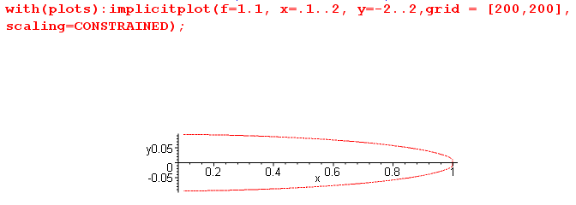

The curves "look like" ellipses, but at this point I am not sure whether they really are ellipses.

Note added 12.9.10. Go back to our potential with a = 1:

u(x,y) = [ – (1/4π)ln(2) -(1/4π) ln( z + $\sqrt{z2-1}$) ] + c.c. z = x + iy
= – (1/2π)ln(2) - (1/4π)[ ln( z + $\sqrt{z2-1}$) + c.c. ]
= – (1/2π)ln(2) - (1/4π)[ ln|( z + $\sqrt{z2-1}$)|2 ]
= – (1/2π)ln(2) - (1/2π)Re [ln( z + $\sqrt{z2-1}$)]

where I just write the same thing several ways. In my

2. The problem then is this:

Write an equation for these contours as a polynomial function of x and y. That is to say, given

| z + $\sqrt{z2-1}$| = K z = x+iy

simply write this out as some

f(x,y,K) = 0

Perhaps we will find that the curves are ellipses, but we don't yet know.
This certainly does not sound like something that would take 20+ hours, does it? But if you are stupid, things like this can take an infinite amount of time.

Jump Ahead: the result is this: ( see red CONCLUSIONS section below)

f(x,y,K) = x2/A2 + y2/B2 - 1 with f(x,y,K) = 0
A = semimajor axis distance = (K2+ 1)/2K
B = semiminor axis distance = |K2– 1| /2K

False Start. We start off with this obvious first step

| x+iy + $\sqrt{(x+iy)2-1}$| = K

As a next step, one is tempted to say this:

(x+iy + $\sqrt{(x+iy)2-1}$)(x-iy + $\sqrt{(x-iy)2-1}$) = K2

(x+iy + $\sqrt{(x2-y2-1) + 2xi}$)(x-iy + $\sqrt{(x2-y2-1) – 2xi}$) = K2

(x2 + y2 ) + $\sqrt{(x2-y2-1)2 + 4x2}$ + (x+iy) $\sqrt{(x2-y2-1) – 2xi}$ + (x-iy) $\sqrt{(x2-y2-1) + 2xi}$ = K2

At this point we are stuck with three square roots, two of which contain "i", things look very messy, and I don't know what to do next. So I look for a better approach.

The Plan. So instead, we take a different tack. Suppose we can write the following

$\sqrt{(x+iy)2-1}$ = a + ib

where a and b are real. So we are just decomposing $\sqrt{z2-1}$ into is real and imaginary parts. That certainly doesn't sound like rocket science. Assume we have done this and that we have a and b as functions of x and y. We can then say this:

| z + $\sqrt{z2-1}$| = K

| x + iy + a + ib | = K

| (x + a) + i (y+b) | = K

| (x + a) + i (y+b) |2 = K2

(x + a)2 + (y+b)2 = K2 since| A + iB|2 = A2 + B2 for real A and B
// checkpoint C = OK
Now let's continue along here as follows

x2 + a2 + 2ax + y2 + b2 + 2by = K2

K2 - (a2 + b2 + x2 + y2) = 2(ax +by)

[ K2 - (a2 + b2 + x2 + y2) ] 2 = 4 (ax+by)2 = 4(a2x2 + b2y2 + 2abxy)

Since we have squared things, we expect to have brought in a bogus curve in addition to our desired curve (maybe several), but that is fine and that is always what happens.
So if we can really find a and b, there is our Cartesian curve just sitting there!
So, let's go try to find a and b!

Find a and b. Start off with

$\sqrt{(x+iy)2-1}$ = a + ib

(x+iy)2 - 1 = (a+ib)2

By squaring both sides, we may be bringing in extra solutions, so be careful. Expand both sides:

x2 - y2 - 1 + 2ixy = a2- b2 + 2iab

Equating real and imaginary parts, we conclude that

x2 - y2 - 1 = a2- b2 and xy = ab

We can then construct a quadratic equation as follows:

b = xy/a

Define

B ≡ - (x2 - y2 - 1) so that -B = a2 - b2

Then we have this quadratic equation:

-B = a2 - (xy/a)2

-a2B = a4 - x2y2

a4 + Ba2 - x2y2 = 0 C = -x2y2

Again, no rocket science here. The solution to this quadratic equation is this

a2 = [ -B ± $\sqrt{B2 + 4x2y2}$] / 2

Suppose B > 0. Then if we were to allow the - sign, we would have a2 < 0 and a would not be real as we assumed at the start. Suppose B < 0. We reach exactly the same conclusion because the second term is larger in magnitude than the first term. Therefore, we have found that

a2 = [ -B + $\sqrt{B2 + 4x2y2}$] / 2

However, we don't know the sign of a yet.

Now, if we make the swap a ↔ b and B→ -B, our starting equation -B = a2 - b2 stays the same. Then all our "math steps" will be exactly the same, and we will conclude that

b2 = [ +B + $\sqrt{B2 + 4x2y2}$] / 2

So, although we have not yet found a and b, we have found a2 and b2:

a2 = [ -B + $\sqrt{B2 + 4x2y2}$] / 2
b2 = [ +B + $\sqrt{B2 + 4x2y2}$] / 2

And we have also found a new fact, which is this

a2 + b2 = $\sqrt{B2 + 4x2y2}$

and we can add this to our already known fact that

b2- a2 = B

Now lets set D = -B because it makes things "look nicer". Then we can "gather up" what we have learned so far about a and b:

D = (x2 - y2 - 1)

a2 = [ D + $\sqrt{D2 + 4x2y2}$] / 2
b2 = [ - D + $\sqrt{D2 + 4x2y2}$] / 2

a2 + b2 = $\sqrt{D2 + 4x2y2}$
a2 – b2 = D

xy = ab

It is a little annoying that after all this effort we don't really know the sign of a and b. We can see that the product of the signs is the sign of xy, so in the first quadrant a and b must have the same sign.

It is possible to take z = reiθ so that z2- 1 = r2 e2iθ - 1. If z lies in the first quadrant, we know that z2-1 lies in the upper half plane because subtracting 1 does not change this half plane. So we know:

(x,y) in first quadrant => b > 0

Then, since a = xy/b , in this first quadrant a will also be a > 0 . Drawing a few pictures shows that this all makes sense.
So let us focus on the first quadrant, and then a > 0 and b > 0 and we have now completed our task of finding a and b. We now define one additional symbol and summarize our results:

D ≡ (x2 - y2 - 1) R ≡ $\sqrt{D2 + 4x2y2}$

a2 = [ D + R] / 2
b2 = [ - D + R] / 2

a2 + b2 = R
a2 – b2 = D

xy = ab

Insert a and b into our locus equation.

Looking back, this equation was,

[ K2 - (a2 + b2 + x2 + y2) ] 2 = 4(a2x2 + b2y2 + 2abxy)

where we have included possible bogus curves along with our real curve. At this point, we will use these two facts from above

a2 + b2 = R

ab = xy

Our equation thus becomes

[ K2 - (R + x2 + y2) ] 2 = 4(a2x2 + b2y2 + 2x2y2)

[ K2 - (R + x2 + y2) ] 2 = 2(2a2x2 + 2b2y2 + 4x2y2)

Next, insert the following expressions for a2 and b2 on the RHS

2a2 = [ D + R ]
2b2 = [- D + R]

We then have

[ K2 - (R + x2 + y2) ] 2 = 2( [ D + R] x2 + [- D + R] y2 + 4x2y2 )

= 2D(x2–y2) + 2R(x2+ y2) + 8x2y2

which we just write again on one line

[ K2 - (R + x2 + y2) ] 2 = 2D(x2–y2) + 2R(x2+ y2) + 8x2y2

where D ≡ (x2 - y2 - 1) R ≡ $\sqrt{D2 + 4x2y2}$ R2 = D2 + 4x2y2

We now need to isolate the radical R so we can square both sides again to get rid of it. So
multiply things out on the LHS

K4 + (R + x2 + y2)2 - 2K2 (R + x2 + y2) = 2D(x2–y2) + 2R(x2+ y2) + 8x2y2

LHS = K4 + (R + x2 + y2)2 - 2K2 (R + x2 + y2)

= K4 + R2 + (x2 + y2)2 + 2R (x2 + y2) - 2K2 (R + x2 + y2)

= K4 + R2 + (x2 + y2)2 -2K2 (x2 + y2) + 2R ( x2 + y2 - K2)

So at this point we then have

K4 + R2 + (x2 + y2)2 -2K2 (x2 + y2) + 2R ( x2 + y2 - K2) = 2D(x2–y2) + 2R(x2+ y2) + 8x2y2

Notice now that the terms 2R ( x2 + y2) cancel on both sides, leaving us with

K4 + R2 + (x2 + y2)2 -2K2 (x2 + y2) + 2R ( - K2) = 2D(x2–y2) + 8x2y2

Let's first move all terms to the LHS:

K4 + R2 + (x2 + y2)2 -2K2 (x2 + y2) + 2R ( - K2) - 2D(x2–y2) - 8x2y2 = 0

Now isolate the R term on the RHS

K4 + R2 + (x2 + y2)2 -2K2 (x2 + y2) - 2D(x2–y2) - 8x2y2 = 2RK2

Now let's try to simplify the non-K terms on the LHS, which are these

R2 + (x2 + y2)2 - 2D(x2–y2) - 8x2y2

= D2 + 4x2y2 + (x2 + y2)2- 2D(x2–y2) - 8x2y2

= D2 + (x2 + y2)2- 2D(x2–y2) - 4x2y2

= (x2 - y2 - 1)2 + (x2 + y2)2 - 2(x2 - y2 - 1) (x2–y2) - 4x2y2

= (x2 - y2)2 + 1 - 2(x2 - y2) + (x2 + y2)2 - 2(x2 - y2 - 1) (x2–y2) - 4x2y2

= 2x4 + 2y4 + 1 - 2(x2 - y2) - 2(x2 - y2 - 1) (x2–y2) - 4x2y2

= 2x4 + 2y4 + 1 -2(x2 - y2)( 1 + x2 - y2 - 1) - 4x2y2

= 2x4 + 2y4 + 1 -2(x2 - y2)( x2 - y2) - 4x2y2

= 2x4 + 2y4 + 1 - 2(x2 - y2)2 - 4x2y2

= 2x4 + 2y4 + 1 - 2( x4 + y4 - 2x2y2) - 4x2y2

= 2x4 + 2y4 + 1 - 2 x4 -2 y4 + 4x2y2) - 4x2y2

= 1 + 4x2y2 - 4x2y2

= 1 !!!

Notice that all the 4th power stuff has gone away! If all this was done properly (could check in Maple), we then have

K4 - 2K2 (x2 + y2) + 1 = 2RK2

Now we square both sides and finally all square roots are gone!

[ K4 - 2K2 (x2 + y2) + 1]2 = 4K4R2

= 4K4 (D2 + 4x2y2)

= 4K4 ((x2 - y2 - 1)2 + 4x2y2)

which we write again on one line:

[ K4 - 2K2 (x2 + y2) + 1]2 = 4K4 [(x2 - y2 - 1)2 + 4x2y2 ]

and again as an equation = 0,

[ K4 - 2K2 (x2 + y2) + 1 ]2 - 4K4 [(x2 - y2 - 1)2 + 4x2y2 ] = 0

Key fact: when we square the left term, we will get a term 4K42x2y2 and this will cancel the other similar terms coming from the second factor, resulting in no x2y2 cross term. This is what will allow this entire thing to be a simple quadratic. ( Obviously there is some simpler way to see all this, but I just wanted to do the brute force method and get it done. )

At this point I am going to use Maple as follows:

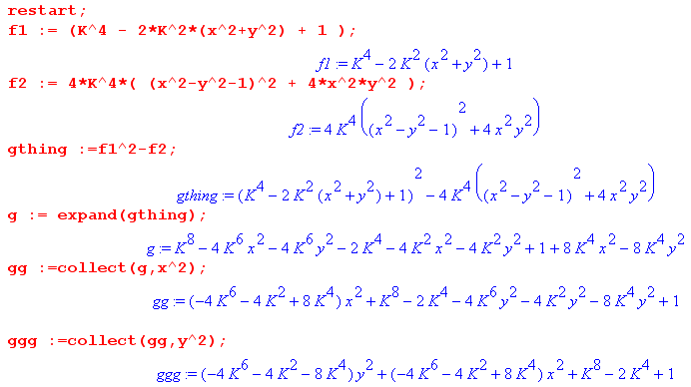

So (finally, after days of stumbling around with errors), we write this as

0 = (-4K6 + 8K4 -4K2 )x2 + (-4K6 - 8K4 -4K2 )y2 + (K4-1)2

0 = (4K6 - 8K4 +4K2 )x2 + (4K6 + 8K4 +4K2 )y2 – (K4-1)2

0 = 4K2(K4 - 2K2 +1 )x2 + 4K2(K4 + 2K2 +1 y2 – (K4-1)2

4K2(K2- 1)2x2 + 4K2(K2+ 1)2 y2 = (K4-1)2

Now divide both sides by (K2- 1)2(K2+ 1)2 = (K4-1)2 to get the following standard ellipse form:

CONCLUSIONS:

x2/A2 + y2/B2 = 1

A = semimajor axis distance = (K2+ 1)/2K A+B = K A-B = 1/K
B = semiminor axis distance = |K2– 1| /2K

C = distance center to focus = 1 because:

C2 = A2- B2 = (A+B)(A-B) = K(1/K) = 1

eccentricity = ε = C/A = 1/A = 2K/(K2+1) // circle has ε = 0

as K→ 1, ε → 1 and B → 0 so we get the super-thin ellipse surrounding our wire

For large K we can approximate things as A = B = K/2 = radius of circle. The ellipse foci are fixed to the endpoints of our little wire. All very simple, now that the facts are in.

So the above ellipse is the locus of points which solve this equation: | z + $\sqrt{z2-1}$| = K

Comment: for large K, our potential line | z + $\sqrt{z2-1}$| = K is a circle far from the wire. As K grows smaller, the circle gets smaller, and gets elliptical. As we finally get to K = 1 + ε, the ellipse exactly wraps the wire.

Question: What happens when 0 < K < 1 ? Consider this way of writing A and B and let K' = 1/K

A = semimajor axis distance = (K2+ 1)/2K = (1/2)( K + 1/K) = (1/2)( K' + 1/K')

B = semiminor axis distance = |K2– 1| /2K = (1/2)| K – 1/K | = (1/2)| K' – 1/K' |

As K runs through down through the range (1,0), K' runs up through range (1,∞) and replicates the same set of ellipses we got during the contraction from K = ∞ down to K = 1.

Distance form of ellipse: |z - 1| + |z-1| = 2A = (K + 1/K). Therefore, these two equations have the same locus:

|z - 1| + |z-1| = (K + 1/K)

| z + $\sqrt{z2-1}$| = K

I have shown this "the very long way". There must be a trivial way to show this. I have fiddled on 6 scratch pages with pictures and trig and it is not obvious to me how it works, so let's put that problem off to yet another document, since the present one is already tangled enough!

Old Garbage Notes Retained (IGNORE ALL OF THIS!)
_________________________________________________________________________________

The Ellipse Mystery Resolved.

This section is now all resolved but I keep it anyway. Earlier I was failing to get the ellipse in the above computation.

I am still mystified by this Maple code which set things off. I will try to narrate what I am doing in Maple. First, we set up the equation g ≡ | z + $\sqrt{z2-1}$|2 = a

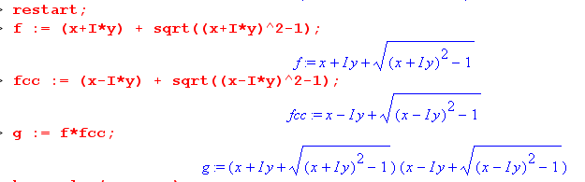

I could not make Maple express this as something not involving "i". We know it is real since it is of the form g = AA*, so there must be some function such that g = g(x,y).

Then we ask Maple if it can solve the equation g(x,y) = a for x:

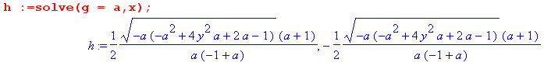

I was and still am amazed at this solution. It basically says this:

x2 = f1(a) y2 + f2(a) f1(a) = (1/4) (a+1)2(-4a2)/[ a2(a-1)2] = - (a+1)2/(a-1)2
f2(a) = (1/4) (a+1)2 (-a)(-a2+2a-1) /[ a2(a-1)2]
and this i = (1/4) (a+1)2 (a)(a2-2a+1) /[ a2(a-1)2]
= (1/4) (a+1)2 (a)(a-1)2 /[ a2(a-1)2]
= (1/4) (a+1)2/a

We find f1(a) < 0 and f2(z) > 0 since a>0, so this is always the equation of an ellipse centered at (0,0)! That is what amazed me! For example, if I set a = 2, here is what happens:

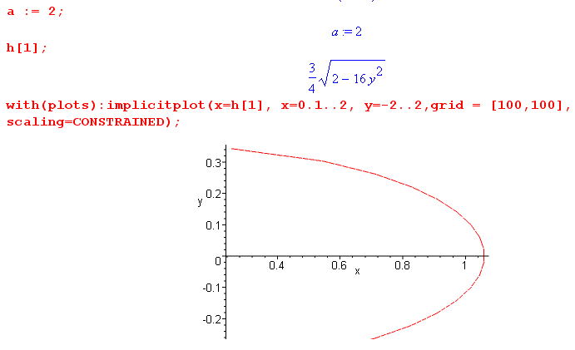

where I have plotted a piece of the ellipse.
Now of course we are always allowed to CHECK on Maple to see if it has really found a solution as it says it has. So with a = 2, here is the value of g ≡ | z + $\sqrt{z2-1}$|2 when we replace x = h[1] as shown above:

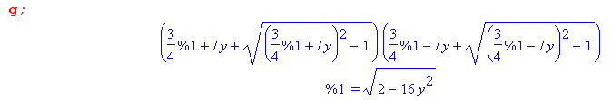

Now let's try a value of y such that we know the locus touches that value of y, such as y = 0.21345.

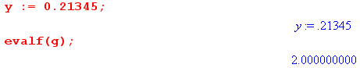

Sure enough, this is a solution! This would seem to be telling us that the locus of g = a is always an ellipse, despite all the messy work we have done in previous sections of this document !!! So my confidence is completely shaken by what Maple is saying here.

Let's go back to the equation of our ellipse:

x2 = f1(a) y2 + f2(a) f1(a) = - (a+1)2/(a-1)2 f2(a) = (1/4) (a+1)2/a

x2 = - (a+1)2/(a-1)2 * y2 + (1/4) (a+1)2/a

x2 = - (a+1)2/(a-1)2 * y2 + (a+1)2/(4a)

x2 + [ (a+1)2/(a-1)2 ] y2 - (a+1)2/(4a) = 0

We know that a = K2 so rewrite this as

x2 + [ (K2+1)2/(K2-1)2 ] y2 - (K2+1)2/(4K2) = 0

x2 + By2 - C = 0 B = (K2+1)2/(K2-1)2 C = (K2+1)2/(4K2)

Now divide through by C:

x2 (4K)2/(K2+1)2 + y2 (K2+1)2/(K2-1)2(4K)2/(K2+1)2 = 1

x2 (4K)2/(K2+1)2 + y2 /(K2-1)2(4K)2 = 1

which is the same result we got above.

*****************************************************************************

Checking calculations: these were used to find and correct bugs in the above

*****************************************************************************

Check my a+ib calculation against Maple

Here is some Maple code where I enter $\sqrt{z2-1}$ and I come up with particular value for (x,y) and I have Maple compute this quantity:

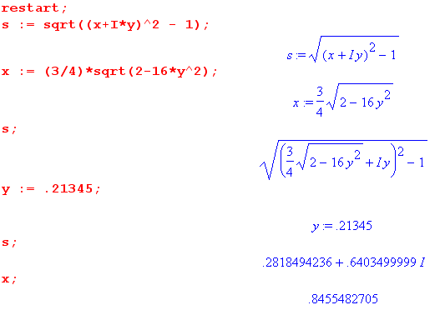

The complex value here called "s" is what I called a + ib above. I want to see if my above computation of a+ib agrees with the "s" reported here. This would just be a check on my a,b algebra and I expect everything to agree. Our "data" on this subject from above is this:

D ≡ (x2 - y2 - 1) R ≡ $\sqrt{D2 + 4x2y2}$
a2 = [ D + R] / 2
b2 = [ - D + R] / 2
a2 + b2 = R
a2 – b2 = D
xy = ab

So I enter more code as follows:

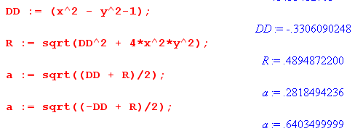
which we can compare with what we just did above,

s = .2818494236+.6403499999*I

So we do in fact find that s = a+ib ! I have not screwed up the equations for a and b. So probably Maple computes these things just the way I do.

Try to Resolve the Maple Contradiction

Here is what Maple is telling me. If we pick (x,y) to lie anywhere on the elliptic locus

x := 3/4*sqrt(2-16*y^2)

then we always find, at any point on this locus, that the following is true:

| z + $\sqrt{z2-1}$|2 = 2 = K2 so K = $\sqrt{2}$.

One such point on the ellipse with K = $\sqrt{2}$ was this

y := .21345; x := .8455482705;

So it seems hard to deny that at least a locus in the z plane which satisfies this equation is this ellipse! Yet my calculation above claims that we do NOT get an ellipse. I cannot rest until this blatant contradiction is resolved. No tennis today, sorry.

So maybe I will probe my algebra at each step along the way and see where I went wrong.

A. Probe at the End. Let's start at the very end. In the math above I developed this equation

g = [ K4 - 2K2 (x2 + y2) + 1 + 4x2y2 ]2 - 4K4 [(x2 - y2 - 1)2 + 4x2y2 ] = 0

and I entered this into Maple and let it do the math. Maple gets:

What happens if I install here my values shown above?

K = $\sqrt{2}$ y := .21345; x := .8455482705;

Then g = this
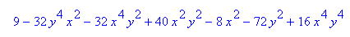

and evaluating this I get .527200400 when I am supposed to get 0 ! So this says that yes, I have an error somewhere in the math.

B. Probe at the Start. I have already done this and got the right answer.

C. Probe at this point: (x + a)2 + (y+b)2 = K2. Things seem OK here, as the last line of this code shows:

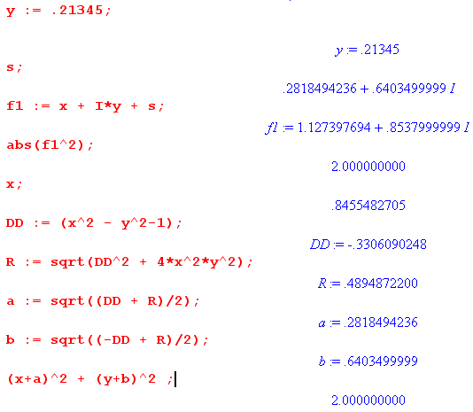

D. Probe at this point: Here is what I start the "insert a and b" section with:

[ K2 - (a2 + b2 + x2 + y2) ] 2 = 4(a2x2 + b2y2 + 2abxy)

I just add a few lines of code to the above, and it looks good:

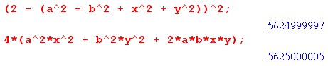

E. Probe at this point: A few lines down from the above checkpoint, I get this

[ K2 - (R + x2 + y2) ] 2 = 2D(x2–y2) + 2R(x2+ y2) + 4x2y2

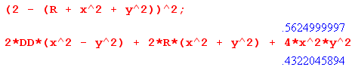

So an error was made between the last two points! And it is with the RHS. I found a mistake, fixed it, and now we are good at this point

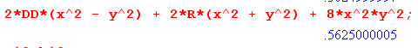

I am now propagating this fix through all my algebra!

F. Probe at this point:

K4 + R2 + (x2 + y2)2 -2K2 (x2 + y2) - 2D(x2–y2) - 8x2y2 = 2RK2

It looks good:

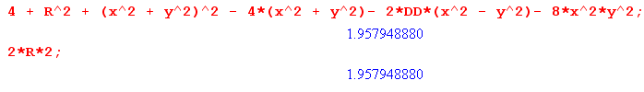
G. Probe at this point:

K4 - 2K2 (x2 + y2) + 1 = 2RK2

It looks good:
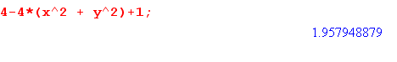

H. Probe at this point: good

[ K4 - 2K2 (x2 + y2) + 1]2 = 4K4 [(x2 - y2 - 1)2 + 4x2y2 ]

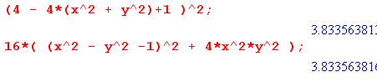

Older notes
________________________________________________________________________

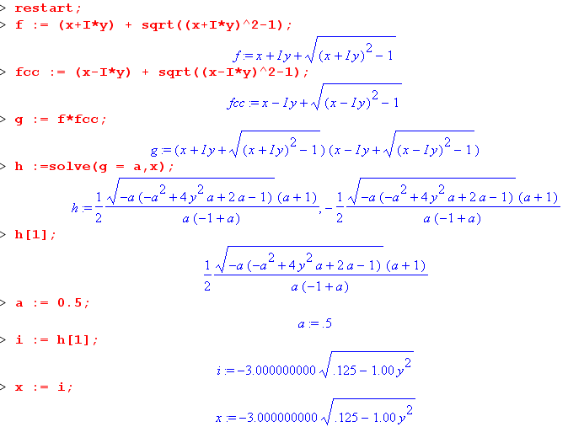

This code is saying that

g = | z + $\sqrt{z2-1}$|2 = a = K2

It seems to say that it can solve this equation for x in terms of y. But I used in my example

a = (1/2) = K2 => K = 1/$\sqrt{2}$ < 1

But the regime of my curves is only K ≥ 1 and I have not really understood the meaning of my equation for the case K < 1. But I know the Cartesian form, so I could plot and see what I get for several values of K which are < 1:

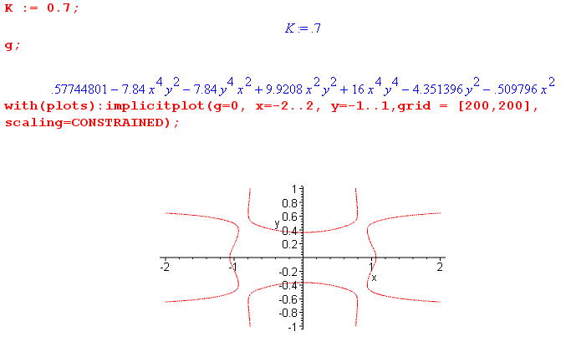

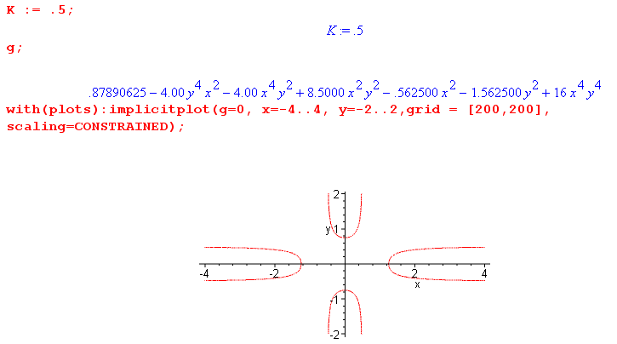

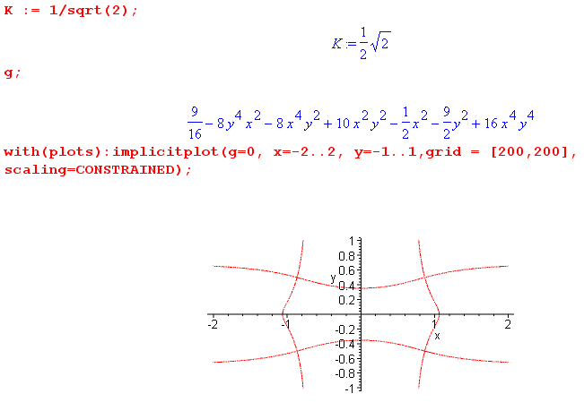

There are some contours, but I don't know what they mean! Maybe they are all just bogus due to my squaring of things. Back to that in a moment. Notice that in all cases, for a given value of y, there are (at least) two solution values of x which have opposite sign.

___________________________

If I have done everything without errors, this last line g = 0 is our desired Cartesian equation! As a test, if we set K = 1.1 we get

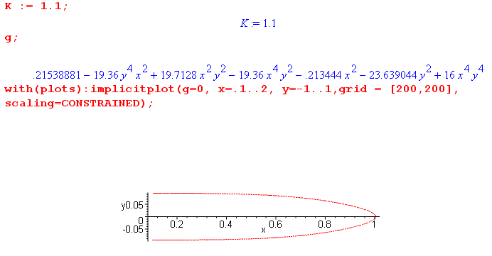

which we can visually compare with the same plot obtained at the start of this document

I think we are on the money finally!

******************************************

The Factor Question:

Now comes a big question: is it possible that this thing factors into the product of two factors, one of which describes an ellipse? In other words, can the above be written as

0 = (Ax2 + By2 - C)(second factor)

Maple does not factor it on command, but maybe it still factors. If it did, we would have a form like this,

0 = (Ax2 + By2 - C)(Dx2 + Ey2 + Fx4 + Gx2y4 + Hx4y2 ....)

Idea #1. Now in the Mystery section below, I find a "candidate ellipse" which is this:

x2 + [ (K2+1)2/(K2-1)2 ] y2 - (K2+1)2/(4K2) = 0

x2 + By2 - C = 0 A = 1 B = (K2+1)2/(K2-1)2 C = (K2+1)2/(4K2)

So the obvious thing to try is to make Maple divide the big mess by this factor. I try this, and it cannot do the divide, does not think it works. Maybe H have an error somewhere. Let's try manually and see if things are even close

(x2 + [ (K2+1)2/(K2-1)2 ]y2 - (K2+1)2/(4K2)) *

( 4K2(K2-1)2 - 4K2 (K2-1)2 - 16K2y4 - 16K2 [ (K2-1)2/(K2+1)2 ]x4

+ 16 x2y4 + c )

I cannot make it fly (but maybe I am not seeing the right way to do this factoring).
So it seems to me that it does NOT factor. So:

Idea #2: Suppose the expression for g does factor for arbitrary K. Then it certainly must factor for any specific factor of K I select. If we pick K = 2, for example, we get this for g

0 = (K4-1)2 + 16 x4y4 + 8(1+K4) x2y2 - 16 K2(x4y2 + y4x2) - 4K2(K2-1)2 x2 - 4K2(K2+1)2 y2

Maple cannot factor this thing. There is no numerical common divisor to make it simpler. Manually if I try to factor as ellipse * factor, it just does not work. I could of course have an algebra error and in fact it does factor.

For the moment, I will assume it does not factor.

This equation can only be called an "eighth degree curve", it is NOT an ellipse. We saw this above in our specific K = 1.1 case

