Potential of Extruded Strip, v2 PhL 10.13.09

See Overview below. I include a detailed contents here just to show the amount of flailing that this 30 page doc contains!! I even had a section showing that ellipses are not ellipses!

Overview ( most written earlier, header written 12.9.10, 6 pages) 1
Setting up to do the Integral 7
Analysis of Maple's "confusion" about doing this simple integral. 11
Comments on the dilog function 13
Conclusion about Maple's Problem with this integral. 14
Maxima 14
Sage 15
Continue with our 2D electrostatics problem. 15
Show that u is constant on the wire: 16
Next, how can I recover the surface charge density from this solution for u(x,y)? 17
Note added later: What about doing the normal derivative directly using 6.141 18
Next, what do we know about the tangential derivative? 18
Now what would happen if we just applied ∂_{x} to 6.146 for our problem? 18
Digression: is there some Stak boundary layer limit "extra term" situation here? 20
Does my limit here involve the "extra term" ? [ conclusion is: NO ] 22
Finally, here are some plots of the potential for this wire problem: 25
My Proof as to why the equipotentials are NOT ellipses. 27
Maybe my Logic has failed in the last section, try again. 28

____________________________________________________________________________________

Overview ( most written earlier, header written 12.9.10, 6 pages)

Please read the first three paragraphs of the v1 doc which set the framework for what we are doing here.
I am trying to do a simple integral in order to obtain the potential of a 2D wire, given that I know the charge density on the wire.
With this as introduction, I now copy my overview of this doc which is embedded in the Stak Chap 6 raw 2 notes, page 42. This overview ends with an overview of the overview!
The main point is that I am able to do the integral and thus I finally know the potential of the 2D wire, which can be written this way

u(ax,ay) = – (1/2π)ln(2) – (1/4π) [ ln( z + $\sqrt{z2-1}$) ] + c.c. ] z = x + iy

It occurs to me right now that this is likely related to a conformal map which maps a unit circle of constant potential into the 2D wire at constant potential: the circle is just crushed but maintains its two halves in the wire limit. Well, see ellipse.doc elsewhere.
If we define x' = ax and y' = ay, we find that

ln( z + $\sqrt{z2-1}$) = ln(1/a) + ln( z' + $\sqrt{z'2-a2}$) z' = x' + iy'

Thus, we can write the above as

u(x', y') = – (1/2π)ln(2) – (1/4π) [ { ln(1/a) + ln( z' + $\sqrt{z'2-a2}$) } + c.c. ]
= – (1/2π)ln(2) – (1/2π) ln(1/a) – (1/4π) [ ln( z' + $\sqrt{z'2-a2}$) + c.c ]
= – (1/2π)ln(2/a) – (1/4π) [ ln( z' + $\sqrt{z'2-a2}$) + c.c ]

So then here is the potential in the general case that the wire is 2a long:

u(x, y) = – (1/2π)ln(2/a) – (1/4π) [ ln( z + $\sqrt{z2-a2}$) + c.c ] z = x + iy

and you see that a replaces 1 in two places on the RHS.

Summary of external notes. "potential of extruded strip v2.doc"

(1) What is the potential? I started afresh, this time maintaining the (-1,1) endpoints instead of breaking in two. I did separate the log of the quadratic into two pieces (as before) and made more progress:

u(ax,ay) = – (1/2π)ln(2) -(1/4π2) $^{\int_{-1}^{1}{}}$dτ ln ( [x-τ]2 + y2 ) / $\sqrt{1- τ2}$
J1
J1 ≡ $^{\int_{-1}^{1}{}}$dτ ln ( [x-τ]2 + y2 ) / $\sqrt{1- τ2}$
= $^{\int_{-1}^{1}{}}$dτ ln ( [x-τ] + iy ) / $\sqrt{1- τ2}$ + $^{\int_{-1}^{1}{}}$dτ ln ( [x-τ] - iy ) / $\sqrt{1- τ2}$
J2 c.c.

J2 ≡ $^{\int_{-1}^{1}{}}$dτ ln ( [x-τ] + iy ) / $\sqrt{1- τ2}$ = $^{\int_{-π/2}^{π/2}{}}$dθ ln(z - sinθ) z = x+iy τ = sinθ

where suddenly I have J2 as a simple integral involving a complex variable z. This was a first.

At this point, I wandered down another wrong path and wrote this as

J2 = π ln (z) - $^{\int_{-π/2}^{π/2}{}}$dθ ln (1 - sinθ/z)

Here I expanded the log in its usual power series and got this result (z = reiφ)

J1 = J2 + c.c. = π ln |z|2 + Σn=2,4.. (2n/n) B[(n+1)/2, (n+1)/2] (z-n + -n)
= 2π ln(r) + 2 Σn=2,4.. (2n/n) B[(n+1)/2, (n+1)/2] r-ncos(nφ)

which then resulted in a final result

u(x,y) = – (1/2π) ln(2r/a) - (1/2π2) Σn=2,4.. (2n/n) B[(n+1)/2, (n+1)/2] (r/a)-ncos(nφ)

which has the known correct large r limit, and is of course a power series in (1/r) so this is a fine large-r expansion for the solution. I was pretty happy to get this result, since all previous efforts were going nowhere fast. I think this solution only converges for r > a, so not useful "close in" where I want to study things. I tried to compute the convergence radius looking at the Stirling large-n limit of the Beta function.

I then just noticed that there was a better way to write J2 which was this

J2(z) = $^{\int_{-π/2}^{π/2}{}}$dθ ln(z - sinθ) = $^{\int_{0}^{π}{}}$dθ ln(z + cosθ)

u(ax,ay) = – (1/2π)ln(2) -(1/4π2) [J2(z) + c.c ] = the potential

I was then able to do this last integral in two ways:

Way 1: Differentiate with respect to parameter z to remove that unpleasant log,

∂z J2(z) = $^{\int_{0}^{π}{}}$dθ / (z + cosθ ) = π/(z2-1)1/2 // GR p 383 top would apply with n = 0

Then integrate this to get

J2(z) = $^{\int_{}^{z}{}}$dz π/(z2-1)1/2 = π ln(z + $\sqrt{z2-1}$) + K

Then by looking at the large z limit, I concluded that K = K = π ln(1/2) and then sol is

J2(z) = π ln[ z + $\sqrt{z2-1}$]/2

Way 2: I then found my ln(z + cosθ) sitting in GR p 527 # 9 (previously circled!!!) with a = z and b = 1

J2(z) = $^{\int_{0}^{π}{}}$dθ ln(z + cosθ) = π ln[ ( z + $\sqrt{z2-1}$)/2 ] // restrictions z ≥ 1 ≥ 0

I then became more confident of this result, and then the solution to the problem of the potential of the 2D wire of length 2a centered at the origin and aligned along the x axis was this:

u(ax,ay) = { – (1/4π)ln(2) - (1/4π) ln( z + $\sqrt{z2-1}$) } + c.c. z = x + iy

So finally I had a "candidate" solution that can be written in closed form on one line, involving a simple elementary function.
Before arriving at this point, I gave Maple a shot at my ln(z + cosθ) integral and it kept reporting out a huge mess that was about 16 terms long involving messy logs and dilogs! This was a huge distraction. I located "rules for dilogs" and could see how the messy Maple result might equal my simple result. I concluded that Maple did this integral in some strange way and then found itself faced with a host of maybe 6 branch decisions, when the original integral is pretty much "branch free", a fact I also showed. I then downloaded the freeware Maxima, but it could not do this integral at all (though it does ask about a list of branch decisions)! The Wolfram online integrator won't do definite integrals. Sage was too big.
There is a lesson to be learned here: you cannot trust computer integrators to find the solution you are looking for. Sometimes it is MUCH better to use paper, pencil, and GR. The trick here, as the notes above show, is that you have to cast your integral into some form that GR uses.

(2) At this point, having a viable solution for the potential, I evaluated it on the wire itself to see if it really was constant on the wire. This is a very easy calculation:

u (on wire) = – (1/4π)ln(2) -(1/4π) ln[ ( x + i $\sqrt{1-x2}$) ] + c.c

= – 2(1/4π)ln(2) -(1/4π) ln [ x2 + (1-x2) ] = – (1/2π)ln(2)

At this point I send an email to Jim on this subject, asking what he thought of the weird Maple results.

(3) Next, I took the closed-form solution for u(x,y) and computed ∂yu(x,y), the "normal derivative". The result I obtained was -∂yu(x,y) |y=0 = (1/2) [ 1/π$\sqrt{1-x2}$]. I interpret this as the charge density on the top or bottom of the wire, and you add these together to get the total I(x), though I did not separately compute the top and bottom results carefully.

(4) Next, I took the solution for u(x,y) and computed ∂xu(x,y), the "tangential derivative". Since this is the tangent E field, it had better be 0 since this is an electrostatics problem. As I took the limit y→0 I got ∂xu(z)|y=0 = -(1/2π2) $^{\int_{-1}^{1}{}}$dξ (x-ξ)-1/$\sqrt{1-ξ2}$ and I was "concerned" that this integral goes right through a pole. I then went off on a long "digression" (so marked in notes). I was concerned that this limit y→0 might have an "extra term" as in Stak's long boundary layer discussion. I expressed this integral in terms of a cos(θ)/r form, but then paused on that. I then tried to do the integral as a half pole residue plus a principle part, but made a huge error (see read WRONG). Then I returned to the "is there an extra term" discussion related to the above integral limit. This forced me to review the entire "extra term" discussion in 2D and I concluded that, just as Stak said, there is NO extra term issue with this tangential derivative. I then corrected my half-pole integration attempt and got no useful result. This is where it says "end of Digression".
So I then returned to this integral with the pole. I realized that I knew how to do this integral already from previous work ( GR p 383) and realized that you have to think again of the surface charge as being half on top and half on bottom. I then found that ∂xu(z)|y=0 has two contributions, one from the upper charge and one from the lower charge:

-∂xu(z)|y=0 = (1/2) (1/2π2) $^{\int_{-1}^{1}{}}$dξ (x+iε-ξ)-1/$\sqrt{1-ξ2}$ = +i (1/2) π/$\sqrt{x2-1}$ // from upper charge
-∂xu(z)|y=0 = (1/2) (1/2π2) $^{\int_{-1}^{1}{}}$dξ (x-iε-ξ)-1/$\sqrt{1-ξ2}$ = -i (1/2) π/$\sqrt{x2-1}$ // from lower charge

When you add these together you get the total tangential "force on a test charge" which is 0. This then agreed with my earlier evaluation from the closed form potential, and with the idea that things are "static".

(5) Finally, here are some plots of the potential for this wire problem:

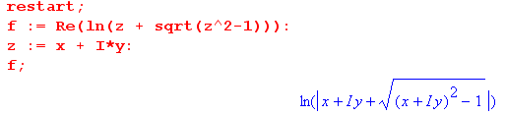

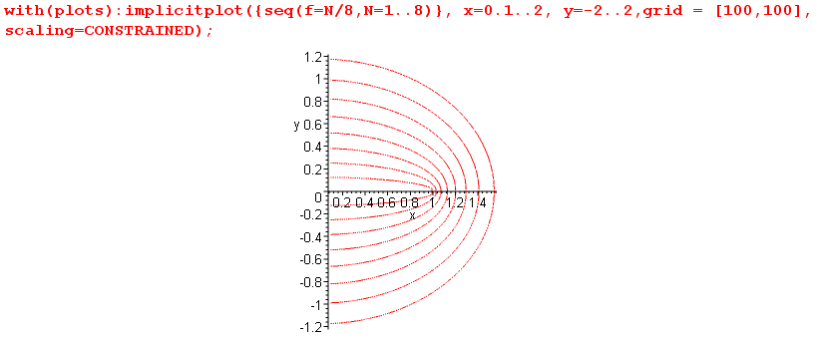

The plotter has trouble near x=-0 so I started at x = 0.1. This plot is of course just what you would expect. The contours approach circles fairly quickly. At this point in time, I suspected the curves were ellipses, but I did not know that and it was a question I used to motivate detailed analysis.

Summary of the above v2 doc summary

All these results go beyond what Stakgold has stated in his section on the 2D wire.

• The potential for the 2D wire can be written as an integral in this manner:

u(ax,ay) = – (1/2π)ln(2) -(1/4π2) $^{\int_{-1}^{1}{}}$dτ ln ( [x-τ]2 + y2 ) / $\sqrt{1- τ2}$

= – (1/2π)ln(2) -(1/4π2) [ J2(z) + c.c ]

which is just 6.141 where we have inserted our known surface charge I(τ) and written out the fundamental solution E. The integral J2 can be written several different ways, and I eventually "did the integral".

J2 ≡ $^{\int_{-1}^{1}{}}$dτ ln ( [x-τ] + iy ) / $\sqrt{1- τ2}$ = $^{\int_{-π/2}^{π/2}{}}$dθ ln(z - sinθ)

= π ln (z) - $^{\int_{-π/2}^{π/2}{}}$dθ ln (1 - sinθ/z) = $^{\int_{0}^{π}{}}$dθ ln(z + cosθ) = π ln[ z + $\sqrt{z2-1}$]/2

Therefore, the potential of the 2D wire is given by

u(ax,ay) = – (1/2π)ln(2) -(1/4π) [ ln( z + $\sqrt{z2-1}$) ] + c.c. ] z = x + iy

• If you evaluate this potential directly on the wire itself, you find that the z-dependent [...] above is zero for any x on the wire, because

ln( z + $\sqrt{z2-1}$) ] + c.c. = ln [( x + i$\sqrt{1-x2}$)( x - i$\sqrt{1-x2}$)] = ln [ x2 + (1-x2)] = ln (1) = 0

Another way to say this is that ln [( x + i$\sqrt{1-x2}$)] is purely imaginary, being equal to i cos-1(x). Thus, we verify the important fact that u = constant on our metal wire.

• If you compute the normal derivative of the potential directly from the closed form solution, you find
that -∂yu(x,y) |y=0 = (1/2) [ 1/π$\sqrt{1-x2}$] = (1/2) I(x) which is the charge on either the upper or lower surface, and you have to add these to get the total charge.

• If you compute this same normal derivative from the general formula p 174 D1 which applies both above and below the wire, you get this same result exactly. The integral part of D1 is 0 because the ∂y brings out a factor of 2y. In other words, the total result is the "extra term" (1/2) I(x). Recall that when a surface is flat, this is what happens (ie, there is no residual integral).

• If you compute the tangential derivative directly from the closed form solution, you find that

∂xu(x,y) = -(1/4π)/ $\sqrt{z2-1}$ + cc

which vanishes on the wire since $\sqrt{z2-1}$ is pure imaginary. This is what we expect, since it says that the total tangential force on a static test charge should be 0, otherwise we would not be "static".

• If you compute the tangential derivative from the general formula 6.141, we get this result:

∂xu(z)|y=0 = -(1/2π2) $^{\int_{-1}^{1}{}}$dξ (x-ξ)-1/$\sqrt{1-ξ2}$

and there is no "extra term" in this situation, though the integral goes right through a pole. But this is an integral I already encountered with playing with J2, namely

$^{\int_{-1}^{1}{}}$dξ (x-ξ)-1/$\sqrt{1-ξ2}$ = ∂z J2(z) = $^{\int_{0}^{π}{}}$dθ / (z + cosθ ) = π/$\sqrt{z2-1}$ GR p 383

which we can write this way:

∂xu(z)|y=0± = -(1/2π2) $^{\int_{-1}^{1}{}}$dξ (x±iε-ξ)-1/$\sqrt{1-ξ2}$ = ± iπ /$\sqrt{1-x2}$

I interpret this as saying that the tangential force on a test charge has two components which we must add together to get the total force. The + sign gives us the force on our test charge from the charge on the upper surface, while the - sign gives the force from the lower surface. But these forces are imaginary and cancel, giving a net result of zero force on a test charge.
____________________________________________________________________________________

Setting up to do the Integral

I think this is the solution to the problem in integral form, wire is length 2a centered at origin:

u(ax,ay) = – (1/2π)ln(2) -(1/4π2) $^{\int_{-1}^{1}{}}$dτ ln ( [x-τ]2 + y2 ) / $\sqrt{1- τ2}$

The problem is doing the integral. Let the integral be

J1 = $^{\int_{-1}^{1}{}}$dτ ln ( [x-τ]2 + y2 ) / $\sqrt{1- τ2}$

= $^{\int_{-1}^{1}{}}$dτ ln ( [x-τ] + iy ) / $\sqrt{1- τ2}$ + $^{\int_{-1}^{1}{}}$dτ ln ( [x-τ] - iy ) / $\sqrt{1- τ2}$

= $^{\int_{-1}^{1}{}}$dτ ln ( [x-τ] + iy ) / $\sqrt{1- τ2}$ + c.c. = J2 + J2cc

Let's try setting τ = sinθ so dτ = cosθdθ and $\sqrt{1- τ2}$ = cosθ so our integral is

J2 = $^{\int_{-π/2}^{π/2}{}}$dθ ln(z - sinθ) = $^{\int_{-π/2}^{π/2}{}}$dθ ln(z - zsinθ/z)

= $^{\int_{-π/2}^{π/2}{}}$dθ ln {(z)(1 - sinθ/z)} = $^{\int_{-π/2}^{π/2}{}}$dθ ln (z) - $^{\int_{-π/2}^{π/2}{}}$dθ ln (1 - sinθ/z)

= π ln (z) - $^{\int_{-π/2}^{π/2}{}}$dθ ln (1 - sinθ/z)

Now use Stak p 103 to say ie, ln(1+x) = x - x2/2 + x3/3...
ln(1-x) = -x - x2/2 - x3/3..
- ln (1 - sinθ/z) = Σn=1∞ (sinθ/z)n/n

which converges only if |sinθ/r| ≤ 1 which really means you need (r/a) ≥ |sinθ| when we get done. This will need some interpretation later. Assuming convergence, we have

J2 = π ln (z) + Σn=1∞(z-n/n) $^{\int_{-π/2}^{π/2}{}}$dθ (sinθ)n

If n is odd, the integral is 0 because then the integrand is odd. If n is even, get same from both halves of the integral. Thus,

J2 = π ln (z) + Σn=2,4..∞(z-n/n) 2 $^{\int_{0}^{π/2}{}}$dθ (sinθ)n μ-1 = n GR p 369

= π ln (z) + Σn=2,4..∞(z-n/n) 2 * 2n-1 B[(n+1)/2, (n+1)/2]

= π ln (z) + Σn=2,4..∞ (z-n/n) 2n B[(n+1)/2, (n+1)/2]

This is not too bad, good for large z too. Now we add the CC to get our full answer:

J1 = π ln (z) + Σn=2,4..∞ (z-n/n) 2n B[(n+1)/2, (n+1)/2]
+ π ln () + Σn=2,4..∞ (-n/n) 2n B[(n+1)/2, (n+1)/2]

= π ln |z|2 + Σn=2,4.. (2n/n) B[(n+1)/2, (n+1)/2] (z-n + -n)

Now write z = reiφ and we have

J1 = 2π ln(r) + Σn=2,4.. (2n/n) B[(n+1)/2, (n+1)/2] r-n (e-inφ + einφ)

= 2π ln(r) + 2 Σn=2,4.. (2n/n) B[(n+1)/2, (n+1)/2] r-ncos(nφ)

So our final answer should then be

u(ax,ay) = – (1/2π)ln(2) -(1/4π2)J1

= – (1/2π)ln(2) -(1/4π2) 2π ln(r) -(1/4π2) 2 Σn=2,4.. (2n/n) B[(n+1)/2, (n+1)/2] r-ncos(nφ)

= – (1/2π)ln(2) -(1/2π) ln(r) -(1/2π2) Σn=2,4.. (2n/n) B[(n+1)/2, (n+1)/2] r-ncos(nφ)

= – (1/2π) ln(2r) - (1/2π2) Σn=2,4.. (2n/n) B[(n+1)/2, (n+1)/2] r-ncos(nφ)

This is a result I can live with! So final result is then:

u(x,y) = – (1/2π) ln(2r/a) - (1/2π2) Σn=2,4.. (2n/n) B[(n+1)/2, (n+1)/2] (r/a)-ncos(nφ)

which has the correct large r limit.

Aside: The large argument B function is this

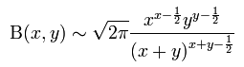

so we get B(x,x) ~ $\sqrt{2π}$ x2x-1 / (2x)2x-1/2 = $\sqrt{2π}$ x-1/2 21/2-2x so set x = n/2 and get

B[(n+1)/2, (n+1)/2] ~ B[n/2, n/2] ~ $\sqrt{2π}$ (n/2)-1/2 21/2-n ~ 2-n n-1/2

Then (2n/n) B[(n+1)/2, (n+1)/2] ~ n-3/2

We then wonder about convergence of the sense. The tail is looking like this

Σn=tail n-3/2(r/a)-ncos(nφ)

Certainly when r > a it converges. But it has distributional behavior of a < r.

What happens when we set φ = 0 ? Then get

u(r,φ=0) = – (1/2π) ln(2r/a) - (1/2π2) Σn=2,4.. (2n/n) B[(n+1)/2, (n+1)/2] (r/a)-n

Let's go back to

u(x,y) = – (1/2π) ln(2r/a) - (1/2π2) Σn=2,4.. (2n/n) B[(n+1)/2, (n+1)/2] (r/a)-ncos(nφ)

and set n = 2m so we have

u(x,y) = – (1/2π) ln(2r/a) - (1/2π2) Σm=1∞ (22m/(2m)) B[(2m+1)/2, (2m+1)/2] (r/a)-2mcos(2mφ)

and now go to φ = 0

u(r,φ=0) = – (1/2π) ln(2r/a) - (1/2π2) Σm=1∞ (22m/(2m)) B[(2m+1)/2, (2m+1)/2] (r/a)-2m

For r = a, this seems to converge more or less to something like 2.11 . This would be right at the tip of the wire. But what if we have r = a/2 so that (r/a)-2m = 22m . Then it certainly seems to diverge, says Maple.
So I wonder how one would make practical use of this thing? Once again:

u(r,φ) = – (1/2π) ln(2r/a) - (1/2π2) Σn=2,4.. (2n/n) B[(n+1)/2, (n+1)/2] (r/a)-ncos(nφ)

One passing notion:

J2(z) = $^{\int_{-π/2}^{π/2}{}}$dθ ln(z - sinθ)

∂z J2(z) = $^{\int_{-π/2}^{π/2}{}}$dθ /(z - sinθ)

Let θ' = θ + π/2 and then sin(θ) = sin(θ'-π/2) = - sin(π/2-θ') = -cos(θ') so get

∂z J2(z) = $^{\int_{0}^{π}{}}$dθ / (z + cosθ ) J2(z) = $^{\int_{0}^{π}{}}$dθ ln(z + cosθ)

You wonder if GR p 383 top would apply with n = 0. If so we have

$^{\int_{0}^{π}{}}$ dθ / (z + cosθ ) = π/(z2-1)1/2 = a = z b = 1

which Maple seems to verify [ csgn is a +1 or -1 ]

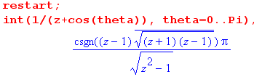

Then the claim would be that

J2(z) = $^{\int_{0}^{π}{}}$dθ ln(z + cosθ) = $^{\int_{}^{z}{}}$dz π/(z2-1)1/2
= π $^{\int_{}^{z}{}}$dz / (z2-1)1/2 = π ln(z + $\sqrt{z2-1}$) + K

which would be pretty amazing if true. How might we evaluate the constant. Let's try this:

K = $^{\int_{0}^{π}{}}$dθ ln(1 + cosθ) =

Then our full answer would just be

J1 = π ln(z + $\sqrt{z2-1}$) + π ln( + ) + constant z = x + iy a = 1

No series, no nothin', this would just be it! Maybe continue on this tomorrow.

Weds Oct 14, 2009

Let's once again back up to this point:

J2(z) = $^{\int_{-π/2}^{π/2}{}}$dθ ln(z - sinθ) = $^{\int_{0}^{π}{}}$dθ ln(z + cosθ)

This integral appears GR p 527 number 9 (previously circled!!!) where a = z and b = 1 so we get

= π ln[ ( z + $\sqrt{z2-1}$)/2 ] for a ≥ |b| > 0 from the SW source (meaning z ≥ 1 ≥ 0

I have shown above how you might actually do this integral to get

J2(z) = $^{\int_{0}^{π}{}}$dθ ln(z + cosθ) = $^{\int_{}^{z}{}}$dz π/(z2-1)1/2
= π $^{\int_{}^{z}{}}$dz / (z2-1)1/2 = π ln(z + $\sqrt{z2-1}$) + K

In the limit of very large z we get J2 = π ln(z) on the LHS and we get π ln(2z) + K on the RHS, so we would conclude that πln(2) + K = 0 so K = π ln(1/2) and then sol is π ln[ z + $\sqrt{z2-1}$]/2 exactly as GR state. So once I actually know HOW to do an integral.

Analysis of Maple's "confusion" about doing this simple integral.

Now why is it that, when I ask Maple to do this integral, $^{\int_{0}^{π}{}}$dθ ln(z + cosθ), I get a huge mess? I need to get a better handle on this. Maple says

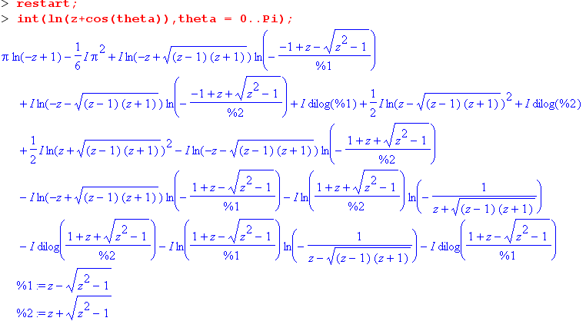

where dilog(x) = int(ln(t)/(1-t), t=1..x) = $^{\int_{1}^{x}{}}$ln(t)/(1-t). Again, consider:

J2(z) = $^{\int_{0}^{π}{}}$dθ ln(z + cosθ)

If I pick some complex z, the region of integration of the log argument is the dotted line in this picture, right to left,

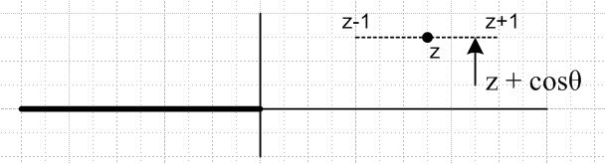

and there is really no interaction with the log branch cut. The result should be completely unambiguous if we say that z is on the principle sheet of ln(z). Also, if z is real and z > 1, the integration is adding up a bunch of real numbers so it should be real. But consider this:

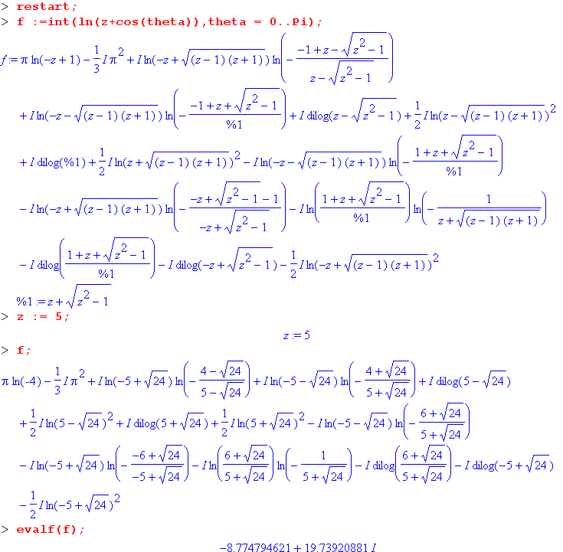

We let Maple do the integral symbolically, we then set z = 5, and the result comes out being complex!
Now I think Maple is really screwing up badly. Can I force it to do numerical integration? The Rule:

"In the case of a definite integral which returns unevaluated, numerical integration may be invoked by applying evalf to the unevaluated integral. To invoke numerical integration without first invoking symbolic integration, use the inert function Int as in: evalf( Int(f, x=a..b) )"

So consider:

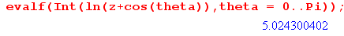

and this is the same as my GR answer:

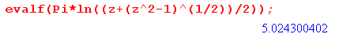

Before stating my conclusions on this mystery, let's look a little at Maple and the dilog function:

Comments on the dilog function

Now AS page 1004 show the dilog function under the name dilog(x) = f(x). They also show certain properties of the function which would simplify the above mess if only Maple know about them. The properties have restricted arguments, but we always "continue" and I don't think that is the issue. Places comment that dilog(z) = polylog(2,z).
Maple does know about the dilog(z) rules, as seen here:

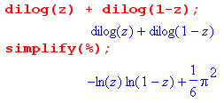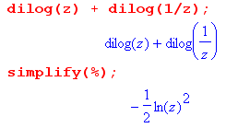

Notice that it uses these rules without needing restrictions on z. So if it knows these rules, why does it not USE the rules to simplify the expression above, which I can simplify by hand and all the dilogs go away.
Now I was able to get Maple to remove the dilogs by this explicit command:

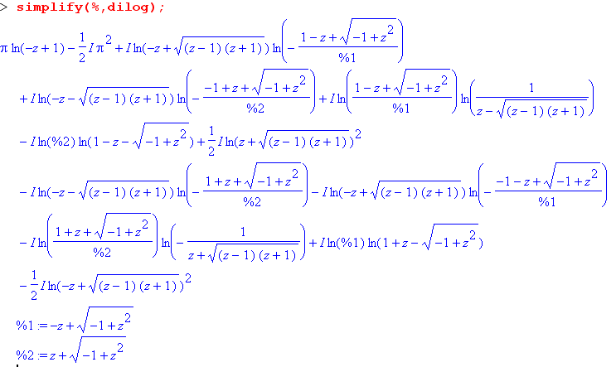

where the simplify argument tells it "what to work on, especially", I guess.
Now why is it still such a mess? I assume it is "branch issues". For example, consider the last item above, it is unclear which sign of the square root, and of course that is true everywhere.
One problem is this: although the original integral has no branch issues, the Maple result for the integral has terms which do seem to have branch issues!

Question: when does Maple to symbolic integration, and when numeric?

"In the case of a definite integral which returns unevaluated, numerical integration may be invoked by applying evalf to the unevaluated integral. To invoke numerical integration without first invoking symbolic integration, use the inert function Int as in: evalf( Int(f, x=a..b) )"

Conclusion about Maple's Problem with this integral.

The actual integral is unambiguous and for real z > 1 is a well-defined real number. When Maple does this integral using its internal methods, it gets a sum of functions many of which have branch cut ambiguities. When you then enter some number for z, it makes assumptions which are not correct.

Maxima

I just downloaded maxima 5.10.b and will see what it has to say about this integral. Wolfram provides a free indefinite integrator on its site, but it does not do definite integrals! Maxima is supposed to be a freeware thing that is "mature", we shall see. It is 15.5 megs. But it can't do this integral at all! GR is smarter than all of them. Maxima asks you about signs of things for each branch decision and has a strange GUI.

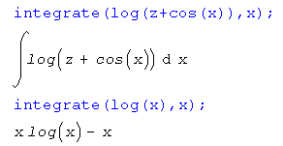

Sage

This is another free system but requires VmWare to be on your windows system. That thing is 50 MB, so I am downloading it now, 2.5.3 VMware Player. But Sage is 800 MB!! This is not for me. This is an academic bloatware baby. I downloaded the VMware but did not install it.

Continue with our 2D electrostatics problem.

Let's once again back up to this point:

J2(z) = $^{\int_{-π/2}^{π/2}{}}$dθ ln(z - sinθ) = $^{\int_{0}^{π}{}}$dθ ln(z + cosθ)

This integral appears GR p 527 number 9 (previously circled!!!) where a = z and b = 1 so we get

= π ln[ ( z + $\sqrt{z2-1}$)/2 ] for a ≥ |b| > 0 from the SW source (meaning z ≥ 1 ≥ 0

I am now confident that this integral is correct. So here is where we sit now:

u(ax,ay) = – (1/2π)ln(2) -(1/4π2) $^{\int_{-1}^{1}{}}$dτ ln ( [x-τ]2 + y2 ) / $\sqrt{1- τ2}$

J1 = $^{\int_{-1}^{1}{}}$dτ ln ( [x-τ]2 + y2 ) / $\sqrt{1- τ2}$

= $^{\int_{-1}^{1}{}}$dτ ln ( [x-τ] + iy ) / $\sqrt{1- τ2}$ + c.c.

= J2 + c.c.

J2(z) = $^{\int_{-π/2}^{π/2}{}}$dθ ln(z - sinθ) = $^{\int_{0}^{π}{}}$dθ ln(z + cosθ) = π ln[ z + $\sqrt{z2-1}$]/2

So the solution to my problem is this:

u(ax,ay) = – (1/2π)ln(2) -(1/4π2) J1

= – (1/2π)ln(2) -(1/4π2) [J2 + c.c.]

= – (1/2π)ln(2) -(1/4π2) [π ln[ ( z + $\sqrt{z2-1}$)/2 ] + c.c.]

= – (1/2π)ln(2) -(1/4π) ln[ ( z + $\sqrt{z2-1}$)/2 ] + c.c.

= – (1/2π)ln(2) -(1/4π) ln[ ( z + $\sqrt{z2-1}$) ] + (1/4π) ln(2) + c.c.

= – (1/4π)ln(2) -(1/4π) ln[ ( z + $\sqrt{z2-1}$) ] + c.c.

So one more time

u(ax,ay) = – (1/4π)ln(2) -(1/4π) ln[ ( z + $\sqrt{z2-1}$) ] + c.c. z = x + iy

Show that u is constant on the wire:

It would seem you just multiply by 2 and get

u(ax,0) = – (1/2π)ln(2) -(1/2π) ln[ ( x + $\sqrt{x2-1}$) ]

Let's now assume a = 1 to avoid constant confusion, so we have

u(x,0) = – (1/2π)ln(2) -(1/2π) ln[ ( x + $\sqrt{x2-1}$) ]

At x = +1 we get ln(1) = 0. So as you approach this right tip from the right, potential gradually approaches u = – (1/2π)ln(2). But to get to other points on the wire, I think we need to be careful about how we approach! So maybe go back to the general expression and write z = 1 + reiφ so we are going to pivot around the tip. Then we have

z2 -1 = (z-1)(z+1) = reiφ ( 2 + reiφ) z = 1 + reiφ

So land on the wire top or bottom, we will set φ = ±π and in either case we have

z2 -1 = (z-1)(z+1) = - r( 2 - r)) z = 1 - r

where r is the distance out to the z=1 tip. So we then get (assuming r < 2)

u(ax,ay) = – (1/4π)ln(2) -(1/4π) ln[ ( z + $\sqrt{z2-1}$) ] + c.c.

= – (1/4π)ln(2) -(1/4π) ln[ (1-r) + i $\sqrt{r(2-r)}$] + c.c

= – 2 (1/4π)ln(2) -(1/4π) ln{[ (1-r) + i $\sqrt{r(2-r)}$] [ (1-r) + i $\sqrt{r(2-r)}$]}

= – 2 (1/4π)ln(2) -(1/4π) ln{[ (1-r)2 + r(2-r)] }

= – 2 (1/4π)ln(2) -(1/4π) ln{[1] } = – (1/2π)ln(2)

which I like a lot. This is the same thing we got at the tip at z = 1. So the potential really is a constant on our entire wire!
I could have gotten this same result I suppose just using $\sqrt{x2-1}$ = i $\sqrt{1-x2}$then have

– (1/4π)ln(2) -(1/4π) ln[ ( x + i $\sqrt{1-x2}$) ] + c.c

= – 2(1/4π)ln(2) -(1/4π) ln [ x2 + (1-x2) ] = – (1/2π)ln(2)

So I am starting now to believe this answer. I don't recall Stakgold ever claiming that his c0 was the constant value of u in the wire, but that seems here to be the case.

Next, how can I recover the surface charge density from this solution for u(x,y)?

Go back to

u(x,y) = – (1/4π)ln(2) - (1/4π) ln[ ( z + $\sqrt{z2-1}$) ] + c.c. z = x + iy

Now we want this

I(x) = -∂yu(x,y) |y=0 where |x| < 1

∂yu(x,y) = -(1/4π) ( z + $\sqrt{z2-1}$)-1 * ( i + 1/2(z2-1)-1/22z (i) ) + cc

= -(1/4π) ( z + $\sqrt{z2-1}$)-1 * i ( 1 + (z2-1)-1/2z ) + cc

= -(1/4π) ( x + $\sqrt{x2-1}$)-1 * i ( 1 + (x2-1)-1/2x ) + cc

= -(1/4π) ( x + $\sqrt{x2-1}$)-1 * i ($\sqrt{x2-1}$ + x )/ $\sqrt{x2-1}$ + cc

= -(1/4π) * i /$\sqrt{x2-1}$ + cc

Now if we are at |x| > 1, this thing is 0! This reminds me again of Jackson's study of the disk problem in 3D where he had Neumann in the disk's plane. So here we have ∂nu = 0 along the line of the wire outside the wire. But we have u = constant on the wire itself, so you could treat our wire problem as a mixed BC problem.
Now look on the wire. Then we have $\sqrt{x2-1}$ = +i $\sqrt{1-x2}$to always be consistent. So

∂yu(x,y) = -(1/4π) * i /$\sqrt{x2-1}$ + cc = -(1/4π) / $\sqrt{1-x2}$ + cc

= - (1/2π) /$\sqrt{1-x2}$

and then

I(x) = -∂yu(x,y) |y=0 = (1/2π) 1/$\sqrt{1-x2}$

Now why is this (1/2) of the total expected answer 6.153 ? I have computed the charge on the upper side of the wire! If we were in 3D thinking about a flat disk (Jackson), this would be like talking about the surface charge on one side of the disk. So in our current problem, we imagine half the charge on the top of the wire, and half on the bottom. I really think this is correct, I was wondering how this was going to come out.

Note added later: What about doing the normal derivative directly using 6.141

In this situation we get the "extra term" as shown on page 174 D1,2 . The integral appearing in these equations will be our familiar one (ignore constant multiplier)

∂y$^{\int_{-1}^{1}{}}$dτ ln ( [x-τ]2 + y2 ) / $\sqrt{1- τ2}$ = 2y $^{\int_{-1}^{1}{}}$dτ ( [x-τ]2 + y2 )-1 / $\sqrt{1- τ2}$

and as we take y→0, this integral vanishes due to the y sitting out front. As we approach our wire either from above or below, we are always approaching "from the outside of the boundary" in my finite size wire way of thinking, which goes with the s+ notation in D1, and then D1 tells us

-∂yu(x,y) |y=0 = +(1/2) I(x)

so we get half the charge on each "side" of the wire, exactly as we found above.

Next, what do we know about the tangential derivative?

u(x,y) = – (1/4π)ln(2) - (1/4π) ln[ ( z + $\sqrt{z2-1}$) ] + c.c. z = x + iy

∂xu(x,y) = -(1/4π) ( z + $\sqrt{z2-1}$)-1 * ( 1 + 1/2(z2-1)-1/22z 1 ) + cc

= -(1/4π) ( z + $\sqrt{z2-1}$)-1 ($\sqrt{z2-1}$ + z) / $\sqrt{z2-1}$ + cc

= -(1/4π)/ $\sqrt{z2-1}$ + cc

For real z to the right, this is some real number. But for z on the wire, we get 0. We expect this because this is really -Ex, the electric field at the wire, and it should be 0 since surface charge is static!

Now what would happen if we just applied ∂x to 6.146 for our problem?

Since this is a tangential derivative, there is no "extra term" to worry about (stay away from ends), and we get [ Question: is this allowed? I have already taken the limit x+iy → x, and NOW I try to do ∂x ]

∂xu(x) = $^{\int_{-1}^{1}{}}$dξ ∂xE(x|ξ)I(ξ) = -(1/2π) $^{\int_{-1}^{1}{}}$dξ ∂xln |x-ξ| I(ξ)

= -(1/2π) { $^{\int_{-1}^{x}{}}$dξ ∂νln |x-ξ| I(ξ) + $^{\int_{x}^{1}{}}$dξ ∂νln |x-ξ| I(ξ) }

= -(1/2π) { $^{\int_{-1}^{x}{}}$dξ ∂νln (x-ξ) I(ξ) + $^{\int_{x}^{1}{}}$dξ ∂νln (ξ-x) I(ξ) }

= -(1/2π) { $^{\int_{-1}^{x}{}}$dξ (x-ξ)-1 I(ξ) + $^{\int_{x}^{1}{}}$dξ (ξ-x)-1 (-1) I(ξ) }

= -(1/2π) { $^{\int_{-1}^{x}{}}$dξ (x-ξ)-1 I(ξ) + $^{\int_{x}^{1}{}}$dξ (x-ξ)-1 I(ξ) }

= -(1/2π) $^{\int_{-1}^{1}{}}$dξ (x-ξ)-1 I(ξ)

=?= 0 // since there should be no tangential electric field at x.

BUT this looks fishy to me because we are integrating right through a pole. Let's try this a little more carefully. Let z = x+iy with some y>0,

∂xu(z) = $^{\int_{-1}^{1}{}}$dξ ∂xE(z|ξ)I(ξ) = -(1/2π) $^{\int_{-1}^{1}{}}$dξ ∂xln |z-ξ| I(ξ)

= -(1/4π) $^{\int_{-1}^{1}{}}$dξ ∂xln |z-ξ|2 I(ξ) = = -(1/4π) $^{\int_{-1}^{1}{}}$dξ ∂xln [ (x-ξ)2+y2] I(ξ)

= -(1/4π) $^{\int_{-1}^{1}{}}$dξ [ (x-ξ)2+y2]-1 2(x-ξ) I(ξ)

= -(1/2π) $^{\int_{-1}^{1}{}}$dξ [ (x-ξ)2+y2]-1 (x-ξ) I(ξ) $\sqrt{(x-ξ)2+y2}$

Now let's install the known charge density and just see what happens:

I(ξ) = (1/π) 1/$\sqrt{1-ξ2}$ so

∂xu(z) = -(1/2π2) $^{\int_{-1}^{1}{}}$dξ [ (x-ξ)2+y2]-1 (x-ξ) /$\sqrt{1-ξ2}$

Now we seem to have a zero where we previously had a pole! Suppose now we try to take y→0, then (assuming there is no "extra term") we get

∂xu(z)|y=0 = -(1/2π2) $^{\int_{-1}^{1}{}}$dξ [ (x-ξ)2]-1 (x-ξ) /$\sqrt{1-ξ2}$ = -(1/2π2) $^{\int_{-1}^{1}{}}$dξ (x-ξ)-1/$\sqrt{1-ξ2}$

and the pole is back.

******************************** Digression ******************************

I think everything below the above asterisk line is no longer relevant. [??]

Digression: is there some Stak boundary layer limit "extra term" situation here?

Hmm. This is probably exactly the kind of situation we read all about in that boundary layer section. I want to let y→ 0 and we approach the surface normally! Look at the bottom of page 121 for hints. Let's go back to the above:

= -(1/2π) $^{\int_{-1}^{1}{}}$dξ [ (x-ξ)2+y2]-1 (x-ξ) I(ξ)

= -$^{\int_{-1}^{1}{}}$dξ [ cos(z-ξ, x-ξ) /(2π$\sqrt{(x-ξ)2+y2}$)] I(ξ)

where here is a little picture showing why the cosθ appears

cos(θ) = (x-ξ)/ $\sqrt{(x-ξ)2+y2}$ = cos(z-ξ, x-ξ)

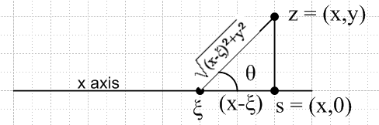

Now I am doing a tangential derivative, not a normal derivative. That is why we don't see the usual normal vector in the cosine. This is doing nothing about the pole!

Comment: I think this is a singular boundary layer situation that Stak did not talk about! He always said the tangentials were OK, maybe so. Note that (x-ξ) = (x+iε - ξ) => pole located at ξ = x+iε so go under it. So here is our integral situation, where I show the branch cuts from I(ξ). Suppose we try to do this integral by taking half the residue shown plus the principle part. I am supposed to know how to do this.

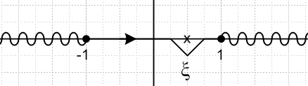

Let's take this as our integral

∂xu(x) = -(1/2π) $^{\int_{-1}^{1}{}}$dξ (x-ξ)-1 I(ξ)

The pole half-residue does this ( pole is written backwards, - (ξ-x) )

contrib = +(1/2π)2πi I(x) (1/2) = +(1/2π)πi I(x) // the half residue part

Now the principle part integral is what it is:

limε→0 -(1/2π) { $^{\int_{-1}^{x-ε}{}}$dξ (x-ξ)-1 I(ξ) + $^{\int_{x+ε}^{1}{}}$dξ (x-ξ)-1 I(ξ) }

Now if ε is very small, and since I(ξ) is smooth (ignoring the two endpoints), we can say

limε→0 -(1/2π) I(x){ $^{\int_{-1}^{x-ε}{}}$dξ (x-ξ)-1 + $^{\int_{x+ε}^{1}{}}$dξ (x-ξ)-1} WRONG!!!

= limε→0 -(1/2π) I(x){ - ln(x-ξ)|x-ε-1 - ln(x-ξ)|1x+ξ }

= limε→0 -(1/2π) I(x){ -ln(x-x+ε) + ln(x+1) - ln(x-1) + ln(x-x-ε) }

= limε→0 -(1/2π) I(x){ -ln(ε) + ln(x+1) - ln(x-1) + ln(-ε) }

= limε→0 -(1/2π) I(x){ ln(x+1) - ln(x-1) + ln(-ε/ε) }

= limε→0 -(1/2π) I(x){ ln(x+1) - ln(x-1) + ln(-1) }

= -(1/2π) I(x){ ln[(x+1)/(x-1)] +iπ}

So our integral has now become

∂xu(x) = -(1/2π) $^{\int_{-1}^{1}{}}$dξ (x-ξ)-1 I(ξ)

= +(1/2π)πi I(x) - (1/2π) I(x) iπ -(1/2π) I(x){ ln[(x+1)/(x-1)]

= -(1/2π) I(x){ ln[(x+1)/(x-1)]

= -(1/2π) { ln[(x+1)/(x-1)]/(π $\sqrt{1-x2}$)

But I am expecting this to be 0 ! At x = 0 however we get -(1/2π)(iπ)/π ≠ 0.

Does my limit here involve the "extra term" ? [ conclusion is: NO ]

If it does, it might explain my problem here. First, review how this arises in 3D. On page 114 F,G,J,I Stak shows that

limx3→0 ∂x3E = limx3→0 (-x3/4πr3) = - (1/2) δ(x1)δ(x2) x3/r = cos(θ) see below

You can see that if both x1 and x2 = 0, then in this limit r = 0 and things are blowing up, so not too strange really. Then he applies this result to the limit of a derivative in 6.37 in the simple layer situation and out pops that "extra term" which is half the layer evaluated at the touch point. This was done with a perfectly flat surface. If the surface is curved, you get the residual integral as well and then we have the form shown as 6.42. So the key thing is that sort of form (-x3/4πr3) you see above. We can express this in terms of an angle in this way
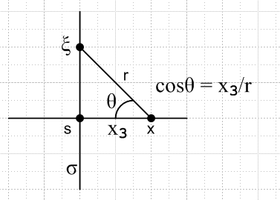
where the point x → s and cosθ → 0.

In 2D, things are very similar, as shown page 121 and in my raw notes. We still have this same angle situation, but we have instead of the above

limx3→0 ∂x3E = limx3→0 (-x3/2πr2) = - (1/2) δ(x1) x3/r = cos(θ) see below

where here r2 = x12 + x32 only. This leads to exactly the same "extra term" as shown p 121.

So, does my tangential derivative have this strange behavior? My situation looks superficially similar, here are some results from above,

∂xu(z) = $^{\int_{-1}^{1}{}}$dξ ∂xE(z|ξ)I(ξ) before the limit y→ 0

= -(1/2π2) $^{\int_{-1}^{1}{}}$dξ [ (x-ξ)2+y2]-1 (x-ξ) /$\sqrt{1-ξ2}$

= -$^{\int_{-1}^{1}{}}$dξ [ cos(z-ξ, x-ξ) /(2π$\sqrt{(x-ξ)2+y2}$)] I(ξ)

= -$^{\int_{-1}^{1}{}}$dξ cos(θ)/2πr I(ξ)

But my angle is different

Since I am doing a tangential derivative, it would be taking this limit in our 2D layer case

limx3→0 ∂x1E = limx3→0 (-x1/2πr2) = ??

If x1 = 0, then as x3→ 0, we get r→0 and it does seem that we might have a problem to worry about. We have to examine the little piece of surface right under the landing point, similar to p 114 G :

$^{\int_{-ε}^{ε}{}}$dx1 (- x1/ [ x12 + x32 ] ) = 0 since integrand is odd

In contrast, in the normal derivative case we have (Maple)

$^{\int_{-ε}^{ε}{}}$dx1 (- x3/ [ x12 + x32 ] ) = - 2 $^{\int_{0}^{ε}{}}$dx1 (x3/ [ x12 + x32 ] ) = - 2 tan-1(ε/x3)

which looks suspicious since we want to take both ε and x3 to 0. We can now mimic p 114G,H to say

$^{\int_{-∞}^{∞}{}}$dx1 (- x3/ [ x12 + x32 ] ) = - 2 $^{\int_{0}^{∞}{}}$dx1 (x3/ [ x12 + x32 ] ) = - 2 (π/2) = - π

But

lim x3→0 2 $^{\int_{b}^{∞}{}}$dx1 (- x3/ [ x12 + x32 ] ) = - lim x3→0 (π - 2tan-1 (b/x3)) = -(π-π) = 0

which lets us conclude that

lim x3→0 (-x3/ [ x12 + x32 ] ) = -π δ(x1)

lim x3→0 (-x3/ 2π[ x12 + x32 ] ) = - (1/2) δ(x1)

My conclusion: There is no extra term here for the tangential derivative! I have done my due diligence!

Back to the contour integral:

Let's take this as our integral

∂xu(x) = -(1/2π) $^{\int_{-1}^{1}{}}$dξ (x-ξ)-1 I(ξ)

The pole half-residue does this ( pole is written backwards, - (ξ-x), direction is normal CCW )

contrib = +(1/2π)2πi I(x) (1/2) = +(1/2π)πi I(x) // the half residue part

Now the principle part integral is what it is:

limε→0 -(1/2π) { $^{\int_{-1}^{x-ε}{}}$dξ (x-ξ)-1 I(ξ) + $^{\int_{x+ε}^{1}{}}$dξ (x-ξ)-1 I(ξ) }

We have to install I(ξ) = 1/[ π $\sqrt{1-ξ2}$] and the PP is then

limε→0 -(1/2π2) { $^{\int_{-1}^{x-ε}{}}$dξ (x-ξ)-1 / $\sqrt{1-ξ2}$ + $^{\int_{x+ε}^{1}{}}$dξ (x-ξ)-1/$\sqrt{1-ξ2}$ }

******************************** end of Digression ******************************

Resume analysis of ∂xu(z)|y=0 = -(1/2π2) $^{\int_{-1}^{1}{}}$dξ (x-ξ)-1/$\sqrt{1-ξ2}$ :

So here is our presumed result since there are no "extra term" problems:

∂xu(z)|y=0 = -(1/2π2) $^{\int_{-1}^{1}{}}$dξ (x-ξ)-1/$\sqrt{1-ξ2}$

But we recognize this from our discussion above: (middle integral of second line below)

J2(z) = $^{\int_{0}^{π}{}}$dθ ln(z + cosθ) = $^{\int_{-1}^{1}{}}$dτ ln (z-τ ) / $\sqrt{1- τ2}$ z = x + iy

∂z J2(z) = $^{\int_{0}^{π}{}}$dθ / (z + cosθ ) = $^{\int_{-1}^{1}{}}$dτ (z-τ)-1 / $\sqrt{1- τ2}$ = π/$\sqrt{z2-1}$ GR p 383

This is the integral for z > 1, for example. If you want to approach the wire from above or below, you will need to use $\sqrt{z2-1}$ = ±i $\sqrt{1-x2}$ . This is a reflection of the fact that the contour either goes over or under the pole. I think there is a subtlety here as follows.

Explanation: You need to think of half the charge I(x) being on the top of the wire and half being on the bottom. After all, this is the distribution we found when we looked at the normal derivative above. Stak's solution 6.153 of I(x) = π/$\sqrt{z2-1}$ is the sum of the two sides. If we consider the effect only of the charge on the top, we get this result (ie, we put z = x+iε in our tangential derivative

∂xu(z)|y=0 = -(1/2) (1/2π2) $^{\int_{-1}^{1}{}}$dξ (x+iε-ξ)-1/$\sqrt{1-ξ2}$ = +i (1/2) π/$\sqrt{x2-1}$ // from upper charge

The negative of this quantity would be the tangential force which would act on a test charge located at position (x,0). However, this test charge also feels the effect of the charge on the lower surface of the wire, which is going to be

∂xu(z)|y=0 = -(1/2) (1/2π2) $^{\int_{-1}^{1}{}}$dξ (x-iε-ξ)-1/$\sqrt{1-ξ2}$ = -i (1/2) π/$\sqrt{x2-1}$ // from lower charge

When we add these two together, we get the correct result which is 0 !

Finally, here are some plots of the potential for this wire problem:

The plotter has trouble near x=-0 so I started at x = 0.1. This plot is of course just what you would expect. The contours approach circles fairly quickly.

Question: How can you express the following equation without any square roots appearing:

(z + $\sqrt{z2-1}$)( + ) = a z = x + iy

The reason is that this would then be the locus of an equipotential for this problem. When I fiddle with this, I don't see how to get rid of the square roots, they keep appearing. Let w = $\sqrt{z2-1}$. You then have

(z+w) (+) = a

|z|2 + |w|2 + w + z = a |w|2 = |w2| = |z2-1| = still has a square root

We really need to get to

|w|4 = |z2-1|2 = (z2-1) (2-1) = |z|4 + 1 - (z2 + 2 ) = (x2+y2)2 + 1 - 2(x2 + y2)

One idea is to isolate all the w's on one side:

a - |z|2 = |w|2 + w + z

(a - |z|2)2 = (|w|2 + (w + z))2

= |w|4 + 2 |w|2 (w + z) + (w + z)2

but then what do you do ?

(a - |z|2)2 - |w|4 = 2 |w|2 (w + z) + w22 + 2 z2 + 2 |w|2 |z|2

Each time you square, things become uglier, so this time-honored method does not seem to be panning out. Maple suggests, however, that it is in fact possible to get rid of the square root. Here is why:

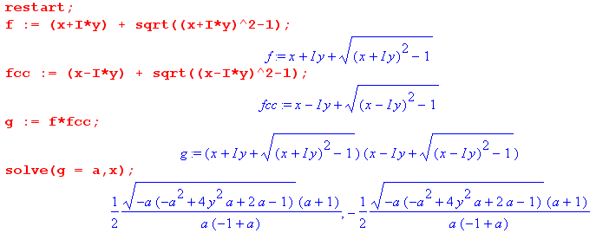

This is saying that is we set (z+w) (+) = a, we can solve for x as above, then square to get

x2 = (1/4) (a+1)2/[a2(a-1)2] (-a)(-a2+4ay2a + 2a-1)

which certainly looks like an ellipse. And the plots certainly look like ellipses. I am not happy to be stumped by this 9th grade high school problem, but it happens to me all the time. I am missing some fact here that makes it obvious.

I don't believe Maple's solution! I will do a counterexample. Suppose a = 1/2. Maple says very clearly that

x = ± -3(1/8 - y2)1/2 //which says need |y| ≤ 1/8 to get a real x

Now let's insert this result for x into our original expression for g shown above. Maple then says
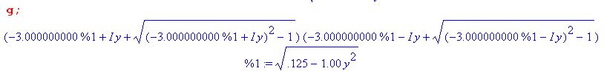

We were expecting this to be 1/2 ! Well, if I set y = 1/8 or y = 1/16, I do in fact get a = .5. Now suddenly I believe Maple's solution! I can install any value of y that is in the range y ≤ 1/8 and I always get g = 0.5.

My Proof as to why the equipotentials are NOT ellipses.

If it really is an ellipse, it will certainly be described in this way:

|z - α| + |z+α| = C

We know our picture is symmetric, so the focus points must be at z = ±α . So there must be some real positive numbers α and C such that the above equation is the same as this equation for some real positive K,

| z + $\sqrt{z2-1}$| = K

I suspect for tight contours we might have α → 1, but certainly for large contours, which are circles, we then have α → 0. So I don't want to claim that α = 1. Claim only α ≤ 1. So we then have this equation

| z + $\sqrt{z2-1}$| = K = (K/C) C = (K/C) (|z - α| + |z+α|)

So there must be some positive numbers α and β so this is true for all z,

| z + $\sqrt{z2-1}$| = β (|z - α| + |z+α|)

For large z, LHS = |2z| and RHS = β 2 |z|, therefore it must be that β = 1, so we now have

| z + $\sqrt{z2-1}$| = (|z - α| + |z+α|)

But if we take z = 0, then LHS = 1 and RHS = 2 |α|. That suggests that α = 1/2. Moreover:

For z = α we find that

| α + $\sqrt{α2-1}$| = 2α

Let's assume that α ≤ 1 based on our rough argument above. Then we have

| α + i $\sqrt{1-α2}$| = 2α

| α + i $\sqrt{1-α2}$|2 = 4α2

( α + i $\sqrt{1-α2}$)( α – i $\sqrt{1-α2}$) = 4α2

α2 + (1-α2) = 4α2

1 = 4α2

α = 1/2

Then, if our original assumption is true that | z + $\sqrt{z2-1}$| = K is an ellipse, then it must be true that

| z + $\sqrt{z2-1}$| = |z - 1/2| + |z +1/2|

I am completely blind to why this might be true, and doubt it is in fact true! If we evaluate both sides at z = 2 we get

LHS = 2 + $\sqrt{3}$ RHS = 1.5 + 2.5 = 4

So it is NOT true after all. If we restrict to 1/2 < z < 1, then LHS = 1 and RHS = 2z , so not true there either.

Maybe my Logic has failed in the last section, try again.

• Assume that the locus of z values in the z-plane such that | z + $\sqrt{z2-1}$| = K is a symmetric ellipse in the z plane.

• Any symmetric ellipse can be described by the equation |z - α| + |z+α| = C where we let α and C be arbitrary positive real numbers.

• Therefore, if | z + $\sqrt{z2-1}$| = K is in fact a symmetric ellipse, then there must be α(K) and C(K) such that the locus of |z - α| + |z+α| = C exactly aligns with the locus of | z + $\sqrt{z2-1}$| = K. Let's assume that we have found these two numbers and we will just call them α and C. Then we have that

| z + $\sqrt{z2-1}$| = K and |z - α| + |z+α| = C

describe the same ellipse curve. Each equation is true ONLY for z on the ellipse, not for any z.

• Let's compare the right-side ellipse intercept with the real axis. This occurs at some z = (x,0). We know from our picture of | z + $\sqrt{z2-1}$| = K that this intercept happens for x ≥ 1. So we have then'

x + $\sqrt{x2-1}$ = K

$\sqrt{x2-1}$ = K - x

(x2-1) = (K-x)2

x2 - 1 = K2 -2xK + x2

-1 = K2 -2xK

2xK = K2+1

x = (K2+1)/(2K)

So this is the rightmost point on the ellipse for value K. Now let's do the same for the other form of our ellipse. We have (x-α) + (x+α) = C = 2x. So this point is then x = C/2.

Since these rightmost points must be the same point, these two values of x are equal, and we have

C = (K2+1)/K

That is certainly an interesting and new conclusion.

• Let's now compare the top ellipse intercepts where z = (0,y) with y > 0. Then we have

| iy + $\sqrt{(iy)2-1}$| = K

| iy + $\sqrt{-y2-1}$| = K

| iy ± i $\sqrt{y2+1}$| = K

| y ± $\sqrt{y2+1}$| = K

I don't know which sign is correct, they give different y > 0 solutions. Let's consider them both. Here is the first solution,

y + $\sqrt{y2+1}$ = K

$\sqrt{y2+1}$ = K-y

y2 +1 = y2 + K2-2Ky

1 = K2-2Ky

2Ky = K2-1

y = (K2-1)/(2K)

The other solution is this:

$\sqrt{y2+1}$ -y = K

This gives the solution

y = - (K2-1)/(2K)

If K > 1, then the first y is the ellipse top point, and the second y is the bottom ellipse point, fine.

Now look at the other locus

|z - α| + |z+α| = C

2 $\sqrt{y2 + α2}$ = C = (K2+1)/K

(y2+α2) = (K2+1)2/(2K)2

α2 = (K2+1)2/(2K)2 - y2

= (K2+1)2/(2K)2 - (K2-1)2/(2K)2

= [(K2+1)2 - (K2-1)2] /(2K)2

= [K4 + 2K2 + 1 - K4 + 2K2 - 1] /(2K)2

= [4K2] /(2K)2 = 1

So we conclude that α = 1.

So if the hypothesis that the two ellipses are the same everywhere is correct, then:

Given | z + $\sqrt{z2-1}$| = K, and assuming it is a symmetric ellipse, then it must be equivalent to this ellipse:

|z - 1| + |z+1| = (K2+1)/K

So I am then claiming that these two equations describe the same ellipse:

| z + $\sqrt{z2-1}$| = K

|z - 1| + |z+1| = (K2+1)/K = K + K-1

My mental block continues, and I still don't know whether | z + $\sqrt{z2-1}$| = K is really a symmetric ellipse. I do know that if it IS, then it must be the same as the locus shown, and so the foci MUST then be at α = ±1. This blockage has now lasted about 4 hours, I have been unable to break through. And I have been unable to find a way to prove it is NOT true.

It is easy to show that the second equation can be written like so:

$\sqrt{(x-1)2+ y2}$ + $\sqrt{(x+1)2+ y2}$ = K + K-1

But I seem unable (blocked) to write out the first equation without an "i" appearing. I keep having this feeling that you cannot resolve this unless you go to parabolic coordinates or some such weird thing!

Maybe this will be helpful:

$\sqrt{z2-1}$ = $\sqrt{(x+iy)2-1}$ = a + ib

(x+iy)2 - 1 = (a + ib)2 = a2 - b2 + 2iab = x2 - y2 - 1 + 2ixy

Then we have two equations in two unknowns

a2 - b2 = x2 - y2 - 1 => a2 + y2 = x2+ b2- 1
ab = xy

a2 - (xy/a)2 = x2-y2- 1

a4 - x2y2 = (x2-y2- 1)a2

a4 - (x2-y2- 1)a2 - x2y2 = 0

a2 = (1/2) [ (x2-y2- 1) ± $\sqrt{(x2-y2- 1)2 + 4 x2y2}$]

Note in passing that the argument of this radical can also be written as (x2+y2- 1)2 + 4y2.

If (x2-y2- 1)> 0, then we MUST have the + sign. If (x2-y2- 1)< 0, again MUST have +. So the sign is a plus sign! If we repeated the above analysis solving for b instead of a, get same result but B = -B. Then we get

b2 = (1/2) [ - (x2-y2- 1) ± $\sqrt{(x2-y2- 1)2 + 4 x2y2}$]

If (x2-y2- 1)> 0, then in b2 we MUST have the + sign. If (x2-y2- 1)< 0, again MUST have +.

So here is what we have learned.

2a2 = (x2-y2- 1) + R > 0 a = ± $\sqrt{a2}$
2b2 = - (x2-y2- 1) + R > 0 b = ± $\sqrt{b2}$

a2 + b2 = R
a2 - b2 = (x2-y2- 1)

ab = xy

R = $\sqrt{(x2-y2- 1)2 + 4 x2y2}$ R2 = (x2-y2- 1)2 + 4 x2y2

Now write out

| z + $\sqrt{z2-1}$|2 = K2

| x + iy + a + ib |2 = K2

|(x + a) + i(y+b) |2 = K2

(x + a)2 + (y + b)2 = K2

x2 + a2 + 2ax + y2 + b2 + 2yb = K2

K2 - (x2 + a2 + y2 + b2) = 2(ax + yb)

[K2 - (x2 + a2 + y2 + b2)]2/4 = (ax + yb)2 = a2x2 + y2b2 + 2axby

[K2 - (x2 + a2 + y2 + b2)]2/4 = (ax + yb)2 = a2x2 + y2b2 + 2x2y2 // critical step!

[K2 - (x2 + a2 + y2 + b2)]2/4 = a2x2 + b2y2 + 2x2y2

[K2 - (x2 + y2 + R)]2/4 = a2x2 + y2b2 + 2x2y2

[K2 - (x2 + y2 + R)]2/2 = 2a2x2 + 2y2b2 + 4x2y2

[K2 - (x2 + y2 + R)]2/2 = [ + (x2-y2- 1) + R ]x2 + [ - (x2-y2- 1) + R ]y2 + 4x2y2

[K2 - (x2 + y2 + R)]2/2 = R(x2+ y2) + 4x2y2 ****

[K2 - (x2 + y2 + R)]2 = 2R(x2+ y2) + 8x2y2

K4 - 2K2(x2 + y2 + R) + (x2 + y2 + R)2 = 2R(x2+ y2) + 8x2y2

K4 - 2K2(x2 + y2 + R) + (x2 + y2)2 +R2 + 2R(x2+ y2) = 2R(x2+ y2) + 8x2y2

K4 - 2K2(x2 + y2 + R) + (x2 + y2)2 +R2 = 8x2y2

K4 - 2K2(x2 + y2 + R) + (x2 + y2)2 + (x2-y2- 1)2 + 4 x2y2 = 8x2y2

K4 - 2K2(x2 + y2 + R) + (x2 + y2)2 +(x2-y2- 1)2 = 4 x2y2

K4 - 2K2(x2 + y2 + R) + (x2 + y2)2 +(x2-y2)2 + 1 -2(x2-y2) = 4x2y2

K4 - 2K2(x2 + y2 + R) + 2x4 + 2y4 + 1 -2(x2-y2) = 4x2y2

K4 - 2K2(x2 + y2 + R) + 2x4 + 2y4 + 1 -2x2 +2y2 - 4x2y2 = 0

K4 - 2K2(x2 + y2) + 2x4 + 2y4 + 1 -2x2 +2y2 - 4x2y2 = 2K2 R

[K4 - 2K2(x2 + y2) + 2x4 + 2y4 + 1 -2x2 +2y2 - 4x2y2 ]2 = 4K4 R2

[K4 - 2K2(x2 + y2) + ( 2x4 + 2y4 + 1 -2x2 +2y2 - 4x2y2) ]2 = 4K4[ (x2-y2- 1)2 + 4 x2y2 ]

[K4 - 2K2(x2 + y2) + 1 + 2(x2-y2)(x2-y2-1 ) ]2 = 4K4[ (x2-y2- 1)2 + 4 x2y2 ]

[K4 - 2K2(x2 + y2) + 1 + 2(x2-y2)(x2-y2-1 ) ]2 – 4K4[ (x2-y2- 1)2 + 4 x2y2 ] = 0

This last line is the equation of our locus in Cartesian coordinates, something I have been trying to write down all day. If K is very large, then we can simplify this by keeping only the leading terms:

K8 ≈ 4K4[ (x2-y2- 1)2 + 4 x2y2 ]

K4/4 = [ (x2-y2- 1)2 + 4 x2y2 ]

Now go back to our starting point:

| z + $\sqrt{z2-1}$| = K

Conjecture: If K < 1, there are no points in the z-plane which satisfy this equation .

If z is in the interval (-1,1), I know that K = 1. This is the limit of our potential contours. If we increase K, the contours move out and eventually become R = K/2 with a circle.

Now enter the above locus equation into Maple

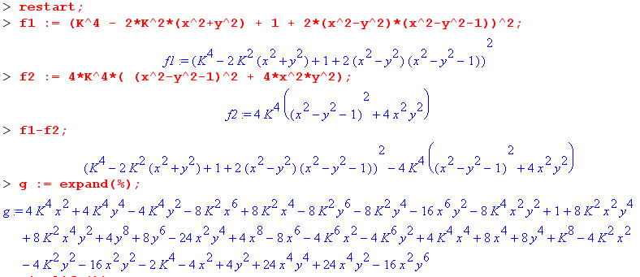

This appears to be some kind of 8th degree curve. Let's now take the specific case K = 2:

The curve is this thing = 0, and there is no doubt that this is NOT an ellipse.

