Lorentz Group Representations PhL 9.25.08

Today I hunted around on the web for the explicit Dirac representation generator and finite matrices, which appear half-baked in BD1. I found Guy Moore at McGill who teaches QFT and had some nice stuff on his web site. One of his courses is QFT Physics 610,

http://www.physics.mcgill.ca/~guymoore/ph610/index.html

A little info on him, PhD Princeton 1997. Wonder if Crodt knows him?
University of Washington, 1999-2002 [Postdoc]
McGill University, 1997-1999 [Postdoc]
Princeton University, 1992-1997 [Grad. Student]
Harvey Mudd College, 1988-1992 [Undergrad]
Thompson Valley High School, 1985-1988,
Junior High, Grade School, Preschool, In Utero....
For more complete details see my CV, either postscript or pdf.

guymoore@physics.mcgill.ca

1. His comments on books in the field.

The course will follow the textbook

M. Peskin and D. Schroeder, An Introduction to Quantum Field Theory
and you can get it, for instance, from Amazon.ca or Chapters/Indigo (same price)

He goes not say why he picked this book, but he does comment on other books:

For those of you who would like additional or alternative textbooks, I will make a few recommendations. Shop around for prices, I just gave links to show you exactly what book I meant.
Mark Srednicki's book covers the same material (almost) in a different and in my opinion better order, is very readable, and in many ways is a better textbook.
Lowel Brown's book introduces QFT in a completely different way than Peskin which you may prefer but which means it does not get as far in the same number of pages. Beware, he uses a different metric convention.
Ryder's book is a slightly less advanced text which many people like but which I don't know well myself.
Zinn-Justin is the bible of Quantum Field Theory but is much more formal than I intend to be in our class. Buy it if you intend to take Quantum Field Theory really seriously but not if you are on a tight budget.
Steven Weinberg's book is a place to go if you want everything spelled out in complete detail, but not if you want clear expository explanations; and it uses a different metric convention than we will.

He says nothing about path quantization which seems odd. Maybe all books do it this way now.

2. His offered notes

Lectures are not available that I can see, but he offers three items as follows:

Various Notes
A set of notes on symmetries, representations, and group theory can be found here in postscript.
A similar set of notes for Lorentz symmetry, spinors, and the Dirac algebra is here in postscript. You may find the following useful:
Quick lookup sheet of commonly needed equations, in postscript or pdf

I have downloaded these as Moore1,2,3. Of particular interest to me today is item #2 which contains the information I am seeking!

3. His own book.

Moore has written a book called "The Standard Model: a Primer" which is $60, 560 pages, 2006. I suspect this is a Levitt-like book. Amazon has no reviewers yet. You can "look inside" at Amazon. Here is the table of contents:

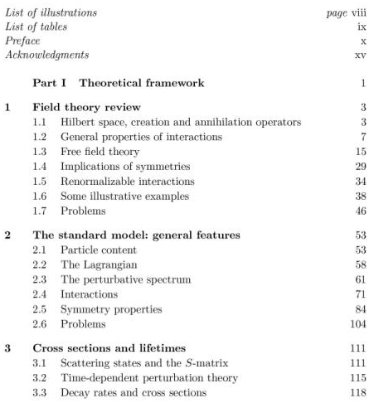
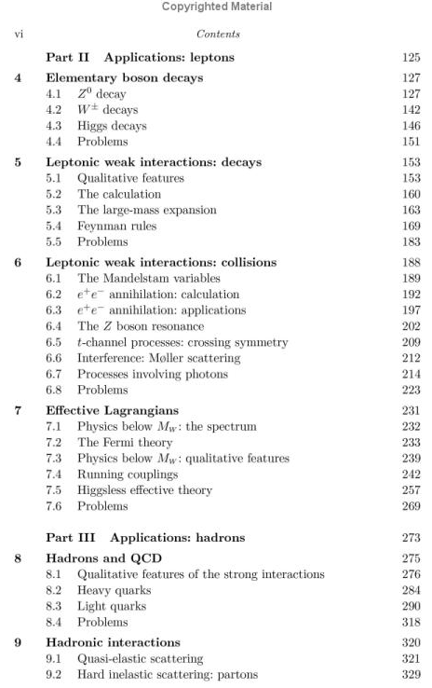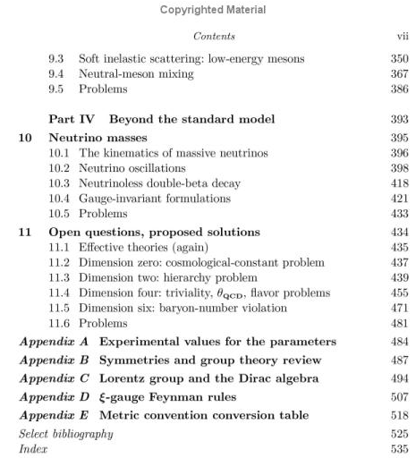

So we learn that two of his free downloads are appendices B and C of this book, which are called Appendices 2 and 3 in the actual download.
One item I notice in his first chapter is this, something I had been trying to remember a while ago.

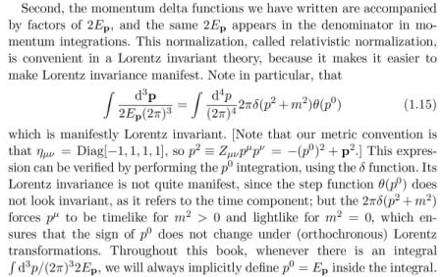

4. Moore's Lorentz Notes

He uses ημν = gμν matching BD. In his opening section, he talks about the coordinate transformation and for a scalar to stay scalar, we must have this be true:

If you do infinitesimal you find

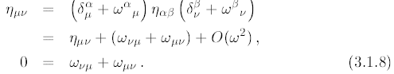

So in this section, the object ωαμ is a combination of generator and parameter, which I always find confusing, same as done in BD. I agree that this thing with both indices lowered is antisymmetric. But then later on he writes 3.2.2 below, using the same symbol ω, but now ω is just the parameter part, not the generator part. I suspect that 3.2.2 is the general case, and for the vector representation we get the above form. As shown below, the vector representation has these generators

(Jμν)αβ = i ( gμαgνβ – gναgμβ) = explicitly antisymmetric in μ and ν

in which case we get:

[(i/2) ωμν Jμν]αβ = - ½ ωμν ( gμαgνβ – gναgμβ) = - ½ ( ωαβ – ωβα)

Well, lower the α on both sides to get:

[(i/2) ωμν Jμν]αβ = - ½ ωμν ( gμαgνβ – gναgμβ) = - ½ ( ωαβ – ωβα) = - ωαβ

where I use the antisymmetry of ωμν as discussed below. So for the vector representation we can write

U = 1 - i/2 ωμνJμν => Uαβ = δαβ - i/2 ωμν(Jμν)αβ = δαβ + ωαβ

which is the usual way you see things for the vector representation where "parameter and generator are combined". The generator is really there, it is just hard to see it! The point is that this ω thing really is the parameter matrix in both the vector and general case, I guess I had not realized that. Also, the logic above shows the reason for the ½ factor. Then, given the antisymmetry of ωαβ, we have this most general form for the parameter matrix ωαβ:

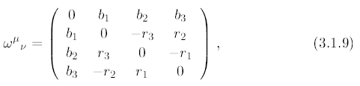

where Guy uses the suggestive boost and rotation letters b and r. This matrix of course is not antisymmetric due to the metric tensor. It is symmetric in the space-time parts and antisymmetric in the space-space parts, as you can see.

Now on to the general situation. He considers small transformations and defines abstract (hatted) generators as follows:

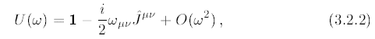

Without showing details, he claims that by considering the known finite transformations, you can deduce the Lie algebra which is this: (in fact, this is the complete Poincare Lie algebra, of which the Lorentz is a subset, or subalgebra).

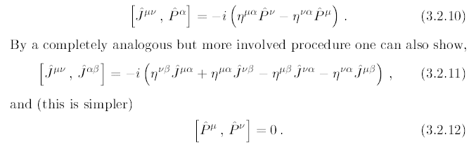

Now I think I can show that the generators must be antisymmetric in their labels. Here is a compact notation for the Lorentz algebra:

[ μν, αβ] = -i ( μα + νβ- να - μβ)

On the RHS, I show only the J labels, because we can always figure out the g indices from the J labels shown. We can see "by inspection" that the RHS here is antisymmetric in μ↔ν and in α↔β. So we know that

[Jμν, Jαβ] = [Jμν, – Jβα]

For a fixed αβ, this is true for ALL μν. I think this is enough to claim then that Jαβ = – Jβα. So, I am happy to accept that the generators are antisymmetric in their labels, just from the look of the Lie algebra.
Then given this fact, when we think about the combination of parameter and generator ωμνJμν , if we tried some "general" ωμν = ωμνA + ωμνS, we could find that ωμνSJμν = 0 and so ωμνS has no significance -- it does nothing at all. So we might as well take ωμν = antisymmetric and just set ωμνS = 0.

Comment: the Jμν shown above agree with the Mμν of BD according to my notes, but I can't really find a full statement of the Lie algebra in BD either volume. Other people like Weinberg might use Mμν = ± iJμν which removes the "i" from the Lie algebra. ( Then maybe the generators are symmetric and real and hence Hermitian? )

Theorem: the parameter matrix ωμν and the generators Jμν are each antisymmetric. For ωμν, the two letters are in fact matrix indices, whereas for Jμν the two letters are labels, not matrix indices.

Then, just as I would have done, he restates things in terms of some J and K generators:

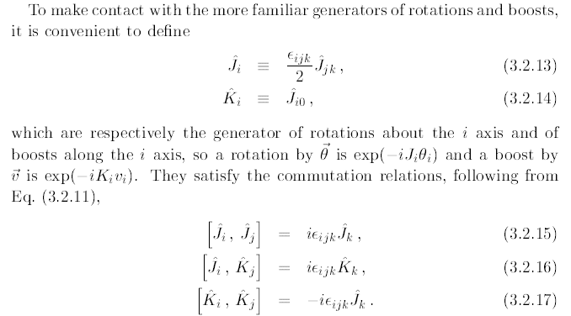

and these agree with my old notes. Notice that the first two are really just saying that J and K transform as vectors under rotation, the interesting one is the third that boosts do not commute. Notice, by the way, that everything here is "representation independent", could talk vector or scalar or spinor, etc.
He then starts talking about "representations" in this sense

where he is transforming a "field" and where Λ is how the coordinate transforms. Here is how a vector field must transform

Note: He uses * for † when we are in the abstract Hilbert space, so * is the mathematical adjoint symbol in this case.

Note added 10-3-08: I had to undertake a 7-day side trip before I was able to really understand the above transformation equations! I wrote two documents on the subject, which of course bring in many related ideas as well.

Answer: As Moore points out in his Moore1 Appendix a notes, you can define a "symmetry" as follows in the Quantum Mechanics Hilbert Space:

|φ'> = U|φ> O' = UOU†

=> <φ'| O' | ψ'> = <φ| U† (UOU†) U |ψ> = <φ| (U†U)O(U†U) |ψ> = <φ| O |ψ> if U†U = 1

Sometimes this is phrased in terms of saying " If you do |φ> → U|φ> and O → UOU†, and if nothing changes in the theory, meaning <φ| O |ψ> → <φ| O |ψ>, then U defines a symmetry and it is a unitary transformation in the Hilbert Space with U†U = 1". The could be an internal or a spacetime related symmetry. In all of the above, operators like O and U are "abstract operators" in the QM Hilbert space.
Now an example would be to take a field operator like Aμ(x). Then the 3.3.3 above says this:

A'μ(x') = UAμ(x)U† = (Λ-1)μν Aμ(Λx)

Now why do we want an inverse on this thing? More generally he is saying

φ'a(x') = U(ω)φa(x)U+(ω) = D-1ab(ω) φb(Λx)

where Dab(ω) is a representation of the group element ω.
Regarding this inverse, my little rotation group notes have always said R V R† = R-1V and have this same notion of inversion. Why do I have that inverse there? [ This was the question that started my 7-day tangential voyage.]

In general, the matrix D shown above is represented in terms of the generators as follows:

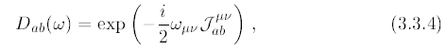

where there is a minus sign, and where ab are the matrix indices, and where ωμν are the parameters of the transformation which live in a symmetric 4x4 matrix with only 6 distinct terms, as we know. At first I regard this as a little strange, but I guess it is good. We know why the ½ is in there. The exponent is a world-scalar which is the main point I think. By the way, notice that the matrix Jμν does not have a hat, but the general operator does. He repeats the generator algebra without hats and says the matrices must respect it. Fine.

Comment: Moore does not write it anywhere, but I presume this is true:

U(ω) = exp(-i/2 ωμνμν)

Both this and the matrix form above are functions of a matrix argument ω. We know that U will be Unitary for rotations but not for boosts, so the letter U is perhaps a bit misleading.

Note added 10.3.08. But, U will be unitary for boosts in the QM Hilbert Space with covariant ket normalization, something I learned on my 7-day digression. In this case, since U-1 = U†, we may conclude that that generators Jμν are each Hermitian, that is, μν = {μν}† :

U(ω) = exp(-i/2 ωμνμν)
U-1(ω) = U(-ω) = exp(+i/2 ωμνμν)
U†(ω) = exp(+i/2 ωμν{μν}†) // since ωμν are real

Remember that this fact is not true for the boost generators in the 4-vector represenation!

Now comes the part that is completely new to me, but which Geoff Chew was talking about at Torrey. It is the left and right business. If we redefine generators as shown here, the Lie algebra's completely decouple from each other:

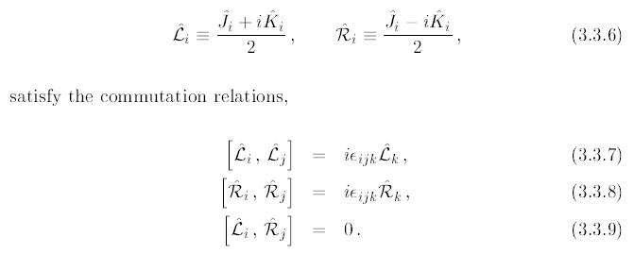

Each decoupled side, the Left and Right, is just a rotation group algebra! So somehow SO(3,1) is equivalent to SO(3) ⊕ SO(3), and this is the basis of the representation notation as (jL,jR). He comments that we shall be interested in 4 representations, to wit: scalar = (0,0). Vector = (1/2,1/2):

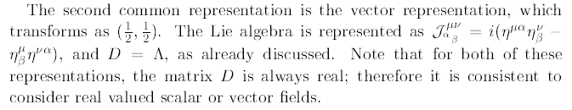

Notice that he is giving the explicit generators here and I used them above. I do have this in my notes where generators are Mμν.
Now back to the left and right stuff and the "spinor representations" First, we get the following 2D representation of the above L,R algebra

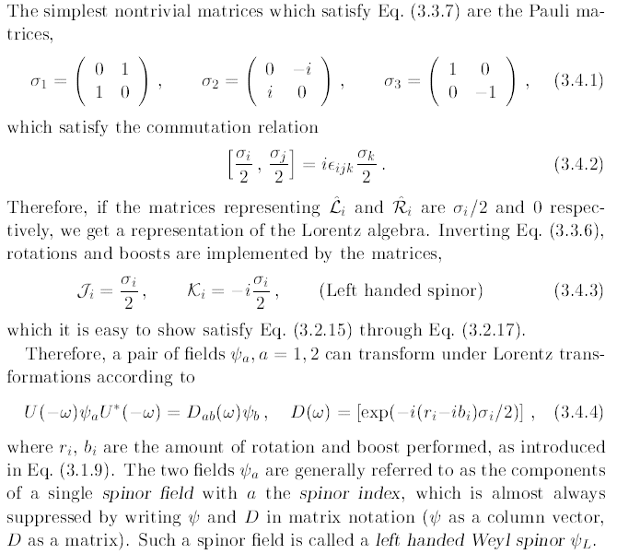

So in the above, we have explicit 2x2 matrices for the J and K in what I guess must be called the ½ ⊕ 0 representation because he has L = σ/2 and R = 0, as stated in the text above. Notice that we have the parameters b and r as commented on above. A field that transforms as above is a "left-handed Weyl spinor" , sounds good to me.
Obviously, there will be a right-handed one going with 0 ⊕ ½ , and we have

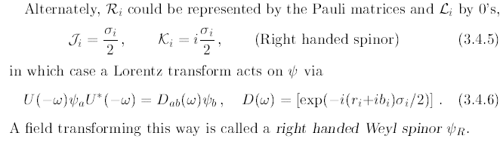

The difference is the sign on the K matrices. Nothing is arbitrary here, it all follows from the equations shown earlier that relate K,J and R,L.
So at this point we have two distinct 2D spinor representations of the Lorentz group. He then shows that you can convert a ψL spinor into a ψR and vice versa according to these rules:

ψL' = – ε ψR* ε = i σ2 ψR' = +ε ψL*

I put a prime on things because all we are saying is that ψL' transforms as a left handed spinor, we don't know otherwise what it might be.

He then comments on the "Weyl notation" which does seem a bit strange:

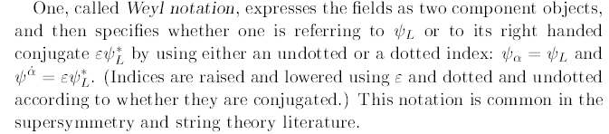

As he says, ε on a ψ-lower raises the index, and complex conjugation is a dot on the index. This would be a little hard for me to use in my Word system, and I have never seen this notation before.
Next is the "Majorana notation"

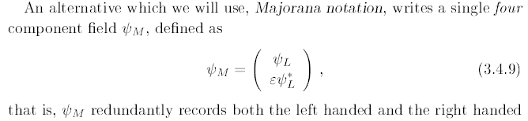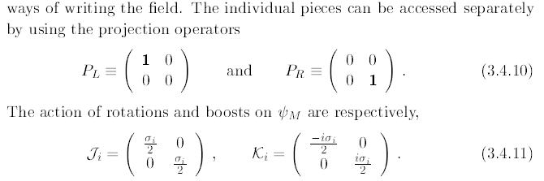

He has not said why we would want to make a 4-column vector or why we would want to do any of the above. But if you do it, then he is quoting the 4x4 generator matrices, which is what I have been looking for today. The big question is how this might relate to the Dirac equation.
Notice that the Ji are Hermitian whereas the Ki matrices are anti-hermitian meaning Ki† = - Ki. Also, right here, let's take note of these matrix facts for our 4-spinor Majorana thing

Jiβ = $\left(\begin{matrix}σi/2 & 0 \\ 0 & σi/2\end{matrix}\right)$ $\left(\begin{matrix}0 & 1 \\ 1 & 0\end{matrix}\right)$= $\left(\begin{matrix}0 & σi/2 \\ σi/2 & 0\end{matrix}\right)$

βJi = $\left(\begin{matrix}0 & 1 \\ 1 & 0\end{matrix}\right)$$\left(\begin{matrix}σi/2 & 0 \\ 0 & σi/2\end{matrix}\right)$= $\left(\begin{matrix}0 & σi/2 \\ σi/2 & 0\end{matrix}\right)$ = Jiβ

Kiβ = $\left(\begin{matrix}0 & 1 \\ 1 & 0\end{matrix}\right)$= $\left(\begin{matrix}0 & -iσi/2 \\ iσi/2 & 0\end{matrix}\right)$

βKi = $\left(\begin{matrix}0 & 1 \\ 1 & 0\end{matrix}\right)$$\left(\begin{matrix}-iσi/2 & 0 \\ 0 & iσi/2\end{matrix}\right)$= $\left(\begin{matrix}0 & iσi/2 \\ -iσi/2 & 0\end{matrix}\right)$ = – Kiβ

so we have shown that in this Dirac-type representation,

βJi = + Jiβ P1
Kiβ = – Kiβ

Then for the finite rotations we have this

D(ω) = exp[ -iriJi -i biKi] = e+C
D-1(ω) = exp[ +iriJi +i biKi] = e-C = D(-ω)
D†(ω) = exp[ +iriJi† +i biKi†] = exp[ +iriJi –i biKi]

D†(ω)β = exp[ +iriJi -i biKi] β = β exp[ +iriJi + i biKi] = β D-1(ω) P2

a fact we shall use below.

He next writes the Dirac 4-spinor as (EL, ER) where he says

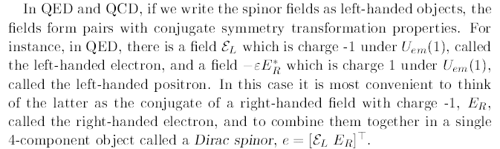

So things are not very clear at this point! The EL is describing a "left handed electron", while he says that
-εER* is a left-handed positron. Recall from BD that iγ2 was the "charge conjugation operator" and you did things like this: ψc = iγ2ψ* . There surely is some connection to Moore's discussion here. He goes on to say

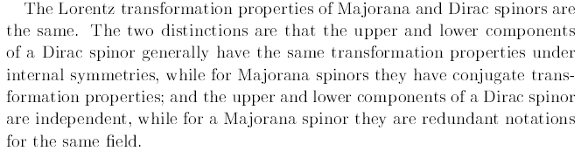

So the 4-spinor really is a (left,right) combination, and that must be where ½ ⊕ 0 + 0 ⊕ ½ is coming from. He is saying that in the Dirac case, the upper and lower subspinors are "independent", whereas in Majorana they are, as he clearly shows above, redundant. Either object (the Majorana spinor, or the Dirac spinor), transforms according to the representation ½ ⊕ 0 + 0 ⊕ ½.

Next here is why the "bar" appears:

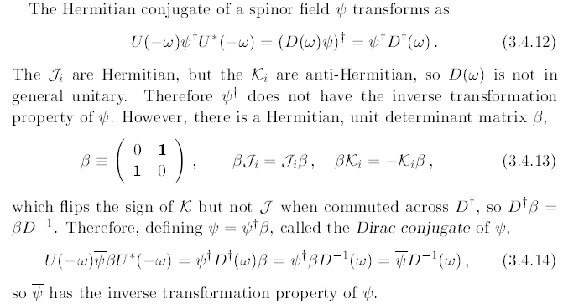

Note: last equation has a typo, should say U U* with no β.

Note added 10.3.08. Derivation of the above equations. Start with this from our digression document, and compare to Moore's statement of the same thing.

Λ Ar(x) Λ-1 = S(Λ-1)rs As(x') x' = Λx

so in Moore notation we have

U(ω) ψa(x) U†(ω) = D-1(ω)ab ψb(x')

which we can rewrite as follows to expose D(ω)ab on the RHS

U(-ω) ψa(x) U†(-ω) = D(ω)ab ψb(x')

Everything is an operator equation in our QM HS, but of course D(ω)ab are just numbers. Think of the LHS as the product of three matrices, and apply † to both sides using the usual matrix rules to get:

U(-ω) ψ†a(x) U†(-ω) = [D(ω)ab ψb(x')]† = D(ω)*ab ψb†(x') = ψb†(x') D(ω)†ba

or suppressing the 4x4 spinor indices,

U(-ω) ψ†(x) U†(-ω) = [D(ω)ψ(x')]† = D(ω)* ψ†(x') = ψ†(x') D(ω)†

Notice we handle the dagger on the matrix D sort of manually. The † on ψ is with respect to the infinite dim HS, while the † on D is a 4x4 matrix thing. So this is our derivation of (3.4.12) above. I continue however to show the spatial argument.
Now apply the 4x4 matrix β = γ0 from the right. It of course passes through the U operator because it is not in the same space (obvious if you maintain the spinor indices), and we get

U(-ω) ψ†(x) β U†(-ω) = [D(ω)ψ(x')]† = D(ω)* ψ†(x') = ψ†(x') D†(ω) β = ψ†(x') β D-1(ω)

where we used fact P2 to do the last step, and this then agrees with 3.4.14 above. So we can compare:

U(-ω) ψ(x) U†(-ω) = D(ω) ψ(x')

U(-ω) (x) U†(-ω) = (x') D-1(ω)

Then of course we get

U(-ω) (x) ψ(x) U†(-ω) = (x') D-1(ω) D(ω) ψ(x') = (x') ψ(x')

which says that when we rotate our operator expression, we get

(x) ψ(x) → (x') ψ(x')

Now recall our general field operator transformation rule from the digression document:

(A")r(x') ≡ Λ-1 Ar(x) Λ = S (Λ)rs As(x) x' = Λx // operator backward

If Ar(x) transformed as a scalar (and had only one component), we would get

(A')(x') ≡ Λ A(x) Λ-1 = A(x') x' = Λx // operator forward

which says

Λ-1 A(x) Λ = A(x')

which we compare to the above which says

U(-ω) (x) ψ(x) U†(-ω) = (x') ψ(x')

So we can compare A(x) to (x) ψ(x) and say that either one transforms as a world-scalar.

I recall Moore commented on errata, and I now see that he has a "complete replacement" for this entire appendix! Ouch! In the new version, he has changed to the Weinberg metric for ημν and he has corrected the above typo. Somewhere I have a program that can compare PDF's and indicate the differences. But neither CSDIFF nor my context menu program can do it. Back burner for now, let's just stay with the original appendix.

Side note on the finite rotation in general terms (no specific representation)

U(ω) = exp(-i/2 ωμνμν) Ji = i/2 εijkJjk Ki = Ji0 // J1 = i J23, etc

Now let's write out

ωμνμν = ωμνJμν = 2(Σi ωi0Ji0 + ω12J12 + ω23J23 + ω31J31)

where the 2 comes from the non-listed terms which have all indices reversed. Now make the replacements:

ωμνJμν = 2(Σi ωi0 Ki + ω12J3 + ω23J1 + ω31J2)

Looking back now at 3.1.9, we can write that ωαβ = gβνωαν = ωανgνβ in correct matrix order. Using 3.1.9 above, I find by hand that

ωαβ = 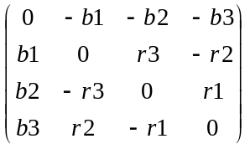

so that ωi0 = row i, col 0 = bi and ω12 = +r3 and cyclic. This we have

ωμνJμν = 2(Σi bi Ki + r3J3 + cyclic ) = 2(b•K + r•J)

and then finally,

U(ω) = exp(-i/2 ωμνμν) = exp(-i (b•K + r•J)) // which is the way I like to see things.

Of course b and r are real. I don't know anything more about the properties of K and J, such as whether they might be hermitian or symmetric, etc. That probably is representation dependent.

Resuming now,

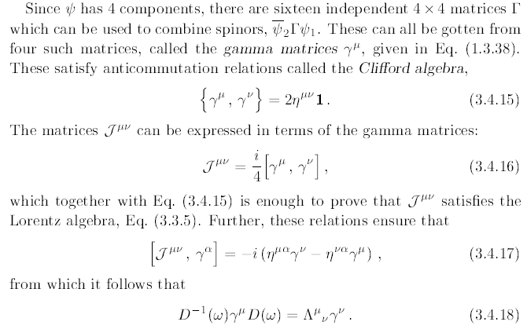

So here we have another form for the generator matrices in terms of γ matrices. And we get a clear statement of what the matrix representation does to the γμ.

TBC

