About the Lai book in general PhL 10.22.12

1. I bought this book from phatcampus at the bargain price of $7 shown below, today it is $34 on the same site, and at Amazon it is $74. They must have had a temporary overstock. Abe is $23, Walmart $85



This book must have been a poor seller? Why is it $7 pray tell? I got the lead on Amazon where it was $8.

2. Information on Mr. Lai:

Lai's home page is here:

http://me.columbia.edu/w-michael-lai-0 // most current

W. Michael Lai is Professor Emeritus of Mechanical Engineering and Orthpaedic Bioengineering at Columbia University. He received his Ph.D in Engineering Mechanics in 1962 from the University of Michigan. Between 1962 and 1986, he was a faculty member in the Mechanical Engineering Department at Rensselaer Polytechnic Institute. He joined the Columbia faculty in 1987 with a joint appointment between the Department of Mechanical Engineering and the Department of Orthopaedic Surgery. He served as Chairman of the Mechanical Engineering Department from 1996 to 2002 and became Professor Emeritus in 2004.
His research field has been in Orthopaedic Bioengineering with a special interest in soft tissue mechanics. Many of his publications have been in the constitutive modeling of articular cartilage for which he received the ASME Melville Medal in 1982 and the ASME Lissner Medal in 2001. The triphasic model considers the tissue as consisting of three phases: a solid phase, a fluid phase and an ionic phase with two ionic species. The model has been used to study the mechanical and the electromechanical behavior of the tissue including the signal transduction problems in chondrocytes . He is a Fellow of ASME and a founding Fellow of the American Institute for Biomedical and Biological Engineering (1995). At Columbia, he has received a Distinguished Faculty Teaching Award from the Columbia Engineering School Alumni Association (2000).

Recall that the first edition of Lai was 1972. It seems that he writes about 4 papers per year on the continuum mechanics of biological tissues, so there are 40 papers in the ten years 1991-2000. He is Taiwan BS 1952, PhD in 1962 Michigan so maybe he is 18 years older than me, 64+18 = 82. Orthopedic Biomechanics. I guess he stopped doing papers in 2000 which is 12 years ago, so maybe when he was 70. The ME faculty at Columbia shows 14 professor types, 1 is a woman, one black, 5 Asian, Lai is not there. Lai is one of three emeritus and I have his email

wml1@columbia.edu for my errata!

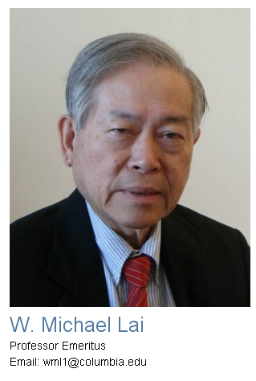
I could find no errata on his site, he is probably 82, so not surprising.

2. Information on Mr. Krempl

This guy was at Renssellaer Polytech in tree-filled Troy, NY, and went emeritus in 2004, but he does not show in either the regular or emeritus faculty lists for ME there. I did find this small note

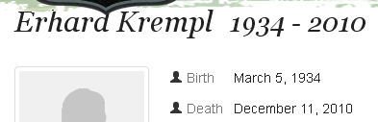

but no connection to the author, though time frame might be right. And then here is a random picture which is probably him

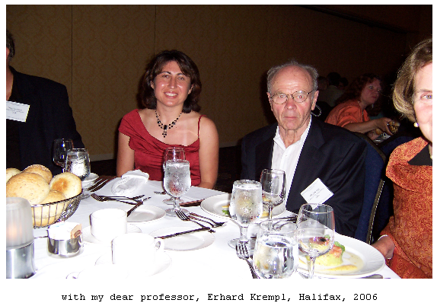

and here I finally found it in the Rensselaer alumni notes:

Erhard Krempl, John J. Redfern Professor Emeritus and former department head, a world leader in the field of solid mechanics; Dec. 11, 2010.

3. Information on David Rubin

He worked at Weidlinger Associates, birth date maybe 1942.

www.wai.com, 30 Oct 2010 [cached]
"Application of a Frequency-Domain Reduced-Order Model to UNDEX Event Selection," by Mr. Adam Hapij, Dr. David Rubin, Dr. Jeffrey Cipolla (Weidlinger Associates), and Dr. R. Atkatsh (NAVSEA 05P)

Weidlinger Associates® was founded in Washington, DC, in 1949, established headquarters in New York in 1951, and became a corporation in 1982. The firm currently employs 350 people worldwide and generates approximately $55 million per year. Paul Weidlinger pioneered in the fields of high-rise buildings and high-strength concrete and collaborated with many renowned 20th-century architects. The firm owes its reputation for innovative design to the distinguished group of engineers he chose as partners, five of whom joined him as elected members of the National Academy of Engineering

Rubin has papers in 2008 and 2010, but I cannot find an email address. There is a 2010 annual report for the W company which I downloaded in which there are 3 papers with his name on them, a SAVIAC conference, that org is disbanded now.

The 1942 date might be right, so Rubin would be age 70, probably the youngest of the bunch and probably still alive. No email.

So I guess Mr. Lai would be my only contact. A similar situation to Stak.

What about a direct search for errata?

Amazon reviews.

2 star: A panning review of the 3rd edition. Very insulting, anonymous. Only 7 total reviews. I read them all, most are very short and positive.

I find nothing on errata. "introduction to continuum mechanics" Lai Krempl errata

Due diligence is done. Publisher is Elsevier Butterworth Heinemann

Here is my proposed Amazon review of this book

Knowing nothing about continuum mechanics, I read this entire book in 2012 and found it to be excellent. For sure, the math is non-trivial, but is pretty much all derived in Chapter 2, a sort of tensor boot-camp for would-be readers, where things are done in Cartesian, spherical and cylindrical coordinates. Admittedly I already knew much of this stuff, but not all of it. The book is populated with many nuts and bolts examples which bring esoteric concepts down to earth. The examples are rather sly in that seemingly obscure results of earlier examples are applied in later examples, sometimes far down the road. There are also many problems for the reader to solve, though I confess I did only a few. The text develops the general theory of dealing with "particles of continuous matter" (solid or fluid). Chapter 3 treats strain, then Chapter 4 does stress. Up to this point things are general, but then Chapter 5 applies the theory to elastic solids, providing a mini-textbook on this subject, beams and torsion and all that good stuff. Some material on anisotropic solids and large deformations is included at the close. Chapter 6 then changes the focus from solids to Newtonian viscous fluids (like water and air) and the non-linear Navier-Stokes equations are derived. The whole subject of boundary layers and Reynolds numbers and the lift of airplane wings is pretty much skipped over, the reader must find other books on these traditional subjects. I was a bit disappointed, but the book after all is an "introduction". No Magnus Effect for curving baseballs and top-spinning tennis balls. Instead, in Chapter 7 the reader gets a nice treatment of the Reynolds Transport Theorem which shows how to replace time derivatives of material-volume integrals with control-volume integrals. The five guiding conservation principles (mass, linear and angular momentum, energy and entropy) are derived here for the third time in the book. The problem of a rope hanging over the edge of a table (treated as a fluid) demonstrates the control volume method. In the middle of all this action descends a discussion of non-inertial reference frames and then your garden rotating sprinkler is treated with a non-inertial control volume. Finally, Chapter 8 concerns non-Newtonian fluids, those that have both viscous and elastic properties. Along the way, the reader learns about synovial fluid's impressive viscosity decrease with shear rate, and the effect of human age on this fluid. Mr. Lai spent much of his career on biological applications of continuum mechanics. Since this is a fourth edition book (first was 1974), the authors are in "senior status" (Mr. Krempl died in 2010) and one suspects that much of their accumulated teaching wisdom is embodied in this text. I have put some minor errata up on the web (search Phil Lucht). This 500-page text gets five stars, but requires serious disciplined effort on the reader's part.

The above is maybe 18 * 29 = 522 words, Amazon limit used to be 1000. I will do the errata first.

Errata are done. Here is the review

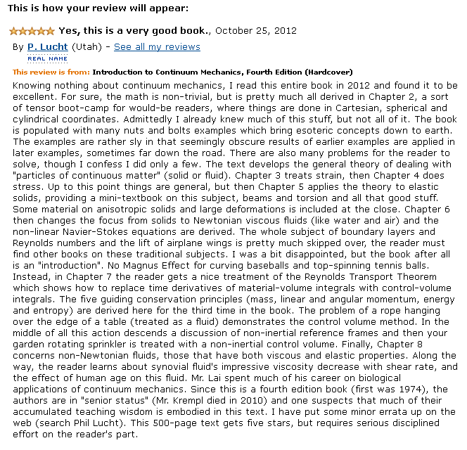
If it is there in 48 hours, they accepted it.

