Lai Continuum Mechanics Notes PhL 1.16.12

Motivation: This is the right place to start, THEN you can do quantum field theory and general relativity.

In the four Parts A,B,C,D below I have pasted in at the start the apropos section of Lai's official TOC.

The first 70 pages of the 500-page Lai book are "math preliminaries" which the author needs to get written down.

The subheadings below are just those where I took some notes, where something was new to me.

Comment: The following tensor analysis notions do NOT appear in this 70 page section:
metric tensor, contravariant/covariant vectors, up and down indices (it is mostly all Cartesian)
only n = 2 and n=3 are considered. All indices are "down".
There is no notion of a general transformation, but Q is used as my R for the linearized xform.
No tangent or reciprocal vectors. No notion of equation covariance.
Only spherical and cylindrical curvilinears are considered, no general formulas.
No comments on the ε tensor, no tensor densities.

From my review of books: 1
Chapter 1: Introduction 2
Chapter 2: Tensors 2
Part A: index notation 2
Part B: Tensors 2
Use of bold font for matrices. 3
Dyadic Product of two vectors 4
Orthogonal matrices and similarity/congruence transformations 6
Transformation of general tensors 6
The Dual Vector associated with an Asymmetric Matrix 7
Eigenvectors and Eigenvalues of a Real Symmetric Matrix 8
Diagonal elements of T matrix bounded by eigenvalues 9
Three invariants which are functions of the three eigenvalues 10
Part C: Tensor Calculus 10
Facts involving time derivatives of an orthogonal matrix. 11
The Stakgold rigid body fact that dr/dt = ω x r 11
Gradient of a scalar 12
Gradient of a vector, object ∇v, dyad but indices reversed. 12
Divergence of a Matrix 13
Curl associated with a dual vector 14
Part D: Curvilinear Coordinates 15

From my review of books:

Lai 1993 has 3 authors. It opens with tensors and curvilinear coordinates, which I think I like. Then comes strain and then stress. Then "the elastic solid" and yes, here are wave discussions. Eventually we get off into viscous fluids, wow, a freebie. This one is the best book so far in my collection.
The book is Lai, Ruben and Krempl which I shall call Lai. I see there is a 4th edition (my copy is 3rd). I just brought in the 4th Ed from here:

http://search.4shared.com/postDownload/2KIBRu6e/introduction_to_continuum_mech.html

It has the same structure, so I guess I would go with this later edition if I get launched. Date is 2009. It does not have a TOC so I had to get that from elsewhere. Amazon has the book for $60 free shipping and there are reviews. But not many reviews, and one is a major pan, lots of typos, etc, in 3rd Ed. But this is 4th Ed some 18 years later, so I would assume things are cleaned up.
I will give Lai 4th Edition a go. I could find no online errata at the Lai site. I think this book can be bought for $12 including shipping from a used place, but in "new" condition. I might do that at some point, but right now let's use the PDF and see what we see.
This book has no TOC! Maybe this is some strange draft? I will scan for other downloads. It is here with TOC http://www.scribd.com/doc/61554693/-3PfiF1Gdb but it blocks me for money. I go to home page, and am already logged in to scribd. This thing is not in the search list for scribd somehow (notice the Swiss bank account identifier above.) I was able to use the above to create my own detailed TOC in a separate doc. Fine.

Note Added 1.18.12. I just found a new, 4th Ed, copy of this at phatcampus for $7 + $4 ship = $11 and I just ordered it via PayPal with instant $ transfer.



I included a "message" saying: I assume Lai et al book is 4th Ed, new and clean. If that is not the case, please let me know. It claims to be new on their website: (notice the word "new")

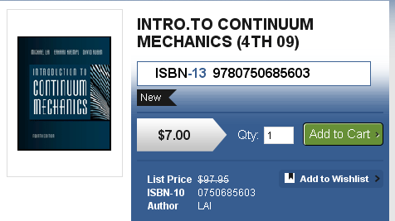

This book must have been a poor seller? Why is it $7 pray tell? I got the lead on Amazon where it was $8. Other places have it as well for $10-$20. The official Amazon price is $104 marked to $60.05. Be careful when buying a book on Amazon! I wonder why only 5 comments in Amazon, one of which is horrible, another says it is great. // On Jan 27 I checked on my order since I heard nothing, and it Phatcampus did not recognize me at all, so I had to sent them a customer service email. We shall see. // On Jan 28 it arrived and is in perfect condition. I sent Phat a second email belaying the first, and then registered there as xmission email and ginger. It came from Sterling book wholesaler in Florida with a cellophane wrap

Chapter 1: Introduction

The idea is to neglect microscopic details. CM is the study of how a "continuous" system responds to loading. There are two parts to the theory and method. First, general facts like energy conservation that apply to all systems. Second, specific "constitutive equations" for a specific system. This latter is what distinguishes an elastic solid from a viscous liquid, for example. Lai claims that there are two types of relations of interest: integral form ones which involve a volume, and differential ones at a "point". The book will look at four different models: linear and non-linear elastic solid (Ch 5), Newtonian viscous fluid (Ch 6), non-Newtonian fluid (Ch 8).

Chapter 2: Tensors

Part A: index notation

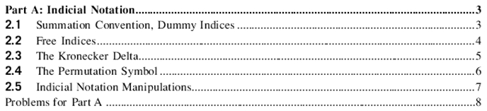

Comment: This stuff is very well done for the undergraduate, I like it, it would make teaching easier. There are lots of examples AND problems every step along the way. You know that typical undergrads need to be hand-held along the way and this book does just that. This book is for all students, not just for the smart students.
I already know 95% of all this stuff very well, BUT there is 5% that is new to me and I will comment on below.
Repeated indices called Einstein notation I am happy to see. Index on both sides of an equation is called "a free index", very good. Kronecker delta. The ε tensor is called "the permutation tensor".

Part B: Tensors

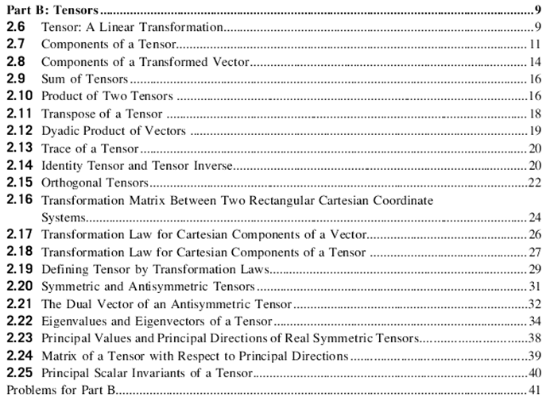

Use of bold font for matrices.

Here is the first sign of strangeness:
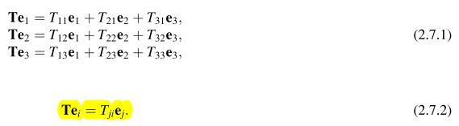

The three RHS's of 2.7.1 are the three column vectors of matrix T. For example

T e1 = T [ e1 ] = $\left(\begin{matrix}T11 & T12 & T13 \\ T21 & T22 & T23 \\ T31 & T32 & T33\end{matrix}\right)$$\left(\begin{matrix}1 \\ 0 \\ 0\end{matrix}\right)$ = $\left(\begin{matrix}T11 \\ T21 \\ T31\end{matrix}\right)$ = T11e1 + T21e2 + T31e3 = ΣkTk1ek

OK, my confusion is that this set of authors wants to represent a matrix with a bold letter T perhaps to distinguish that from a scalar. This is something I would NEVER do, but they do it. Fine. Perhaps think of their T as T. I wonder if this bold matrix notation is "standard" in this field? What is especially confusing is that this Te1 notation looks like the later ab dyadic notation in which the two bolded objects are vectors, whereas in Te1 the left object is a tensor and the right a vector.
Now consider

[Te1]j = [ ΣkTk1ek ]j = ΣkTk1 δkj = Tj1

It is true that the object [Te1] is itself a vector with these components (ie, it is the first column of T), and you could argue that since it is a vector, you should bold the whole thing.

C1 = [Te1]

so I guess that is their justification. But I really think they just mean T and they want to bold it, as in

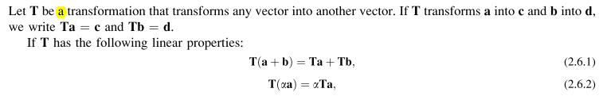

Now I like to write

Tij = <i | T | j > = ei • T ej T = operator T = matrix

On and on we to, transpose is TT . Then we have

TTij = <i | TT | j > = Tei • ej T = operator T = matrix

Tji = ej • Tei

More generally

a • Tb = Σij aiTijbj = Σij aiTTjibj = Σij TTjiaibj = TTa • b

as they say (with role of a and b reversed) ,

Dyadic Product of two vectors

Section 2.12 is on the dyadic stuff, pay special attention please! For me, a dyadic is a rank-2 tensor you obtain by taking the outer product of two rank-1 tensors, so for example

Wij = aibj

The dyadic people want to write this in the following notation

W = ab

and since Lai bolds matrices, he writes this as

W = ab

So in Lai's book, you cannot tell by looking at an equation which bolded things are vectors and which are matrices. For example, he would also write W = AB as the product of two matrices. For example

He has never defined a vector. They seem to use lower case for vectors when both are present, but not always. He does note that people write a ⊗ b and this makes more sense to me, this is really what the outer or direct product is. So yes, we now have
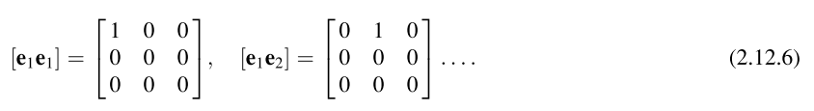
where sometimes people write e1e1 = .
I suppose the benefit of writing the dyadic ab is that you don't have to come up with another name for this matrix , like W = ab . Later we will see examples where a = ∇ and then ∇a is a dyadic.
I would write

W = abT = $\left(\begin{matrix}a1 \\ a2 \\ a3\end{matrix}\right)$ (b1 b2 b3 ) = ...

and they write this out for me:

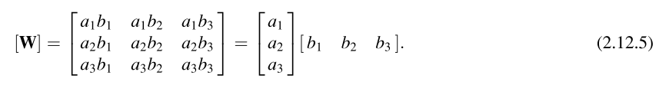

I must admit that my notation is then inconsistent. I really should write

W = abT

Since my vectors are bolded, I know they are not matrices. But then I do have two adjacent bolded vectors with no operator between them. OK OK.
Notice this fact:

det(ab) = εij(ab)1i(ab)2j = εija1bia2bj = a1 a2εijbibj = 0 by symmetry

tr(ab) = aibi = a • b

In their "inverse of a matrix" section, they fail to state the formula for A-1! They are just saying that A-1 might exist, and identity I always exists.
Notice this dyadic rule:

I will prove it here: [ I now write this as (abT)c = a (bTc) = a(b•c) so all obvious.]

[(ab)c]i = (ab)ijcj = matrix acting on a vector = aibjcj = ai(b•c)

Therefore [(ab)c]i = ai(b•c) => (ab)c = a (b•c) or Wc = a (b•c) = a vector

Orthogonal matrices and similarity/congruence transformations

Then we have orthogonal tensors Q-1 = QT, example of a z rotation. Eventually we have

which I would write as

T' = QT T Q

The matrix elements of T' can then be written

T'ij = <e'i | T |e'j> where

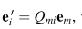

M&M call this T' = QT T Q a "congruence transformation" so that T and T' are congruent. ( M&M use an over-twiddle for transpose. ). A similarity is T' = Q-1 T Q and if Q is orthogonal, then congruence and similarity are the same. Lai uses none of these names.

Transformation of general tensors

Eventually we get to tensors of arbitrary rank:

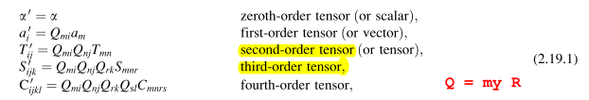

so things are tensors with respect to a linear transformation Q (which is the R of my tensor doc). Lai then shows how tensors "transform".
Well be careful. This book does not address the subject of contra and covariant vectors! If I assume that these down indices are really contravariant, as in my "developmental notation", then one would have

a'i = Rijaj or a' = Ra => Qij = (RT)ij or Q = RT

This seems a slightly strange way to do things.

The Dual Vector associated with an Asymmetric Matrix

Next new item is the dual vector in their Section 2.21. Consider

T a = tdual x a

which is applied ONLY to an antisymmetric matrix T. First of all, I claim that you can represent any antisymmetric 3x3 matrix in this manner (such a matrix has only 3 distinct elements)

Tij = εijkbk

To prove, this we need to find vector b. So

T12 = b3
T23 = b1
T31 = b2 all done!

Then

bi = (1/2) εijkTjk

b1 = (1/2) ε123T23 + (1/2) ε132T32 = ε123T23 = T23 etc.

So now consider the claimed dual equation

T a = tdual x a

This says

Tijaj = [εijkbk] aj = [tdual x a]i = εijk tdualj ak

or

εijkbk aj = εijk tdj ak = εikj tdk aj = - εijk tdk aj

so then

εijk aj bk =- εijk aj tdk

and I conclude that

bk = - tdk

and then

T12 = b3 = -td3 = - T21 => td3 = T21

which agrees with Lai. In general

tdi = - bi = – (1/2) εijkTjk

2 tdi = – εijkTjk

The vector version of this would be

2 td = Σi2 tdi = Σi[– εijkTjk] = – εijkTjk

with implied summation on index i. Thus they say

Comments: The vector I called tdual is associated with the antisymmetric matrix T and has nothing to do with the scratch vector a used in the work above. It seems very strange that the write tA for this dual vector, since the superscript A seems to mean nothing at all. Maybe it means Antisymmetric!
I am not sure where this dual vector idea will be used.

Eigenvectors and Eigenvalues of a Real Symmetric Matrix

We move then to E3 eigenvalue stuff. Lai writes

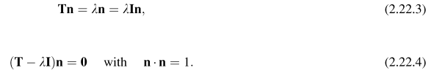

where n are supposed to be orthonormal eigenvectors. In order for the second equation NOT to be invertible for n ( which would give n = 0), we must have det(T-λ1) = 0 which is a cubic for λ and that is how you find the EV's. They call this the characteristic equation. They write αi as the components of n instead of ni, very strange.
For a real symmetric matrix (a Hermitian matrix), Lai quotes the famous results. EV's are real, EF's are in general orthogonal. The EF's are called "principle directions" . They are of course unit vectors each pointing in some direction. The EV's are n1 n2 and n3 and if you use those for new basis unit vectors, the new T will be diagonal, yes yes. [ I think in the Lai application of the the EF/EV world, the eigenvectors will in fact be directions in 3-space, perhaps why he uses the letter n. ]

Diagonal elements of T matrix bounded by eigenvalues

They then prove something I did not know: If you write down Tij in every possible basis and examine the diagonal elements, you will find that max(Tii) = λmax and min(Tii) = λmin . How would I prove this myself? I think any two bases must be related by a rotation since we are talking orthonormal basis, so we really have

T = R-1Λ R where Λ is diag(λ1,λ2,λ3)

Then look at a diagonal element

Tii = [R-1Λ R]ii = Σjk R-1ij ΛjkRki = Σjk R-1ij δjk λkRki = R-1ik λkRki

Therefore

Σi Tii = Σi Σk RkiR-1ik λk = Σk δkk λk = Σk λk

I have just shown that trace is invariant under a rotation which I guess I knew. so

T11+ T22+ T33 = λ1+ λ2+ λ3

OK, I will ignore this for now and do it later if need be, they prove it on page 40. I showed above that

Tii = Σk R-1ik λkRki = Σk λk(Rki)2

If we write λ1≥ λ2≥λ3 then

Tii = Σk λk(Rki)2 ≤ λ1 Σk(Rki)2

But now

Σk(Rki)2 = ΣkRkiRki= Σk R-1ik Rki = δii = 1

Therefore I get that, if λ1 is the largest EV,

Tii ≤ λ1 = max of the λi

Similarly,

Tii = Σk λk(Rki)2 ≥ λ3 Σk(Rki)2

Tii ≥ λ3 = min of the λi

So I have proven that

min(λk) ≤ Tii ≤ max (λk) i = 1,2,3

which says that if we consider ALL matrices T obtained by rotating the diagonal one, the diagonal elements are all bounded as shown from above and below.

Three invariants which are functions of the three eigenvalues

Invariants: I have just shown above that the tr(T) is an invariant under rotations of T. I know that the determinant is also, since det(T) = det(R-1ΛR) = det(Λ) = λ1λ2λ3. And tr(T) = λ1+ λ2+ λ3. They quote a third invariant that is another linear combination. First we need

tr(T2) = Tr(TT) = Tr(R-1Λ R R-1Λ R) = Tr(R-1Λ2 R) = Tr(R R-1Λ2) = Tr(Λ2) = λ12+λ22+λ32

(1/2) [ {tr(T)}2 - tr(T2) } = (1/2) [ { λ1+ λ2+ λ3}2 - { λ12+λ22 + λ32)} }

= (1/2) [ 2{ λ1λ2+ λ2λ3+ λ3λ1} ] = λ1λ2+ λ2λ3+ λ3λ1

and so now I have all three of these invariants computed:

I1 = tr(T) = λ1+ λ2+ λ3

I2 = (1/2) [ {tr(T)}2 - tr(T2) } = λ1λ2+ λ2λ3+ λ3λ1

I3 = det(T) = λ1λ2λ3

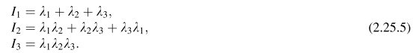

I have no idea what these three combinations of EV's might be used for.

(My notes got a little out order here, but I will just plough ahead for now. )

Part C: Tensor Calculus

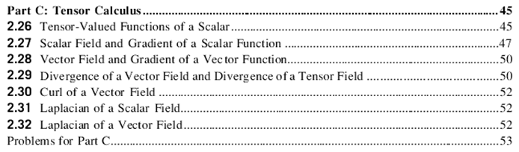

This section on "tensor calculus" deals with various kinds of derivatives acting on scalars, vectors and matrices. No integrals appear.

There is stuff here I am not used to, so more notes! It involves time derivatives.

Facts involving time derivatives of an orthogonal matrix.

P 46: consider for the case that Q is an orthogonal matrix,

0 = ∂t1 = ∂t(QQT) = (∂tQ)QT + Q(∂tQT)

=> [(∂tQ)QT] = – Q(∂tQT) = -Q (∂tQ)T = – [(∂tQ)QT]T

The first thing to note is that ∂t and T commute:

[∂tQT]ij ≡ ∂tQTij ≡ [∂tQij]T

That is, ∂tA is must a matrix of derivatives of the Aij. Above I have just proven this theorem:

Theorem 1: if QT = Q-1 then (∂tQ)QT is an antisymmetric matrix.

The Stakgold rigid body fact that dr/dt = ω x r

Now consider r(t) = R(t)r0 where R is a rotation matrix which depends on time. Then I would say

∂tr = ( ∂tR) r0 = ( ∂tR)R-1r = [(∂tR)RT] r ≡ T r
____________________________________________________________________________

Note added: Suppose R = exp(-iθ•J) = exp(-iΩ•J) where Ω= θ . Then

T = (∂tR)RT = exp(-iΩ•J) (-i∂t Ω•J) exp(+iΩ•J) = -i(∂tΩ)•J = - i(∂tΩ)a Ja

Tij = - i(∂tΩ)a (Ja)ij = - i(∂tΩ)a [ -i εaij] = - (∂tΩ)a εaij = – εija (∂tΩ)a = antisym!

Then given the equation below we get

tdi = – (1/2) εijkTjk = – (1/2) εijk{ – εjka (∂tΩ)a } = (1/2) εijk εjka (∂tΩ)a

(1/2) εijk εajk (∂tΩ)a = (1/2) 2 δi,a(∂tΩ)a = (∂tΩ)i = ωi => td = ω

So we can write the above as

dr/dt = T r = td x r = ω x r = (dΩ/dt) x r
____________________________________________________________________________

Thus ∂tr is an antisymmetric matrix acting on r! But above I showed that when T is antisymmetric

T a = td x a where tdi = – (1/2) εijkTjk

Therefore we know that

∂tr = td x r where tdi = – (1/2) εijkTjk = – (1/2) εijk[( ∂tR)RT]jk

One says that td is the dual vector of the matrix (∂tR)RT .
Now how do I make the connection that td = ω ? Here is my derivation from Goldstein notes, where I am using dΩ ≡ θ, and I use the usual R = exp(-iθ•J) [ correcting my Goldstein notes here only ]

dr = [-iθ•J] r => // θ is a small angle so doing ex = 1 + x

drj = [-iθ•J]jk rk = [-dΩ•iJ]jk rk = [ -dΩm iJm]jk rk = -dΩm (iJm)jk rk = -dΩm εmjkrk

= -εjkm rk dΩm = -[ r x dΩ]j => dr = -r x dΩ = dΩ x r

Therefore, dividing both sides by dt

dr/dt = dΩ/dt x r = ω x r ω = dΩ/dt = (dθ(t)/dt) (t)

In this equation, then, ω is the instantaneous rotational status of a rigid body. It says what axis it is rotating around at that instant, and at what angular frequency ω. The Goldstein idea is that the most general motion of a rigid object with a point fixed is a rotation. You could take that fixed point as the center of mass, for example. So the notion of ω is specific to some selected fixed point.

Gradient of a scalar

Comment on gradient of a scalar:

dφ = ∇φ • dr = |∇φ | cosθ dr

dφmax = |∇φ | dr

So if you select dr normal to ∇φ , you get the max change in φ for a given scalar dr motion. I am quite familiar with this fact. For this direction, note that quantity |∇φ | is what appears:

| v |2 = v • v = Σi vi2
|∇φ |2 = ∇φ • ∇φ = Σi (∂iφ)2 = (∂xφ)2 + (∂yφ)2 + (∂zφ)2

|∇φ | = [Σi (∂iφ)2]1/2

A nice example is given for linear heat flow rule with temperature field specified where k = scalar thermal conductivity. Lai calls this the Fourier Heat Conduction law, q = -k ∇Θ . This tells you that the heat flow is normal to the isotherms of temperature field Θ.
He then considers a non-isotropic medium where k becomes matrix K and q = -K ∇ Θ , and of course here in an example Lai shows that q is NOT normal to the isotherms.

Gradient of a vector, object ∇v, dyad but indices reversed.

Next comes the idea I noted above that we have a dyad derivative (but not quite!!)

matrix = ∇v matrixij = (∇v)ij = ∂jvi = ∂vi/∂xj

Notice the order of his indices which matches the longer partial derivative notation (and which is in my book the reverse of the usual dyadic ordering)

Later Lai claims that

dv = (∇v) dr // proof on next line...; note also that dv = d(dx/dt) = (∇v) dx = Dt(dx)

which says

dvi = (∇v)ij drj = ∂jvi dxj = the partial chain rule QED

Now consider this interesting claim:

∇• v = tr(∇v)

LHS = ∂xvx + .... = ∂jvj

RHS = ∂xvx + ...

I have never seen this ∇v notation before, it looks just fine though.

Note Added: Here is why Lai treats ∇v in this manner, first consider this "normal" statement:

dui = ui(r + dr) - ui(r) = ∂jui(r) dxj = ∇ui • dr i = 1,2,3...n

We can get rid of the hanging index and make it all vector notation like so

du = u(r + dr) - u(r) = ∂jui(r) dxj = (∇u)ij dxj = (∇u) dr = matrix acting on a vector

Notice that the "matrix index ordering" in (∇u)ij dxj = Tijbj only works if we define matrix (∇u)the way Lai did. This structure du will appear many times in CM.

Note: I went off and spend about 4 days "learning about" this object ∇v and how to express it in curvilinear coordinates. This resulted in a large new section 7 (w) in my tensor doc.

Divergence of a Matrix -- a vector formed by taking the divergence of the row vectors.

Next Lai wants to think about the divergence of a matrix! Again, something I have never considered. He wants it to be this:

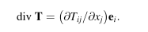
This says that

∇• T = Σij ∂jTij = ∂jT1j + ∂jT2j + ∂jT3j

Here, ∂jT1j is the divergence of the vector which is the first row of matrix T. So you take these three divergences and create a vector from them. I have no idea where such a concept would be useful. Let's now verify his theorem that

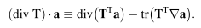

LHS = (Σij ∂jTij ) • a = (Σij ∂jTij) ( • a) = (Σij ai ∂jTij)

RHS1 = div(TTa) = Σi ∂i (TTa)i = Σij ∂i (TTijaj) = Σij ∂i (Tji aj) = Σij ∂j (Tij ai)

= Σij( ∂j Tij) ai + Σij( ∂j ai) Tij

RHS2 = tr(TT∇a) = Σi (TT∇a)ii = Σij (TTij[∇a]ji) = Σij Tji(∂iaj)

= Σij Tij(∂jai) = second term of RHS1

Therefore

RHS1 - RHS2 = Σij( ∂j Tij) ai = LHS QED

So I imagine that the more general definition can be used in curvilinear coordinates. We shall see.

Consider this little exercise:

div (α T) = Σij ∂j(αTij) = Σij (∂jα)Tij + Σij α(∂jTij) = T1 + T2

T1 = Σij (∂jα)Tij = Σij Tij (∇α)j = Σi [ T ∇α ]i = T ∇α = matrix act on vector = vector

T2 = α Σij (∂jTij) = α div T

so we have shown that

div (α T) = T ∇α + α div T

Curl associated with a dual vector

Next: the curl is associated with that dual vector:

[curl v ]i = εijk ∂jvk curl v = ∇ x v

Recall that for antisymmetric T,

T a = td x a 2 tdi = – εijkTjk

The claim is that if we decompose

∇v = (∇v)S + (∇v)A

then curl v = 2 td where td goes with (∇v)A.

Proof: Start with ( I happened to select the wrong sign here)

Tjk ≡ (∇v)Ajk = (1/2) [ ∂jvk - ∂kvj]

Then

2 tdi = – εijkTjk = – εijk (1/2) [ ∂jvk - ∂kvj] = – εijk∂jvk = - [curl v ]i

so I have shown that

- [curl v ]i = 2 tdi

so we disagree by a sign. I think Lai has defined (∇v)Ajk with the opposite sign, as in

Tjk ≡ (∇v)Ajk = – (1/2) [ ∂jvk - ∂kvj] = (1/2)[ ∂vj/∂xk - ∂vk/∂xj ]

which is natural if you write out the partial derivative in full. Lai has failed to write his (∇v)Ajk down except in a detailed matrix which I see does agree with what I just said.

Summary of the above: The curl of a vector v can be related to the object ∇v. The relation is this:

curl v = 2 td where td is the dual vector associated
with the antisymmetric matrix (∇v)Ajk ≡ (1/2) [ ∂kvj - ∂jvk] ,
which is just the antisymmetric part of matrix ∇v .
One then has 2 tdi = – εijk(∇v)Ajk.

M&F use this concept as well. It is not clear to me what the payoff is for this unusual connection. I think later Lai will use this fact to compute curl v in curvilinear coordinates given ∇v !

Comment: Here is an inconsistency in Lai notation. First, for dyad he says

=> 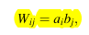 => (ab)ij = aibj

From this you would conclude, setting a = ∇,

W = ∇b => Wij = ∇ibj = ∂ibj

But instead Lai has

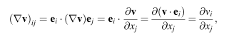

Admittedly by doing it this non-dyad way he gets the desired result

Part D: Curvilinear Coordinates

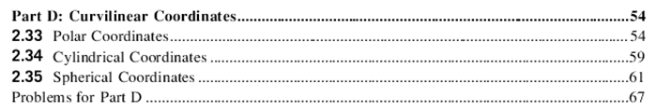

Polar Coordinates: Lai obtains these results:

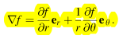
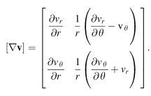
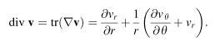
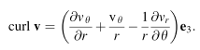
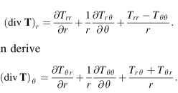
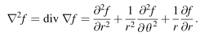
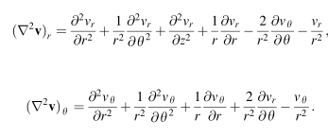
I have not verified all these results, but could easily do so.

Comments: In my tensor doc, I never consider objects like (∇v), so let's consider that here.

(∇v)ij = ∂jvi = [grad vi]j

I will try to copy paste and edit my grad section from tensor doc and apply it here:

STOP. OK, this is where I spent my 4 days. Since ∂jvi is not a rank 2 tensor, you cannot just use the new general formulas I recently developed for expansion. The upshot of all this time is the new Section 7 (w) in my tensor doc where everything is explained including ∇v as a non-tensor example. I got a nice expression for ∇v in any curvilinear system, and got Maple going on it. All this work is now in a little folder called Lai grad-v work.

Cylindrical Coordinates: A similar set of results

Spherical Coordinates: A similar set of results.

Problems for Part D. 2.70 to 2.80

