Expressing ∇v in curvilinear coordinates PhL 1.24.12

Here I obtained the correct Lai results for polar and spherical coordinates for the first time using Maple. The work here is entirely replaced by Appendix F of tensor doc which gets the result for non-orthogonal as well as orthogonal. So this doc is historical only, don't ever read it again!

Part I: Grind down to something we can compare to Lai. 1
Part II: Show that in fact P_{ij}(last) has the desired form shown just above with lai2.mws 4
Part III: Summary and start over using lai3.mws 6
Part IV: For other systems. 10
Part IV: Misc Questions. 11

Part I: Grind down to something we can compare to Lai.

In Cartesian coordinates we have

(∇v)ab = ∂bva(x)

(∇v) = Σab (∇v)ab uaubT = Σab(∂bva) uaubT = Σcd(∂cvd) uducT

I have shown in various places now that we can write

ud = Σe h'e-1 Red e
ucT = Σf h'f-1 Rfc fT
uducT = [Σe h'e-1 Red e] [Σf h'f-1 Rfc fT] = Σef h'e-1 Red h'f-1 Rfc e fT

Therefore we can write

(∇v) = Σcdef(∂cvd) h'e-1 Red h'f-1 Rfc e fT (*)

We want to express (∂cvd) entirely in terms of x'-space coordinates and objects. To this end we write

∂cvd = (Ric∂'i)( Rjdv'j)

where sums are on the first index since we are going "backwards" from x'-space to x-space. Here is a little in-line proof that this indexing is right:

v'e= Recvc => Reb v'e= Reb Recvc = δbcvc = vb QED

Notice that we do in fact have ∂dvc expressed as desired, since we can regard Rij as being functions or r and θ which are x'-space coordinates. But we go ahead and expand a little

∂cvd = (Ric∂'i)(Rjdv'j) = Ric ∂'i(Rjdv'j)

= Σij Ric [(∂'iRjd) v'j + Rjd (∂'iv'j)]

Without further ado, we insert this into (*) above to get

(∇v) = Σcdef(∂cvd) h'e-1 Red h'f-1 Rfc e fT

= Σcdef{ Σij Ric [(∂'iRjd) v'j + Rjd (∂'iv'j)]} h'e-1 Red h'f-1 Rfc e fT

= Σcdefij Ric [(∂'iRjd) v'j + Rjd (∂'iv'j)] h'e-1 Red h'f-1 Rfc e fT

= Σcdefij (Rfc Ric) [(∂'iRjd) v'j + Rjd (∂'iv'j)] h'e-1 Red h'f-1 e fT

= Σcdefij (Rfc Ric) [Red (∂'iRjd) v'j + (Red Rjd) (∂'iv'j)] h'e-1 h'f-1 e fT

= Σcdefij (δfi) [Red (∂'iRjd) v'j + (δej) (∂'iv'j)] h'e-1 h'f-1 e fT

= Σcdefj [Red (∂'fRjd) v'j + (δej) (∂'fv'j)] h'e-1 h'f-1 e fT

= [Red (∂'fRjd) v'j + (∂'fv'e)] h'e-1 h'f-1 e fT

= [(∂'fv'e) + Red (∂'fRjd) v'j] h'e-1 h'f-1 e fT

= [(∂'fv'e) + Red (∂'fRkd) v'k] h'e-1 h'f-1 e fT

= [(∂'jv'i) + Rid (∂'jRkd) v'k] h'i-1 h'j-1 i jT

and this is the form we seek. I did one change per line above to allow error tracking. Write then as

(∇v) = [(∂'jv'i) + Rid (∂'jRkd) v'k] h'i-1 h'j-1 i jT

Our matrix of interest is this one:

Pij ≡ [(∂'jv'i) + Rid (∂'jRkd) v'k] h'i-1 h'j-1 where (∇v) = Σij Pij i jT

Now we know that v'i are the covariant x'-space velocity components. To compare with Lai, we really want to see our unit-vector components appear. We know that (App C previous doc)

v'n ≡ v'n h'n and v'n = g'nnv'n = h'n-2v'n

Therefore

v'n = h'n2 v'n = h'n2 (v'n/ h'n ) = h'n v'n

Therefore we can write

Pij = [(∂'j[h'i v'i]) + Rid (∂'jRkd) [h'k v'k]] h'i-1 h'j-1

= [(∂'jh'i) v'i + h'i (∂'jv'i) + Rid (∂'jRkd) h'k v'k] h'i-1 h'j-1

Let's check the middle term right now:

Pij(middle) = h'i (∂'jv'i) h'i-1 h'j-1 = (∂'jv'i) h'j-1

I can write this four terms out:

P11(middle) = (∂'1v'1) h'1-1 = (∂'1v'1) = (∂rvr)

P12(middle) = (∂'2v'1) h'2-1 = (∂'2v'1) (1/r) = (∂θvr) (1/r)

P21(middle) = (∂'1v'2) h'1-1 = (∂'1v'2) = (∂r vθ)

P22(middle) = (∂'2v'2) h'2-1 = (∂'2v'2)(1/r) = (∂θvθ)(1/r)

Therefore, this part of our matrix has this form:

Pij(middle) = $\left(\begin{matrix}(∂rvr) & (∂θvr) (1/r) \\ (∂rvθ) & (∂θvθ)(1/r)\end{matrix}\right)$

For comparison, here is the Lai matrix:

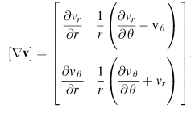

I am extremely happy to see that this all matches. In order to verify Lai, here is what we need to show:

Pij(other) = $\left(\begin{matrix}0 & -vθ/r \\ 0 & vr/r\end{matrix}\right)$

Right now this is not very obvious, since we have

Pij(other) = [(∂'jh'i) v'i + Rid (∂'jRkd) h'k v'k] h'i-1 h'j-1

= (∂'jh'i) h'i-1 h'j-1 v'i + h'i-1 h'j-1 Σkd Rid (∂'jRkd) h'k v'k

Let's just do the first term right here:

Pij(first) = (∂'jh'i) h'i-1 h'j-1 v'i
P11(first) = (∂'1h'1) h'1-1 h'1-1 v'1 = (∂r1) v'1 = 0

Pij(first) = (∂'jh'i) h'i-1 h'j-1 v'i
P12(first) = (∂'2h'1) h'i-1 h'2-1 v'1 = (∂θh'i) h'2-1 v'1 = 0

Pij(first) = (∂'jh'i) h'i-1 h'j-1 v'i
P21(first) = (∂'1h'2) h'2-1 h'1-1 v'2 = (∂rr) (1/r) vθ = vθ/r

Pij(first) = (∂'jh'i) h'i-1 h'j-1 v'i
P22(first) = (∂'2h'2) h'2-1 h'2-1 v'2 = 0

So we find that

Pij(first) = $\left(\begin{matrix}0 & 0 \\ vθ/r & 0\end{matrix}\right)$

We must have then

Pij(first) + Pij(last) = Pij(other)
or
Pij(last) = Pij(other) – Pij(first) = $\left(\begin{matrix}0 & -vθ/r \\ 0 & vr/r\end{matrix}\right)$ – $\left(\begin{matrix}0 & 0 \\ vθ/r & 0\end{matrix}\right)$ = $\left(\begin{matrix}0 & -vθ/r \\ -vθ/r & vr/r\end{matrix}\right)$

So I will have succeeded if I can show that

Pij(last) =$\left(\begin{matrix}0 & -vθ/r \\ -vθ/r & vr/r\end{matrix}\right)$

where

Pij(last) = h'i-1 h'j-1 Σkd Rid (∂'jRkd) h'k v'k

Part II: Show that in fact Pij(last) has the desired form shown just above with lai2.mws

Write

Pij(last) = h'i-1 h'j-1 Σkd Uid (∂'jDkd) h'k v'k

U11 = cosθ U12 = sinθ U21 = -rsinθ U22 = rcosθ

D11 = cosθ D12 = sinθ D21 = -sinθ / r D22= cosθ/r

For each ij choice, there are four terms to add up. Just do manually:

P11(last) = h'1-1 h'1-1 Σkd U1d (∂'1Dkd) h'k v'k

= Σkd U1d (∂'1Dkd) h'k v'k

P11(last,kd=11) = U11 (∂'1D11) h'1 v'1 = cosθ (∂r cosθ ) ... = 0
P11(last,kd=12) = U12 (∂'1D12) h'1 v'1 = sinθ (∂r sinθ) ... = 0
P11(last,kd=21) = U11 (∂'1D21) h'2 v'2 = cosθ(∂r[-sinθ / r]) r vθ = -sinθcosθ (∂rr-1)r vθ
P11(last,kd=22) = U12 (∂'1D22) h'2 v'2 = sinθ(∂r[cosθ/r])r vθ = sinθ cosθ (∂rr-1)r vθ

The sum of these four terms is 0. and that is the desired result!

I will get Maple to compute these things, too much room for PL error here. // That effort was successful! First, I will report out the evaluation of Pij(last) by Maple, then in the next section, I will do the complete Pij in a single shot.
The setting up Maple entries were these, where the qi are defined and then h, D and U entered:

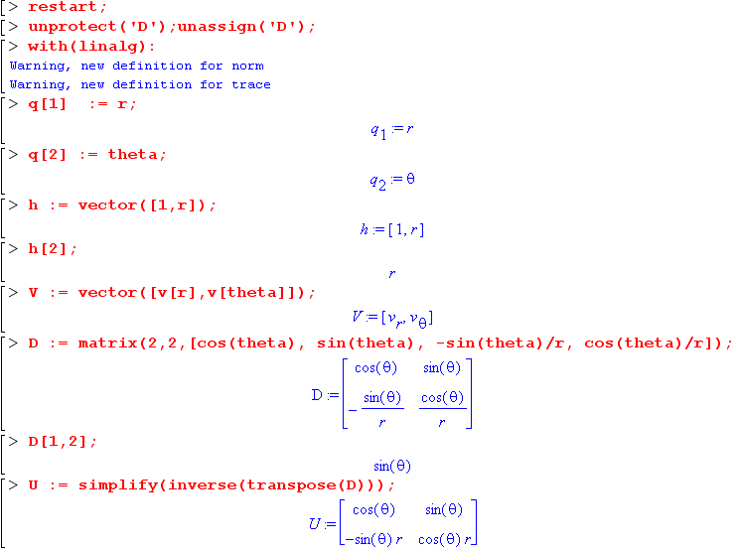

I had to use inert Sum and Diff operators to get things to work, and I put this as an example in my Maple doc matrix section. The first step is to create matrix Pij(last) willed with symbolic expressions:

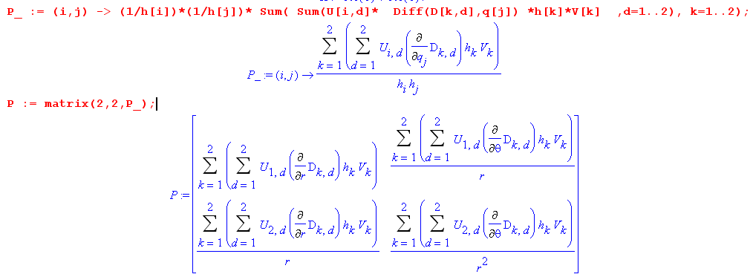

The remaining code evaluated this matrix:

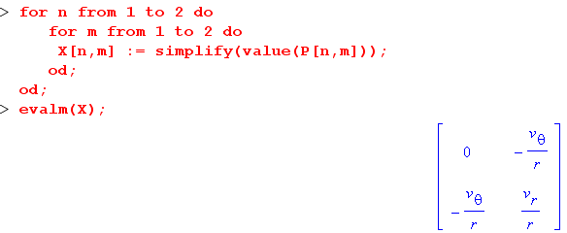

and the final result is what we were hoping to find above, namely,

Pij(last) =$\left(\begin{matrix}0 & -vθ/r \\ -vθ/r & vr/r\end{matrix}\right)$

Part III: Summary and start over using lai3.mws

So finally I have verified Lai's ∇v matrix for polar coordinates "the hard way". I think this took me Jan 20 through 9 AM Jan 25, today. I remember guessing 6 days when I started. Here is a review of what I did.

1. I started with ∇v expressed in Cartesian coordinates, using the quasi-dyadic notation

(∇v) = Σab (∇v)ab uaubT = Σab(∂bva) uaubT = Σcd(∂cvd) uducT

2. I then used ud = Σe h'e-1 Red e to rewrite the unit vector part this way

uducT = [Σe h'e-1 Red e] [Σf h'f-1 Rfc fT] = Σef h'e-1 Red h'f-1 Rfc e fT

so that then

(∇v) = Σcdef(∂cvd) h'e-1 Red h'f-1 Rfc e fT (*)

I did this in analogy with my tensor doc method of expression things in terms of e vectors in x-space. In this step 2 we have assumed we have orthogonal curvilinear coordinates in x'-space.

3. I then expressed (∂cvd) in terms of x'-space objects and coordinates to get,

∂cvd = (Ric∂'i)( Rjdv'j) = Σij Ric [(∂'iRjd) v'j + Rjd (∂'iv'j)]

which shows the "extra term" which appears in this kind of derivative. It is this extra term recall which causes ∂cvd NOT to be a rank-2 tensor. The above equation is valid for non-orthogonal as well as for orthogonal x' coordinates.

Installing this into (∇v) gave (and we are back now only to orthogonal x' coordinates)

(∇v) = [(∂'jv'i) + Rid (∂'jRkd) v'k] h'i-1 h'j-1 i jT

which means the Lai matrix of interest is this

Pij ≡ [(∂'jv'i) + Rid (∂'jRkd) v'k] h'i-1 h'j-1 where (∇v) = Σij Pij i jT

Once again, this result is valid for any orthogonal curvilinear coordinates.

4. I then changed from covariant vi' to unit-vector according to

v'n = h'n v'n

to get

Pij = [(∂'jh'i) v'i + h'i (∂'jv'i) + Rid (∂'jRkd) h'k v'k] h'i-1 h'j-1

or
Pij = [(∂'jh'i) v'i + h'i (∂'jv'i) + Uid (∂'jDkd) h'k v'k] h'i-1 h'j-1
P1 P2 P3

Once again, this result is valid for any orthogonal curvilinear coordinates.

5. I then wrote Maple program lai3.mws which does the following steps:

In Maple I first set things up like this:

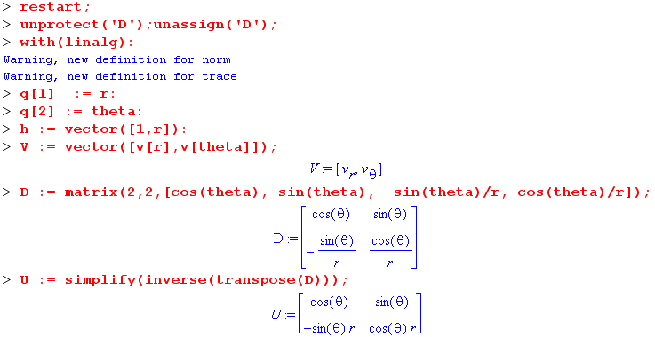

Then I had to split P into three matrices for technical reasons, so

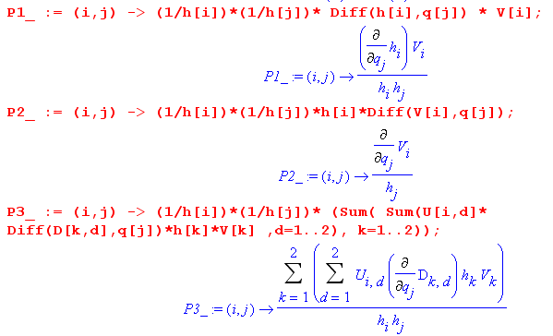

Then I constructed these three matrices

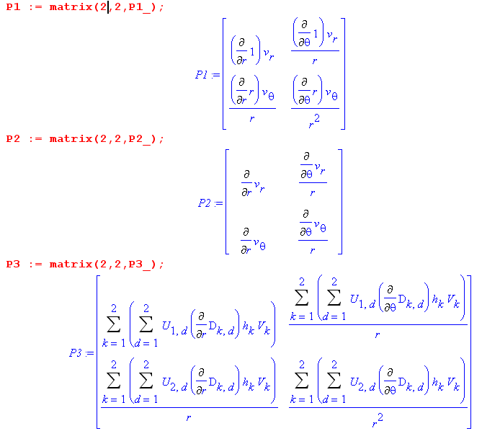

Then I added them together to get the final result

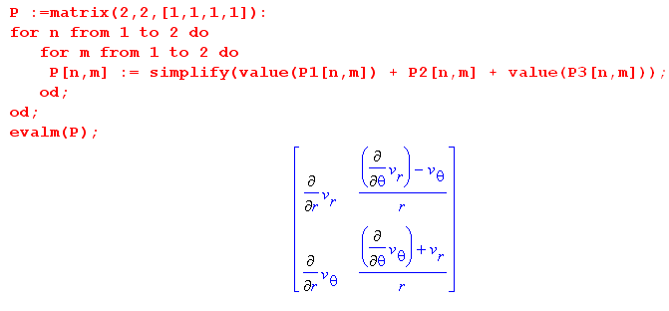

which can be compared to the Lai result, where νn|Maple = v'n = (vr,vθ)|Lai

and these are seen to agree.

Part IV: For other systems.

The easiest matrix to obtain is Uab = Rab = Sab = (∂xa/∂x'b) because one always has x(x') and one can make Maple compute this directly. For example, for sphericals

x = r sinθ sinφ
y = r sinθ cosφ
z = rcosθ

Note that

Sab = Sab = Rba = Uba => U = ST

Rab = Rab = Dab = (S-1)ab => D = R = S-1

In program lea4.mws I did all this and obtained this result for Pij

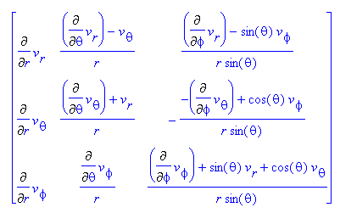

which compare to Lai

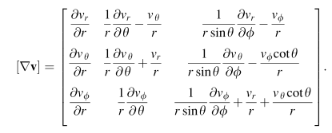
and they agree! So I think I can use my "method" to compute ∇v in any orthogonal coordinate system.

Part IV: Misc Questions.

1. How do we interpret this result:

(∇v) = Σij Pij i jT

I know I can apply n to the right side and Tm to the left to get

Tm (∇v) n = Pmn = < m | ∇v | n >

which is a matrix element of operator ∇v in the e-basis. The Cartesian matrix element would be

(∇v) = Σij Cij i jT Cmn = < m | ∇v | n> = (∇v)mn

This does suggest a simple connection.

ud = Σe h'e-1 Red e = Σe Qed e Qed = h'e-1 Red = a rotation

(∇v)mn = < m | ∇v | n> = < Σf Qfm f | ∇v | Σe Qen e >

= Σf Qfm Σe Qen< f | ∇v | e > = Σfe Qfm Qen Pfe = Σfe Q-1mf Pfe Qen

= [Q-1PQ]mn

One could invert this for Pfe, but that does not yield Pfe in the x'-space coordinates! One cannot avoid the little "extra term" business.

How do we interpret this result :

V = ΣiVi i

Here I can draw a little picture of V as an arrow with projections on the i axes being Vi. But it is just less obvious to me what this means

(∇v) = Σij Cij i jT = Σij Pij i jT

A reason it is useful to have this second thing is this. Suppose you have an equation

a = (∇v) c

and suppose you know vectors a and c in curvilinear coordinates. Then

c = Σici i a = Σiai i

Then you can write

Σiai i = Σij Pij i jT (Σncn n) = Σij Pij i (Σncn) δj,n

= Σij Pij i cj = Σi[ Σj Pij cj] i

Then you know that

ai = Σj Pij cj

So THIS is the motivation for expressing it in the form Σij Pij i jT : you end up with a simple connection between the curvilinear projections of a and c.

Notice that ∇v is NOT a differential operator the way all the other ones are, so I am not sure it makes sense to include it in my tensor doc discussion.

2. What about the other notation:

From my tensor expansions doc I know that

[(∇a) v]i = (∇ai) • v = (∂jai)vj

But in this notation, with the ai appearing we have committed to Cartesians I think. You really have to do something like

ai(x) = Rji a'j(x')

so then

[(∇a) v]i = (∇ai) • v = (∂jai)vj = [ (Raj ∂'a)(Rbi a'b(x'))] Rci v'c(x')

and then you are off and running on the big mess that we have to do either way.
So I guess this does explain to me the utility of the matrix (∇a) in various coordinate systems.

2. What about the differential notation:

We start with

(∇v)ij = ∂jvi

dvj(xn) = (∂ivj(xn))dxi // just chain rule on a function

dvj = (∇v)ji dxi

dvj= (∇v)ji dxi = [(∇v)dr]j

dv = (∇v)dr

So this is the derivation of this simple vector equation which then can be studied in any system. Suppose we write

dv = Σidv'i ei dr = Σidx'i ei

and suppose we have

(∇v) = Σab pab ea ebT

Then we get

dv = (∇v)dr

v = Σiv'iei

dv = Σi(dv'i)ei + Σiv'i(dei)

Now there are going to be coefficients f(i)ab such that

(dei) = Σab f(i)abdx'a eb

and this equation is "the hard part" of this method I think. For sphericals it is not too bad, and I could probably write a general formula. For example, go back to

un = Σm amn em

Do not assume orthogonal, but assume x-space Cartesian, and then write

un • ei = Σm amn em• ei = Σm amn g'mi

un • ei = gab(un)a (ei)b = gab δna Rib = gnb Rib = Rin // p 80 and g = δ

Then we get

Σm amn g'mi = Rin

g'im amn = Rin

Apply g'ji from the left

g'ji g'im amn= g'ji Rin

δjm amn= g'ji Rin

ajn = g'ji Rin => amn = g'mi Rin

so our general result is then

un = Σmi g'mi Rin em

and this can be inverted to get some

en = Σmi Fmi um

den = Σmi (dFmi) um = Σmi (dFmi) Σai g'ai Rin ea

en ≡ Se'n =>

Σadv'a ea = [Σab pab ea ebT ][ Σidx'i ei]

= [Σab pab ea ][ Σidx'i] ebT ei

= [Σab pab ea ][ Σidx'i] eb• ei

= [Σab pab ea ][ Σidx'i] g'bi

= Σa{ Σb pab Σidx'i g'bi} ea

so the coefficients must match

dv'a = Σb pab Σidx'i g'bi

Now suppose g'bi = δbi h'i2 for orthogonal, then we have

dv'a = Σb pab Σidx'i δbi h'i2 = Σb pab dx'b h'b2

∂v'a/∂x'b = pab h'b2

but this seems too simple, you would never got those other linear terms.

