Lai Problem 5.71 page 316 PhL 4.8.12

This was a nice little logjam thrown in the road by Lai at the top of page 264. The issue is how to write the Airy equations in non-Cartesian coordinates. It is extremely non-trivial and took this 10 page effort to get it cleaned up. If I need similar equations in some other coordinate system, I can use this method. But that would have to be some other 2D coordinate system since that is where Airy really applies.

This led to major additions and alterations to tensor doc, now all finished. So most of what appears below is now somewhere in tensor doc. See red comments below.

1. Review of vector transformation. 1
2. Relation between A^{i} and A^{()i} . 1
3. Example: Polar Coordinates. 2
4. Fact that Nª_{b} = { ₁ , ₂, .... } in general case. 2
5. Theorem: _{n} orthogonal => Mª_{b} and Nª_{b} are rotation matrices. 3
6. More general tensors. 4
7. Rank-2 tensors. 4
8. Rest of Problem 5.71 Setup. 5
9. Now we have to compute ∂₁ and ∂₂. 6
10. Finish solving Problem 5.71. 6
12. Is there some simpler way? 8
Appendix A : orthog and completeness for "non orthog" system. 9

1. Review of vector transformation. [ in tensor doc ]

Our famous x-space vector expansions are

A = ΣiAi ui // axis aligned unit vectors
A = ΣiA'i ei // tangent base vectors
A = ΣiA'i ei = ΣiA'i h'i i = A()ii // unit tangent base vectors
A()i = A'i h'i and A'i = h'i-1 A()i

where recall that

A'a = RabAb and the inverse: Aa = SabA'b

We put the index on A()i in the "up" position only because we obtained A()i from A'i and this latter thing had the index in the "up" position. We know that A()i is not a contravariant vector, but we have to put the index somewhere.

2. Relation between Ai and A()i . [ in tensor doc App E (h) ]

Now, we want to find out how Ai and A()i are related to each other.

A()a = A'a h'a = h'a A'a = h'a RabAb = (h'a Rab) Ab ≡ MabAb

Going the other direction

Aa = SabA'b = Sab h'b-1 A()b = (h'b-1Rba) A()b ≡ Nab A()b

Therefore we have A = A()ii

A()a = MabAb Mab ≡ h'a Rab
Aa = Nab A()b Nab ≡ h'b-1Rba = h'b-1 Sab

It seems that M and N should be inverses of each other, so let's check

Mab Nbc = h'a Rab h'c-1 Sbc = h'a h'c-1 Rab Sbc = h'a h'c-1 δac = δac M = N-1

Notice that we have not specified an orthogonal coordinate system for x'-space yet, these results are completely general. At this point, M and N need not be rotations, for example.
Before continuing in the general case, let us now consider polar coordinates which happens to be an orthogonal system.

3. Example: Polar Coordinates. [ in tensor doc App E (h) ]

Example of Polar Coordinates with 1,2 = r,θ first in developmental notation:

Sij = ( ∂xi/∂x'j)

S11 = (∂x/∂r) = cosθ
S12 = (∂x/∂θ) = -rsinθ
S21 = (∂y/∂r) = sinθ
S22 = (∂y/∂θ) = rcosθ

Sij = $\left(\begin{matrix}cosθ & -rsinθ \\ sinθ & rcosθ\end{matrix}\right)$ Rij = $\left(\begin{matrix}cosθ & sinθ \\ -sinθ/r & cosθ/r\end{matrix}\right)$ // Note on this just added to tensor doc.

Now we want to compute the M and N objects:

Mab ≡ h'a Rab = $\left(\begin{matrix}1 & 0 \\ 0 & r\end{matrix}\right)$$\left(\begin{matrix}cosθ & sinθ \\ -sinθ/r & cosθ/r\end{matrix}\right)$ = $\left(\begin{matrix}cosθ & sinθ \\ -sinθ & cosθ\end{matrix}\right)$ = Rz(-θ) in my matrix rot doc

Nab ≡ Sab h'b-1 = $\left(\begin{matrix}cosθ & -rsinθ \\ sinθ & rcosθ\end{matrix}\right)$$\left(\begin{matrix}1 & 0 \\ 0 & 1/r\end{matrix}\right)$ = $\left(\begin{matrix}cosθ & -sinθ \\ sinθ & cosθ\end{matrix}\right)$ = Rz(θ)

4. Fact that Nab = { 1 , 2, .... } in general case. [ in tensor doc App E (h) ]

Now back to the general case. We know from Section 3 of tensor doc that

en ≡ Se'n or en ≡ Sun or h'n n = S un
so
n = h'n-1 S un or
or
(n)a = h'n-1 Sab (un)b = h'n-1 Sab δnb = h'n-1 San = Nan

and this last says that the nth column of Nan is equal to n . Therefore

Nab = { 1 , 2, .... }

So this tells us that the matrix Nab is composed of the unit tangent base vectors as its columns.

5. Theorem: n orthogonal => Mab and Nab are rotation matrices. [ in tensor doc App E (h) ]

We want to show now that if the n are orthogonal, then Nab must be a rotation matrix. I don't know how to do that in standard notation, so let's work in developmental notation which matches the notation of ordinary linear algebra. Then

Nan = (n)a → Nan = (n)a

Then consider

NanNTnc = NanNcn = (n)a (n)c = ?

Suppose the n are orthogonal in x-space. Then we know that

n • m = δnm or <n|m> = δn,m

In the orthogonal case we know that completeness can be stated this way,

1 = |n><n| => <ua|uc> = <ua|n><n| uc> = (n)a (n)c = δa,c

We can now complete what was started above

NanNTnc = NanNcn = (n)a (n)c = δa,c

=> NNT = 1

So as long as the set of basis vectors n forms a complete orthonormal set, we find that N is real orthogonal. Meanwhile

NNT = 1 => det(N)2 = 1 det(N) = ± 1

and we can just assume det(N) = 1.

Theorem just proved: If the unit tangent base vectors n are orthogonal, then N = rotation, and of course this means that M = the inverse rotation.

6. More general tensors. [ in tensor doc App E (h) ]

Above we talked about vectors, and here we want to generalize the above comments to tensors of arbitrary rank. Our expansions are these (from tensor doc)

A = Σijk... Aijk... (ui⊗uj⊗uk...) Aijk... = contravariant components of A in x-space

A = Σijk... A'ijk... (ei⊗ej⊗ek...) A'ijk... = contravariant components of A in x'-space

We rewrite the second one in terms of unit tangent base vectors

A = Σijk... h'ih'jh'k.......A'ijk... (i⊗j⊗k...)

= A()ijk... (i⊗j⊗k...) where A()ijk... ≡ h'ih'jh'k.......A'ijk...

Then we write

A'ijk... = Rii'Rjj'Rkk'...... A i'j'k'...

and so multiplying both sides by h'ih'jh'k... we get

A()ijk... = h'iRii'h'jRjj'h'kRkk'...... A i'j'k'...

= Mii' Mjj' Mkk' ..... A i'j'k'...

Going the other way, we use the fact that N is the inverse of M to write

Aijk... = Nii' Njj' Nkk' ..... A() i'j'k'...

We showed in the last section that if the i are orthogonal, then M and N are rotation matrices.

7. Rank-2 tensors. [ in tensor doc App E (h) ]

In the special case of rank-2 tensors we can write

A()ij = Mii' Mjj' A i'j'
Aij = Nii' Njj' A() i'j'

If we now convert this to developmental notation, we have

A()ij = Mii' Mjj' A i'j'
Aij = Nii' Njj' A() i'j'

which then allows us to write

A()ij = Mii' A i'j' MTj'j
Aij = Nii' A() i'j' NTj'j
or
A() = MA MT
A = NA()NT

If the i are orthogonal, then M and N are rotations, so we can write these as

A() = MA M-1 = MA N
A = NA()N–1 = NA()M

Example: In polar coordinates, we can write

$\left(\begin{matrix}Arr & Arθ \\ Aθr & Aθθ\end{matrix}\right)$ = $\left(\begin{matrix}cosθ & sinθ \\ -sinθ & cosθ\end{matrix}\right)$ $\left(\begin{matrix}A11 & A12 \\ A21 & A22\end{matrix}\right)$$\left(\begin{matrix}cosθ & -sinθ \\ sinθ & cosθ\end{matrix}\right)$

Thus, we have proven the first part of Problem 5.71. It took a lot of fiddling!

Comment #1: I might want to add the above to tensor doc, and maybe reconsider my θ,r ordering once again. It has caused me endless trouble. ***********

Comment #2: Even in the very simple 2x2 case of polar coordinates, things are complicated! The object Arr for example is some linear combination of ALL the Aij .

8. Rest of Problem 5.71 Setup. [ in tensor doc App E (h) ]

For plane strain and plane stress applications in Cartesian coordinates, we used the Airy function in this manner:

T11 = ∂22φ T22 = ∂12φ T12 = T21 = – ∂1∂2φ

Therefore we can write our polar coordinates stress tensor situation as follows

$\left(\begin{matrix}Trr & Trθ \\ Tθr & Tθθ\end{matrix}\right)$ = $\left(\begin{matrix}cosθ & sinθ \\ -sinθ & cosθ\end{matrix}\right)$ $\left(\begin{matrix}∂22φ & – ∂1∂2φ \\ – ∂1∂2φ & ∂12φ\end{matrix}\right)$$\left(\begin{matrix}cosθ & -sinθ \\ sinθ & cosθ\end{matrix}\right)$

where ∂n refers to xn.

The following stuff is NOT in tensor doc!

9. Now we have to compute ∂1 and ∂2. [ results only in tensor doc App E (h) ]

x1 = r cosθ θ = tan-1(x2/x1)
x2 = r sinθ r = [x12+ x22]1/2

∂1 = ∂/∂x1 = ∂r/∂x1 ∂r + ∂θ/∂x1∂θ
∂2 = ∂/∂x2 = ∂r/∂x2 ∂r + ∂θ/∂x2∂θ

∂r/∂x1 = (1/2)r-12x1 = x1/r = cosθ
∂r/∂x2 = (1/2)r-12x2 = x2/r = sinθ

∂θ/∂x1 = 1/(1+(x2/x1)2) (-x2/x12) = x12/(x22+x12) (-x2/x12) = -x2/r2 = -sinθ/r
∂θ/∂x2 = 1/(1+(x2/x1)2) (1/x1) = x12/(x22+x12) (1/x1) = x1/r2 = cosθ/r

Then

∂1 = cosθ ∂r - (sinθ/r)∂θ
∂2 = sinθ ∂r + (cosθ/r)∂θ

Question: Is there some simple way to make Maple do the above work, now that I have done it?
The answer is a resounding YES. Here is how you do it:

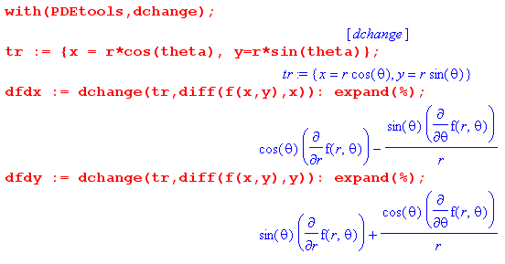

This should be put into my User Guide right now!!! DONE.

10. Finish solving Problem 5.71. [ results only in tensor doc App E (h) ]

Our situation so far is this:

$\left(\begin{matrix}Trr & Trθ \\ Tθr & Tθθ\end{matrix}\right)$ = $\left(\begin{matrix}cosθ & sinθ \\ -sinθ & cosθ\end{matrix}\right)$ $\left(\begin{matrix}∂22φ & – ∂1∂2φ \\ – ∂1∂2φ & ∂12φ\end{matrix}\right)$$\left(\begin{matrix}cosθ & -sinθ \\ sinθ & cosθ\end{matrix}\right)$ = M T MT

∂1 = cosθ ∂r - (sinθ/r)∂θ
∂2 = sinθ ∂r + (cosθ/r)∂θ

Maple is going to know about these last two lines for ∂1 for ∂2 from the transformations tr I enter below. Here then is how I got Maple to do everything (see Lai5_71b.mws). First, we implement the above matrix equation: (the Cartesian matrix is Tij while TP = T()ij, but we work in dev not so all indices are down and say then we start with Tij and we are computing TP = T()ij )

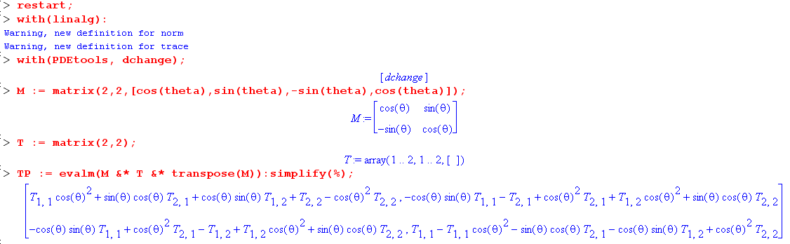

Next, I tell it what the Tij are in terms of the Airy function φ ,

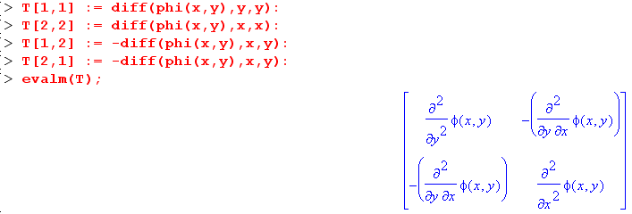

I then use dchange to handle all these messy derivatives. Applying dchange just to matrix Tij gives pretty messy results, for example here is ∂y2φ = [sinθ ∂r + (cosθ/r)∂θ]2 φ :
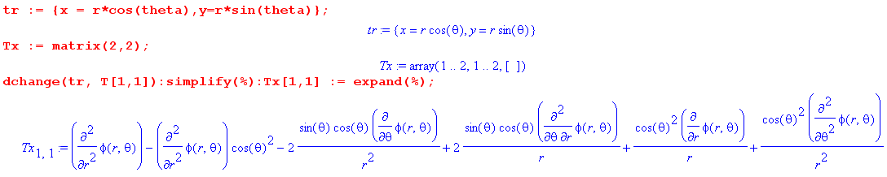

where there are 5 different types of terms! But if we go ahead and do this and then compute the TP matrix which includes Trr (and which matrix I call TPx), we get

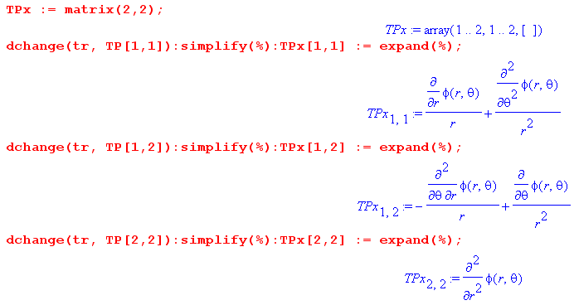

and this agrees with the results Lai shows on in Problem 5.70 (p 316) and on page 264 top. So there are lots and lots of terms, but there is a huge amount of cancellation. I then finished up in Maple like this:

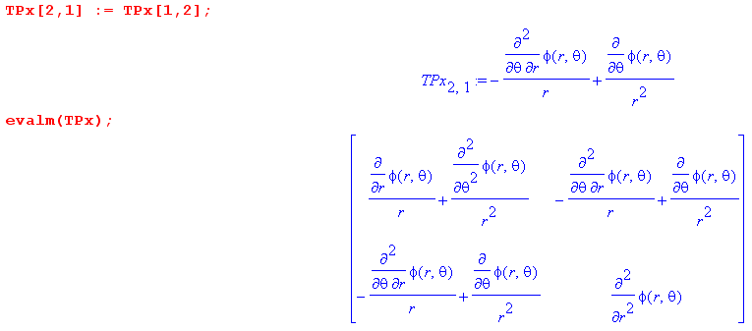

12. Is there some simpler way? [ I don't think so ]

Well, if you want to write ANY expression for Trr you have to somehow express Trr in terms of the Cartesian animals, and that was provided above by

$\left(\begin{matrix}Trr & Trθ \\ Tθr & Tθθ\end{matrix}\right)$ = $\left(\begin{matrix}cosθ & sinθ \\ -sinθ & cosθ\end{matrix}\right)$ $\left(\begin{matrix}T11 & T12 \\ T21 & T22\end{matrix}\right)$$\left(\begin{matrix}cosθ & -sinθ \\ sinθ & cosθ\end{matrix}\right)$

There IS no other way that I know to relate Trr to the four Cartesian Tij objects. This then gave

so you can see for Trr there are essentially 3 terms since the two T's are equal.
THEN, having found an expression for Trr you install the Airy guys

$\left(\begin{matrix}Trr & Trθ \\ Tθr & Tθθ\end{matrix}\right)$ = $\left(\begin{matrix}cosθ & sinθ \\ -sinθ & cosθ\end{matrix}\right)$ $\left(\begin{matrix}∂22φ & – ∂1∂2φ \\ – ∂1∂2φ & ∂12φ\end{matrix}\right)$$\left(\begin{matrix}cosθ & -sinθ \\ sinθ & cosθ\end{matrix}\right)$

I just don't know how else you could do this! Yes, you can show as Lai does on page 264 that the resulting forms satisfy the two polar static Navier equations, and then just start your theory from that point. I never tested that out, by the way, which is problem 5.70 (I have not done it, but could), using Maple to compute everything.
So no, I don't think there is any simpler way.

Appendix A : orthog and completeness for "non orthog" system. [ tensor doc App E (g) ]

Suppose n are complete but non-orthogonal. How do you write completeness in this case?

Well, the claim is that for any vector A you can expand as follows

A = An n |A> = An|n >

Then

A • m = An n• m = An g'nm // really should be g-bar in dev not

A • m (g'-1)mk = An g'nm (g'-1)mk = Anδnk = Ak
so
Ak = (A • m ) (g'-1)mk

so at least I can write something for the coefficient.
Is it possible that completeness still says

1 = |n><n| ?

If we apply this to |m > we would get

|m > = |n><n|m > = |n> g'nm

Then close left with <m| to get

<m|m > = <m|n> g'nm

1 = <m|n> g'nm = (g'nm)2

which is wrong. So conjecture that completeness looks like this instead

1 = |n>(g'-1)nm<m|

Now repeat the above steps

|m > = |n>(g'-1)nk<k|m > = |n>(g'-1)nkg'km = |n> δnm = |m >

and then we are happy again.
Here is another way to say all this: In all cases (orthog or not) we know that

<n|m > = δnm n• m = δnm

1 = |n> <n| // this is correct

