Lai and my PVC pipe PhL 4.14.12

This relates to Lai p 267 concerning pipes.

PVC pipe Example: how much Tθθ can it take? We will set Tθθ = pi 2 / [ (b/a)2 - 1 ]

Conclusion : theory agrees with practice, ball park.

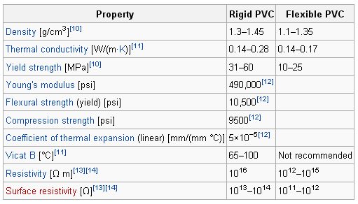

I guess the PVC pipe would be "rigid".

The yield strength or yield point of a material is defined in engineering and materials science as the stress at which a material begins to deform plastically.

So let's do some measurements right now, or look it up

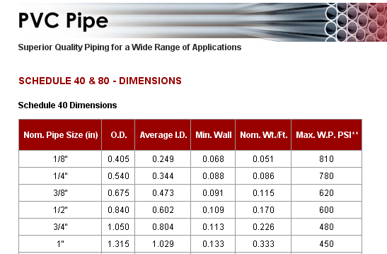

The stuff we use for sprinklers has ID ≈ OD ≈ 1", so it is the 3/4" nominal. Then

a = 0.804" b = 1.050: (b/a)2 = 1.71

My condition will be at the outer surface so

Tθθ = YS = Tθθ = pi 2 / [ (b/a)2 - 1 ] = pi2/.71 = 2.8 pi

So the pipe starts stretching when

pi = Tθθ/2.8 = 31 MPa/2.8 = 11 MPa ≈ 10 atmos ≈ 150 psi

That is not really very much! I used the low end of the yield strength range, the high end would give 300 psi, and my pipe has 200 psi printed on it! This is for the weaker "Schedule 40" type pipe. Here is a table suggesting 480 psi.

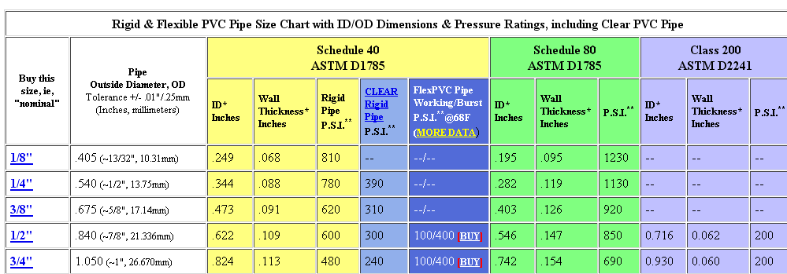

But here is a different quote on yield strength

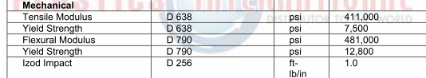

I think "tensile modulus" means Young's modulus at 411,000 psi here and 490,000 psi in the previous table, so ball park. Here yield strength is 7500 psi and 1 MPa is 145 psi so this is 7500/145 = 51.72 MPa, again in our range!
Here from a PDF

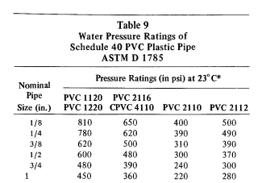

which shows a range of 240-480 psi depending on the kind of PVC ! They note that Sch 40 is too thin to allow threaded connections, whereas Sch 80 does allow that, though you get much lower psi rating.

