Essay on covariance of constitutive equations PhL 9.27.12

Example 1: A massless spring (aligned in the x direction) connects two objects A and B and is stretched an amount Δx = 1 cm. The two objects are pulled together by a force F = kΔx. Assume k = 1, so then F = 1 dyne. This equation is an example of a constitutive equation, F = kΔx, which relates a "state of stress" to a "state of deformation". Now suppose our entire Apparatus including A and B is in a frame of reference that accelerates in the x direction with respect to some fixed observer. Let S be the frame of the fixed observer (an inertial frame), and let S' be the accelerating frame. Here is the question: do both observers agree that the force pulling A and B together is 1 dyne? Well, let's imagine that we have some sort of computer control system or whatever which makes sure the spring is stretched 1 cm despite any acceleration (or rotation) that is applied to frame S to get frame S'. Obviously just a mass on a spring is not going to do this, but we could imagine some control system that does do the job. So both observers see a 1 cm stretch of the spring (we are of course non-relativistic here). [ The control system might be that both ends of the spring are nailed down to a board, so A and B are the two nails.] We feel pretty strongly that both observers observe the same spring constant k for the same spring, and both observers will "see" the same stretch 1 cm and the same force 1 dyne. They will probably measure this force with some other "calibrated spring" which works regardless of acceleration. So the upshot, as I like to say, of this example, is that both observers see that same Δx and the same F. These quantities (and k as well) transform as scalars with respect to a transformation which involves acceleration in the x direction. The constitutive equation F = kΔx is therefore "covariant" with respect to this type of transformation, and in fact both sides are scalars.

Example 2: We now take the same system of Example 1 (perhaps board onto which a stretched spring is nailed down, so A and B are the two nail). This time we think of our system as moving in 3D space, and our constitutive equation is F = k Δr. Again frame S is fixed, while frame S' is allowed to move and accelerate and rotate with complete abandon relative to frame S. It could be a rough ride for our Frame S' observer. Suppose at some instant in time frames S and S' are related by a rotation R(t), so Δr' = R(t)Δr. This means that Δr transforms as a vector under R(t). Our Frame S' observer, despite all the strange accelerations he feels, is going to measure this Δr' in some direction at some time, with magnitude | Δr' | = 1cm and is going to measure F' being in this same direction, with magnitude |F'| = k | Δr' | = 1 dyne. This observer sees this equation F' = k' Δr' with k' = k. The conclusion is that F transforms in the same way as Δr under the transformation relating the two frames. The equation F = k Δr is then "covariant" between our two frames, since it has exactly the same form in the two frames. So F' = R(t) F. Both sides of our constitutive equation F = k Δr then transform as vectors under our time dependent rotation R(t), and in fact this is also true if we generalize our transformation to be an arbitrary time dependent Galilean transformation (ie, if we add a translation). Maybe a better way to say this result is that both an observer in an inertial frame S and an observer in a non-inertial (possibly rotating) frame S' see the same equation which is the constitutive equation. This is very different from what we say about an equation of motion!

Theorem 1: We want our constitutive equation to be covariant with respect to any time dependent Galilean transformation. We want this because we want any Galilean observer to have the same equation relating stress to deformation. Specifically, we want both sides of our constitutive equation to transform as tensorial tensors (of the same type) with respect to 3D time dependent rotations R(t). The translations won't play much role really. Tensorial tensors which are tensors with respect to the time-dependent rotation R(t) are called objective tensors (or indifferent tensors). All tensors in Lai are in fact tensorial tensors with respect to time-independent rotations R, so the key thing here is time-dependent R(t). As shown in Example 3 below, velocity v is a tensorial vector with respect to R, but not R(t).

Comment. Notice that we are NOT saying that the equation of motion should be covariant under a time-dependent Galilean transformation. In fact, it won't be for sure, since F = ma is not.

Theorem 1 says for the continuum mechanics world that we want the equation relating our state of stress to our state of deformation to be covariant in frames S and S' related by time-dependent Galilean transformations. One nice way to achieve this goal is to have both sides of the constitutive equation be the same kind of tensorial tensor with respect to the Galilean transformation. Our usual stress tensor T (the Cauchy stress tensor, as opposed to one of the Piola-Kirchhoff ones, say) we know is a tensorial tensor under time-independent rotations, just as we know that force F in the Example 2 is a tensorial vector under time-independent rotations. We will later show that the deformation tensor named B transforms as a tensorial rank-2 tensor under a time-dependent Galilean transformation. Just as we "conjectured" that the spring force F transforms as a tensorial vector under time dep Gal transforms, so we "conjecture" that the Cauchy tensor T transforms as a tensorial rank-2 tensor under time dep Gal transforms. Probably we could prove this conjecture using the fact that the components are in fact forces/area and area does not change, etc etc. Lai however just takes this as an ansatz. Therefore, the equation T = kB with k being a scalar under time dep Gal transforms would be a viable covariant constitutive equation, because both sides transform the same way, ie, as rank-2 tensors. It is easy to show that if B transforms as a rank-2 tensor, so does B2 and so does any power, and so then does any polynomial of B. To the extent that a smooth function f(B) can be fitted with a polynomial (perhaps of infinite degree), we conclude that f(B) transforms as does B, and therefore T = f(B) is also a viable covariant equation for any reasonable function f.

Example 3. Suppose x'-space and x-space in tensor doc with xμ = (x,t) as coordinates are related by this 4x4 matrix transformation F of x' = F(x) which says x'μ = Fμν xν with

F = R4x4 = $\left(\begin{matrix}R(t) & 0 \\ 0 & 1\end{matrix}\right)$

where R(t) is a time-dependent 3x3 rotation matrix. In this case we have x' = R(t) x and t' = t as the transformation written in two parts. Since x' = R x, we conclude that x transforms as a vector under this 3x3 rotation transformation, even though it is time dependent. But now consider,

' = R + x or v' = R v + x

Our first conclusion is that velocity v does not transform as a tensorial 3-vector under rotation R(t) because we have that extra term x. It seems very likely that F = ma as an equation of motion won't be covariant under the transformation F stated above (we have two different F objects here). Thus, in the rotating frame of x'-space, although we do have m' = m, we will not have F' = ma' . As confirmation of this conjecture, we have "frames doc" which tells us that in fact we have F' = ma' + fictitious forces. So in this little transformation example, which does not include translations, we still find the idea that the velocity of a particle v fails to be a tensorial vector under R3x3(t) and F = ma is non-covariant.

Theorem 2: Suppose T = f(B) is covariant, so that T' = f'(B') in frame S'. We know that

T' = R(t)TR(t)T T is an objective rank-2 tensor

B' = R(t)BR(t)T so is B

Therefore, T' = f'(B') says

RTRT = f'(RBRT)

If (added ingredient!) our medium is isotropic, then frame S' observer's function f' should be the same as frame S observer's function f, and then we get

RTRT = f(RBRT) (*)

as a condition of function F.

Theorem 3: (see notes on Appendix 5C.1 in Lai Ch 5 notes) [ theorem stated last paragraph ]

(a) Now we might suppose that f(x) is some arbitrary polynomial for T = f(B). A more restrictive assumption might be that f(x) is some arbitrary polynomial whose coefficients are scalars under R(t). Then we would have f(B) = Σn=0∞ αn(B) Bn where the αn are scalar functions of Bij. Then we have

f(RBRT) = Σn=0∞ αn(RBRT)n = Σn=0∞ αn(RBnRT) = R { Σn=0∞ αnBn } RT = R f(B) RT = R T RT

and we have satisfied our isotropic requirement (*) above. Notice the subtle step in the above line where we assume that the αn , which we know must be functions of the Bij, are scalar functions of the Bij and therefore [R(t), αn ] = 0 so we can change the order and write αnR as Rαn in each term. In general, of course, we know that [R(t), Bij] ≠ 0 because the Bij themselves are NOT scalars (they are elements of a tensor). [ I forget what this commutator is, probably same as for product of two vectors viwj ]

(b) Lai shows on page 40 that for a 3x3 symmetric matrix B, there are in general only three αn(B) you can construct which are scalars under rotations. They are called "the principle scalar invariants" I1, I2, I3 where I3 = det(B). Thus, our coefficients in the infinite f(B) series above would have to be functions of these three scalar invariants.

(c) Since B = FFT is symmetric, B has eigenvalues and eigenvectors, so Bni = Λini. As usual, the eigenvalues come from the secular equation det(B-ΛI) = 0 which is Λ3 + aΛ2 + bΛ + c = 0 where it turns out a = -I1, b = I2, c = -I3, where these Ii are those "invariants" which are functions of the Bij (Lai p 40) and in particular I3 = det(B) = Λ1Λ2Λ3. These "invariants" are in fact scalars under R(t), and most people are familiar at least with the determinant of B being a scalar. According to the C-H theorem, any symmetric matrix B must satisfy its own secular equation, so we have B3 + aB2 + bB + c = 0. This is the key fact, written perhaps as B3 = - [aB2 + bB + c]. Therefore, any f(B) polynomial which has scalar coefficients can be reduced to the form f(B) = a0I + a1B + a2B2 where the ai are functions of the Ii and are therefore themselves rotational scalars. If B is invertible, then we know that B2 + aB + b + cB-1 = 0 so we can replace B2 to get f(B) = φ0I + φ1B + φ2B-1 which is an alternate "most general form" for f(B).

Our theorem then states: for an isotropic medium, the constitutive equation which is covariant under time dependent Galilean transformations has the most general form T = a0I + a1B + a2B2 where the ai are scalars and can be regarded as functions of the scalar invariants Ii (or we can use the other form). This is a very powerful theorem I would say!

Example 4. Imagine some flow of a continuum medium of some sort. The flow is filmed by one static cameraman located in inertial frame S, and by another in flying frame S'. The flying frame starts at time t0 being in exact alignment with frame S. The last frame of film is at some time t > t0.
The Frame S person measures dx = F dX as the motion of the dumbbell dX and so dx is visible in his last frame of film. The Frame S' person measures in his last frame dx' = F' dX' with dX' = dX at time t0 since the two frames were aligned then. We want to know how F and F' are related:

dx' = F' dX' = F' dX = F' [(F-1)dx] = (F' F-1) dx

At time t, the two frames are related by some rotation R(t). It has been changing in time, and this is the rotation we end up with. Again, at time t which is the end of both films, S' and S are related by some rotation R(t) and some translation c(t) which does not matter for a dx type object. Thus, dx' = R(t) dx. Comparing this to the line above we find that

F' F-1 = R => F' = RF

This appears as F* = QF on page 336 equation (5.56.21).

Theorem 4: The "deformation gradient" Fij is not even a tensor under time-independent rotations. Lai never refers to it as a tensor. In Frame S' an observer sees F' = RF and not F' = RFRT.

Example 5. Here is another "view" of the situation of Example 4,

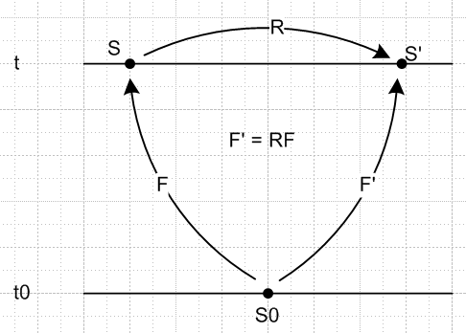

Now we have three "spaces" called S0, S and S'. We know that matrix F is the transformation-F for the transformation on the left between S0 and S, so there we have dx = F dX where dX is in Frame S0. Similarly, matrix F' is the transformation-F for the transformation on the right between S0 and S', so there we have dx' = F' dX' where dX' = dX is in Frame S0. The picture shows that F' = RF in going between the two spaces S and S' on the top of the figure. This is reminiscent of pictures I show in tensor doc. We are not claiming here that either F or F' is a "tensor". They are more like the R and S matrices of tensor doc which have a leg in each of the two associated worlds. We never tried referring to R and S as tensors and in fact showed they were not tensors. A tensor must live in some space. Here, F, R and F' are all transformations between spaces, so they are not tensors in a specific space.

Example 6. Same scenario as above, but consider the object C = FTF for the frame S observer and consider the object C' = F'TF' for the frame S' observer. We have

C' = F'TF' = (RF)T(RF) =FTRTRF = FTF = C

so we end up with C' = C for this object. Again, C is not a tensor because it doesn't live in one space, it is like F in this regard. It just happens that the non-tensor objects C and C' are the same. If you were to "regard" C as an object in space S, and C' as an object in space S', you could "say" that each element of the matrix C is a scalar with respect to rotation R. Similarly, you can say that F is neither a scalar nor a vector nor rank-2 tensor in this same "regarding" sense, since F' = RF. Maybe you could regard F as a set of three column vectors each of which is really a tensorial vector under R, something like that. Here is a little web clip I found supporting this view:

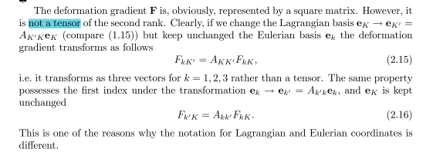

So this guy Krzysztof Wilmanski of Poland says directly that "F is not a rank-2 tensor" and then he says direction "it transforms as three vectors", so I am supported on both these conjectures. So why do people refer to F as a "tensor"?

Example 7. Same scenario with B = FFT on the left and B' = F' F'T on the right. The line is then

B' = F' F'T = (RF)(RF)T = R F FTRT = R B RT

In the case of B, we find that if we regard B as in S and B' as in S', then B transforms as a rank-2 tensor under rotation R. So of the three matrices F, C, B, only the matrix B transforms as a tensorial rank-2 tensor under R. Here are some comments on this subject in a Los Alamos pdf. First we have this

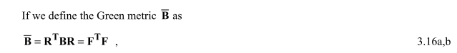

so this thing is really our object C (forget the middle object), and this author refers to it as "The Green metric" and does not call it a "tensor". Then in Appendix C this guy says.

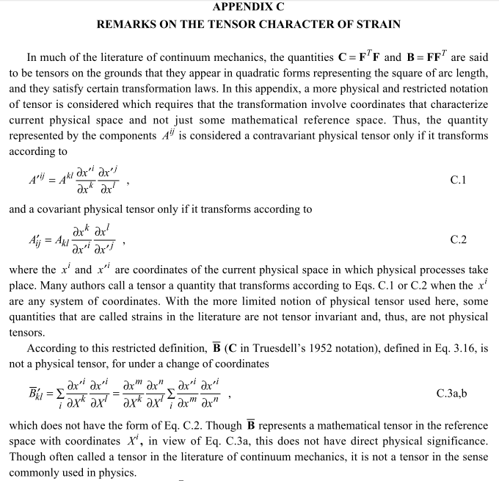

So he first shows that my C = FTF object does not really transform as a tensor. He then basically says right there" Although C is often called a tensor in cont mech, it is not really a tensor" ! Hurray, we agree on this notion. He goes on to say

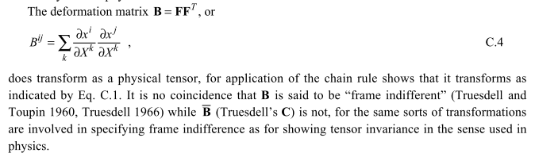

So basically the cont mech people refer to certain objects as "tensors" when in fact they are not really tensorial tensors. This is now 100% confirmed.

Comments on the above working notes:

1. Consider again the picture of Example 5 above

Although F is really a transformation between two "spaces" (S0 and S, with X and x as coordinates), we can interpret it as a property of the medium at x and t. It is a property of a particle at x, at time t. It tells you the "state of deformation" of that particle. Now true, that state is relative to the state it was in at reference time t0, but that is OK, it is still a property of the particle at x,t. We might write Ft0(x,t) to show the appropriate dependences. And yes, on the right we have some F't0(x',t) where let's just say space S' is simply rotated by some specific matrix R relative to S, which means x' = Rx.

2. We don't need R to be time dependent except in this sense: if R were completely independent of time, when we would have x' = Rx at all times including time t0. But one of our conditions is that x' = x at time t0 so we must have had R = 1 at that time. So yes, in this sense we must regard R as R(t). But perhaps R(t) moved away from R = 1 early in the flow above, and reached some constant value R1 and then froze at that value for a long time before the flow got to t. So then at time t, we don't necessarily have a rotation linking S and S' which is at that moment changing in time. That rotation would be R1 which has been constant for a while and will be constant for a while in the future. The point I am making here is this: both S and S' could be inertial frames in the neighborhood of time t. It is not important to this discussion that if one is inertial, the other is not.

3. So the upshot is that we have this property at point x which is called Ft0(x,t) for an observer in Frame S, and is called F't0(x',t) for an observer in Frame S', and the two frames are related by a rotation which we can regard if we like as either a constant or not a constant.

4. We can show that [Ft0(x,t)]ij , although a matrix with two indices, is not in fact a tensorial tensor under the rotation R. So it is not a rank 2 tensor with respect to R. However, its columns are rank 1 tensors with respect to R! (need to make sure it is not the rows). In fact there is no transformation anywhere in this picture or any picture with respect to which this F thing transforms as a rank-2 tensor.

5. We can define B and C as functions of F, and thus B and C can also be regarded as properties of the point x in the fluid (albeit, with respect to time t0, just as with F). In S' they are B' and C'. We show above that in fact C = C' which says that each element of C transforms under R as a scalar. We also show that B' = RBRT and therefore, among all these three tensor-like objects, this one really does transform as a rank-2 tensor with respect to R.

6. Once we can somehow establish that the Cauchy stress tensor T transforms under rotation as a rank-2 tensor, THEN we can arrive at the reasonable idea that we must have T = f(B) as outlined above, since then both sides transform as a rank-2 tensor, and then we have a constitutive equation which is covariant, so it has the same form in frame S as in frame S'. Unlike with the equation of motion, this covariance of the constitutive equation is valid even if both S and S' are non-inertial frames!

I am now going to attempt to rewrite my tensor doc sections right here, with this improved understanding of things, and then when I finish Chapter 8, I can see whether something else has been misunderstood, and then I will republish tensor doc.

Section 5 (a).

There are, however, applications of transformations where the scalarity of (ds)2 is not required and in fact it is crucial that (ds)2 change under a transformation. For example, in continuum mechanics one can consider x-space to be a space describing a flow of continuous matter at some initial time t0 and x'-space to be the same flow at a later time t. A general flow has x' = F(x) where x is the position of a continuum "particle" at time t0 and x' is the position of that same particle at time t. In general F is a non-linear transformation (we use F in place of F due to a new F to appear below). The distance between two differentially spaced particles at the two times is dx and dx', and one has dx' = R dx where R is the linearized F. The whole point here is that during the flow, the distance vector between two close particles rotates and stretches in some manner, and in general (due to this stretch), |dx| ≠ |dx'| , so (ds)2 is definitely not invariant under the flow (ie, under the transformation F). In this case, the rule ' = ST S does not apply, and one is free to select a metric tensor in each space independently. Since material flows usually occur in Cartesian space, one usually takes g = 1 and g' = 1. As we show later in section (o), the equation dx' = Rdx translates into dx = FdX in Lai (p 105) where F (our R) is called the deformation gradient and is written F = (∇Xx) which is a dyadic like notation discussed in Appendix E and G.
In general, we shall be assuming that in fact (ds)2 is a scalar in almost everything that follows.

Section 5 (o)

(o) Continuum Mechanics and its Metric Tensors

Flow considered as a transformation

One can describe (Lai) the forward "flow" of a continuous blob of matter by x = x(X,t) where X = x(X,t0). A "particle" of matter (imagine a tiny cube) that starts at location X at time t0 ends up at x at time t. Two points in the flow separated by dX at t0 end up separated by some dx at t. The relation between them is given by dx = F dX where F is called the deformation gradient. F describes how a particle starting say with a cubic shape at t0 gets deformed into some parallelepiped (3-piped) shape at t.
The finite-time flow x = x(X,t) from time t0 to time t can be thought of as a generic (generally non-linear) transformation of the form x = F(X) as in section 1 above (but we replace our usual F by F to avoid confusion between two F symbols: F is now the linearization of transformation F at a point x). The two times are regarded as fixed parameters. Both the starting X-space and the ending x-space are Cartesian spaces, since this flow occurs in the physical world! Thus, the metric tensors for x-space and X-space are both 1 for Cartesian coordinates in each of these spaces. This in turn means that the covariant tensor analysis concepts such as the preservation of the length of a vector under the transformation go out the window, and in fact the vector dX typically gets stretched as dX → dx so that | dX | ≠ | dx |. This was discussed briefly at the end of Section 5 (a).
In order to put this flow into the notation of this document, let X → x and x → x' so that

continuum mechanics this document (Forward Flow)
x, X ↔ x', x
x = x(X,t) ↔ x' = F(x) // Lai p70 (3.1.4)
dx = F dX ↔ dx' = R dx // as in Section 2 // Lai p86 (3.7.6), p105 (3.18.3)
F ↔ R
X = Cartesian ↔ = 1
x = Cartesian ↔ ' = 1
B = FFT ↔ ' = RRT // as in Section 5 (l) // Lai p121 (3.25.2)

Thus, the deformation gradient F is just the R matrix of the forward transformation x = x(X,t) = F(X). What we might call the "would-be" metric tensor, ' = RRT = STS ( that is, the ' metric tensor that would have resulted in scalars being true scalars under the transformation), appears as B = FFT and this is known as the left Cauchy-Green deformation tensor (manifestly symmetric).
Regarding the above as a description of forward flow, one could consider instead the inverse flow process, but with F having the same meaning as in the forward flow, dx = F dX. Then the inverse flow translation table would be this :

continuum mechanics this document (Inverse Flow)
X, x ↔ x', x
X = X(x,t) ↔ x' = F(x)
dX = F-1 dx ↔ dx' = R dx // as in Section 2 x = F(X)
F-1 ↔ R
F ↔ S // S = R-1 and Sik = (∂xi/∂x'k) ↔ Fik = (∂xi/∂Xk)
X = Cartesian ↔ = 1
x = Cartesian ↔ ' = 1
C = FTF ↔ ' = STS // as in Section 5 (l) // Lai p114 (3.23.2)

In this direction the would-be ' tensor corresponds to C = FTF which is the right Cauchy-Green deformation "tensor".
Given the above flow situation, it is then possible to add two more transformations F1 and F2 which take X-space and x-space to independent sets of curvilinear coordinates X' and x':

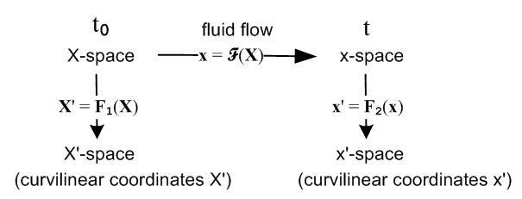

and we then have an interesting triple application of the notions of Section 1 to a real-world problem. This drawing is the implicit subject of Section 3.29 (p131) of Lai.
In (reverse) dyadic notation the deformation gradient is written F = (∇x) where ∇ means ∇(X)so that

dx = F dX = (∇x) dX Fij = (∇x)ij = ∂j(X)xi = ∂xi/∂Xj

The (∇x) notation is explained in Appendix E, and in Appendix G the object (∇v) for an arbitrary vector field v(x) is expressed in general curvilinear coordinates.

Length, Area and Volume

Section 8 discusses how length, area and volume transform under a transformation like F. In that discussion we can regard the Section 8 picture with its "Cartesian-View" x'-space and the skewed N-piped to its right as describing the (inverse) fluid flow situation for a tiny fluid particle. It is shown there that the length, area and volume magnitude ratios are given by (converted to developmental notation),

| dx(n)|/ dL'n = h'n = ['nn]1/2 = the scale factor for edge dx(n)

| (n)|/ dA'n = (1/h'n) |J| = (1/h'n) g'1/2 = ['nn g']1/2 = [cof('nn)]1/2

|dV| / dV' = |J| = g'1/2 // g' ≡ det('ij) = J2 , ' = STS

which can be translated into our inverse flow context as follows :

| dx(n)| / | dX(n)| = ['nn]1/2 = [(FTF)nn]1/2 = [Cnn]1/2 // Lai p114 (3.23.6)

| dAn| / | dA0n| = [cof('nn)]1/2 = [cof((FTF)nn)]1/2 = ['nn g']1/2 // Lai p129 (3.27.11) *

|dV| / |dV0| = |J| = [det('ij)]1/2 = [det(FTF)]1/2 = |det(F)| // Lai p 130 (3.28.3)

where
edge area volume
X-space : dX(n) dA0n dV0 time t0
x-space : dx(n) dAn dV time t

Thus, for example, the volume change of a "flowing" particle of continuous matter is given by the Jacobian |J| = |detF| associated with the deformation gradient F. We put quotes on "flowing" only because this might be a particle of solid steel that is momentarily moving and deforming a very small amount during an oscillation or in response to an applied stress.

* Details of the area ratio in developmental notation. The end of Section 8 (c) item 9 gives the transformation of covariant differential area expressed in developmental notation,

' = J ST J = det(S) = g'1/2 g' ≡ det('ij) = det(STS) = det(RRT) .

Here ' is the covariant differential area in Curvilinear-View x'-space,

' = g' (dx'[1]) x (dx'[2]) ... x (dx'[N-1])

(')i = 'iabc..x (dx'[1])a(dx'[2])b.... (dx'[N-1])x

= g' iabc..x (dx'[1])a(dx'[2])b.... (dx'[N-1])x = permutation tensor

Defining ' as the corresponding differential area in Cartesian-View x'-space, then

' ≡ (dx'[1]) x (dx'[2]) ... x (dx'[N-1])

' = g' ' = J2'

and the above transformation rule becomes ' = J ST = J2' or

' = J-1 ST

which can be inverted to give,

= J (ST)-1' .

Now write = (dA)n and ' = (dA')n' where n and n' are unit vectors to get

(dA) n = (dA') J (ST)-1 n'

In the inverse flow scenario shown above, x'-space = X-space = the flow status at time t0 so one can replace primes with 0 subscripts and replace S by F to get

dA n = dA0 J (FT)-1 n0 J = det(F) = g'1/2 // Lai p 129 (3.27.12)

In the special case that n0 points along the k-axis in X-space, the above becomes (uk is a unit vector)

dA(k) n = dA(k)0 det(F) (FT)-1 uk // Lai p 129 (3.27.10) with k=3

dA(k) = dA(k)0 det(F) | (FT)-1 uk | // Lai p 129 (3.27.11) with k=3

where the second line shows the Cartesian magnitude of both sides. But

| (FT)-1 uk |2 = | RT uk |2 = [RTuk]i[RTuk]i = Rki Rki = (RRT)kk = 'kk
so
dA(k) = dA(k)0 det(F) ['kk]1/2 = dA(k)0 g'1/2 ['kk]1/2 = dA(k)0 [cof('kk)]1/2

where the theorem of Section 8 (c) item 6 has been used. Thus the claim of the above table is verified,

dA(k)/ dA(k)0 = [cof('kk)]1/2.

We have shown all this for general dimension N, but of course the Lai book uses N = 3.

It might be noted that the Lai book does in fact use our "developmental notation" in that all indices are written "down" (when indices are shown), but no overbars mark covariant objects. Here are a few examples:

Lai notation Developmental notation Standard Notation
dA0 = dX(1)x dX(2) (3.27.1) 0 = dX(1)x dX(2) (dA0)i= εijk [dX(1)]j [dX(1)]k
[divT]i = ∂jTij (4.7.3) [divT]i = jTij [divT]i = ∂jTij

Lai writes tensors in bold face such as F for the deformation gradient noted above, or T for the stress tensor. Perhaps this is done to emphasize the notion of a tensor as an operator as in our Appendix E (g). Lai writes a specific matrix as [T], but a matrix element is Tij. Notation is an ongoing burden.

Comment An interesting semantic issue arises concerning the differential area dA. As shown above, one regards this as a covariant vector in the sense of Section 8 (c) item 9 since, in standard notation,

dAi = εijk dx[1]j dx[2]k // standard notation

In developmental notation, one puts a bar over covariant objects and lowers indices on the dx vectors, to get

i = ijk dx[1]j dx[2]k // developmental notation
' = J ST // transformation rule to Curvilinear-View ' (from above)
' = J-1 ST // transformation rule to Cartesian-View ' (from above)

so one might say that i and ' are covariant with respect to the way they transform.
On the other hand, in Cartesian x'-space the metric "tensor" is set to 'ab = δa,b = 'ab so, as discussed in Section 5 (h), for any vector one has = V and vectors are both covariant and contravariant. This would seem to imply that ' = dA'. So we end up with a subtle distinction between covariant in the sense of how something transforms, and covariant in the sense of the action of the metric "tensor" 'ab in this situation where g and g' are not related in the usual rank-2 tensor way (whereas g and g' are).

Which continuum mechanics tensors are really tensors?

In the continuum mechanics situation described above one has dx = FdX describing the separation of two flow points dx at time t which were separated by dX at time t0. One can regard the deformation gradient F as a property of a continuous medium at point x and time t, which is referenced back to some time t0. One might write F = Ft0(x,t) to expose all this dependence.
Imagine at time t that an observer in a frame of reference S sees this F and dx at location x. Imagine another observer in a frame of reference S', also at time t, which is rotated by rotation R relative to frame S (and translated by amount c). That observer sees a deformation gradient F' and a displacement dx' at location x' = R(x-x0) + c ( if rotation is about origin x0). From this last equation, or since dx transforms as a vector under rotations, we know that dx' = Rdx. Assume that at t = t0 this rotation R(t) was in fact R(t0) = 1, which means dX = dX', but at time t we have some R(t) ≠ 1. This situation can be depicted as follows,
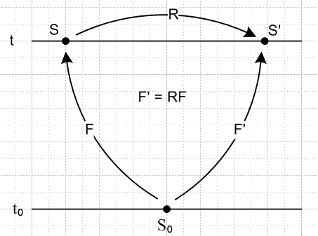

where S0 is a frame that both observers had in common at t = t0, where our flow "begins". One might think of the two observers as being on board separate flying camera platforms which are aligned at t = t0 and end up at some arbitrary positions and angles in space at time t. The platform motions can include translations as well as rotations, but translations don't affect things like dx so we consider only the rotation part. According to the above picture, F' = RF where we concatenate the two transformations F and R. Here is a simple derivation of this fact not requiring a picture, where we use dx' = F'dX', dX' = dX, and dx = F dX:

dx' = F' dX' = F' dX = F' (F-1 dx) = (F' F-1)dx = R dx =>F' F-1 = R => F' = RF .

Had we obtained instead the equation F' = RFRT we would have said, according to section (f) above, that the matrix F, whose elements are Fij , transforms as a rank-2 tensor under rotation R. But in fact we have only F' = FR which says instead that the three columns of matrix F transform as vectors under R:

F'ab = RacFcb or F'(b)a = RacF(b)c or F'(b) = R F(b), b = 1,2,3

where F(b) is the vector which is column b of matrix R, and F(b)a = Fab.
The conclusion is that the deformation gradient matrix F does not transform as a tensor under R or under any other associated transformation. F is not a "tensorial tensor", but a quick web search shows that traditionally F is almost always referred to as the deformation gradient tensor. One is reminded of Section 2 (k) regarding the fuzzy meaning of the words "scalar" and vector". One might choose to call any matrix a "tensor", but calling it one does not make it transform as one.
We can then look at the two Cauchy-Green deformation "tensors" defined above. Recall these were the "would-be" metric tensors of the forward and reverse flow transformations. We can regard B = FFT and C = FTF again as properties of the continuous material at x and t in frame S, and B' = F'F'T and C' = F'TF' as properties of the material at x' and t as seen in frame S'. So:

C' = F'TF' = (RF)T(RF) = FTRTRF = FTF = C => C' = C

B' = F' F'T = (RF)(RF)T = RF FTRT = R B RT => B' = R B RT .

Even more so than F, these B and C matrices are always called tensors, but we see that only B transforms as a tensor under R. The object C is a matrix all of whose elements transform as scalars, so one cannot in any manner think of matrix C as transforming as a rank-2 tensor.
The tradition in continuum mechanics seems to be this: (1) any object with indices is called a tensor (including scalar, vector, rank-2, and higher); (2) objects with indices which in fact transform as tensors are called "objective tensors" or "indifferent" tensors. The term "indifferent" comes from the phrase "frame-indifferent" which is the notion of equations being "covariant" as noted below. One might regard these variations in terminology as resulting from non-mixing laminar flows in the history of mathematical physics.
For a continuous medium one can consider a stress/deformation relationship of the form T = f(B). In frame S', one will find some T' = f'(B'). If the medium is isotropic (rotationally invariant in its properties), then f' = f and one will have T' = f(B') in Frame S'. If f is a polynomial, or a function which can be approximated by one, then T = f(B) with polynomial coefficients which are rotational scalars is a highly viable form for the following reason: since B is a rank-2 tensor, so is any power of B, and if the polynomial coefficients are scalars, then f(B) is a rank-2 tensor. Just as a particle force F transforms as a rank-1 tensor under rotations, the Cauchy stress tensor T transforms as a rank-2 tensor under rotations, and then both sides of T = f(B) transform in the same way -- as rank-2 tensors. The scalar coefficients must be functions of the Bij and there are three such scalars known as the principal scalar invariants of B, one of which is det(B), so the scalar coefficients can be any functions of these three scalar invariants. Furthermore, one can use the fact that B = FFT is symmetric along with the Cayley-Hamilton theorem (matrix B satisfies its own secular equation) to show that any powers of B in polynomial f(B) larger than degree 2 can be expressed as a linear combination of I, B and B2. One ends up then with T = aI + bB + cB2 where a,b,c are functions of the three scalar invariants of tensor B.
Since both sides of T = f(B) transform in the same way (rank-2 tensors), the equation T = f(B) is "covariant" as discussed in Section 7 (u), meaning it has the same form in frame S' as it has in S.
The equation T = f(B) is a relation between stress and strain in the form of deformation, and is called a constitutive equation for the continuous material. One wants such equations to be covariant between frames of reference related by any Galilean transformation, even if one or both of these frames are non-inertial. This is an extension of Hooke's Law for a spring, F = -k Δr , which is covariant under rotations and translations.
In contrast, equations of motion are only covariant if both frame S and S' are inertial frames.
Notice that this entire discussion falls apart completely if one tries T = f(F) or T = f(C) as a candidate constitutive relation, since then the two sides of the equation don't transform the same way.
This subject is discussed in Lai pp 334-342 and p 40 for the scalar invariants. Instead of frames S and S', Lai uses frames S and S*, our rotation matrix R(t) is called Q(t), and matrices as well as vectors are bolded.

Q(t)Ft* = Q(τ)Ft

Which continuum mechanics tensors are really tensors, Part II

Now consider the situation with the "relative" tensors, in Lai notation

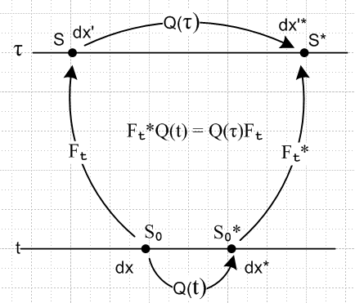

I see now why he uses Q for rotation: R is reserved for the R in the polar decomposition !!! Ouch. Now we take a strange new view of the picture above. I am going to think of τ as a "reference time" *(it could be that τ < t, but the drawing shows τ > t) and t as the "current time". Notice that Ft is really Ft(x,τ), so think now of t as the active time label and τ as a reference time label. So we think of Ft as a property of the continuous material in frame S0 and Ft* as the property viewed in frame S0*. That is to say, Ft describes a property of the material at position x and time t, where x' and τ are reference information. Now look what happens to all our objects:

Ft* = Q(τ)FtQ(t)T // Ft not a tensor since the left Q time is not t

Ct* = Ft*T Ft* = [Q(τ)FtQ(t)T]T Q(τ)FtQ(t)T = Q(t) FtT Q(τ)T Q(τ)FtQ(t)T

= Q(t) FtTFtQ(t)T = Q(t) CtQ(t)T // Ct a tensor since Q times are both t

Bt* = Ft* Ft*T = Q(τ)FtQ(t)T [Q(τ)FtQ(t)T]T = Q(τ)FtQ(t)TQ(t)FtTQ(τ)T

= Q(τ)FtFtTQ(τ)T = Q(τ)BtQ(τ)T // Bt not a tensor, both Q times are τ instead of t

