Brachistochrone Problem Reviewed PhL 10.30.16

1. Preliminaries: Cycloid Curve and the Rolling Wheel 1
2. The Brachistochrone Problem: Doing the initial set up 5
3. The Brachistochrone Problem: Turning the Crank 6
4. The Brachistochrone Problem: Finding the Solution 9
5. The Brachistochrone Problem: Finding everything there is to know. 12

1. Preliminaries: Cycloid Curve and the Rolling Wheel

Here is my little section on this subject,

Digression: The rolling wheel of radius R. Here is the rolling wheel model (it rolls to the right)

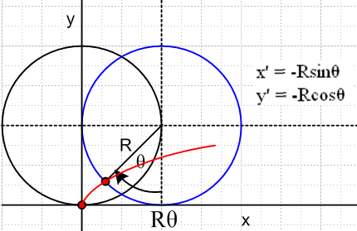

Relative to the center of the wheel the illuminated point (red LED attached to edge of rim) has coordinates x' = -Rsinθ and y' = -Rcosθ. The center of the wheel is at xc = Rθ and yc = R. Thus, the expressions for the point (x,y) are

x = xc+ x' = Rθ -Rsinθ = R(θ-sinθ)

y = yc + y' = R-Rcosθ = R(1-cosθ)

So the red LED on the wheel traces out a positive-bumps cycloid curve.

The rolling wheel LED generates a positive-bumps cycloid where θ starts at 0 and increases to the right. The wheel has radius R, y is up, and the equations are these

x = R(θ-sinθ)
y = R(1-cosθ)

As noted, one has xC = Rθ. If the wheel's center moves to the right at constant speed vC, then one has

vC = dxC/dt = R dθ/dt

and then = vC/R and integrate to get θ(t) = (vC/R)t +θ(0) and for our setup θ(0) = 0 and then

θ(t) = (vC/R) t

Here is a plot for θ going from 0 to 6π with R = 2:

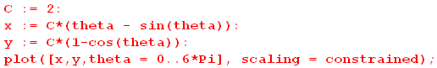
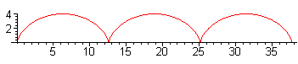
In general, a "cycloid" curve can have R < 0 as well. Here is a plot for R = -2 again for θ from 0 to 6π,

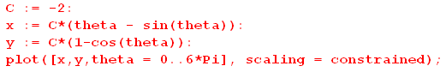

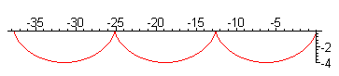

Now positive θ is associated with the left part of this curve, whereas for R = 2 it was associated with the right part of the curve. If you are interested in a down-bumps cycloid on the right side, you have to run θ through negative values like so:

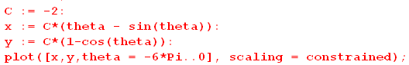

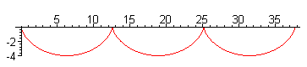

In the brachistochrone application below, this is the kind of curve we want! We are going to write the cycloid equation in this manner, exactly like that shown above

x = C(θ-sinθ) C < 0 and θ < 0 and y direction up
y = C(1-cosθ)

BUT we have to keep in mind these two things:
(1) C < 0 to get the negative bumps
(2) θ < 0 to get these negative bumps to be on the right side

If we were to define φ = -θ and D = -C, we would have

x = D(φ-sinφ) D > 0 and φ > 0 and y direction up
y = -D(1-cosφ)

This would be a simpler way to start on the problem below. Marion really confuses things on page 184-5 where he draws the x and y axes in a strange way and then his equations are (9). Goldstein on page 36 talks about our problem, but he has the y axis pointed down. For me that is too confusing since I want to see negative bumps as drawn above.

I could start over using the D and φ angles, but I will stick with C and θ as defined above. In any result one can replace C = -D and φ = -θ.

Definition: A cycloid curve is one with the parametric definition shown above where C can have either sign and θ can have whatever range you want it to have.

Fact: You cannot express the curve in a closed form y = f(x) in terms of normal functions such as y = sin(x). I don't know exactly why theoretically this is the case. I know that Maple cannot solve the following equations for C and θ:

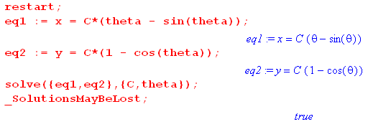

Discussion of the above Fact: A similar situation arises when you write

x = y - siny

You cannot invert this equation to get y = f(x) using normal functions.

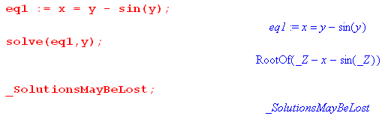

In this last case, y = f(x) exists, but you just can't write it in terms of normal functions. So if you want to find a value y that goes with some x, you have to do a numerical solution. This notion is associated with the phrase "transcendental equation" but I doubt that is really accurate.
Think of the above situation as y - sin(y) - x = 0 where x is just "a constant". This equation really is transcendental because its "roots" are not those of a polynomial equation. That is to say, this is not a polynomial equation in y. This word is used by Saxon for particle in finite box. Functions which solve poly equations are called "algebraic" functions. So in our cycloid case where we treat x and y as constants,

C(θ-sinθ) - x = 0
C(1-cosθ) -y = 0

it is the first equation which is transcendental in the variable θ and which causes the trouble. You can eliminate θ using the second equation (ignoring branch issues),

cosθ = 1 - y/c θ =cos-1(1 - y/c) sinθ = $\sqrt{1 - (1 - y/c)2}$

Then the first equation becomes

C(cos-1(1 - y/c) - $\sqrt{1 - (1 - y/c)2}$) - x = 0

and this is a transcendental equation in variable y. So I guess that is the theoretical reason you cannot find a way to write y = f(x) for the cycloid.

Conclusion: Consider the cycloid equations shown above,

x = C(θ-sinθ)
y = C(1-cosθ)

At θ = 0, this curve passes through the point x = 0 and y = 0. Suppose you want it to pass through some arbitrary other point as well, some (x1, y1). You would then want to solve

x1 = C(θ-sinθ)
y1 = C(1-cosθ)

for θ and C. You can do this only numerically!!!!

2. The Brachistochrone Problem: Doing the initial set up

This problem is begun for me in Goldstein page 36, He sets up an integral to measure the time it takes for a particle to run along a path with some speed v(t).

t = ∫dt = ∫ds (dt/ds) = ∫ds / (ds/dt) = ∫ds / v

and we know how to express this as either a dx or dy integral. For example,

ds2 = dx2 + dy2 = dx2 (1 + (dy/dx)2) ⇒ ds = dx $\sqrt{1 + (dy/dx)2}$

and we would then have

t = ∫dx $\sqrt{1 + (dy/dx)2}$/ v

But here Goldstein next uses energy conservation

(1/2)mv2 = mgy or vx2 + vy2 = 2gy or v = $\sqrt{2gy}$

In writing this equation, he has the y axis going down (which I don't want to have). But staying with him for the moment, we get

t = ∫dx $\sqrt{1 + (dy/dx)2}$ / $\sqrt{2gy}$

where y = y(x) describes the curve. This is a case of the general problem

t = ∫dx f( y(x), y'(x), t)

and to make this stationary to find the shortest time, you write the Euler Lagrange equation for f and we have

f = $\sqrt{1 + (dy/dx)2}$ / $\sqrt{2gy}$

However, I will make the y axis go up, so I will instead have

f = $\sqrt{1 + (dy/dx)2}$ / $\sqrt{-2gy}$

The problem we have is this: We start a frictionless particle at t = 0 at the origin in the usual (x,y) plane and it slides down a curved "ramp" to arrive at some end point (x,y) where y < 0 and x > 0. We want to know what ramp design gets the particle to the end point the fastest. It is not a straight line path even though that would be the shortest distance
In this problem the "coordinate" is the function y(x).
Notice that parameter t (time) does not enter into the problem at this point. We are trying to find a curve y = y(x) which is the fastest curve.
To make it easy to write things, Goldstein writes dy/dx as and you just have to remember what the dot means here. It is not the time derivative. then

f = / $\sqrt{-2gy}$

The Euler Lagrange equation is

∂f/∂y - dx(∂f/∂) = 0
or
∂f/∂y - dx(∂f/∂y') = 0
or
dfdy - dx(dfdyp) = 0
or
dfdy - dfdypdx = 0

to show the Maple notation to be used below.

3. The Brachistochrone Problem: Turning the Crank

It takes a bit of work to write out what the Euler-Lagrange equation says, and I had Maple do it as follows. First,

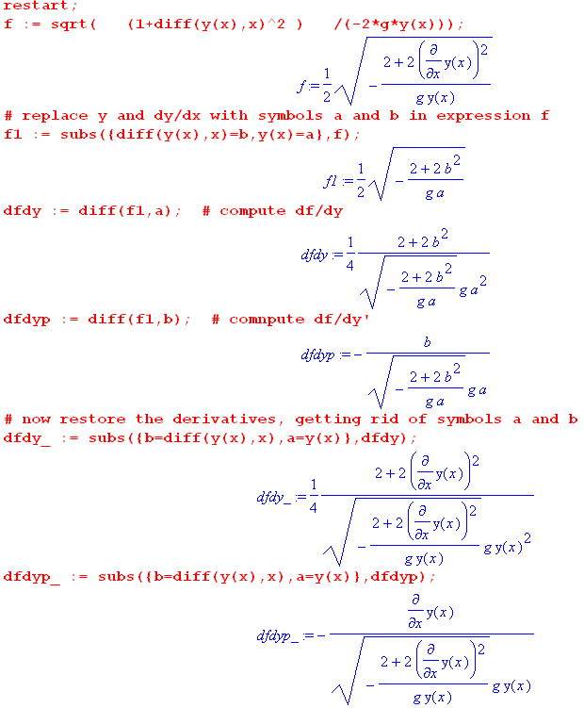

This was a big problem all by itself and I got help from someone on line on how to do it. Note that my y axis is going up in the first equation, hence the - sign inside the radical. I then replace y and y' by a and b and this allows me to differentiate expressions with respect to a and b, which is otherwise hard to do. After doing the derivatives, I get rid of these symbols a and b. So last items are df/dy and df/dy'. Next:

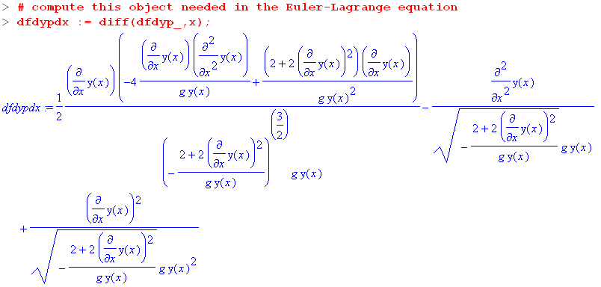

Here I have computed dx∂f/∂y' . I cannot have a and b in there when I do this, since they are really functions of x. So this must be computed after the removal of a and b and their restoration. Next,

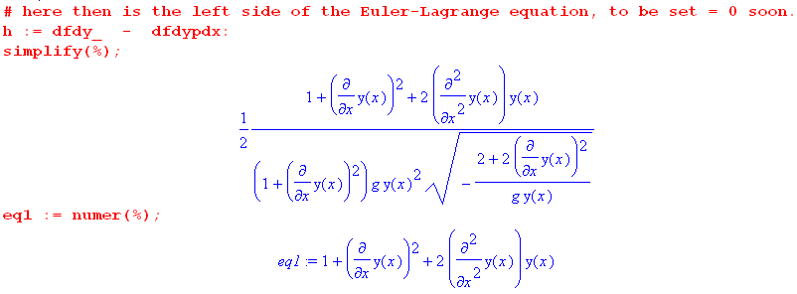

This is the result I am after. It is an ODE for the sought-after function y(x). That equation is therefore

2 y(x) y"(x) + y'(x)2 + 1 = 0 (2)

Meanwhile, I just write down this other equation with no justification yet, where C/2 is any constant,

[ 1 + y'(x)2] y(x) = C/2 (3)

It turns out that if you differentiate (3), you get (2). And if you integrate (2) from some lower endpoint x0, you get (3) with C/2 = [ 1 + y'(x0)2] y(x0). Thus we have

Theorem 1: Eq 3 true ⇒ Eq 2 true for any value of K in Eq 3

Theorem 2: Eq 2 true ⇒ Eq 3 with C/2 = [ 1 + y'(x0)2] y(x0)

Now Eq 2 is what really comes out of the Euler-Lagrange analysis. If we can solve equation (3) for some constant C/2, then that solution also solves equation (2) and thus solves the Euler-Lagrange equation. So our task is now to search for solutions to equation (3).

4. The Brachistochrone Problem: Finding the Solution

It turns out, as I verify in the previous doc, that the unique solution to equation (3) is this:

x = C(θ-sinθ)
y = C(1-cosθ)

So, this is exactly the cycloid parametric function we just studied above. So we now have a connection between the brachistochrone problem and cycloid curves for C < 0 and θ < 0 on the right to get the negative bumps, quoting from above

It turns out that we only use the leftmost down-bump of this function. Our particle starts at the origin and slides down that curve which is the curve of least time since it satisfies the EL equation for our problem. I did not bother to time is minimized. You can imagine that it is not a max because if it were, and miles long path would be larger than what you see here.

Fact: θ = 0 at the origin, θ = -π at the bottom of the first dip, and θ = -2π at the end of the first dip.

Proof:

x = C(θ - sinθ)
y = C(1-cosθ) .

vx = C(1 - cosθ)θ'
vy = C(sinθ θ') // since C<0, θ<0,vy<0 must have θ' < 0

At θ = -π you see that vy = 0 so it is the lowest point. At θ = 2π we have y = 0 again for first time.

Fact: At the low point θ = -π one has y = 2C < 0 and x = -πC > 0. The ratio of depth to width for the bump is then |depth/width| = | 2C/-πC | = 2/π ≈ 2/3. Applies to flat-earth train application.

Proof: all obvious.

Now, to find an explicit solution for a curve passing through the point (x1, y1) with y1 = - h1 with h1> 0, we can do this

x1 = C(θ-sinθ)
-h1 = C(1-cosθ)

x1/h1 = - (θ-sinθ)/(1-cosθ) // equation eq1

Here is code which numerically, for your entered values of x1 and h2, computes and plots the least time curve.

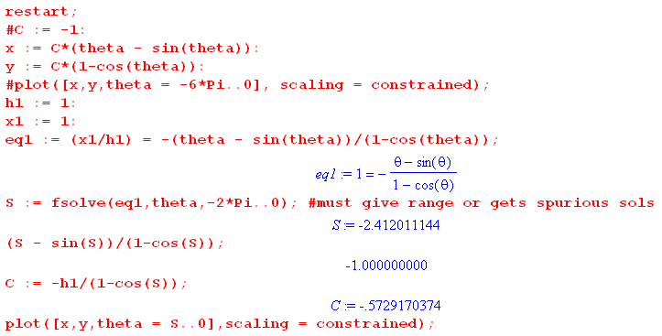

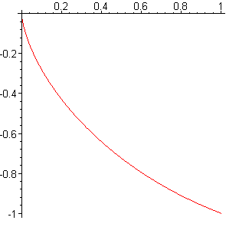

The numerical calculation in this case finds that θ = -2.41 radians at the ramp end-point. and it then finds that C = - .573. Knowing C, Maple can then do the ramp curve as shown. Particle starts at the origin at time t = 0 and slides down the ramp to the ending point shown. In general, this ending point is just a point which we want the curve to pass through.

I then did a set of plots for various values of x1 and h1 which I replicate here:

h1=1 x1=0.2 ratio = 0.2

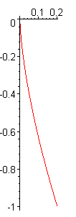

h1=1 x1=1 ratio = 1

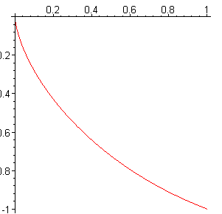

h1=1 x1=π/2 ratio = π/2 (zero slope at the end of the run)

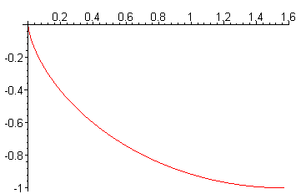

h1=1 x1=2 ratio = 2 (starting to come back up)

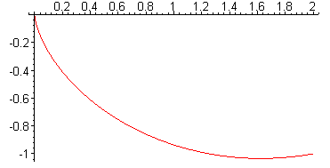

h1=1 x1=4 ratio = 4 (lots of coming back up)

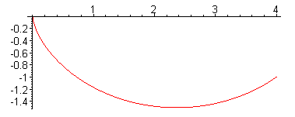

h1=1 x1=20 ratio = 20 (coming WAY back up)

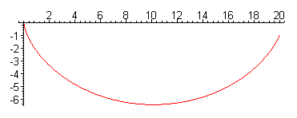

h1=1 x1=100 ratio = 100 (coming WAY WAYback up)

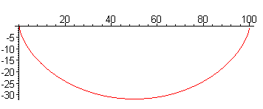

You see various facts on display here:

1. The fastest path may involve going down and then back up some. Perhaps an unexpected result.

2. One never uses anything other then "the first down-bump" of the cycloid curve.

3. If the end point of interest is far away and near the surface, you almost use up the entire bump.

5. The Brachistochrone Problem: Finding everything there is to know.

Big Mistake that took me a long time to realize. I argued "if you add the normal force of the ramp to the gravitational force, you get a total force F. This F must be along the path since a is along the path". Then I used Fy/Fx= dy/dx. That is just completely wrong. F is not along the path, just as it is not along the path for a ball on a string. That is to say, v is along the path, but a is not along the path. For a straight ramp a is along the path, as in Lagrange doc App D.

Fact: The relationship between the parameter θ and time is very simple,

θ(t) = - $\sqrt{g/(-C)}$ t
Proof:

Use this fact from energy conservation,

(1/2)mv2 = mg(-y)

along with

vx = C(1 - cosθ)θ'
vy = C(sinθ θ')

to get:

v2 = -2gy
or
vx2 + vy2 = -2gy
or
C2(1 - cosθ)2θ'2 + C2(sin2θ θ'2) = -2g C(1-cosθ)
or
C(1 - cosθ)2θ'2 + C(sin2θ θ'2) = -2g (1-cosθ)
or
Cθ'2[ (1 - cosθ)2 + sin2θ] = -2g (1-cosθ)
or
Cθ'2[ 1 + cos2θ - 2cosθ + sin2θ] = -2g (1-cosθ)
or
Cθ'2[2 - 2cosθ ] = -2g (1-cosθ)
or
2Cθ'2[1 - cosθ ] = -2g (1-cosθ)
or
Cθ'2 = -g
or
θ'2 = -g/C
or
θ' = - $\sqrt{g/(-C)}$

But θ(0) = 0, so conclude that

θ(t) = - $\sqrt{g/(-C)}$ t QED

Here then is "everything you might want to know". Use

θ(t) = - $\sqrt{g/(-C)}$ t θ' = - $\sqrt{g/(-C)}$ θ" = 0

in the following:

x = C(θ - sinθ)
y = C(1-cosθ) // position at any time

vx = C(1 - cosθ)θ'
vy = C(sinθ θ') // velocity at any time

ax = C[(1 - cosθ)θ" + sinθ θ'2]
ay = C( cosθ θ'2 + sinθ θ") // acceleration at any time

Fx = max
Fy = may // total force at any time

Nx = Fx = max
Ny = Fy + g = may + g // normal force at any time

dy/dx = vy/vx = sinθ/ (1-cosθ) // slope at any time

The duration of the trip would be

t = - θ(t) / $\sqrt{g/(-C)}$

where θ(t) is for whatever point you want. You have to get C numerically for chosen point on curve. But if you know or just specify C, you can obtain θ graphically and hence t.

Special Case: Suppose the trip "takes you back to the surface". Then θ = -2π and

t = 2π/$\sqrt{g/(-C)}$ = 2π $\sqrt{(-C)/g}$

But in this case we also know that, if x is the distance away of the surface-located ramp endpoint,

x = C(θ - sinθ) = C(-2π - 0) = -2πC so -C = x/2π

and then

t = 2π $\sqrt{(-C)/g}$= 2π $\sqrt{x/2πg}$ = $\sqrt{2πx/g}$

and this is a well-known result quoted in the train website The speed at the midpoint would be θ = -π

vx = C(1 - cosθ)θ' = C 2 θ' = C 2 [- $\sqrt{g/(-C)}$] = 2 (-C) $\sqrt{g/(-C)}$ = 2 $\sqrt{g(-C)}$

= 2 $\sqrt{g(x/2π)}$ = ($\sqrt{2/π}$) $\sqrt{gx}$ m/sec = 0.80 * $\sqrt{gx}$

Example: A trip of 1 km has $\sqrt{gx}$ = $\sqrt{10*1000}$ = 100 m/sec.

A trip of 100 km has $\sqrt{gx}$ = $\sqrt{10*1000}$ = 1000 m/sec
62 miles 621 mph

A trip of 1000 km has $\sqrt{gx}$ = 1000 $\sqrt{10}$ = 3167 m/sec
620 miles 1963 mph

And scale all speed results down by 0.80.

https://brilliantuniverse.wordpress.com/2014/04/02/trains-and-tunnels-the-brachistochrone/

Unlike an airplane flight, this train tunnel thing's duration is proportional to the square root of distance. As they point out, passengers might be uncomfortable as the train dives straight down at the start!

5. The Brachistochrone Problem: Marion page 185 approach.

In Goldstein page 36 he has

f(y(x),y'(x), x) =$\frac{1 + y'2}{2gy}$

t = ∫$\frac{1 + y'2}{2gy}$dx // the "variable" is x

∂f/∂y - dx ∂f/∂y' = 0 (2-11)

and this integral is over the horizontal axis. Marion in contrast integrates over the vertical axis. If I do x↔y with Marion page 185 so we are both talking about the Goldstein picture, then Marion writes

t = ∫$\frac{1 + x'2}{2gy}$dy f(x(y),x'(y), y) =$\frac{1 + x'2}{2gy}$ // the "variable" is y

∂f/∂x - dy ∂f/∂x' = 0

With things set up this way, notice that ∂f/∂x = 0 (which Marion calls ∂f/∂y) and so that kills off one of the two terms in the EL equation. The equation then says

dy ∂f/∂x' = 0

∂f/∂x' = constant ≡ 1/$\sqrt{2a}$

This then produces

$\frac{x'2}{y(1+x'2)}$ = 1/(2a)

and this is then your basic equation for x' = dx/dy .

2a (dx/dy)2 = y (1 + (dx/dy)2) variable = y

2a (dx/dy)2 - y(dx/dy)2 = y

(2a-y) x'(y)2 = y // compare to my [ 1 + y'(x)2] y(x) = C/2

It is just a different ODE, but I guess it has the same cycloid solution. In fact,

x'(y)2 = y/(2a-y)

x'(y) = $\sqrt{y/(2a-y)}$ = dx/dy

$\sqrt{y/(2a-y)}$dy = dx

∫$\sqrt{y/(2a-y)}$dy = x + constant Marion (6)

and this is an integral Marion can actually integrate to get this result

x = a(θ-sinθ)

and this is one of the cycloid equations obtained directly with no guessing. Marion then just pulls the other equation out of the air. He could have shown that the pair solves his ODE.

I have a pencil cycloid reference to "Brixey", probably some book I found in a library. This appears to be one of the very few Marion sections I have ever read, based on the absence of markup. I have this book dated at Oct 1971. I used this book as a TA for a course in 1973 at UCB. This text was never used in a course by me, but Goldstein was in Glashow's class in Spring 1970, so I probably bought it then.

So Marion takes a different path from Goldstein. His swap of x and y is to make the reader more comfortable with y(x) rather than x(y), I understand.

Question: Suppose you know the ramp shape as a cycloid. Could you express it as a holonomic constraint of the form a(x,y) = 0 ?? Well, think of R as a fixed constant, but now you have x,y,θ all as variables. If you could write y = f(x) for the constraint, they a(x,y) = y - f(x) and yes, but we just said above that the cycloid cannot be written in the form y = f(x). So no. Also, I don't see how to write it as a non-holonomic constraint.

x = R(θ-sinθ) dx = R(1 - cosθ)dθ
y = R(1-cosθ) dy = R(sinθ)dθ

You always have three variables tangled together, I don't think you can do it.

