Brachistochrone Problem PhL 10.29.16

Here I just finish the solution started by Goldstein page 36. To avoid confusion, I am going to assume the particle starts at t = 0 and y(0) = 0 and goes down to negative y (G likes that to be positive y which just makes a mess for me). We then have

f = (1) y ≤ 0

Here means dy/dx.

Have Maple compute the required stuff. // I did this, and I end up with this ODE = 0 (see brachisto.mws)

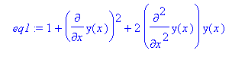
or

2 y(x) y"(x) + y'(x)2 + 1 = 0 (2)

Wolfram claims this is equivalent to

[ 1 + y'(x)2] y(x) = constant (3)

Proof: If I differentiate the latter, I get

[ 1 + y'(x)2] y'(x) + [2y'(x) y"(x)] y(x) = 0
or
[ 1 + y'(x)2] + [2 y"(x)] y(x) = 0 (4)

and sure enough, this is exactly my equation (2). I have just shown that

(3) true ⇒ (2) true

Can we go the other direction? This is what I just showed above:

d { [ 1 + y'(x)2] y(x) } /dx = [ 1 + y'(x)2] + [2 y"(x)] y(x)
or
d { [ 1 + y'(x)2] y(x) } = { [ 1 + y'(x)2] + [2 y"(x)] y(x)}dx

This is a perfect differential, so integrate this from x = x0 to some t to get

[ 1 + y'(x)2] y(x) - [ 1 + y'(x0)2] y(x0) = $^{\int_{0}^{x0}{}}${ [ 1 + y'(x)2] + [2 y"(x)] y(x)}dx

Now if I know that { [ 1 + y'(x)2] + [2 y"(x)] y(x)} = 0, then I know that

[ 1 + y'(x)2] y(x) = [ 1 + y'(x0)2] y(x0)

and this then has a specific constant. So what I know is

(2) true ⇒ (3) true with the specific constant shown.

Comment: Be careful, if you set x0 = 0 and y(x0) = 0 you get infinite slope times 0 here. This part of the curve only applies if your final point is directly underneath your starting point.

To summarize:

Equation 2 2 y(x) y"(x) + y'(x)2 + 1 = 0

Equation 3 [ 1 + y'(x)2] y(x) = K

Theorem 1: Eq 3 true ⇒ Eq 2 true for any value of K in Eq 3

Theorem 2: Eq 2 true ⇒ Eq 3 but only for K = [ 1 + y'(x0)2] y(x0)

Now Eq 2 is what really comes out of the Euler-Lagrange analysis.

Resume: Now I only have to solve a first order ODE

[ 1 + y'(x)2] y(x) = C/2 (3)

We are then supposed to try this "cycloid" solution which is the ONLY solution in fact,

x = C(θ - sinθ)
y = C(1 - cosθ)

dx/dθ = C(1 - cosθ)
dy/dθ = +Csin(θ)

≡ dy/dx = sinθ/(1-cosθ)

[ 1 + y'(x)2] y(x) = [ 1 + sin2θ/(1-cosθ)2 ]C (1-cosθ) = K ??
or
[(1-cosθ)2 + sin2θ ] C(1-cosθ) = K (1-cosθ)2 ??
or
[(1-cosθ)2 + sin2θ ]C = K (1-cosθ) ??
or
[1+cos2θ - 2cosθ + sin2θ ] C = K (1-cosθ) ??
or
[2 - 2cosθ ]C = K (1-cosθ) ??
or
2C = K ??

This is true if K = C/2. So then I claim that for the above cycloid solution this equation is true,

[ 1 + y'(x)2] y(x) = C/2

Now in my non-Goldstein world the y axis points up as usual, so we must have C < 0 which will make y < 0 on our trajectory. For example, we then have

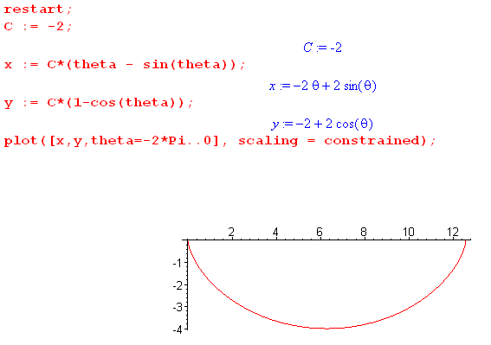

Remember that y axis goes up, x axis goes to the right, particle starts at origin and drops down the curve. It happens that the right side of the curve above has θ < 0 as Maple plotting shows.

Where is the bottom of this curve? Look for dy/dx = 0. But above dy/dx = sinθ/(1-cosθ) so the bottom occurs at θ = -π. And at that point y = 2C. And also x = -Cπ and y = 2C. Ratio is -y/x = 2/π ≈ 2/3. Interpret 2C = the lowest value that y attains on a hump. C = (1/2) ymin < 0.

Digression: The rolling wheel of radius R. Here is the rolling wheel model (it rolls to the right)

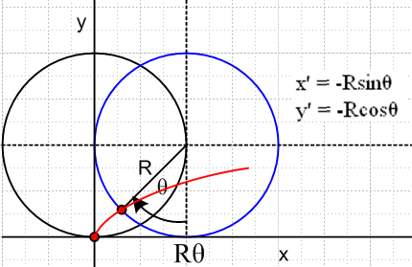

Relative to the center of the wheel the marked point has coordinates x' = -Rsinθ and y' = -Rcosθ. The center of the wheel is at xc = Rθ and yc = R. Thus, the expressions for the point (x,y) are

x = xc+ x' = Rθ -Rsinθ = R(θ-sinθ)

y = yc + y' = R-Rcosθ = R(1-cosθ)

So the dot painted on the wheel traces out the right side of the second red curve shown above, R > 0 here.

Back to the problem:

What then exactly is the curve? It starts at the origin, and you want it to go through some point (x,y) where x > 0 and y < 0. So consider (where we know C < 0)

x = C(θ - sinθ)
y = C(1-cosθ) .

What do we learn from the origin point (x,y) = (0,0)? Only that θ = 0.

But from the other point we

x1 = C(θ - sinθ)
- h1 ≡ -|y1| = C(1-cosθ)

So this is two equations in two unknowns. Here hi is the drop distance > 0. Take the ratio to get

x1/h1 = - (θ - sinθ)/(1-cosθ)

Use this to solve for θ, then use either of the above to solve for C which we know is C < 0:

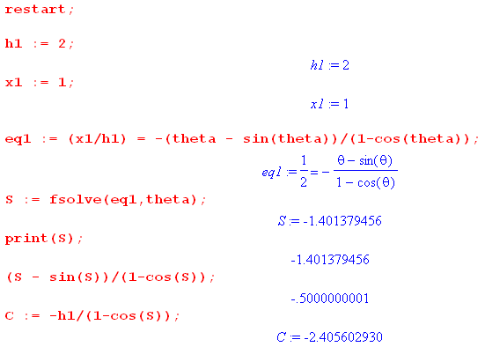

So to make the brach path start at the origin and pass through the point (x,y) = (1,-2), we find that the solution angle parameter is θ = -1.40 radians (implies right side), and C = -2.41 (neg as expected).

Selected Plots and Conclusions

The point we want to pass through is (x,y) = (x1, -h1) where x1 and h1 are positive.
Define a ratio ratio = x1/h1. If this ratio is small, you do a dive. If it is large, you dive and come back up again. Specific examples

h1=1 x1=0.2 ratio = 0.2

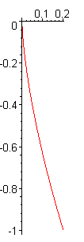

h1=1 x1=1 ratio = 1

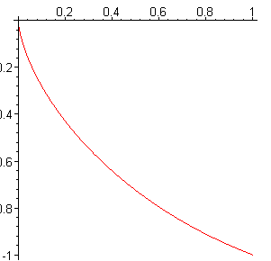

h1=1 x1=π/2 ratio = π/2 (zero slope at the end of the run)

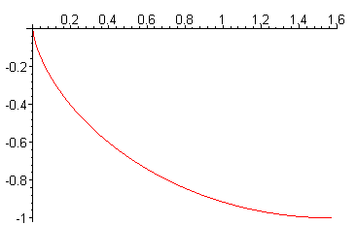

h1=1 x1=2 ratio = 2 (starting to come back up)

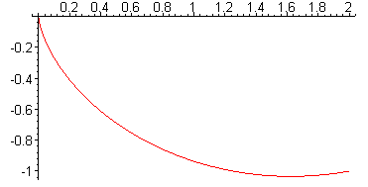

h1=1 x1=4 ratio = 4 (lots of coming back up)

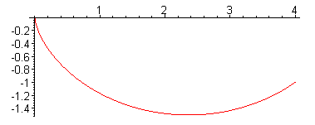

h1=1 x1=20 ratio = 20 (coming WAY back up)

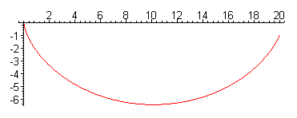

h1=1 x1=100 ratio = 100 (coming WAY WAYback up)

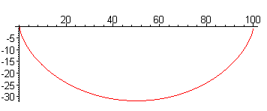

In this kind of limit, the ratio of x/2 at half way to ymax is π/2 ≈ 3/2 as noted above. Another way to say it is that x/depth = 2 (x1/2/depth) = 2 (π/2) = π. So the depth is 1/π times the distance for a long trip.

I found a note on Brachistochrone trains here:

https://brilliantuniverse.wordpress.com/2014/04/02/trains-and-tunnels-the-brachistochrone/

Question: What is the speed at any point on such a trip?
Question: What is position at any given time?

x = C(θ - sinθ)
y = C(1-cosθ) .

vx(t) = C(∂tθ - cosθ∂tθ) = C(θ-cosθ)(∂tθ)
vy(t) = C(1-cosθ) = Csinθ(∂tθ)

How do you do stuff like this when you only have a parametric form??

At some instant you know it is sliding at this angle

dy/dx = sinθ/(1-cosθ) = tan(φ)

We know

ds = $\sqrt{1 + (dy/dx)2}$ dx

But this just tells you ratio of speeds.

Acceleration along the curve might be this

as = g sin(φ) = d2s/dt2 // could use above to get some as(θ)

Then work back to velocity and then position.

Day Two 10.30.16

Idea for finding θ(t): use the two equations obtained by setting ax = 0 and ay = -g by twice diffing the expressions for x and y, all in Maple. Here are the results

x = C(θ - sinθ)
y = C(1-cosθ) .

vx = C(1 - cosθ)θ'
vy = C(sinθ θ') // since C<0, θ<0,vy<0 must have θ' < 0

ax = C[(1 - cosθ)θ" + sinθ θ'2]
ay = C( cosθ θ'2 + sinθ θ")

Now I should be able to inject "the physics" into the problem using Newton's law:

ax = 0
ay = - g // because y is up in my world, gravity pulls down

STOP!!! I am using F = ma but I am neglecting the constraint force in these equations !!!!
So ignore everything in blue below this point in this doc!! Resume after

The two equations are then

0 = C[(1 - cosθ)θ" + sinθ θ'2]
-g = C[ cosθ θ'2 + sinθ θ"] wrong

The first equation tells us that

(1 - cosθ)θ" + sinθ θ'2 = 0

which relates θ" to θ' which seems helpful. Try now to eliminate θ'2 :

θ'2 = - [ (1 - cosθ)/sinθ ]θ" or θ" = - sinθ/(1-cosθ) * θ'2 (*)

Note: for small negative θ, θ" > 0.

Note: Examine ay for small negative θ:

ay = C( cosθ θ'2 + sinθ θ")
- + - + // cannot determine the sign of ay in this way

Then the second equation says

-g/C = cosθ θ'2 + sinθ θ"

= - cosθ[ (1 - cosθ)/sinθ ]θ" + sinθ θ"

= [ - cosθ(1 - cosθ)/sinθ + sinθ] θ"

= [ - cosθ(1 - cosθ) + sin2θ] θ" / sinθ

= [ - cosθ + cos2θ + sin2θ] θ" / sinθ

= [ - cosθ +1] θ" / sinθ

So we finally have an ODE for θ

(1- cosθ) θ" + (g/C) sinθ = 0

Now use half angles

2sin2(θ/2) θ" + (g/C) 2sin(θ/2)cos(θ/2) = 0
or
sin(θ/2) θ" + (g/C) cos(θ/2) = 0
or
θ" + (g/C) cot(θ/2) = 0

How can I verify that I did this correctly? Here is an attempt:

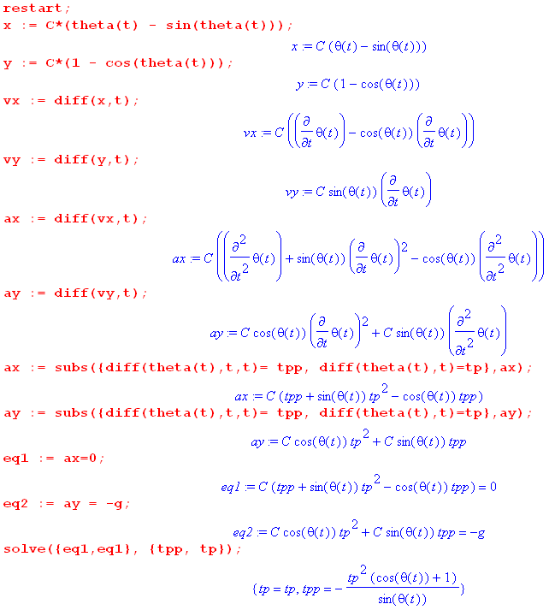

Last line says θ" = - θ'2 (1+cosθ)/sinθ which disagrees with my (*) above which was

θ" = - sinθ/(1-cosθ) * θ'2

Is it possible that

(1+cosθ)/sinθ = sinθ/(1-cosθ) ?

(1+cosθ) = sin2θ/(1-cosθ) ?

(1-cosθ)(1+cosθ) = sin2θ ?

1 - cos2θ = sin2θ ? yes!

So we agree on that result. I then do more Maple and it seems to say

ay = -C θ'2

But something is wrong here because I know C< 0 but want ay = -g, sides then have different signs.

Can I get that result by hand? Back up to this point,

ax = C[(1 - cosθ)θ" + sinθ θ'2]
ay = C( cosθ θ'2 + sinθ θ")

θ'2 = - [ (1 - cosθ)/sinθ ]θ" or θ" = - sinθ/(1-cosθ) * θ'2 (*)

Use the second in ay to get

ay = C( cosθ θ'2 + sinθ [ - sinθ/(1-cosθ)θ'2])

= Cθ'2( cosθ + sinθ [ - sinθ/(1-cosθ)] )

= Cθ'2( cosθ - sin2θ/(1-cosθ) )

= Cθ'2( cosθ(1-cosθ) - sin2θ )/(1-cosθ)

= Cθ'2( cosθ-cos2θ - sin2θ )/(1-cosθ)

= Cθ'2( cosθ-1 )/(1-cosθ)

= -Cθ'2

OK, it is verified. But I still have the sign of sides problem!

We now have this fairly simple ODE to deal with

-Cθ'2 = ay = - g

Cθ'2 = g

θ'2 = (g/C)

θ' = - $\sqrt{g/C}$

θ(t) = - $\sqrt{g/C}$t + θ(0)

Now θ(0) = left end of curve = 0, so we have

θ(t) = - $\sqrt{g/C}$t

as the connection between the two "parameters" .

There must be some trivial way I could know this. Energy conservation says

mg(-y) = (1/2)m(vx2+vy2)

Above I had

vx = C(1 - cosθ)θ'
vy = C(sinθ θ')

y = C(1-cosθ)

Then energy says

-mg C(1-cosθ) = (m/2)C2 [ (1-cosθ)2 + sin2θ ] θ'2

-g (1-cosθ) = (1/2)C [ (1-cosθ)2 + sin2θ ] θ'2

-g (1-cosθ) = (1/2)C [ 1 + cos2θ - 2cosθ + sin2θ ] θ'2

-g (1-cosθ) = (1/2)C [ 2 - 2cosθ ] θ'2

-g (1-cosθ) = C [ 1 - cosθ ] θ'2

-g = C θ'2

Paradox: In the equation ay = -Cθ'2 we have a sign disagreement on the two sides.

1. Why is C negative? Go back to y = C(1-cosθ). We know 1-cosθ >0 and y < 0, therefore we know that C is negative.

2. Why do I think ay = - g? The mass is being pulled down by gravity. Down is the minus y direction because that is how I have set things up.

3. Is x really positive? I have x = C(θ - sinθ) = C(-|θ| + sin|θ|) for small neg θ on the right, so

x = -C(|θ| - sin|θ| ) here |θ| - sin|θ| > 0 and C < 0 to x > 0, correct.

4. Again from y = C(1-cosθ) for small θ we have y < 0 if C<0 and this is correct.

Resume. The ramp has a normal force N and if we draw a little picture, we see that N + g must point along the ramp [wrong]. Total force is F = N + g and g = -g with g>0. So write F = N -g and then we have N = F + g and Nx = Fx and Ny = Fy + g

Fx = Nx + gx= Nx ok
Fy = Ny + gy = Ny - g ok

Fy/Fx = (Ny - g)/Nx ok

We then need F to point down along the curve [wrong]. Then

wrong
Fy/Fx = dy/dx = sinθ/(1-cosθ) // from far above
- + - + - +

We then have
wrong
(Ny - g)/Nx = sinθ/(1-cosθ)

Now we can use F = ma so // F = ma = N + g

Fx = max Fy = may ok

ok wrong ok
ay/ax = Fy/Fx = dy/dx = sinθ/(1-cosθ) ok

ay = [sinθ/(1-cosθ)] ax wrong
- - + +

At least we now have a relationship between the two acceleration components [wrong] . Maple tells us that

ax = C[(1 - cosθ)θ" + sinθ θ'2]
ay = C( cosθ θ'2 + sinθ θ") // checked this with new Maple code

Divide to get
wrong
ay/ax = [ cosθ θ'2 + sinθ θ"] / [(1 - cosθ)θ" + sinθ θ'2] = [sinθ/(1-cosθ)]

Don't know if this will help, but at least it is a new fact of interest:

[ cosθ θ'2 + sinθ θ"] / [(1 - cosθ)θ" + sinθ θ'2] = [sinθ/(1-cosθ)]
or
(1-cosθ)[ cosθ θ'2 + sinθ θ"] = [sinθ] [(1 - cosθ)θ" + sinθ θ'2]
or
(1-cosθ)[ cosθ θ'2 + sinθ θ"] - [sinθ] [(1 - cosθ)θ" + sinθ θ'2] = 0
or
θ'2{ (1-cosθ)cosθ - sin2θ } + θ"{(1-cosθ)sinθ - [sinθ] [(1 - cosθ)] } = 0
or
θ'2{ (1-cosθ)cosθ - sin2θ } = 0
or
θ'2{cosθ-cos2θ - sin2θ } = 0
or
θ'2{cosθ-1 } = 0

⇒ θ' = 0

which of course is a wrong result. [ and now I know why it is wrong ]

Paradox of 8:15AM

This says that θ'(t) = 0 which says θ(t) = constant = θ(0) = 0 so θ(t) = 0 which is total garbage. I checked the algebra in red. There is then a mental logic error somewhere in the above foot of file. Here are the possibilities of what is wrong:

1. F = ma is wrong where F is the total force on m (seems unlikely that this is wrong).

2. Fy/Fx = dy/dx is wrong. ( drew careful picture, seems right) wrong

3. ax = C[(1 - cosθ)θ" + sinθ θ'2] one or both is wrong
ay = C( cosθ θ'2 + sinθ θ") (both lines copied directly from Maple and x,y correctly entered)

4. dy/dx = sinθ/(1-cosθ) is wrong (but this is verified below)

5. Algebra above is done wrong. (Maple says θ'(t) = 0 as well, see below)

Look at item 4:

x = C(θ - sinθ)
y = C(1-cosθ) .

dx = C(dθ - cosθdθ)
dy = C( + sinθdθ)

dy/dx = sinθ/ (1-cosθ) agrees with 4 as quoted.

Let Maple do algebra of step 5. First we have this

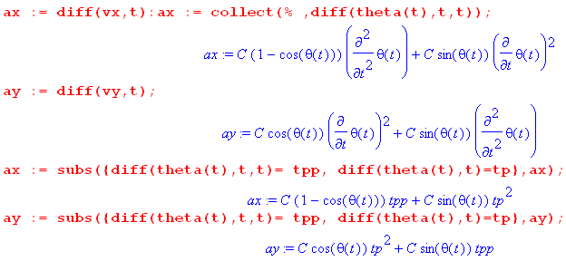

Then we do this

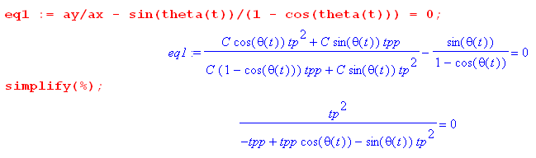

The only way this does NOT say θ' = 0 is if the denominator vanishes. That would require

-θ" + cosθ θ" - sinθ θ'2 = 0
or
θ"(cosθ-1) = sinθ θ'2

θ" = [sinθ/(cosθ-1)] θ'2

But the second line above says θ"(cosθ-1) - sinθ θ'2 = 0 or θ"(1-cosθ) + sinθ θ'2 = 0 . But recall above

ax = C[(1 - cosθ)θ" + sinθ θ'2]

So this little option says ax= 0, but I know that is wrong because object does accelerate to the right as if slides down the ramp. How else would it pick up vx > 0 after the vertical start?

Status of paradox 8:40AM. I made a list of 5 possible error sources, and checked each one and none of these sources appear to be wrong. Paradox lives on!!!

Did a whiteboard session and I found the mistake. It is item 2. Although v must point along the track, in general a and therefore F do not point along the track. Think ball on string going around, or perhaps circular track with track surface pointing to the center. In that case a points to the center, it does not point along the track. It is v which points along the track.

Did I make this same mistake somewhere in Lagrange doc??? Well there I had a linear track as an example in Appendix D, so in that case the force F was along the track, whew!

OK, maybe this is what I want to look at : it is v which points along the track, not a.

sinθ/ (1-cosθ) = dy/dx = vy/vx = C(sinθ θ') / C(1 - cosθ)θ' = sinθ/(1-cosθ)

OK, this is true, but adds no new information. So here is what I know

x = C(θ - sinθ)
y = C(1-cosθ) .

vx = C(1 - cosθ)θ'
vy = C(sinθ θ')

ax = C[(1 - cosθ)θ" + sinθ θ'2]
ay = C( cosθ θ'2 + sinθ θ")

dy/dx = vy/vx = sinθ/ (1-cosθ)

How about using this extra fact from energy conservation

(1/2)mv2 = mg(-y)

This says

v2 = -2gy
or
vx2 + vy2 = -2gy
or
C2(1 - cosθ)2θ'2 + C2(sin2θ θ'2) = -2g C(1-cosθ)
or
C(1 - cosθ)2θ'2 + C(sin2θ θ'2) = -2g (1-cosθ)
or
Cθ'2[ (1 - cosθ)2 + sin2θ] = -2g (1-cosθ)
or
Cθ'2[ 1 + cos2θ - 2cosθ + sin2θ] = -2g (1-cosθ)
or
Cθ'2[2 - 2cosθ ] = -2g (1-cosθ)
or
2Cθ'2[1 - cosθ ] = -2g (1-cosθ)
or
Cθ'2 = -g
or
θ'2 = -g/C
or
θ' = - $\sqrt{g/(-C)}$

This seems perhaps reasonable. Then

θ(t) = - $\sqrt{g/(-C)}$ t + θ(0)

But θ(0) = 0, so conclude that

θ(t) = - $\sqrt{g/(-C)}$ t

and finally I have the connection between θ(t) and t and it is completely trivial. Marion does not mention this equation. Maple verifies this now

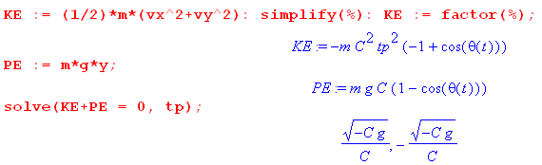

So I can now write out everything with θ(t) = - $\sqrt{g/(-C)}$ t :

x = C(θ - sinθ)
y = C(1-cosθ) .

vx = C(1 - cosθ)θ'
vy = C(sinθ θ')

ax = C[(1 - cosθ)θ" + sinθ θ'2]
ay = C( cosθ θ'2 + sinθ θ")

Fx = max
Fy = may

Nx = Fx = max
Ny = Fy + g = may + g

dy/dx = vy/vx = sinθ/ (1-cosθ)

This is everything you ever wanted to know. But I want something to determine C from my assumed point on the trajectory which is say x1,y1 :

x = C(θ - sinθ)
y = C(1-cosθ) .

Want to eliminate the angle. Second says

y/C = 1-cosθ
or
cosθ = 1-y/C
or
θ = cos-1(1-y/C).

Now for our range -2π < θ < 0 you have to be careful about the cos-1 function. But ignore for a moment and continue

sinθ = - $\sqrt{1-cos2θ}$ = - $\sqrt{1-(1-y/C)2}$ = - $\sqrt{2y/C - (y/C)2}$

Then you get

x = C( cos-1(1-y/C) - $\sqrt{2y/C - (y/C)2}$)

which you would have to solve for C in terms of x,y . Try other

x2 = C2(θ - sinθ)2
y2 = C2(1 - cosθ)2

(x2+y2)/C2= (θ - sinθ)2 + (1 - cosθ)2

= θ2 + sin2θ - 2θsinθ + 1 + cos2θ - 2cosθ

= θ2- 2θsinθ + 2 - 2cosθ = not very simple

I think it is only numerically solvable, a "transcendental equation". Maple cannot solve it, for example,

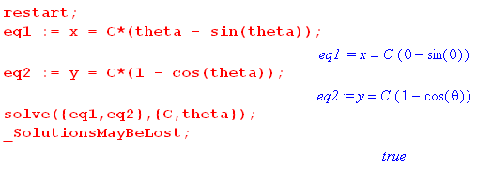
Maple can only do it numerically.

Question: what is the duration of a Bracky train trip on a flat earth?

Answer: θ(t) = - $\sqrt{g/(-C)}$ t so set θ = -2π to get

2π = $\sqrt{g/(-C)}$t ⇒ t = 2π $\sqrt{-C/g}$

But the article quoted above says

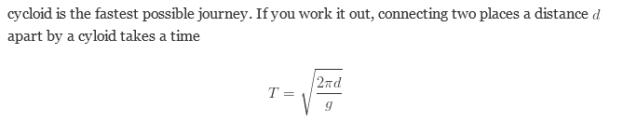

Now for the special problem where y = 0, we do know that

y = C(1-cosθ) = 0 ⇒ cosθ = 1 ⇒ θ = -2π for our situation

x = C(θ - sinθ) = C(-2π -0) = 2π(-C)

In this case we know that C = - (x/2π) so my result above gives

t = 2π $\sqrt{-C/g}$ = 2π $\sqrt{x/2πg}$ = $\sqrt{2πx/g}$

and this agrees with the quoted result. In this case we have

y = - (x/2π) (1-cosθ)

and this takes its larges neg value at θ = -π so we get

ymin = - (x/2π) (2) = - x/π which is about 1/3 of x

H

