Euler Angles compared with exp(-iu n.J) parameters PhL 11.19.16

0. Goal of this document 1
1. Derive Goldstein's rotation matrices shown on his page 109 2
2. Compare R_{z}(-ψ)R_{x}(-θ)R_{z}(-φ) to e^{-iγn}•^{J} using infinitesimals only 3
3. Compare R_{z}(ψ)R_{x}(θ)R_{z}(φ) to e^{-iun}•^{J} using finite rotations 6
4. Direction (n,u) → (ψ,θ,φ) 7
5. Direction (ψ,θ,φ) → (n,u) 9

0. Goal of this document

I know two ways to represent a general rotation :

way1: R = Rz(ψ)Rx(θ)Rz(φ) Euler angles using x in the middle

way2: R = e-iun•J = exp(-iu n • J) Rotation of amount u about axis n (unit vector)

The goal is the following:

(1) express (ψ,θ,φ) in terms of (n1,n2,n3,u)
(2) express (n1,n2,n3,u) in terms of (ψ,θ,φ)

To get the results, I make use of a certain result from "exp nJ calc...doc" which is this

Rn(u) = exp(-iun•J) = $\left(\begin{matrix}1 & 0 & 0 \\ 0 & 1 & 0 \\ 0 & 0 & 1\end{matrix}\right)$ + (cosu-1) $\left(\begin{matrix}1-n12 & -n1n2 & -n1n3 \\ -n1n2 & 1-n22 & -n2n3 \\ -n1n3 & -n2n3 & 1-n32\end{matrix}\right)$ + sinu $\left(\begin{matrix}0 & -n3 & n2 \\ n3 & 0 & -n1 \\ -n2 & n1 & 0\end{matrix}\right)$

I derived the above in 2005 but had a wrong sign in the middle term, it is now corrected in that document and the correct result is stated above and used below.

The results are given in boxes in Sections 4 and 5 below which I copy to the next page :

I have always known there were such relations between the two parametrizations, but I had never figured them out until today.

In Section 1 I simply derive certain rotation matrices which appear in Goldstein's book.

In Section 2 I show that just looking at infinitesimal rotations does not solve the problem.

Section 3 is just setup for the following two sections where the results are obtained.

Results:

Summary for (1): express (ψ,θ,φ) in terms of (n1,n2,n3,u)

cosθ = 1 + (cosu-1)(1-n32) 0 ≤ θ ≤ π
sinθ = $\sqrt{1-cos2θ}$ > 0

sinψ = [-(cosu-1)n1n3 + sinu n2]/sinθ 0 ≤ ψ ≤ 2π
cosψ = [(cosu-1)n2n3 + sinu n1]/sinθ

sinφ = [-(cosu-1)n1n3 - sinu n2]/sinθ 0 ≤ ψ ≤ 2π
cosφ = [-(cosu-1)n2n3 + sinu n1]/sinθ

Summary for (2): express (n1,n2,n3,u) in terms of (ψ,θ,φ)

cosu = [ (cosθ-1) + (cosθ+1)( cosψcosφ - sinψsinφ) ]/2 = cos2(θ/2)cos(ψ-φ) -sin2(θ/2)

From that you can get

sinu = cos(θ/2) $\sqrt{(cos(ψ-φ) + 1)[2-cos2(θ/2)(cos(ψ-φ) + 1)]}$ > 0

Then

n3 = [cosψsinφ +sinψcosθcosφ + sinψcosφ + cosψcosθsinφ] /2sinu
n1 = [cosψsinθ + sinθcosφ]/2sinu
n2 = [sinψ sinθ - sinθsinφ]/2sinu

1. Derive Goldstein's rotation matrices shown on his page 109

I thought I had this somewhere but could not find it. So I will do this right here using Maple and using my sign conventions for active rotations where I have

Rx(θ) = 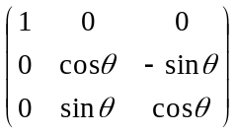 Ry(θ) = 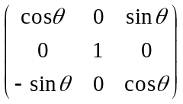 Rz(θ) = 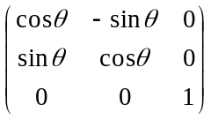

I do this in Euler angle matrices.mws. First I enter the above matrices and verify against the above,

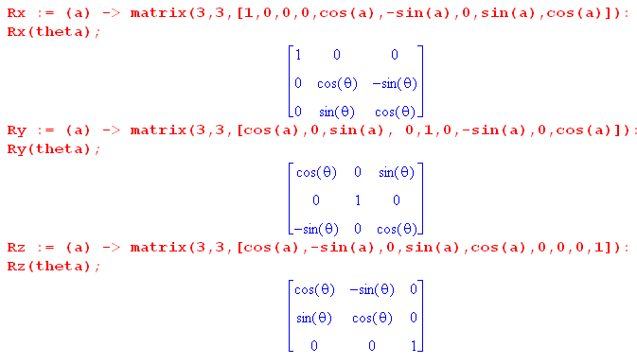

Then I think this should generate Goldstein's page 109 A matrix (here I use negative angles)

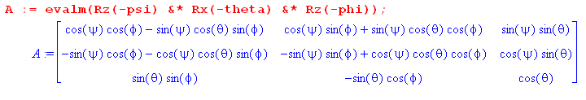

and this agrees with his (4-46), I checked every entry. The inverse is then

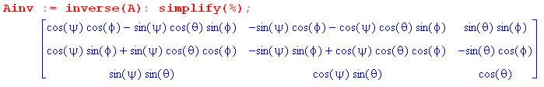

and this agrees with his (4-47).

2. Compare Rz(-ψ)Rx(-θ)Rz(-φ) to e-iγn•J using infinitesimals only

The question here is this: can you relate (ψ,θ,φ) to (n1,n2,n3,γ) merely by looking at a very small rotation? I once thought yes, but now I think no, there is not enough information in the infinitesimal.

Evaluate both sides to first order in small angles,

Rz(-ψ)Rx(-θ)Rz(-φ) = [ 1 + iψJ3] [ 1 + iθJ1] [ 1 + iφJ3]

= 1 + iψJ3 + iθJ1 + iφJ3 + order(angle2)

= 1 + i(ψ+φ)J3 + iθJ1 + order(angle2)

Let's construct this infinitesimal matrix in Maple as well using my data

Jx = 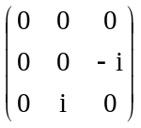 Jy = 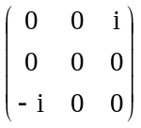 Jz = 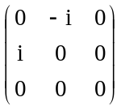

Here then are the generators and they verify with the above.

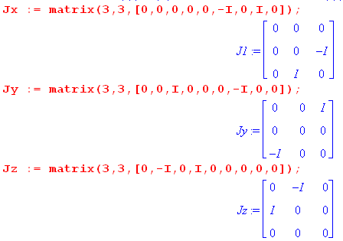

Then Rz(-ψ)Rx(-θ)Rz(-φ) for small angles is this matrix,

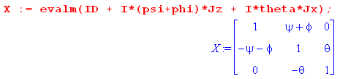

On the other hand we know that

GEN ≡ e-iγn•J = 1 - iγ n • J = 1 - iγ(n1J1+ n2J2+ n3J3)

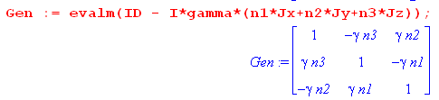

These two matrices have to be the same to first order, so you find that

ψ+φ = -γ n3

n2 = 0

θ = -γn1

n12 + n33 = 1 since n2 = 0

So if we are given n1 and n3 with n2 = 0, then we know that

ψ+φ = -γ n3 any way you want to allocate

θ = -γ n1

On the other hand, if we are given ψ,θ,φ, now can we compute γ and n ? We have 2 in 2:

ψ+φ = -γ n3
θ = -γ $\sqrt{1-n32}$

Rewrite

(ψ+φ)2 = γ2n32

θ2 = γ2(1-n32) = γ2 - γ2n32 = γ2 - (ψ+φ)2

Then we have an expression for γ ,

γ2 = θ2 + (ψ+φ)2

and then

n1 = -θ/γ n2 = 0 n3 = - (ψ+φ)/γ

But since angles are very small, I guess we can say

γ2 = θ2 +ψ2 + φ2

So this seems to be the solution to the problem when all angles are very small

γ = $\sqrt{θ2 +ψ2 + φ2}$
n1 = -θ/γ n2 = 0 n3 = - (ψ+φ)/γ

I could check this later for a small rotation, but the point is that this does NOT tell you the connection between (ψ,θ,φ) to (n1,n2,n3,γ) for finite values of things. You learn nothing by doing this!

3. Compare Rz(ψ)Rx(θ)Rz(φ) to e-iun•J using finite rotations

I know from exp nJ calculation.doc the following finite matrix (after I corrected 2nd term sign !!!! )

Rn(u) = exp(-iun•J) = $\left(\begin{matrix}1 & 0 & 0 \\ 0 & 1 & 0 \\ 0 & 0 & 1\end{matrix}\right)$ + (Cu-1) $\left(\begin{matrix}1-n12 & -n1n2 & -n1n3 \\ -n1n2 & 1-n22 & -n2n3 \\ -n1n3 & -n2n3 & 1-n32\end{matrix}\right)$ + Su $\left(\begin{matrix}0 & -n3 & n2 \\ n3 & 0 & -n1 \\ -n2 & n1 & 0\end{matrix}\right)$

And I have from above that, going back to my usual active notation,

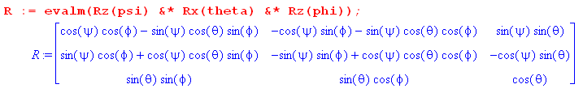

I am going to set these two matrices equal thereby find out how (ψ,θ,φ) to (n1,n2,n3,γ) are related. There are a total of 9 equations that can be used. The R matrix only has 6 independent elements, but it is convenient nevertheless to make use of all 9 equations to obtain simple forms for expressions.

Top row:

1 + (cosu-1)(1-n12) = cosψcosφ - sinψcosθsinφ (1)

-(cosu-1)(n1n2) - sinu n3 = -cosψsinφ -sinψcosθcosφ (2)

-(cosu-1)n1n3 + sinu n2 = sinψ sinθ (3)

Second row:

-(cosu-1)n1n2 + sinu n3 = sinψcosφ + cosψcosθsinφ (4)

1 + (cosu-1)(1-n22) = -sinψsinφ + cosψcosθcosφ (5)

-(cosu-1)n2n3 - sinu n1 = -cosψsinθ (6)

Last row:

-(cosu-1)n1n3 - sinu n2 = sinθsinφ (7)

-(cosu-1)n2n3 + sinu n1 = sinθcosφ (8)

1 + (cosu-1)(1-n32) = cosθ (9)

Finally

n12+n22+n32 = 1 (10)

4. Direction (n,u) → (ψ,θ,φ)

Since angle θ only ranges 0 to π. equation (9) fully determines cosθ, so we have

cosθ = 1 + (cosu-1)(1-n32) 0 ≤ θ ≤ π

sinθ = $\sqrt{1-cos2θ}$ > 0

Then from (3) and (6) we have

-(cosu-1)n1n3 + sinu n2 = sinψ sinθ (3)
(cosu-1)n2n3 + sinu n1 = cosψsinθ (6)

and this then tells us sinψ and cosψ.

Then from (7) and (8),

-(cosu-1)n1n3 - sinu n2 = sinθsinφ (7)

-(cosu-1)n2n3 + sinu n1 = sinθcosφ (8)

and this tells us sinφ and cosφ. So here is the solution in this direction:

Summary: Compute

cosθ = 1 + (cosu-1)(1-n32) 0 ≤ θ ≤ π
sinθ = $\sqrt{1-cos2θ}$ > 0

sinψ = [-(cosu-1)n1n3 + sinu n2]/sinθ 0 ≤ ψ ≤ 2π
cosψ = [(cosu-1)n2n3 + sinu n1]/sinθ

sinφ = [-(cosu-1)n1n3 - sinu n2]/sinθ 0 ≤ ψ ≤ 2π
cosφ = [-(cosu-1)n2n3 + sinu n1]/sinθ

You can see that n,u → a specific solution (ψ,θ,φ) with no ambiguity.

Test this result for n1 = 1 and n2= n3 = 0 :

cosθ = 1 + (cosu-1)(1) = cosu ⇒ θ = u
sinθ = sinu

sinψ = 0
cosψ = [sinu n1]/sinθ = 1 ⇒ ψ = 0

sinφ = 0 0 ≤ ψ ≤ 2π
cosφ = [ + sinu n1]/sinθ = 1 ⇒ φ = 0

and this is the desired result.

Let's verify that this is correct for the R11 matrix element. That element is this:

LHS = R11 = 1 + (cosu-1)(1-n12)
RHS = R11 = cosψcosφ - sinψcosθsinφ

So

RHS = cosψcosφ - sinψcosθsinφ

= [(cosu-1)n2n3 + sinu n1]/sinθ * [-(cosu-1)n2n3 + sinu n1]/sinθ

- [-(cosu-1)n1n3 + sinu n2]/sinθ* [1 + (cosu-1)(1-n32)] * [-(cosu-1)n1n3 - sinu n2]/sinθ

Multiply through by sin2θ to get

A = sin2θ RHS =

= [(cosu-1)n2n3 + sinu n1] * [-(cosu-1)n2n3 + sinu n1]

- [-(cosu-1)n1n3 + sinu n2] * [1 + (cosu-1)(1-n32)] * [-(cosu-1)n1n3 - sinu n2]

B = sin2θ LHS = sin2θ [ 1 + (cosu-1)(1-n12) ]

= (1 - cos2θ) [ 1 + (cosu-1)(1-n12) ]

= ( 1 - [1 + (cosu-1)(1-n32)]2) [ 1 + (cosu-1)(1-n12) ]

So I want to show that A-B = 0. So I will make Maple do this:

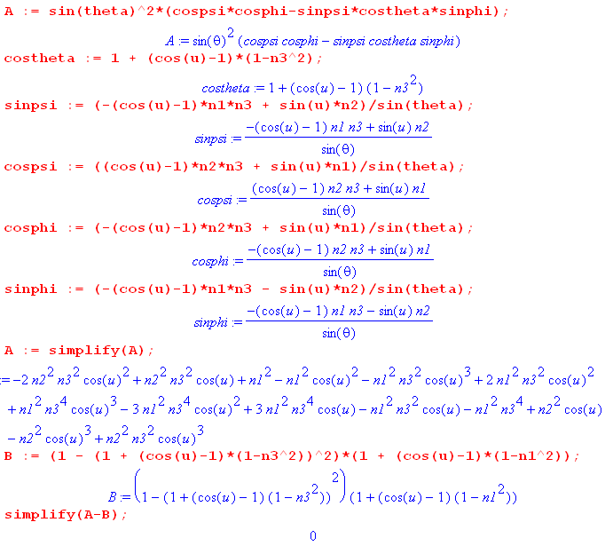

And so I have verified just the R11 element.

5. Direction (ψ,θ,φ) → (n,u)

Consider these 3 equations from above

1 + (cosu-1)(1-n12) = cosψcosφ - sinψcosθsinφ (1)
1 + (cosu-1)(1-n22) = -sinψsinφ + cosψcosθcosφ (5)
1 + (cosu-1)(1-n32) = cosθ (9)

If you add these up you get the left side being

3 + (cosu-1)[ 3 - n2] = 3 + (cosu-1)[ 3 - 1] = 3 +2(cosu-1) = 1 + 2cosu

You then know that

1 + 2cosu = cosψcosφ - sinψcosθsinφ -sinψsinφ + cosψcosθcosφ+ cosθ

Rewrite as

1 + 2cosu = cosψcosφ(1+cosθ) - sinψsinφ(1+cosθ) + cosθ

= (cosθ+1)( cosψcosφ - sinψsinφ) + cosθ

Then

1 + 2cosu = (cosθ+1)( cosψcosφ - sinψsinφ) + cosθ

2cosu = -1 + (cosθ+1)( cosψcosφ - sinψsinφ) + cosθ

cosu = [ (cosθ-1) + (cosθ+1)( cosψcosφ - sinψsinφ) ]/2

Try one angle at a time. If ψ=φ = 0 and θ = θ get

cosu = [ (cosθ-1) + (cosθ+1)( 1) ]/2 = cosθ // correct

Consider now,

(1-cosu)(n1n2) + sinu n3 = cosψsinφ +sinψcosθcosφ (2)
-(1-cosu)n1n2 + sinu n3 = sinψcosφ + cosψcosθsinφ (4)

Add these to get

2n3sinu = cosψsinφ +sinψcosθcosφ + sinψcosφ + cosψcosθsinφ

Then consider

(cosu-1)n2n3 + sinu n1 = cosψsinθ (6)
-(cosu-1)n2n3 + sinu n1 = sinθcosφ (8)

Add these to get

2sinu n1 = cosψsinθ + sinθcosφ

Then consider

-(cosu-1)n1n3 + sinu n2 = sinψ sinθ (3)
-(cosu-1)n1n3 - sinu n2 = sinθsinφ (7)

Subtract these to get

2sinu n2 = sinψ sinθ - sinθsinφ

At this point I then know that

2n3sinu = cosψsinφ +sinψcosθcosφ + sinψcosφ + cosψcosθsinφ
2n1sinu = cosψsinθ + sinθcosφ
2n2sinu = sinψ sinθ - sinθsinφ

If I square and add, this tells me sin2u but no sign for sinu. So no better than knowing just cosu as earlier.

OK, I guess I can consider 0 < u < π and allow the ni to have arbitrary sign and that is fully general. Then
I determine u first as follows:

cosu = [ (cosθ-1) + (cosθ+1)( cosψcosφ - sinψsinφ) ]/2

cosu = [ -2sin2(θ/2) + 2cos2(θ/2)cos(ψ-φ)]/2

cosu = cos2(θ/2)cos(ψ-φ) -sin2(θ/2)

Maple tells me that

1 - cos2u = cos2(θ/2)(cos(ψ-φ) + 1)[2-cos2(θ/2)(cos(ψ-φ) + 1)]

So sinu is just a big mess

sinu = cos(θ/2) $\sqrt{(cos(ψ-φ) + 1)[2-cos2(θ/2)(cos(ψ-φ) + 1)]}$

If ψ = φ = 0, however, we get

sinu = cos(θ/2) $\sqrt{(1 + 1)[2-cos2(θ/2)(1 + 1)]}$ = cos(θ/2) $\sqrt{2[2-cos2(θ/2)2]}$

= 2 cos(θ/2)$\sqrt{[1-cos2(θ/2)]}$ = 2 cos(θ/2)sin(θ/2) = sinθ // which is correct

Then I use the above three to get the ni

n3 = [cosψsinφ +sinψcosθcosφ + sinψcosφ + cosψcosθsinφ] /2sinu
n1 = [cosψsinθ + sinθcosφ]/2sinu
n2 = [sinψ sinθ - sinθsinφ]/2sinu

Summary: Compute

cosu = [ (cosθ-1) + (cosθ+1)( cosψcosφ - sinψsinφ) ]/2 = cos2(θ/2)cos(ψ-φ) -sin2(θ/2)

From that you can get

sinu = cos(θ/2) $\sqrt{(cos(ψ-φ) + 1)[2-cos2(θ/2)(cos(ψ-φ) + 1)]}$ > 0

Then

n3 = [cosψsinφ +sinψcosθcosφ + sinψcosφ + cosψcosθsinφ] /2sinu
n1 = [cosψsinθ + sinθcosφ]/2sinu
n2 = [sinψ sinθ - sinθsinφ]/2sinu

In theory, you should be able to insert these into

Rn(u) = exp(-iun•J) = $\left(\begin{matrix}1 & 0 & 0 \\ 0 & 1 & 0 \\ 0 & 0 & 1\end{matrix}\right)$ + (Cu-1) $\left(\begin{matrix}1-n12 & -n1n2 & -n1n3 \\ -n1n2 & 1-n22 & -n2n3 \\ -n1n3 & -n2n3 & 1-n32\end{matrix}\right)$ + Su $\left(\begin{matrix}0 & -n3 & n2 \\ n3 & 0 & -n1 \\ -n2 & n1 & 0\end{matrix}\right)$
and you should end up with

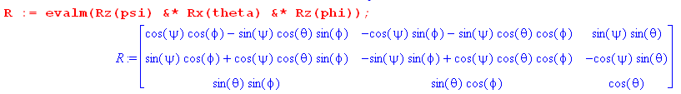

As before, let's try the first element and see what happens ,

R11 = 1 + (cosu-1)(1-n12)

= 1 + (cosu-1) (1 - [cosψsinθ + sinθcosφ]2/(2sinu)2 ) ?

Multiply through by 4sin2u to get,

RHS = 4sin2u R11 = 4sin2u + (cosu-1)(4sin2u - [cosψsinθ + sinθcosφ]2 )

= 4 - 4cos2u + (cosu-1)(4 - 4cos2u - [cosψsinθ + sinθcosφ]2 )

LHS = 4sin2u (cosψcosφ-sinψcosθsinφ)

= (4 - 4cos2u) (cosψcosφ-sinψcosθsinφ)

If these really are equal, I should find RHS - LHS = 0. Here is Maple on the subject:

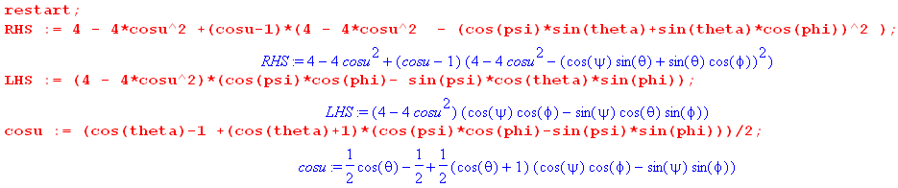

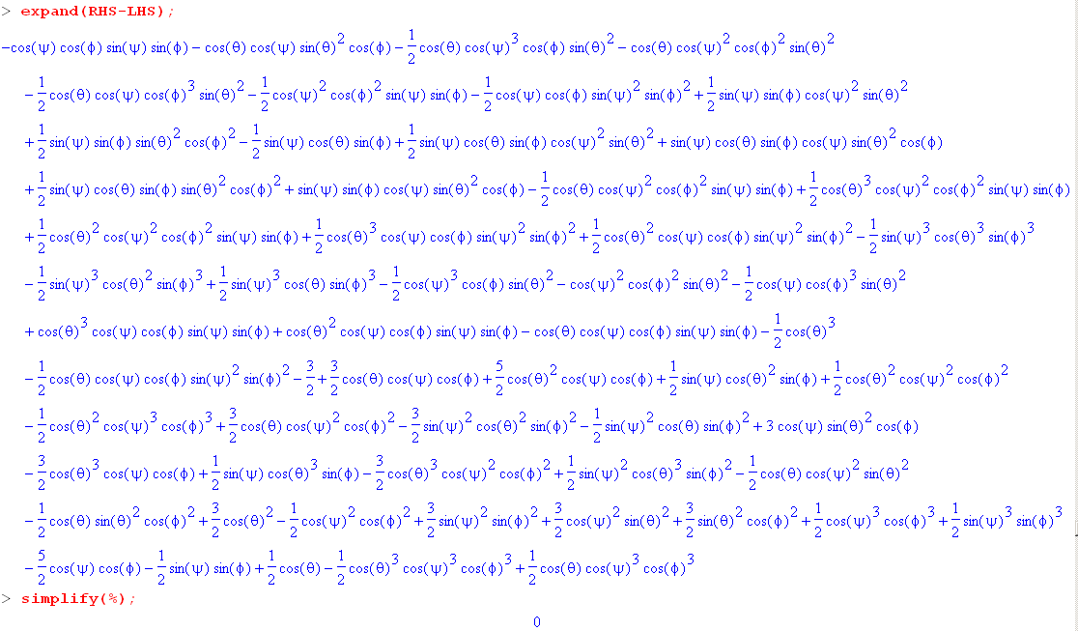

So there you have it, for the R11 it really works.

Footnote: Look back at my conclusion above that

1 + 2cosu = cosψcosφ - sinψcosθsinφ -sinψsinφ + cosψcosθcosφ+ cosθ

with

Goldstein p 123 notes that you can write Qn = for some rotation Q, and then

Rn = n ⇒ QRn = ⇒ QRQ-1 = ⇒ QRQ-1 = Rz(u)

Here you have rotated your coordinate system so the rotation by amount u is about the z axis. But then you know that tr(R) = tr(Rz(u)) = 1 + 2cosu. Thus you would claim that

1 + 2cosu = ΣiRii

In our R matrix that means

1 + 2cosu = cosψcosφ - sinψcosθsinφ - sinψsinφ + cosψcosθcosφ + cosθ

and this agrees with what I found above by brute force.

