Binary Star Orbits PhL 11.13.16

In the equivalent 1-body problem the solution for r = r,θ is this from (3-46),

r = (l2/μk) /(1 - ε cosθ) ε = ε(E,l,μ,k)

Here I use a minus sign in the denominator so that the ellipse goes off to the right instead of to the left. See just written document on Ellipse in Polar Coordinates. (math/geometry).

I like to think of the planet as being off to the right!

The standard form for an ellipse going to the right is this, where a is the semi-major axis,

r = a(1-ε2) /(1 - ε cosθ) ε = ε(E,l,μ,k) (1)

Question: What is the value of c and b for this ellipse?

Answer: (1) c = εa from the definition of ε.
(2) b = a$\sqrt{1-ε2}$ since b2 = a2-c2 = a2 - ε2a2 = a2(1-ε2)

Now, comparing our two ellipse formulas we conclude that,

a(1-ε2) = (l2/μk) ⇒ a = l2/[μk(1-ε2)]

We have an expression for ε but I won't use it here. Think of it as the free variable instead of E.

We also know that

1/μ = 1/m1+1/m2 = (m1+m2)/(m1m2) μ = (m1m2)/(m1+m2)

k = m1m2G G = gravitational constant

Then

μk = G (m1m2)2/(m1+m2)

We also know that if we set R = 0 to force the center of mass to be at the origin, then

r = r1- r2 R = (m1r1+m2r2)/(m1+ m2) = 0

has the solution

r1 = [m2/(m1+ m2)] r and r2 = - [m1/(m1+ m2)] r

Another way to write this uses m2/(m1+ m2) = (1/m1) (m1m2)/(m1+m2) = (1/m1) μ = μ/m1, so

r1 = (μ/m1) r and r2 = - (μ/m2) r

In polar coordinates. these leading scalar factors simply scale down the r-vector and leave the θ coordinate untouched, except the minus sign takes θ to θ+π. I restate this just below.

Now suppose we have an ellipse for r = (r,θ) as shown above in (1).

And suppose we know that r1 = (μ/m1) r . What does this tell us about the orbit of r1 ? Every point of the r orbit is "scaled toward the origin". Every point has θ1 = θ, but r1 = (μ/m1)r so then

r1,θ1 = (μ/m1)r, θ

r2,θ2 = (μ/m2)r, θ+π // since a minus sign

So now I can write the equations for these two individual ellipses for the 2 bodies,

r = (l2/μk) /(1 - ε cosθ) // the 1-body problem ellipse

r1 = (μ/m1)(l2/μk) /(1 - ε cosθ1) = (l2/m1k) /(1 - ε cosθ1) right side

r2 = (μ/m2)(l2/μk) /(1+ ε cosθ2) = (l2/m2k) /(1 + ε cosθ2) left side

k = m1m2G

Now if you want to use the semimajor axes a, a1 and a2 you have to rewrite as

r = a(1-ε2) /(1 - ε cosθ) // the 1-body problem ellipse

r1 = a1(1-ε2) /(1+ ε cosθ1) // left side ellipse for mass m1 object

r2 = a2(1-ε2) /(1 - ε cosθ2) // right side ellipse for mass m2 object

where
a = $\frac{l2}{μk(1-ε2)}$ a1 = $\frac{l2}{m1k(1-ε2)}$ a2 = $\frac{l2}{m2k(1-ε2)}$

a1 = (μ/m1)a a2 = (μ/m2)a ⇒ a1/a2 = m2/m1 (2)

a1+a2 = aμ(1/m1+1/m2) = a μ (1/μ) 1 a ⇒ a = a1+ a2 (3)

I am now in good agreement with this clip I put into Goldstein raw notes,

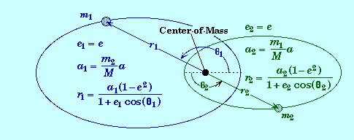

except I have an expression for a and for ε.

Now suppose m1 is very large (like the sun). Then a1 = (μ/m1)a is very small, so the left ellipse has a very small major axis and this eventually shrinks down around the origin.

The Maple file "binary star orbit.mws" is how set to replicate the above plot.

e := .85; a := 1;m1 := 1; m2:= 1.5;

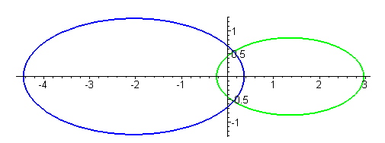

e := .6; a := 1;m1 := 10; m2:= 1;

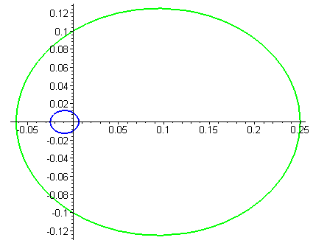

So there is your sun on the left doing a small path. If this is a sun/earth orbit, what you really observe from the earth is r = rsun-rearth and that vector does the 1-body ellipse. You could observe that with a transparent earth by taking a shot every sidereal day.

Has anyone every seen a binary star close enough to verify these orbits?

Question: What can an astronomer learn by observing a binary star?

Answer: If you know how far away d the binary is (by other means), and if you know the period T of the orbits, and if you know where the CMS is after observing, and if it is a "visual binary" so you can measure the various angles, then you can determine the two masses m1 and m2, as described below. This is a direct measurement really, and does not depend on things like color or HR diagram location (if you know d).

An "optical double" is a fake, two distant stars on the same line of sight. An "eclipsing binary" lets you get the period from the light periodicity. A "spectrum binary" can be detected by the two stars having different spectra. A "spectroscopic binary" is detected by periodic Doppler shifts of the spectra.

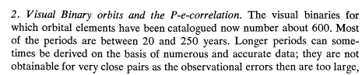

Jupiter is 12 years around the sun, near the low end above

First, we need to extract more equations from the above work. Recall from above that

r1 = a1(1-ε2) /(1+ ε cosθ1) // left side ellipse for mass m1 object

r2 = a2(1-ε2) /(1 - ε cosθ2) // right side ellipse for mass m2 object

At some instant in time we have

r1/r2 = a1/a2 (1 - εcosθ2)/ (1 + εcosθ1)

where θi are the "natural polar angles" one uses to parameterize each ellipse. They are both measured up from the right-directed x axis. But at any instant, we know that θ2 = θ1± π, so the last ratio is one and

r1(t)/r2(t) = a1/a2 at any time t

But from (2) we know more, so we end up with

r1(t)/r2(t) = a1/a2 = m2/m1

in agreement with my PDF

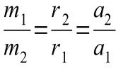

Suppose you knew the distance to the binary star, and suppose you knew you were looking at it flat as this picture shows, and suppose you had enough observations to know where the CMS is located. Then consider

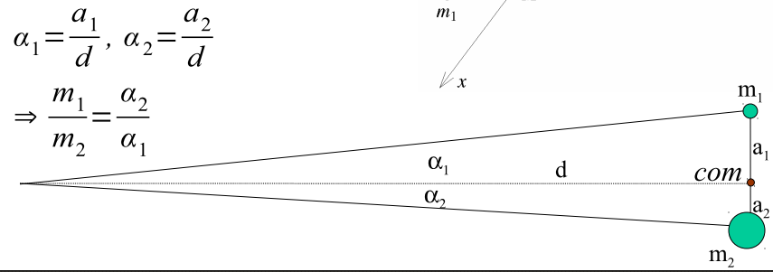

You know d, you measure angles α1 and α2 so then you know a1 and a2 and you then know m1/m2.

Kepler 3 from Goldstein p 80 says this

τ = 2πa3/2$\sqrt{μ/k}$

where I already know about from 1-body equivalent that

μ = (m1m2)/(m1+m2) k = m1m2G

so then

τ2 = 4π2a3 [ [(m1m2)/(m1+m2)] / m1m2G ]

= 4π2a3 / [ G(m1+m2)]

and this also agrees with my PDF,

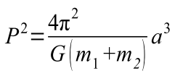

Now with the above measurements, you know a1 and a2 and by (3) you know a = a1+a2. You know G. You then have these equations

a1/a2 = m2/m1

P2 = 4π2(a1+a2)3 / [ G(m1+m2)]

You have measured a1, a2 and if it moves fast enough, you measure P, so you can then determine the two masses m1 and m2 ! Game over says the guy. So this works with the conditions I state above.

PDF author goes on to show you can adjust for a tilted binary orbit plane relative to the line of site. You can detect the tilt because focus will appear to be in the wrong place. Gives some math.

What do I know about velocities of the two stars? Recall

r1(t) = (m2/m1)r2(t)
so
v1(t) = (m2/m1)v2(t)

at some instant in time. With spectroscopy you can measure the "radial" component of each velocity toward or away from the observer on Earth. So you can measure what the PDF calls v1r and v2r . You can then factor in the tilt of the plane as discussed earlier in the PDF and then again you get two equations in two unknowns

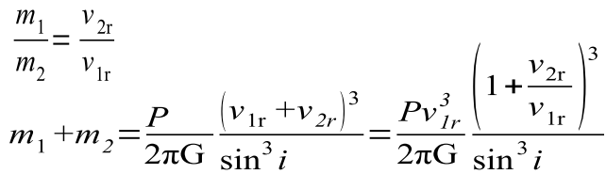

You know the tilt angle i and you measure v1r and v2r

The PDF author is David Golimowski who was at JHU in 1995 but no longer. His notes are for "physics 371" perhaps at JHU. He is now at the Space Telescope Science Institute STScI. Hubble went up in 1990. He is listed there at STScI today 11.14.16. But where are the rest of his notes?

https://www2.onu.edu/~j-pinkney/PHYS3471/.../phys371_w3Binary_Stars.pdf

I took in a few teaching PDF's on astronomy in general.

