Elliptic Functions PhL 8.7.08

This is a subject I never came up against in my entire history, although it occurs in the simple problem of the plane pendulum I now realize. This is a complex subject with many pieces. Until you know some of these pieces, it is pretty hard to just read properties in a handbook. [ did some updating 10.25.10 ]

0. The Inverse Functions Idea. 1
2. Changing from x to φ. 3
3. Complete integrals. 4
Notation ambiguity with K: 5
4. Second and third kind. 5
5. The basic Jacobi functions: 6
6. The ellipse connection and the origin of the Jacobi functions. 6
Make a plot of u(θ) versus θ. 10
Make a plot of θ(u) versus u. 11
Why is sn(u) periodic? 12
How would you make a plot of sn(u) versus u? 12
What about complex values? 13
7. Comments and Notations used by various authors 14
8. Transformations of Elliptic Functions 22
9. Integral representations for sn⁻¹(x), cn⁻¹(x) and dn⁻¹(x). 23

0. The Inverse Functions Idea. I am following some nice notes in a PDF I will store somewhere. Suppose someone hands you the integral (imagine integration variable is x'):

y = F(x) = $\int_{0}^{x}{}$ dx $\sqrt{1-x2}$

You could ask about the inverse function x =F-1(y). In this case, it happens that

F(x) = sin-1(x) so x = F-1(y) = sin(y)

You might find that the inverse function x = sin(y) is "easier to think about" than y = sin-1(x). For example, we are familiar with lots of properties of sin, and not so many of sin-1. Notice that you can then write

y = $\int_{0}^{sin(y)}{}$ dx $\sqrt{1-x2}$

so the thing on the upper end point is the inverse function of y = F(x).
____________________________________________________________________________

Note Added: Is this always true? Yes it is, and here is the theorem of interest:

Theorem 1:

F(x) ≡ $^{\int_{a}^{x}{}}$ds f(s) => x = $^{\int_{a}^{F-1(x)}{}}$ds f(s)

so that "the thing appearing as the upper endpoint" is the inverse of the function F(x).

Proof: Start with F(x) ≡ $^{\int_{a}^{x}{}}$ds f(s). Define a new variable y by y = F(x) so that x = F-1(y). We then just rewrite our equation as y = $^{\int_{a}^{F-1(y)}{}}$ds f(s). Then rename variable y to be x, QED.

Example 1: f(s) = 1/$\sqrt{1-s2}$. Then F(x) = sin-1(x)|xa = sin-1x - sin-1a = y, so x = F-1(y) = sin(y+sin-1a). So our statement would then be that x = $^{\int_{a}^{sin(x+sin-1a)}{}}$ds /$\sqrt{1-s2}$ and the thing in the exponent is then the inverse of the function F(x) = $^{\int_{a}^{x}{}}$ds/$\sqrt{1-s2}$ = sin-1x - sin-1a.

Example 2. If a = 0 in Example 1, we find that x = $^{\int_{a}^{sin(x)}{}}$ds /$\sqrt{1-s2}$ and the thing in the exponent is then the inverse of the function F(x) = $^{\int_{0}^{x}{}}$ds/$\sqrt{1-s2}$ = sin-1(x).
________________________________________________________________________________

1. The Main Example. Suppose someone hands you a different integral, which happens to contain a constant k, but we show it all the time just so we are reminded it is there:

G(x,k) = $\int_{0}^{x}{}$ dt $\sqrt{(1-t2)(1-k2t2)}$ |x| ≤ 1 to keep things real.

where now G plays the role of F in our discussion above. This is the "incomplete elliptic integral of the first kind" in one of several notations we shall soon see. There must be some inverse function, and it goes by the name "sn", so we have y = G(x, k) and then

x = G-1(y,k) = sn(y,k) => G(x,k) = sn-1(x,k) => x = sn(G(x,k),k) (*)

y = G(x,k) = $\int_{0}^{G-1(y,k)}{}$ dt $\sqrt{(1-t2)(1-k2t2)}$ = $\int_{0}^{sn(y,k)}{}$ dt $\sqrt{(1-t2)(1-k2t2)}$

Like sin(y) above, sn(y,k) is "easier to work with" than the function G(x). This fact was a discovery of
Jaco'bi around 1829. If we set k = 0, we find that

G(x,0) = $\int_{0}^{x}{}$ dt $\sqrt{(1-t2)(1-k2t2)}$ = $\int_{0}^{x}{}$ dt $\sqrt{(1-t2)}$ = sin-1(x) => G-1(x,0) = sin(x)

Thus we see that

sn(x,0) = sin(x)

so this sn function is one which approaches the regular sine with k is small. So one more time:
G(x,k) = $\int_{0}^{x}{}$ dt $\sqrt{(1-t2)(1-k2t2)}$ = sn-1(x,k)
We are supposed to normally think of k as being in the range 0 ≤ k < 1. If k = 1, the above integral diverges, so we stay away from that end point. The quantity k is called the "elliptic modulus".

2. Changing from x to φ. Now suppose in the above integral we make the replacement t = sinθ so that
θ = sin-1t. . We can then rewrite the above integral as

u = G(x,k) = $\int_{0}^{sin-1(x)}{}$ dθ $\sqrt{1-k2sin2θ}$ = sn-1(x,k)

where now the integrand certainly looks simpler. Suppose we define φ = sin-1(x) so x = sinφ. Then we could write the above as

u = G(sinφ, k) = $\int_{0}^{φ}{}$ dθ $\sqrt{1-k2sin2θ}$ = sn-1(sinφ,k)

3. Suppose we decide we like working with the variable φ instead of x. We could then define F as

F(φ,k) ≡ G(sinφ, k)

Now let's write this in every way possible.

F(φ,k) = G(sinφ, k) = $\int_{0}^{φ}{}$ dθ $\sqrt{1-k2sin2θ}$ = sn-1(sinφ,k) = $\int_{0}^{sinφ}{}$ dt $\sqrt{(1-t2)(1-k2t2)}$

F(sin-1x,k) = G(x, k) = $\int_{0}^{sin-1x}{}$ dθ $\sqrt{1-k2sin2θ}$ = sn-1(x ,k) = $\int_{0}^{x}{}$ dt $\sqrt{(1-t2)(1-k2t2)}$

This thing F(φ,k) is the official definition of the "elliptic integral of the first kind" as used by GR page 904. They don't use the word "incomplete" but others do.

Note: it is not unusual to get a result of the form F(sin-1x,k) and in that case it might be nicer to express the result as sn-1(x ,k) as on the line above. An example is the potential of a charged ellipsoid au Kelvin.

Comment: Notice that, in all of the above, we don't really have any expression for sn(x,k). We only have an expression for sn-1(x,k) as a certain integral. We do know that sn(x,0) = sin(x), which shows that the function sn(x,0) is a periodic function in x. We suspect that sn(x,k) is also periodic in x, but since our limited theory here does not give us any expression for sn(x,k), we cannot confirm or deny this. A deeper probe into the theory, below in this document, shows that in fact sn(x,k) is periodic with a period which is 4 K(k) where K is defined below.
_________________________________________________________________________

Small argument limit: ( added 11.29.09)

F(δφ,k) = $\int_{0}^{δφ}{}$ dθ $\sqrt{1-k2sin2θ}$ ≈ [ $\sqrt{1-k2sin2θ}$]θ=0 δφ = δφ

Second argument 1 limit: (added 10.8.10)

F(φ,1) = $\int_{0}^{φ}{}$ dθ $\sqrt{1-sin2θ}$ = $\int_{0}^{φ}{}$ dθ /cosθ = ln [ (1+sinφ)/cosφ ] // Maple
___________________________________________________

In the above we have used y = G(x,k) as our left hand side. It is a tradition to use the letter u instead, so one see things like this [ see (*) above] where on the right we show the inverse function:

u = $\int_{0}^{x}{}$ dt $\sqrt{(1-t2)(1-k2t2)}$ = sn-1(x ,k) with x = sn(u,k)

If we write x = sinφ, the above becomes

u = $\int_{0}^{sinφ}{}$ dt $\sqrt{(1-t2)(1-k2t2)}$ = sn-1(sinφ ,k) with sinφ = sn(u,k)

This usually appears as sin(φ) = sn(u) in the literature [ see below ].

3. Complete integrals. If you make a rough plot of the integrand 1/$\sqrt{1-k2sin2θ}$, you see that the values it takes going 0 to π/2 are repeated (but reverse order) going π/2 to π, and then that entire pattern repeats in the range π to 2π. If you set φ = π/2, you get the "complete elliptic integral of the first kind" and they write

F(π/2,k) = u = G(sin(π/2), k) = $\int_{0}^{π/2}{}$ dθ $\sqrt{1-k2sin2θ}$ = $\int_{0}^{1}{}$ dt $\sqrt{(1-t2)(1-k2t2)}$ ≡ K(k)

where "K" is the name of this complete function, and it is always bolded! This is one quarter of the area under the integrand curve were we to integrate for a full 2π period. Thus, K(k) is sometimes called "the quarter period". In fact K(k), as we will show below, is one quarter period of sn(x,k), which is then the real reason for the name.
The integral representations given above for F(φ,k) are valid for φ in the range 0 to π. If you want to go to larger φ, you are supposed to imagine that you wind around and accumulate the sum. Thus, for example

F(π + φ,k) = $\int_{0}^{π+φ}{}$ dθ $\sqrt{1-k2sin2θ}$ = 2 $\int_{0}^{π/2}{}$ dθ $\sqrt{1-k2sin2θ}$ + $\int_{0}^{φ}{}$ dθ $\sqrt{1-k2sin2θ}$

2 K(k)+ F(φ,k) // see GR 8.121.3 page 907

Here you see directly that K(k) is the quarter period of F(φ,k). [ More on this below.]

Notation ambiguity with K: GR define K(k) in the manner just shown, that is, K(k) = F(π/2,k). However, AS on page 591 confuse the issue by talking about K(m) = K(k2), we they have a different argument! So now I have to go look how everyone else handles this:

K(k) GR, Bateman p 314, wiki, Wolfram, k = "elliptic modulus" , M&F, Maple
K(k2) AS
Schaum fudges by never showing an argument! Same for W&W.
M&M nada

F(φ,k) me, Bateman p 314, Wolfram,

Basically A&S is off the program here.

4. Second and third kind. I will mention that there are two other kinds of functions with letters E and Π, which are the second and third kind functions. Here are the first and second kind from GR:

F(φ,k) = $\int_{0}^{φ}{}$ dθ $\sqrt{1-k2sin2θ}$ = $\int_{0}^{sin(φ)}{}$ dt $\sqrt{(1-t2)(1-k2t2)}$ first kind K(k) = F(π/2,k)

E(φ,k) = $\int_{0}^{φ}{}$ dθ $\sqrt{1-k2sin2θ}$ = $\int_{0}^{sin(φ)}{}$ dt $\sqrt{(1-k2t2)}$$\sqrt{(1-t2)}$ second kind E(k) = E(π/2,k)

Notice the inconsistency in the naming of the "complete" functions. The second E is just a bolded version of E, but K is used instead of F. There is also a third-kind function which has an extra argument n which is called "the characteristic":

Π(φ,n,k) = $\int_{0}^{φ}{}$ dθ $\sqrt{1-k2sin2θ}$ = $\int_{0}^{sin(φ)}{}$ dt $\sqrt{(1-t2)(1-k2t2)}$ third kind

and you see this has the extra denominator factor compared to F(φ,k). We have Π(φ,n=0,k) = F(φ,k). Right now I don't care about the second and third kind functions, but be warned that there are a lot of notational variations. For example, from page 590 of AS we seem to have

ΠAS(n; φ\α) = Π(φ,-n,k = sin2α)

There is also another integral D(φ,k) which seems to have "no name", GR page 905, it is a difference thing between F and E.

5. The basic Jacobi functions:

We have already seen that sn(u) is the inverse function to the first kind elliptic integral:

u = G(x,k) = $\int_{0}^{x}{}$ dt $\sqrt{(1-t2)(1-k2t2)}$ = F(φ,k) x = sinφ

x = G-1(y,k) = sn(u,k)

If follow that

sn(u,k) = x = sinφ

and φ is always called "the amplitude" of u. It is the distance you integrate in the dθ form of F.

φ = am(u) x = sinφ = sin[am(u)] = sn(u)

φ = am(u) = sin-1[ sn(u)]

If we invert the "am" function, we get the "arg" function, as follows

u = arg(φ) = F(φ,k)

As shown page 910 on GR, we see that cn(u) and dn(u) are also the inverse functions of certain integrals.

6. The ellipse connection and the origin of the Jacobi functions.

So far we have said nothing about an ellipse, just "elliptic functions". From our pdf notes we take this picture, where notice that the half-height minor axis is b = 1, and origin is at center, not at a focus: [ see better picture below]

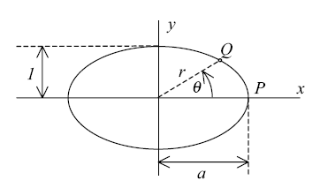

The point Q has coordinates x,y and we know x2 + y2 = r2. The ellipse equation is

(x/a)2 + y2 = 1

This ellipse becomes a circle when a→1 of course. If a is the major axis of our ellipse with semi-major axes a and b, then the eccentricity is given by

ε' = $\sqrt{1 - b2/a2}$ // ... and if b is the major axis, we get ε = $\sqrt{1 - a2/b2}$

and this ε is the thing we want below so I give it the name ε. The Schaum formula is ε2 = 1 - b2/a2 page 38 for case a is the major axis. As a increases and ellipse thins, ε approaches its limit of 1. As a approaches b to make a circle, ε approaches 0. So the point is eccentricity is in the range (0,1).

Now we define u as the following integral:

u = u(θ) ≡ (1/a) $^{\int_{0}^{θ}{}}$dθ' r(θ')

Author points out, the integral part is NOT an area, and it is NOT an arc length, and has dimensions of length, so that u(θ) is then dimensionless since we have (1/a). If a circle, then the integral part is = rθ and it then is the arc length along the circle and going around gives 2πr which is the circumference.
So u is some complicated function of r for which we have no convenient geometrical interpretation.

Now let's draw our ellipse with b > a so it is vertical:

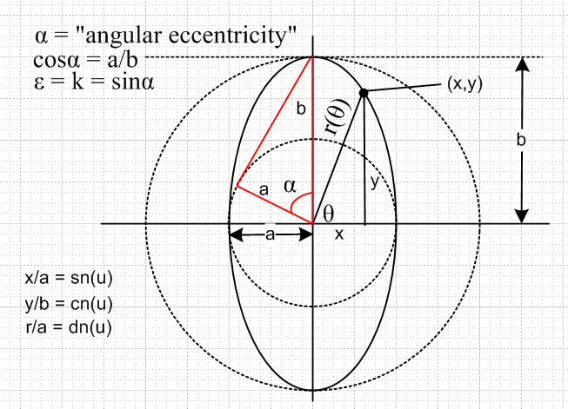

We know that

x = rcosθ y = rsinθ (rcosθ)2/a2 + (rsinθ)2 /b2= 1 so cos2θ /a2 + sin2θ/b2 = 1/r2

so r(θ) = 1/$\sqrt{cos2θ/a2 + sin2θ/b2}$ = 1/$\sqrt{(1 – sin2θ)/a2 + sin2θ/b2}$ = a/$\sqrt{1 – k2sin2θ}$

where

k2 = a2(1/a2 - 1/b2) = 1 - a2/b2 = ε2 // where a is the minor axis so a < 1 in the picture

Thus, we may conclude that k is the eccentricity of our ellipse if a < b. As a gets smaller, the ellipse gets thin vertically and ε → 1.

Aside: There is another historical measurement of eccentricity called angular eccentricity. I think in older books it is called oε, but nowadays it is usually called α. We have

cos(α) = a/b so ε2 = k2 = (1-a2/b2) = 1-cos2(α) = sin2(α) => ε = k = sin(oε)

and I have shown this angle α in the above picture in a red triangle. Here are the extreme cases:

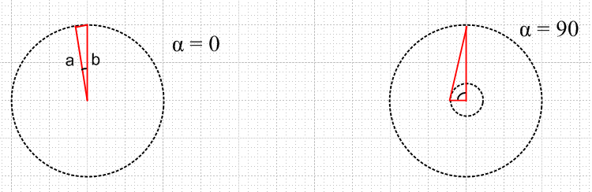

We may also conclude that, based on our definition of F(θ,k) given earlier.

u(θ) ≡(1/a) $^{\int_{0}^{θ}{}}$dθ' r(θ') = (1/a) $^{\int_{0}^{θ}{}}$dθ'[ a/$\sqrt{1 – k2sin2θ'}$] = $^{\int_{0}^{θ}{}}$dθ' 1/$\sqrt{1 – k2sin2θ'}$ = F(θ,k)

so this strange function u(θ) is our first kind elliptic integral F.

Now here are the Jacobi function definitions, and we copy down our picture:

sn(u) = sin(θ) = y/r(θ)
cn(u) = cos(θ) = x/r(θ)
dn(u) = a/r(θ) = ratio of two distances, hard to show as a trig function = $\sqrt{1 – k2sin2θ}$

Now let's go around the above ellipse and watch what happens.
First for sn(u): At θ = 0, sn(u) = 0 since y=0. At θ = π/2, it is clear that r(θ) = y so sn(u) = +1. It then goes back to 0 and heads off to -1. Thus, sn(u) is very much like sin(u), but the "rate" is different because (x,y) is going around an ellipse instead of a circle. I don't have an easy graphical explanation of the this effect, but the upshot is that as the vertical ellipse gets thinner and k → 1, the peak of sn(u) gets flattened out relative to sin(u), and you can see this on the plot below.
The cn(u) function is similar to cos(u) but has the opposite distortion -- pointy at the peaks -- as shown in the plot below. It is of course 90 degrees out of phase with sn(u).
Note from the definition that sn2(u) + cn2(u) = 1 for any u.
The dn(u) = a/r(θ) function is a new animal. At θ = 0 we have r=a so it starts at +1. It then decreases as we do our first quarter turn, because r increases, and it reaches a min value of a/b. It then goes back to where it was, and that pattern repeats forever, here is a plot stolen from below:

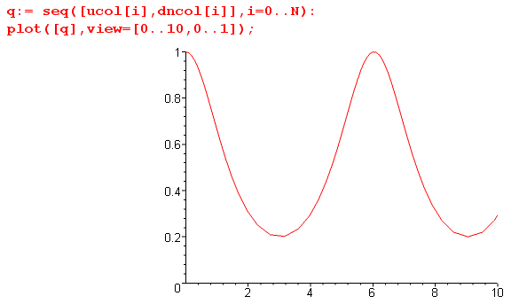 dn(u) versus u

Once again, it always peaks at 1, but the minima are at a/b. For a circle it would be a horizontal line.

Notice that our first result above says sn(u) = sinθ which we derived far above using θ=φ. We like θ when we are talking about ellipses in polar coordinates, but we like φ when talking about elliptic integrals!
As for the dn, on GR page 910 we are told that dn(u) = $\sqrt{1 – k2sin2θ}$ which from above is a/r(θ), so that verifies the third definition above.

Make a plot of u(θ) versus θ.

I find it very helpful to see a plot of u(θ) versus θ just to get a feel for things. In this plot, I have let θ run from 0 to 4π ≈ 12, so we have "gone around the ellipse" twice. The green line is θ(θ), while the red curve is u(θ), the horizontal axis is θ : [ a=2,b=7 so k2 = .91 ]

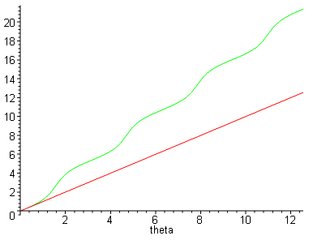

I made this plot by doing numerical integration to get u(θ) at various θ. The following has k2 = .92. The closer k comes to 1, the more θ dependence there is in r(θ), and the "curvier" the above plot becomes. Here is the code for the plot:

restart;
> a := 2:
> b := 7:
> k := sqrt(1-(a/b)^2);
> evalf(k^2);
> r := a/sqrt(1-(k*sin(theta1))^2);
> u := (theta2) -> evalf(Int(r,theta1=0..theta2));
> plot(u(theta),theta=0..2*Pi);

Make a plot of θ(u) versus u.

This is harder to do, since we don't have an explicit functional form the way we have the integral for u(θ). But we can do it numerically this way. Imagine stepping θ in evenly spaced small steps and recording two columns of data, θi and ui = u(θi) , getting u by doing those numeric integrations as above. We could then make a scatter plot putting θi on the vertical axis and ui on the horizontal then we have θ(u) as desired.
First, we generate 5 columns of data but we only use 2 of these columns right now (N=100)

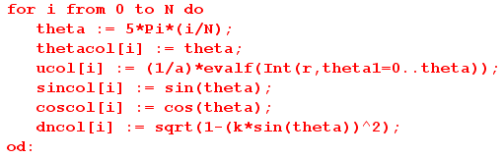

Then we do the following plotting instructions

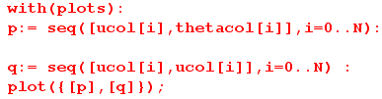

This second set of points q is obviously a straight line (red), and it plots u(u), while the first plots θ(u) which is green. Notice that it starts off bending the opposite way our red plot above does.

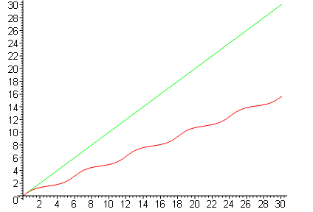

Why is sn(u) periodic?

From our definition we have sn(u(θ)) = sinθ. We know that each time θ goes around 2π, the values of sinθ are going to repeat those of the previous loop around the ellipse. If these values repeat, then the function sn(u(θ)) takes a set of values that exactly repeat. Now to declare sin(u) to be "periodic", we don't only need to know that values repeat, but that they repeat in exactly the same way, at the same "speed". It is not quite obvious to me how to show this, but I will now try. As θ moves around the ellipse, we know that u(θ) takes these values [ we know this from the definition of u(θ) as an integral, K = K(k) of course, and each time around the integral is 4K ]

u(θ) = int(θ/[2π]) * 4K + u(rem(θ/[2π])

Let's write θ = 2πN + φ so that φ only runs the range (0,2π) no matter how large θ gets. Then we have

u(θ) = N4K + u(φ)

and we can write

sn[N4K + u(φ)] = sinθ = sin(2πN + φ) = sinφ

where N is any integer. For example, if N = 0 we know that

sn[u(φ)] = sinφ

Therefore we have shown that

sn[u(φ) + N4K ] = sn[u(φ)]

sn[u + N4K ] = sn[u] N = integer

This last then conclusively states that sn(u) is a periodic function with period 4K!

How would you make a plot of sn(u) versus u?

In making our plot of u(θ) above, we already generated a column of sin(θ) values called sincol[i], so we can use that to make our sn(u) versus u plot as follows: (here I use a=1, b=5 so k = .98 to make things quite visibly flat on the top)

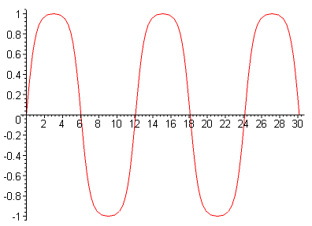

We might as well just plot all three functions on the same graph:

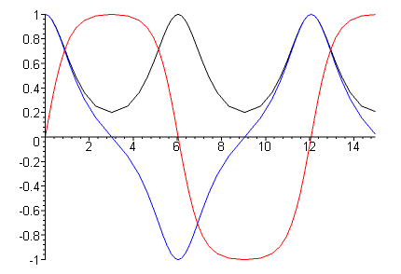

Notice that, whereas sn(u) flattens at the peaks, cn(u) gets more pointy at its peaks. This is how it arranges to maintain sn2(u)+ cs2(u) = 1.

What about complex values?

Look back at our starting facts

u(θ) ≡(1/a) $^{\int_{0}^{θ}{}}$dθ' r(θ') = (1/a) $^{\int_{0}^{θ}{}}$dθ'[ a/$\sqrt{1 – k2sin2θ'}$] = $^{\int_{0}^{θ}{}}$dθ' 1/$\sqrt{1 – k2sin2θ'}$ = F(θ,k)

sn(u) = sin(θ) = y/r(θ)
cn(u) = cos(θ) = x/r(θ)
dn(u) = a/r(θ) = ratio of two distances, hard to show as a trig function = $\sqrt{1 – k2sin2θ}$

We can certainly ask what happens if we let θ go complex. For example, if θ = iμ, we get

u(θ=iμ) = i $^{\int_{0}^{μ}{}}$ dμ' 1/$\sqrt{1 + k2sh2μ'}$

The integral is certain well defined and non-singular, so this gives u = i B where B is some real number. If you look up this integral in GR7 p 134 you see
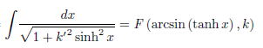

where the k appearing in the F is the complement thing to the k which appears in the integral. So in my case you could have

$^{\int_{}^{μ}{}}$ dμ' 1/$\sqrt{1 + k2sh2μ'}$ = F(sin-1(thμ), k' ) where k2 + k'2 = 1

Now as we increase μ in our u(θ=iμ) integral above, the integrand gets exponentially smaller so u approaches some limit value which is F(sin-1(1),k') = F(π/2,k') = K(k') = K($\sqrt{1-k2}$). So basically u(θ=iμ) goes from 0 to iK(k') monotonically as we go up the imaginary θ plane axis. So if we then consider that sn(u) = sin(θ), it would seem that sin(θ) blows up exponentially on this ray. But the corresponding path in the u plane is not an infinite ray, it is the line segment from 0 to i K(k'). So if we head straight north in the u plane, we find that sn(u) has some kind of pole sitting there at i K(k'), something we shall see in the pictures below.
But then how to you go "further north" beyond this pole? I suspect you just take θ to be on some arbitrary θ-plane ray (but not the vertical axis), and then you can show that you are periodic in both directions. I leave this development for some rainy day.

7. Comments and Notations used by various authors

(1) We first define u = u(θ) ≡(1/a)$\int_{0}^{θ}{}$dθ' r(θ') = F(θ,k) as some strange function of θ. We are associating this integral with the above ellipse picture, but we don't really have a geometric construction to show u somewhere on the figure. It is not an arc length.

It turns out that u(θ) and sin-1θ don't differ by very much, even for values of k close to 1 where they vary the most. Recall that F(φ,k=0) = sin-1φ just looking at the first integrals given in this write-up.

For example.

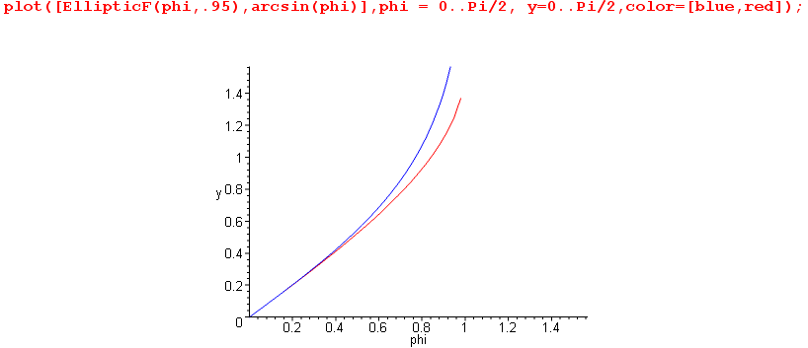

The red curve gives the first π/2 worth of the sin-1φ sine wave in the vertical direction, and F(φ,k) is pretty close to it all the time. This with k = 0.95. Here is with k = .5:

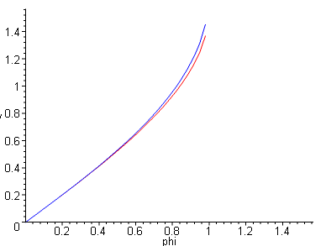

Here is another way to view this situation: plot the ratio of F(φ,k)/ sin-1φ for three k values

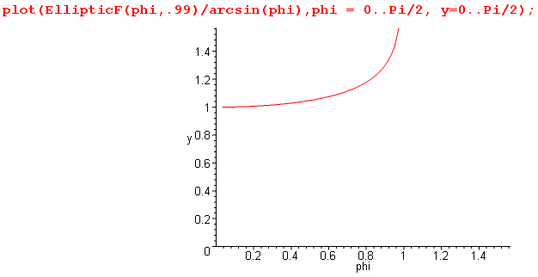
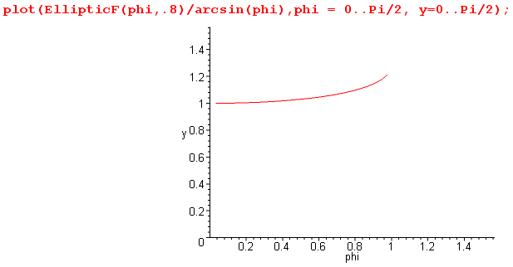
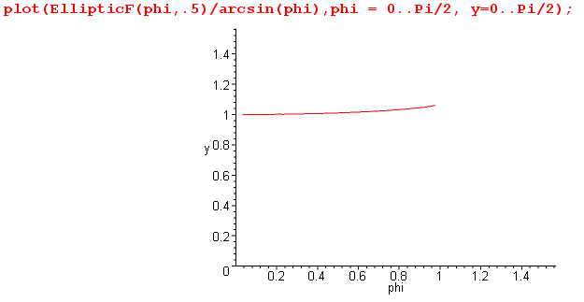

(2) now, once we have defined this function u(θ), we define the three basic Jacobi functions like this:

sn(u) = sin(θ) = y/r(θ)
cn(u) = cos(θ) = x/r(θ)
dn(u) = a/r(θ) = ratio of two distances, hard to show as a trig function. = $\sqrt{1 – k2sin2θ}$

where angle θ and distance r(θ) appear very clearly in our picture. So these functions like sn(u) are clearly associated with the ellipse, giving the sine of the regular angle.

(3) It is often remarked that the sn(u) type functions are periodic in both directions in the complex u plane. Here is a little Maple plot sort of confirming this idea:

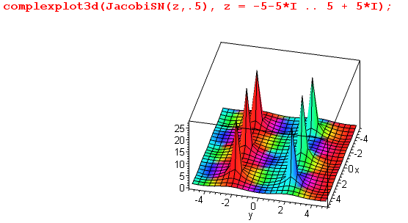

Think of starting in the center where things are blue (a zero exists in the center of each blue region). If you go "right or left" you get to the next zero patch, and that agrees with our sn(u) plot above. If you go due north (ie, left) from the origin, you hit the center red pole, as noted above.
So sn and the other functions are periodic on a certain grid and there are poles at some corners and zeros at others. In this plot, the height is the magnitude of the resulting complex function, and the color shows the phase. By way of contrast, the sin(u) function is periodic in only one direction and exponential in the other.

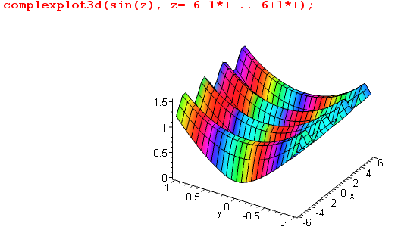

(4) Because these functions like sn(u) are geometrically connected with the ellipse (as a deformation of a circle), they are called the "Jacobian elliptic functions".

(5) Here is a good wiki discussion of "the grid" on which the Jacobi functions are doubly periodic:

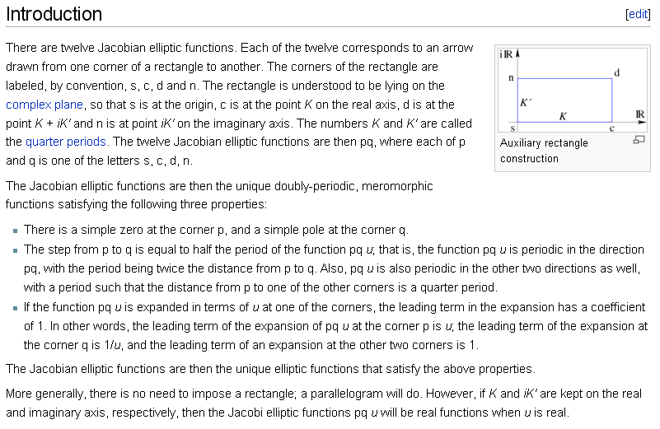

Meromorphic means analytic except for poles.

For example, my function pq(u) = sn(u) should have these properties
• a zero at the s corner
• a pole at the n corner
• moving s to n (up) says the half period in the imaginary direction is K'
• if you move right to corner c, you find that K is a quarter period
• if you move to corner d (diagonal), the diagonal distance is a quarter period
• expand sn(u) at the s corner and leading term is u.
• expand sn(u) at the n corner, and leading term is 1/u.
• at the d an c corners, the leading expansion term is 1, function is flat there.

Notice that the values of K and K' are functions of k. Look at GR page 914 table and it says that for the function sn(u), the period in the real direction is 4K, while in the imaginary direction it is 2K', which agrees with what was just said above.
To make the function pq(u), you can select four corners for the first letter and then 3 for the second letter, so there are 12 Jacobi elliptic functions and they have "various relations" to each other.

(6) Notation. Our handout claims this notation is used:

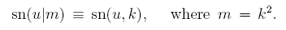
The above is what AS do on their page 571. Instead of using k and k', they use m and m1, fine. That is to say:
m = k2 m1 = 1- k2 = k'2

Schaum on page 179 is basically the same notation as GR, but he reverses the order of the arguments in F and E!

(7) A&S have a huge amount of information. One nice trick is shown on page 578. You define certain "theta functions" ( which have k hidden in them), and then you can write every Jacobi function as a ratio of these theta guys according to pq(u) = θp(u)/θq(u). These theta things of course only have zeros, so here is how you get the zeros and poles of pq(u). The thetas that do this trick are linear combinations of Jacobi's original theta functions which he called Θ , Θ1, H and H1.

(8) A&S have a separate chapter 17 on "Elliptic Integrals" , while chapter 16 is on "Jacobi elliptic functions and theta functions". Only in Chapter 17 do we see two new notations:

• m = k2 is called the "parameter" so that k can still be called the "modulus".

• m = k2 = sin2α so that k = sinα and this new thing α is the "modular angle". But looking above, we see that this thing α is the same as our oε "angular eccentricity" of the ellipse.

• So A&S trick (p 589) to distinguish how things are parameterized is to say this:

F(φ,k) = F(φ|m) = F(φ\α) k = sinα m = k2

• See note above on p 4 about fact that KAS(k2) = Keveryone else(k)

• Just a reminder that GR use F(φ,k) exactly as I use it here, see note earlier on GR

• Bateman Vol II also has a lot to say about all these elliptic integrals and functions, a whole chapter.

• In the various expansions for these elliptic functions, we often see the following function

q(k) = exp[-πK'(k)/K(k)]

which has the strange name of "the nome". Here is a little detail from wiki,

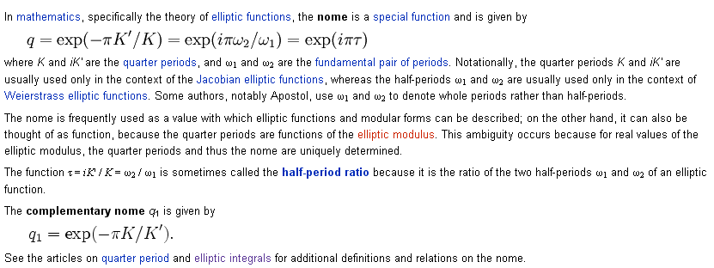

I would guess that Jacobi came up with the word "nome" for this function. He did his elliptic treatise around 1830. His paper "Fundamenta nova theoria functionum ellipticarum" published in 1829, together with its later supplements, made fundamental contributions to this theory of elliptic functions.

• What is the arc length of an ellipse? Here is a blurb on that

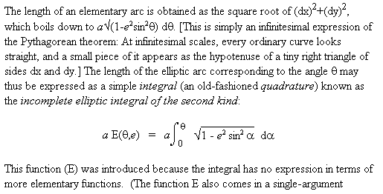

So, our second kind E function is exactly what we want. Note use of ε for k here. See also page 7 of Schaum, who gives also an approximate formula.

(9) You might ask "how sn(u) is defined and computed". The F(φ,k) integral of course is cleanly stated and can be studied for complex x = sinφ and k, etc. Presumably, the inverse function sn(u,k) must be similarly defined. One approach: we define sn(u) in this way, obtain a series expansion of it in some disc, and then analytically continue it as needed to wherever we want to go. This last can be done using the various transformation formulas or associated differential equations or other series. In this way, one discovers that sn(u) is periodic in both directions in the u-plane. Obviously the theory here is much deeper than my cursory review of "the basic facts".

(10) What do we know about sn(u; k) as a function of real u?
• From our discussion above, we know that the quarter period is K(k). So we might be interested in what THIS function looks like!

plot(EllipticK(k)/(Pi/2), k=0..1); // K(k=1) = ∞, blows up slowly. K(.999999) = 7.95

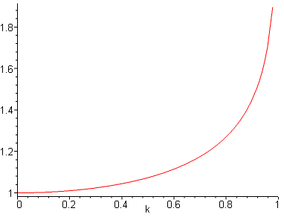

So, the quarter period starts out being π/2 for small k, meaning the period is 2π, as for the sine. But as k increases, this period increases. At k = .916 or so, the period has increased by 50%.
• We also know from sn(u) = sin(φ) that sin(u) is sinusoidal in nature varying between 1 and -1. Here is a plot comparing sn(x) to sin(x) for k = .5:

plot([JacobiSN(x,.5),sin(x)], x = -20..20, color = [red,blue]);

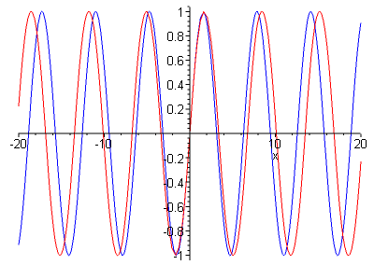

You would think at least for small k, you could approximate sn(u) as a sin(Au) with an adjusted period. We already know that sn(u) = sin(φ) and we might approximate in this way:

u = F(φ,k) ≈ φ /k' // just looking at the integral

so then we are saying

sn(t) ≈ sin(k't) where of course k' = $\sqrt{1 - k2}$

and since k' < 1, sin(k't) goes at a lower frequency ω and has a longer period as shown. !

8. Transformations of Elliptic Functions

I did not discover this until I fiddled more with the pendulum. Of my books, only GR gives a nice table of transformation formulas on page GR 915. The Wolfram mathematica site has all this stuff but they like to use the sn(u|m) notation instead of sn(u,k) where m = k2 .
Here is an important transformation for sn:

sn(ku,1/k) = k sn(u,k)

It is important because it then lets you cover the entire real range of k, not just k ≤ 1. I suppose k=1 is always a problem child.
Can I derive the above? Consider

w = $\int_{0}^{sn(w,k)}{}$ dt $\sqrt{(1-t2)(1-k2t2)}$ (1)

The RHS is true for any value of k. For example, it is true for k' = 1/k, so can write

w = $\int_{0}^{sn(w,1/k)}{}$ dt $\sqrt{(1-t2)(1-k-2t2)}$
It is also true for any value of w, so try w = ku to get

ku = $\int_{0}^{sn(ku,1/k)}{}$ dt $\sqrt{(1-t2)(1-k-2t2)}$

Now change the integration variable according to t' = t/k. Root arg becomes (1-k2t'2)(1-t'2) so the two factors sort of swap places. we also have dt = kt' and the upper end endpoint in the t' integration goes to 1/k where it went before. So we then have

ku = $\int_{0}^{(1/k)sn(ku,1/k)}{}$ k dt' $\sqrt{(1-k2t'2)(1-t'2)}$

Cancel the k's and rename t' to be t again, swap lower order, get

u = $\int_{0}^{(1/k)sn(ku,1/k)}{}$ dt $\sqrt{(1-t2)(1-k2t2)}$

But write (1) above for w=u to get

u = $\int_{0}^{sn(u,k)}{}$ dt $\sqrt{(1-t2)(1-k2t2)}$

Therefore, the upper endpoints must be the same, so get

sn(u,k) = 1/k sn(ku,1/k)

and thus we have proven our transformation. QED.

Note added 11.2.09. GR page 908 show "transformations" for the K function so you can, for example, replace an imaginary argument with a real one, such as 8.128.1. I was doing this with my half spherical shell problem today.

9. Integral representations for sn-1(x), cn-1(x) and dn-1(x).

Just for the record, here are three GR7 integrals of interest:

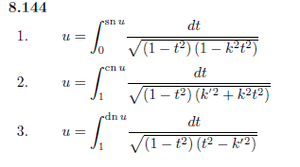
If we apply the results of our Theorem in section 0 above, we conclude that each of these three integrals, if taken to x as an upper endpoint, would represent sn-1(x), cn-1(x) and dn-1(x). It was the first of these three that we worked on earlier in this doc, but one should be aware of the other two as well.

