Summary of the Plane Pendulum Problem PhL 8.10.08

This is a summary of details presented at length in an earlier document on the 2D pendulum.

Contents:
1. The Basics
2. Libration Solution
3. Rotation solution
4. Doing only the first integration : Phase Space
5. Hamilton Jacobi Theory
6. Action Angle Approach
7. The Quantum Mechanical Plane Pendulum

1. The Basics

The problem is set up this way:

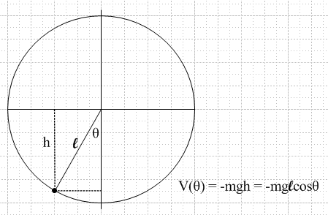

V(θ) = mg[l-lcosθ] = mgl(1-cosθ) V(0) = 0 at the bottom !!

H = T + V = p2/2m + mgl(1-cosθ)
L = T - V = p2/2m – mgl(1-cosθ)

vθ = l // as in p = mvθ
L = ½ ml22 – mgl(1-cosθ) // Lagrangian(θ,)

pθ = ∂L/∂ = ml2 // canonical momentum

T = ½ mv2 = ½ m (l)2 = ½ m (pθ/ml)2 = pθ2/(2ml2) // kinetic energy

H(qi, pi) = H(θ,pθ) = pθ2/(2ml2) + mgl(1-cosθ) // Hamiltonian(θ,pθ)

Hamilton's Equations are

= ∂H/∂pθ = pθ/(ml2) θ = – ∂H/∂θ = – mglsinθ

which we can combine to get, using ω2 = g/l,

ml2 = – mgl sinθ or l = – gsinθ = – (g/l) sinθ = – ω2 sinθ

We use initial conditions θ=0 and = v: start at the bottom with a kick, so E = ½ m l2v2 :

θ(0)=0 and (0) = v => E = ½ m l2v2

For small θ, this becomes the obvious harmonic oscillator + ω2θ = 0. But in general we are in need of solving + ω2 sinθ = 0, which is an example of an autonomous equation = f(θ). You solve by integrating twice, picking up an integration constant in each stop.

2. Libration Solution

We define θ0 as the max swing angle. Doing our two integrations, we find this problem solution:

ωt = (1/$\sqrt{2}$) $\int_{}^{θ}{}$dθ [1/$\sqrt{cosθ – cosθ0}$] where v2 = 2ω2(1-cosθ0) => v = 2ω sin (θ0/2)
This integral is in the books, and we can write the solution again as

ωt = F[ sin-1($\frac{sin(θ/2)}{sin(θ0/2)}$) , sin(θ0/2)] using F(φ,k) k = sin(θ0/2)

where F(φ,k) is the incomplete elliptic integral of the first kind. We invert this equation to get

sin(θ/2) = sin(θ0/2) sn(ωt; k) k = sin(θ0/2) = v/(2ω) v = 2ω sin (θ0/2)

θ(t) = 2 arcsin [sin(θ0/2) sn(ωt; k) ] valid v ≤ 2ω

which is the exact solution of the libration problem, confirmed on the web. The function sn(x,k) is one of the three basic Jacobi elliptic functions, and one of the 12 functions of the full set.

The energy of this pendulum comes from the initial condition

E = 1/2ml2v2

In the small angle limit (small k) sn = sin and we get that

sin(θ/2) = sin(θ0/2) sn(ωt; sin(θ0/2)) → θ/2 = θ0/2 sin(ωt)

A plot of the exact solution shown above shows how the sine-like waves flatten off as k → 1, meaning as we get closer to the critical point separating the libration and rotational solutions: you can see on the right that the mass can have a long "hang time" at the top.

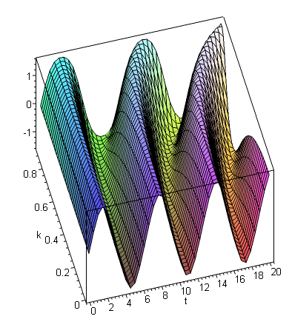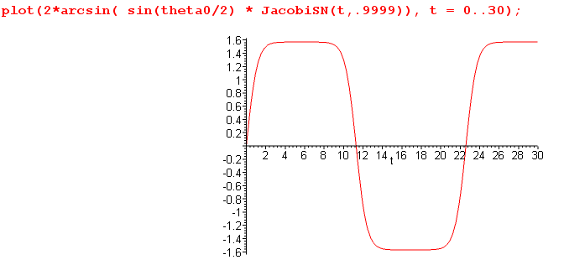

It is known that the period of the function sn(x,k) is given by 4K(k), where K is the complete elliptical integral of the first kind, and K(k) = F(π/2,k). Then the period of sn(ωt,k) is ωT = 4*K(k), ω2 = g/l, which is also written ω' = 2π/T = [2π/4K(k)]ω. For small k, K = π/2 and you get ω' = ω, matching the small oscillation case. But then ω' slows down as you increase the angle. The period becomes 15% slower for example when thing swings 90 degrees to each side. Here is a graph of K, and T = 4*K(k)/ω :

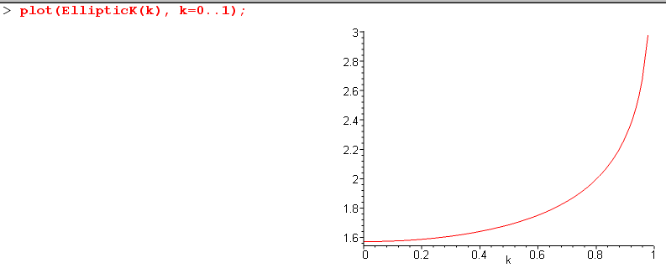

3. Rotation solution

In our libration solution above, we have sn(ωt,k) where k = sin(θ0/2) = v/(2ω). When the initial kick v reaches the value v = 2ω, we reach the critical point. For larger v, we know the pendulum will keep swinging around and around, not back and forth, and this is the "rotation" type solution. This occurs when k > 1, but the sn(ωt,k) function behaves as you think only when k < 0. Therefore, we have to use a transformation formula to get to another form that is useful for rotation. That formula is this

sn(ku,1/k) = k sn(u,k)

If we now redefine k to be one over what it was before, our solution takes this simple form:

sin(θ/2) = sn(vt/2; k) k = (2ω/v) valid v ≥ 2ω

θ(t) = 2 arcsin [sn(vt/2; k) ]

and we write the corresponding inverse solution several ways

(v/2)t = F(θ/2,k) k = (2ω/v)

ωt = k F(θ/2,k) // the inverse

For very large v, we get k→0 and the solution becomes

sin(θ/2) = sn(vt/2; k) → sin(θ/2) = sin(vt/2) => θ/2 = vt/2 => θ(t) = vt = (0)t

where we just wing around very fast and gravity has no effect. The inverse solution gives the same result in this limit, since F(x,k) → x as k→0.
Here is a plot of the rotation solution for k very close to 1. K has increased from π/2 = 1.57 to the much larger value 4.5. Here is the Maple code and the plot:

> k := .999:
> K := EllipticK(k);

K := 4.495596396

> f1 := 2*arcsin(JacobiSN(t,k)):
> f2 := 2*( arcsin(JacobiSN(t-2*K,k))+2*q):
> q := Pi/2:
> plot(piecewise(t>=-K and t<K,f1,t>K and t<=3*K, f2, 0),t=-K..3*K);

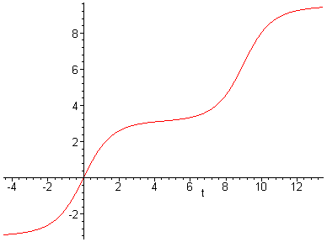

4. Doing only the first integration : Phase Space

This first integration is of course used in finding the solution above, and here we state it explicitly

½ 2 = ω2cosθ + C C = E/(ml2) - ω2 = ½ v2 - ω2 = -ω2cosθ0

E = ½ ml2v2 ω2 = g/l E' ≡ E/mgl

You can quickly see that ½ v2 = ω2 + C, and that is how C gets determined, which is the "first integration constant" . Recalling that pθ = ml2, we can write our first integration equation in this way

pθ2 = 2ml2E - (2ml2ω)2 sin2(θ/2) = [2m2gl3] ( E' – 2sin2θ/2 )
= [2m2gl3] ( {E'– 1}+cosθ )

The motion of the pendulum with energy E' must lie on the above curve in the space whose coordinates are θ on the horizontal and pθ on the vertical, the so-called "phase space" plane. Here is a plot

plot([seq((E/10 - 2*sin(theta/2)^2)^(1/2),E = 1..30)],theta = -Pi..Pi,color =[seq(red,E = 1..30)], numpoints=1000);

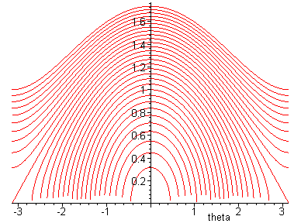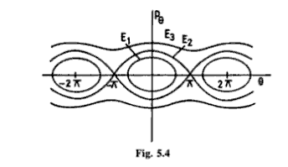

This pattern runs in the range -π to π and is repeated to the left and right. It is also repeated under the axis, but reflected. Thus, you get ellipse-like closed orbits for libration, you reach the critical point shown, and then you have rotation "orbits" which are wavy lines going on forever. The picture at the right shows the general idea. Of course the nature of the orbit is a function of the energy E', and criticality is E' = 2 which means the point where v = 2ω or k=1 in the above discussion. In the quantum world, you can think of the libration orbits as bound states, and the rotation orbits as scattering solutions.

5. Hamilton Jacobi Theory

The HJE for constant energy situations is this

H(θ, pθ= ∂W/∂θ,pθ = αθ) = α1 = E

and when we insert this into our Hamiltonian given above H = pθ2/(2ml2) + mgl(1-cosθ) we get this equation:

(∂W/∂θ)2/(2ml2) + mgl(1-cosθ) = E

Notice that this differs from the other major equations we will encounter in this summary:

+ ω2 sinθ = 0 // classical for θ(t) autonomous
½ 2 = ω2cosθ + C // first integral of above integrable
B + [ (E'-1) + cos(t)] ψ(t) = 0 // quantum for ψ(t) eigenvalue
a 2 + b(1-cos(t)) - E = 0 // HJE with t as variable integrable

where we have put all four equations with "t" as the argument, just for comparison. All four equations are different. We can, however, just integrate the HJE to solve it for W,

W(θ,E) = $\sqrt{2}$ml2ω ∫ dθ $\sqrt{(E'-1) + cosθ}$ E' ≡ E/mgl B = 2$\sqrt{2}$$\sqrt{ml2}$
= B$\sqrt{E}$ E(θ/2,k) k = (2ω/v) = $\sqrt{2/E'}$ as used in the rotation solution

and this is the incomplete elliptic integral of the second kind.
In HJ theory, our main interest is in this very important result,

t + β1 = ∂W/∂α1 = ∂W/∂E

We can compute the W derivative either before or after the integration. Doing so gives,

∂W/∂E = ( 1/$\sqrt{2}$ω) ∫dθ 1/$\sqrt{(E'-1) + cosθ}$ // before doing integral

= B[ $\sqrt{E}$ ∂E(θ/2, k)/∂k * ∂k/∂E + (1/(2$\sqrt{E}$)) E(θ/2,k)] // doing after

= (k/ω) F(θ/2, k) k = (2ω/v) = $\sqrt{2/E'}$

Thus, from our HJ theory we conclude that

ω(t+β1) = k F(θ/2, k)

Since we want θ = 0 when t=0, this becomes

ωt = k F(θ/2, k) k = (2ω/v)

But this is exactly the inverse solution to the libration problem we found earlier! Using HJ theory, we get to this result following a completely different path! We had a different differential equation, and a different function we solved that equation for, namely W, the Hamilton characteristic function.

6. Action Angle Approach

In the HJ theory for constant E, we do a canonical transformation from our original p,q to some P,Q which are all constant except for Q1 = t + β1. In other words, we get

P1 = α1 = E Q1 = β1+ t i = 1 W = solution to the HJE
Pi = αi Qi = βi i > 1 Qi = ∂W/∂αi

where this last result comes from the canonical transformation equation set. In the previous section, we used this result to find the solution to our problem. This method only works if the coordinates are separable, as in Kepler motion, so that we can think of each coordinate and its little phase space plane as being independent.
If one works with an arbitrary "shuffled set of constants" γi = γi(αj), one gets this result instead

Pi = γi Qi = βi + νit Qi = ∂W/∂γi all i

so the only difference is that all the Qi equations are linear in time with constant frequencies νi. This is just a minor modification of the situation stated above.
In action angle variables, one makes a particular choice of the constants γi, namely, one uses the action integrals Ji . In this case, the Qi are called wi and the above becomes

Pi = Ji wi = βi + νit wi = ∂W/∂Ji

The significance of this particular choice is that the constants νi can be interpreted as the frequencies of the solution motion of the problem!
In our case there is only one variable θ and one phase-space plane to worry about. The object Jθ is the area inside one of the closed orbits, or the area under one period of a rotation orbit. In our case we are going to have

Jθ = p dq = pθ dθ =(∂W/∂θ) dθ = 2$\int_{0}^{π}{}$ dθ (∂W/∂θ) = 2 W(π,E)
= B$\sqrt{E}$ E(π/2,k) = B$\sqrt{E}$ E(k) B = 2$\sqrt{2}$$\sqrt{ml2}$

where E is the complete elliptic integral of the second kind. So Jθ is just twice the W function evaluated at π.
The next step in action-angle is to compute

wθ = ∂W/Jθ = ∂W/∂E' / ∂Jθ /∂E' = ½ F(θ/2,k)/ K(k) k = $\sqrt{2/E'}$

so this coordinate wθ is the replacement for the original coordinate θ.
The next step is to state the frequency of the solution motion according to

νθ = θ = (1/2K(k) ) ∂F(φ,k)/∂φ |φ=θ/2 * ∂φ/∂t|φ=θ/2 = 1/($\sqrt{1 - k2sin2(θ/2)}$ ) ½ (t)

We can then integrate this thing once to get

(t) = 4 νθ K(k) $\sqrt{1 - k2sin2(θ/2)}$ // aside: => (0) = v = 4 νθ K(k)

=> $\int_{0}^{θ}{}$dθ 1/ $\sqrt{1 - k2sin2(θ/2)}$ = 4 νθ K(k) t

But changing to φ = θ/2 reveals the left integral to be

4 νθ K(k) t = 2 $\int_{0}^{θ/2}{}$dφ 1/ $\sqrt{1 - k2sin2φ}$ = 2 F(θ/2,k)

But from just above, we know that v = 4 νθ K(k) so we get

(v/2)t = F(θ/2,k)

and low and behold, this is in fact our rotation solution to the problem found earlier! So here we found this same solution using the Action-Angle Method.

7. The Quantum Mechanical Plane Pendulum

The time independent Schrodinger equation is this:

(1/l2) ∂2ψ(θ)/∂θ2 + A-1 (E-V)ψ(θ) = 0 A-1 = 2m/2 V(θ) = mgl(1-cosθ)

which I recast into this form

Bψθθ + [ (E'-1) + cosθ] ψ = 0 B = A/mgl3 = 2/(2m2gl3) E' = E/mgl

This can be recast one more time into the following equation

ψθθ + (a – 2q cos(2θ))ψ = 0 a = (E' - 1)/B 2q = – 1/B

This equation is known as the Mathieu equation (mat-YEU), and E.L. Mathieu was a guy who ran into this thing in 1868 doing membranes on elliptical drumheads, so this comes up in elliptical coordinates. At that time there was no known Schrodinger equation, so he did not know it applied also to the quantum plane pendulum. The solutions of interest are sine and cosine like. The eigenvalues for E are determined by the requirement that the solutions be correctly periodic from =π to π since the potential is periodic:

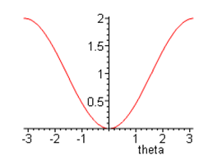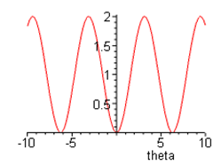
The solution Mathieu functions have these names

sen(θ/2;q) sine like
cen(θ/2;q) cosine like

and here is what some of the eigenfunctions look like for various q values:

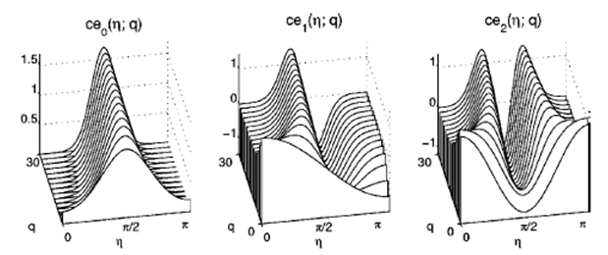

where in this approach, θ = 0 is at the TOP of the pendulum, so η = θ/2 = π/2 is then at the BOTTOM of the pendulum. You can see how the ground state on the left has probability mostly at the bottom, but then others do not.
We would then construct the classical solutions by taking wave packets formed from these states. At low energy, these packets would bounce back and forth, emulating the classical librating pendulum. At higher energy, these packets would skid along the periodic potential to ever-increasing θ, emulating the rotational solutions.

