The Spherical Pendulum PhL 9.6.12

Motivation: In doing frames doc, I wanted to add an appendix on the Foucault pendulum. In trying to write this appendix, I realized that I have never even done a non-Foucault pendulum where the ball motion is allowed to be elliptical and not just planar, something I am calling a 3D pendulum [ but the correct name is spherical pendulum; 2D and 3D pendulums are other animals] . Somehow I thought this was just two separate problems which are independent in x and y, but now I am not so sure. I want to solve this 3D problem at some point in a coordinate system that shows a θ type variable which later I can associate with the Foucault precession thing. It would be nice to do this for large angles and not just for small angles. I would like to avoid fancy formalisms and just write the F = ma equation of motion and solve things from there. In my Foucault attempt I used cylindrical coordinates, but now I think spherical would be more appropriate, since the ball motion is in fact constrained to a spherical surface.

Conclusion: (see Summary Section 13 below) The motion of the spherical pendulum is NOT just a superposition of independent x and y motions which is the case for the 2D harmonic oscillator. You don't get some kind of simple ellipse type motion. The spherical pendulum motion is in fact extremely complicated in general and contains its own precession (having nothing to do with the Coriolis force!), and this is true even when the θ angle is small, so that is why you absolutely must start your Foucault pendulum in perfect planar swing motion!!! I now realize that it is totally pointless to try to analyze a Foucault pendulum which is started off in non-planar swinging motion. But that was non-obvious to me when I started this doc! I thought you could start off a little narrow ellipse motion and watch it do Coriolis procession, but in fact it will do its own precession as well! I just made a pendulum and watched it precess rather quickly!

1. Draw a Picture and write Newton's Law 1
2. Compute v and a in sphericals. 2
3. Use this computed a in Newton's Law 4
4. Energy conservation and initial conditions 5
5. Angular Momentum and Torque 6
6. Two Special Case Solutions for the 3D Pendulum 8
7. Pondering the equations for the general case 9
8. Scanning the web verification of my equations 11
9. A better way to write the third equation: conservation of L_{z} . 12
10. The General Problem has an exact solution from L&L 13
11. A separated ODE for θ(t) and some approximate solutions 14
12. Muller's notes on the general problem (very good, I have the pdf called mechnotes) 17
13. A summary of what I did on this spherical pendulum problem. 21

1. Draw a Picture and write Newton's Law

This is always my first step in doing anything. Here is my opening gambit,

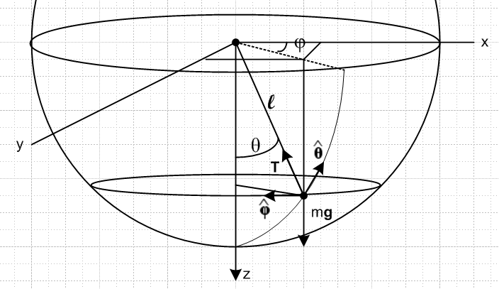

Spherical coordinates with z axis pointing down instead of up. Dot shows pendulum mass. The mass is moving along some path on the surface of the sphere of radius r = l , the length of the string holding the mass. This path may or may not be elliptical, I don't know yet what it is. The path is described by the two functions θ(t) and φ(t). We know that r(t) = l, so that part is simple. The only forces acting on the mass are tension T and gravity mg as shown. Newton's Law says

ma = T + mg

We can write

g = g

T = -T

so Newton says

ma = -T + m g

This seems much better than the cylindrical coordinates I was trying with Foucault frame S'.

2. Compute v and a in sphericals.

Now how do you write out acceleration a in sphericals?

r = r

= + r = r since = 0

Maybe do it like this

d/dt = d/dθ * dθ/dt + d/dφ * dφ/dt

At this point I did a huge digression written up in "spherical unit vectors.doc" with the results transferred to Appendix A of frames doc. These results are these

d/dr = 0 d/dθ = d/dφ = sinθ
d/dr = 0 d/dθ = - d/dφ = cosθ
d/dr = 0 d/dθ = 0 d/dφ = -sinθ -cosθ (A.15)

We only need two of these results to continue along. Thus,

d/dt = d/dθ * dθ/dt + d/dφ * dφ/dt

= () + (sinθ )
so

= + sinθ

This then is our key result so far,

v = = r = l [ + sinθ ]

The next step is to differentiate again to get acceleration a as needed in Newton's Law,

a = = l d/dt[ + sinθ ]

Maybe write this as

a/l = d/dt[ + sinθ ]

= + + + cosθ + sinθ + sinθ

Similarly to above we write

d/dt = d/dθ * dθ/dt + d/dφ * dφ/dt

= (0) + (-sinθ -cosθ )

= (-sinθ -cosθ )

so that

= -sinθ - cosθ

We are also going to need

= d/dt = d/dθ * dθ/dt + d/dφ * dφ/dt

= (- ) + (cosθ )

= - + cosθ

Then we have
a/l = + + + cosθ + sinθ + sinθ

= + + [- + cosθ ] + cosθ + sinθ + sinθ [-sinθ - cosθ ]

= + - 2 + cosθ + cosθ + sinθ - sin2θ 2 - sinθcosθ 2

= (- 2- sin2θ 2) + (+ - sinθcosθ 2) + (+ cosθ + cosθ + sinθ )

= (- 2- sin2θ 2) + (+ - sinθcosθ 2) + ( 2cosθ + sinθ )

This is not looking super simple but let's assume for the moment that it is correct. At least the dimensions are correct. We therefore have

ma = ml(- 2- sin2θ 2) + ml (+ - sinθcosθ 2) + ml (2cosθ + sinθ )

3. Use this computed a in Newton's Law

The equations of motion are then

ma = -T + mg

or
ml(- 2- sin2θ 2) + ml (+ - sinθcosθ 2) + ml (2cosθ + sinθ )

= -T + mg

But how is related to the spherical unit vectors? From frames appendix A,

= cosθ - sinθ (A.13c)

so we then have

ml(- 2- sin2θ 2) + ml (+ - sinθcosθ 2) + ml (2cosθ + sinθ )
= -T + mg[cosθ - sinθ ]

ml(- 2- sin2θ 2) + ml (+ - sinθcosθ 2) + ml (2cosθ + sinθ )
= (mgcosθ-T) - mgsinθ

Finally we can match components to get three scalar equations of motion

ml(-2- sin2θ 2) = (mgcosθ-T)
ml (+ - sinθcosθ 2) = - mgsinθ
ml (2cosθ + sinθ ) = 0

We can simplify these a little bit

2 + sin2θ 2 = - (g/l) cosθ + T/(lm)
- sinθcosθ 2 = - (g/l)sinθ
+ 2cotθ = 0

The unknowns are θ, φ, T and we have 3 equations. I am rather amazed at how complicated this is. As far as I know, I have made NO approximations to this point. Well OK, g = constant, but that is fine.

4. Energy conservation and initial conditions

Just out of curiosity, what do we know about energy conservation? The height of the ball is r(1-cosθ), and we know that

v = l [ + sinθ ]

v2 = l2(2+ sin2θ 2)

Therefore

1/2 m l2(2+ sin2θ2) + mgl(1-cosθ) = constant
or
2 + sin2θ2 + 2(g/l) (1-cosθ) = constant

The initial conditions are fairly tricky I think.

θ0 φ0 0 0

The ball starts at some point on the sphere (r, θ0, φ0) and with some angular velocities which you could think of as linear velocities perp to each other. The number 4 of conditions seems right.
I think if you just "let it go" from some θo,φ0 initial location, you will get planar motion only.

5. Angular Momentum and Torque

What do we know about angular momentum?

L/m = r x v = r x l [ + sinθ ]

= l2 x [ + sinθ ]

= l2 [ - sinθ ]

so that

L = ml2 [ - sinθ ]
or
Lr = 0 Lθ = - ml2 sinθ Lφ = ml2

L = Lθ + Lφ

I will soon draw in these unit vectors. L about the pivot point can never have an component.
Note that neither of these two angular momentum components is a constant, though Lr is a constant, namely 0.
Now what about torques? τ = r x F and about the pivot point r x T = 0 so T does not generate any torque. Gravity does, however,

τ = r x mg = r x mg = mgl x [cosθ - sinθ ]

= mgl [0 - sinθ ( )] = -mgl sinθ

Now the rotational version of F = dp/dt says that τ = dL/dt . So this last equation says

-mgl sinθ = dL/dt = d/dt {ml2 [ - sinθ ] }

-(g/l) sinθ = d/dt [ - sinθ ]

Well, we have to evaluate the RHS using work above.

RHS = + - cosθ - sinθ - sinθ

= + [-sinθ - cosθ ] - cosθ - sinθ - sinθ [- + cosθ ]

= (-sinθ + sinθ ) + (- cosθ - cosθ - sinθ ) + ( -sinθcosθ2)

= (- 2cosθ - sinθ ) + ( -sinθcosθ2)

then setting LHS = RHS we get

-(g/l) sinθ = (- 2cosθ - sinθ ) + ( -sinθcosθ2)

and balancing terms tells us that

-(g/l) sinθ = -sinθcosθ2 // this is the F = ma equation

- 2cosθ - sinθ = 0 // this is the F = ma equation

Thus, consideration of angular momentum merely replicates two of our three F = ma equations.

What about Lz and the equation τz = dLz/dt ? We know that r x mg has no z component (draw a picture), and that as shown above τ = r x mg = -mgl sinθ which lies in a horizontal plane. So I think we can conclude that Lz is a constant. But how do you compute Lz ?

L = mr x v

Lz = L • = m (r x v) •

= m ( x r) • v

But we know that

= cosθ - sinθ (A.13c)
so
x r = l x = l [cosθ - sinθ ] x = l [+sinθ ] = lsinθ

Then we have

Lz = m ( x r) • v

= m lsinθ • [l [ + sinθ ]]

= ml2sin2θ

so indeed, this quantity is conserved as the weak wiki website confirms. This means that

d/dt(sin2θ ) = 0

and this in fact replicates my third equation! And it validates various steps above.

6. Two Special Case Solutions for the 3D Pendulum

The Planar Solution. If we just let the ball go at t = 0, we should have a solution with φ(t) = φ0. Here are the general equations from above,

2 + sin2θ 2 = - (g/l) cosθ + T/(lm)
- sinθcosθ 2 = - (g/l)sinθ
+ 2cotθ = 0

This φ(t) = φ0 certainly satisfies the last equation. The other two then become

2= - (g/l) cosθ + T/(lm)
= - (g/l)sinθ

The second equation here is the 2D pendulum equation, so we like seeing that! I show the exact solution to this problem for θ(t) in my 2D document, and for small angles it is θ(t) = θo sin(ωt) with ω2 = g/l . We then know that = ω θo cos(ωt). Since θ0 is very small, we neglect the left term in the first equation above and we set cosθ = 1 and we find that T = mg and our small-angle plane solution looks good. More generally, we can do the Jacobi solution for θ and compute and put that in the first equation to get T.

The Circular Solution. We now look for a solution where θ = θ0. Here are the general equations from above,

2 + sin2θ 2 = - (g/l) cosθ + T/(lm)
- sinθcosθ 2 = - (g/l)sinθ
+ 2cotθ = 0

which then become

sin2θ0 2 = - (g/l) cosθ0 + T/(lm)
cosθ0 2 = (g/l)
= 0

The last equation tells us that = constant which we shall call ω for this problem (a different ω). The equation gives us the value,

2 = (g/l) secθ0 .

We can then solve the equation for T

sin2θ0 [(g/l) secθ0] = - (g/l) cosθ0 + T/(lm)

sin2θ0 [mgsecθ0] = - mg cosθ0 + T

T = mg (sin2θ0/cosθ0 + cosθ0) = mg secθ0

Does this solution "make sense" ? If so, we can regard this as a "check" on our three equations. So consider this solution independently. A side view would show three forces acting on the mass. The centrifugal force is mω2lsinθ0 to the right. Gravity is mg down. Tension must provide the balance. So here are our two force balance equations:

Tcosθ0 = mg
Tsinθ0 = mω2l sinθ0 = m [(g/l)secθ0 ]l sinθ0 = mg sinθ0 secθ0 => T = mg secθ0

The two equations are exactly the same, so they are consistent and T is correct. Thus, this independent solution method gives exactly the same solution, so far so good.

7. Pondering the equations for the general case

Our equations are these,

2 + sin2θ 2 = - (g/l) cosθ + T/(lm)
- sinθcosθ 2 = - (g/l)sinθ
+ 2cotθ = 0

These equations appear to be pretty strongly coupled together! One could solve the 2nd equa for 2and put that result into the first. First from the 2nd,

+ (g/l)sinθ = sinθcosθ 2

tanθ + (g/l)tanθ sinθ = sin2θ 2

Then the first reads

2 + tanθ + (g/l)tanθ sinθ = - (g/l) cosθ + T/(lm)

cotθ 2 + (g/l)sinθ = - (g/l) cotθcosθ + cotθT/(lm)

+ cotθ 2 + (g/l)sinθ = - (g/l) cotθcosθ + cotθT/(lm)

+ cotθ 2 + (g/l)[sinθ + cotθcosθ] = cotθT/(lm)

[sinθ + cotθcosθ] = sinθ + cos2θ/sinθ = cscθ

+ cotθ 2 + (g/l)cscθ = cotθT/(lm)

tanθ + 2 + (g/l)secθ = T/(lm)

So here at least we have a fully separated non-linear ODE that is valid in the general case [ but what use is it with T sitting there as another unknown?]. We then have

2 + sin2θ 2 = - (g/l) cosθ + T/(lm) 1
- sinθcosθ 2 = - (g/l)sinθ 2
+ 2cotθ = 0 3

tanθ + 2 + (g/l)secθ = T/(lm) 4 // 2 stuck into 1

For small angles, we want to argue that θ is small and so is so equ 1 just says T = mg, so we have then used up that equation. The second equation might then read

- θ 2 = - (g/l)θ 2 ωθ2 = (g/l)

+ (g/l)θ = θ 2 2

Unless we just assume that = 0, I don't know what to do with this equation (!), so just let it be for now.
The third equation is, for small angles

tanθ + 2 = 0 3

θ + 2 = 0 3

So we then have to deal with this pair of coupled equations in looking for our small angle solution

+ (g/l)θ = θ 2 2
θ + 2 = 0 3

There surely is some trick to finding the decoupling here (see trick below). So maybe for the first time I will look on the web to see what others have done for this 3D pendulum! I have gone as far as I can, and I may have made errors along the way.

8. Scanning the web verification of my equations

[PDF #1]. It says my plane pendulum problem is 1D, not 2D. What I am doing here is a "spherical 2D pendulum". The 3D pendulum is a much fancier object which has some 3D shape and is not just a ball on a string. So let's restart our search and look for a 2D spherical pendulum since that is what I care about today.

[http://www.maths.surrey.ac.uk/explore/michaelspages/Spherical.htm, Mike Hart 2004]. This one gives two equations

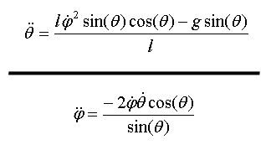

which I can rewrite as

= 2 sinθcosθ - (g/l)sinθ
sinθ = -2 cosθ
or
- 2 sinθcosθ = - (g/l)sinθ
= -2 cotθ

which I can compare to my three equations

2 + sin2θ 2 = - (g/l) cosθ + T/(lm) 1
- sinθcosθ 2 = - (g/l)sinθ 2
+ 2cotθ = 0 3

SO, this is my first confirmation that my equations 2 and 3 are correct, and we then have to regard the first equation as determining T. So I have the right equations, and now I hope to learn how you solve the pair! Mike Hart does not solve the equations and his applet fails to run in either F or IE. But at least he confirmed my equations.

[ same author PDF ] Uses my same setup, his r = l as well. He computes T and then the Lagrangian and then uses Euler's equations and gets the equations shown above. He is mainly concerned with his applet and makes no comments at all about doing an analytic solution.

[peeterjoot] Does a Hamiltonian approach. He first gets H. But then he never shows any ODE's.

9. A better way to write the third equation: conservation of Lz .

[wiki] Computes Lagrangian L and obtains these two equations

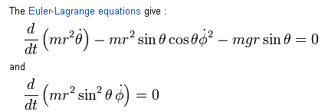

The first equation says

ml2 - ml2 sinθcosθ 2 - mglsinθ = 0

- sinθcosθ 2 - (g/l)sinθ = 0

This seems to be my equation 2 but he has a sign error I show in red. His other equation says

ml2( 2sinθcosθ + sin2θ) = 0

2sinθcosθ + sin2θ= 0

2cosθ + sinθ= 0

2cotθ + = 0

and this does give my equation 3. So we can write equation 3 therefore in this manner

d/dt(sin2θ ) = 0

He claims this is conservation of L in some sense which seems to conflict with what I did above. Also, he suggests that Landau-Lif Vol 1 mechanics treats this problem! That is a valuable lead!

10. The General Problem has an exact solution from L&L

[ Landau ref, 3rd Ed 1976 ] I found this on page 60 (book p 33):

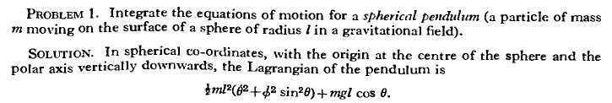

This agrees with the wiki quote, and note that it has 2 in there. Continuing:

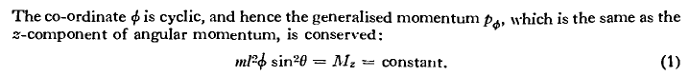
Again we have and this confirms my earlier stuff and the claim of wiki. He uses Mz instead of Lz. Continuing more,
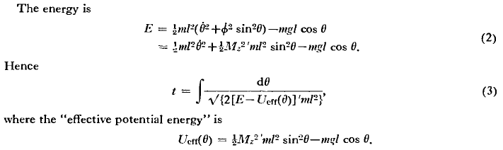

I think I could find support for this in my Goldstein notes. Continuing to the conclusion,

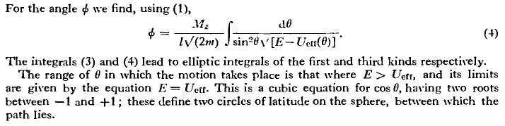

So there is basically the complete solution to this problem, but nothing is said about how to get there from those coupled differential equations. Nor does he give any small-angle approximate solutions.
Do I really want to go do Goldstein right now to confirm all this stuff?

11. A separated ODE for θ(t) and some approximate solutions

[http://farside.ph.utexas.edu/teaching/336k/Newton/node82.html]

This page is Robert Fitzpatrick 2011, he a physics prof at Austin. He seems to have the entire makings of a book on his site, in html. He says he did it this way

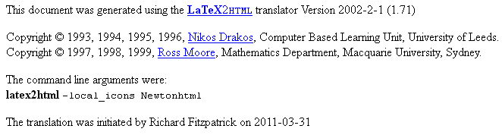
So I guess Fitzpatrick is NOT the author!

http://farside.ph.utexas.edu/teaching/336k/Newton/Newtonhtml.html

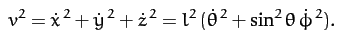 // confirmation of my v2

OK, this site is helping me! Go back to the three equations

2 + sin2θ 2 = - (g/l) cosθ + T/(lm)
- sinθcosθ 2 = - (g/l)sinθ
+ 2cotθ = 0

write the third in this manner

d/dt(sin2θ ) = 0

which is the same as

sin2θ = h where h is some constant.

NOW we can write

sinθcosθ 2 = sinθcosθ ( h2/sin4θ) = h2cosθ/sin3θ

and equation 2 becomes

- h2cosθ/sin3θ = - (g/l)sinθ

and this is an ODE entirely in terms of θ but it is non-linear because it does not just show a term with just θ. But at least it is a nice ODE. So this is the "trick" I was looking for. His site says

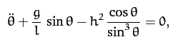

Author then looks at the circular solution where θ = θ0. We at once conclude from sin2θ = h that = constant, and in fact = h/sin2θ0. My equ 2 then says

cosθ0 2 = (g/l)

2 = (g/lcosθ0) = (g/d) d = lcosθ0 = height of circular orbit over origin.

The author then goes on to treat the case of "nearly circular motion" which he calls "near conical" so θ = θ0 + δθ with δθ small. He gets this solution

θ = θ0 + δθ0cos(Ωt) Ω = 0 [ 1 + 3 cos2θ0]1/2 = a constant

In this approximation, what is φ doing?

sin2θ = h => = h/ sin2θ = h/[ sin2(θ0 + δθ0cos(Ωt)]

Now write

sin(θ0 + δθ0cos(Ωt)) ≈ sin(θ0) + δθ0cos(Ωt) cos(θ0) = sin(θ0) [ 1 + δθ0cos(Ωt) cot(θ0)]

1/ sin2(θ0 + δθ0cos(Ωt)] ≈ sin-2(θ0) ( 1 - 2 δθ0cos(Ωt) cot(θ0) )

= h sin-2(θ0) ( 1 - 2 δθ0cos(Ωt) cot(θ0) ) = not a constant

= 0 ( 1 - 2 δθ0cos(Ωt) cot(θ0) )

But that is not what the author is getting at. He wants us to consider a half revolution. Such a half revolution takes time t = (1/2) 2π/Ω = π/Ω and then during this time Δφ ≈ 0 π/Ω as he says. This leads to some interesting motion:

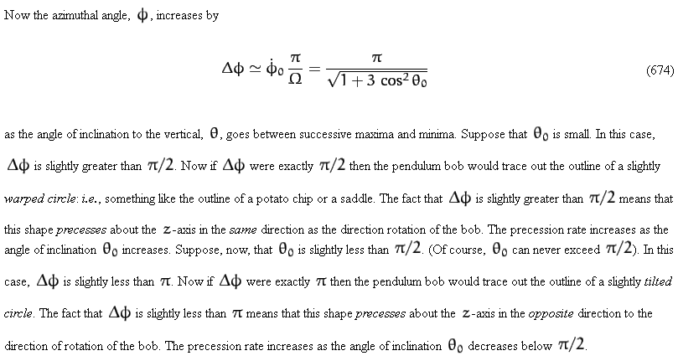

So his first case of interest is small θ0 and we get a potato-chip orbit that precesses in the same direction of the rotation (at a rate I can compute). This fact alone tells me that the Foucault pendulum would be very complicated because you would then have this procession superposed with the Foucault procession. That is just the kind of fact I have been looking for.

His second case of interest is θ0 nearly horizontal so the thing is winging around fast. This time you get a tilted circle that precesses.

[http://www.prt.fernuni-hagen.de/lehre/KURSE/PRT001/course_main/node23.html]

This guy writes the coupled equations in matrix form, but I don't see why this is useful.

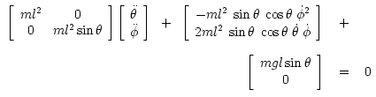

[http://www.youtube.com/watch?v=Ksi5hR5w9_I] Shows the complex motion with over the top action. Other animations also show how amazingly complex the motion can be!

12. Muller's notes on the general problem (very good, I have the pdf called mechnotes)

Note: Goldstein mentions the spherical pendulum in three places, one showing the potential curves, but does not do any of this detailed analysis. Two places are in problems!

The author here is Sebastian Muller at Dept of Math, U of Bristol which is 150 miles west of London.

http://www.maths.bris.ac.uk/~maxsm/

[pdf downloaded ] This gives a detailed presentation of that L&L solution, lots of pages on this pendulum problem!

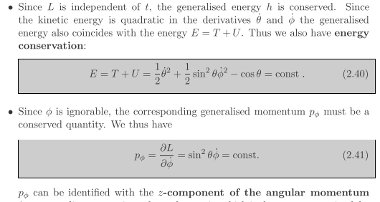

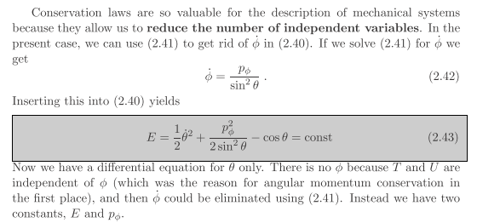

So this equation purely in θ is simpler than the one I found earlier. You can think of the first term as a KE and the second as en effective potential.

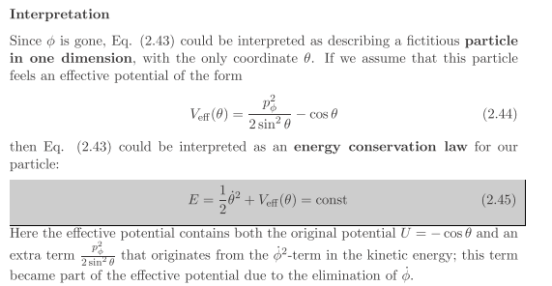

If you now write dE/dt = 0 you get an even simpler equation,

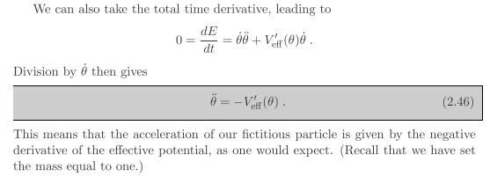

So at this point, all you have to do is integrate the above equation twice and you have the exact solution!

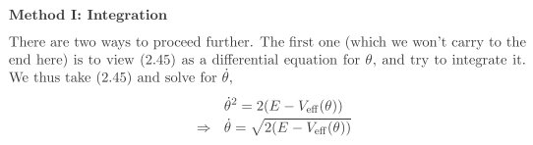
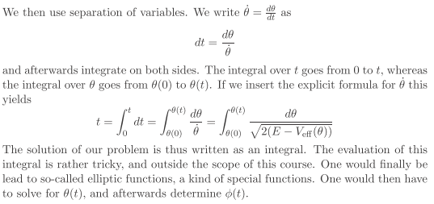

So that is an outline of the complete solution.
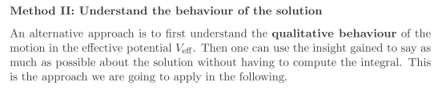

If pφ = 0, you get the plane pendulum problem.

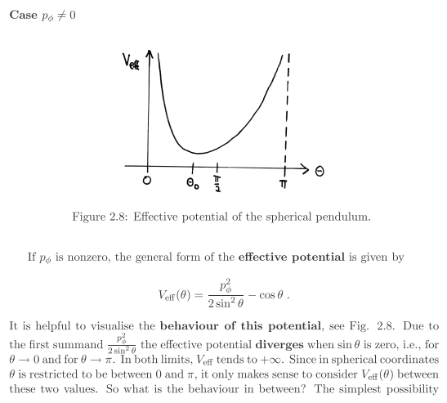

Author then shows there is some transc equation which lets you find the low point of the effective potential which they call θ0. Then this picture shows at once that the motion is bounded by two θ angles,

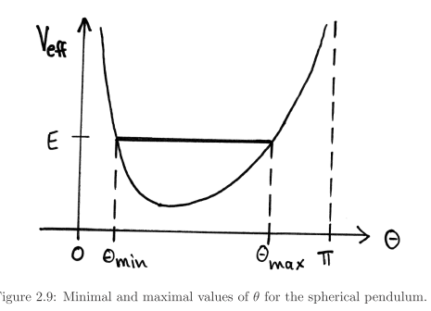

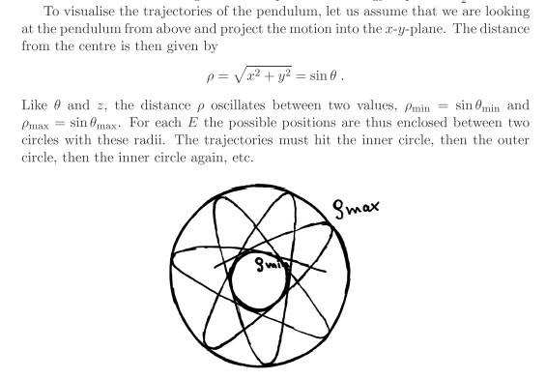

13. A summary of what I did on this spherical pendulum problem.

I made a reasonable drawing which I won't requote from above, with r = l. Newton's law in the inertial frame of the pendulum origin is

ma = T + mg = -T + m g .

I then computed v and then a in spherical coordinates, which took some work. This involved various preliminary calculations such as

= cosθ - sinθ (A.13c)

and
= + sinθ
= - + cosθ
= -sinθ - cosθ

which in turn were based on these other results which I added to my spherical unit vector document and also to frames doc,

d/dr = 0 d/dθ = d/dφ = sinθ
d/dr = 0 d/dθ = - d/dφ = cosθ
d/dr = 0 d/dθ = 0 d/dφ = -sinθ -cosθ (A.15)

Results for v and a came out to be

v = = l = l [ + sinθ ] // web verified

a = = l(- 2- sin2θ 2) + l( - sinθcosθ 2) + l( 2cosθ + sinθ )

The velocity is constrained to the surface of the sphere as the first line shows, whereas in general a has all three components as shown. I then inserted this expression for a into my Newton's law above and matched components to get these three equations of motion:

2 + sin2θ 2 = - (g/l) cosθ + T/(lm)
- sinθcosθ 2 = - (g/l)sinθ // web verified
+ 2cotθ = 0 // web verified

The problem is to solve the last two equations which are very strongly coupled together. Once you solve these, the first equation just tells you tension T.

For fun I also wrote down the total energy as E = T + V where E = 1/2mv2 and V = mgl(1-cosθ). Note that from the v expression above,

v2 = l2(2+ sin2θ 2) // web verified

E = 1/2 m l2(2+ sin2θ2) + mgl(1-cosθ) = a constant of the motion (could drop mgl )

Also for fun, I computed the angular momentum vector and torque to be

Lr = 0 Lθ = - ml2 sinθ Lφ = ml2

L = Lθ + Lφ

τ = r x mg = -mgl sinθ

and then I showed that the angular equations of motion τ = dL/dt give the last two of my three Newton's Law equations. I then did a separate computation to find that

Lz = L • = m (r x v) • = m ( x r) • v = ml2sin2θ

Since the torque shown above has no component, we know that Lz is also a constant of the motion, and therefore the following combination is a constant

h ≡ sin2θ

This last equation is completely equivalent to my third equation of motion since d/dt(sin2θ ) = 0 gives my third equation.
I then looked that the "plane motion" special case and my equations simplified to

2= - (g/l) cosθ + T/(lm)
= - (g/l)sinθ

The second equation is the famous one for the plane pendulum, and then the first tells you T. If you go do small θ0 in this plane case, you find that ωθ2 = g/l.
I next looked at the special "conical motion" case where the mass goes around in a perfect circle. I could solve the equations in this case and found that

2 = (g/l) secθ0 = ωφ2 ωφ = angular rotation rate
T = mgsecθ0

I showed that this solution agrees with a high school physics calculation for this special case.
I then pondered the pair of coupled equations for a while, and later I got a better approach from a web paper which showed how you can at least write an equation involving only θ

- h2cosθ/sin3θ = - (g/l)sinθ h = sin2θ = constant of the motion

If you consider this equation for small angles, or the original one, either way you get

+ (g/l)θ = θ 2 .

You cannot neglect the RHS unless you assert that = 0 and you have the planar solution. For ≠ 0 the RHS is the same order of magnitude as the (g/l)θ term for small. So for small angles, we don't have a simple solution of the spherical pendulum, unless you take the planar case.
I then found the Muller paper which shows how you can obtain the equation

+ V'eff(θ) = 0 Veff(θ) = Lz2/2sin2θ - cosθ

and this can be integrated to obtain in effect θ(t) in terms of elliptic integrals and Jacobi functions and all that good stuff. This is a general method Goldstein discussed. So a big point: the problem of the spherical pendulum is analytically solvable, just as is the problem of the plane pendulum, for large general θ.
Since the spherical pendulum started in a non-planar state precesses of its own accord, it is totally inappropriate for a Foucault application.

