Active Passive and Covariance PhL 11.24.16

Now have a separate folder for this topic, as my confusions escalate. This v1 doc is my 4th start on this topic.

Review of what my existing docs have to say on these topics.

My frames doc basically is "all about Frame S and Frame S' " so perhaps I will start my review with that doc. This is a rather thorough review since the entire doc is really focused in my issues of interest. I want to make sure I identify all discussion relevant to "active, passive and covariance".

1A. Rotating Frames Doc (frames doc)

SECTION 1

Right off the bat I say there are two Frames called S and S' which have Cartesian basis vectors ei and e'i which are related in this manner (R is a rotation, not a general thing like in tensor doc),

Thus, the e'n are "back-rotated" versions of the en. I do not make any connection here to tensor doc. I show that the above is equivalent to

I then consider Frame S and Frame S' expansions of a vector a as follows

I then "suppose" that some other vector a' is lurking around in Frame S. Then each of a and a' has two expansions, and I write all four expansions in more detailed notation notation,

I then show that if R is any rotation , then RTR = 1 and we have

I then show using the above facts that

I then say "suppose it happens that a' = Ra" . In that case I show that

and then comparing this with the previous result we find that

for this special kind of vector pair where a' = Ra. I am suggesting that in what lies ahead, not all vector pairs will have this relation. As my first counter-example, I note that the pair en and e'n does NOT have this pair relationship (since back rotation idea). Another counter-example is r' = r - b. For such pairs you must keep track of the location of the prime symbol.

I then continue to work with both Frame S and Frame S'. I distinguish (df/dt)S from (df/dt)S' as being "measured" in different frames. I say nothing about any frames being "inertial frames". I then show that there are four distinct velocities one can talk about in (1.32). There are then 8 accelerations, where the cross ones are admittedly not too interesting and no-one would generally measure something that way. I then go on to treat the angular momentum vector L in both frames. I then claim that ∂S and ∂S' are the same for a function which is a scalar, since that function is the same in both frames. Right now I have to question this notion. Do I claim that (∂(a)n(t))S = (∂(a)n(t))S' ?? Well maybe OK, I will come back to this later on.

SECTION 2

Here I derive what I call the G Rule,

I can apply this rule to any vector including a and a' and en and e'n and r and r'. You do not need to have the target vector be pair of a pair v,v' where v' = Rv.

SECTION 3

Frame S is rotating with respect to Frame S' , and Frame S at rest wrt paper. Mention that F = ma only valid if Frame S is inertial, but that is not assumed as we go on. I talk about an Observer in Frame S' and what he can see and what he can measure. He measures only ∂S' derivatives. I write various equations showing what he might measure.

SECTION 4

This mostly describes the role of the ω vector in my picture. I take note of two "special cases" where the rotation axis passes through one of the origins. I set up the turntable as a model. I set up the Earth as another model.

SECTION 5

I set the goal of the following sections. I mention the "inverse problem" only in passing. We are going to focus on the forward problem only in the next sections.

SECTION 6

Using rules established in earlier sections I develop various equations relating velocities in the two frames. But there are 4 kinds of velocity, so I do several equations.

SECTION 7

I repeat the above development of equations for accelerations.

SECTION 8

I now assume that Frame S is inertial for F = ma applies. I show how this creates fictitious forces in the rotating Frame S'.

I then attempt to "interpret" the various kinds of fictitious forces and I use the "cone pictures". I then specialize there results to Special Case #1 type problems (rot axis thru origin of Frame S). I show that the Earth model is of this case. I then go on to talk about tethered satellites and 2-body orbit tides. This is a long discussion on tides.

SECTIONS 9 AND 10

I compare my equations to those of standard textbooks.

SECTION 11

Fictitious torques and angular momentum, sort of a repeat of F = ma for rotational motion. I do lots of work here with the L vector. I end up with "fictitious torques" and compare them to the "fictitious forces" of the F = ma world. I then digress into continuum mechanics applications of such forces and torques.

SECTION 12

I state my forward problem results which let you express any primed quantity in terms of unprimed quantities. So expression Frame S' quantities are given in terms of Frame S quantities. I then explain that these results are written in my no-swap notation. I say that you could globally reverse primes with no primes in a general S ↔ S' naming change, and then you end up with my "swap notation". I then rewrite the no-swap equations in swap notation. Note that this naming change leaves b as b, there is no b'. Also there is no ω' vector anywhere.

SECTION 13

Now for the first time I define both a forward problem and an inverse problem:

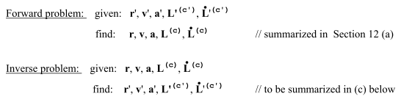

and this is meaningful for example in the original no-swap notation. I then write down the solutions to the Inverse problem, a set of equation e g for v' in terms of v and r.

I do not immediately comment on this question the reader must be asking: does no-swap to swap change forward problem to inverse problem? But later as a separate notion from swap and no-swap notation, I talk about a set of Swap Rules which do convert the forward problem to the inverse problem.

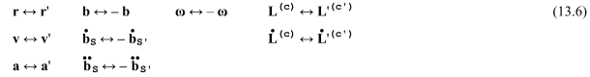

One can see that the Swap Rules are different from swap/noswap notational change because there are various minus signs in the Swap Rules that do not occur in the swap↔no-swap name change.

But I don't mention these Swap Rules yet. Instead, I then do a brute-force solution to get inverse problem equations and I write them all down. Then I state the Swap Rules method and I show that these rules duplicate the "brute force" method results.

After this introduction, I then state the Inverse Problem solutions in my usual no-swap notation. I then repeat all these equations in the swap notation. In the last section I show why the Swap Rules work.

SECTION 14

Curvilinear coordinates? I suggest

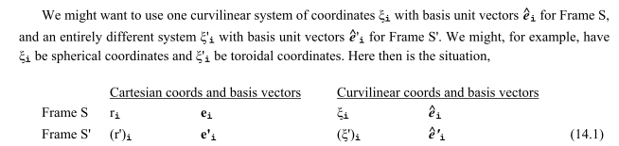

Again there is no mention of tensor doc and this notation has no connection to tensor doc. I then write out the vector expansions in all four coordinate systems (two Cartesian and two curvilinear but orthogonal).

SECTION 15

This finally is ant on turntable problems. I do Problems 1,2 and 3. Then I take on the "projectiles problem" started earlier and I solve it completely.

APPENDIX A

Here I derive the 3x3 rotation matrix in terms of spherical coordinates. I show how this is a special case of using the affine connection and here I think is my first tensor doc reference.

APPENDIX B

Aha! Here I claim that I will discuss how the notation of frames doc relates to that of tensor doc. I talk about Application 1 where x-space and x'-space are both Cartesian so up/down indexing does not matter. I end with this text,
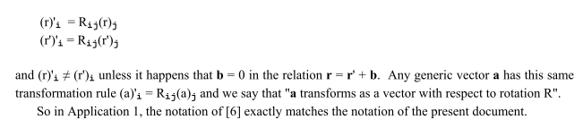

I think that the frames doc and tensor doc notations "match" but only for vectors like a or V. I don't make any comments about how the en and e'n of frames doc is related to any basis vectors discussed in tensor doc !!!! A reader familiar with tensor doc would wonder how it is that in frames doc I say e'n = R-1en (back-rotation) whereas in tensor doc I say e'n = Ren where tensor doc happens to have basis vectors called en and e'n which may or may not be related to the same names used in frames doc. I think I need to add text to this App D to clarify this issue (once I figure it out !!! ).

I next talk about Application 2 which is Frame S Cartesian to Spherical coordinates, as an example of Cartesian to general curvilinear coordinates. Here I make the claim that in fact en of frames doc = un of tensor doc, And then I claim that 'n of frames doc = n of tensor doc where of course en are the tangent base vectors. I guess this is OK because I am not really talking about frames of reference here, I am only talking about the "curvilinear coordinates application" of tensor doc.

Then I talk about Application 3 which is Frame S' Cartesian to Spherical coordinates. I comment that things do not work because the prime symbol is overloaded with two different meanings (1) in frames doc it refers to things in Frame S' (2) in tensor doc it refers to curvilinear coordinates. I then go on to redo frames doc by replacing Frames S and S' with Frames A and B. I show what a mess this produces, but that might be a useful mess when the day is done!

APPENDIX C

The G Rule for a tensor.

APPENDIX D

The Foucault pendulum. This is basically a fifth problem, added to the four done above. I then talk about a certain Spherical pendulum as a distinct entity. The latter is on a non-rotating earth, just a fixed gravity problem but the pendulum is free to move on a spherical surface.

1B. Comments on Frames Doc

The word "active" only appears when I write what I call "active rotation matrices" for certain angles, such as

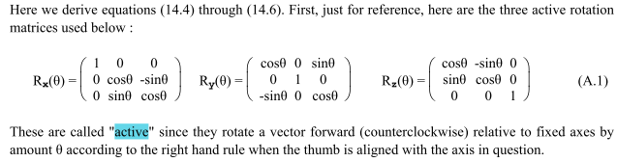

The phrase "active rotation" of a vector (except in the one quote above) does not appear in frames doc.

The word "passive" in the sense of active vs passive does not appear anywhere in frames doc.

The word "covariant" in the sense of equations being covariant in different frames of reference does not appear in frames doc.

The word "back-rotated" does not appear, although I would describe e'n = R-1en (which appears in frames doc) as saying that the e'n are back rotated, and I would also say this is the opposite of tensor doc.

So this doc does not really say much about the topic of this current doc I am writing. However, it does mention that for some vectors a' = Ra, and there is a missing piece of information in Appendix B as noted above, which is to explain how en and e'n of frames doc are related to basis vectors of tensor doc. Also, how does Frame S and Frame S' related to x-space and x'-space of tensor doc?

Fact: Tensor doc has 4 kinds of basis vectors called un, u'n,en,e'n with u'n = Run and e'n = Ren . NONE of these basis vector pairs is back-rotated going from x-space to x'-space which we would like to think of as going from Frame S to Frame S'. Thus neither the pair u,u' nor the pair e,e' of tensor doc fits the mold of e,e' of frames doc.

It is true, however, that en = R-1un in tensor doc, so one could think of u,u as a back-rotated basis pair. But both vectors en and un live in x-space, so this does not seem to be anything that relates x-space to x'-space. But you might claim this parallel situation:

tensor doc en = R-1un un = Frame S en = Frame S'
frames doc e'n = R-1en en = Frame S e'n = Frame S'

So with this parallel situation, Frame S' in tensor doc has nothing to do with x'-space.

The tensor doc model of x-space and x'-space is set up to handle the situation of covariant equations, not the situation of active/passive. But frames doc is set up really for the active/passive application (even though these words are not used) and not for the covariant equations application.

V V' α θ

