Active vs Passive in my docs PhL 11.23.16

This one page note sets out to review all my rotation-related docs, but does not get far! But I do realize a key thing here which is the strong association between tensor doc's way of doing things and covariant equations. I also get a hint that maybe I can use u'n = R-1un as an equation to construct a version of the active/passive story which relates to tensor doc, but I don't actually do it here.

1. Tensor Doc

It includes the following equations, for example

I do mention "frames of reference" in several places. A main idea is this one

The idea is that in Frame S' a covariant equation "has the same form but everything is primed". In the above example I would write F' = RF and a' = Ra and m' = m, but I don't interpret this beyond implying that the Frame S' person would measure primed quantities. Frame appears a lot in App K about deformation tensors. But below K.5.26 I say this
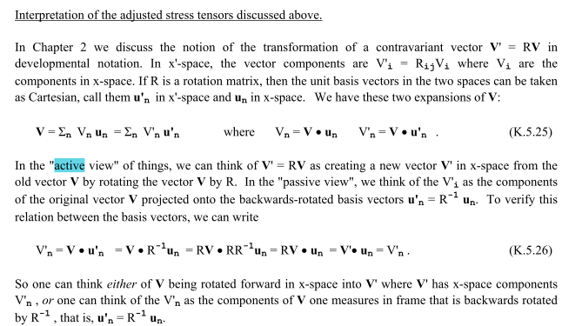

This is the only place that the word "active" appears in tensor doc, and this is my usual active vs passive discussion.

