Two different pairs of basis vectors PhL 11.24.16

I think this last doc in my series clarifies everything and shows how each of my Xmission docs is tied in. The key idea is that you have two different operations here. One is Active/Passive associated with Experiment A/B and back-rotated vectors and this is the basis of frames doc. The other is Experiment C where things rotate together so you have covariant equations and this is the basis of tensor doc.

1. Three sets of basis vectors all at once 1
2. Consider just the basis set pairs c_{n} and c'_{n} (Frame S and Frame S'): Experiment C 2
Application to Tensor Doc (Type C) 4
3. Consider just the basis set pairs c_{n} and c"_{n} (Frame S and Frame S"): Type A and Type B 5
Application to Tensor Doc (Type A/B) 6
Application to Frames Doc (Type A/B) 7
4. Experiments A,B and C ( wedge world but not in wedge doc) 9
5. Sun-earth doc 11
6. Wedge doc 11
7. Review: need to rewrite frames doc Appendix B and C. 12
8. Comments on x-space and x'-space and Frames 13

1. Three sets of basis vectors all at once

Consider the following picture which is drawn in 2D just to keep things simple, but it is meant to stand for a more general 3D picture (or even an nD picture),

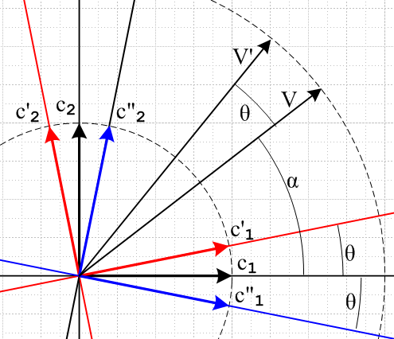

We start with orthonormal Cartesian basis vectors cn (Frame S) shown in black.

We then define two other orthonormal Cartesian basis vector sets as follows

c'n = R cn forward-rotated by θ red Frame S'

c"n = R-1cn back-rotated by θ blue Frame S"

where for our particular picture R = Rz(θ) where points to the reader. Each set of basis vectors defines a corresponding frame of reference which we call Frame S, S' and S".

We also show vectors V and V' which are related by

V' = RV

We now expand the vector V onto each of the three bases, and we then do the same for V' :

V = Σn(V)ncn = Σn(V)'nc'n = Σn(V)"nc"n

V' = Σn(V')ncn = Σn(V')'nc'n = Σn(V')"nc"n

Our notation here for components is to put the name of the vector (V or V') inside the parentheses, and then to indicate whether the component is for the cn, the c'n , or the c"n basis by using zero, one, or two primes on the component outside the parentheses. Since cn• cm = c'n• c'm = c"n• c"m = δnm, we can write the following expressions for the 6 expansion coefficient types, then on the right we write an explicit expression for the 1 component based on the above drawing,

(V)n = V • cn (V)1 = V • c1 = Vcosα *
(V)'n = V • c'n (V)'1 = V • c'1 = Vcos(α-θ)
(V)"n = V • c"n (V)"1 = V • c"1 = Vcos(α+θ) **

(V')n = V' • cn (V')1 = V' • c1 = Vcos(α+θ) **
(V')'n = V' • c'n (V')'1 = V' • c'1 = Vcos(α) *
(V')"n = V' • c"n (V')"1 = V' • c"1 = Vcos(α+2θ)

Notice that the two components marked * are the same, and the two marked ** are the same.

2. Consider just the basis set pairs cn and c'n (Frame S and Frame S'): Experiment C

For this basis set pair, which involves the initial basis cn and the forward-rotated basis c'n, we quote from above,

(V)n = V • cn (V)1 = V • c1 = Vcosα *
(V)'n = V • c'n (V)'1 = V • c'1 = Vcos(α-θ)

(V')n = V' • cn (V')1 = V' • c1 = Vcos(α+θ)
(V')'n = V' • c'n (V')'1 = V' • c'1 = Vcos(α) *

We pause to make the point that if a and b are vectors, and if a' = Ra and b' = Rb (they both "transform as vectors under R"), then

a' • b' = (Ra) • (Rb) = (Ra)T(Rb) = aT RT R b = aT 1 b = aT b = a • b

where we have used the fact that since R is a rotation one has RTR = 1. Now apply this fact to the vectors V' and c'n to get

V' • c'n = (RV) • (Rcn) = V • cn

This is the generalization to all basis vectors that the two * items are equal.

Suppose we have an "true tensor equation" of the form

V • cn = 5 ***

Since the two vectors V and cn "transform as vectors with respect to R" (meaning that V' = RV and
c'n = Rcn ), and since 5 is a scalar, we know that our equation *** is "covariant" meaning it has the same form in Frame S' as it does in Frame S. The only difference is that non-scalar objects are primed. So in Frame S' we have

V' • c'n = 5 ****

and we have already shown that *** implies ****.

We wish now to make more drawings to clarify the nature of this pair of basis vectors. First, here is the above drawing with the c"n basis vectors removed,

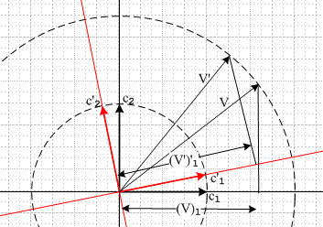

and here we show the two equal distances marked by * above, (V)1 = (V')'1. Now we break this drawing into two drawings as follows,

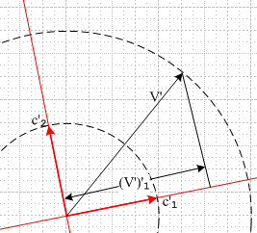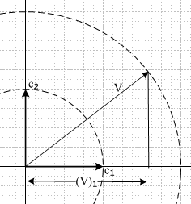

Application to Tensor Doc (Type C)

In tensor doc, we have cn → un and c'n → u'n where u'n = Run and then the pictures are these

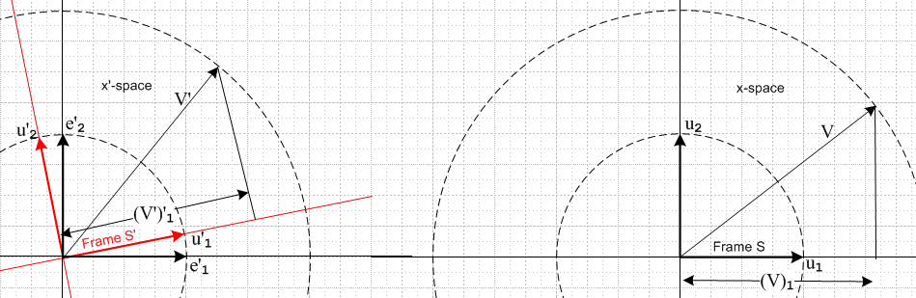

We have now finally arrived at the notions of x'-space on the left (containing Frame S') and x-space on the right (containing Frame S). On the left we have added the axis-aligned basis vectors of x'-space which are called e'n in tensor doc. When we write the equation V' = RV, we think of it taking the vector V in x-space over to the vector V' in x'-space. I now clip from tensor doc the two appropriate expansions from (7.13.10) and (7.13.11)

Here we write both (V)1 = (V')'1 simply as V1 (actually V1 to maintain up down).

Summary: By looking at two of our three basis vector sets, we have threaded a path from this document to tensor doc. The general description of tensor doc is optimized for the discussion for equations which remain covariant under the transformation V' = RV and similarly for higher tensors.
The same framework is used in tensor doc to discuss the curvilinear coordinate transformation x' = F(x). In that discussion xi are coordinates in Cartesian x-space (like x,y,z) , and x'i are the curvilinear coordinates (like r,θ,φ) in x'-space.
In our present discussion R is a rotation, but in tensor doc it is a more general matrix involving both rotation and stretch.
In terms of "observer and apparatus", the tensor doc transformation is what I think I call Type C, where both the apparatus and the coordinate system are rotated together. I will later find my discussion of rotation "types", I know it is somewhere.

3. Consider just the basis set pairs cn and c"n (Frame S and Frame S"): Type A and Type B

For this basis set pair, which involves the initial basis cn and the back-rotated basis c"n, we quote from above (we still have V' = RV) ,

(V)n = V • cn (V)1 = V • c1 = Vcosα
(V)"n = V • c"n (V)"1 = V • c"1 = Vcos(α+θ) **

(V')n = V' • cn (V')1 = V' • c1 = Vcos(α+θ) **
(V')"n = V' • c"n (V')"1 = V' • c"1 = Vcos(α+2θ)

Notice that

V • c"n = V • (R-1cn) = V • (RTcn) = VTRTcn = (RV)Tcn = (RV) • cn = V' • cn

This is the generalization to all basis vectors that the two ** items are equal.

We wish now to make more drawings to clarify the nature of this pair of basis vectors. First, here is the above drawing with the c'n basis vectors removed,

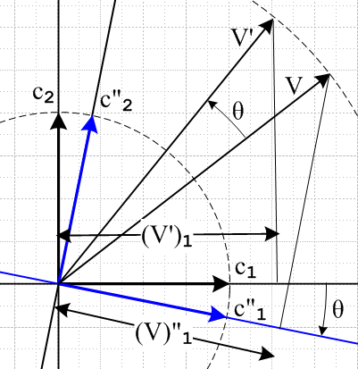

and here we show the two equal distances marked by ** above, (V')1 = (V)"1. As we did with the previous two sets of basis vectors, we can break this picture into two separate pictures.

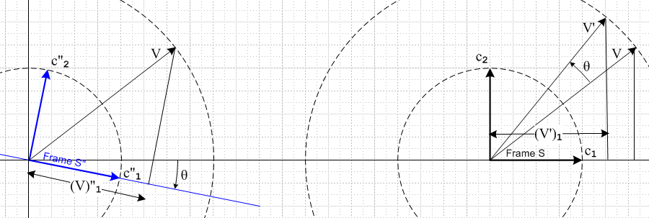

On the right, we think of the vector V' as being a new vector given by V' = RV and we "actively rotate" the vector V into the vector V' within Frame S in this case by R = Rz(θ). The new vector has certain coordinates in Frame S, one of which is (V')1.

On the left, we have the original vector V, but it is now "viewed from" Frame S" which is back-rotated by the amount θ. The coordinate (V)"1 of this vector V viewed in Frames S" is the same as the coordinate (V')1 of the actively rotated vector V' in Frame S. We refer to these two pictures as the "active" and "passive" views of "rotating a vector". On the right we rotate the vector V forward. On the left we leave V where it was, but we rotate the coordinate system backward. The terms active and passive are used in the real world, not just by me, as web search just showed.

I can associate active and passive with my Experiments (see below)

active = Experiment A = apparatus (V) is rotated forward, coordinate system stays put

passive = Experiment B = apparatus (V) stays put, coordinate system is rotated backwards
// frames doc!!
Where do I use this active/passive picture of rotations?

Application to Tensor Doc (Type A/B)

In my recent "active and passive in tensor doc" I point out that you could utilize the existing tensor doc basis vectors en and un in this fashion

ei = R-1ui back-rotated pair from tensor doc

c"n = R-1cn back-rotated pair from this doc

e'n = R-1en back-rotated pair from frames doc (just adding this here for reference)

Then my last picture above could be drawn as

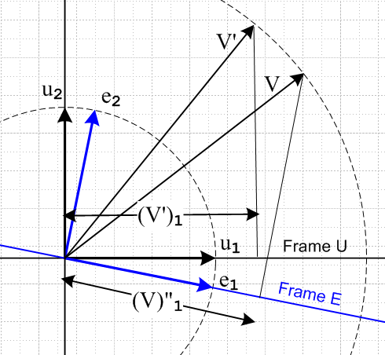

Then you could regard Frame un = Frame S and Frame en = Frame S'. In this case, you could associate Frame S = Frame un with x-space, but you cannot associate Frame S' = Frame en with x'-space because x'-space plays no rule at all here, everything occurs within x-space. We just have two frames in x-space.

Application to Frames Doc (Type A/B)

In frames doc, I have ONLY the active/passive framework because the experiments I want to do are the active/passive type, not the co-rotation type! I have in frames doc

e'i = R-1ei back-rotated pair from frames doc Frame S' and Frame S

c"n = R-1cn back-rotated pair from this doc Frame S" and Frame S

This is clearly laid out in Section 1 (a) of frames doc. I am going to read that section right now to make sure there is nothing blatantly wrong in it.

(a) all OK, notation label method is same as I use in this doc here. I do not comment on the fact that tensor doc has basis vectors named e'n and en which are different from those of frames doc, but they are different since the rotation sense is forward in tensor doc and backward in frames doc.

(b) I imagine there exists vectors a and a' which are not necessarily related by rotation. For each of these vectors I write two expansions and do all the dot products.

(c) Here I take the special case where a and a' are related by a' = Ra. I show in this case that the ordering of the parens and primes in the notation makes no difference, so (a')i = (a)'i in (1.12). In this current doc, this equation appears as :

c"n = R-1cn ⇒ (V')1 = (V)"1 this document

e'i = R-1ei ⇒ (V')1 = (V)'1 frames doc

In frames doc by using ei and e'i I am minimizing notational clutter. Don't want to use e"i for example.

At the end of Section 1 (c) I have a footnote which I think no needs some scrutiny. I refer to tensor doc:

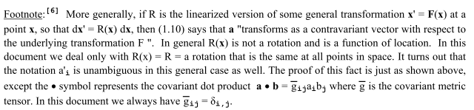

First sentence says that a' = Ra can be generalized for R not being a rotation, I guess that is OK. Second sentence is OK. Third also OK. Fourth sentence claims that you can drop the parens in the notation of tensor doc, where I write things like V'i without fancy parens. I imply in the next sentence that a proof of this fact is "just as shown above" with a fancier meaning for • . This claim I think is weak:

Phrase "just as above" implies that in the fancier tensor doc world you still have some en and e'n which work as they do in frames doc. You need this to write down these steps

(a)'n = a • e'n = [R a] • [R e'n] // valid for any rotation R as shown above
= [R a] • en // used the specific rotation appearing in en = R e'n
= [R (a)m em] • en // inserted expansion a = (a)m em
= (a)m (Rem) • en // extracted number (a)m from [...]
= (a)m (Rem)k(en)k // wrote out dot product
= (a)m Rki(em)i(en)k // wrote out (Rem)k
= (a)m Rkiδm,iδn,k // used (em)i = δm,i twice
= Rnm (a)m

Suppose I were to replace en, en' of frames doc with ui, ei of tensor doc. Then the above reads,

(a)'n = a • en = [R a] • [R en] // valid for any rotation R as shown above
= [R a] • un // used the specific rotation appearing in un = R en
= [R (a)m um] • un // inserted expansion a = (a)m um
= (a)m (Rem) • un // extracted number (a)m from [...]
= (a)m (Rem)k(un)k // wrote out dot product
= (a)m Rki(em)i(un)k // wrote out (Rum)k
= (a)m Rkiδm,iδn,k // used (um)i = δm,i twice
= Rnm (a)m

Here we have the clumsy situation of Frame S' spanned by en and Frame S by un but it does work.

Is there some way to derive (a)'n = (a')n in frames doc without mentioning the basis vectors? I don't think so since the very essence of these symbols is that they are components in some basis. So a reader tracing out my footnote could be a bit confused. I might add to the Footnote as follows.
___________________________________________________________________________________

Footnote:[6] More generally, if R is the linearized version of some general transformation x' = F(x) at a point x, so that dx' = R(x) dx, then (1.10) that a' = Ra says that a "transforms as a contravariant vector with respect to the underlying transformation F ". In general R(x) is a combination of rotation and stretch and is a function of location. In our current document we deal only with R(x) = R = a rotation that is the same at all points in space. It turns out however that the notation a'i is unambiguous in the general case as well as we shall now show. Ref [6] uses a different notation for basis vectors, and to make the connection between our current document and Ref [6] one must take

{en,e'n} → {un,en} Frame S = {en} → Frame S = {un}
en = R e'n → un = Rei Frame S' = {e'n} → Frame S' = {en} .

Then in the language of Ref [6], where • is the "covariant dot product", one has (implied summations),

(a')n = a' • un = (Ra) • (Ren) = (Ra)i(Ren)i = Rij(a)j Rik(en)k = (RijRik) (a)j(en)k

= δjk(a)j(en)k = (a)j(en)j = a • en = (a)'n .
___________________________________________________________________________________

Now this footnote is more honest and I actually prove the claim and no need to mention metric tensor. I have added the above to my frames doc errata.

(d) I am then off on other topics in frames doc.

Are there other references to tensor doc in frames doc? Tensor doc is Ref [6]. I search for [6].

Appendix A: I mention the affine connection, think this is OK

Appendix B is all about Ref [6] so I will have to study it. ********* (see Sec 7 below)

Appendix C on G Rule for tensors is another place, I will have to study this too! ********** (see Sec 7 below)

4. Experiments A,B and C ( wedge world but not in wedge doc)

Where is my writeup of Experiments A,B,C ? It is in a subdirectory of my wedge world, but it is NOT in wedge doc. Let's go review that subdirectory. There are three relevant docs there

"transformations and experiments.doc" Created 11.24.15

Here I do indeed define the three Experiments A,B and C. This doc was started 11.24.15 and is quite long with lots of Questions asked and some red line comments inserted.

"an experiment question.doc" Created 11.25.15

This is a day later doc of 11.25.15. I scanned it and there are more Questions that seem painful.

"vector and scalar temp REVIEWED.doc" Created 4.6.16

The doc ends with a section titled "Vector or Scalar?" which I once had inside wedge doc. The question of interest here is that one writes Vn = un • V = u'n • V' so we have a seeming contradiction that Vn transforms as a scalar, when being a component of a vector it should transform as a vector. ( I refer to Tensor appendix E.2 which I will look at below. ) This little section is very good! In Experiments A and B the observer finds that V'n = RnmVm and concludes that Vm transforms as a vector. But in Experiment C he finds that Vm transforms as a scalar (with respect to Experiment C).

Frame doc involves Experiments A and B, while tensor doc involves Experiment C (covariance idea).

Question: Why then, in tensor doc which is supposedly Experiment C, do I still have V'n = RnmVm which says the Vm transforms as a vector?

Answer: V'n = RnmVm refers to Experiment A which is the active rotation in x-space. On the other hand, it is true that Vn = un • V = u'n • V' so if one defines Frame S with the un and Frame S' with u'n , one would "measure" the component value Vm in both these frames.

Question: But when I write V'n = RnmVm I always say that V is in x-space and V' is in x'-space. How do you explain this situation?

Answer: This is exactly the picture above which I copy down here for the Experiment C case

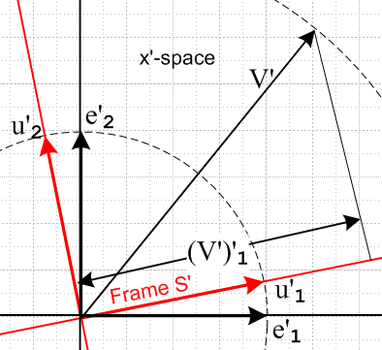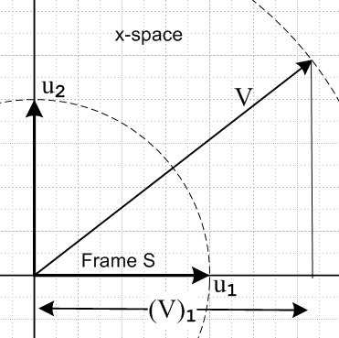

Yes, V is in x-space and V' is in x'-space. If we go from Frame-un to Frame -e'n, we basically have the active rotation V'n = RnmVm and V transforms as a vector in the active sense. But if we go from Frame-un to Frame-u'n, we find the components of V are the same as the components of V' which is Exper C.

I just read tensor doc E.2 and it is not as clean as it should be, but is OK. Experiments 1, 2(active), 3(passive) are really Experiments C, A(active), B(passive).

5. Sun-earth doc

What does Sun-Earth have to say? Appendix B there is titled The Active and Passive Views of Vector Rotation. (a) on the active view is very clear. (b) is longer but also clear. (c) summary OK. I then claim that this business has something to do with equation 6.1 of sun earth doc. Well I look there and see that I have some basis vector relations so I invoke the passive "base vectors go backwards from vectors" rule to develop some equations, it all seems OK. I do have various Frame S and Frame S' situations in sun-earth doc, and Section 6 and Figure 6.1 is one of them. I will review these all right here:

p 13 Fig 1.4 geo to heliocentric connection // discussion seems OK as I read it now

p 18 Fig 2.1 earth tilting pix. Frame S' is fixed at north pole and rotates. Frame S at center of earth aligned with earth and does not rotate.

p 47 Fig 6.1 the same earth center Frame S is still used here, but now Frame S' is no longer a rotating frame at the north pole. Now Frame S' is the frame of the red ecliptic.

p 61 Fig 7.1 Frame S is the same, but Frame S' is glue to surface of the earth. I use Frame S and S' to develop the main equations of sun-earth doc about how the sun path looks from a point on the surface of the earth which is a rotating Frame S'. These frames continue for a long time

p 106 same Frames S and S', analemma photographer is in Frame S' on earth surface.

p 107 I define Frame Sc as frame of camera. Then (11.20) is the Eye Transformation S' to Sc. Then there is a screen frame, and all the computer graphics stuff.

So sun-earth doc seems to have no confusions outstanding regarding frames of reference or rotations. I just use the various Frames as tools to get results of interest. I don't talk much about velocity and acceleration of anything, mainly just position.

6. Wedge doc

So what appears in wedge doc concerning rotations? In Section 2 I review tensor doc and one sees the four tensor doc basis vectors un, en, u'n and e'n. The symbol R appears a lot of course. I show the x-space and the s'-space of tensor doc various times. I have all the tensor doc vector expansions onto these four kinds of basis vectors.
Then on page 35 I have a section called "confusion about vectors and scalars" which I will now read. OK, here I make no mention of the three Experiments. I am in the Experiment C or tensor doc context all the time where s(n) is a set of n scalars and happens to be equal to Vn. Someday I might improve this by saying that this is an Experiment C situation where the basis vectors and regular vectors rotate the same way (the basis vectors here are vectors). So with respect to Experiment C the Vn are scalars. I just added an errata to wedge doc to think about a change here. I say nothing here about experiments A,B,C or about active or about passive. I use the official un and en tensor doc basis vectors to show expansions of vectors and tensors and I define λi = <ui| as the dual space basis vector. I use both Dirac and • type scalar products all the time. I get this claim of scalarity of a tensor function, simplest case,

I talk about the covariant transpose MT and how even the most general R matrix is real-orthogonal in terms of this special transpose operation.
There is nothing in Section 2 particularly about Frames and rotations. It is all tensor doc stuff.
All this stuff comes back for a reprise in the differential forms section, kinematics sections. I identify the basis vectors u'n as the "tangent space spanning vectors". I start drawing x'-space pictures on the right instead of the left. The pull back idea then arrives

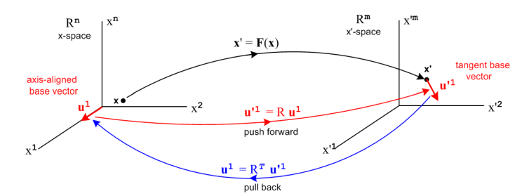

where I am heavily using the un and u'n tensor doc basis vectors, x'-space on the right.
Again, there is nothing really in the main body of wedge doc that deals with reference Frames and rotations. So really wedge doc is off on its own and I have nothing really to say here. It is closely allied with tensor doc.

7. Review: need to rewrite frames doc Appendix B and C.

So what motivated me to get into this recent study of frames and rotations? I went back and read through all the previous docs of this series, and I think all my questions are answered and we are happy campers once again. No disasters were discovered.

What about frames doc Appendix B? I think my Application 1 is wrong. The reason is that it implies the association Frame S = x-space and Frame S' = x'-space, and this is not how things really work. If you want to use the Active/Passive story for tensor doc, you need to have Frame S = un and Frame S' = en and both these frames are in x-space. So this section needs to be somehow repaired. I add now to errata. The whole appendix is wobbly in light of the current doc you are reading.

Appendix C is also a mess and it needs a full rewriting in light of Frame S' ≠ x'-space.

8. Comments on x-space and x'-space and Frames

The tensor doc picture of polar coordinates shows the usefulness of having these two spaces when you are talking about curvilinear coordinates. In x'-space you then have r and θ axes.

For simple rotations, the model of x-space and x'-space is only useful for Type C stuff where you rotated the apparatus and the basis vectors in the same direction. You can then refer to the two spaces as Frame S and Frame S'. Now recall

active = Experiment A = apparatus (V) is rotated forward, coordinate system stays put

This is sort of what the two spaces do: the coordinates that stay put are the e'n in x'-space being basically the same as the un in x-space. And V' = RV rotates the vector actively, so you really do have this picture

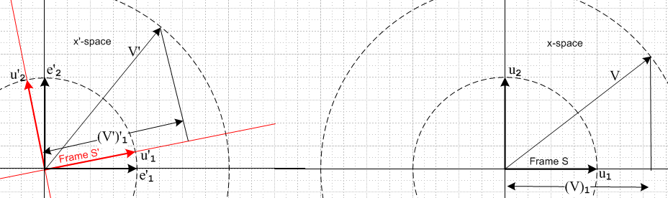

where V' is drawn in x'-space and V is drawn in x-space. This is Experiment A (ignore u'n). We just actively rotate the apparatus and keep the basis vectors the same (though they have new cosmetic names). The two "frames" left and right are really the same frame, and this is the "active" viewpoint. No recall,

passive = Experiment B = apparatus (V) stays put, coordinate system is rotated backwards

What tensor doc does NOT do well is this passive Experiment B. To achieve that, you end up with two frames which are both in x-space

This is the only way we can have back-rotated basis vectors. Then x'-space plays NO ROLE AT ALL.

Summary:

(1) tensor doc works well for Type C where both apparatus and basis rotate forward. In this case you can think of un as Frame S in x-space, and u'n as Frame S' in x'-space, and you can at least use both spaces.

(2) tensor doc works for Type A. But type A "active" only requires one frame (Frame S) and in this application, x'-space is really redundant, it is just a copy of x-space with renamed axes and we use it to hold the rotated apparatus, but we could just as well use x-space for this purpose.

(3) tensor doc only works for Type B "passive" if you ignore x'-space and have basis un and back-rotated basis en both drawn in x-space. Then un is Frame S and en is Frame S'. This is frames doc.

So for things like rotations or Lorentz Transformations where you want to think active or passive thoughts (Type A and B), the model of x-space and x'-space is just not very useful. It is useful for Type C thoughts where you want to talk about covariant equations, which I do in tensor doc.

