Why do I set ei = Re'i in frames doc PhL 11.20.16

This was my first confused doc in this little series. I am trying to state the active/passive story in a way that somehow relates to tensor doc, but I cannot seem to get any reasonable connection to tensor doc. Below I make three half-hearted attempts to find such a connection, and fail. I deleted a fourth attempt that never even got rolling. So move on to the next doc!

This seems to be backwards from my tensor doc idea that V' = RV for a vector V. I have gotten tangled in this question perhaps 100 times during my life, it never seems to get nailed down.

OK, let's start with the usual discussion of "active versus passive" rotations. Do I have a current writeup of this topic? Here is a doc on this subject,

D:\Work\My Interests\Math\Curvilinear Systems\active vs passive.doc

BUT, I just noticed that this is the topic of a very concise Appendix in Sun Earth Kinematics, and I have just read that thing and will try to summarize it here.

1. Statement of the Usual Active/Passive Discussion: basis vector names are en and back-rotated e'n
_____________________________________________________________________________

1. You have your Frame S and it holds a vector V, and you define V' = RV as an active rotation of the vector V within Frame S to produce a new vector V'.

2. The expansions of these vectors in Frame S are these

V = Σn(V)nen (V)n = V • en

V' = Σn(V')nen (V')n = V' • en

At this point there exists no Frame S'. We assumed the en form an orthonormal basis for Frame S.

3. Now still within Frame S suppose we define this new set of orthonormal basis vectors,

e'n = R-1en .

Since these e'n are in Frame S, and since vector V is in Frame S, we can certainly expand V on these new basis vectors,

V = ΣnA'ne'n A'n = V • e'n

where we call the components A'n because we are unsure of how to name them. Now consider

A'n = V • e'n = [R-1V'] •[R-1en] = V'T (R-1)T R-1 en = V'T RR-1 en = V'T en = V' • en = (V')n

We have then shown that A'n = (V')n so we can then write the above as

V = Σn(V')ne'n (V')n = V • e'n

4. Now finally we define a new Frame S' for which the above basis vectors e'n are axis-aligned. In this new frame of reference, we can expand a vector T and say

T = Σn(T)'ne'n (T)'n = T • e'n

The vector name is T and we write (T)'n with a prime to indicate a component in Frame S' of the vector whose name is T. So now apply this to our earlier vector T to get

V = Σn(V)'ne'n (V)'n = V • e'n

Comparing to the above, we end up with

(V')n = (V)'n

This "simple" result is only true if you define e'n = R-1en as shown above.
________________________________________________________________________

5. We have a slight "discomfort" with the above discussion for the following reason. Someone might say to you:

Critic Says: " Well, if you write V' = RV to define a primed vector within Frame S to produce a new vector V' , and since en is certainly a vector in Frame S (like V), then you should be able to write (en)' = Ren in complete analogy with V' = RV and then (en)' is a new vector in Frame S which is obtained by rotating the vector en in Frame S by R. But this seems to conflict with e'n = R-1en which you have written above. " [ A correct critique: so we cannot identify en and e'n above with basis vectors of the same name in tensor doc! ]

6. Before addressing this complaint, which seems quite a valid one, I want to understand what my bible "tensor doc" has to say about these things.

Suppose in tensor doc we have x' = F(x) being linear so it then says x' = Rx as in tensor doc 2.8.6. What does this mean in terms of the picture 8.2.2

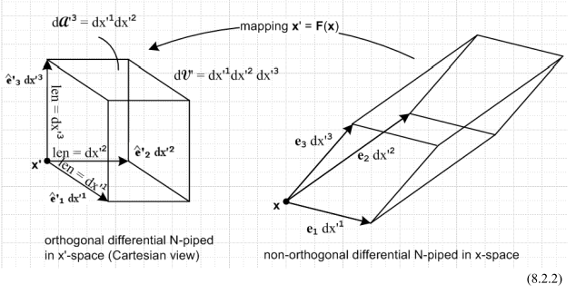

I think what we have on the right is a rotated cube in this linear case, if R is a rotation. But I usually don't think of the en as being the "axis-aligned vectors in x-space". So I cannot just think of the right picture as Frame S and the left picture as Frame S'.

In the general case we have from td (3.2.4) that

and this says

e'n = Ren

which is the equation brought up by our "critic". The critic has read tensor doc and shows you this equation, and has a very valid complaint. My expansions from tensor doc are

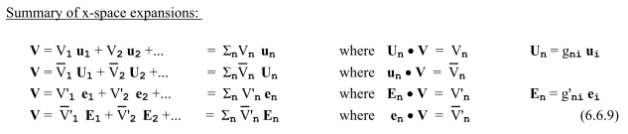
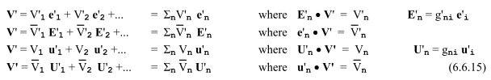

Notice in particular these two expansions from above

In the case of rotations, we would have Un = un and E'n = e'n. I think this gives a hint as to the resolution of the critic's complaint. I will start all over with the above discussion using new symbols.

2. Try using tensor doc un for en and then make whole new e'n different from tensor doc.
This attempt makes no sense to me later on, so I will make it blue. It ends up with two different versions of e'n one which exists in x'-space and another in x-space.
_____________________________________________________________________________

1. You have your Frame S and it holds a vector V, and you define V' = RV as an active rotation of the vector V within Frame S to produce a new vector V'.

2. The expansions of these vectors in Frame S are these ( the un are Frame S axis-aligned basis vectors)

V = Σn(V)nun (V)n = V • un

V' = Σn(V')nun (V')n = V' • un [fine]

At this point there exists no Frame S'. We assumed the un form an orthonormal basis for Frame S.

3. Now still within Frame S suppose we define this new set of orthonormal basis vectors,

e'n = R-1un . // back-rotated

Since these e'n are in Frame S, and since vector V is in Frame S, we can certainly expand V on these new basis vectors,

V = ΣnA'ne'n A'n = V • e'n

where we call the components A'n because we are unsure of how to name them. Now consider

A'n = V • e'n = [R-1V'] •[R-1un] = V'T (R-1)T R-1 un = V'T RR-1 un = V'T un = V' • un = (V')n

We have then shown that A'n = (V')n so we can then write the above as

V = Σn(V')ne'n (V')n = V • e'n

4. Now finally we define a new Frame S' for which the above basis vectors e'n are axis-aligned. In this new frame of reference, we can expand a vector T and say

T = Σn(T)'ne'n (T)'n = T • e'n

The vector name is T and we write (T)'n with a prime to indicate a component in Frame S' of the vector whose name is T. So now apply this to our earlier vector T to get

V = Σn(V)'ne'n (V)'n = V • e'n

Comparing to the above, we end up with

(V')n = (V)'n

This "simple" result is only true if you define e'n = R-1un as shown above.
________________________________________________________________________

Now look at the critic's complaint:

Critic Says: " Well, if you write V' = RV to define a primed vector within Frame S to produce a new vector V' , and since en is certainly a vector in Frame S (like V), then you should be able to write (en)' = Ren in complete analogy with V' = RV and then (en)' is a new vector in Frame S which is obtained by rotating the vector en in Frame S by R. This DOES NOT CONFLICT with e'n = R-1un which you have written above. So I no longer have a criticism.

Now it would be nice if I could show in fact that e'n = R-1un in tensor doc. I don't usually mix these two worlds in tensor doc, but I can check by brute force:

un = R e'n ?

(un)i = Rij(e'n)j ?

δni = Rij δnj ?

δni = Rin ?

This does not fly. The components are in different bases here I think. Start again

un = R e'n ?

un • um = R e'n • um ?

δnm = [ R e'n ] • um ?

δnm = [ R e'n ]i • (um)i ?

δnm = Rik (e'n)k • (um)i ?

δnm = Rik δnk δmi ?

δnm = Rmn ?

Still does not fly (glad I get the same result really).

So the difficulty continues unabated and reminds me of certain "paradoxes" I have dealt with before in this same area.

3. Let's try again with the whole shebang with new names: bn and e'n

_____________________________________________________________________________

1. You have your Frame S and it holds a vector V, and you define V' = RV as an active rotation of the vector V within Frame S to produce a new vector V'.

2. The expansions of these vectors in Frame S are these (the bn are Frame S axis-aligned basis vectors)

V = Σn(V)nbn (V)n = V • bn

V' = Σn(V')nbn (V')n = V' • bn

At this point there exists no Frame S'. We assumed the bn form an orthonormal basis for Frame S.

3. Now still within Frame S suppose we define this new set of orthonormal basis vectors,

e'n = R-1bn .

Since these e'n are in Frame S, and since vector V is in Frame S, we can certainly expand V on these new basis vectors,

V = ΣnA'ne'n A'n = V • e'n

where we call the components A'n because we are unsure of how to name them. Now consider

A'n = V • e'n = [R-1V'] •[R-1bn] = V'T (R-1)T R-1 bn = V'T RR-1 bn = V'T bn = V' • bn = (V')n

We have then shown that A'n = (V')n so we can then write the above as

V = Σn(V')ne'n (V')n = V • e'n

4. Now finally we define a new Frame S' for which the above basis vectors e'n are axis-aligned. In this new frame of reference, we can expand a vector T and say

T = Σn(T)'ne'n (T)'n = T • e'n

The vector name is T and we write (T)'n with a prime to indicate a component in Frame S' of the vector whose name is T. So now apply this to our earlier vector T to get

V = Σn(V)'ne'n (V)'n = V • e'n

Comparing to the above, we end up with

(V')n = (V)'n

This "simple" result is only true if you define e'n = R-1bn as shown above.
________________________________________________________________________

Now look at the critic's complaint:

Critic Says: " Well, if you write V' = RV to define a primed vector within Frame S to produce a new vector V' , and since en is certainly a vector in Frame S (like V), then you should be able to write (en)' = Ren in complete analogy with V' = RV and then (en)' is a new vector in Frame S which is obtained by rotating the vector en in Frame S by R. This DOES NOT CONFLICT with e'n = R-1bn which you have written above. So I no longer have a criticism.

OK, so now we are looking for some vectors bn for which this is true

bn = Re'n

and then everything flies above. What would they be?

(bn)i = Rij(e'n)j = Rijδnj = Rin

BUT, I am now back to my old question of "the meaning of an index". It really means a dot product with something and you have to know what that something is. Where did I run into this paradox stuff? I think this issue arose in Wedge doc Chapter 2. Do I have some kind of definitive statement about this topic there? See "tensor doc and component types.doc" there. My "resolution" there is that you need to put a label on your vector, saying onto which basis it is expanded. For example, for tensor doc basis vectors,

V = Σn[V(u)]nun

V = Σn[V(e)]nen

Here is my second shot above with enhanced notation:

[ I think my latest doc on this subject has no problems with "meaning of an index". ]

This is going to be a real nightmare. I have at least 4 docs published

frames doc sun earth doc tensor doc wedge doc

and they each use some kind of notation for the concepts here, and it is all a total haze right now!

