Notes on the Butikov tide paper PhL 1.20.17

This is an 11 page paper written 2001. Author Eugene is at St Pete Russia.

[I] Introduction. He will to the static ellipse thing, but then will study the dynamic "waves" which the tides of course imply.

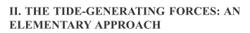

He defines my same Frame S' similar to a "frying pan in the hands of a cook". Talks about how to teach this subject to students. On page 2 his four points of interest are these (he does sun, not moon)

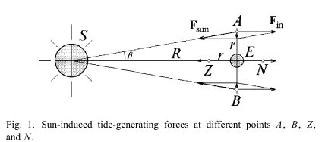

[3] He gets the four point forces in this section but not the general formula yet.



He quickly gets the formula of interest,

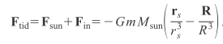

and an approximate version

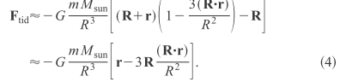


[4] Here he does what I do in my polar coordinates expression of the tidal force. And he drops the constant factor I mention,

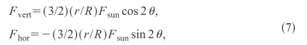

and he has this

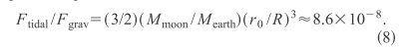

supporting my claim of 10-7 good!



Gets the result

and quotes the 54 and 24 cm standard results. Why do I always say 53 and 24? Maybe fix this! ****

[5]

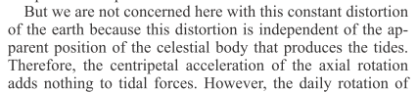

So as I do, he ignores the centrifugal force on the rotating Earth. Mentions that the tidal field is "quadrupole" in nature. What does that really mean? The field has quadrupole moments I guess. I know how to compute the q moments of a charge distribution, but how does that apply here to the tidal force? I cannot get a quick explanation so I won't use this word.
He claims to be able to describe the tidal force at some θ' byut I don't see any fancy equations, so I don't think he does what I do on this subject.



[6] Here author uses the potential method to obtain the same tide height number a, similar to Taylor. So Butikov can claim to do both methods.

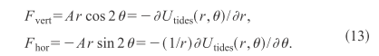

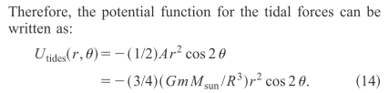



OK, I just scanned the rest of the doc on forced oscillations and read none of it. Done here.

