A Frame S and Frame S' notational danger PhL 7.19.12

This doc asks and then answers several good questions related to rotating frames. Everything is correct, this is not a temp/scraps doc item. It got me going in the Primes notation used in frames doc.

1. Transformation Example 1 (not very exciting but I leave it intact) 1
2. Transformation Example 2 (better) 2
3. Comment about basis vectors in tensor doc 3
5. Why did this component priming confusion not arise in tensor doc? 4
6. Does this notational "danger" exist for vectors other than the position vector r? 4
7. Other notations that might ameliorate this potential danger? 5
8. How do we treat the vector ω in terms of frames? 6

Overview (8.1.12)

In Section 1 I inquire as to what things might transform as a vector and a scalar under a translation transformation r' = r + a. I come up with some examples, and r is not a vector under this F.

In Section 2 I inquire as to what things might transform as a vector and a scalar under a Galilean transformation. In each case I come up with a few examples, and r is not a vector under this F.

In Section 3 I related the rotating-frames basis vectors to those of tensor doc.

In Section 4 I take note (for the first time formally) that in something like r' = r + a, you can project on either set of basis vectors en or e'n, but for components you have four distinct prime notations to worry about. This is the potentially "dangerous" thing the title mentions. For example (r')i ≠ (r)'i .

In Section 5 I show why we never had this kind of priming notation problem in tensor doc. It is because we always there dealt with true vectors under F where V' = RV, unlike r under r' = r + a.

In Section 6 I note that this same danger (and need for careful prime notation) also exists for other vectors, such as a velocity in an equation of the form v' = v - ω x r.

In Section 7 I consider and then reject two notational alternatives to the "primes notation".

In Section 8 I conclude that ω is a "normal vector under rotations" and ω' = Rω. Although I did not mention or even realize it here, frames doc shows how this means you don't need parens in ω'i. In a sense, there was no "other vector" named ω', so we could just do our usual ω' = Rω idea. We would say that ωi are the components of ω in Frame S, and ω'i are the components of ω in Frame S', but it is the same vector ω in we are talking about, there is only one ω vector.

In Section 9 I ask "when are two vectors equal" and this got a berth frames doc.

________________________________________________________________________________

In tensor doc, we frequently see this equation

V' = RV

and something that transforms in that way is called a vector, where R is the linearized F.

1. Transformation Example 1 (not very exciting but I leave it intact)

Consider the transformation

r' = r + a = F(r)

where a is a constant vector. Note that this is not a linear transformation.

(a) Scalars. A function φ(r) is a scalar under this transformation if φ(r) = φ(r'), meaning φ(r) = φ(r+a) . Scalar under this F means function is translation-invariant. Here are two examples of scalar functions

φ(r) = C

φ(r) = A sin (k•r) where k•a = 2nπ, n = integer ,

the reason being that

sin(k•r') = sin(k•[r+a]) = sin(k•r+k•a]) = sin(k•r + 2πn) = sin(k•r)

Now the equation k•a = 2nπ describes a plane in k-space having normal a and passing distance
d = |n|2π/a from the origin. As we vary n, we get an infinite number of planes and any vector from the origin to any point on any of these planes is an OK k to use in this scalar function.

(b) Vectors. The transformation has this property,

dr' = dr => R = S = 1 in tensor doc notation

and anything that transforms in this manner is a contravariant vector with respect to F. Since R = S = 1 we have ST= 1 and anything transforming as the above is also a covariant vector, so there is only one kind of vector. Notice that dr transforms as a vector, but r does not [correct]. An example of a vector

dr'/dt = dr/dt v' = v

So velocity transforms as a vector under this F.
Since r does not transform as a vector, we cannot write

r' = r // wrong

Conclusion: Under the transformation r = r' + a, r does not transform as a vector (while dr does).

2. Transformation Example 2 (better)

Consider the transformation

r' = Rr + a = F(r)

where a is a constant vector and R is a real orthogonal matrix.

(a) Scalars. A function φ(r) is a scalar under this transformation if φ(r) = φ(r'), meaning φ(r) = φ(Rr+a) . Here are two examples of scalar functions

φ(r) = C

φ(r) = A sin (Rk•r) where Rk•a = 2nπ, n = integer

the reason being that ( note detail that Rk•Rr = k • RTRr = k•r since RTR = 1)

sin(Rk•r') = sin(Rk•[Rr+a]) = sin(Rk•Rr +Qk•a]) = sin(k•r + 2πn) = sin(k•r)

Now the equation Rk•a = 2nπ is the same as k • R-1a = 2nπ so this is a set of parallel planes which all have normal R-1a and which have closest approach to the origin of d = 2|n|π/|R-1a| = 2|n|π/a

(b) Vectors. The transformation has this property,

dr' = Rdr => R = S-1 in tensor doc notation

and anything that transforms in this manner is a contravariant vector with respect to F. As before, an example would be v = dr/dt, velocity. A covariant vector transforms like the gradient

∇r' = ST∇r = R-1,T ∇r = R∇r

As before, there is only one kind of vector for this transformation.
Since r does not transform as a vector, we cannot write

r' = Rr // wrong

(c) Basis Vectors. So we have this sort of Galilean transformation r' = Rr + a. I think when we write this, we still think of two frames each with its little triad which would still be called e'n and en and each triad has its members' tails on the respective origin. If we set a = 0 to make these origins align, we know that we must have e'n = R-1 en. Why do we know this? I think I explain this in "active vs passive" Section 1 called "The Passive View". If a vector goes as V' = RV, then we e'n = R-1 en. When a ≠ 0, we retain the same equation e'n = R-1 en which just embodies the desired relative orientation of frame S and frame S' : all three vectors are rotated in the same way in going from S to S'.

Conclusion: Under the transformation r = Rr' + a, r does not transform as a vector (while dr does). The basis vectors en do, however, transform as vectors.

3. Comment about basis vectors in tensor doc

There, we use un as our Cartesian basis vectors in x-space and en as the tangent base vectors in x-space. The e'n = Ren are the mapping of the en into x'-space. Matrix R need not be a rotation matrix.

In our analysis of Frame S and Frame S' we still have the equation e'n = Ren, but the meaning of the vectors is different. The en are the Cartesian basis vectors in Frame S, what we called un in tensor doc. In this Frame stuff, we only care about R being a rotation matrix. The e'n are then the Cartesian basis vectors in Frame S'. In fact we regard e'n = Ren as being the definition of Frame S', apart from a possible translation.

4. A notional problem to ponder in the discussion of Frame S and Frame S'

Consider the second transformation above where r' = Rr + a where R is a rotation matrix. As discussed in section 2 (c) above, we have e'n = R-1 en as a statement of how the basis vectors are oriented even through a ≠ 0. We can expand any vector on either set of basis vectors, so we have, for example,

r' = (r')iei = (r')'ie'i (r')i = r' • ei (r')'i = r' • e'i

r = (r)iei = (r)'ie'i (r)i = r • ei (r)'i = r • e'i

We have here a potentially dangerous situation which requires attention:

(r')i ≠ (r)'i when a ≠ 0

The reason in this example is easy to see

(r')i = r' • ei = (Rr + a) • ei = Rr • ei + a • ei

(r)'i = r • e'i = r • R-1 ei = r • RT ei = Rr • ei

When a ≠ 0, these two objects differ by quantity a • ei .

Problem: I just said that r was not a vector, but then I say it is a vector and write r = (r)iei = (r)'ie'i. Well yes, r is not a vector under transformation r' = Rr + a , but it is a vector under r' = Rr . Look at this picture:

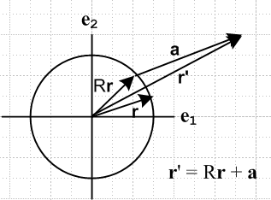

I see no reason why you cannot expand either r or r' on either set of basis vectors. You can do this with any triplet which is a "vector under rotations", and both r and r' are such vectors.

5. Why did this component priming confusion not arise in tensor doc?

In tensor doc we had

V = Viui = V'iei ei = tangent base vector in x-space

V' = V'ie'i

The component on the first line V'i was the exact same thing as the component on the second line, so there was no need for a fancy parentheses notation!

6. Does this notational "danger" exist for vectors other than the position vector r?

In the now-infamous transformation rules between frames S and S' we find equations like

v' = v - ω x r

where any of these vectors can be expanded on either basis. So vector v will have a notational issue similar to that vector r has above!

(v')i = v' • ei = (v - ω x r) • ei = v • ei - ω x r • ei

(v)'i = v • e'i = v • R-1 ei = v • RT ei = Rv • ei

Since the second object depends on the relative orientation of the basis triads and the first does not, we can see that in general these two objects are different.

7. Other notations that might ameliorate this potential danger?

Plan A: Instead of using Frame S and Frame S', you might use Frame Sspace and Sbody. Then you would have basis vectors (ebody)n and (espace)n and components would be eg [(espace)n]i which seems quite clumsy. Our transformations above would be

rbody = Rrspace + a

vspace = ω x rspace + vbody

I am not quite sure whether to put labels on a and ω, defer for the moment. Derivatives:

(drbody/dt)space (drbody/dt)body (drspace/dt)space (drspace/dt)body

Goldstein thinks of space as an inertial frame, but maybe we don't want to imply that so directly. The prime system is more neutral about that. But even Goldstein in 4-104 cannot bear to write

vspace = vbody + ωspace x rspace

Instead he writes

vs = vr + ω x r

where he now introduces completely new labels s = space and r = body, and fails to mark r and ω with any label, as if the default were "space". [ See below concerning ω ]

Plan B. For a while I was testing out this notation:

V' = RV
[V]F ≡ { V • eFn}
[V]S = (V1,V2)
[V]S' = (V'1,V'2)

What this really means I think is this

[V]S,i = Vi = (V • ei) // now I would call this (V)i
[V]S',i = V'i = (V • e'i) // now I would call this (V)'i

So my notation with the [...] really had to do with components, a way to label components. It now seems much clumsier than what I show on the right. Let's look at all four that I lies in temp3 v3.doc

[V]S = (V1,V2) // first term is V • e1
[V]S' = (V'1,V'2) // first term is V • e'1
[V']S = (V'1,V'2) // first term is V' • e1
[V']S' = (V"1,V"2) // first term is V' • e'1

which I might now write as

[V]S,i = Vi // now I would call this (V)i
[V]S',i = V'i // now I would call this (V)'i
[V']S,i = V'i // now I would call this (V')i
[V']S',i = V"i // now I would call this (V')'i

In the case that V' = RV, we have the special case that (V')i = (V)'i since there is no translation vector added to this equation.

Conclusion: I prefer the "primes plan" to either plan A or plan B outlined here.

8. How do we treat the vector ω in terms of frames?

I keep putting this question off, but the time has now come. The first place we encounter ω is here

(de'i/dt)S = ω x e'i

which is derived in (4.4) of some doc. We ID ω as the instantaneous rotation vector which explains how frame S' is moving relative to frame S. It first appears as vector dφ as in

e'n(t+dt) = R(dφ) e'n(t)

Whereas r and ei are things which live within frame S, and r' and e'i are things which live within frame S', the objects dφ and ω involve the relationship between the two frames. They are like the R and S of vector doc in this regard? Well, they really are vectors. Hmmm.
Here is a Fig 1 type picture where we are a little more general about how frames are oriented.
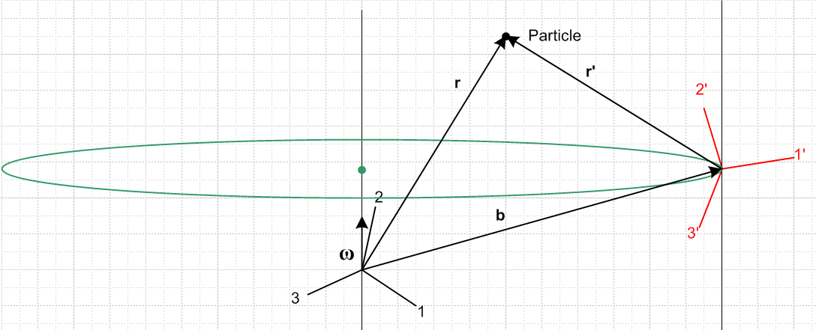

The ω vector really exists in frame S and it tells how frame S' is moving relative to frame S. In this figure, at some particular moment in time ω(t) points in the direction shown which is mean to be an arbitrary direction in frame S system. The thin vertical line on the left is then the instantaneous rotation axis at this instant in time, and the origin of frame S' is momentarily doing circular motion along the large circular path shown in green (whose center is at the green dot). Since ω is like any other "vector under rotations", it will look different when viewed from frame S'. Using our convention from above that V' = RV and e'n = R-1 en, we will find that

ω' = Rω .

There is no translation element in this equation. Seen from either frame, the vector ω lies on an axis which passes through the frame S origin. We can expand ω and ω' each in two ways, as usual,

ω = ωiei = (ω')ie'i

ω' = (ω')iei = (ω')'ie'i

So yes, we have both ω and ω' vectors. It is the ω vector which appears in all our equations. Thus, in full blown Goldstein notation we really should say

vspace = vbody + ωspace x rspace

where ω then has the space label. But in our more compact notation, this becomes

v = v' + ω x r

9. If you translate both ends of a vector (tip and tail), is it the same vector?

This question keeps coming back. Look at this picture for example,

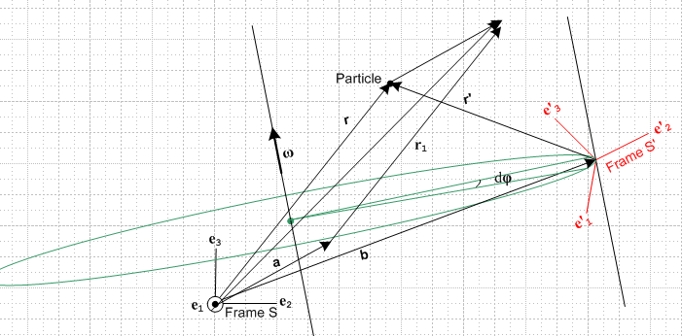

The particle is at the tip of the vector r as shown. If we were to translate vector r by amount a we get a new vector r1. The particle is not at the tip of vector r1. When we say "the particle is at location r in frame S", we imply that the vector r is drawn exactly as shown above.
Note the 2-piped which has r and r1 as two of its parallel sides. Is it true that r1 = r + a ? No that is not true. The vector r + a would be the diagonal shown of the 2-piped. The only possibility is r1 = r. If we write this, it seems we are saying that r and r1 are "the same", they are "equal".
So let's try this as a solution to our confusion:

(1) two vectors are equal if they have the same components in the same coordinate system.
(2) two vectors related by a translation are equal.
(3) when we say that a particle is at location r, we mean that IF we take the vector r and place its tail at the coordinate system origin, THEN the tip of the arrow will be at the location of the particle. We are saying that the particle "is displaced by r from the origin of frame S ".

I suppose if you want to be really fussy you could define a "regular" and a "strong" equality:

a = b two vectors are the same even though perhaps translated relative to each other
a b in addition to the above, the two vectors actually coincide.

I think we should think of a vector as a concept independent of the location of its tail. It is really defined by its components, and these are independent of tail position.
Now, consider "the two expansions" of r :

r = riei = (r)'ie'i

If you actually draw the first expansion, vector r will have its tail at the frame S origin.
If you actually draw the second expansion, vector r will have its tail at the frame S' origin.
Nevertheless, the two expansions are equal, just as r = r1 in the example above. To be really fussy we could say

riei = (r)'ie'i
riei (r)'ie'i

so the two expansions are not equal under the "strong" equality sense. That is fine, but I don't think we ever care about such a fact.

