Example 2 reconcile PhL 7.11.12

This is more work on Example 2. I just keep going down the same path to nowhere.

There is some notational problem with my Example 2 picture. First, recall the temp3 v4 picture:

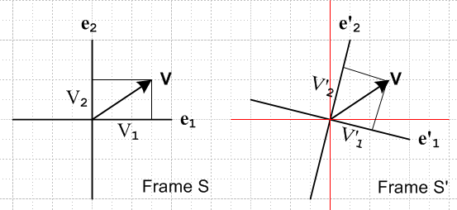

where we are illustrating the "passive view" and the vector is V in either picture and we can expand V in either of two ways, so V = Vnen = V'ne'n . There is no vector V' in the above pictures. But we are able to write, in order to relate components, that V' = RV, and then suddenly V' appears and if we like, we can draw it into the left picture to get,
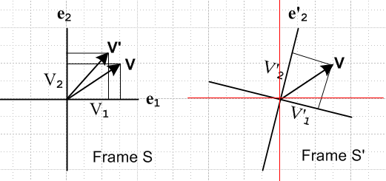

Now with the above large picture in mind, consider our Example 2 picture,

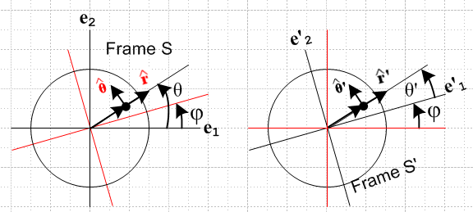

Here the long arrow is the position of the ant, and I am implicitly writing it as r'(t) on the right and as r(t) on the left, which 100% conflicts with the notation above. Taking the simpler case, I could draw unit vectors from the origin, and then I have on the left, but I have ' on the right for the same vector! Again this is a 100% conflict with my declared notation. So after declaring a clean notation, the very first thing I do is ignore it and draw some wrong pictures!
Maybe my confusion is that I should not be drawing two pictures! Maybe I should just be drawing a single picture like this, which I do think is a much better way to do things.

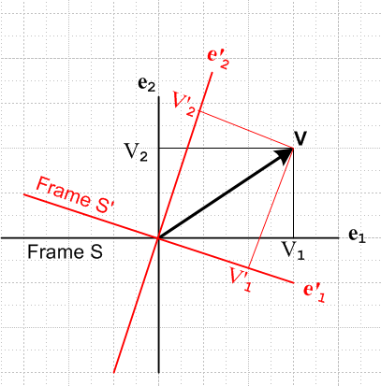

So let's now make a corresponding ant-on-record picture drawn for some specific time t:

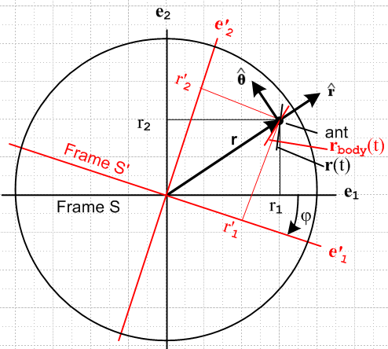

en = Rz(φ) e'n = Re'n
V' = Rz(φ)V = RV

So now there is no need for vectors r' or ' to be drawn on this picture. We could draw them as rotated vectors, but we don't want to.
OK, how now do I describe the ant's body trajectory rbody(t) ? This is the path the ant follows in frame S' but displayed in frame S coordinates, and I show this as a short red line segment. Because of the rotation effect, the actual path of the ant in frame S is going to be some other path r(t) which I show as a black line segment. Think of both as curves, my drawing is just schematic.

[ Above I am seeing early signs of things like cross velocities and accelerations. ]

But now I want a specific example of an ant trajectory. Suppose then that in frame S' we have

r'body(t) = 3t e'1 + 2t2 e'2 = $\left(\begin{matrix}3t \\ 2t2\end{matrix}\right)$

What would the frame S' components of this path be?

rbody(t) = R-1 r'body(t) = $\left(\begin{matrix}cosφ & sinφ \\ -sinφ & cosφ\end{matrix}\right)$$\left(\begin{matrix}3t \\ 2t2\end{matrix}\right)$ = $\left(\begin{matrix}3tcosφ+2t2sinφ \\ -3tsinφ + 2t2cosφ\end{matrix}\right)$

This would be the point in frame S of this ant body trajectory at time t where angle is φ(t).
Let's do another example. The ant walks radially only in frame S' so that

r'body(t) = r'(t) '

So now ' shows up for the first time, a new complication. This vector does not appear in the picture. I don't even know what this means. How is ' related to ? If I treat it just as I would treat any other generic vector V, I get one answer. But if I treat it as a basis vector, I get a different answer. Which is it? Well suppose instead we compare r' and r ? That suggests treat as a generic. On the other hand

V = Vr + Vθ = V'r ' + V'θ '

suggests it is in the basis vector class of things. Here we are using "curvilinear coordinates" which you would think I would know something about by now.
OK, I have now made a new picture, maybe having both together will help somehow:

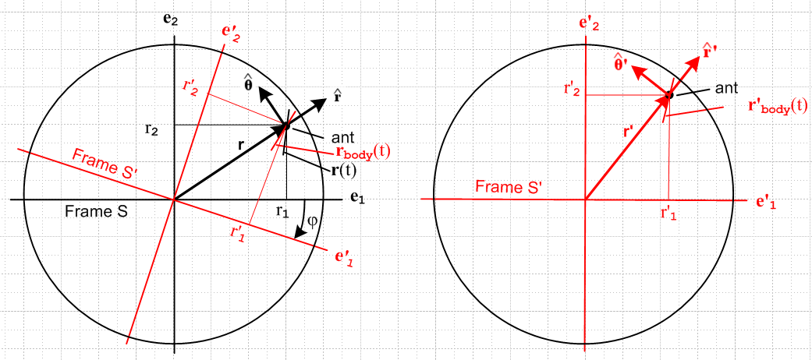

Let's think the vector r' on the right as being something that has components r'1 and r'2 as shown.
The vector r on the left is something that has components r1 and r2.
The components are different and the vectors appear different on the paper. In both cases, the components are found by projecting onto paper vertical and horizontal axes. And it seems reasonable that

' = Rz(φ)
' = Rz(φ)
r' = Rz(φ) r

and we can see for sure that, at least in the left picture,

en = Rz(φ) e'n

So the answer seems to be that we want to treat r, , as "generic vectors".
Now let's try one more time on our body path attempted above,

r'(t) = r'(t) '

where I don't use a body subscript since there is no confusion about what this means. It is the trajectory of the ant in Frame S which is the body frame or the right picture. The vector ' is fixed, and only the radius varies for this example body path. Now in frame S I guess we have

r(t) = Rz(φ)-1 r'(t) = r'(t) Rz(φ)-1'

and at time t, which applies for left picture, this lines up with the black arrow and

(t) = Rz(φ(t))-1'

So I guess this means we can write

r(t) = r'(t) (t)

r(t) = r'(t) Rz(φ(t))-1'

This then is the actual trajectory in frame S.

Question #1: Often I have said something like this:

Let r'(t) = r'(t) ' be the body path of the ant. Being a vector equation, we can write the components in any frame we want. In frame S', we can draw the trajectory and it is a line lying on the red arrow. In frame S, this same trajectory would be a line lying along the black arrow on the left. This is the trajectory the ant would have if the phono record were frozen at angle φ(t). True, but that seems a very useless object to talk about. The record does not stop, it is always turning, and this trajectory on the left means nothing at all. At some later time t1 and some larger φ, the left side black arrow rotates downward and you could say that at time t1 the body path trajectory lies along this new black arrow.

So suppose we have some completely general body path r'(t) and we draw its trajectory on the right. At any time t, this could be drawn in frame S as a rotated picture of this trajectory. But only the point at the ant really means anything in frame S. The "bulk" trajectory seems useless. But maybe in a differential sense we have more meaning. Consider then

dr = dφ x r + drbody

Here, the second term is our dr'(t), but it does have to be moved into frame S coordinates so that all terms in this equation are in frame S coordinates. So that is why we want to say

r'(t) = r'(t) ' = r'body(t)

drbody(t) = Rz(φ(t))-1 dr'body(t)

In the differential we don't talk about a trajectory for rbody(t), just a tiny piece of that trajectory near time t. We are just doing vector addition of two tiny vectors. This drbody(t) is how much the ant would move in frame S if motion were frozen. And dφ x r is the piece we add to account for the motion.
You could perhaps integrate drbody(t) to get some rbody(t), but I claim that trajectory has no useful meaning, and I also claim that you won't have rbody(t) = Rz(φ(t))-1 r'body(t). This would only be true if we have φ(t) = constant as you can for sure see by staring at the above last equation.
So the moral of the story is this: we will deal with drbody(t), but never with rbody(t) . On the other hand, we can deal with r'body(t) = r'(t) which is our full ant trajectory in frame S'.

Question #2. So, how do you find the frame S trajectory of the ant, r(t) ?

Let's trace this out. Start with the above

dr = dφ x r + drbody where drbody(t) = Rz(φ(t))-1 dr'body(t)

So we know drbody if we are given φ(t) and r'body(t). Then we have

v(t) = dr/dt = ω x r + (drbody/dt)

Note that

(drbody/dt) = Rz(φ(t))-1 (dr'body(t)/dt)

so this is something then we fully know. So we now have v(t), but only as a function of r(t) !

r(t) = r(0) + $^{\int_{0}^{t}{}}$ v(t')dt'

and THAT then is how you get the trajectory r(t) . But I think this is an integral equation for r(t).

Example 2 Redone.

The ant path in frame S' is given by some completely general (in 2D) equation

r'body(t) = r'body(t) '(t)

Our rotation convention is now this one:

en = Re'n where R = Rz(φ)
V' = RV.

(a) Our first step is to compute

(dr'body(t)/dt) = (dr'body(t)/dt) '(t) + r'body(t) (d'(t)/dt)

This is as specific as we can get here. In more compact notation

(dr'body(t)/dt) = (dtr'body) ' + r'body(dtd')

and in fact since there is no confusion, we can write this as

(dr'body(t)/dt) = (dtr') ' + r'(dtd')

(b) Our second step is then to wrote

drbody(t)/dt = Rz(φ(t))-1 dr'body(t)/dt = R-1 [(dtr') ' + r'(dtd')]

(c) Our third step then is this

v(t) = dr/dt = ω x r + (drbody/dt) = ω x r + R-1 [(dtr') ' + r'(dtd')]

Again:

dr/dt - ω x r = R-1 [(dtr') ' + r'(dtd')]

This is a first order PDE for r(t) which is driven by some known function of time on the right. How do you solve such a thing? We can just write this as

dr/dt - ω x r = b(t) b = drbody(t)/dt

Maybe try doing this in cylindricals. Locate this cylindrical system such that its origin lies at the tail of the position vector r, and such that ω = -ω. Then of course r = r . Since ω ≡ dφ/dt, and since φ is defined in "the wrong way" in my drawing, we have the minus sign in ω = -ω which I don't much like.

ω x r = [-ω] x [r] = -ωr

So now the equation looks like this

dr/dt + ωr = b(t)

Next, I suppose

dr/dt = (dr/dt) + r (d/dt)

Now we can think of r = (r,θ,z) with z = 0 in our ant case. Then with θ having its usual meaning, I think we can say

(d/dt) =

Then we have

dr/dt = + r

Then our PDE becomes

dr/dt + ω x r = b(t)

+ r + ωr = b(t) = br + bθ

and this then breaks into two equations

= br
(r + ωr) = bθ or ( + ω) = bθ/r

I am of course anxious to try this in some simple cases now. Recall that

b(t) = R-1 [(dtr') ' + r'(dt')]

I think we can say that

(dt') = ' '

so then

b(t) = R-1 [(dtr') ' + r' ' ' ]

If it is correct to treat these unit vectors as "generic vectors", then since V' = RV we have V = R-1 V' and that means = R-1' and similarly, so this then says

b(t) = ' + r' ' = br + bθ

and we now have it in frame S unit vectors. I am not quite sure of this last step but I hope it is valid. If so, then our equations are

= '
(r + ωr) = r' ' or ( + ω) = ' (r' /r)

But, at any time t, we must have r = r' so our equations are then

= '
( + ω) = '

We can provide a general solution to these two equations as follows

r(t) = r0 +$^{\int_{0}^{t}{}}$'(t) dt
θ(t) = θ0 +$^{\int_{0}^{t}{}}$ ('(t) - ω(t)) dt

Case 1: The ant is completely at rest in frame S', he is glued to the record.

r(t) = r0
θ(t) = θ0 -$^{\int_{0}^{t}{}}$ω(t)) dt

Case 2: The ant moves only in the ' direction in frame S' and stays at a fixed radius r' = r0.

r(t) = r0
θ(t) = θ0 +$^{\int_{0}^{t}{}}$ ('(t) - ω(t)) dt

Case 3: The ant moves only in the ' direction in frame S' and stays at a fixed radius θ' = θ'0.

r(t) = r0 +$^{\int_{0}^{t}{}}$'(t) dt
θ(t) = θ0 -$^{\int_{0}^{t}{}}$ ω(t) dt

