Physical relation between S and S' PhL 7.23.12

[ In the general picture used in frames doc, you could imagine that we start with both frames aligned. First we do some rotation of frame S' relative to S, and second we translate frame S' out by vector b. This is Plan A below. But somehow the details of how these frames are related does not seem to matter much. We always just assume we have some set of en and some set of e'n and they are related by some R. ]

Plan A : Rotate Frame S' about the Frame S origin, then translate Frame S'

1. Start off with S and S' having a common origin and being perfectly aligned.

2. Do some rotation of S' relative to S,

e'n(t) = R(-θ(t)) en

3. Consider a small change in each Frame S' basis vector

de'n = dφ x e'n

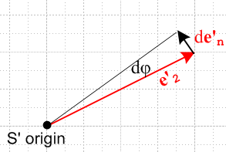

The vector dφ describes the instantaneous change of all the S' basis vectors.

We can see that the tip of e'n here is being rotated about the S' origin, so our rotation axis must be passing through that origin. We then continue the analysis in the usual way

e'n(t+dt) = R(dφ) e'n (t) = R(dφ) R(-θ(t)) en

=> (de'n /dt) = ω x e'n ω = dφ/dt

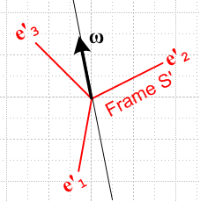

We can regard ω(t) is defined as that vector which makes the above equation be true at time instant t.

(de'n /dt)S = ω(t) x e'n(t)

One can describe a completely arbitrary gyroscopic tumbling (origins stay fixed) of S' relative to S by this equation. One could integrate the equation and thereby obtain θ(t) in e'n(t) = R(-θ(t)) en . This would then define our frame S' tumble program. As developed in the above, the infinite line which coincides with the vector ω passes through the S' origin, and the three basis vectors are instantaneously rotating about this line.

4. Next, rigidly translate the entire Frame S' system an amount b relative to frame S. This of course translates the origin of S' by b relative to the origin of S. We now have

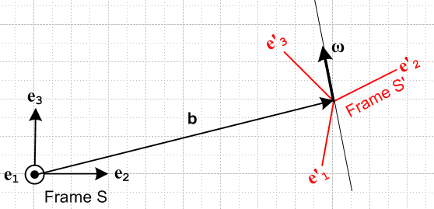

The relationship between frames has 6 parameters: 3 for b and 3 for ω.

Plan B : Translate Frame S', select an ω axis, then rotate Frame S' about this axis

1. Start off with S and S' having a common origin and being perfectly aligned.

2. Rigidly translate the entire Frame S' system an amount b relative to frame S. We now have

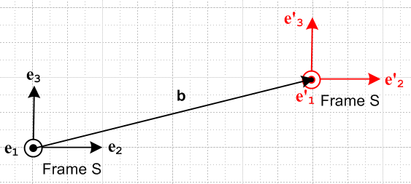

3a. Select a rotation axis at some arbitrary location in 3D space and associate this axis with a vector ω ,

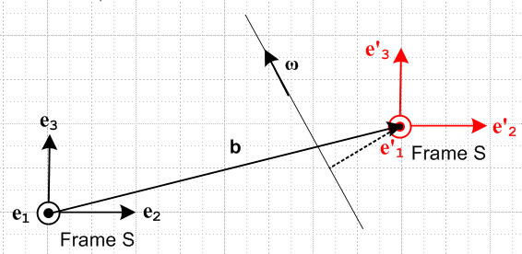

3b. Rotate system S' about this rotation axis. If everything is in the plane of paper, then the dotted line shows the radius on which we rotate the frame S' origin. When we do this, the origin of S' will no longer be at the point b. This is not a situation we ever want to use! I want vector b to connect the origins of the two systems at all times.

Comment: We could redefine b so that it tracks with the origin of S' as that origin rotates about the rotation axis shown. In this case, we have to regard b as a function of ω and the rotation axis location and not as something independent of these things. In such a physical situation, I would say that the drivers are ω and the axis location, and then b comes out whatever it comes out being. Certainly I can imagine a physical situation that operates in this manner. I think the following is still true.

(de'n/dt) = ω x e'n .

If we were to add a pre-rotation of Frame S' prior to starting Plan B, the above picture becomes the one I have been long using in the G Rule doc,

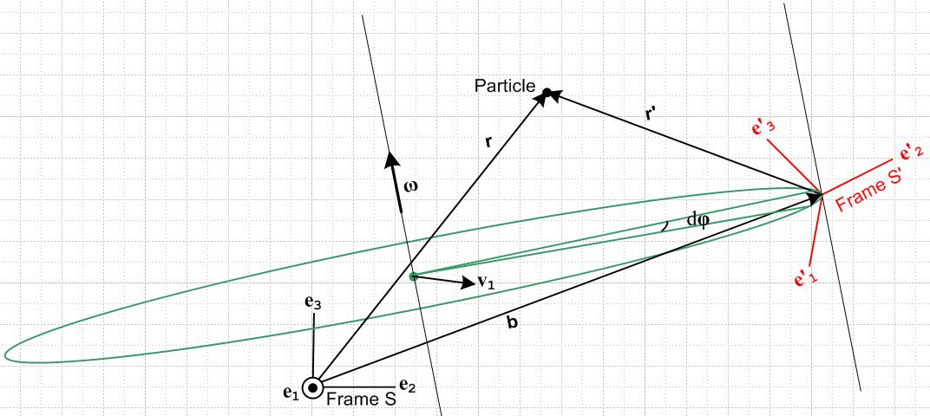

Now I have a few questions. Is this true? :

(de'n/dt)S = ω x e'n

I think the answer is yes, because I showed that it does not depend on the distance between the rotation axis and the Frame S' origin. Next, is this true? :

(db/dt)S = (db/dt)S' + ω x b

In the derivation of this G Rule, ω gets into the act because (de'n/dt)S = ω x e'n which we just said is valid. And we use things like b = b'i e'i which is surely true.
Now if the above picture is "OK", then so is my rotated version of it, which is this

