Ant on Phono Record PhL 7.12.12

Here I work at once in polar coordinates r,θ in Frame S and r',θ' in Frame S. I don't have a general framework at this time. I am still in the older context where the G Rule involves drbody. I seem to get some separated equations = ' and - ω = ' which are each ODE's. I do simple cases and make a few spiral plots. I then try to find r,v,a equations in a more general sense, but it all ends badly. This is now all systematized in frames doc so I will just regard this as an early attempt at doing ant on record problems.

1. Kinematics and variables. 1
2. Equation of Motion using the Goldstein r equation 2
3. Separating and then Solving the Equation of Motion. 2
4. Special Cases 4
5. Solving the same problem in a trivial fashion. 6
6. Finding velocity v, acceleration a, and angular momentum L. 6
7. Examine the Goldstein equation in v 7

1. Kinematics and variables.

Here is the picture showing the situation in frames S and S' : ( = 3 out of plane of paper) ( the picture on the left is valid for a specific time t )

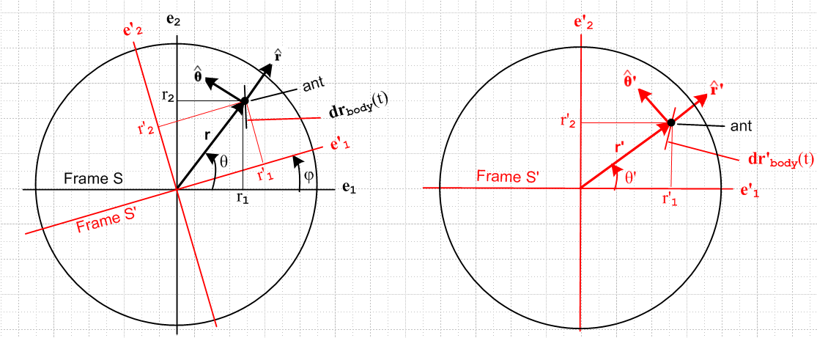

The convention here is for symbol R is as follows:

e'n = Ren where R = Rz(φ) expansions: V = Vnen = V'ne'n
V = RV'.

With components define relative to the axes of paper, we can see that the second line above can be applied to four vectors in the pictures:

r = Rr'
= R'
= R'
drbody = R dr'body(t)

We agree from discussion elsewhere that, although we shall think of r'body(t) as a full path of some sort of the ant in frame S', we shall never give consideration to any object named rbody(t). However, we shall give consideration to objects dr'body(t) and drbody(t).

2. Equation of Motion using the Goldstein r equation

The main equations of interest are these.

dr = dφ x r + drbody
drbody = R dr'body

The first is pretty obvious in that you just add the two displacements to get the total displacement. The first displacement dφ x r is in the direction as right hand rule shows and is of course caused by the rotational motion of S' relative to S. The second displacement is dr'body which has been mapped into Frame S as shown above. A key idea to keep in mind is that drbody appears in the equation, and not dr'body(t).
The second equation was already stated above.
Upon division by dt, may be written

dr/dt = ω x r + drbody/dt where ω = dφ/dt
drbody/dt = R dr'body /dt

which we can also write as

v = ω x r + vbody where ω = dφ/dt
vbody = R v'body

The first equation here shows clearly why we had to use the "body" subscript on vbody etc.
We may regard our first equation as a first order PDE in variable r(t)

dr/dt – ω x r = vbody

where ω, R, and v'body are all functions of time. In any problem we shall consider, we shall be given the following facts: ω(t) , R(t), and r'body(t), and some reasonable initial conditions.
Notice that, in official parlance, and in Cartesian coordinates, the above equation is in fact a system of three coupled, first-order, partial differential equations for functions x,y,z with variable time t:

dxi/dt - εijkωj(t)xk = [vbody(t)]i

The equations are inhomogeneous in that there is a driving term on the right side. As shown below, for our special case this equation, in polar coordinates, separates into a pair of decoupled first-order ODEs.

3. Separating and then Solving the Equation of Motion.

We work first on the RHS driving term in the above equation:

v'body = dr'body /dt

Let's assume that someone has specified r'body(t), and we express it in this manner in terms of our polar (or cylindrical) unit vectors,

r'body(t) = r'(t) = r'(t) '(t) .

In Frame S' we know that

d'/dt = ' ' d'/dt = - ' '

Therefore, we compute

v'body = dr'body /dt = dt[r'(t) '(t)] = ' ' + r' ' '

We then find that

vbody = R v'body = R [' ' + r' ' '] = ' R ' + r' ' R' = ' + r' '

Looking at the left picture above, and noting the r' = r, this result seems very reasonable.

Meanwhile, we have of course that

r = r ω = ω => ω x r = [ω] x [r ] = ω r

Now, analogous to the above, we have in Frame S,

d/dt = d/dt = -

so
dr/dt = dt(r ) = + r

which has the exact same form as (**) above. We now insert these pieces into our equation of motion,

dr/dt – ω x r = vbody

+ r - ω r = ' + r' '

We can isolate from this two separate equations:

= '
c

But for our ant, r = r', so these equations simplify to

= '
- ω = '

These equations are fully "separated" and may be solved by single quadrature:

r(t) = r(0) + $^{\int_{0}^{t}{}}$ '(τ) dτ
θ(t) = θ(0) + $^{\int_{0}^{t}{}}$ ['(τ) + ω(τ)] dτ

But of course we can do the integrals of the dotted objects to get

r(t) = r(0) + [ r'(t) - r'(0) ]
θ(t) = θ(0) + [ θ'(t) - θ'(0)] + $^{\int_{0}^{t}{}}$ ω(τ) dτ

But since r = r' in general, the first equation is a trivial identity. The second says

θ(t) = φo + θ'(t) + $^{\int_{0}^{t}{}}$ ω(τ) dτ

So here are our general solutions

r(t) = r'(t)
θ(t) = φo + θ'(t) + $^{\int_{0}^{t}{}}$ ω(τ) dτ

4. Special Cases

Here we do a few "sanity checks" on the above result.

Case 1: Ant is glued to the phono record so that '(τ) = 0 and '(t) = 0. The solution is then

r(t) = r'(t)
θ(t) = φo + θ' + $^{\int_{0}^{t}{}}$ ω(τ) dτ = θ(0) + $^{\int_{0}^{t}{}}$ ω(τ) dτ

In the even more specialized case the ω = constant, this says

r(t) = r'(t)
θ(t) = φo + θ' + ωt = θ(0) + ωt

This solution is in exact agreement (including signs) with the above kinematics picture.

Case 2: Ant is only allowed to move radially in frame S' . Then of course θ'(t) = θ'0 and

r(t) = r'(t)
θ(t) = φo + θ'0 + $^{\int_{0}^{t}{}}$ ω(τ) dτ = θ(0) + $^{\int_{0}^{t}{}}$ ω(τ) dτ

The angular equation is the same as Case 1. while the radial equation does the obvious.
So the ant moves out radially say if ' > 0, and picks up the CCW motion of the record. If would be fun to plot this case in Maple.

x(t) = r(t) cos(θ(t)) = r'(t) cos(θ(0) +ωt)
y(t) = r(t) sin(θ(t)) = r'(t) sin(θ(0) +ωt)

Here it is, where ant starts at r0= 0 and θ0= 0 and has '= 2 and ω= 3

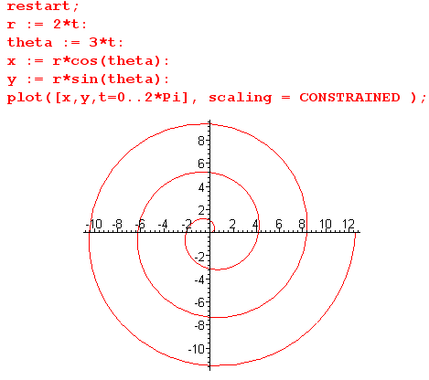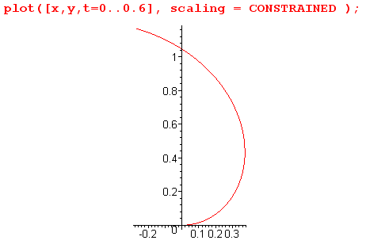

The plot on the right is a blowup of that of the left near the origin, and you can see r0= 0 and θ0= 0 a bit more clearly.

Case 3: Ant is only allowed to move tangentially in frame S' :

r(t) = r'(t) = r0
θ(t) = φo + θ'(t) + $^{\int_{0}^{t}{}}$ ω(τ) dτ

If both ω and ' are constants, we get

r(t) = r0
θ(t) = φo + [θ'(0) + ' t] + ωt = θ0 + (' + ω)t

where the angular velocities just add together.

5. Solving the same problem in a trivial fashion.

The position of the ant in frame S is given by

r(t) = R(t)r' = R(t) r'body(t)

which we can write as

$\left(\begin{matrix}x(t) \\ y(t)\end{matrix}\right)$ = $\left(\begin{matrix}cosφ & -sinφ \\ sinφ & cosφ\end{matrix}\right)$$\left(\begin{matrix}x'(t) \\ y'(t)\end{matrix}\right)$

x(t) = cosφ(t) x'(t) - sinφ(t) y'(t)
y(t) = sinφ(t) x'(t) + cosφ(t) y'(t)

and this certainly is a full solution to the problem where

φ(t) = φ(0) + $^{\int_{0}^{t}{}}$ ω(τ)dτ .

How would we convert the above solution to polar coordinates? We know from our picture (or from the above equations) that

r(t) = r'(t)
θ(t) = θ'(t) + φ(t)

Thus, our equations are

r(t) = r'(t)
θ(t) = φ(0) + θ'(t) +$^{\int_{0}^{t}{}}$ ω(τ)dτ

and these are the same equations obtained in the previous section using the Goldstein r equation.

6. Finding velocity v, acceleration a, and angular momentum L.

Above (using two methods) we found the solution r(t) in terms of r(t) and θ(t).

r(t) = r'(t)
θ(t) = φo + θ'(t) + $^{\int_{0}^{t}{}}$ ω(τ) dτ .

We can certainly write

r(t) = r(t) (t) = (r(t) cosθ(t), r(t)sinθ(t)) = r = (rcosθ, rsinθ) .

Then the following lines follow from what we have done above, including the facts that

d/dt = - and d/dt = .

We get this sequence:

r(t) = r // true position of the ant in frame S

v(t) = dr/dt = r d/dt + = r +

a(t) = dv/dt = ( + r + r [-]) + ( + [])
= ( - r2) + (2+ r )

L = r x p = m r x v = m r x [r + ] = mr2

dL/dt = mr2 + 2m r = mr (r + 2 ) .

Now we can also write

r(t) = rr where rr = r

v(t) = vr + vθ where vr = vθ = r

a(t) = ar + aθ where ar = - r2 aθ = 2+ r

L(t) = Lz where Lz = mr2

7. Examine the Goldstein equation in v

That equation says this (I think the second line is correct, just another vector)

dv = dφ x v + dvbody
dvbody = R dv'body

dv/dt = ω x v + dvbody/dt where ω = dφ/dt
dvbody/dt = R dv'body /dt

which we can also write as

a = ω x v + abody where ω = dφ/dts
abody = R a'body

Again, we are happy to have our body subscript on abody .
We may regard our first equation as a first order PDE in variable v(t)

dv/dt – ω x v = abody

where ω, R, and a'body are all functions of time. In any problem we shall consider, we shall be given the following facts: ω(t) , R(t), and r'body(t), and some reasonable initial conditions.

We work first on the RHS driving term in the above equation:

a'body = dv'body /dt = dt[' ' + r' ' '] = five terms

= ' ' + ' ' ' + ' ' ' + r'' ' + r' ' [- ' ']

= (' - r''2) ' + (r'' + 2 ' ' ) ' .

Then the next step is as above to get (primes go away on the unit vectors)

abody = (' - r''2) + (r'' + 2 ' ' )

Meanwhile, we have of course that

v = vr + vθ ω = ω => ω x v = [ω] x [vr + vθ] = ω vr – ω vθ

Also, we have

dv/dt = r + vr + θ + vθ[- ] = (r - vθ) + (vr + θ)

We now insert these pieces into our equation of motion,

dv/dt – ω x v = abody

(r - vθ) + (vr + θ) - ω vr + ω vθ = (' - r''2) + (r'' + 2 ' ' )

(r - vθ + ω vθ) + (vr + θ - ω vr) = (' - r''2) + (r'' + 2 ' ' )

We can isolate from this two separate equations:

r - vθ + ω vθ = ' - r''2
vr + θ - ω vr = r'' + 2 ' '
or
r + (ω - )vθ = ' - r''2
θ - (ω - )vr = r'' + 2 ' '

And now the two equations are not decoupled! Things are much more complicated than before. No doubt we could solve these equations somehow, but I am not going to try. My main interest is to verify that these equations are true!!
From the previous section we found that

v(t) = vr + vθ where vr = vθ = r

So we can say

vr =
r =

vθ = r
θ = r +

Then our two coupled equations above become

r + (ω - )vθ = ' - r''2
θ - (ω - )vr = r'' + 2 ' '
or
+ (ω - ) r = ' - r''2
r + - (ω - ) = r'' + 2 ' '

Let's whittle away on the first equation

+ (ω - ) r = ' - r''2

- ' r = - r'2 // since r = r' and since φ - θ = -θ' so ω - = - '

' r = r'2

= '

- ' = 0

ω = 0 // something bad happened somewhere

Let's whittle away on the second equation

r + - (ω - ) = r'' + 2 ' '

r + - (ω - ) = r' + 2 '

r ( -') + - (ω - ) = 2 '

r ( -') + - (-') = 2 '

r ( -') + +' = 2 '

r ( -') + = '

r ( -') + (-') = 0

r + ω = 0 // something is wrong here as well

So both our equations come out wrong! This is certainly telling me something. I think this is exactly the problem I have been puzzling over for the last 2 weeks. Something is wrong in my understanding here because I think the algebra has been done right.

