retired on 7.17.12

[ This was an early version of my frames doc inverse problem section. I made some mistakes here. ]
[ this could be discarded I think ]

11. The Inverse Problem

Consider these two problems which concern the exact same physical situation:

Original Problem: given r', v', a', L' find r, v, a, L

Inverse Problem: given r, v, a, L find r', v', a', L'

We have found the solutions to the Original Problem as summarized in the previous section. What then are the solutions to the Inverse Problem? We shall obtain the results after a few steps.

(a) Review. First of all, here is the picture for the Original Problem along with the solution equations:

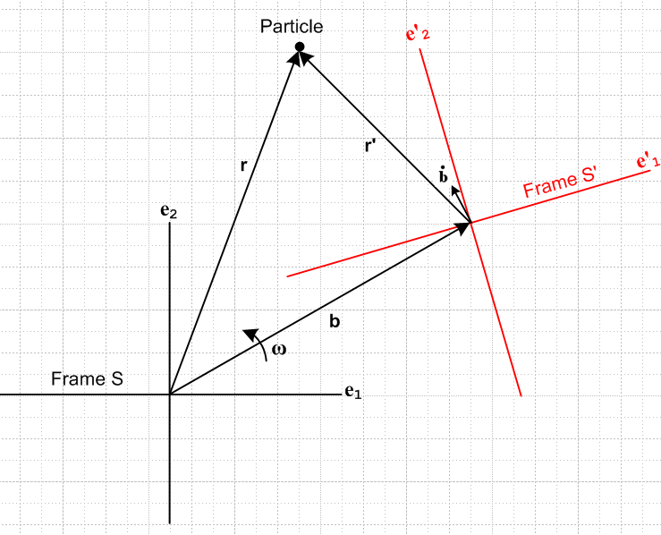 Fig 1

r = b + r' (5.1)
v = (dr/dt)S = ω x r + v' = ω x r' + ω x b + v' (6.9)
a = (dv/dt)S = ω x (ω x r) + x r + 2 ω x v' + a' (7.6)
L = r' x (ω x r) + b x (ω x r) + r' x v' + b x v' (9.4)
(dL/dt)S = - (r•ω) (r x ω) - r x (r x ) + 2r x (ω x v') + r x a' (9.13)

e'n(t) = R(θ) en R(θ) = exp(-iθ • J) i (Jk)ij = εkij (4.1)

TEST DEBUG. Particle glued to origin of Frame S'. Equation is : v = ω x r + v' . Seems that r' = 0 and v' = 0 and r = b. Then get v = ω x b . As b moves around, v changes, and in fact v moves around in a circle and all is well at this debug point.

In this figure, Frame S is glued to the paper and Frame S' is rotating counter-clockwise (say) about frame S by ω. In an Application of Fig 4, we think of Frame S "at rest" and it might be an inertial frame if it is really at rest relative to the stars. So if we are told some facts about what is happening within the rotating frame S' (facts such as r', v', a', L' ), our analysis above gives expressions for r, v, a, L. This is what we are calling the Original Problem.

(b) Rotate Fig 1. Now let's simply to rotate Fig 1 to bring Frame S' into alignment with paper at time t,

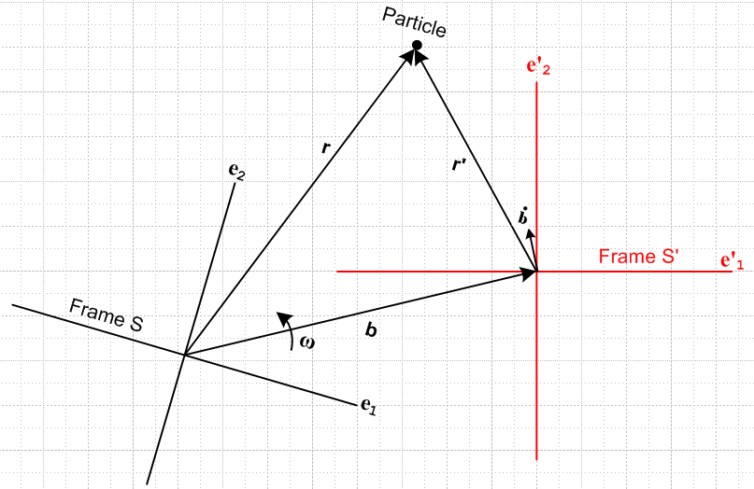 Fig 5

(c) Reinterpret Fig 5. Next, we want to think of frame S' glued to the paper, so Frame S is then rotating CCW about frame S'. Here is the new picture with this interpretation (we have just moved the rotation arrow)

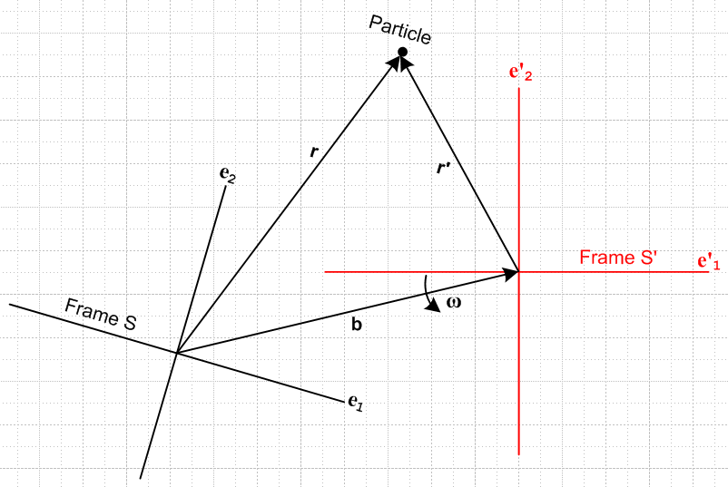 Fig 6

In Fig's 1,5 and 6 the vector ω always points in the same direction (out of the plane of paper).

ERROR. I have moved the axis of the rotation vector, and that changes the physical situation! In Fig 5 the axis passes through the Frame S origin, but in Fig 6 it passes through the Frame S' origin. So my step (c) is illegal!

TEST DEBUG One equation is this: v = ω x r + v' If Particle at rest at Frame S' origin, then v' = 0, r' = 0, r = b and so v = ω x b . But it seems to me we should have v = 0. Something is wrong.

Now we can regard Frame S' as being "at rest" (and possibly inertial) and Frame S is rotating around Frame S'. In an Application of this picture, if we are told some facts about what is happening within the rest frame S' (facts such as r', v', a', L' ), our analysis above gives expressions for r, v, a, L as seen from the rotating frame (a "camera platform"). We then use exactly the same expressions above for r, v, a, L, but we just have to keep in mind the meaning of the vector b in these equations. It is as shown in the above picture. In Fig 6, b has its tip at the rest frame origin, whereas, in Fig 1, b has its tail on the rest frame.

(d) The tail of b. Perhaps we like always having the tail of b being at the rest frame origin. In this case, we could redefine b in Fig 6 by doing b → -b, and at the same time we need to do b → -b in our equations. Then we end up with this situation:

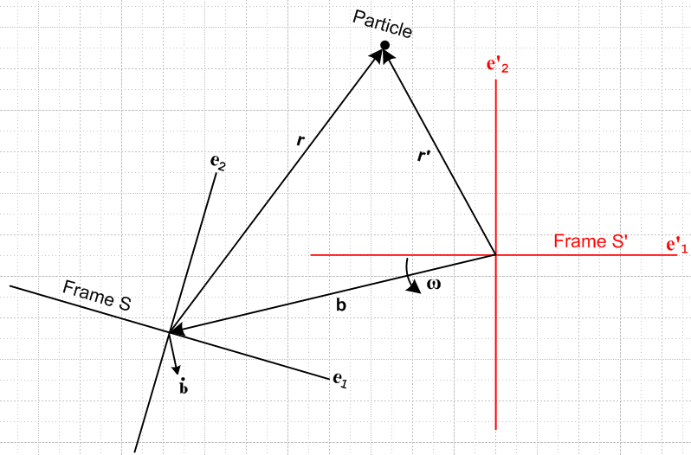 Fig 7

r = -b + r' (5.1)'
v = (dr/dt)S = ω x r + v' = ω x r' - ω x b + v' (6.9)'
a = (dv/dt)S = ω x (ω x r) + x r + 2 ω x v' + a' (7.6)'
L = r' x (ω x r) - b x (ω x r) + r' x v' - b x v' (9.4)'
(dL/dt)S = - (r•ω) (r x ω) - r x (r x ) + 2r x (ω x v') + r x a' (9.13)'

e'n(t) = R(θ) en R(θ) = exp(-iθ • J) i (Jk)ij = εkij (4.1)

(e) Primed-Unprimed Swap. Now to be obstinate, perhaps we want to swap the names of things ( primed ↔ unprimed), so that in the above picture, the rest frame is unprimed and the rotating frame is primed. Perhaps at the same time we make the rest frame axes be black and the rotating frame axes be red. That is all pretty easy to do, and we get (swapping all the names of things)

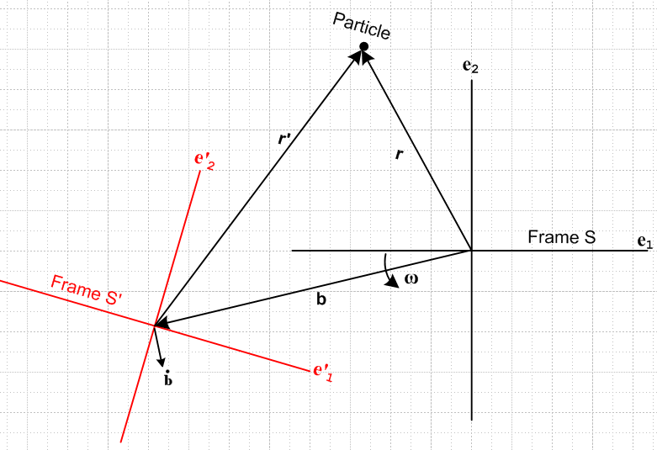 Fig 8

r' = -b + r (5.1)"
v' = (dr'/dt)S' = ω x r' + v = ω x r - ω x b + v (6.9)"
a' = (dv'/dt)S' = ω x (ω x r') + x r' + 2 ω x v + a (7.6)"
L' = r x (ω x r') - b x (ω x r') + r x v - b x v (9.4)"
(dL'/dt)S' = - (r'•ω) (r' x ω) - r' x (r' x ) + 2r' x (ω x v) + r' x a (9.13)"

en(t) = R(θ) e'n R(θ) = exp(-iθ • J) i (Jk)ij = εkij (4.1)

(f) Compare and reach Conclusion. Now here is a side by side comparison between Fig 1 and Fig 8

Figure 1 Figure 8

But Fig 8 is really the same as Fig 1 except :
(1) The Particle position r is different location in the two figures.
(2) Vector b points in a different direction in the two figures
(3) we selected a different orientation for Frame S':
Fig 1: e'n(t) = R(θ) en
Fig 8: e'n(t) = [R(θ)]-1en

None of these cosmetic facts matters in terms of developing the equations summarized in Section ** . We could just as well used Fig 8 in place of Fig 1.

Therefore, the set of equations shown above under Fig 8 really also apply to Figure 1, and are therefore the solutions to the Inverse Problem.

(g) Summary. All the above effort is just a long-winded way of saying the following: The equations of the Inverse Problem can be obtained from the equations of the Original Problem by swapping all primed with unprimed "things", and doing b → -b.

Example 1: In Fig 1, the Particle is selected as just floating at the origin of Frame S which is an inertial frame, so the Particle stays there forever. We then have

r = 0 v = 0 a = 0 L = 0

What are the corresponding vectors as seen from the rotating Frame S' system? Copy and edit the double primed set of equations shown above to get

r' = -b
v' = (dr'/dt)S' = ω x r' = - ω x b
a' = (dv'/dt)S' = ω x (ω x r') + x r' = -ω x (ω x b) - x b = ω x v' - x b
L' = b x (ω x b) = (-b) x v'
(dL'/dt)S' = + (b•ω) (ω x b) - b x (b x ) = –(b•ω) v' – b x (b x )

The Particle as seen from Frame S' is "heading southeast" at v'(t) = - ω x b(t) at time t. Since b(t) changes direction with time, v'(t) changes direction

Something is wrong. Imagine this particle at spindle center, and frame S' rotates around at some b. In frame S', the spindle does not move so we should have r' = fixed, and that agrees with r' = -b and the fact that b rotates around with frame S'. But what about v' ? It would seem that we should have v' = 0 as seen from frame S' since the Particle is in a fixed location!

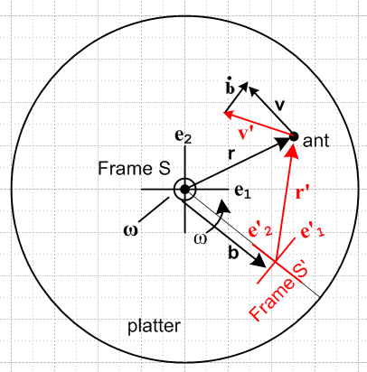

v = ω x r + v' // original

v' = ω x r' + v // Inverse

Test the inverse!

v = ω x r + v' = ω x r + ω x r' + v => ω x r + ω x r' = 0?

=> ω x [r+r'

******************************************************88

Let's try "manual inversion" of our equations

r = b + r' (5.1)
v = (dr/dt)S = ω x r + v' = ω x r' + ω x b + v' (6.9)
a = (dv/dt)S = ω x (ω x r) + x r + 2 ω x v' + a' (7.6)
L = r' x (ω x r) + b x (ω x r) + r' x v' + b x v' (9.4)
(dL/dt)S = - (r•ω) (r x ω) - r x (r x ) + 2r x (ω x v') + r x a' (9.13)

The first one is easy

r' = r - b // done

The second one is v = ω x r + v' so it then says

v' = v - ω x r // done

The third one says a = ω x (ω x r) + x r + 2 ω x v' + a' and therefore

a' = a - ω x (ω x r) - x r - 2 ω x v'

= a - ω x (ω x r) - x r - 2 ω x (v - ω x r)

= a - ω x (ω x r) - x r - 2 ω x v + 2 ω x (ω x r)

= a +ω x (ω x r) - x r - 2 ω x v // done

The fourth one says L = L' + r' x (ω x r) + b x (ω x r) + b x v' so invert to get

L' = L - r' x (ω x r) - b x (ω x r) - b x v'

= L - (r-b) x (ω x r) - b x (ω x r) - b x [v - ω x r]

= L - r x (ω x r) + b x (ω x r) - b x (ω x r) - b x v + b x (ω x r)

= L - r x (ω x r) + b x (ω x r) - b x v // done

The last equation I think I need in a different form.

