Example Paradox PhL 7.18.12

I am trying now some N=2 type examples.

[ Two paradoxes and both resolved. In the first, at this time I had the ω axis always through the Frame S origin, but then I tried to apply that to a problem where it went through the Frame S' origin and got a bad result. This led me to generalize the location of the ω axis in frames doc. In the second, I get a paradox which is explained in another doc as noted below. ]

Example 1 Paradox?

Consider this picture

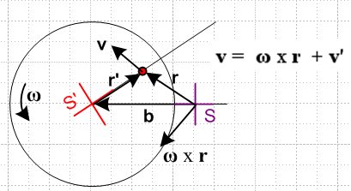

Frames S and S' are clearly shown. S' rotates CCW with the platter. The red ant is fixed on the platter as it rotates. In frame S, surely the ant appears to have the velocity v shown. Vectors r and r' are correctly labeled. The ant being at rest on the platter has v' = 0. The formula predicts then that v = ω x r . We can see that ω is out of the plane of paper. Then I have drawn the vector ω x r and it completely disagrees with the direction v! So here in the very first trivial example I concoct we have a huge inconsistency.

Resolution: If you draw the ω vector in the picture, it emerges from the spindle.

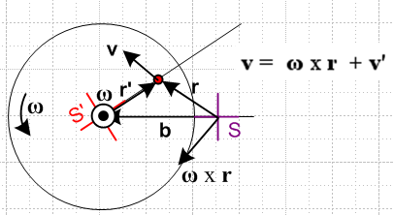

But that is the wrong location for this vector in terms of Figure 1 which shows the ω vector passing through the origin of frame S.

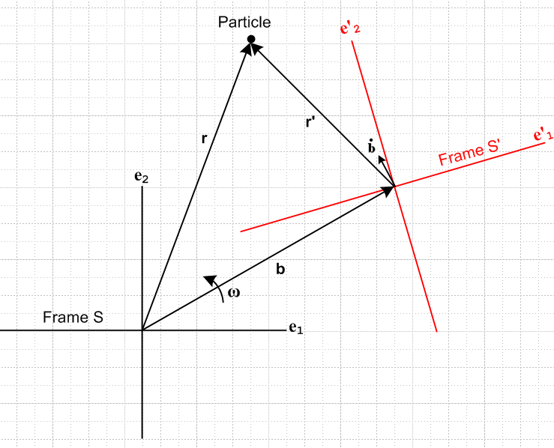

I thought my Fig 1 was quite general, but in fact it cannot even handle my little N=2 example! The Fig 1 picture is appropriate for Coriolis earth physics and is the situation Goldstein treats.
To handle the above case, I would need a more general picture

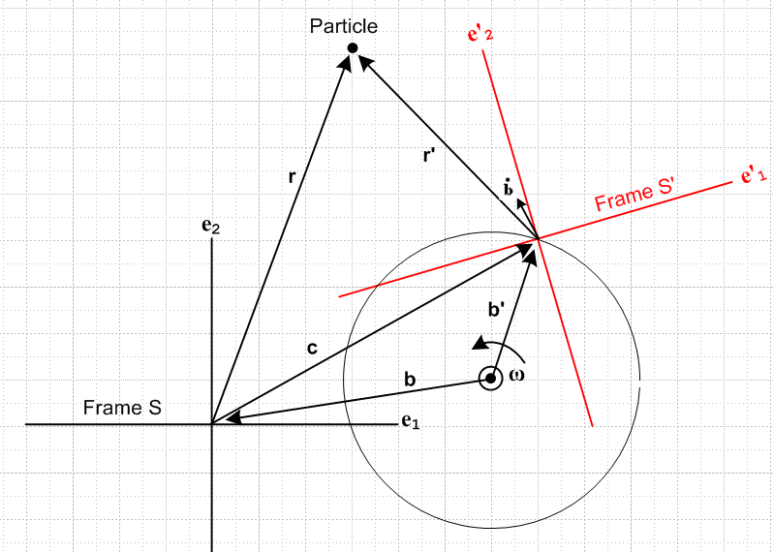

Now from S' is rotating about some arbitrary third point where we put ω. We now need two new vectors which I have renamed as shown to be b, b' and c. If the ω point is put at S origin, then c = b'. How hard would it be to "do" the above picture? Maybe play right here a bit. In general, c,b,b' are 3D vectors and ω points in some strange direction and the picture just shows a simple case. Our camera location lies on the axis of the ω vector which is why it appears as a dot. This picture is a tough one.

Frame S is fixed to paper in this picture. G Rules are still valid. Observer still lives in S'. We still have some initial orientation of S' relative to S as described. But what do the unit vectors do now? The little section on that starting with e'n(t+dt) = R(dφ) e'n(t) still applies I think to give (de'n/dt)S = ω x e'n where ω and dφ are relative to the ω point.
Now let's run through the remaining paper sections. But hold for now.

Example 2 Paradox?

We may now summarize the solution of the Inverse Problem:

r' = r - b (10.1)

v' = v - ω x r (10.2)

Example 2: Referring to Fig 1, suppose a Particle floats at rest at some point r = r0 in inertial Frame S. This means that we have r = r0, v = 0, a = 0, L = 0. What does an Observer within Frame S' see?

r' = r0 - b // says r'(t) describes a circular motion which seems right.

v' = - ω x r0 // this seems wrong since it says v' = constant

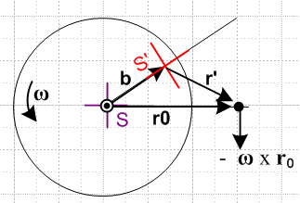 Version of Fig 1

[ This mystery is dealt with in "Examples that once confused me.doc". Expressed in Frame S components, it is really true that v' is a constant. Note that v' = v'S' which is not a cross velocity ].

