Faucault v2 (cylindrical coordinates version) PhL 9.5.12

Here I use cylindrical coordinates for Frame S' and I think that is a bad choice. So I am now going to attempt to rewrite this appendix using sphericals for frame S'. [ Yes, it was a bad choice if you want to talk spherical pendulum! Most books just use Cartesian!]

Appendix D: The Foucault Pendulum

(a) Pictures showing Frame S and Frame S'

For this problem, we use the "earth" kinematic picture shown above as Fig 4.9,

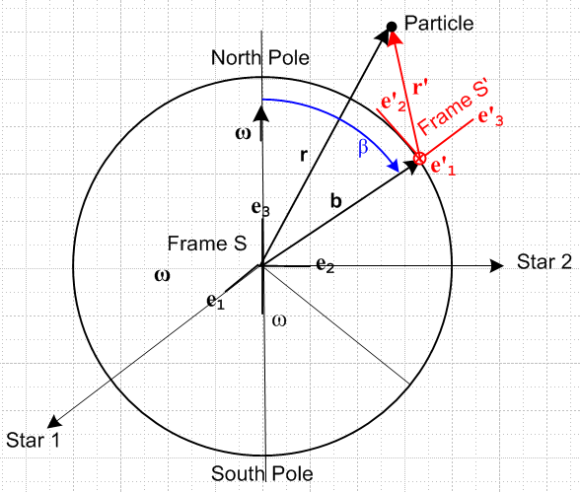 Fig D.1

For Frame S, with origin at the center of the Earth and fixed relative to distant stars, we select spherical coordinates, so r = (r,θ,φ). We shall assume that the origin of Frame S' is located at b = (b, β, α) where β is the polar angle measured down from the north pole (colatitude, range 0 to π), α is the origin's azimuth (longitude), and b is the radius of the Earth.
For Frame S', with origin on the surface of the Earth (red, shown in the northern hemisphere), we select cylindrical coordinates, so r' = (r',θ',z') as will be described momentarily.
Note that ω = ωe3 with ω > 0 since the Earth rotates counterclockwise as viewed from above the north pole, causing the sun to rise in the east. The same Earth, viewed looking upward from beneath the south pole, appears to rotate clockwise (and the sun still rises in the east).

The Cartesian unit basis vectors e'n of Frame S' can be expressed in terms of the Frame S spherical unit basis vectors , , evaluated at the position r = b = (b, β, α) as follows,

e'1 = = "east"
e'2 = - = "north"
e'3 = = "up" // = '

According to the picture above, ω = ωe3 can be expanded on these Frame S' basis vectors,

ω = ωcosβe'3 + ωsinβe'2 . (D.1)

If we position ourselves some distance up on the '3 axis and look down at the origin of Frame S' located on the surface of the earth, we see what is shown on the left below,
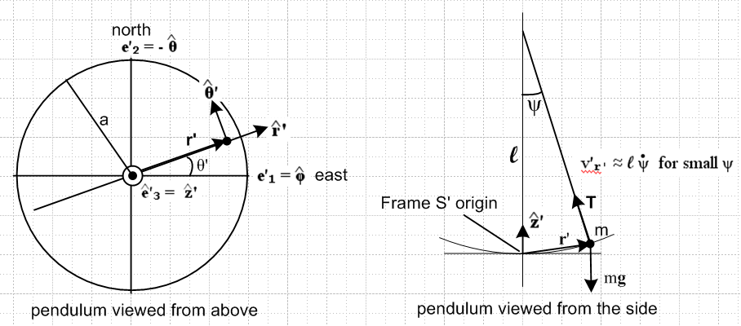
Fig D.2

where now the meaning of Frame S' cylindrical coordinates r',θ',z' should be clear. At some instant of time the Foucault pendulum mass m, suspended some distance l up the ' axis, is located at position r'. We imagine the pendulum has some maximum amount of swing indicated by radius a of the circle. To keep things simple we shall assume that the pendulum swing angle ψ is very small. This brings out the main feature of problem solution and avoids the need for Jacobi functions. In this case, if the maximum swing angle is ψ0, then a ≈ l ψ0.
The Cartesian basis vectors e'n for Frame S' are related to the curvilinear ones for Frame S' as follows (from the picture)

e'1 = cosθ' ' – sinθ' '
e'2 = sinθ' ' + cosθ' '
e'3 = ' (D.2)

(b) Qualitative Solution

On each swing the pendulum veers a little "to the right" in the northern hemisphere due to the Coriolis fictitious force -2m ω x v', so the problem is to compute the time for a full 360 degree rotation:

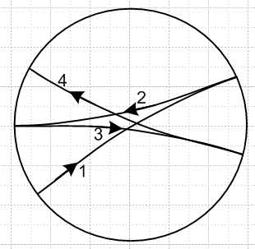 Fig D.3

The amount of veering shown in the drawing is highly exaggerated since we know that when the pendulum is located at the north pole, the period will be one sidereal day ( ≈ 23 hours 56 minutes). If each swing takes 10 seconds, that would be about 24*60*60/10 = 8,640 swings for a full revolution, so each swing would be 360/8640 ≈ .04 degrees. Away from the north pole we know the revolution period will be even longer, at the equator it will be infinite, and in the southern hemisphere the pendulum will rotate the opposite direction. These qualitative facts may be deduced from the direction and magnitude of the Coriolis force as discussed in Section 8 (c).

(c) Solution

As outlined in Section 8 (e) concerning problems on the surface of the earth, the equation of motion for the Foucault pendulum is given by (8.3),

F'eff = ma' (D.3)

where, from (8.15),

F'eff = mg + T – 2m ω x v' . (D.4)

Here T is the tension in the string of the pendulum, and g is the adjusted gravity vector into which is absorbed the Frame S' centrifugal fictitious force. Equation (D.3) is the "bogus" Newton's Law which we are applying in the non-inertial frame S' in which fictitious forces exist. For our purposes, we can ignore the small distinction between g and g0 (see section ***) to get this equation of motion

m' = – mg' + T – 2m ω x v' . (D.5)

The velocity vector v' can be expanded on the cylindrical basis vectors according to

v' = v'r'' + v'θ'' + v'z'' (D.6)

Notice that each component bears two primes. One is part of the name of the vector v', while the other indicates the appropriate Frame S' basis vector. For example, v'θ' = v' • ' . The ω vector (D.1) can be similarly expanded, using (D.2) for e'2,

ω = ωcosβe'3 + ωsinβe'2 = ωcosβ' + ωsinβ [ sinθ' ' + cosθ' ' ]

= ωsinβ sinθ' ' + ωsinβ cosθ' ' + ωcosβ' . (D.7)

Similarly, the string tension vector may be expanded as

T = Tr'' + Tz'' (D.8)

Since the string lies in the '- ' plane, the T vector which lies along the string has no ' component.

The time derivatives of the Frame S' basis vectors are given by ( see Fig D.2 above)

(d'/dt)S' = ' = + ' '
(d'/dt)S' = ' = – ' '
(d'/dt)S' = ' = 0 . (D.9)

We can derive expressions for the velocity components in the usual manner,

r' = r' ' + z' '
so
v' = (dr'/dt)S' = ' = ' ' + ' ' + r' ' = ' ' + ' ' + r' ' '

which tells us the well-known facts that

v'r' = '
v'θ' = r' '
v'z' = ' . (D.10)

The problem now is to solve the equation of motion (D.5) for v'(t).

At this point, we suppress all the Frame S' primes and restate the problem in this less cluttered manner:

m = -mg + T – 2m ω x v (D.11)

v = vr + vθ + vz (D.12)
ω = ωsinβ sinθ + ωsinβ cosθ + ωcosβ (D.13)
T = Tr + Tz (D.14)

d/dt = = +
d/dt = = –
d/dt = 0 (D.15)

vr =
vθ = r
vz = (D.16)

The derivatives of the last three lines are given by

r =
θ = r +
z = (D.17)

From (D.12) and (D.15) we can obtain the left side of our equation of motion (D.11) (without the m) as,

= r + θ + z + vr + vθ

= r + θ + z + vr – vθ

= (r – vθ ) + (θ + vr) + z . (D.18)

Next, the Coriolis cross product is found using (D.12) and (D.13) ( think of r,θ,z as cyclic 1,2,3 for doing unit vector cross products)

ω x v = [ωsinβ sinθ + ωsinβ cosθ + ωcosβ ] x [vr + vθ + vz]

= ωsinβ sinθ x [vθ + vz]
+ ωsinβ cosθ x [vr + vz]
+ ωcosβ x [vr + vθ ]

= ωsinβ sinθ [vθ – vz]
+ ωsinβ cosθ [- vr + vz]
+ ωcosβ [vr – vθ ]

= ω(sinβ cosθ vz - cosβ vθ)
+ ω(–sinβ sinθ vz + cosβ vr)
+ ωsinβ(sinθ vθ – cosθvr) (D.19)

Using (D.18) and (D.19) the equation of motion (D.11) then becomes

m(r – vθ ) + m(θ + vr) + mz
= – mg + Tr + Tz
– 2mω(sinβ cosθ vz – cosβ vθ)
– 2mω(–sinβ sinθ vz + cosβ vr)
– 2mωsinβ(sinθ vθ – cosθvr)

Matching components, we have these three scalar equations of motion

m(r – vθ ) = Tr – 2mω(sinβ cosθ vz – cosβ vθ)
m(θ + vr) = – 2mω(–sinβ sinθ vz + cosβ vr)
mz = – mg + Tz – 2mωsinβ(sinθ vθ – cosθvr) (D.20)

Then from (D.16) and (D.17) the above become

m( – r 2 ) = Tr - 2mω(sinβ cosθ – cosβ r )
m(r + 2 ) = - 2mω(–sinβ sinθ + cosβ )
m = – mg + Tz - 2mωsinβ(sinθ r – cosθ) (D.21)

The small ψ assumption mentioned above tells us that ≈ 0 and also ≈ 0. Since ω is a very small number, we drop the last term in the last equation (to be justified after the fact) so it then reads

0 = – mg + Tz . (D.22)

By the same small ψ assumption T ≈ Tz so (D.22) says T ≈ mg. The first two equations with ≈ 0 and

Tr ≈ – T sinψ ≈ – mg sinψ ≈ – mgψ

become

m( – r 2 ) = – mg ψ + 2m ωcosβ r
m(r + 2 ) = - 2mωcosβ (D.22)

The mass cancels out giving

– r 2 = – g ψ + 2ωcosβ r
r + 2 = - 2ωcosβ (D.23)

For small ψ motion we have r = l ψ, = l and = l so the above equations become

l – l ψ 2 = – g ψ + 2ωcosβ l ψ
l ψ + 2 l = - 2ωcosβ l
or
– ψ 2 = – (g/l) ψ + 2ωcosβ ψ
ψ + 2 = - 2ωcosβ
or
+ (g/l) ψ = ψ ( + 2ωcosβ)
+ 2 (/ψ) = - 2ωcosβ (/ψ)

***************************** stop **************************

Comment: I realize that I don't know how to solve the 3D pendulum problem. Forget Foucault! Go off and solve the 3D pendulum perhaps only for small oscillations, then come back and ponder the Foucault problem. You are not ready for the Foucault problem yet in its more general motion sense.

Maybe it is better to choose r,θ as the variables instead of ψ,θ because r,θ are more closely related to x,y and I think I know how to solve this problem in the x,y world. Maybe I don't, but let's just try our e

But vr = = l for the small-angle pendulum motion, and = l so the equations become

l – r 2 = -g ψ + 2 ωcosβ r
r + 2 l = - 2ωcosβ l (D.24)

We have already seen in the qualitative solution that is exceedingly small, and after the fact we can verify that the terms can be dropped in the first equation so it becomes

l = -g ψ
or
+ (g/l) ψ = 0 (D.25)

from which we conclude that the pendulum swings in its traditional manner,

ψ(t) = ψ0 cos(Ωt) where Ω = $\sqrt{g/l}$ (D.26)

where we assume the swing is initialized at angle ψ0 with vr = l = 0.
In the second equation of (D.24) we drop the term (to be justified below) to get

2 l = - 2ωcosβ l
or
= - ωcosβ (D.27)

Restoring the primes, this last result reads

' = - ωcosβ (D.28)

and this is the solution to the problem of the Foucault pendulum. At the north pole, cosβ = 1 and we find that ' = - ω so the pendulum in Frame S' appears to rotate once per sidereal day in a direction opposite the rotation of the earth. At the south pole, cosβ = -1 and ' = + ω

The period of the earth's rotation is Te = 2π/ω and the period of the pendulum's rotation is Tp = 2π/' so then

Tp = 2π/' = 2π/[ - ωcosβ ] = – (2π/ω) secβ = -

We know that vθ and therefore θ are going to be very small, so we make another simplification to be justified after the fact and set vθ = θ = 0 in these equations to get

(r) = gsinψ
(vr) = -2ωcosβ vr .

For the pendulum we know that vr ≈ l and sinψ ≈ ψ so the first equation says

l = gψ
or
– (g/l) ψ = 0

from which we conclude that the pendulum swings in its traditional manner,

ψ(t) = ψ0 cos(Ωt) where Ω = $\sqrt{g/l}$

where we assume the swing is initialized at angle ψ0 with vr= l = 0. The second equation then tells us the solution to our problem:

= -2ωcosβ

The answer is off by a factor of 2, so probably I assumed too much! But I think my basic flow is OK and now I have to go back and do repairs.

Comment Appendix. In tensor doc, I do mention polars as an example on page 166, but I never make a connection between vθ and θ. I was there just showing the various notations of a vector, use of italics, and all that stuff.
So let's examine the connection right here. We are using primes-removed notation.

r = rnen = rrer + rθeθ + rzez = r + z

Then

v = dr/dt [ in frame S' but with no primes] =

= + + r

= + + r

= + r +

So we then have

v = + r +

v = vr + vθ + vz (D.9)

and finally I get what I have been looking for

vr =
vθ = r
vz =

That only took about 2 hours!

