The Moving Camera Platform PhL 7.1.12

This subject keeps coming up, most recently 2 or 3 times in Lai, and I never seem to get it nailed down. So I will try to do that here.

Review comments: I think the camera application is completely nailed down in frames doc in the special case #2 department where you have Galilean b and ω parameters. The current doc seems to be a much earlier attempt to understand that subject. My three-frame picture seems now quite obscure and unnecessary. The G Rule was still fuzzy, and there are some Lai comments at the end of this doc that are probably useless.

0. Preliminary on Active and Passive. 1
1. Three Frames of Reference. 1
2. Quantities measured in various frames. 5
3. Consider a small movement of the camera platform. 9
4. How does this relate to the Lai p 426 moving frame discussion. 12

0. Preliminary on Active and Passive.

I have dealt with this subject perhaps 50 times in my life, and every time is as confusing as the previous time, so let's have yet another go at it. I think I have it nailed down each time, then the nails work loose and it wobbles again.

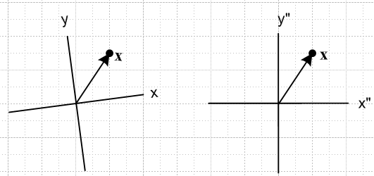

1. Three Frames of Reference.

This whole section seems extraordinarily horrible.

Our starting point is the following picture, [ no picture was here! I will try to find one to insert // DONE ]

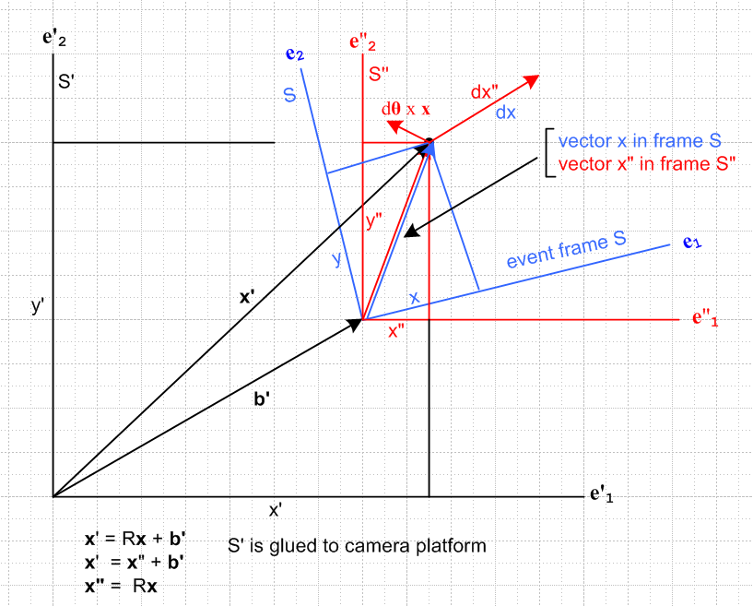

This picture shows three frames of reference S,S',S" and each frame has its own set of Cartesian unit vectors, for example S has e1,e2,e3.
The blue frame S is at some strange 3D orientation with origin as shown. Although I have drawn the entire picture as if the world were 2D, it should be understood that the blue frame could have a z axis that points in some arbitrary direction, not necessarily out of the plane of paper, nor must the blue axes shown necessarily in the plane of paper. I draw the simpler 2D picture because it makes thinking about things easier.
The red frame S" has its three unit vectors lined up with the plane of paper and is related to the blue frame by some kind of rotation about the blue and red origin.
The black frame S' has the exact same three unit vectors as the red frame S", though we continue to use the distinguishing names. For example it is true that e'n = e"n. The red frame is translated by distance b' from the red frame, but is otherwise aligned with it.

In our camera application of this picture, the camera is attached to the black reference frame S'. The "camera" is an "observer". An event is occurring in the blue frame S. This is the event under observation.

The blue-red rotation part. We want to have this equation be true:

x" = Rx where in 2D we have x = (x,y) and x" = (x",y").

The four components x,y,x",y" are marked in the picture. As drawn, it appears that en = Rz(10o) e"n. Therefore we have e"n = Rz(10o)-1 en. We claim this general fact about rotations in N dimensions: these two "views" of the rotation are equivalent:

e"n = R-1 en V fixed passive view

en fixed V" = RV active view .

Rotating the axes backwards by R-1 as shown is equivalent to actively rotating a vector forwards by R. And if we consider V = x, we obtain our desired equation x" = Rx. Here R = Rz(10o).
How do we know the above claim? We know we can write these two expansions for our vector

V = Vn en Vn = V • en

V = V"n e"n V"n = V • e"n

Using the claimed transformation rules shown above for the en and V, we will show that the two expansions above give the same results:

Vi(upper) = [Vn en]i = Vn[en]i = Vnδn,i = Vi

Vi(lower) = V"n [e"n]i = [RV]n [R-1 en]i = RnjVj (R-1)ik (en)k = RnjVj (R-1)ik δn,k

= RnjVj (R-1)in = δij Vj = Vi

Therefore the transformations must be as shown, otherwise the two expansions would not both be true.
In general, we might have

en = R e"n = Rz(ψ,θ,φ) e"n // Euler angles R = Rz(ψ,θ,φ)

e"n = R-1 en = [Rz(ψ,θ,φ)]-1 en = R(-φ,-θ,-ψ) en

x" = Rx

So R-1 tells us what we need to do to more the blue axes into the red axes.
Instead of Euler angles, we can parameterize R differently this way, where θ is a vector,

en = R e"n = R(θ) e"n

e"n = R-1 en = [R(θ)]-1 en = R(-θ) en

x" = Rx

In terms of rotation group generators, we know that

R = R(θ) = exp(-iθ•J) = exp(-iθkJk) where = i (Jk)ij = εkij

Rij(θ) = exp(-iθk[Jk]ij) = exp(-θkεkij)

This turns out to be a more useful parameterization of the arbitrary rotation.

Combining this with the translation part. So we take a blue event vector like x, we move it to x" = Rx which is a vector in frame S" whose axes are parallel to those of frame S'. This being the case, we can do vector addition in the usual way to say that

x' = x" + b' or x'i = x"i + b'i

Thus, we finally arrive at our full transformation from S to S': [ seems OK ]

x' = Rx + b'
t' = t

Motion: From our vantage point sitting in frame S' (we are the camera on the camera platform), we will now assume that the frame S is moving in some arbitrary manner relative to S' , as described by

b' = b'(t) θ = θ(t) ,

and of course we also assume that our vector x is moving within frame S, so it is x(t) . We then have

x'(t) = R[θ(t)]x(t) + b'(t)

We are non-relativistic, so time is the same in both S and S' frames, so it is always just t.

Tensor doc connection. This above can be regarded as a transformation from X = (x,t) to X' = (x',t) in the sense of tensor doc, that is to say, X' = F(X). In this context, R and b' can be arbitrary functions of time, in which case the effective vector-defining linearized 4x4 R matrix is a bit messy. When R and b' are not time dependent, one has R = R ⊕ 1. This subject is discussed in a separate small document.
A Galilean transformation is a special case of the above where b' = a' + v't and t' = t + τ :

x' = Rx + a' + v't
t' = t + τ. [ all seems reasonable]

where the 10 parameters are all constants: τ, v', a' and θ. These transformations form a group.

Comment: The objects Rx and b' are both vectors in x'-space. This is the S' vector space and we are adding two vectors in this space. For that reason, I put a prime on b'.

Comment: We could write this as x' = R(x-x0) + a' to have a different rotation origin, then -Rx0+a' = b', so I don't think we gain anything by allowing a more general origin x0.

Applications. Here are two applications: [ not very useful ]

(1) We have assumed the camera application where the black frame is us "riding" on the camera. We see the blue frame doing strange motions. But in fact, the blue frame is likely to be fixed in space, and it is the camera platform that is doing the motion. In this interpretation we have

-b' = vector from our blue origin to the camera platform origin

R(-θ) = rotation which maps the black camera frame to the blue event frame

Then x' = R(θ) x + b' can be inverted to yield

x = R(-θ) (x'-b')

and this tells us now to map a point x' observed by the camera to its point in blue even space x.

(2) In Goldstein, we might interpret the black frame as the "space" frame which is some inertial frame of reference, and then the moving blue frame is the "body" frame which is attached to some rigid object doing complicated motion. A special case would be when the blue frame is attached to the surface of the rotating earth. The point is that the blue "body" frame can be a non-inertial frame. We need to do the physics in the inertial frame and then map this into the blue frame, and then fictitious Coriolis forces will appear in the blue frame.

2. Quantities measured in various frames.

This seems to be some older material. This is like looking at sediment layers. I use the bracket notation here, so don't want to even try to review this stuff much.

This subject has always been confusing to me and I hope here to nail it down. First:

Comment on vector x in the picture. There is only one vector x, with head and tail as shown in the picture. We can expand it in these two ways, each of which gives different components,

x = xn en xn = x • en

x = x"n e"n x"n = x • e"n

Here is a simpler picture showing the vector x in frame S and S". In both pictures the x arrow has 2 boxes or horizontal extent and 3 of vertical extent (it is the same vector in both pictures, ie):

Now in the above discussion it is true that we have used the bolded symbol x" in x" = Rx, where x" is just a compact abbreviation for the set of numbers (x",y"). And in our example R = Rz(10o). We could if we wanted draw a vector x" = Rx into the picture like so,

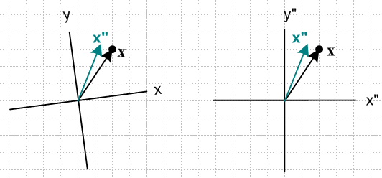

It is true that the components of x" in left picture and the same as the components of x in the right. I guess the main point is that we just don't care about a graphical representation of x" because the vector we care about is x, as in the previous picture.

We are now going to look at various vectors "from" various viewing frames. Consider this notation,

[v]F

where v is some vector, and F is some frame. I want the following to be true

[x]S = [x"]S"

The frame F has unit vectors eFn . So consider,

[v]F = ( v• eF1, v• eF2)

Then for example,

[x]S = ( x• e1, x• e2) = (x,y) = x

[x]S" = ( x• e"1, x• e"2) = (x",y") = x"

[x]S' = ( x• e'1, x• e'2) = ( x• e"1, x• e"2) = (x",y") = x"

Point of major confusion.

According to the above rule we would say

[x"]S" = ( x"• e"1, x"• e"2)

But

The first two lines seem clear, but the third line seems perhaps strange. Consider these questions

Question 1. What are the coordinates of the black dot point in frame S' ?
Answer: The coordinates are x' = (x',y') . The tail of arrow x' is at the S' system origin.

Question 2: What does vector x look like when viewed from frame S' ?
Answer: It looks just like what you see in the picture. The tail is at x' = b' and the head at x' = x' and so the vector you see from frame S' is head - tail = x' - b' = x. You could if you liked translate this arrow x so its tail lay on the S' origin, but that would still be vector x which differs from x'

Now let's try some more

[x']S' = ( x'• e'1, x'• e'2) = (x',y') = x'

[x']S" = ( x'• e"1, x'• e"2) = ( x'• e'1, x'• e'2) = (x',y') = x'

[x']S = ( x'• e1, x'• e2) = ( something, something) = not shown in picture

And our final set of vectors of possible interest (just replace x' by b' in the above three lines)

[b']S' = ( b'• e'1, b'• e'2) = (b'x.b'y) = b'

[b']S" = ( b'• e"1, b'• e"2) = ( b'• e'1, b'• e'2) =(b'x.b'y) = b'

[b']S = ( b'• e1, b'• e2) = ( something, something) = not shown in picture

Now let's take time derivatives of all of the above lines to get

[dx/dt]S = (dx/dt • e1, dx/dt • e2) = (dx/dt,dy/dt) = dx/dt

[dx/dt]S" = (dx/dt • e"1, dx/dt • e"2) = (dx"/dt,dy"/dt) = dx"/dt

[dx/dt]S' = (dx/dt • e'1, dx/dt • e'2) = (dx/dt • e"1, dx/dt • e"2) = (dx"/dt,dy"/dt) = dx"/dt

[dx'/dt]S' = ( dx'/dt • e'1, dx'/dt • e'2) = (dx'/dt,dy'/dt) = dx'/dt

[dx'/dt]S" = ( dx'/dt • e"1, dx'/dt • e"2) = ( dx'/dt • e'1, dx'/dt • e'2) = (dx'/dt,dy'/dt) = dx'/dt

[dx'/dt]S = ( dx'/dt • e1, dx'/dt • e2) = ( something, something) = not shown in picture

[db'/dt]S' = ( db'/dt • e'1, db'/dt • e'2) = (db'x/dt,db'y/dt) = db'/dt

[db'/dt]S" = ( db'/dt • e"1, db'/dt • e"2) = ( db'/dt • e'1, db'/dt • e'2) =(db'x/dt,db'y/dt) = db'/dt

[db'/dt]S = ( db'/dt • e1, db'/dt • e2) = ( something, something) = not shown in picture

Now since we don't really care much about the intermediate frame, let's gather up these results in this more compact grouping

[dx/dt]S = (dx/dt • e1, dx/dt • e2) = (dx/dt,dy/dt) = dx/dt
[dx/dt]S' = (dx/dt • e'1, dx/dt • e'2) = (dx"/dt,dy"/dt) = dx"/dt

[dx'/dt]S' = ( dx'/dt • e'1, dx'/dt • e'2) = (dx'/dt,dy'/dt) = dx'/dt
[dx'/dt]S = ( dx'/dt • e1, dx'/dt • e2) = ( something, something) = not shown in picture

[db'/dt]S' = ( db'/dt • e'1, db'/dt • e'2) = (db'x/dt,db'y/dt) = db'/dt
[db'/dt]S = ( db'/dt • e1, db'/dt • e2) = ( something, something) = not shown in picture

In Lai page 428, we can make these connections to the above

S' → F1 with x' → r
S → F2

Our picture is a little more general than Lai's because he happens to show R = 1, but let's continue anyway. Above we explained the following equation (all in black frame unit vectors, say)

x' = x" + b'

which we can choose to think of as an equation in the S' system:

[x']S' = [x]S' + [b']S'

And we could differentiate to get

[dx'/dt]S' = [dx/dt]S' + [db'/dt]S'

and from our list above we have

[dx'/dt]S' = dx'/dt [dx/dt]S' = dx"/dt [db'/dt]S' = db'/dt

and then the above equation seems to be

3. Consider a small movement of the camera platform.

This small movement is characterized by some dR and some db. We can write { (Ji)jk = -i εijk }

R(θ) = e-iθ•J R(dθ) ≈ 1 - i dθ • J

where
(Ji)jk = -i εijk => -i (Ji)jk = - εijk => -i (Jk)ij = - εkij

We can write out the small rotation matrix this way

R(dθ)ij ≈ δij - i dθ • Jij = δij - i dθk (Jk)ij = δij - dθk εkij

=> dR(dθ)ij = - dθk εkij = + εikj dθk

Now the camera platform does some small movement dR and db, and at the same time, perhaps our point x does some small movement dx in x-space. This all happens in small time interval dt. This movement dR is relative to some finite R(θ) m and movement db relative to some finite b.

x' = Rx + b'

dx' = dR x + R dx + db'

dx'i ≈ (dR)ij xj + Rijdxj + db'i

dx'i ≈ εikj dθk xj + Rijdxj + db'i

dx' = Rdx + dθ x x + db'

and we now see where the famous cross product comes from. If we now divide by dt, we get

dx'/dt = Rdx/dt + ω x x + db'/dt ω = dθ/dt

v' = Rv + ω x x + v'b

x' = Rx + b' // reminder from above

• Note that we are talking here about time-dependent R because ω = dθ/dt . If R were not time-dependent, we would have ω = 0 .

• If both rotational and translational positions are time-independent, then v' = Rv and v then transforms as a vector under rotation R in N-space. Otherwise this is not so.

• Regardless of whether R and b' are time-dependent, if b' ≠ 0, we do not have x' = Rx, and therefore x does not transform as an N-vector under R. If R and b' are time-independent, however, then it is true that dx' = Rdx and so dx transforms as an N-vector under R. In this same case, dX = (dx,t) transforms as an N+1 vector under R = R ⊕ 1.

• Just because we have x' = Rx + b' as our transformation of N-tuple x, that does not mean that for any N-tuple V we will have V' = RV + b' . For example, above we have v' = Rv + ω x x + v'b . Even in the case that ω = 0 and v'b = 0, this says v' = Rv and does not say v' = Rv + b.

Comment. Suppose R = 1 and ω = 0 and v = 0 (x is at rest in S) but we have some v'b . Then the above says

v' = v'b

which somehow seems reasonable. Write this as

dx'/dt = v'b
or
[dx'/dt]S' = v'b .

But at the same time I would claim that

[dx/dt]S' = 0 .

The argument here is this. In time dt, both ends of the vector x move the same amount due to v'b, and therefore the vector x as seen from S' does not change at all, so [dx]S' = 0. The vector x' is different because one end moves and the other does not as seen from S', and for that reason we have [dx']S' ≠ 0. So any notational claim that [dx]S' = [dx']S' is wrong.
This same observation can be made for any vector V which has both ends locked down in frame S. We are going to have [dV]S' = 0, even though frame S and S' might have some time-dependent relative velocity.
Now if the frame S is rotating relative to S', then we are doing to get

[dx/dt]S' = [dx/dt]S + ω x x

and this gives ruse to the operator notion of Goldstein that

[d/dt]S' = [d/dt]S + ω x

but I have not convinced myself of this quite yet. I have at least gotten rid of the relative translation velocity between the frames.
So I need to come up with a unified notation that has both primes and noprimes, but which also has brackets with space labels on them. I did not realize that both are really needed.

So far we have played only with the position vector. What about other vectors? Linear momentum written as p = mv would do this

p' = Rp + mω x x + mv'b

This is certainly not compatible with the following

p' = Rp + b'

so we conclude that p does not transform the way x does. This last equation is nonsense because you would never add b' this way to momentum.

What about angular momentum L = x x p ?

L' = x' x p' = [Rx + b'] x [p + mω x x + mv'b ]

= R L + b'

More generally, we can replace x by any vector quantity G to get

dG' = dG + dθ x G + db'

dG'/dt = dG/dt + ω x G + db'/dt

Compare this to Goldstein notes page 31 where I quote

[dG]space = [dG]body + dΩ x G
[dG/dt]space = [dG/dt]body + ω x G

so in Goldstein, the x-space S is called "body" while the x'-space S' is called space. In Goldstein, the scenario is a little different. For G, the body refers to a coordinate system S glued to some wildly moving rigid object, while space refers to an inertial frame S' . But in our case, the body is moving, and the space frame is moving, so neither might be inertial frames. Also, G is considering only a rotation situation, no simultaneous translation db.

Conjecture: It certainly seems that the connection to Goldstein is this [ I am still trying! ]

[dG]space = dG' = the vector dG observed in the space frame
[dG]body = dG = the vector dG observed in the body frame

I am hopeful that "the prime/noprime notation" can remove the need for those subscript labels.

4. How does this relate to the Lai p 426 moving frame discussion.

[Lai is what got me launched into this whole frames doc business. I hope now that frames doc is done, I can re-study Lai and I think it will make better sense. But as of today I have not done that. ]

Me Lai
x, S x, F2 x = (x)F2
x', S' r, F1 r = (x)F1
(dx/dt) = v (dx/dt)F2 = vF2
(dx'/dt) = v' (dx/dt)F1 = (dr/dt) = vF1
x' = Rx + b' near R=1 r = x + Ro (x)F1 = (x)F2 + R0 7.7.3
dx' = Rdx + db (dx)F1 = (dx)F2 + dR0

Complaint #1. Lai's equation 7.7.4 seems nonsense to me for this reason. In his picture, x is a vector in the F2 frame of reference. The notation (dx/dt)F1 to me means (dr/dt) = vF1 , but to Lai it must mean something different because 7.7.4 clearly says (dx/dt)F1 ≠ (dr/dt) = vF1.

So let's try to bypass his entire page and just get to the results. Here is my main result from the previous section, which I translate to Lai notation using the above table.

dx'/dt = dx/dt + ω x x + db'/dt / me
v' = v + ω x x + v'b / me

vF1 = vF2 + ω x x + dR0/dt
vF1 = vF2 + ω x x + (v0)F1 // This is Lai 7.7.8 which I think is OK (*)

Now let me continue the table above:

Me Lai
Dt = ∂t + v • ∇ (D/Dt)F2
D't = ∂t + v' • ∇' (D/Dt)F1

Now let's try to hack our way into page 429. What is this quantity:

(D/Dt)F1 ∫dm vF1

I think it is meant to be the RHS of 7.6.1 so write out as

(D/Dt)F1 ∫Vm ρ vF1 dV

and we are starting off in our F1 frame which is "the usual frame" I think. Now insert (*) to get

(D/Dt)F1 ∫dm vF1 = (D/Dt)F1 ∫dm[vF2 + ω x x + (v0)F1]

= (D/Dt)F1 [∫dm vF2 + ∫dm ω x x + ∫dm(v0)F1 ]

= (D/Dt)F1 [∫dm vF2 + ω x ∫dm x + (v0)F1∫dm ] // Lai 7.7.9 line 1

= (D/Dt)F1 ∫dm vF2 + (D/Dt)F1[ω x ∫dm x ] + (D/Dt)F1 [ (v0)F1∫dm ]

Now ∫dm = M = a constant, so the last term really has (Dv0/Dt)F1 = (a0)F1 which is the acceleration associated with (v0)F1 . Reorder terms and we then have

= (a0)F1∫dm + (D/Dt)F1 ∫dm vF2 + (D/Dt)F1[ω x ∫dm x ] // Lai 7.7.9 line 2

Now he is going to use (7.7.6) which

