Rotation Rule Debug v3 PhL 7.6.12

This is the third and last doc of another "series" of versions. The "rotation rule" of the title means the G Rule. I seemingly examine a very simple physical situation, and the G Rule as I understood it at the time leads at once to a gaping wrong result. I am trying to learn what assumption is wrong. Review complete.

Here are several differential rotation rules for four different vectors [ I think these terms are the contribution to a change in a vector due to the rotation itself, with no "inside the body frame" motion yet.]

drrot = dθ x rbody
dvrot = dθ x vbody
darot = dθ x abody
dLrot = dθ x Lbody

Then we have expressions for "total change" [ now the body terms are added in ]

dr = drbody + drrot = drbody + dθ x rbody
dv = dvbody + dvrot = dvbody + dθ x vbody
da = dabody + darot = dabody + dθ x abody
dL = dLbody + dLrot = dLbody + dθ x Lbody

Now "divide by dt" to get

dr/dt = drbody/dt + drrot/dt = drbody/dt + ω x rbody
dv/dt = dvbody/dt + dvrot/dt = dvbody/dt + ω x vbody
da/dt = dabody/dt + darot/dt = dabody/dt + ω x abody
dL/dt = dLbody/dt + dLrot/dt = dLbody/dt + ω x Lbody

Now we are ready to ask some "challenge question".

[ I am still not on the program with the meaning of (d/dt) and its label. ]

Question 1: Consider from above

dv/dt = dvbody/dt + dvrot/dt = dvbody/dt + ω x vbody

a = abody + arot = abody + ω x vbody

Suppose we have vbody = 0 and abody = 0 for a particle that is glued down to a phonograph record which is rotating at ω [ok...]. Suppose this record is also accelerating with . We seem to have

a = 0 + ω x 0 = 0

This seems to be the wrong answer [ it is very wrong ], because that particle is in fact accelerating in the space frame. Why does this equation not show that fact? Let's trace backwards. We had this line

dv = dvbody + dvrot = dvbody + dθ x vbody = dvbody + ω x vbody dt

I think this is true whether or not the body frame is accelerating. The dv on the left does not know about any such acceleration of the phono record. [ but you need to know what the pieces mean! Such as, you need to know that dvbody/dt is really (dv/dt)S'. ]
Review comment: The correct result is that a = a' + x r' + 2 ω x v' + ω x (ω x r') + S from frames doc (7.6) so in fact does enter into a. The problem above is that there is simply no precision in what I am talking about. If the v on the LHS really were my vS = v, the G Rule would say a = ∂Sv = ∂S'v +ωxv, and this does indeed look like a = abody + ω x vbody above. But now you have to work out the two terms on the RHS in terms of Frame S' basic quantities, and that is where all the terms come in. We want to see v' and not v on the right, and we have a "cross derivative" ∂S'vS to untangle. My work above is correct if I interpret things as follows:

dv/dt → ∂Sv dvbody/dt → ∂S'v vbody→ v

But at this time I did not know about ∂S and ∂S' or about the correctly stated G Rule.

Search for Light #1. Phonograph Record Problem

Consider a particle on a phono record going in a circle at ω,

r = r d = r dθ (d/dt) = ω

v = dr/dt = (dr/dt) + r (d/dt) d = - r dθ (d/dt) = -ω

= 0 + r ω

a = dv/dt = r - rω[- ω ] = r - rω2

All seems in order here. But what about space versus body coordinates? What are we talking about here? For example, what is the "meaning of" the very first equation r = r ? In the body frame, this would say

[r]S' = [r]S' []S' = constant, independent of time t.

Our point of interest is not moving at all in the body frame, it is glued to the phono record.
Subquestion: Is the equation r = r valid if we evaluate each object in the S frame?

[r]S = [r]S []S

This just shows how to decompose some arbitrary position vector r in the space system. This r could be the position of the ant, expressed in space coordinates, fine.
Maybe a thorough system test with this phono record example is needed. This example is difficult because the unit vectors change direction in S space, say, based on the location you pick in S space. Cartesian base vectors would not have that extra problem. How might we restate all of the above in Cartesians?

r' = r' cosθ' ' + r' sinθ' ' // S' frame evaluation

r = r cosθ + r sinθ // S frame evaluation

r = R(θ-θ') r' // how related

v' = dr'/dt = assume 0 since particle stuck to record.

In this last line, we assume that r', θ', ', ' are all true constants, so v' = 0. Meanwhile,

v = dr/dt = (dR(θ-θ')/dt) r'

Now R(θ) = exp(-iθJz) so

(dR(θ-θ')/dt) = (exp(-i(θ-θ')Jz)/dt) = exp(-i(θ-θ')Jz) [-i Jz] = R(θ-θ') [-i Jz]

Then

(dR(θ-θ')/dt) r' = [-iω J3]R(θ-θ') r' = [-iω J3] r

and then we have

v = dr/dt = [-iω J3] r

vi = [-iω (J3)ij] rj = -ω ε3ijrj = + εi3jω rj

v = ω x r where ω = ω

Notice that everything in this equation is in space coordinates because there are no primes. Using my temp3 notation, the above is

[v]S = ω x [r]S

Now how does this jibe with things like

drrot/dt = ω x rbody

The answer is "it does not fit". Something is wrong with the notation rbody ! Why is this label needed on r? What does rbody "mean". It was intended to indicate some rbody(t) motion of a point within the body frame, which you could "evaluate" in either frame. In the phono example, rbody(t) = ro , a fixed point on the record which again you could evaluate in either frame. So in this sense, our two results are the same

SubStudy: Consider v = ω x r obtained above for the phono record. I am confused as to whether this is a "generic equation", or whether it is an evaluation in frame S only?
So consider just r all by itself

r

[r]S = (the space frame coordinates of r) = r

[r]S' = (the body frame coordinates of r) = r'

What about ω ? It is a vector, and we can view it from our two frames.

[ω]S = (the space frame coordinates of ω) = ω = ω

[ω]S' = (the body frame coordinates of ω) = ω' = ω '

But in this example, = ' so we can write [ω]S = [ω]S' = ω

Imagine in our pictures we are in the space frame looking at ω which is into the plane of paper. Perhaps we have ω = -5. The meaning of this vector is that it is the platter rotation rate. So fine, you can evaluate this vector in any frame you want, so I think this above is OK.

What about v ?

[v]S = (the space frame coordinates of v) = v

[v]S' = (the body frame coordinates of v) = v'

So now interpret this:

[v]S'= ω x [r]S'
or
v' = ω x r'

Ambiguity rears its ugly head again :

v' = (the body frame coordinates of v, which is a time-dependent moving vector)

v' = 0 because our point of interest is not moving in frame S' // wrong

STOP. It almost seems that we need a notation like this:

v (viewed from observer in frame F1, evaluated in the coordinates of frame F2)

and then F1 and F2 can be the same or different! [ maybe this is the notion of cross velocity early on ]

The second line is why I made up the notation vbody . In our example then

vbody = 0 // and this is true in either frame S or frame S' evaluation

OK, let's see you evaluate v' and r' here. Easy as pie:

v' = R(θ)v
r' = R(θ)r

where R(θ) is the matrix which relates the two frames. Then all seems OK

v' = ω' x r'

R(θ)v = R(θ)ω x R(θ)r

v = ω x r

So I think yes, v = ω x r can be regarded as both a generic equation and as the evaluation of that generic equation in frame S.

Question #1 Revisited.

I just quote all of it here. Consider from above

dv/dt = dvbody/dt + dvrot/dt = dvbody/dt + ω x vbody

a = abody + arot = abody + ω x vbody

Suppose we have vbody = 0 and abody = 0 for a particle that is glued down to a phonograph record which is rotating at ω. Suppose this record is also accelerating with . We seem to have

a = 0 + ω x 0 = 0

This seems to be the wrong answer, because that particle is in fact accelerating in the space frame. Why does this equation not show that fact? Let's trace backwards. We had this line

dv = dvbody + dvrot = dvbody + dθ x vbody = dvbody + ω x vbody dt

I think this is true whether or not the body frame is accelerating. The dv on the left does not know about any such acceleration of the phono record.

Question #2. What are the meanings of these two objects: [ that is the right question to ask ]

dvbody/dt

(dv/dt)body =?= abody

Question #3. What is the meaning of rbody ? Consider this situation where an ant starts and the center of a phono record and walks straight out to the radius along a radial line at constant speed.
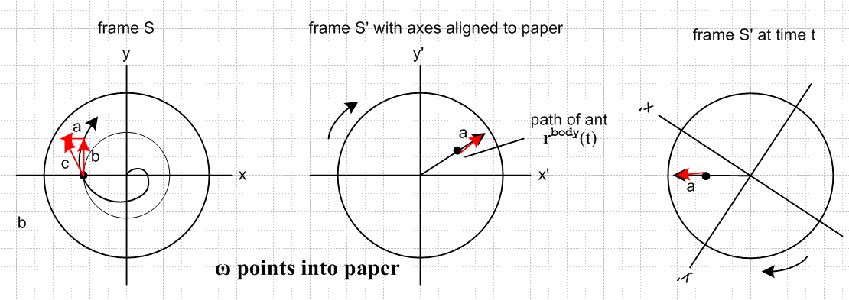

In the body frame S' the record is at rest and the ant does his rbody(t) path (long black arrow). When evaluated in the body frame, this path is something that really exists and we can see it. Maybe the ant leaves a trail of red ink.

[rbody(t)]S'= r' body(t) = black arrow in either of the two rightmost pictures

Now if the record were frozen at t = t, then if we evaluated the path in frame S, we get some result

[rbody(t)]S = r body(t) = black arrow in rightmost picture but in frame S coordinates

As usual, since coordinates are rotated, r' body(t) ≠ r body(t) which is just fine, although the arrows in physical space are the same.
Now if the record is in fact moving, this path [rbody(t)]S = rbody(t) cannot be found physically anywhere in the above picture. The ant trail in frame S will be some [r(t)]S shown as the spiral on the left. We can still talk about rbody(t) , but it is not a physical thing in S space. On the other hand, [rbody(t)]S' is still the ant trail in the body frame and that continues to be a physical thing.
Now consider our equation from above

dr = drbody + drrot = drbody + ω dt x rbody
c a b a b

At time t, the ant is at the position shown by the black dot in the left or right pictures (same picture really). How do we indicate this position? It is rbody(t) in the right picture. We can evaluate this position in either S or S' coordinates. Quantity drbody is the red arrow "a" in the right picture, replicated in the left picture at an offset location. This is the same arrow in both pictures!
The quantity drrot says that, in time dt, if the ant were frozen at that position on the turning record, the ant would move in frame S by drrot = ω dt x rbody. Since ω points into the plane of paper, and since
rbody is the arrow from record center to the black dot in the right picture, drrot points up in the left picture. This vector is tangent to the guide circle shown there. When we add vectors a and b, we get vector c which points along the motion of the ant, called dr. And this could be evaluated in either frame as usual.
I think this is a very reasonable interpretation of the above equation. We could evaluate dr as usual in either coordinate system S or S. In fact any of the terms in the above equation can be evaluated in either frame, it is a generic equation.
Now what happens if we "divide by dt"

dr/dt = drbody/dt + drrot/dt = drbody/dt + ω x rbody
c a b a b
v = vbody + vrot = vbody + vrot ?

I think we can now think of each of the short red arrows as the velocity so labeled here. If one were to ask now "What is the meaning of vbody ?", I think I have an answer. It is the little arrow labeled a in either left or right picture. It is the velocity of the ant in the body frame (at time t) which can then be evaluated in either frame. So I don't seem to have any mysteries here. That is always the case with this particular equation, it is the other ones that have problems.

So let's advance now to the next equation and try to understand it :

dv = dvbody + dvrot = dvbody + ω dt x vbody

Now continue to represent vbody by the red arrow "a" in right or left pictures. What exactly is the meaning of dvbody ? This is supposed to indicate the change in vbody over a time change of dt. Looking at the middle picture we would be inclined to say that dvbody = 0. But looking at the right picture, we instead think of dvbody as something that is tangential and points up. Putting aside this confusion for a moment, the term ω dt x vbody seems to point up, since we think that vbody is the red arrow in the right picture. So however our confusion is resolved on the preceding point, it seems that dv points up. When we then divide by dt, we get

dv/dt = dvbody/dt + ω dt x vbody

and now we have a big problem. If we call this a = dv/dt, then we have a pointing up. But if the ant is moving very slowly relative to ω, we know that in the left picture, acceleration should point to circle center and not up. So we have some major issues here.
Suppose the ant moves so slowly that he is really at rest. Then vbody = 0 we would all agree. Then we get that dv/dt = dvbody/dt and again this is up or nothing.

Conclusion: In the simplest of all possible cases I can think of (the effective N=2), I cannot make sense out of the "rotation equations" listed at the top of this doc. I feel I have a very major misunderstanding of something, but I don't know what that "something" is, Is it bad notation? Is it bad math? [ I did indeed have a bad understanding of the R Gule! ]
This is my 6th day working on this confusion. I thought at first it would take a week to clear up, but now I think much more time will be required. Recall how tensor doc ended up taking 6 months to get a set of related items nailed down. Here I have a similar set of related items, and it may take many weeks to get this cleared up. So I don't think I should just grind 15 hours a day every day on this, because I will get worn out. Think of it as a regular "job" and try to make some small progress each day while doing other things.

[In the rest of this document below, I am sort of on the right track with the dual label concept, but I am unable to make things fly because I am still confused about the underlying G Rule meaning! ]

July 7, 2012. Let's see if some progress might be made with this fancier notation

V (observed from frame F1, evaluated in the coordinates of frame F2) [ eg, v'S , v'S' etc ]

But we need to clarify what we mean by "observed from frame F1". I will define this to mean observed by an observer who is glued to frame F1 and whose view is aligned with the axes of frame F1. For the phono record situation, the left two pictures show observer views. Here is an abbreviation:

V (obs in F1, in F2 coords) = [VF1]F2

Let's try applying this to a few vectors. The simplest is r, the position of the ant at time t in our three pictures

r (obs in S, in S coords) = the black dot in the left (or right) picture in left picture's coordinates

r (obs in S', in S' coords) = the black dot in the middle picture, in that picture's coordinates
= the black dot in the left (or right) picture, in right picture coords

r (obs in S, in S' coords) = the black dot in the right (or left) picture, in right picture coordinates

r (obs in S', in S coords) = the black dot in the right(or left) picture, in left picture coordinates

So taking the lower line in the second case, in all cases the observed r is the same in all four cases. So if we ignore the middle picture, it seems that my first label is not necessary. Let's verify this for velocity to make sure there is no distinction.

v (obs in S, in S coords) = the c arrow in the left picture in left picture's coordinates

v (obs in S', in S' coords) = the red arrow in the middle picture, in that picture's coordinates
= the red a arrow in the right picture, in right picture coords

v (obs in S, in S' coords) = the red c arrow of the left picture copied to right and exp in S' coords

v (obs in S', in S coords) = the red a arrow in the left picture, in left picture coordinates

Now let's consider the Goldstein rotation rule for velocity which we generically writes as

dv = dθ x v

Look at red a arrow in the right picture. Assume for the moment that ant is going at constant velocity on the platter (maybe he accelerates to the rim, and we hold him at constant v for a moment). Thus we get no dv due to his local acceleration. Then in S we see a vertical dv because S' is rotating and in time dt, the red arrow in the right frame swings CW a bit, and we get a dv in the b direction.
So first of all, the v in this equation is the red a arrow, not the c arrow. It is v observed in S'.
What about dv? First, we need a picture which shows velocities

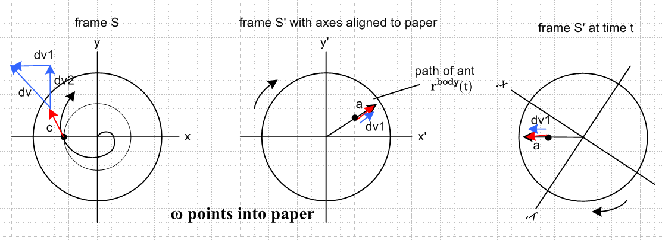

In this new picture, the red arrow in the right pictures indicates the ant's current velocity at time t. We happen to have drawn the arrows with tail on the ant position, but the tail could be at the origin. In the left picture, arrow c represents as well the ant's current velocity (tangent to the and trajectory there). We computed this arrow c in the previous analysis using coordinate r.
Now, there are two components to dv in the left picture. One is dv1 which is the ant's actual change in velocity during time t in the frame S',. And dv2 is the change of the red v arrow in the right picture due to the rotation of the platter. Here is the correct expression for dv2

dv2 = dt ω x vS'

dv2/dt = ω x vS'

d(dv2) = dt [ω(t+dt) - ω(t)] x vS' = x vS' (dt)2

dv = dv1 + dω x vS'(dt) + x vS' (dt)2 = v(t+dt) - v(t)

Paradox: Assume vS' = 0 and dv1 = 0. I know that if there is some , then there will be some and acceleration in frame S due to this . I know it is there, but I am unable to "find it" . If I use the above equation in this case, I get

dv = x vS' (dt)2

dv/dt = x vS' dt → 0 in the limit of small dt

so I get a = 0 which is the wrong answer. That is the paradox that underlies all my pain.

First of all, what is the right answer in this case?

r(t) = Rz(θ(t)) rS'(t) = exp(-iθ(t)J3) rS'(t)

v(t) = dr(t)/dt = [ -iω(t)J3] Rz(θ(t)) rS'(t) + Rz(θ(t)) d rS'(t) /dt

= [ -iω(t)J3] r(t) + Rz(θ(t)) vS'(t)

v(t) = [ -iω(t)J3] r(t)

v(t)i = [ -iω(t)(J3)ij] r(t)j = -ω(t) ε3ij r(t)j = + ω(t) εi3j r(t)j

v(t) = ω x r + Rz(θ(t)) vS'(t)

v(t) = ω x r + [vS'(t)]S

dv(t) = dω x r + ω x dr

= dt x r + ω x v(t) dt

a(t) = dv(t)/dt = x r + ω x v(t)

If v = 0 at some instant, we get

a(t) = x r

So that is the right answer. Now go back to the above

dv(t) = ω x v(t) dt + x r dt

This second term is what I am missing!

Stack Push Down 1 Level.

Consider r = R r'

What this means is

[r]S = R [r]S' = R [r']S

Do the above problem again in generic notation

r(t) = R(t) r'(t)

dr(t)/dt = (dR(t)/dt) r'(t) + R(t) dr'(t)/dt

Now use temp3 doc theorem which says

(dR/dt)V = ω x (RV) => (dR(t)/dt) r'(t) = ω x (Rr') = ω x r

Thus we have

dr(t)/dt = ω x r + R(t) dr'(t)/dt

v(t) = R(t) v'(t) + ω x r v(t)ω=0 = R(t) v'(t)

and this is where I like to say that "therefore, v is not a vector". Now continue along

dv(t)/dt = (dR(t)/dt) v'(t) + R(t) dv'(t)/dt + x r + ω x dr/dt

= ω x (Rv'(t)) + R(t) dv'(t)/dt + x r + ω x v(t)

= ω x (Rv'(t)) + R(t) dv'(t)/dt + x r + ω x [R(t) v'(t) + ω x r]

= 2 ω x (Rv'(t)) + R(t) dv'(t)/dt + x r + ω x (ω x r)
or
a(t) = R(t) a'(t) + 2 ω x (Rv'(t)) + x r + ω x (ω x r)

And this agrees with my general result (9) from temp3 v4 doc. Now suppose the ant moves at a constant velocity v' in S', no acceleration, and no . Then the 2nd line above says

dv(t)/dt = ω x (Rv'(t)) + ω x v(t) v(t) = R(t) v'(t) + ω x r

Where is Goldstein's object which I am expecting to be

dv(t)/dt = ω x v'(t)

Appendix A. I did this and then accidentally erased it, so I will do it again. We want to know if this rule

