The Goldstein Rotation Rule_Version 4 PhL 7.15.12

Motivation for Version 4. The thinking couch pointed out that my frame S' observation frame has always had a common origin with that of frame S. When this is the case, frame S' does not have the "linear accelerator" aspect to it which is related to the terms in expressions. For whatever reason, we really want to separate the origins of frame S and frame S'. We have to do this eventually for earth Coriolis work.

Frame Positions. In our simplified 2D graphic case, the basic idea is this, where frame S is fixed in space, while frame S' is moving in some complicated way,
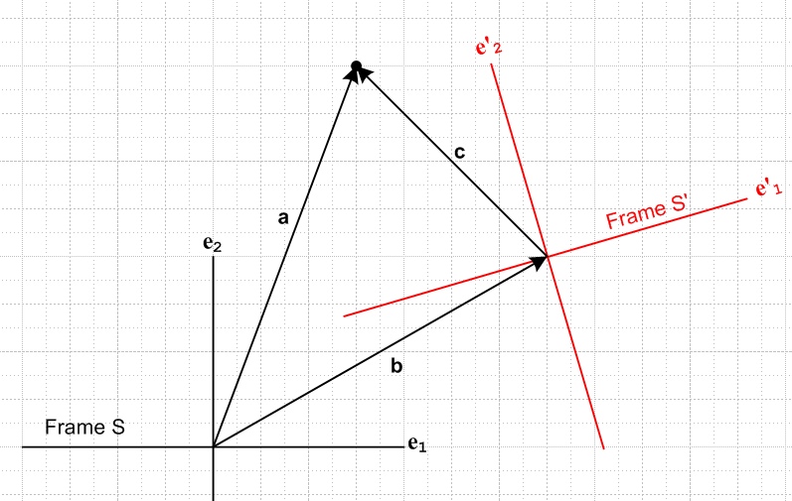

Here are some equations I can associate with the above picture:

a = b + c
a = aiei
b = biei
c = c'ie'i

At the moment, I am treating vectors strictly as drawn, paying attention to location of head and tail of each. From the above we may deduce that

a = aiei = b + c'ie'i

I am trying to mimic the "web G Rule derivation" method. Now, we can compute dta in two ways

dta = dt [aiei ] = iei

dta = dt [b + c'ie'i] = + 'ie'i + c'i'i

Now what can we say about 'i ? If we have b(t) changing, that just causes the e'i unit vectors to translate relative to frame S, so one would say de'i = 0 due to such action. It is the rotation of frame S' that is going to cause some interesting de'i.
Now for the first time I think in all my notes of the last N weeks, we have to worry about the center point for instantaneous rotation. Where do we place the phonograph spindle in the above picture? Since we have two origins, each origin is a candidate. I think for applications of interest to me, I want the rotation origin to be at the frame S origin. Then here is are two photos of the above system at t1 and later time t2 :

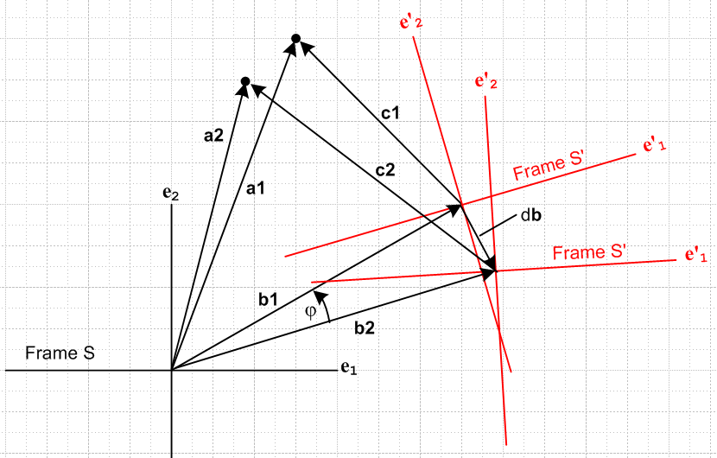

Notice that frame S' is both rotating about its center and translating at the same time.
Despite this complicated picture, all equation given above are still valid, but each object has a time argument and we can set that time to t1 or t2 to get the two pictures above. Notice that we allow a(t) to be moving in frame S.
Now back to our question of computing de'i . Although I had to ponder it for a while, I conclude that since we are rigidly rotating a set of line segments about the frame S origin, we have

de'i = dφ x e'i => 'i = ω x e'i

meaning that each e'i just rotates dφ in our picture above. So our expression for 'i is exactly as it was when we had the two origins be the same point. We also note that

db = dφ x b => = ω x b

Now reconsider our equation above

dta = dt [b + c'ie'i] = + 'ie'i + c'i'i (**)

We may install the above two results to get (I swap the last two terms here)

dta = + c'i'i + 'ie'i

= ω x b + c'i ω x e'i + 'ie'i

= ω x [ b + c'i e'i] + 'ie'i

= ω x a + 'ie'i

which is to say

da/dt = ω x a + 'ie'i (*)

so this is a modified version of our previous G Rule for a.

Next, for the first time let's allow translation of all our vectors "for free", so we then write

a = b + c
a = aiei = a'ie'i
b = biei = b'ie'i
c = ciei = c'ie'i

so now we allow that any of these three vectors can be expanded on either set of basis vectors. If we take the equation a = b + c and dot it with ei , we get ai = bi + ci . And with primed, get primed. So we add some more equations to our list

ai = bi + ci
a'i = b'i + c'i

Then of course we can apply time derivatives to the above two lines to get

i = i + i
'i = 'i + 'i

Then we can write our "modified G rule" in this way

da/dt = ω x a + 'ie'i
= ω x a + ['i - 'i]e'i
= ω x a + 'i e'i - 'i e'i

which is to say

da/dt = ω x a - 'i e'i + 'i e'i

and this now looks like the old rule, but a new term - 'i e'i has been added. If we set b = 0 so the origins align, this term goes away and we recover our previous rule.
Now go back to where we had

= ω x b

dt[b'ie'i] = ω x b

'i e'i + b'i'i = ω x b recall 'i = ω x e'i

'i e'i + b'i ω x e'i = ω x b

'i e'i = ω x b – ω x b'i e'i = ω x b – ω x b = 0

The conclusion is then that

'i = 0

This makes complete sense (now). In the picture, translate b so its tail is at the frame S' origin. This vector b has components b'i in frame S'. Let dt go by. Then b rotates rigidly with frame S', so the components of b in frame S' don't change! This would be true for any vector which rotates rigidly with frame S'.
Therefore, here is our "new" G Rule:

da/dt = ω x a - 'i e'i + 'i e'i

= ω x a + 'i e'i

and we find that it is exactly the same as our "old" G Rule! But of course the picture is now different. In particular, ω is no longer about the origin of S' as it was before.

Comment: I thought some new term was going to appear in this rule, but it did not appear.

Comment: In all of the above analysis, a,b,c have been position vector objects ONLY. The vector b in particular is the distance between origins. None of the above then applies for any a other than r.

Exercise 1. Draw the above picture more accurately if our point stays fixed in frame S'

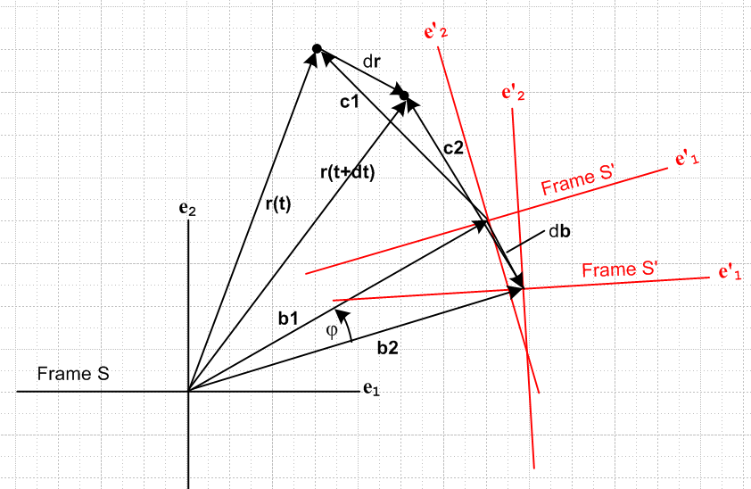

The G Rule is:

dr/dt = ω x r + 'i e'i

Imagine this as a sling shot where particle (stone) is at rest in frame S', so we really have

dr/dt = ω x r

If we compute a from this, yes we get a term and all is well.

Velocity. So continue to assume point is fixed in frame S' and let's add a velocity vector to our picture:

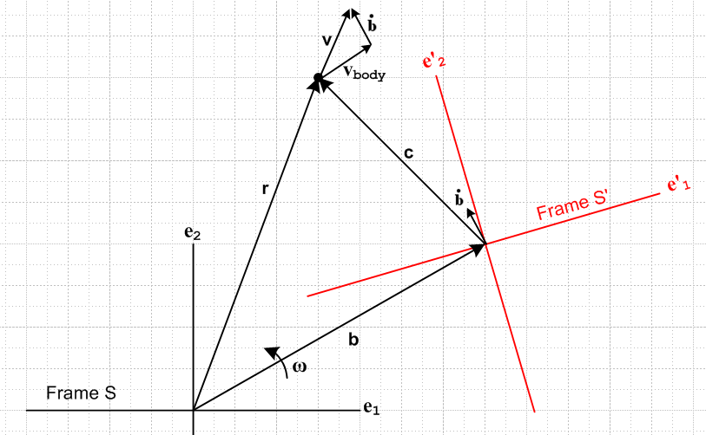

The brand new symbol vbody represents the velocity of our particle as measured from frame S'. But then frame S' has velocity relative to frame S. Recall that = ω x b so this exists because the origin of S' is rotating about the origin of S at rate ω.
So we have now three velocity related vectors, all different arrows in our picture, and if we really wanted we could expand each one in two different ways

v = viei = v'ie'i
= iei = 'i e'i
vbody = vbody,iei = v'body,ie'i

So here is our fundamental velocity equation, no matter which system you express it in,

v = vbody +

and then we find that

= body + = body + ω x + x b

The term ω x represents the centripetal acceleration of the origin of frame S' and it points toward the origin of frame S. The term x b, if indicates an increase in ω, represents a tangential acceleration CCW of the origin of S' relative to frame S. So to me, the above equation "makes sense".
Now at this point we could replace in the second term to get

= body + ω x (v - vbody) + x b
or
= ω x v - ω x body + x b + body

Now THIS is what I would call the Goldstein Rule for velocity v. Notice the two extra terms highlighted in red which don't seem to appear in the his version of this Rule. Notice also that body has a completely unambiguous meaning: it is the acceleration one would measure in frame S' if it were permanently at rest. It contains no strange extra accelerations. Write this out differently,

dv/dt = ω x v - ω x body + x b + (dvbody/dt)

__________________________________________________________________________________

Now we can still derive right here the original flavor G Rule for v :

v = v'ie'i

= 'ie'i + v'i'i = 'ie'i + v'i ω x e'i = 'ie'i + ω x v
or
= ω x v + 'ie'i

Now what is the meaning of this second term? The numbers v'i are the components of v as measured in frame S'. These v'i are not the same as the vbody,i . Now suppose we dot the above equation into e'j :

• e'j = (ω x v) • e'j + 'ie'i• e'j

• e'j = (ω x v) • e'j + 'j

Go back to line above

= 'ie'i + v'i'i

On the other hand, since is a vector, we ought to be able to expand it on the e'i

= 'ie'i

but this conflicts with the previous line. Explain please! A notional hazy issue. Write things out

dv/dt = (dv'i/dt) e'i + v'i'i (1)

= (dv/dt)'i e'i (2)

Maybe this is something to ponder a bit

(dv'i/dt) ≠ (dv/dt)'i when ω ≠ 0

Write out in words what each of these objects means.

(dv'i/dt) Expand v = v'ie'i to determine the function v'i(t). Then differentiate this function.

(dv/dt)'i Compute dv/dt first. Then expand this vector on the e'i

Here is another way to distinguish them

(dv'i/dt) = dv'i/dt = d(v • e'i)/dt

(dv/dt)'i = (dv/dt) • e'i

These are clearly different if e'i= e'i(t).

So here is the original G Rule for v:

dv/dt = ω x v + 'ie'i

= ω x v + (dv'i/dt) e'i

Write again in more detail :

dv/dt = ω(t) x v(t) + (dv'i(t)/dt) e'i(t) (1)

We consider again,

v = v'ie'i = (v • e'i) e'i

Suppose we live all the time in frame S' where the e'i are constants. Then we would say

(dv/dt)for us living in S' = (dv'i/dt) e'i + no second term (2)

This then allows us to write the G rule above as

dv/dt = ω x v + (dv/dt)for us living in S'

Now how should one compare the symbols e'i appearing in (1) versus in those in (2) ? In (1), the vector
e'i(t) is a vector in frame S pointing in a specific direction as indicated in red. In (2), e'i is a vector aligned with the axes of S'. We have

e'i = (e'i• ej) ej // expansion in S

e'i = (e'i• e'j) e'j = δij e'j = e'i // expansion in S'

Question: In practice, we must, at some point, figure out what the (dv'i/dt) actually are! Only then can we say that we know what (dv/dt)for us living in S' is. So here is a computer program to do it.

1. Figure out what v is.
2. Expand v = v'ie'i and determine what the v'i(t) are. That is to say, v'i(t) = v • e'i
3. Compute the derivatives (dv'i/dt)
4. Then dv/dt is given by

dv/dt = ω x v + (dv'i/dt) e'i

But it seems that it would a lot faster to do this program instead:

1. Figure out what v is.
2. Compute dv/dt directly

The program I sort of prefer myself is this

1. Go into frame S' and observe what vbody(t) is .
2. Then compute dv/dt from

dv/dt = body + ω x + x b

Question back on earlier stuff.

Consider again these equations:

v = vbody +

= body + = body + ω x + x b

What happens if b = 0 all the time so the origins coincide. Then it would seem that = 0, since no relative velocity between the origins, and then we would have

v = vbody
= body

But these both seem wrong. Suppose vbody = 0 for ant glued on record. We know that v ≠0. So how can this limit possibly give a bad result? Another oscillation, now 5PM on a Sunday. This is wave # 300 in the oscillation I would say.

•••••••••••••••••••••••••••••••••••••••••••••••••••••••••••••••••••••••••••

(dv/dt)as measured in S' = 'ie'i ≡ (dv/dt)S'

Then we get

(dv/dt) = ω x v + (dv/dt)S'

Notice that the v in the last term is the full v! It is not vbody or any other v. Write as

a = ω x v + (a)S'

This "rule" just relates the components of acceleration vector a in two different frames, nothing more and nothing less. Go back to this version

dv = dφ x v + (dv)S'

(dv)S' = dv'i e'i

In the last term, dv is the total change in v, just

Now comes a big question of notation. I want to somehow express this fact

[v]S = [v]S' +

Perhaps my "current notation" for doing expressing the above fact is this:

v = (v)S' +

But I will now go instead with

v = vbody +

Then maybe I could do something like this (just try it, justify it later)

v = viei

vbody = (v)body,i e'i

Then we have

dv/dt = = (dvbody /dt ) +

Then we have from earlier

= ω x b

= x b + ω x = x b + ω x [v - (v)S'] = x b + ω x v – ω x(v)S'

And then we get

dv/dt = (dvbody /dt ) + x b + ω x v – ω x(v)S'
or
dv/dt = ω x v + x b – ω x(v)S' + (dvbody /dt )
or
dv/dt = ω x + x b + (dvbody /dt )

and this seems to be a new kind of G Rule!
Ah yes, there are now many new questions.

and for the first time ever, we are

v = viei = v'ie'i

which just says we can express vector v in either coordinates. We can as usual write two ways

dtv = dt [viei ] = iei

dtv = dt [ v'ie'i] = 'ie'i + v'i'i

and now there are no terms involving b in this second line. We continue then as before

'i = ω x e'i

dtv = dt [ v'ie'i] = 'ie'i + v'i ω x e'i

dv/dt = 'ie'i + v'i ω x e'i = 'ie'i + ω x v

Now where is our action hiding? Note that

dtv = acceleration of particle wrt frame S

'ie'i = acceleration of particle wrt frame S'

Appendix A. Everything here is wrong because I tried to apply the r rule to things other than r.

Application to velocity of a particle

dv/dt = ω x v + 'i e'i

Now back in the "slightly deflected linear accelerator" interpretation of the merry go round, I had this notion of doing this addition:

accel of particle = accel of particle within frame S' + accel of frame S' relative to frame S

What is this rightmost term? Is it ω x v? I would expect there to be some element in this second term in the linear accelerator contribution. If b is very large, then you would expect frame S' to be linear linearly accelerating with some rate b. Somehow this effect is being lost in the above analysis!

Suppose we just talk about the Origin of frame S' as our point of interest. In the large b case, we expect this origin to have tangential velocity bω and if b is constant and ω changing, then dv/dt = b and there is our term. But this is MISSING from my Rule above.

Exercise 1. How does the fancy picture above apply when vector a is just r, the position vector of a particle which is at rest in frame S' ? Well first of all, if c1 is drawn correctly, c2 is wrong since it must rotate rigidly with frame S'. So here is a corrected picture for this Exercise:

The G Rule for r is then

dr/dt = ω x r + 'i e'i

Imagine this as a sling shot where particle (stone) is at rest in frame S', so we really have

dr/dt = ω x r

If we compute a from this, yes we get a term and all is well. Now:

The G Rule for v is then

dv/dt = ω x v + 'i e'i = ω x v + (dv'i/dt) e'i

Suppose is a whopping huge number, a powerful rubber band on the sling shot. We expect to have some whopping large acceleration dv/dt which is a function of . The ω x v = ω x (ω x r) term does not contain -- it is just the centripetal term. So either the G Rule for v is wrong, or the effect is hidden in the second term.
Now, we have our frame S' camera running. It is pointing at the particle. The particle is at rest at all times the camera is running, so we have v'i(t) = 0 for all time t. Then (dv'i/dt) = 0 and our paradox is alive and well.
So maybe I can trace this paradox backwards through earlier equations to see where it stops existing. For example at point (*) we have

dv/dt = ω x v + 'ie'i

Now c is the position of our particle viewed from S'. Since this c is glued down in frame S', and since the component of c in frame S' is c'i , the numbers c'i(t) are not changing, so 'i = 0. So our paradox still exists at this earlier point. So let's go back some more, say to equation (**)

dtv = dt [b + c'ie'i] = + 'ie'i + c'i'i (**)

We have just said that 'i = 0 so this says

dtv = + c'i'i

Now suppose our "stone" lies right at the S' origin, then surely c'i = 0. Then we have

dtv =

The vector b is moving as our picture shows, and it has velocity = ω x b and THIS is not a function of , so we get that dtv is again independent of . Paradox is still present at (**).

Question: dtv has dimensions L/T2 but is L/T. What is going on here???

